

Maisel IMT Atlantique certify that Mr NERURKAR Pranav Ajeet



**RESERVATION CERTIFICATE**

Has booked an accomodation at IMT ATLANTIQUE

Building SCI RENNES Accommodation Sci-021

Address : 1 rue de la Chataigneraie 35510 CESSON SEVIGNE

From Month 02 March 2020 to Month 31 August 2020.

His (her) monthly rent is : 332.00 € , Security deposit : 300.00 €, Admin charges: 80.00 € Total: 712.00 €

Date, 06/02/2020

Patrice ORUE, Director MAISEL IMT Atlantique

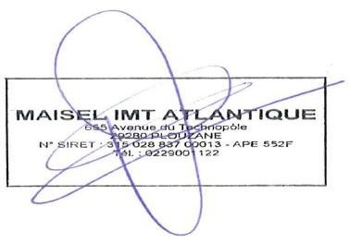

***MAISEL IMT ATLANTIQUE***

***655 Avenue du Technopôle – Bâtiment I3 29280 PLOUZANE***

***Tél : 02 29 00 14 07 / Courriel :*** [***logement-brest@imt-atlantique.fr***](mailto:logement-brest@imt-atlantique.fr)

***N°SIRET : 315 028 837 00013***