How the KO quality pipeline flows
The pipeline scores the metadata of a Knowledge Object - title, subtitle, description and keywords - against a reference summary: the export's own summary (ko_content_flat_summarised) or, with --resummarise, one written fresh from the file itself in the document's own language. Every language is assessed by default, for both the contributor's version and an LLM version written fresh from the summary each run (blind, in the document's own language; --use-existing-llm scores the export's *_llm fields instead). Each field score averages four pillars: three measured on our machine without an LLM (structural, semantic, functional) and an LLM's 0-100 score of the field. The better version of each field is recommended, and the summary used is stored with every run. The worked example below is 10 English PDFs from the June 2026 export, excluding the CC BY-NC-ND licence:
python pipeline.py --limit 10 --file-type pdf --languages en --exclude-licenses "CC BY-NC-ND"
The LLM calls per KO: one to write the LLM version, then one judge call per field that has text, per version - up to 9 in all, counted and printed before any call. --no-llm-score leaves the judge out; --use-existing-llm skips the generation. --resummarise adds 2-4 calls per short document, about two more per further 12 pages, and one transcription call per 10 minutes of video or audio.
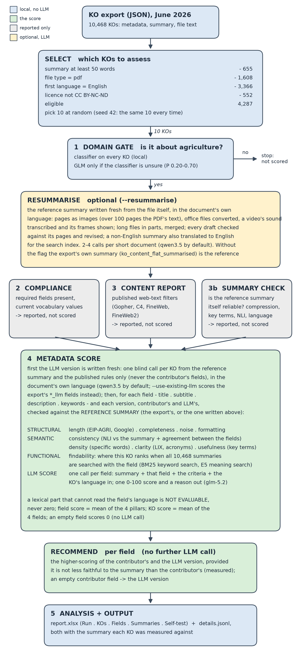

Step by step
Step | What happens | LLM?
Select | Filters the export by summary length, file type, first language and licence, then draws the requested number of KOs at random. The seed makes the draw repeatable. | No
1 Domain gate | A classifier decides whether each KO is about agriculture in the broad sense. Off-domain KOs stop here and are not scored. | Only for the few KOs the classifier is unsure about
Resummarise (optional) | With --resummarise, writes each KO's reference summary fresh from the file itself, in the document's own language. The file is fetched from its @id URL and read as it is: pages as images (a PDF of more than 100 pages as its own text; a PDF over 100 MB is not downloaded), office files converted first, a video's sound transcribed and its frames shown. Long files are summarised in parts and merged, every draft is checked against its pages and revised, and a non-English summary is also translated to English for the search index. A file that cannot be fetched or read falls back to the export's text. Without the flag the export's own summary is the reference. | Yes: 2-4 calls per short document, about two more per further 12 pages, one transcription call per 10 minutes of recording
2 Compliance | Checks that the fields every record must carry are present and that controlled-vocabulary values are current. Reported, never scored. | No
3 Content report | Runs the published web-text quality filters over the file's text. The file is the author's work, so this is reported, never scored. | No
3b Summary check | Measures the reference summary itself against the file text - compression, key-term coverage, NLI support, language - and flags outliers within each file-language group. Reported, never scored. | No
4 Metadata score | First writes the LLM version: one blind call per KO from the reference summary and the published rules, in the document's own language. Then scores each field of both versions against that summary: 10 sub-pillars combined into 3 measured pillars, plus an LLM's 0-100 score of the field (one call per field). A lexical part that cannot read the field's language is marked not evaluable, never zeroed. The field score is the mean of the 4 pillars, the KO score the mean of the 4 fields. An empty field scores 0, without a call. | Yes: 1 generation call per KO, plus 1 judge call per field with text, per version (up to 9 per KO)
Recommend | Per field, the higher-scoring of the contributor's and the LLM version, provided it is not less faithful to the summary than the contributor's (measured accuracy). Where the contributor left a field empty, the LLM version is taken. | No
5 Analysis + output | Explains the weakest sub-pillars of each KO, checks how much the ranking depends on the weights, and writes report.xlsx. | No

What the judge receives
- One field of one version at a time - never several in one prompt, because multi-field answers were where the output broke.
- The reference summary - the export's, or the one --resummarise wrote - the same text the other pillars measure against. The file itself is not sent.
- The criteria of the three measured pillars in words, with the published length rules for title (EIP-AGRI Common Format) and description (Google Dataset guidelines).
- The KO's language, with the instruction to rate meaning across languages and not penalise the field for the language it is written in.
- It returns one 0-100 score, its own reading of each measured pillar's criteria (reported, never scored) and a one-sentence reason. The model, glm-5.2, wrote neither version: the generator is qwen3.5 by default, and the judge is kept out of the writer's model family.
LLM judges may favour LLM-written text, which here is the LLM version; that is why the LLM score is one pillar of four and the recommendation's faithfulness check uses the measured accuracy (METHODS.md §6).

What you get
- report.xlsx - Run: settings, selection, what the fields were measured against and where that summary came from, models, LLM calls, self-test and robustness; KOs: one row per KO with each version's score, the contributor's four pillars and the weakest parts with reasons; Fields: one row per KO, field and version with the 4 pillars, all 10 sub-pillars, the LLM's reason and the recommendation; Summaries: the summary each KO was measured against, its language and basis, and with --resummarise its English version and the platform summary it replaced; Self-test when requested.
- details.jsonl - the raw archive with every piece of evidence, the summary included, for code.
Methods and sources: METHODS.md and LITERATURE_REVIEW.md, and the Word guide How_the_KO_quality_pipeline_works.docx built from them.

