Basic syntax of expressJS
- const express = require('express'); // Returns a function
- var app = express(); // app Can be pass to the createServer as this is the listener
- app.use((req,res,next)=>{ //Implementation of the middleware
next();// Allows to go next
})
- var server = http.createServer(app);
sending response from MIDDLEWARE
- use res.send("<h1>HEADER</h1>"); // this will automatically sets the content type also and other header requirements as per the need
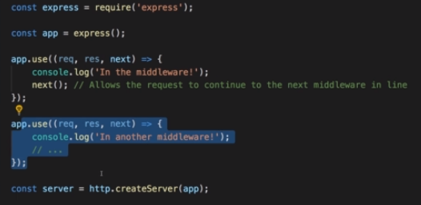
Routing with ExpressJS
-We can route using the use() function->mentioned above.
-A use function is overloaded with different type of arguments.
-We can provide 1st arg as path here(See below)
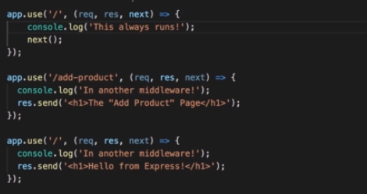
- Make sure that ‘/’ would be mentioned last as it will start with ‘/’ for any ‘/PATH’.Above next() is used.
Parse requests using 3rd part tool Body Parser
- See code 2_parseRequests.js
- Saves use of buffer and handling of chunks and its conversion
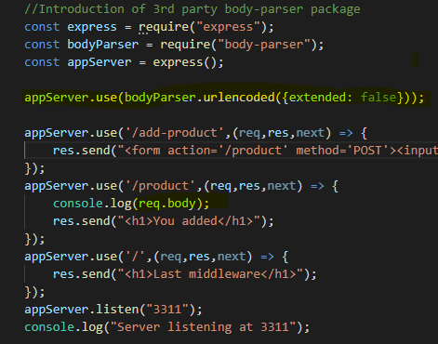

USE GET POST
-///We can use 'use' function for all html requests
/But we can also use POST and GTE to diff the
//method of the request
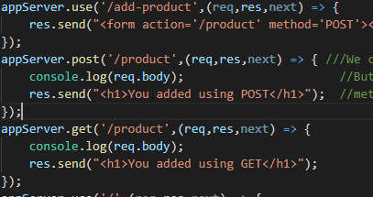

Using Express Router
-We can put middleware code to another js file and can add this code as a module in main code.
-To do this express provides Router function that manages this other functions and by importing this router to main code we can use it as a handlebars.
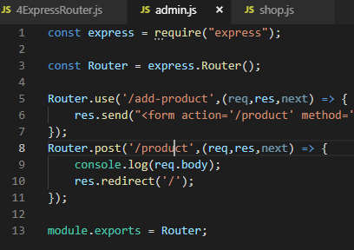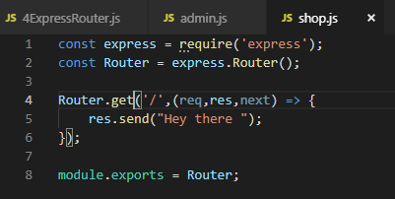

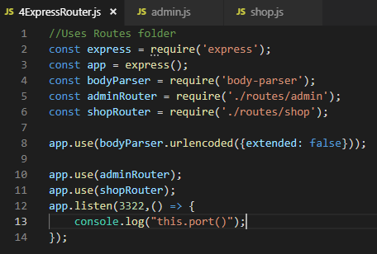
Adding 404 Error page
-After using get method (NOT ‘use’ ) for path ‘/’ this will definitely give below error if page not found.
-We can add below method that will handle any page request and display error to the user adding status as 404.
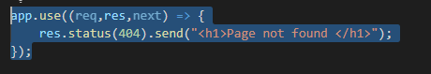
Filtering Paths
- 4ExpressRoter.js and Router Folder
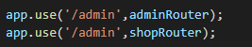
- We can add a pre-path to the router that will be applied all request handlers inside the router hence if adminRouter has path /path1 then this will be accessible at /admin/path1

Serving HTML pages and Use of Core module ‘path’
__dirname -> directory name of this file
‘../’ -> to go one step back as other folder is sibling
‘views’ -> sibling folder views containing htm files
‘filename.htm’ -> file to serve
const path = require('path');
const Router = express.Router();
Router.get('/',(req,res,next) => {
res.sendFile(path.join(__dirname,'../','views','shop.htm'));
});

Using Helper function for Navigation
Working with Express.js
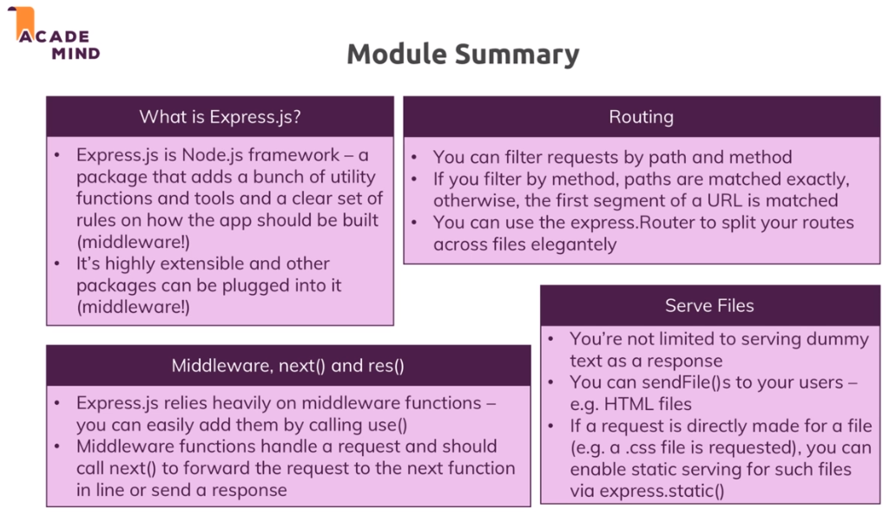
Working with Dynamic Content & Adding Templating Engines


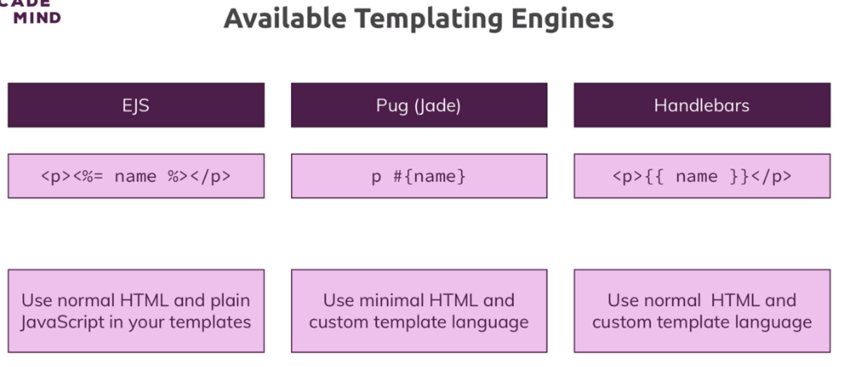
PUG
1st line -> code snippet to tell express to set engine as pug and use it.
2nd line -> code snippet to tells where are the pug files
app.set('view engine','pug');
app.set('views','views');

To send pug file as response -> Add below snippet to render -> need not to specify .pug extension
The below add-product.pug file is in views folder.
res.render('add-product');

Pug Documentation
https://pugjs.org/api/getting-started.html

