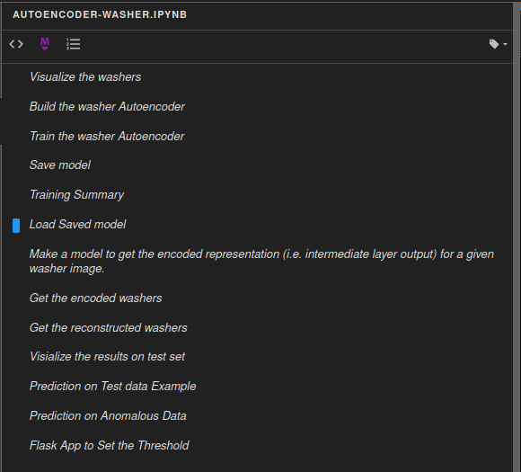
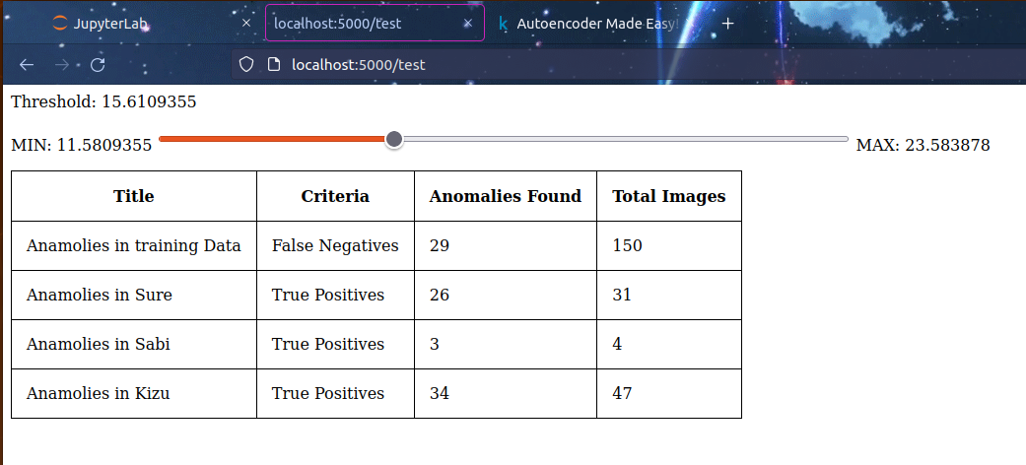
Code Flow in of Jupyter code
1. Please Refer autoencoder-washer.ipynb

