**Name- Pranav A N**

**Roll Number-CH.EN.U4CYS21056**

**Experiment 1- Calculator**

**Code**

**Activity_main.xml file**

<?xml version="1.0" encoding="utf-8"?>  
<LinearLayout xmlns:android="http://schemas.android.com/apk/res/android"  
 xmlns:app="http://schemas.android.com/apk/res-auto"  
 xmlns:tools="http://schemas.android.com/tools"  
 android:id="@+id/main"  
 android:layout_width="match_parent"  
 android:layout_height="match_parent"  
 android:orientation="vertical"  
 android:padding="20dp"  
 tools:context=".MainActivity">  
  
 <TextView  
 android:layout_width="wrap_content"  
 android:layout_height="wrap_content"  
 android:text="Simple Calculator"  
 android:layout_gravity="center"  
 android:textStyle="bold"  
 android:layout_marginTop="50dp"  
 android:textSize="30sp"/>  
  
 <EditText  
 android:id="@+id/number1"  
 android:hint="Enter a number"  
 android:inputType="number"  
 android:layout_marginTop="10dp"  
 android:layout_width="match_parent"  
 android:layout_height="wrap_content"/>  
 <EditText  
 android:id="@+id/number2"  
 android:hint="Enter a number"  
 android:inputType="number"  
 android:layout_marginTop="10dp"  
 android:layout_width="match_parent"  
 android:layout_height="wrap_content"/>  
  
 <LinearLayout  
 android:layout_marginTop="30dp"  
 android:layout_width="match_parent"  
 android:layout_height="wrap_content"  
 android:orientation="horizontal">  
  
 <Button  
 android:layout_width="wrap_content"  
 android:layout_height="wrap_content"  
 android:id="@+id/btn_add"  
 android:text="+"  
 android:textSize="30sp"  
 android:layout_marginEnd="5dp"/>  
 <Button  
 android:layout_width="wrap_content"  
 android:layout_height="wrap_content"  
 android:id="@+id/btn_sub"  
 android:text="-"  
 android:textSize="30sp"  
 android:layout_marginEnd="5dp"/>  
  
 <Button  
 android:layout_width="wrap_content"  
 android:layout_height="wrap_content"  
 android:id="@+id/btn_mul"  
 android:text="x"  
 android:textSize="30sp"  
 android:layout_marginEnd="5dp"/>  
  
 <Button  
 android:layout_width="wrap_content"  
 android:layout_height="wrap_content"  
 android:id="@+id/btn_div"  
 android:text="/"  
 android:textSize="30sp"  
 android:layout_marginEnd="5dp"/>  
 </LinearLayout>  
  
 <TextView  
 android:layout_width="wrap_content"  
 android:layout_height="wrap_content"  
 android:id="@+id/answer"  
 android:layout_gravity="center"  
 android:layout_marginTop="30dp"  
 android:textSize="30sp"  
 android:textStyle="bold"/>  
  
</LinearLayout>

**MainActivity.java**

package com.example.mycaluculator;  
import android.os.Bundle;  
import android.view.View;  
import android.widget.Button;  
import android.widget.EditText;  
import android.widget.TextView;  
import android.widget.Toast;  
  
import androidx.activity.EdgeToEdge;  
import androidx.appcompat.app.AppCompatActivity;  
import androidx.core.graphics.Insets;  
import androidx.core.view.ViewCompat;  
import androidx.core.view.WindowInsetsCompat;  
  
public class MainActivity extends AppCompatActivity implements View.OnClickListener {  
  
 Button buttonAdd, buttonSub, buttonMul, buttonDiv;  
 EditText editTextN1, editTextN2;  
 TextView textView;  
 int num1,num2;  
  
  
 @Override  
 protected void onCreate(Bundle savedInstanceState) {  
 super.onCreate(savedInstanceState);  
 EdgeToEdge.*enable*(this);  
 setContentView(R.layout.*activity_main*);  
 buttonAdd = findViewById(R.id.*btn_add*);  
 buttonSub = findViewById(R.id.*btn_sub*);  
 buttonMul = findViewById(R.id.*btn_mul*);  
 buttonDiv = findViewById(R.id.*btn_div*);  
 editTextN1 = findViewById(R.id.*number1*);  
 editTextN2 = findViewById(R.id.*number2*);  
 textView = findViewById(R.id.*answer*);  
  
 buttonAdd.setOnClickListener(this);  
 buttonSub.setOnClickListener(this);  
 buttonMul.setOnClickListener(this);  
 buttonDiv.setOnClickListener(this);  
  
 }  
  
 public int getIntFromEditText(EditText editText){  
 if (editText.getText().toString().equals("")){  
 Toast.*makeText*(this,"Enter number",Toast.*LENGTH_SHORT*).show();  
 return 0;  
 }else  
 return Integer.*parseInt*(editText.getText().toString());  
 }  
  
 @Override  
 public void onClick(View view) {  
 num1 = getIntFromEditText(editTextN1);  
 num2 = getIntFromEditText(editTextN2);  
 int id = view.getId();  
 if (id == R.id.*btn_add*) {  
 textView.setText("Answer = " + (num1 + num2));  
 } else if (id == R.id.*btn_sub*) {  
 textView.setText("Answer = " + (num1 - num2));  
 } else if (id == R.id.*btn_mul*) {  
 textView.setText("Answer = " + (num1 * num2));  
 } else if (id == R.id.*btn_div*) {  
 textView.setText("Answer = " + ((float) num1 / (float) num2));  
 }  
  
 }  
}

Androidmanifest.xml

<?xml version="1.0" encoding="utf-8"?>  
<manifest xmlns:android="http://schemas.android.com/apk/res/android"  
 xmlns:tools="http://schemas.android.com/tools">  
  
 <application  
 android:allowBackup="true"  
 android:dataExtractionRules="@xml/data_extraction_rules"  
 android:fullBackupContent="@xml/backup_rules"  
 android:icon="@mipmap/ic_launcher"  
 android:label="@string/app_name"  
 android:roundIcon="@mipmap/ic_launcher_round"  
 android:supportsRtl="true"  
 android:theme="@style/Theme.Mycaluculator"  
 tools:targetApi="31">  
 <activity  
 android:name=".MainActivity"  
 android:exported="true">  
 <intent-filter>  
 <action android:name="android.intent.action.MAIN" />  
  
 <category android:name="android.intent.category.LAUNCHER" />  
 </intent-filter>  
 </activity>  
 </application>  
  
</manifest>

**Output- Emulator**

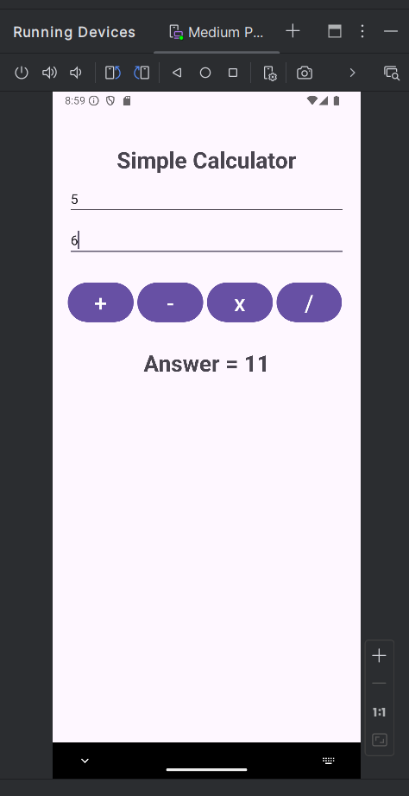

**Output – Phone**

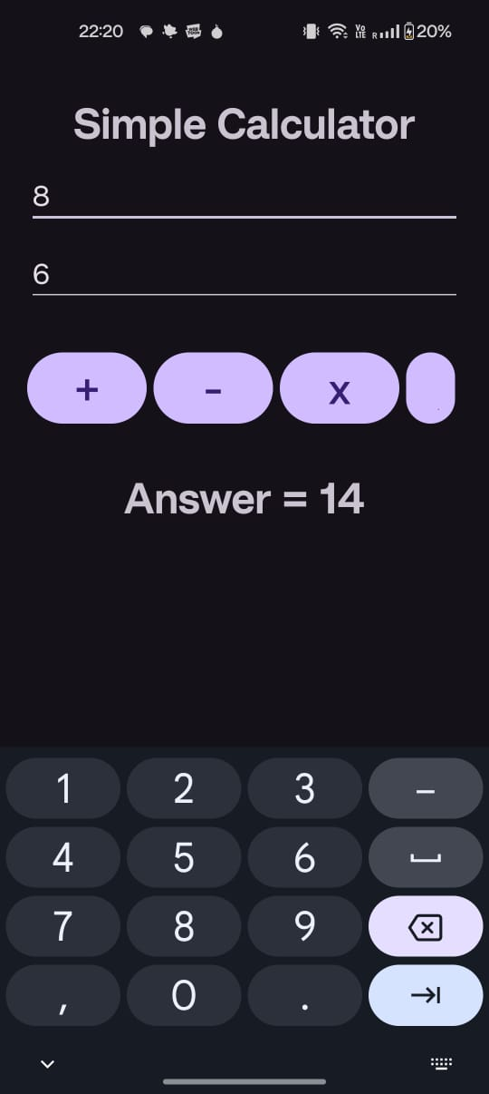

**Experiment-2- Icon Change**

**Code**

**Androidmanifest.xml**

<?xml version="1.0" encoding="utf-8"?>  
<manifest xmlns:android="http://schemas.android.com/apk/res/android"  
 xmlns:tools="http://schemas.android.com/tools">  
  
 <application  
 android:allowBackup="true"  
 android:dataExtractionRules="@xml/data_extraction_rules"  
 android:fullBackupContent="@xml/backup_rules"  
 android:icon="@drawable/logo "  
 android:label="@string/app_name"  
 android:roundIcon="@drawable/insideout"  
 android:supportsRtl="true"  
 android:theme="@style/Theme.Mycaluculator"  
 tools:targetApi="31">  
 <activity  
 android:name=".MainActivity"  
 android:exported="true">  
 <intent-filter>  
 <action android:name="android.intent.action.MAIN" />  
  
 <category android:name="android.intent.category.LAUNCHER" />  
 </intent-filter>  
 </activity>  
 </application>  
  
</manifest>

Output-

Emulator

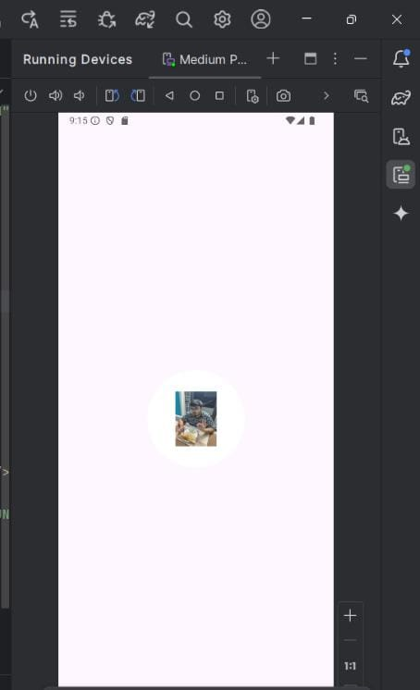

**Output-Phone**

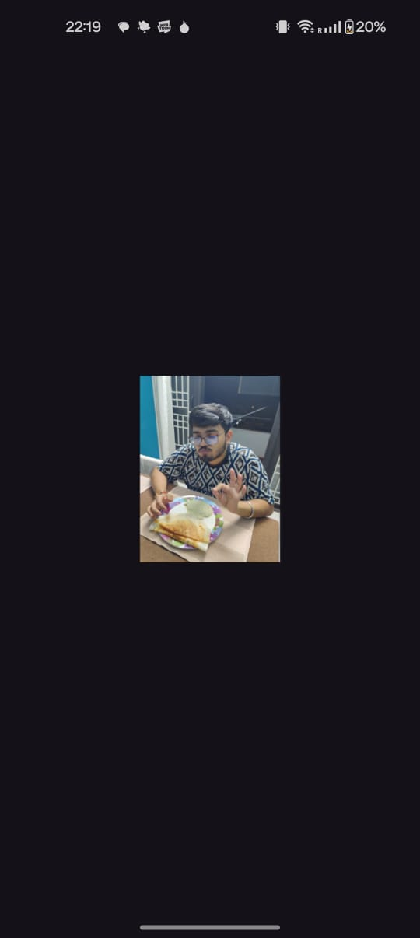

**Experiment 3-Alert and Toast**

**Code**

**Activity_main.xml**

<?xml version="1.0" encoding="utf-8"?>  
<android.widget.RelativeLayout  
 xmlns:android="http://schemas.android.com/apk/res/android"  
 xmlns:app="http://schemas.android.com/apk/res-auto"  
 xmlns:tools="http://schemas.android.com/tools"  
 android:layout_width="match_parent"  
 android:layout_height="match_parent"  
 tools:context=".MainActivity">  
 <Button  
 android:id="@+id/B1"  
 android:layout_width="wrap_content"  
 android:layout_height="wrap_content"  
 android:layout_marginTop="138dp"  
 android:text="Click here"  
 />  
</android.widget.RelativeLayout>

**MainActivity.java**

package com.example.alertandtoast;  
  
  
import android.content.DialogInterface;  
import android.os.Bundle;  
import android.view.View;  
import android.widget.Button;  
import android.widget.Toast;  
  
import androidx.activity.EdgeToEdge;  
import androidx.appcompat.app.AlertDialog;  
import androidx.appcompat.app.AppCompatActivity;  
import androidx.core.graphics.Insets;  
import androidx.core.view.ViewCompat;  
import androidx.core.view.WindowInsetsCompat;  
  
public class MainActivity extends AppCompatActivity {  
  
 Button B1;  
  
 @Override  
 protected void onCreate(Bundle savedInstanceState) {  
 super.onCreate(savedInstanceState);  
 EdgeToEdge.*enable*(this);  
 setContentView(R.layout.*activity_main*);  
  
 B1 = (Button) findViewById(R.id.*B1*);  
 B1.setOnClickListener(new View.OnClickListener() {  
 @Override  
 public void onClick(View v) {  
 Toast.*makeText*(getApplicationContext(),"Hello",Toast.*LENGTH_LONG*).show();  
 try {  
 AlertDialog.Builder builder = new AlertDialog.Builder(MainActivity.this);  
 builder.setTitle("OOPS IT's An Error");  
 builder.setMessage("Something went wrong");  
 builder.show();  
 builder.setPositiveButton("OK", new DialogInterface.OnClickListener() {  
 @Override  
 public void onClick(DialogInterface dialogInterface, int i) {  
 Toast.*makeText*(getApplicationContext(),"Ok Button CLicked",Toast.*LENGTH_LONG*).show();  
 }  
 });  
 builder.setNegativeButton("Cancel", new DialogInterface.OnClickListener() {  
 @Override  
 public void onClick(DialogInterface dialogInterface, int i) {  
 Toast.*makeText*(getApplicationContext(),"Cancel button clicked",Toast.*LENGTH_LONG*).show();  
 }  
 });  
 builder.show();  
 }  
 catch (Exception e){  
 Toast.*makeText*(getApplicationContext(),e.getMessage(),Toast.*LENGTH_LONG*).show();  
 }  
 }  
 });  
 }  
}

Output-Emulator

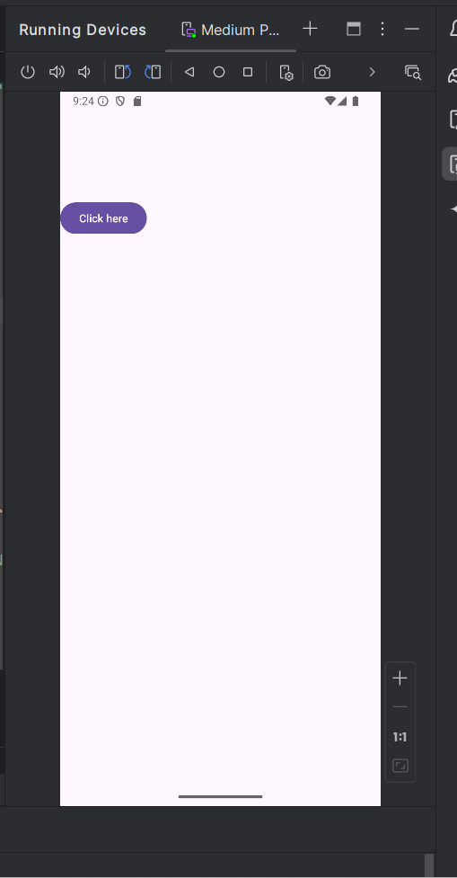

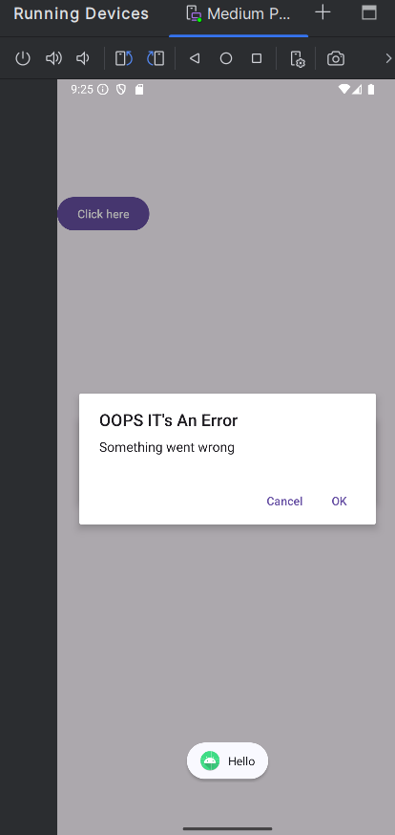

**Output-Phone**

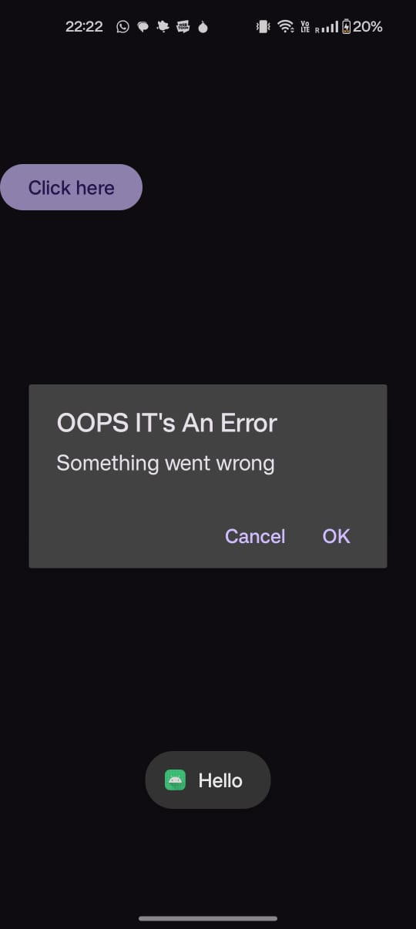

**Experiment 4-Open Browser**

**Code**

**Activity_main.xml**<?xml version="1.0" encoding="utf-8"?>  
<android.widget.RelativeLayout  
 xmlns:android="http://schemas.android.com/apk/res/android"  
 xmlns:app="http://schemas.android.com/apk/res-auto"  
 xmlns:tools="http://schemas.android.com/tools"  
 android:layout_width="match_parent"  
 android:layout_height="match_parent"  
 tools:context=".MainActivity">  
 <WebView  
 android:layout_width="match_parent"  
 android:layout_height="match_parent"  
 android:id="@+id/wv">  
  
 </WebView>  
</android.widget.RelativeLayout>

**MainActivity.java**

package com.example.openbrowser;  
  
import android.os.Bundle;  
import android.webkit.WebChromeClient;  
import android.webkit.WebSettings;  
import android.webkit.WebView;  
import android.webkit.WebViewClient;  
  
import androidx.activity.EdgeToEdge;  
import androidx.appcompat.app.AppCompatActivity;  
import androidx.core.graphics.Insets;  
import androidx.core.view.ViewCompat;  
import androidx.core.view.WindowInsetsCompat;  
  
public class MainActivity extends AppCompatActivity {  
  
 WebView wv;  
  
 @Override  
 protected void onCreate(Bundle savedInstanceState) {  
 super.onCreate(savedInstanceState);  
 EdgeToEdge.*enable*(this);  
 setContentView(R.layout.*activity_main*);  
  
 wv = (WebView) findViewById(R.id.*wv*);  
 wv.setInitialScale(0);  
 WebSettings ws = wv.getSettings();  
 ws.setJavaScriptEnabled(true);  
 wv.setWebViewClient(new WebViewClient());  
 wv.setWebChromeClient(new WebChromeClient());  
 wv.loadUrl("https://www.capgemini.com/");  
 }  
}

**Output-Emulator**

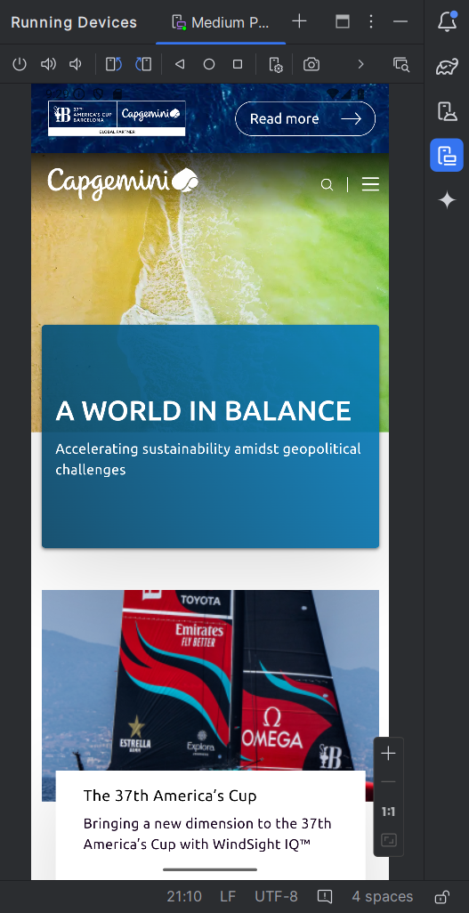

**Output-Phone**



**Experiment 5**

**Multiple Activity**

**Code**

**Activity_main.xml**

<?xml version="1.0" encoding="utf-8"?>  
<RelativeLayout xmlns:android="http://schemas.android.com/apk/res/android"  
 xmlns:app="http://schemas.android.com/apk/res-auto"  
 xmlns:tools="http://schemas.android.com/tools"  
 android:layout_width="match_parent"  
 android:layout_height="match_parent"  
 tools:context=".MainActivity">  
 <Button  
 android:layout_width="wrap_content"  
 android:layout_height="wrap_content"  
 android:text="Press to go to 2nd Activity"  
 android:id="@+id/b1"  
 />  
</RelativeLayout>

**MainActivity.java**

package com.example.multipleactivities;  
  
  
import android.content.Intent;  
import android.os.Bundle;  
import android.view.View;  
import android.widget.Button;  
  
import androidx.activity.EdgeToEdge;  
import androidx.appcompat.app.AppCompatActivity;  
import androidx.core.graphics.Insets;  
import androidx.core.view.ViewCompat;  
import androidx.core.view.WindowInsetsCompat;  
  
public class MainActivity extends AppCompatActivity {  
  
 Button b1;  
 @Override  
 protected void onCreate(Bundle savedInstanceState) {  
 super.onCreate(savedInstanceState);  
 setContentView(R.layout.*activity_main*);  
  
 b1 = (Button) findViewById(R.id.*b1*);  
 b1.setOnClickListener(new View.OnClickListener() {  
 @Override  
 public void onClick(View view) {  
 Intent i = new Intent(MainActivity.this,Main2Activity.class);  
  
 i.putExtra("VALUE1", "WIPRO");  
 i.putExtra("Roll No", "1111");  
 startActivity(i);  
 }  
 });  
 }  
}

activity_main2.xml

<?xml version="1.0" encoding="utf-8"?>  
<RelativeLayout xmlns:android="http://schemas.android.com/apk/res/android"  
 xmlns:app="http://schemas.android.com/apk/res-auto"  
 xmlns:tools="http://schemas.android.com/tools"  
 android:layout_width="match_parent"  
 android:layout_height="match_parent"  
 tools:context=".Main2Activity">  
 <TextView  
 android:layout_width="wrap_content"  
 android:layout_height="wrap_content"  
 android:layout_centerVertical="true"  
 android:layout_centerHorizontal="true"  
 android:text="Welcome to new activity"  
 android:id="@+id/t2"/>  
 <Button  
 android:layout_width="wrap_content"  
 android:layout_height="wrap_content"  
 android:id="@+id/b2"  
 android:text="go to previous activity"/>  
</RelativeLayout>

**MainActivity2.java**

package com.example.multipleactivities;  
  
  
import android.content.Intent;  
import android.os.Bundle;  
import android.view.View;  
import android.widget.Button;  
import android.widget.TextView;  
  
import androidx.activity.EdgeToEdge;  
import androidx.appcompat.app.AppCompatActivity;  
import androidx.core.graphics.Insets;  
import androidx.core.view.ViewCompat;  
import androidx.core.view.WindowInsetsCompat;  
  
public class Main2Activity extends AppCompatActivity {  
  
 Button b2;  
 TextView t2;  
 @Override  
 protected void onCreate(Bundle savedInstanceState) {  
 super.onCreate(savedInstanceState);  
 setContentView(R.layout.*activity_main2*);  
 b2 = (Button) findViewById(R.id.*b2*);  
 t2 = (TextView) findViewById(R.id.*t2*);  
 t2.setText("Welcome"+getIntent().getStringExtra("VALUE1"));  
 t2.append("\nRollNo:"+getIntent().getStringExtra("Roll No"));  
  
 b2.setOnClickListener(new View.OnClickListener() {  
 @Override  
 public void onClick(View view) {  
 Intent i= new Intent(Main2Activity.this, MainActivity.class);  
 startActivity(i);  
 }  
 });  
 }  
}

Output-Emulator

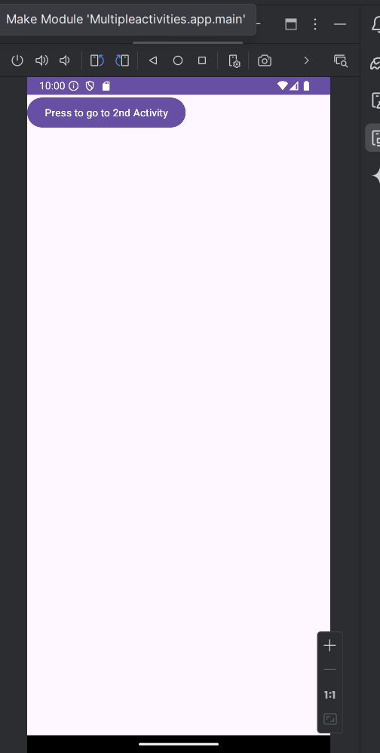

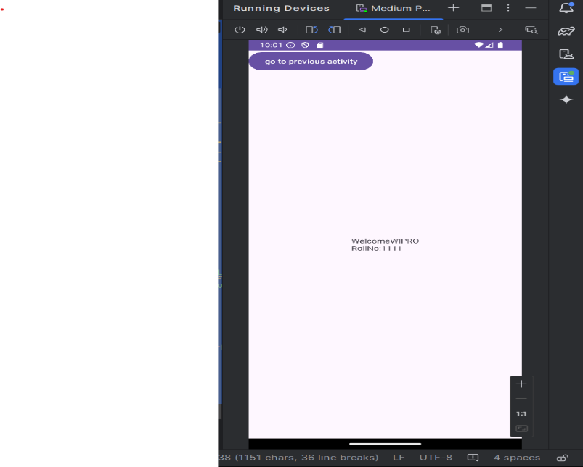

**Output-Phone**

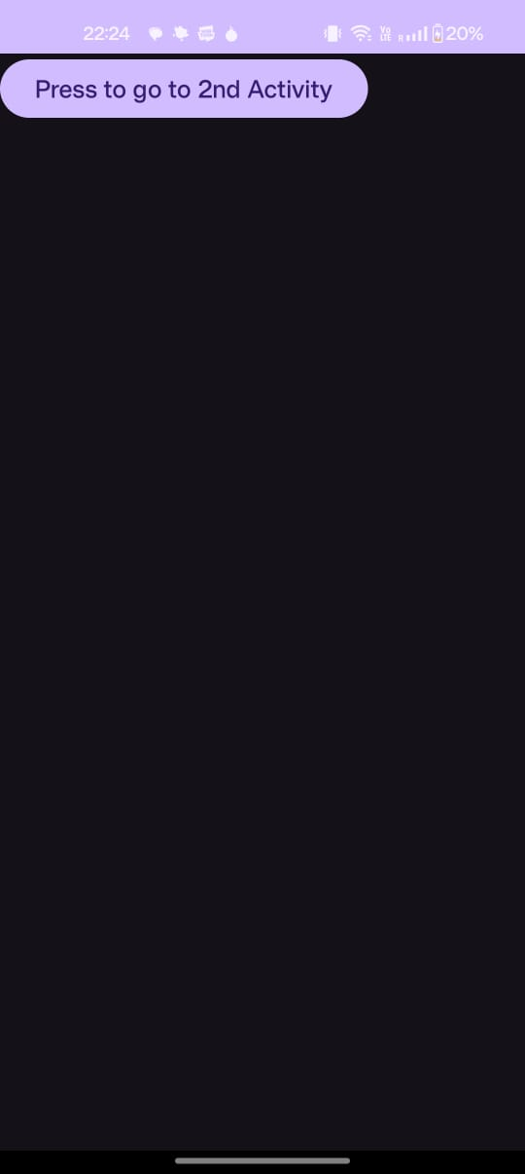

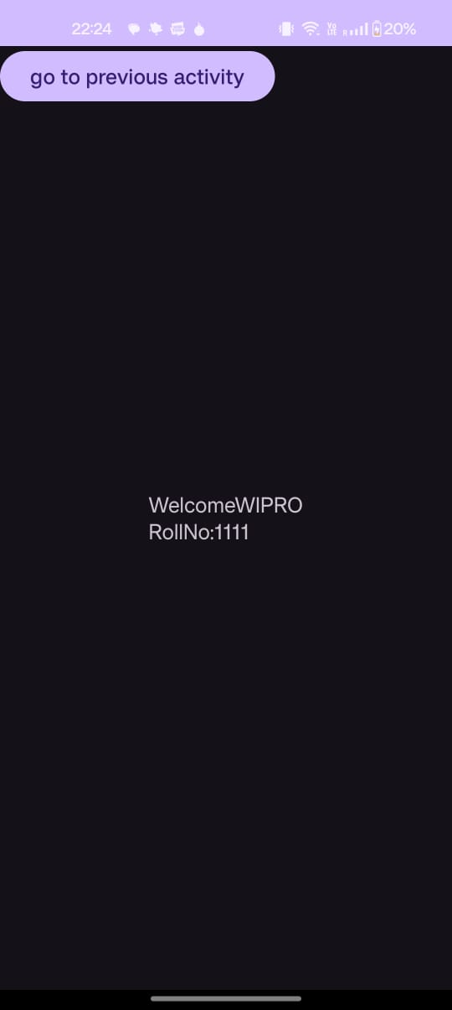

**Experiment-6-Multithreading**

**Code**

**Activity_main.xml**

<?xml version="1.0" encoding="utf-8"?>  
<RelativeLayout  
 xmlns:android="http://schemas.android.com/apk/res/android"  
 xmlns:tools="http://schemas.android.com/tools"  
 xmlns:app="http://schemas.android.com/apk/res-auto"  
 android:layout_width="match_parent"  
 android:layout_height="match_parent"  
 tools:context=".MainActivity">  
  
 <TextView  
 android:layout_width="wrap_content"  
 android:layout_height="wrap_content"  
 android:layout_marginTop="100dp"  
 android:text="Saumya Gaur CYS21076" />  
  
 <Button  
 android:layout_width="wrap_content"  
 android:layout_height="wrap_content"  
 android:layout_marginLeft="25dp"  
 android:layout_marginTop="150dp"  
 android:text="Click here"  
 android:id="@+id/b1"/>  
 <ProgressBar  
 android:layout_width="wrap_content"  
 android:layout_height="wrap_content"  
 android:layout_centerHorizontal="true"  
 android:layout_centerVertical="true"  
 android:max="100"  
 style="@style/Widget.AppCompat.ProgressBar.Horizontal"  
 android:progress="70"  
 android:id="@+id/pb"/>  
</RelativeLayout>

MainActivity.java

package com.example.multithreading;  
  
import android.os.Bundle;  
import android.os.Handler;  
import android.view.View;  
import android.widget.Button;  
import android.widget.ProgressBar;  
  
import androidx.activity.EdgeToEdge;  
import androidx.appcompat.app.AppCompatActivity;  
import androidx.core.graphics.Insets;  
import androidx.core.view.ViewCompat;  
import androidx.core.view.WindowInsetsCompat;  
  
  
  
public class MainActivity extends AppCompatActivity {  
  
 Button b1;  
 Handler hand;  
 ProgressBar pb;  
  
 @Override  
 protected void onCreate(Bundle savedInstanceState) {  
 super.onCreate(savedInstanceState);  
 EdgeToEdge.enable(this);  
 setContentView(R.layout.activity_main);  
 b1=(Button) findViewById(R.id.b1);  
 pb=(ProgressBar) findViewById(R.id.pb);  
 hand=new Handler();  
 pb.setVisibility(View.GONE);  
  
 b1.setOnClickListener(new View.OnClickListener() {  
 @Override  
 public void onClick(View v) {  
 pb.setVisibility(View.VISIBLE);  
 hand.postDelayed(run, 5000);  
 }  
 });  
 }  
  
 Runnable run=new Runnable() {  
 @Override  
 public void run() {  
 pb.setVisibility(View.GONE);  
 }  
 };  
}

**Output- Emulator**

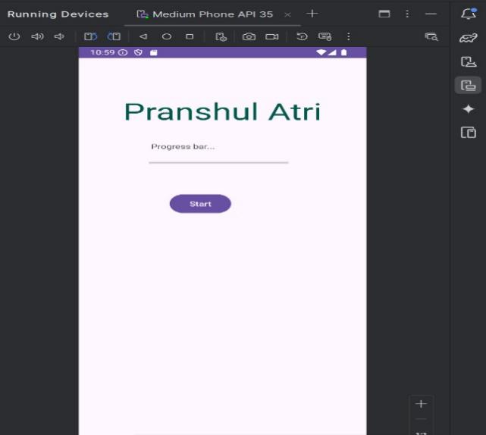

**Output-Phone**

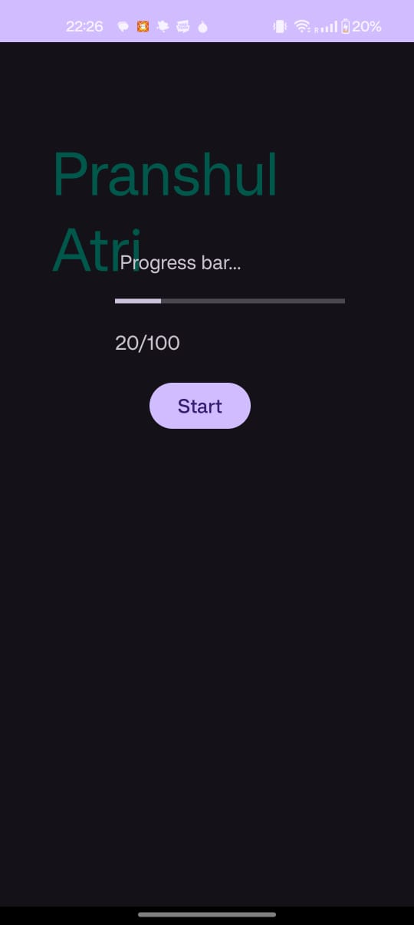

**Experiment 7- Multiple Calculators**

**Code**

**Activity_main.xml**

<?xml version="1.0" encoding="utf-8"?>  
<LinearLayout xmlns:android="http://schemas.android.com/apk/res/android"  
 xmlns:tools="http://schemas.android.com/tools"  
 android:orientation="vertical"  
 android:layout_width="match_parent"  
 android:layout_height="match_parent"  
 android:gravity="center"  
 android:padding="16dp"  
 android:background="@android:color/white">  
  
 <!-- Title Text -->  
 <TextView  
 android:layout_width="wrap_content"  
 android:layout_height="wrap_content"  
 android:text="Welcome to Calculator App"  
 android:textSize="24sp"  
 android:textStyle="bold"  
 android:layout_marginBottom="32dp"  
 android:textColor="#3949AB" />  
  
 <!-- First horizontal layout for Eb bill and Loan Calculator -->  
 <LinearLayout  
 android:orientation="horizontal"  
 android:layout_width="match_parent"  
 android:layout_height="wrap_content"  
 android:layout_marginBottom="16dp">  
  
 <!-- Eb Bill Calculator -->  
 <LinearLayout  
 android:orientation="vertical"  
 android:layout_width="0dp"  
 android:layout_height="wrap_content"  
 android:layout_weight="1"  
 android:gravity="center"  
 tools:ignore="ExtraText">  
  
 <ImageView  
 android:id="@+id/imgEbBill"  
 android:layout_width="60dp"  
 android:layout_height="60dp"  
 android:src="@drawable/eb_bill" />  
  
 <Button  
 android:id="@+id/btnSquare"  
 android:layout_width="match_parent"  
 android:layout_height="wrap_content"  
 android:background="@android:color/holo_orange_light"  
 android:minHeight="84dp"  
 android:text="Eb Bill Calculator"  
 android:backgroundTint="@android:color/holo_orange_light"  
 android:textColor="@android:color/black"  
 android:layout_marginTop="8dp"  
 android:padding="10dp"  
 android:drawableStart="@drawable/eb_bill"  
 android:drawablePadding="8dp"/>  
 </LinearLayout>  
  
 <!-- Loan Calculator -->  
 <LinearLayout  
 android:orientation="vertical"  
 android:layout_width="0dp"  
 android:layout_height="wrap_content"  
 android:layout_weight="1"  
 android:gravity="center">  
  
 <ImageView  
 android:id="@+id/imgLoanCalculator"  
 android:layout_width="60dp"  
 android:layout_height="60dp"  
 android:src="@drawable/loan_cal" />  
  
 <Button  
 android:id="@+id/btnRectangle"  
 android:layout_width="match_parent"  
 android:layout_height="wrap_content"  
 android:background="@android:color/holo_orange_light"  
 android:minHeight="84dp"  
 android:text="Loan Calculator"  
 android:backgroundTint="@android:color/holo_orange_light"  
 android:textColor="@android:color/black"  
 android:layout_marginTop="8dp"  
 android:padding="10dp"  
 android:drawableStart="@drawable/loan_cal"  
 android:drawablePadding="8dp"/>  
 </LinearLayout>  
 </LinearLayout>  
  
 <!-- Second horizontal layout for Fees calculator and Amrita Fine Calculator -->  
 <LinearLayout  
 android:orientation="horizontal"  
 android:layout_width="match_parent"  
 android:layout_height="wrap_content">  
  
 <!-- Fees Calculator -->  
 <LinearLayout  
 android:orientation="vertical"  
 android:layout_width="0dp"  
 android:layout_height="wrap_content"  
 android:layout_weight="1"  
 android:gravity="center">  
  
 <ImageView  
 android:id="@+id/imgFeesCalculator"  
 android:layout_width="60dp"  
 android:layout_height="60dp"  
 android:src="@drawable/fees" />  
  
 <Button  
 android:id="@+id/btnTriangle"  
 android:layout_width="match_parent"  
 android:layout_height="wrap_content"  
 android:background="@android:color/holo_orange_light"  
 android:minHeight="84dp"  
 android:text="Fees Calculator"  
 android:backgroundTint="@android:color/holo_orange_light"  
 android:textColor="@android:color/black"  
 android:layout_marginTop="8dp"  
 android:padding="10dp"  
 android:drawableStart="@drawable/fees"  
 android:drawablePadding="8dp"  
 />  
 </LinearLayout>  
  
 <!-- Amrita Fine Calculator -->  
 <LinearLayout  
 android:orientation="vertical"  
 android:layout_width="0dp"  
 android:layout_height="wrap_content"  
 android:layout_weight="1"  
 android:gravity="center">  
  
 <ImageView  
 android:id="@+id/imgAmritaFine"  
 android:layout_width="60dp"  
 android:layout_height="60dp"  
 android:src="@drawable/amrita_fine" />  
  
 <Button  
 android:id="@+id/btnCircle"  
 android:layout_width="match_parent"  
 android:layout_height="wrap_content"  
 android:background="@android:color/holo_orange_light"  
 android:minHeight="84dp"  
 android:text="Amrita Fine Cal"  
 android:backgroundTint="@android:color/holo_orange_light"  
 android:textColor="@android:color/black"  
 android:layout_marginTop="8dp"  
 android:padding="10dp"  
 android:drawableStart="@drawable/amrita_fine"  
 android:drawablePadding="8dp"/>  
 </LinearLayout>  
 </LinearLayout>  
  
</LinearLayout>

**MainAcitivity.java**

package com.example.areacalculator;  
  
import android.content.Intent;  
import android.os.Bundle;  
import android.view.View;  
import androidx.appcompat.app.AppCompatActivity;  
  
public class MainActivity extends AppCompatActivity {  
  
 @Override  
 protected void onCreate(Bundle savedInstanceState) {  
 super.onCreate(savedInstanceState);  
 setContentView(R.layout.*activity_main*);  
  
 findViewById(R.id.*btnSquare*).setOnClickListener(new View.OnClickListener() {  
 @Override  
 public void onClick(View v) {  
 // Go to Square Activity  
 Intent intent = new Intent(MainActivity.this, SquareActivity.class);  
 startActivity(intent);  
 }  
 });  
  
 findViewById(R.id.btnRectangle).setOnClickListener(new View.OnClickListener() {  
 @Override  
 public void onClick(View v) {  
 // Go to Rectangle Activity  
 Intent intent = new Intent(MainActivity.this, RectangleActivity.class);  
 startActivity(intent);  
 }  
 });  
  
 // Implement for Triangle and Circle similarly  
  
 findViewById(R.id.btnTriangle).setOnClickListener(new View.OnClickListener() {  
 @Override  
 public void onClick(View v) {  
 // Go to Rectangle Activity  
 Intent intent = new Intent(MainActivity.this, TriangleActivity.class);  
 startActivity(intent);  
 }  
 });  
  
 findViewById(R.id.btnCircle).setOnClickListener(new View.OnClickListener() {  
 @Override  
 public void onClick(View v) {  
 // Go to Rectangle Activity  
 Intent intent = new Intent(MainActivity.this, CircleActivity.class);  
 startActivity(intent);  
 }  
 });  
 }  
}

**Output-Emulator**

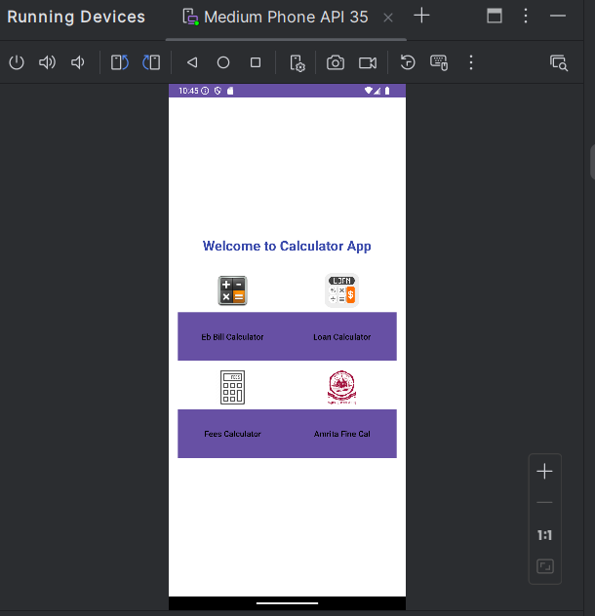

**Output-Phone**

