**D.Y. PATIL COLLEGE OF ENGINEERING & TECHNOLOGY, KOLHAPUR**

**(An Autonomous Institute)**



**DEPARTMENT OF CSE (DATA SCIENCE)**

A

Project Report

on

**“ Parking Management System ”**

Submitted by

|  |  |
| --- | --- |
| **Name** | **Roll No.** |
| Omkar Manik Patil | 51 |
| Pranav Chandrakant Patil | 52 |
| Umer Jahakhan Attar | 33 |

**Under the guidance of**

**Ms.Rabiya Kothiwale**

**Second Year B. Tech. CSE (Data Science)**

**Academic Year 2023-24**

**D. Y. PATIL COLLEGE OF ENGINEERING & TECHNOLOGY, KOLHAPUR**

**(An Autonomous Institute)**

**DEPARTMENT OF CSE (DATA SCIENCE)**

**CERTIFICATE**

|  |  |  |  |
| --- | --- | --- | --- |
| **Roll No.** | **Unique ID** | **Student Name** | **Exam Seat No.** |
| 51 | EN22147953 | Omkar Manik Patil | 17531 |
| 52 | EN22145026 | Pranav Chandrakant Patil | 17542 |
| 33 | EN22156360 | Umer Jahakhan Attar | 17615 |

This is to certify that,

have successfully completed the project work entitled,

**“Parking Management System”**

In partial fulfilment for the curriculum of **S. Y. B. Tech. CSE (Data Science)**. This is the record of their work carried out during academic year 2023-2024.

**Date: Place:** Kolhapur

|  |  |  |
| --- | --- | --- |
| **Ms. Rabiya Kothiwale** | **Prof. DR. G. V. Patil** | **Prof. DR. S. D. Chede** |
| Project Guide | HoD | Principal |

**External Examiner**

#### DECLARATION

We the undersigned students of **S. Y. B. Tech. CSE (Data Science)** declare that the project work report entitled “**Parking Management System ”** written and submitted by us, under the guidance of **Ms.Rabiya Kothiwale** is our original work. The empirical findings in this report are based on the data collected by us. The matter assimilated in this report is not the reproduction of any readymade report. We have not violated any of the provisions under the Copyright and Piracy / Cyber / IPR Act amended from time to time.

**Date:**

**Place:** Kolhapur

|  |  |  |  |
| --- | --- | --- | --- |
| **Roll No.** | **Unique ID** | **Student’s Name** | **Signature** |
| 51 | EN22145026 | Omkar Manik Patil |  |
| 52 | EN22147953 | Pranav Chandrakant Patil |  |
| 33 | EN22156360 | Umer Jahakhan Attar |  |

**ACKNOWLEDGMENT**

We extend our heartfelt gratitude to Prof. DR. A. K. Gupta Sir, Executive Director DYPCET, whose visionary leadership and unwavering support provided the foundation for this endeavor. We also express our sincere gratitude to Prof. DR. S. D. Chede Sir, Principal DYPCET, for their guidance and encouragement throughout this journey. Special thanks to DR. G. V. Patil Sir, Head of Department Data Science, for their invaluable insights and mentorship, shaping our understanding and approach within the field of data science.

We are immensely grateful to our project guide Ms. Rabiya Kothiwale whose expertise and dedication empowered us to navigate challenges and achieve milestones with confidence.

To our esteemed colleagues in the project group, your collaboration and dedication have been instrumental in realizing the goals of this project. Together, we have embraced innovation and teamwork, driving the project towards success. This project report stands as a testament to the collective efforts and support extended by each individual mentioned above. We acknowledge and appreciate your contributions, which have enriched our learning experience and propelled us towards excellence.

**Date:**

**Place:** Kolhapur

**INDEX**

|  |  |  |
| --- | --- | --- |
| **Sr. No.** | **Topic** | **Page Number** |
| **1.** | **Introduction** | **1** |
| **2.** | **Problem Statement & Objectives** | **2** |
| **3.** | **System Design** | **3** |
| **4.** | **Software & Hardware Requirements** | **4** |
| **5.** | **Result Analysis** | **5** |
| **6.** | **Conclusion** | **6** |
| **7.** | **Future Scope** | **7** |
| **8.** | **References** | **8** |

**Introduction**

In this project, we will Build Parking Management System Project Using Python. In today’s world, parking has become a crucial aspect of daily life. Whether it is a shopping mall, office, or residential complex, parking is a necessity.

With the increase in the number of vehicles on the road, managing parking spaces has become a challenge for many. Hence, there is a need for a parking management system that can automate the process of parking management. In this blog, we will discuss a parking management system project using Python.

A Parking Management System mini-project in Python involves creating a software solution to efficiently manage parking lots or spaces. The system typically allows users to check available parking spaces, reserve spots, enter and exit the parking area, and manage payments.

User Interface: Develop a user-friendly interface for both administrators and users. This could be a command-line interface (CLI) or a graphical user interface (GUI) depending on your preference and requirements.

Parking Lot Representation: Design a data structure to represent the parking lot. This could be a simple list or array to represent parking spots, or a more complex data structure to handle various types of parking spaces (e.g., regular, handicapped, reserved).

Functions for Managing Parking Spaces: Implement functions to check the availability of parking spots, reserve spots, and release spots when vehicles exit.

User Interaction: Allow users to interact with the system to check available spots, reserve a spot for a specific duration, and make payments if necessary.

Payment Integration (Optional): Integrate payment processing functionality if required. This could involve integrating with payment gateways or simply simulating payments within the system.

Error Handling and Validation: Implement robust error handling and input validation to ensure the system behaves as expected even in unexpected scenarios.

**Problem Statement & Objectives**

**Problem Statement :**

We know that , nowdays parking of vehicle is become a large problem to our cities because of increased count of vehicles and also there is no space for parking. That’s why parking management becomes mandatory to all.

To see this problem we deside to make project on parking management. So deside problem statement as “parking management using python.”

**Objectives :**

1. Develop a system to define and manage different types of parking spaces (e.g., regular, handicapped, reserved).

2. Implement a user-friendly interface for easy accessibility.

3. Provide real-time sentiment insights for improved decisionmaking

4. Implement security features to prevent unauthorized access and ensure the integrity of the system.

**System Design**

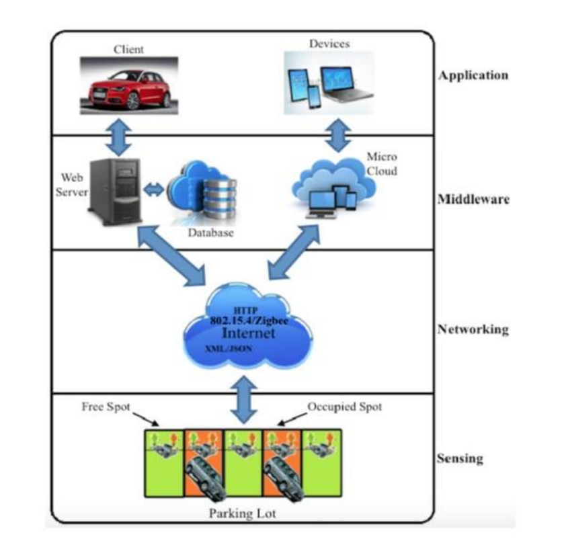

**Software and Hardware Requirements**

**Software Requirement:**

* Visual Studio Code- We this code iditor is use for thr project od parking management system using python.
* Python- nsure you have Python installed on your system. You can download and install Python from the official website: https://www.python.org/
* Python libraries – We us following libraries from python:

datetime: For handling dates and times.

random: For generating random values, which might be useful for simulating parking spot availability or generating ticket numbers..

requests: If you're integrating with external APIs for services like payment processing or mapping.

matplotlib or seaborn (optional): For data visualization if you plan to include reporting features.

**Hardware requirement :**

* Power supply unit

**Result Analysis**

Result analysis for a parking management system using Python involves leveraging various data analysis and visualization libraries to extract insights from the system's data. Here's a brief overview:

Data Collection: First, you need to gather relevant data from your parking management system, including occupancy rates, revenue records, traffic flow data, and customer feedback.

Data Preparation: Clean and preprocess the collected data to remove outliers, handle missing values, and format it into a suitable structure for analysis.

Data Analysis: Utilize Python libraries such as Pandas, NumPy, and SciPy to perform statistical analysis on the prepared data. Calculate key metrics like occupancy rates, revenue trends, utilization patterns, and customer satisfaction scores.

Data Visualization: Use libraries like Matplotlib, Seaborn, or Plotly to create visualizations such as line charts, bar plots, heatmaps, and scatter plots to represent the analyzed data effectively. Visualizations can help in identifying trends, patterns, and outliers in the data.

Machine Learning (Optional): Implement machine learning algorithms using libraries like Scikit-learn or TensorFlow if you want to perform predictive analysis or anomaly detection based on historical data.

Dashboard Creation (Optional): Build interactive dashboards using tools like Dash or Streamlit to present the analyzed results in a user-friendly interface. Dashboards can provide real-time insights and allow stakeholders to explore the data dynamically.

Reporting: Generate summary reports or automated emails containing the analyzed results and actionable recommendations for improving the parking management system.

By leveraging Python for result analysis, you can efficiently process large volumes of data, gain valuable insights, and make informed decisions to optimize the performance of your parking management system.

**Conclusion**

The parking management system project using Python is an efficient and effective way of managing parking spaces. It automates the process of parking management, reducing the workload of the management team. The system is easy to use and provides real-time updates to the admin and users. It also helps in reducing the time taken for parking and improves the overall parking experience.

In conclusion, implementing Python for parking management systems offers a robust framework for comprehensive result analysis and optimization. By harnessing the power of Python libraries for data processing, analysis, and visualization, parking management stakeholders can derive actionable insights to enhance efficiency, profitability, and user satisfaction.

**Future Scope**

The future scope for parking management systems using Python is promising, with several potential advancements and innovations on the horizon:

Integration with IoT Devices: Integration with Internet of Things (IoT) devices such as sensors, cameras, and smart meters can enable real-time data collection on parking space availability, traffic flow, and vehicle movements. Python can be used to analyze and process this streaming data, providing dynamic insights and facilitating proactive management of parking facilities.

Machine Learning for Predictive Analytics: The integration of machine learning algorithms with Python can enable predictive analytics for parking management systems. By analyzing historical data on parking patterns, user behavior, and environmental factors, machine learning models can forecast future parking demand, optimize resource allocation, and improve operational efficiency.

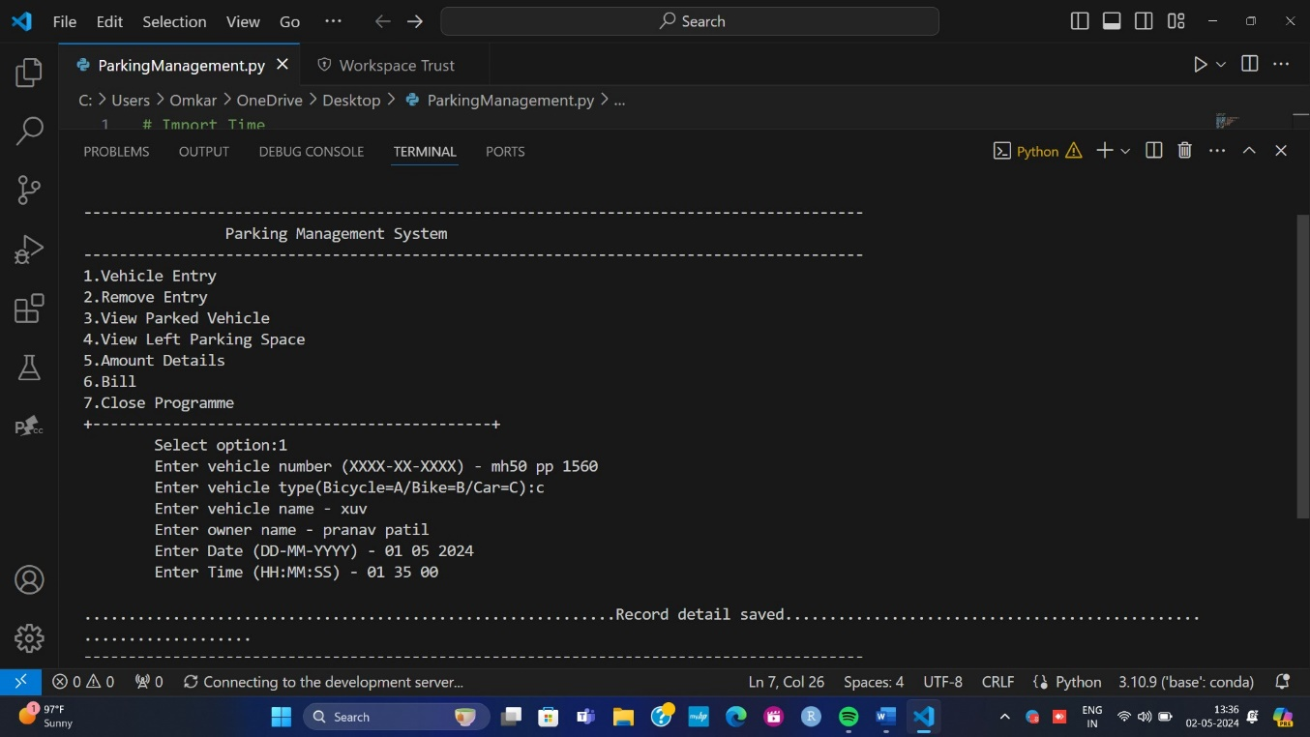

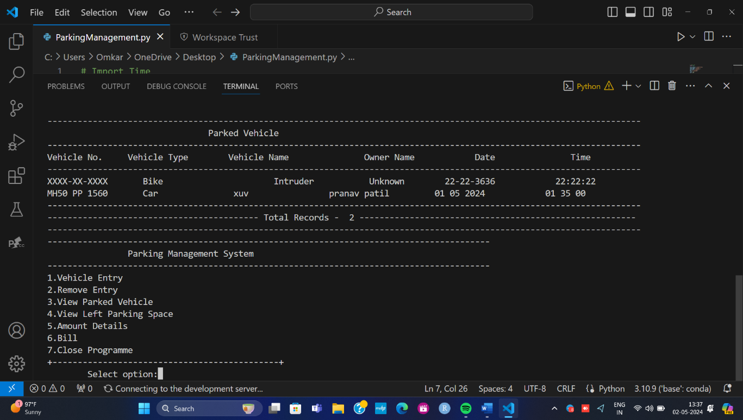

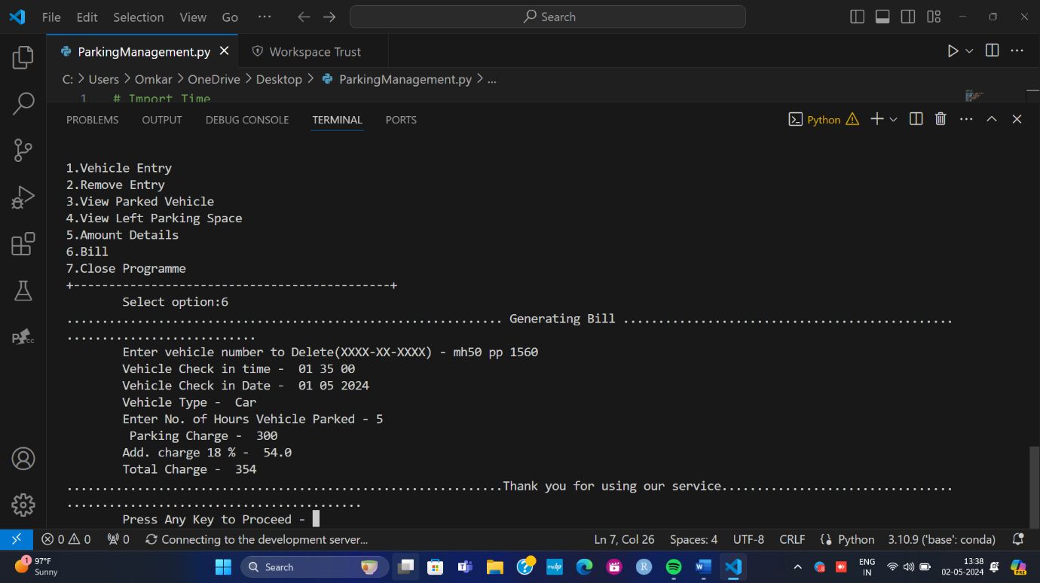

**References**

<https://www.googal.com>

<https://www.youtube.com>