Steps:-
- Created an access key for my IAM user.
- Configured my credentials for the Terraform profile in the VS Code terminal using the following command:
aws configure --profile <profile-name>
aws sts get-caller-identity --profile <profile-name>
- Wrote terraform code for private subnet creation, route table creation and association in existing VPC and NAG Gateway. In terraform code wrote 3 terraform .tf files, those are terraform.tf, main.tf, output.tf.
- terraform init

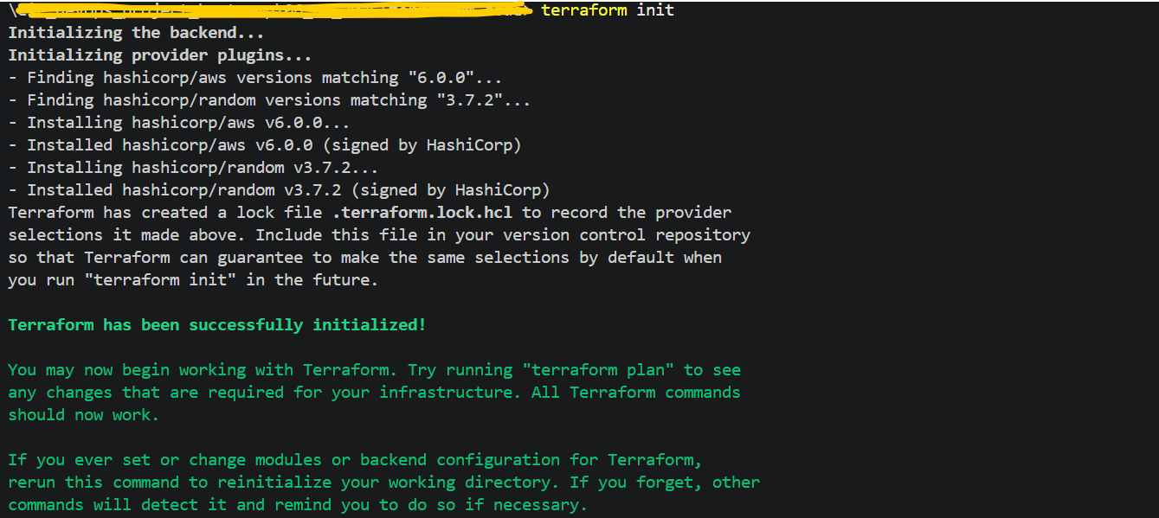

- terraform validate

- terraform plan -out=tfplan

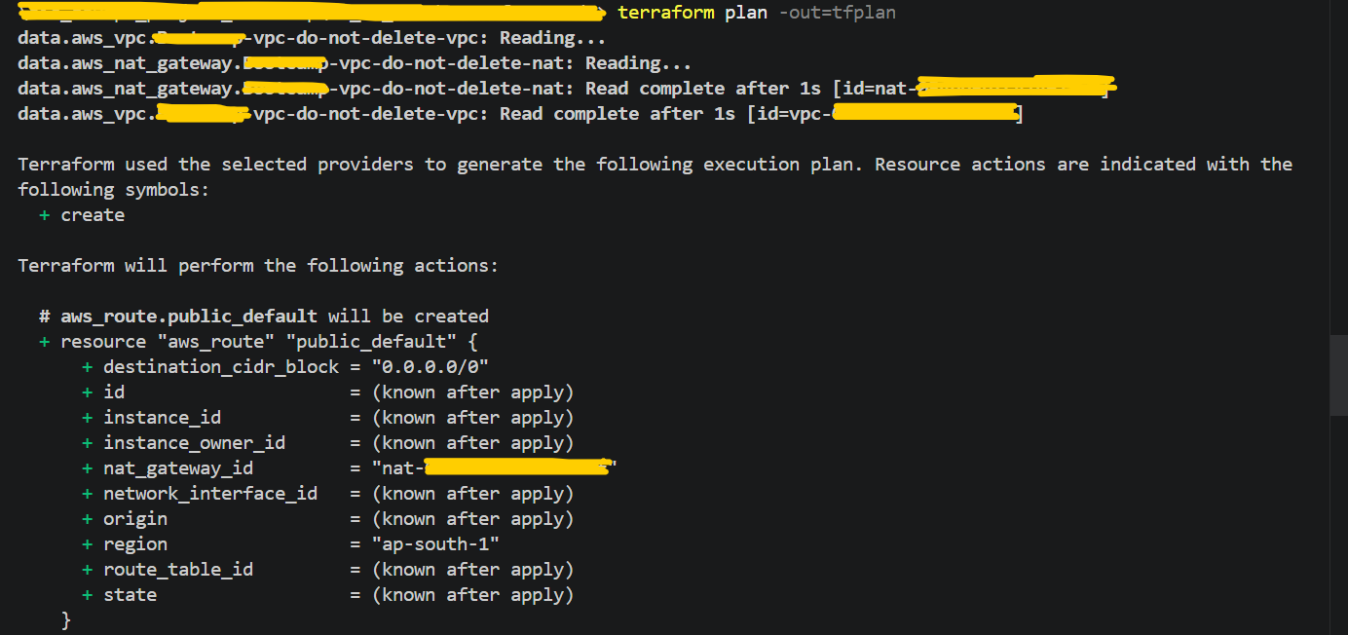

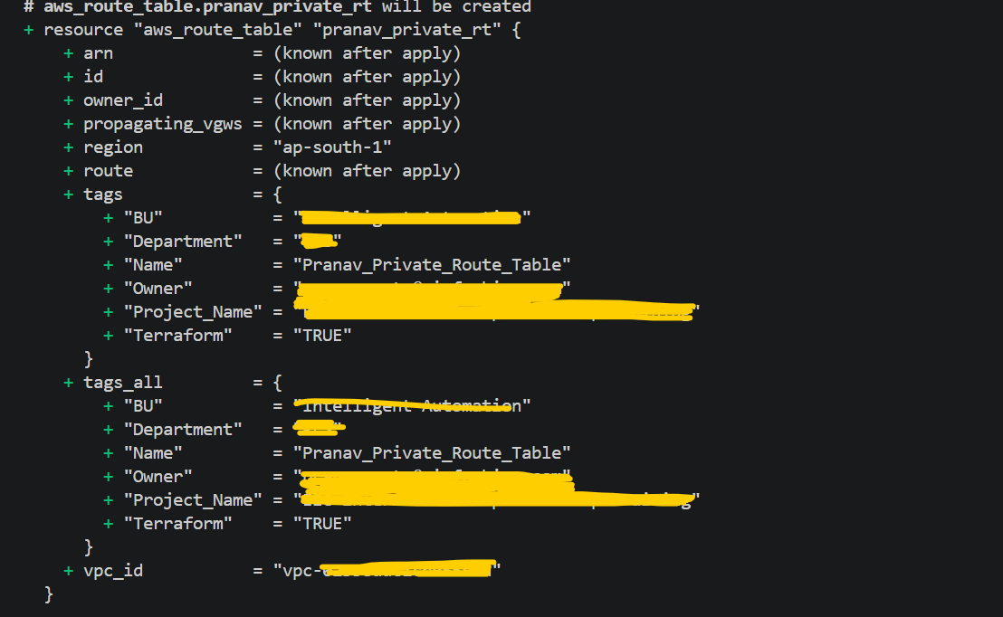

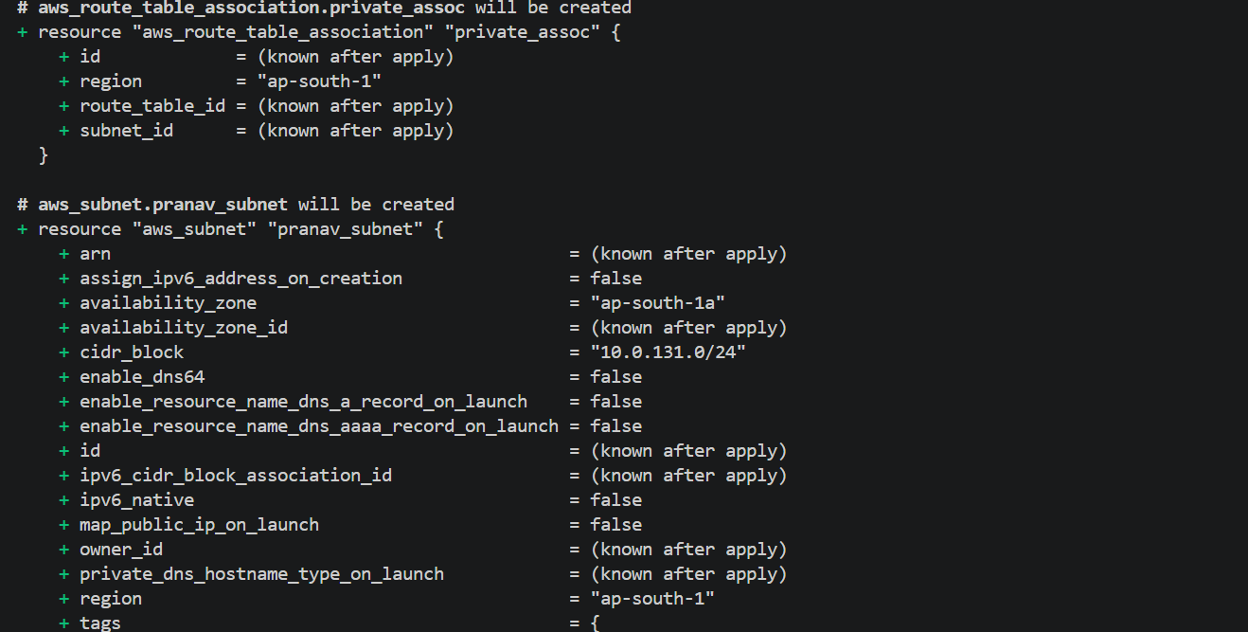

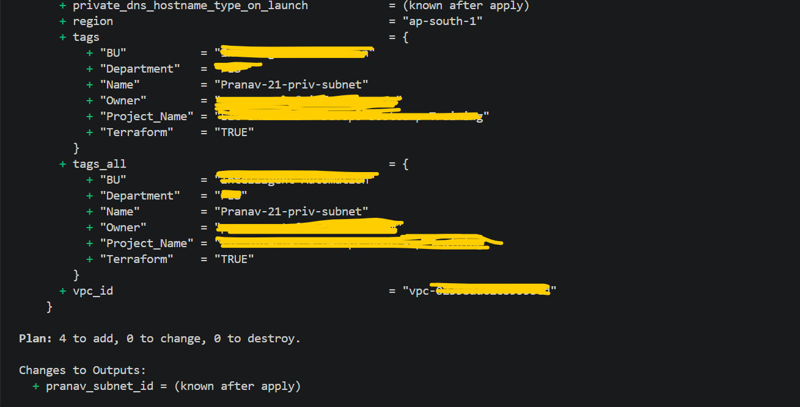

- terraform apply tfplan

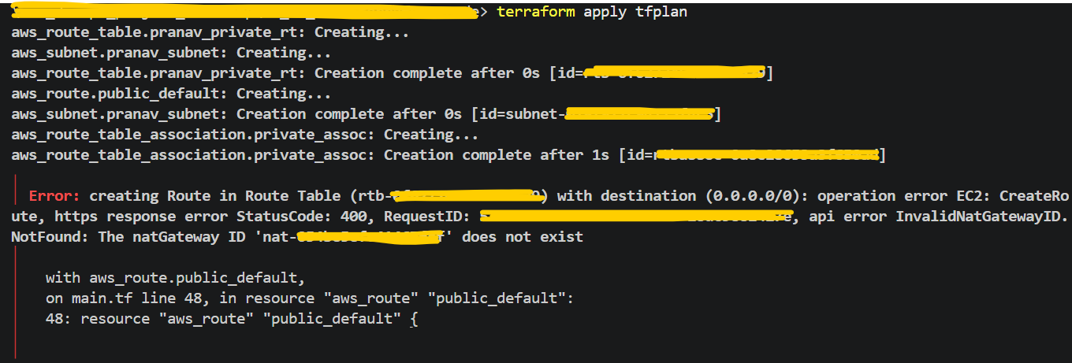

Note:- While performing this practical, NAT gateway has been deleted by Pooja, hence in I have updated terraform code again with Internet Gateway configuration, so in next screenshots existing resources which are created through above terraform operation like my Subnet and Route table and Route table association, those will get deleted and new subnet, route table and Route table association will get created.

- terraform plan -out=tfplan-new

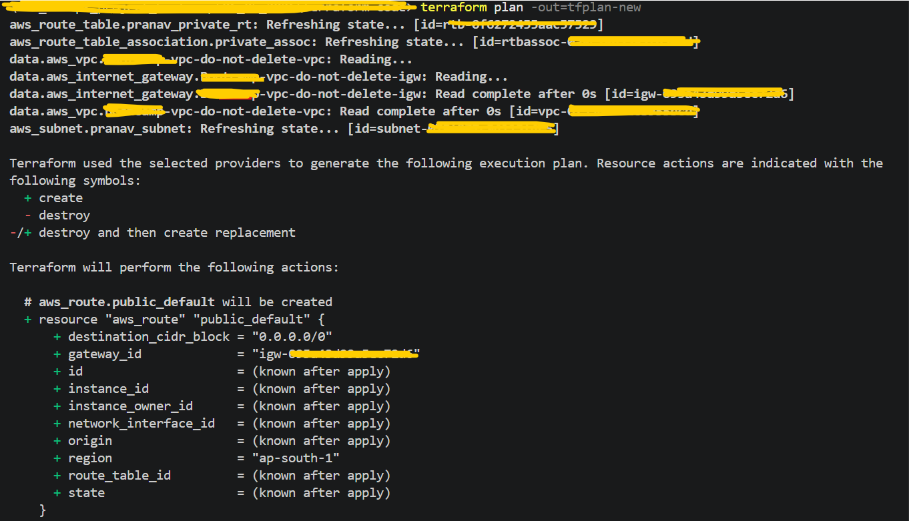

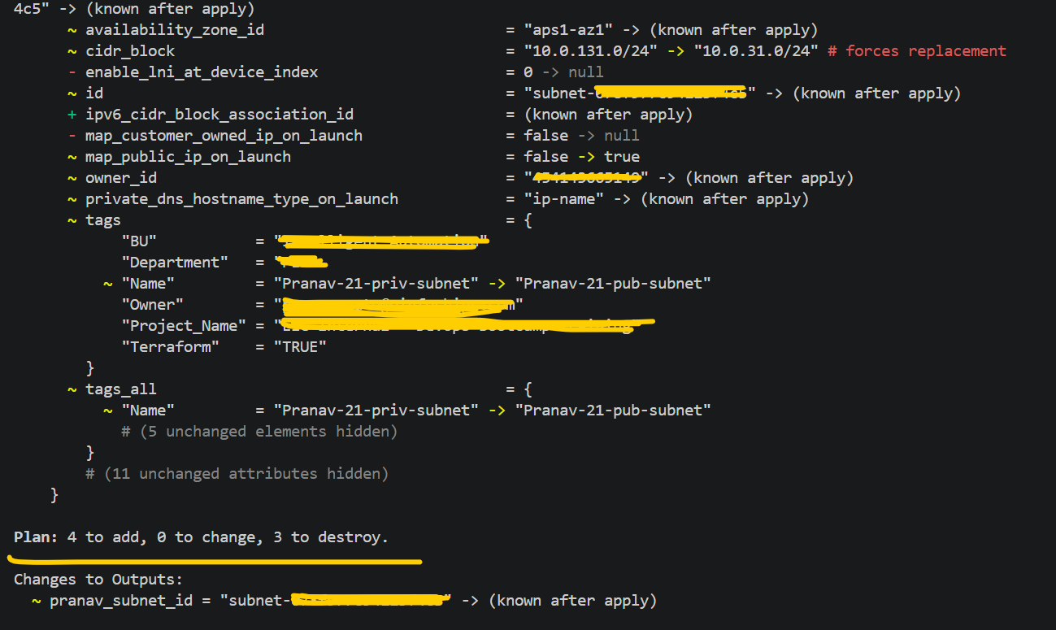

- terraform apply tfplan-new

