Steps:-
- Created EKS Cluster, Node group and require Iam roles for the same through terraform. To do the same copy terraform code from 14_05_2026 folder into 15_05_2026.

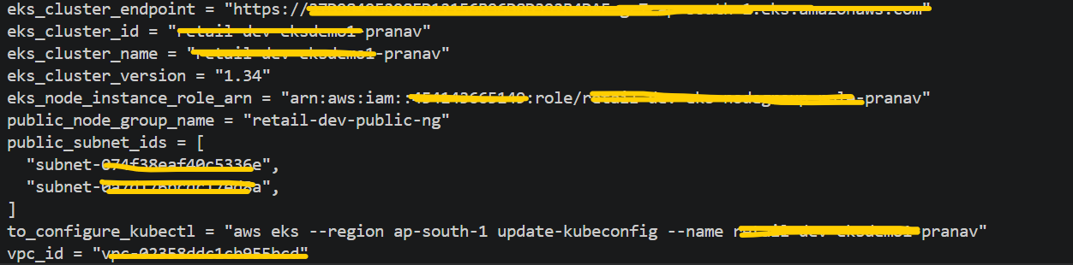

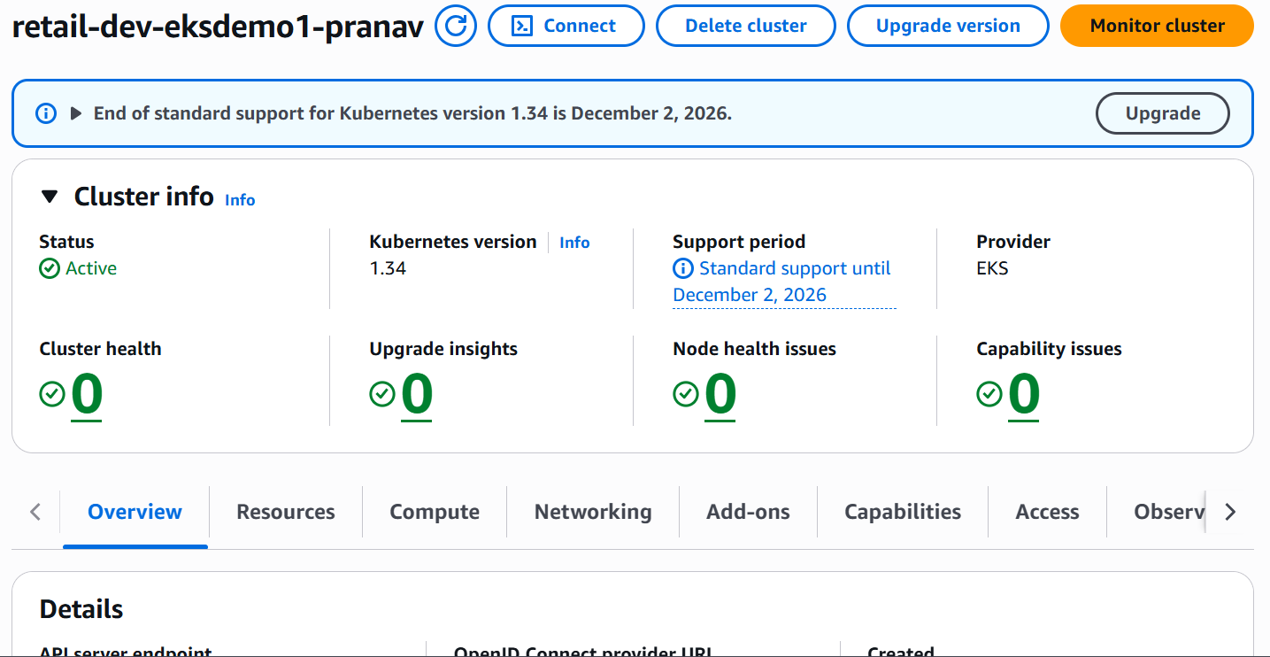

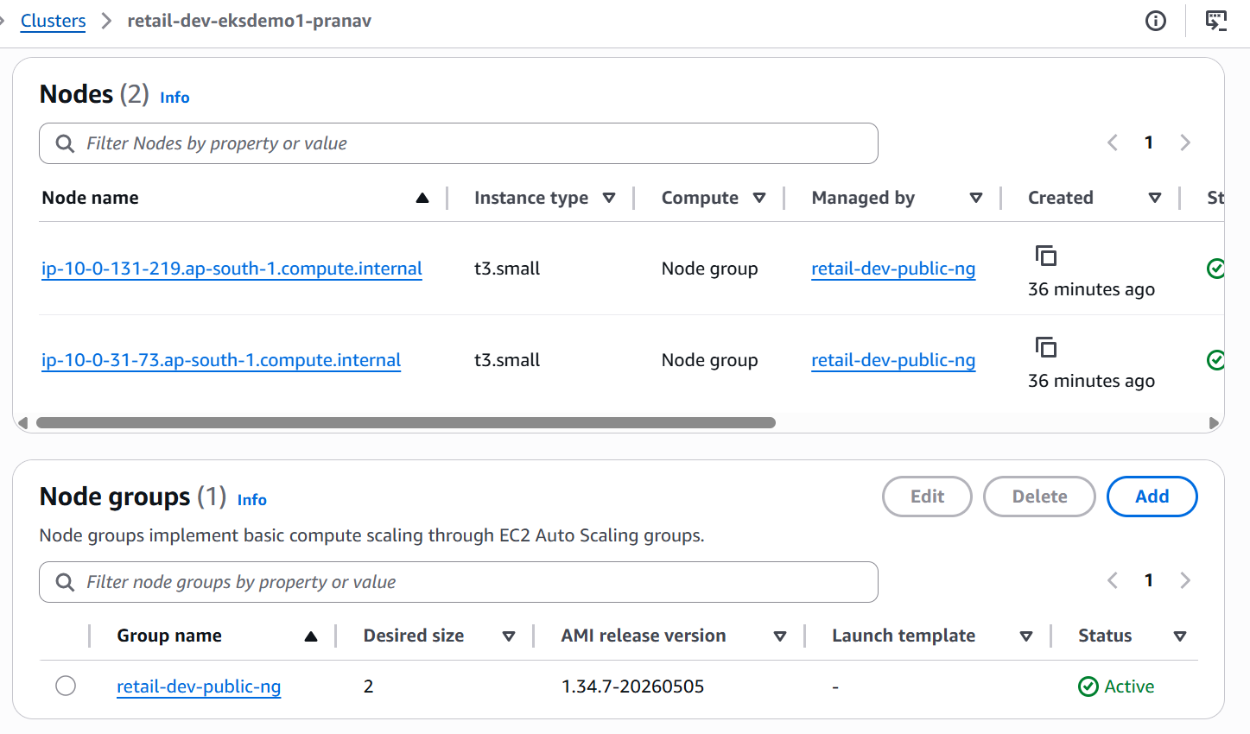

- Add below Add on in EKS Cluster.
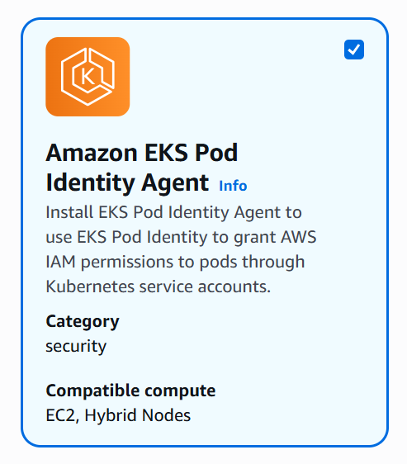

- Run below mentioned commands.
# Configure your local kubectl so it can connect to your AWS EKS cluster.
aws eks --region ap-south-1 update-kubeconfig --name retail-dev-eksdemo1-pranav

# Export Environment Variables
export AWS_REGION="ap-south-1"
export EKS_CLUSTER_NAME="retail-dev-eksdemo1-pranav"
export AWS_ACCOUNT_ID=$(aws sts get-caller-identity --query Account --output text)

# Confirm values
echo $AWS_REGION
echo $EKS_CLUSTER_NAME
echo $AWS_ACCOUNT_ID

# Navigate to respective path through cd command.
cd 11_01_LoadBalancer_Controller_Install/iam-policy-json-files
# Download the official IAM policy
curl -o aws-load-balancer-controller-policy.json \
https://raw.githubusercontent.com/kubernetes-sigs/aws-load-balancer-controller/main/docs/install/iam_policy.json
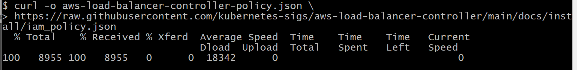
# Create the policy in IAM
aws iam create-policy \
--policy-name AWSLoadBalancerControllerIAMPolicy_${EKS_CLUSTER_NAME} \
--policy-document file://aws-load-balancer-controller-policy.json
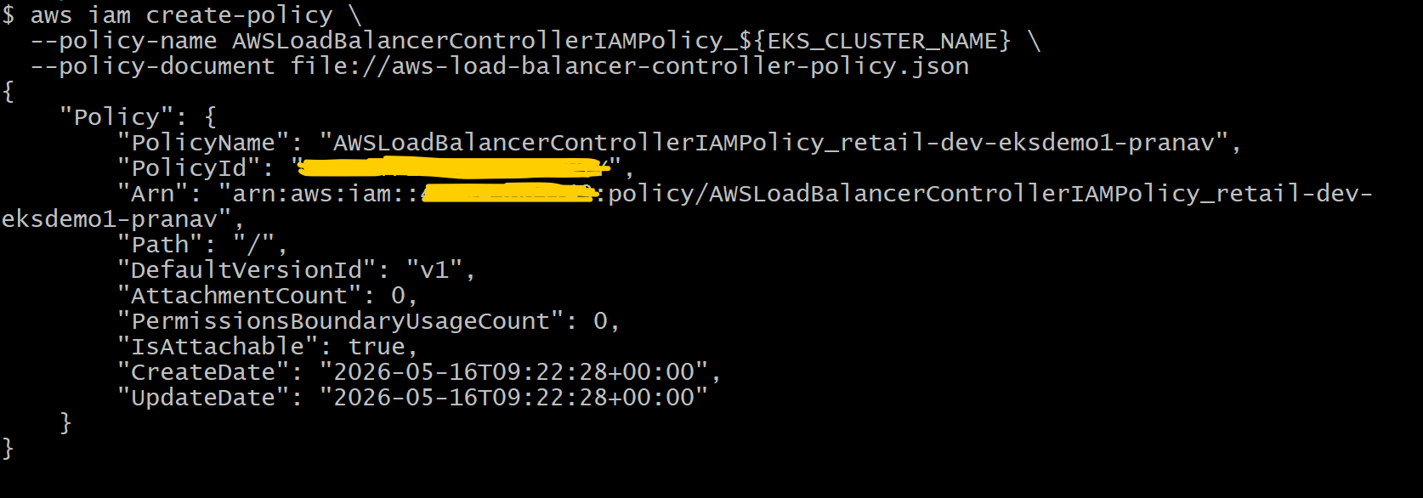

# Cat Trust Policy File
cat aws-load-balancer-controller-trust-policy.json
{
"Version": "2012-10-17",
"Statement": [
{
"Effect": "Allow",
"Principal": {
"Service": "pods.eks.amazonaws.com"
},
"Action": [
"sts:AssumeRole",
"sts:TagSession"
]
}
]
}
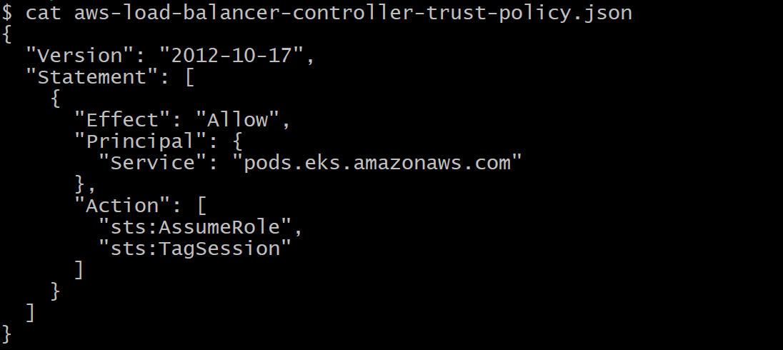
# Create the IAM Role
aws iam create-role \
--role-name AmazonEKS_LBC_Role_${EKS_CLUSTER_NAME} \
--assume-role-policy-document file://aws-load-balancer-controller-trust-policy.json
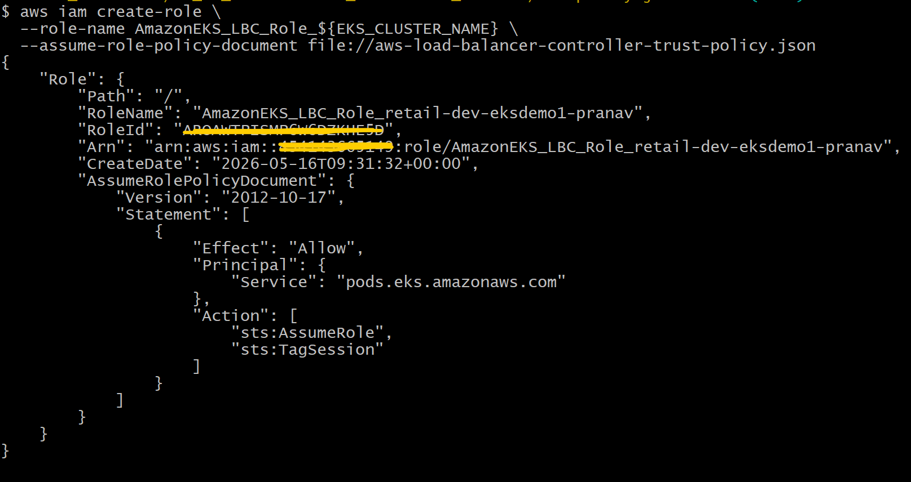

# Attach the LBC IAM Policy
aws iam attach-role-policy \
--role-name AmazonEKS_LBC_Role_${EKS_CLUSTER_NAME} \
--policy-arn arn:aws:iam::${AWS_ACCOUNT_ID}:policy/AWSLoadBalancerControllerIAMPolicy_${EKS_CLUSTER_NAME}

# Verify attachment
aws iam list-attached-role-policies \
--role-name AmazonEKS_LBC_Role_${EKS_CLUSTER_NAME}
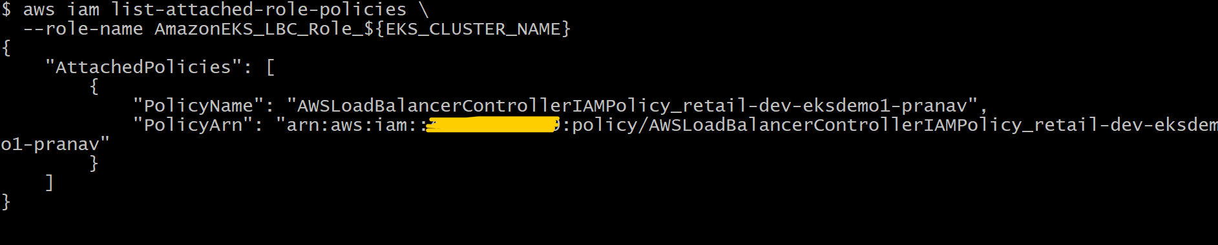

# Create EKS Pod Identity Association

aws eks create-pod-identity-association \
--cluster-name ${EKS_CLUSTER_NAME} \
--namespace kube-system \
--service-account aws-load-balancer-controller \
--role-arn arn:aws:iam::${AWS_ACCOUNT_ID}:role/AmazonEKS_LBC_Role_${EKS_CLUSTER_NAME}
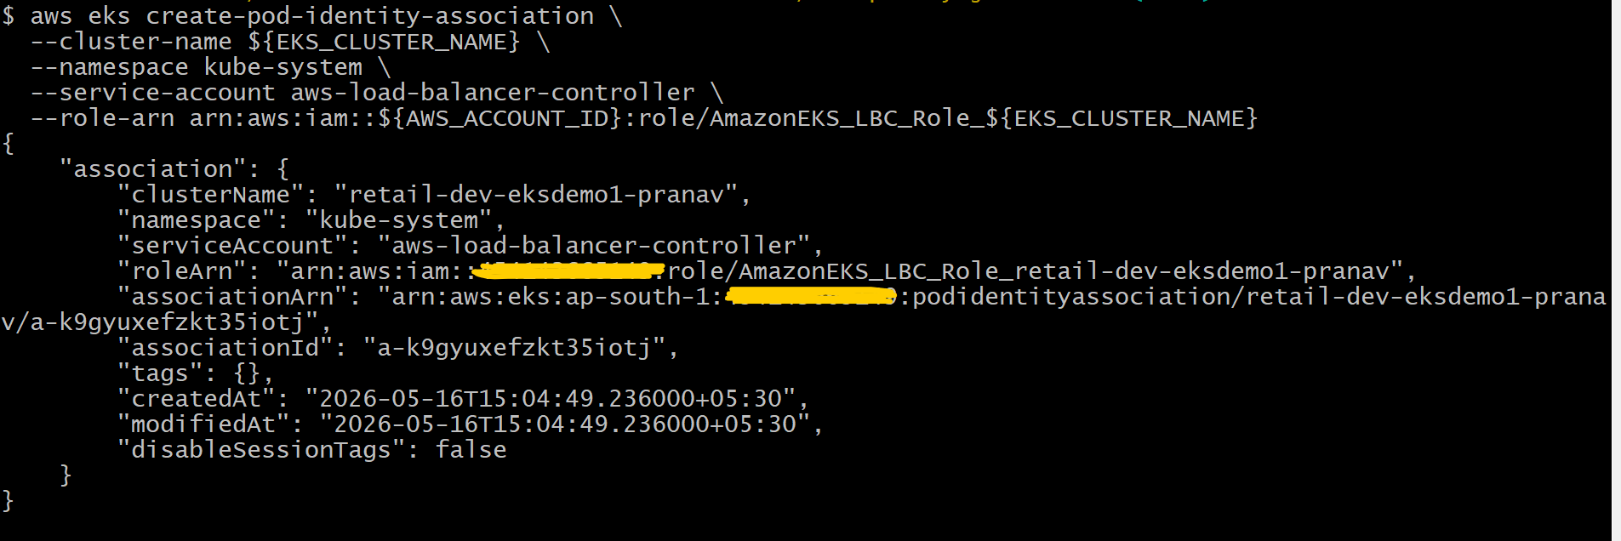
helm repo list
# Install AWS Load Balancer Controller (Helm)
# Add Helm Repo and Update
helm repo add eks https://aws.github.io/eks-charts
helm repo update
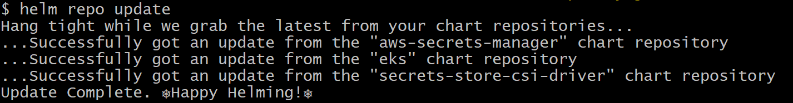
helm repo list command again to verify all the repo’s

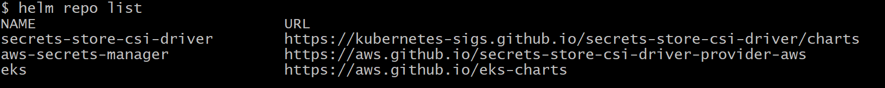

# Install Load Balancer Controller
# Get VPC ID
VPC_ID=$(aws eks describe-cluster \
--name ${EKS_CLUSTER_NAME} \
--query "cluster.resourcesVpcConfig.vpcId" \
--output text)
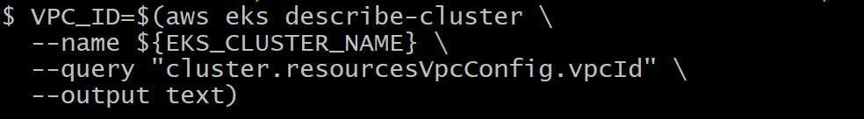
# Verify VPC ID
echo $VPC_ID
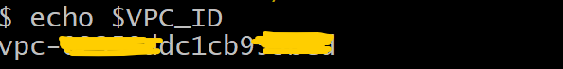
# Install AWS Load Balancer Controller using HELM
helm install aws-load-balancer-controller eks/aws-load-balancer-controller \
-n kube-system \
--set clusterName=${EKS_CLUSTER_NAME} \
--set region=${AWS_REGION} \
--set vpcId=${VPC_ID} \
--set serviceAccount.create=true \
--set serviceAccount.name=aws-load-balancer-controller
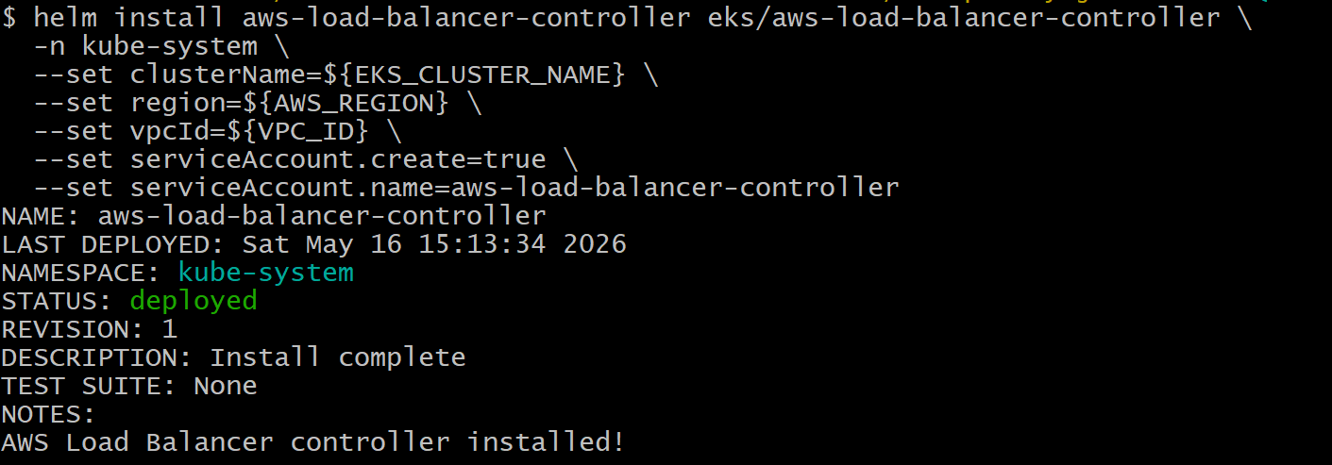
# List Helm releases
helm list -n kube-system
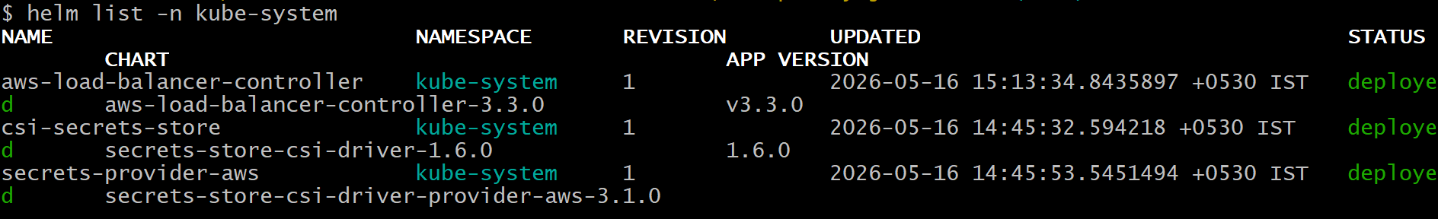
# Check Helm status
helm status aws-load-balancer-controller -n kube-system
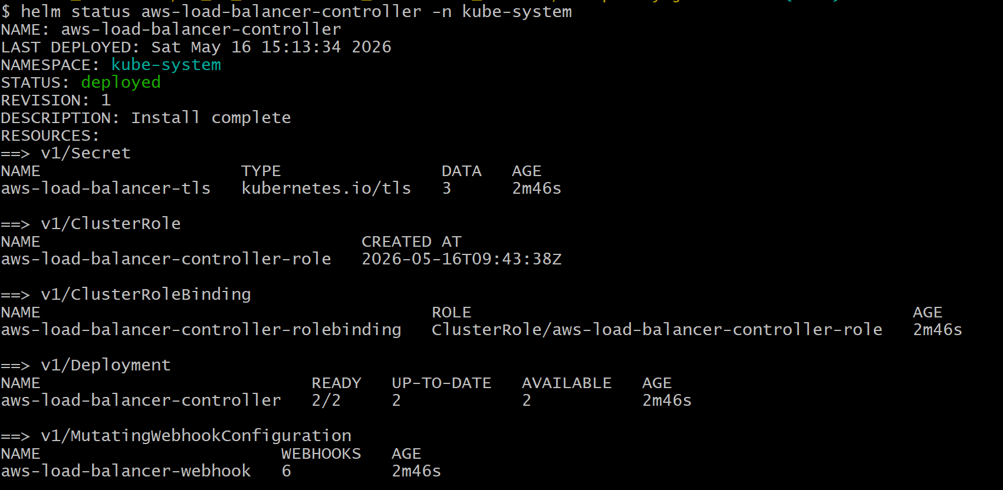
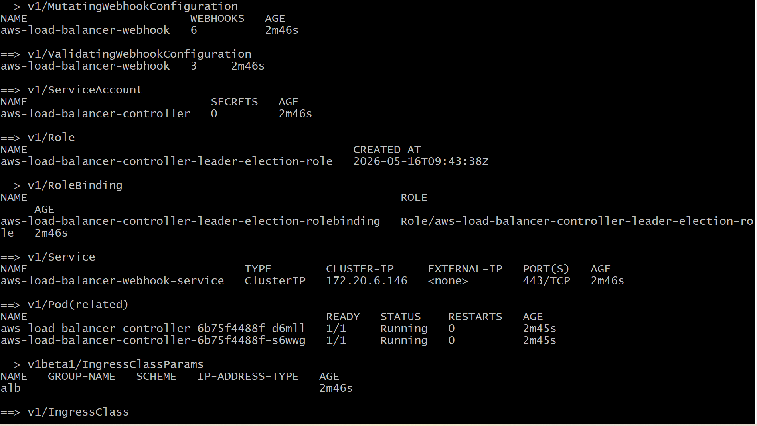

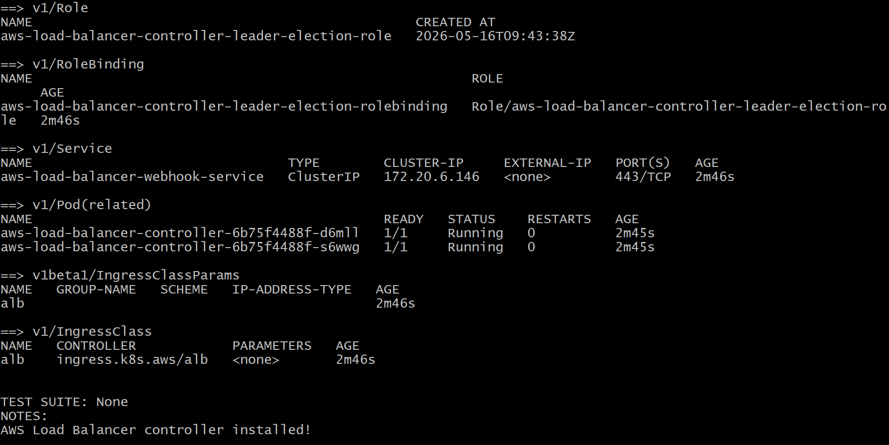
# Controller Deployment
# List Pods
kubectl get pods -n kube-system -l app.kubernetes.io/name=aws-load-balancer-controller

# Check deployment and logs
kubectl get deployment -n kube-system aws-load-balancer-controller
kubectl logs -n kube-system -l app.kubernetes.io/name=aws-load-balancer-controller
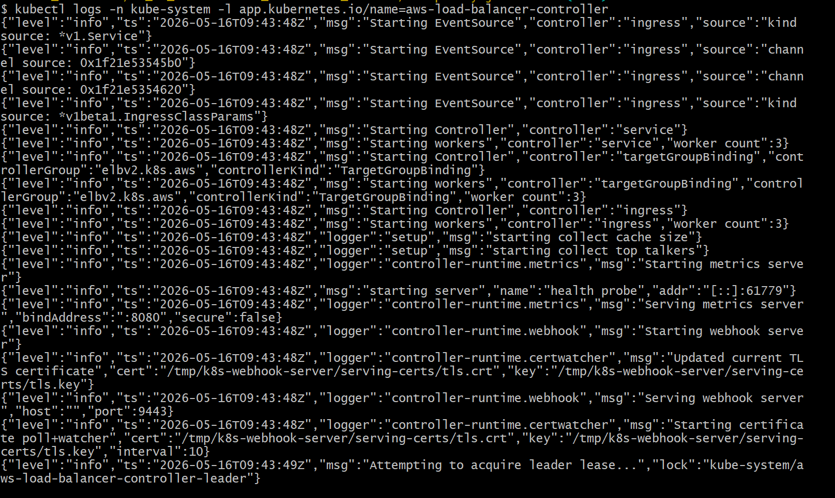
# Apply all HTTP manifests
kubectl apply -R -f http_retail_store_k8s_manifests/

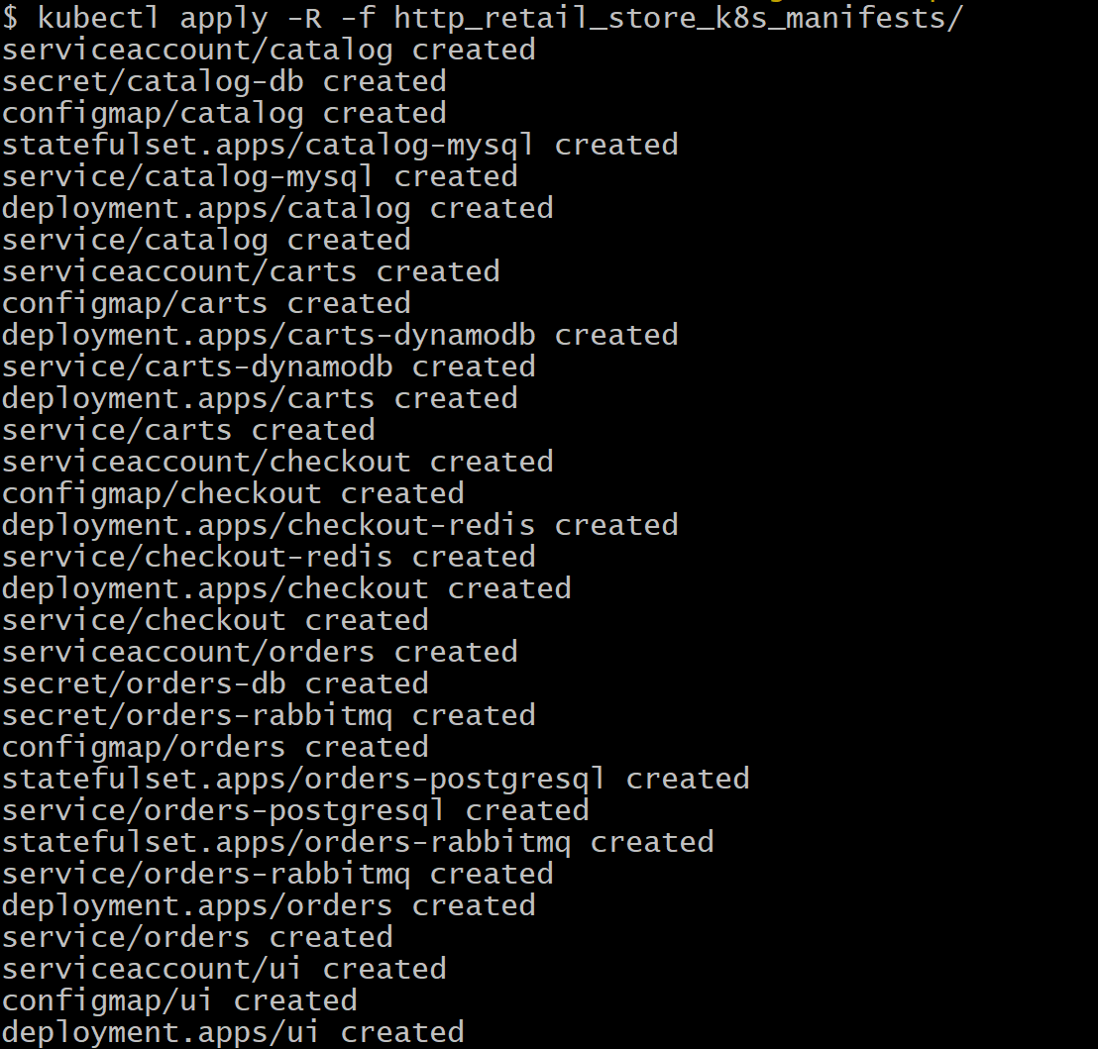

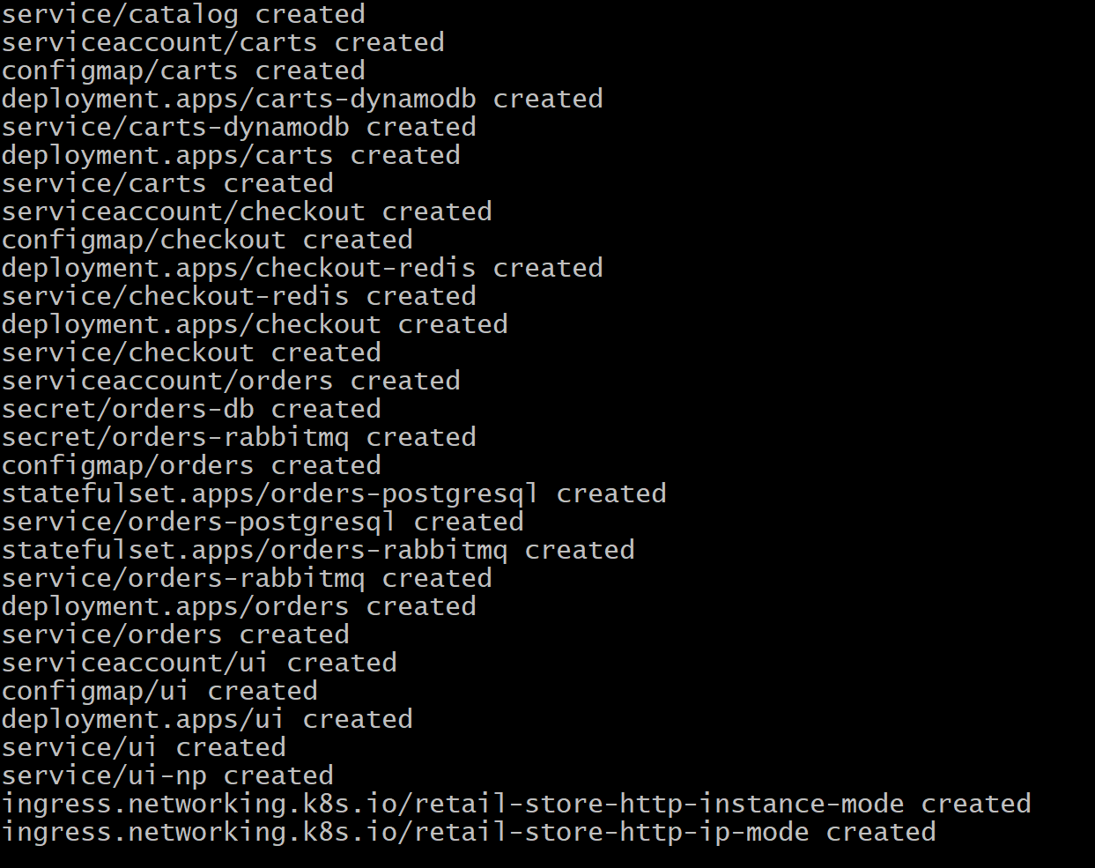
kubectl get deploy
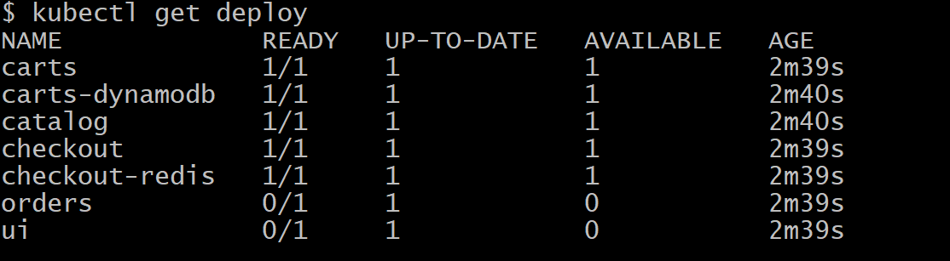
kubectl get sts
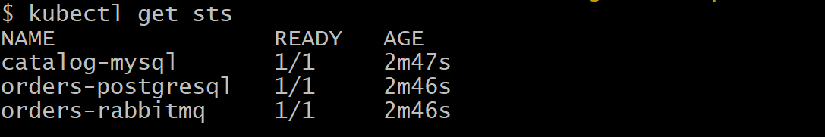

kubectl get svc
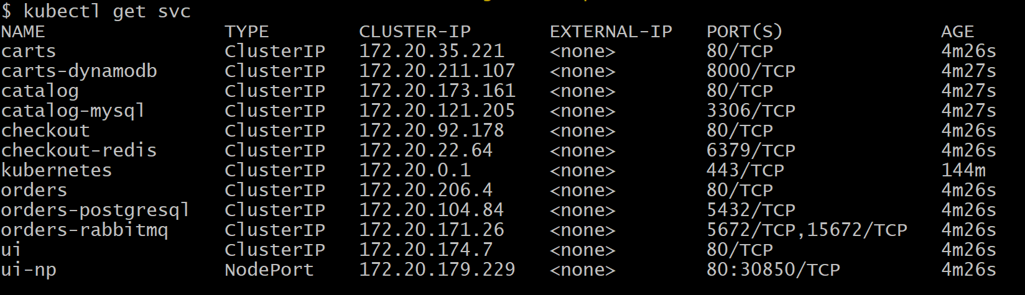
kubectl get cm
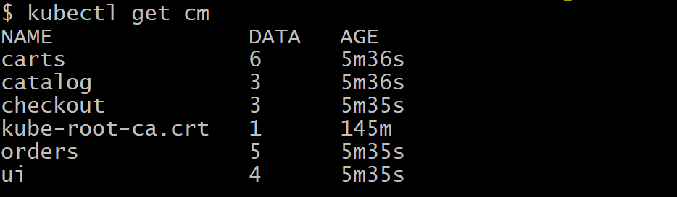
kubectl get sa
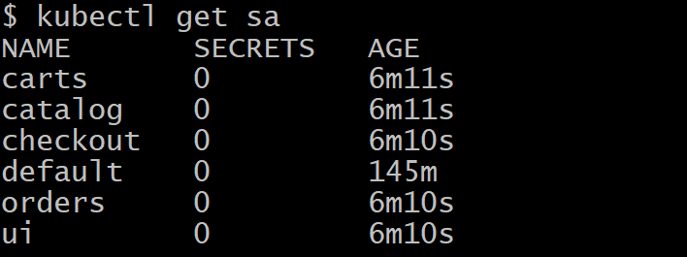
kubectl get secrets
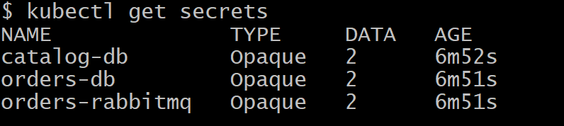

kubectl get pods
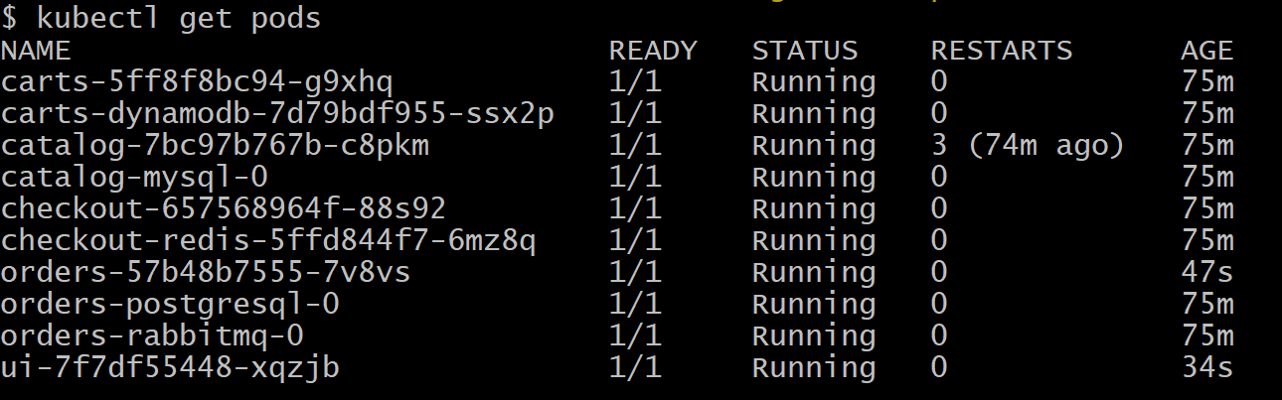
# Verify Ingress HTTP
# Get Ingress and ALB address
kubectl get ingress -A
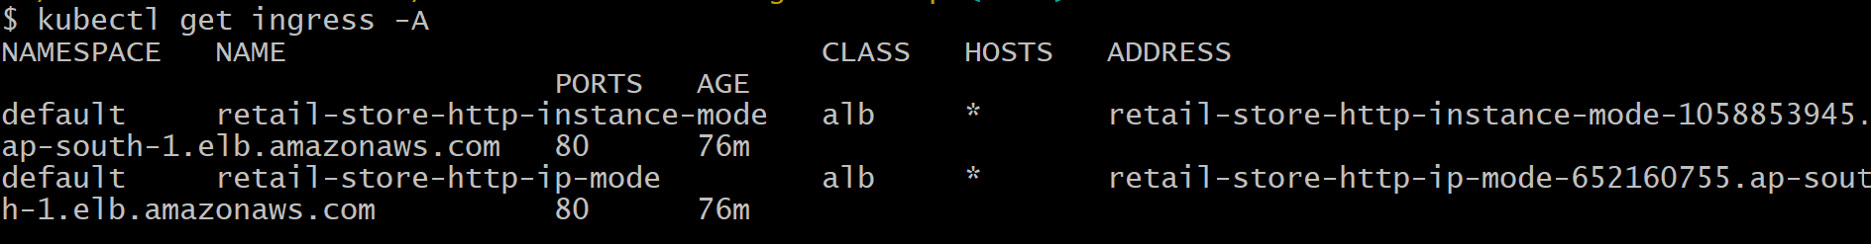
# Describe ingress to review rules/annotations
kubectl describe ingress retail-store-http-instance-mode
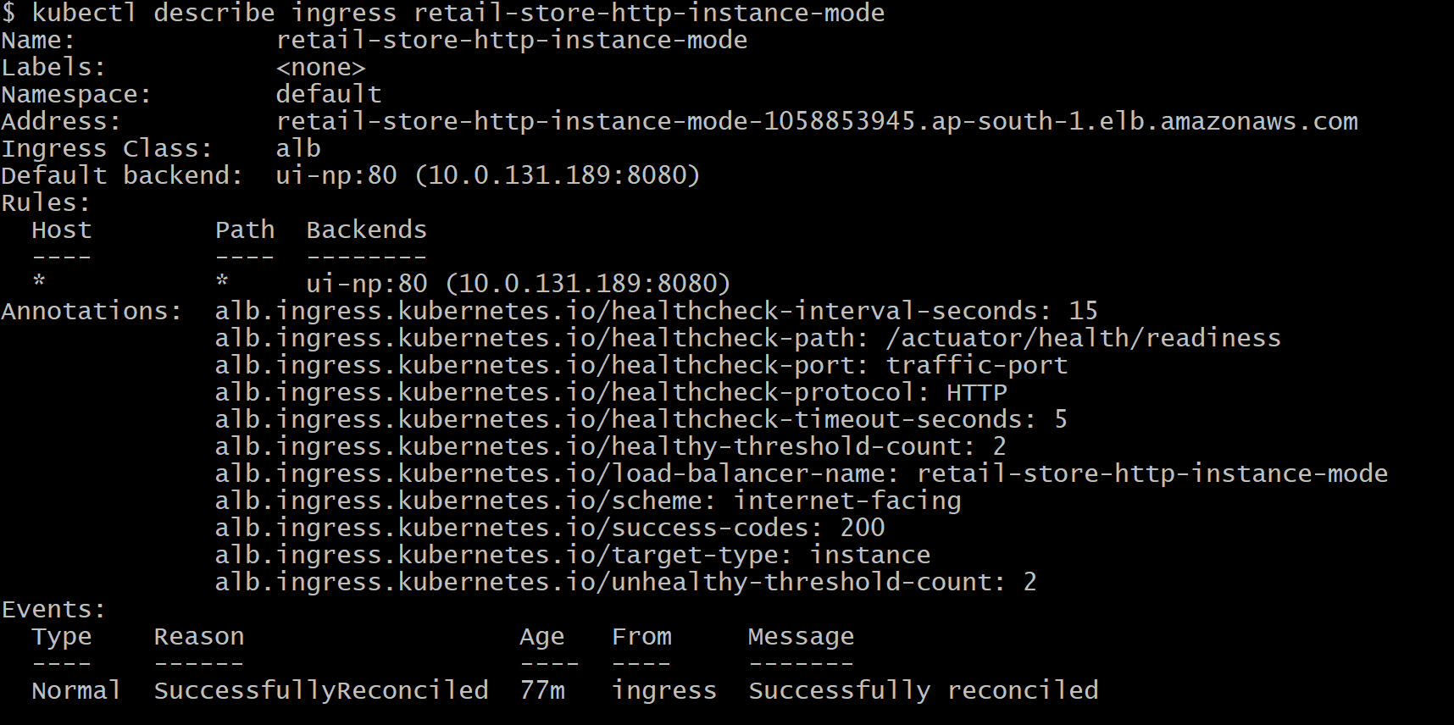
kubectl describe ingress retail-store-http-ip-mode
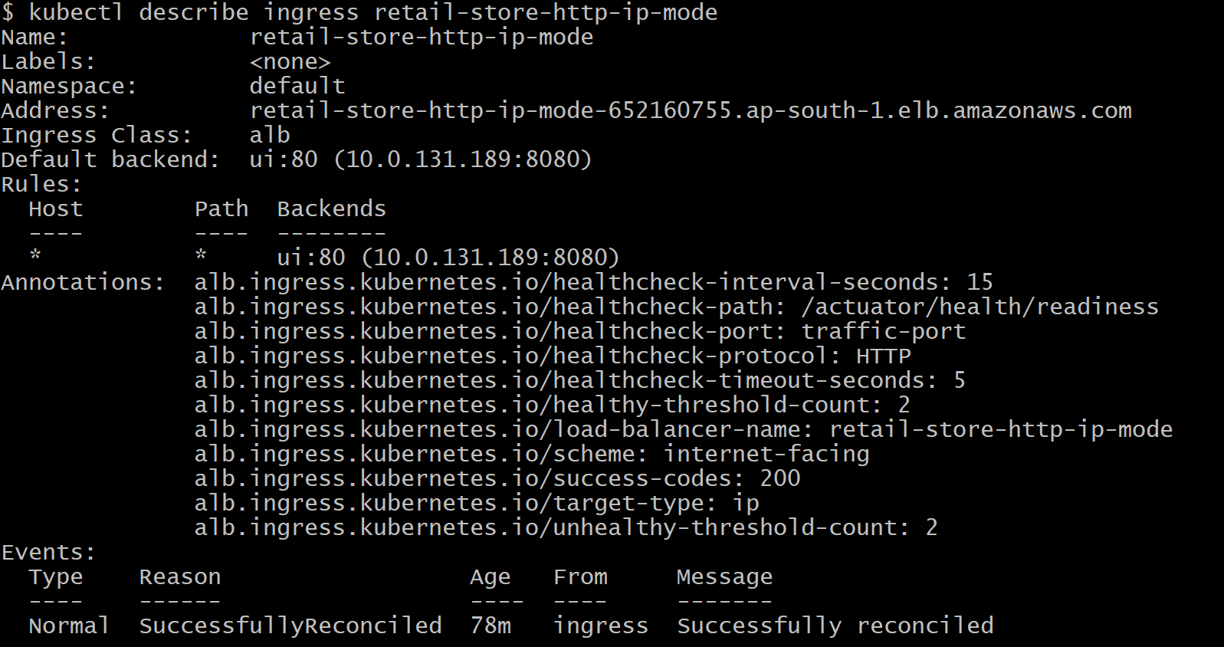

#Verified Load Balancers from AWS Console.
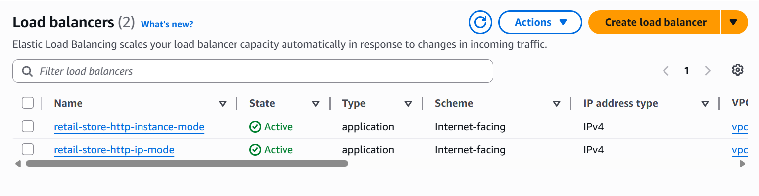

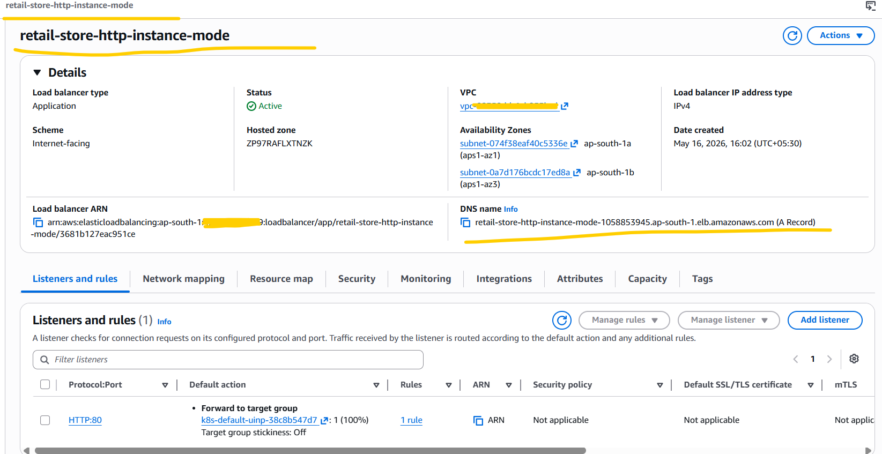
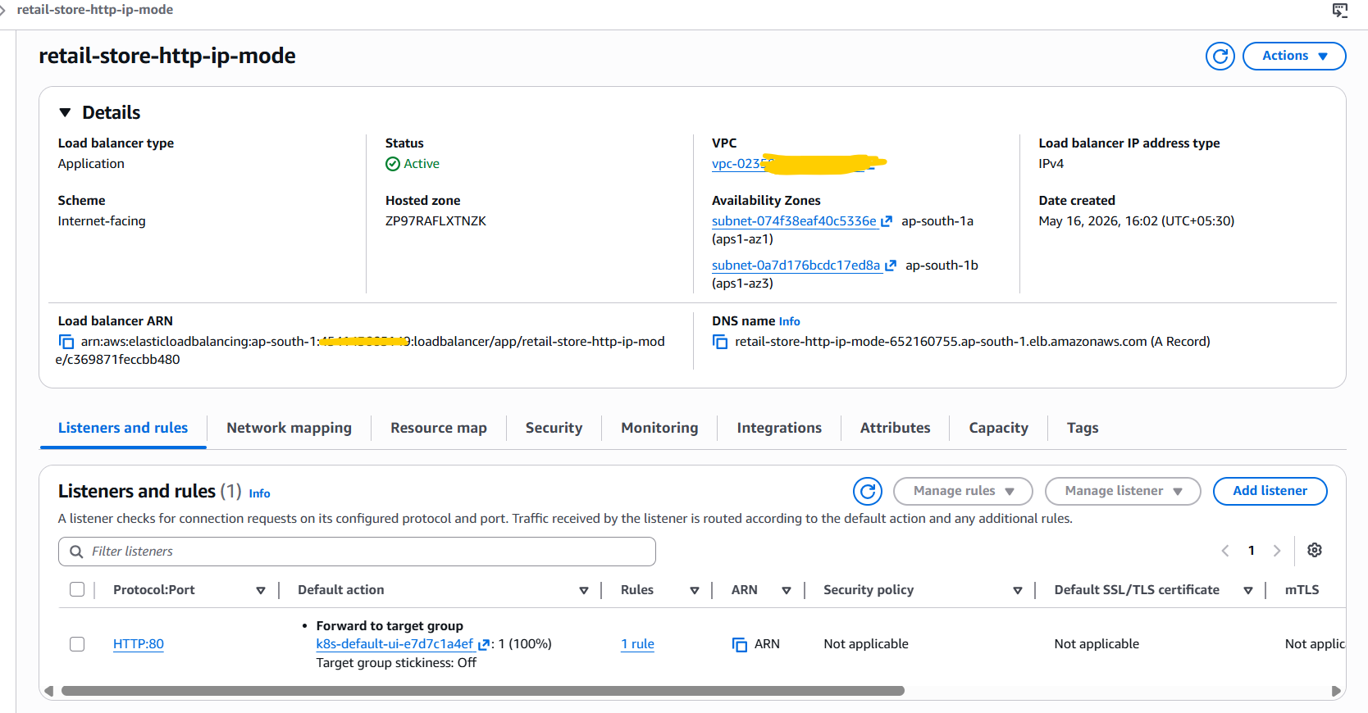
# Performed curl test for both ALB’s DNS name.
curl -v retail-store-http-instance-mode-1058853945.ap-south-1.elb.amazonaws.com
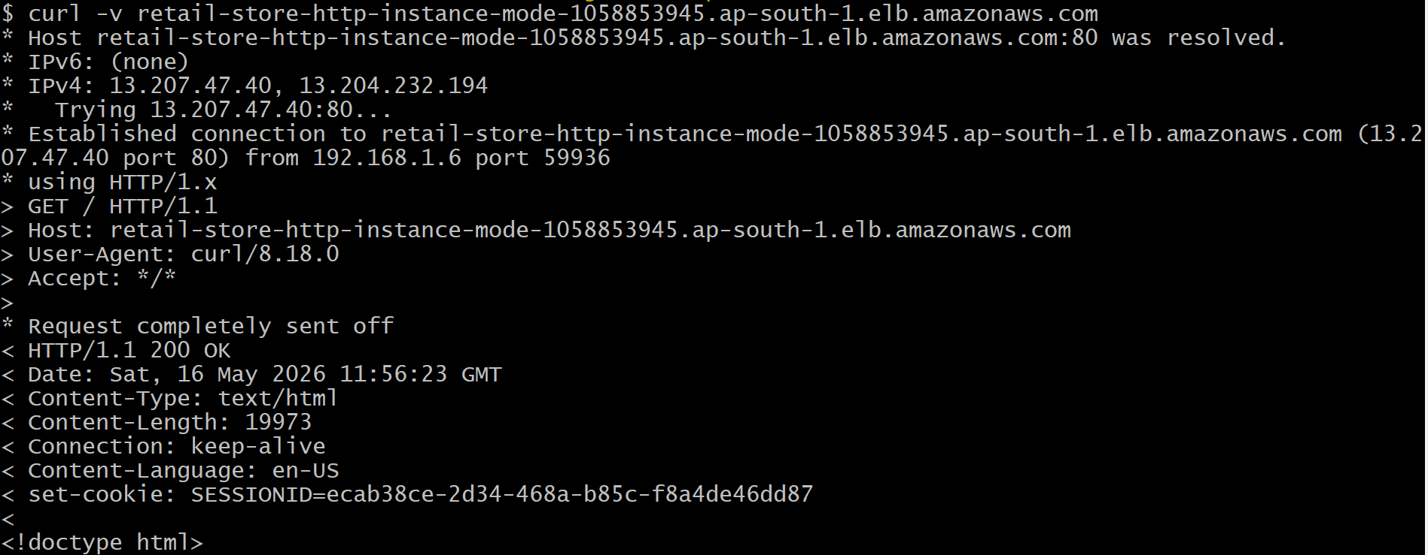
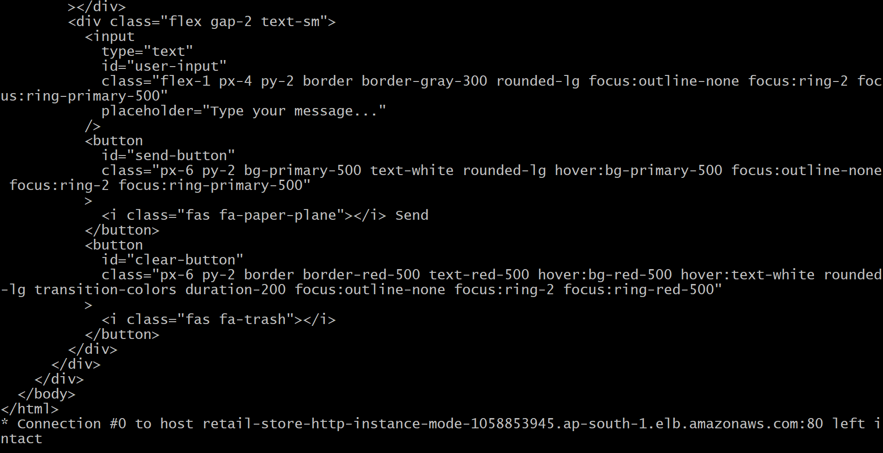
curl -v retail-store-http-ip-mode-652160755.ap-south-1.elb.amazonaws.com
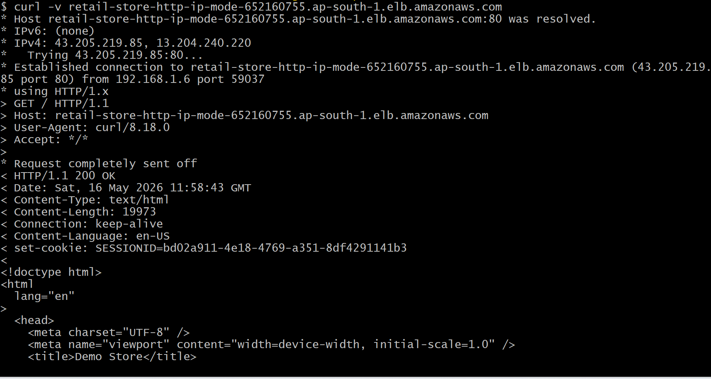
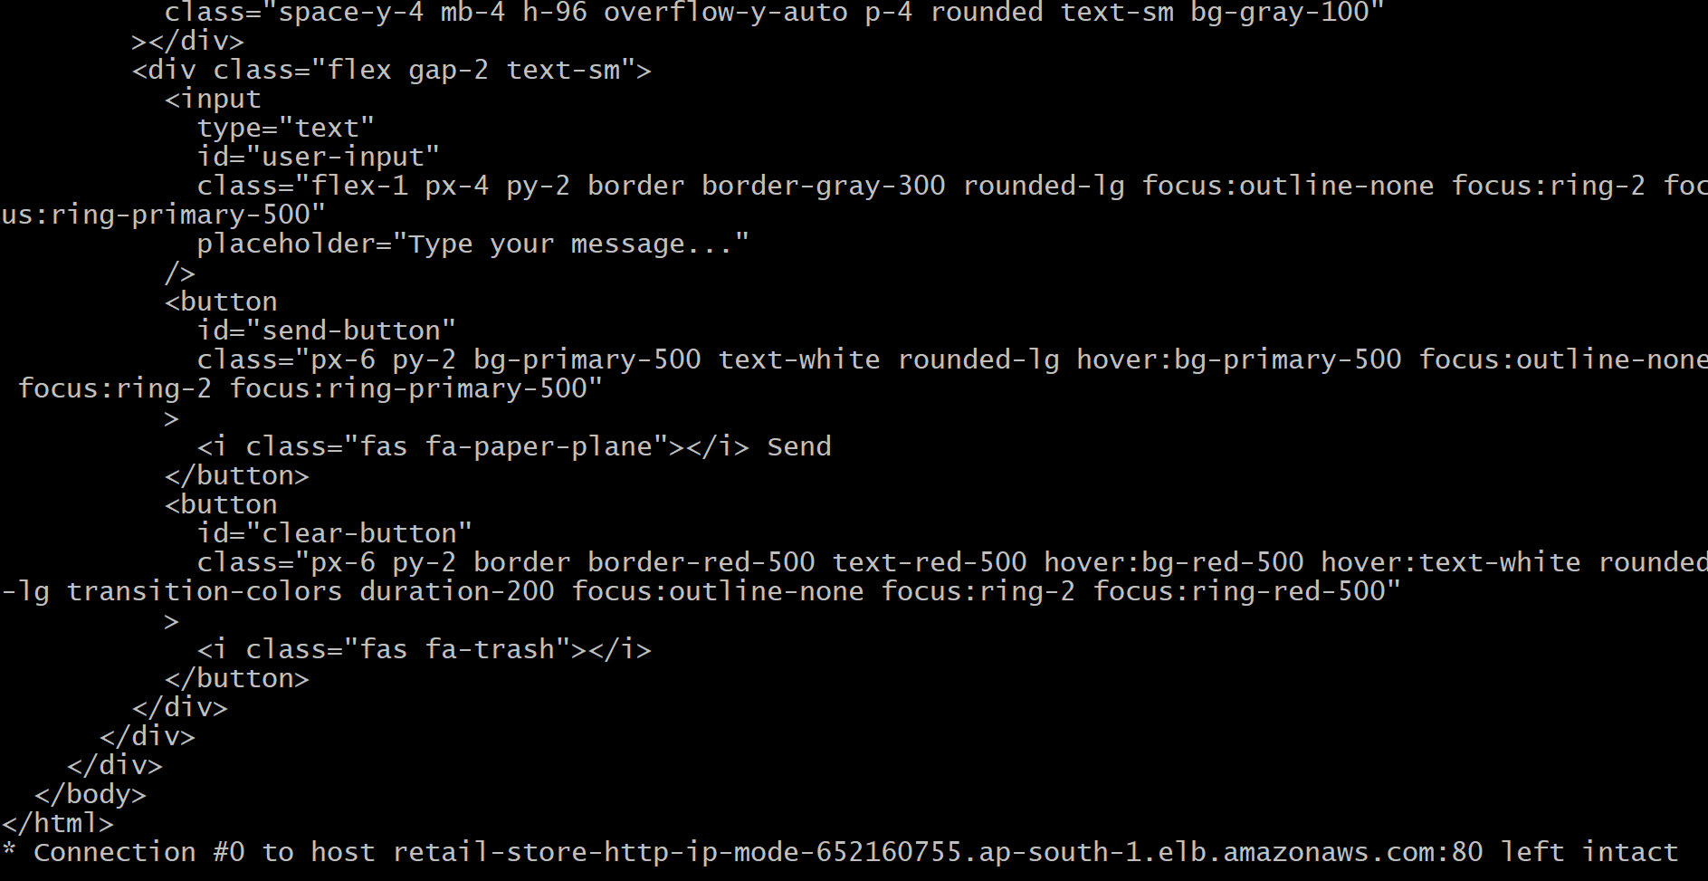
# Verify the ui pod ip in retail-store-http-ip-mode this ALB's k8s-default-ui-e7d7c1a4ef this Target group
kubectl get pods -o wide
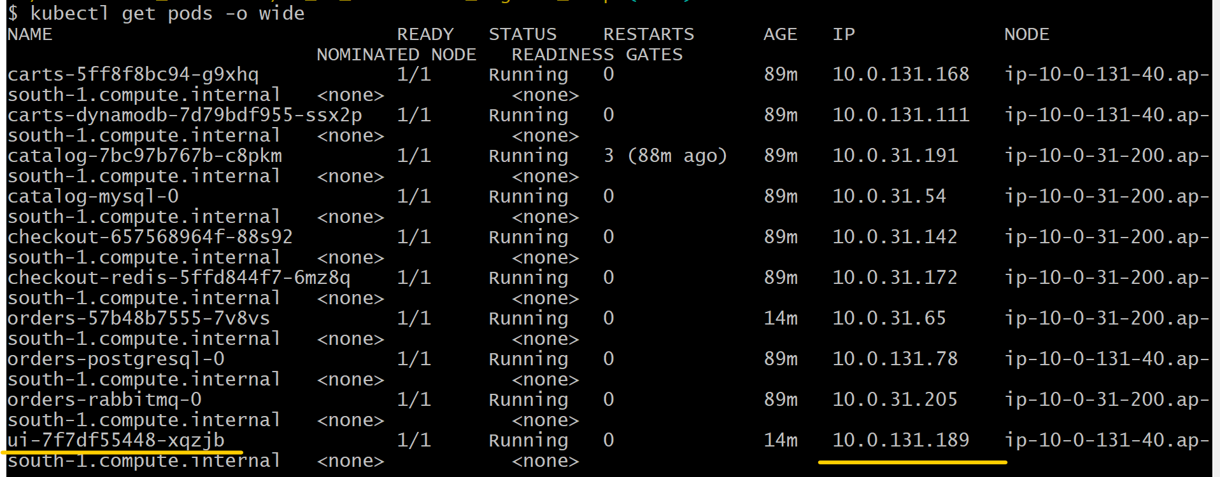

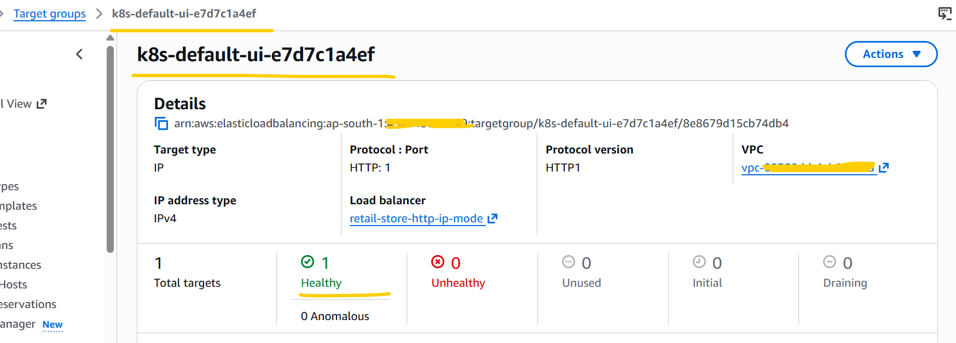
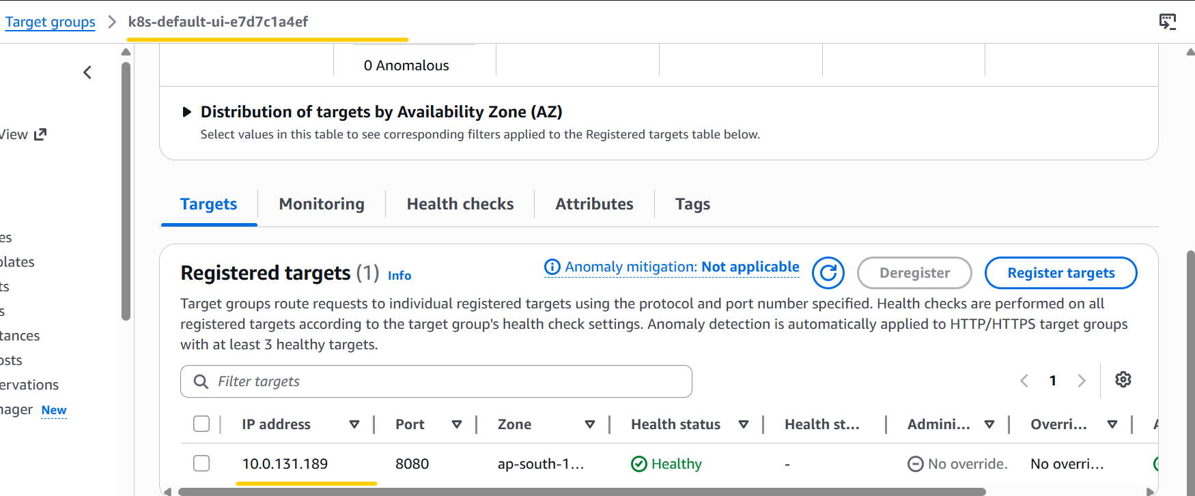
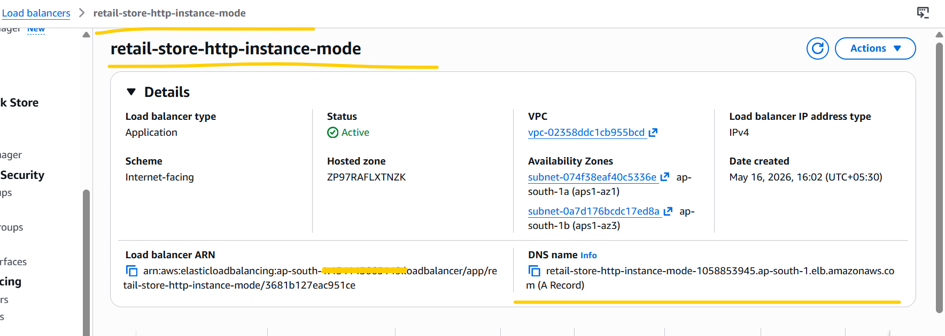

# Try accessing this ALB DNS name, retail-store-http-instance-mode, from my system browser, and I am able to access it successfully.
ALB DNS Link :- retail-store-http-instance-mode-1058853945.ap-south-1.elb.amazonaws.com

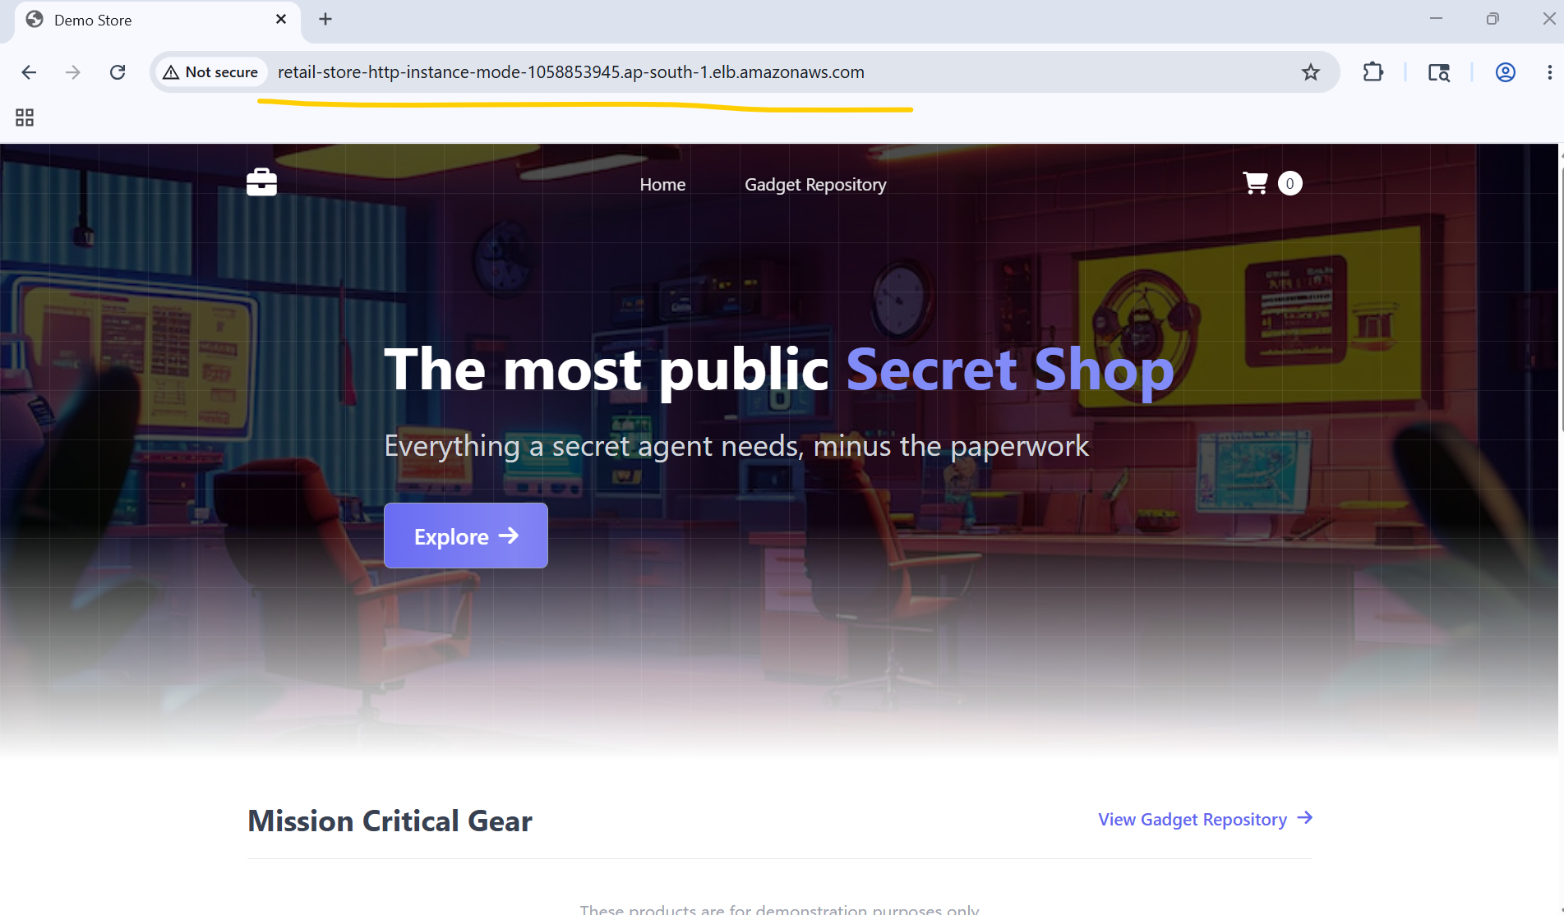
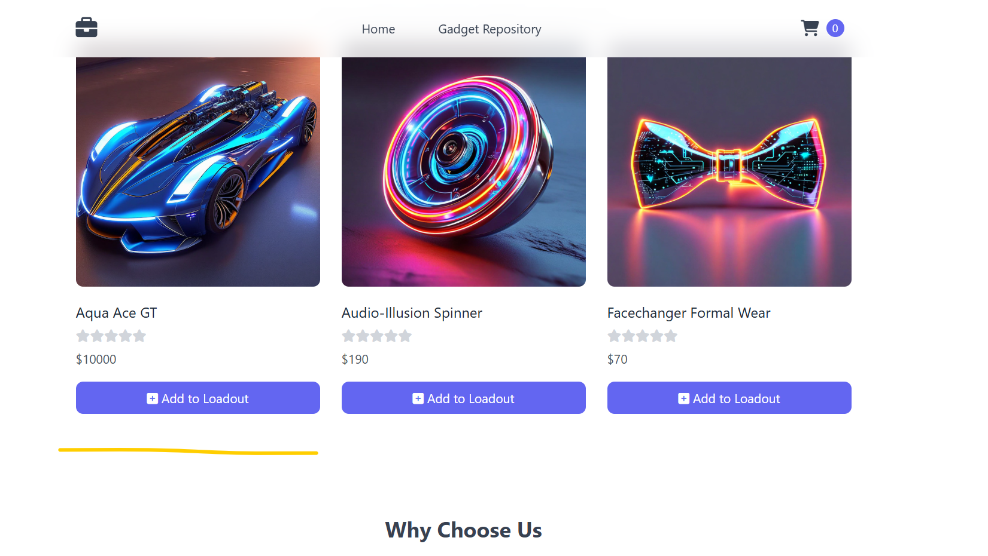
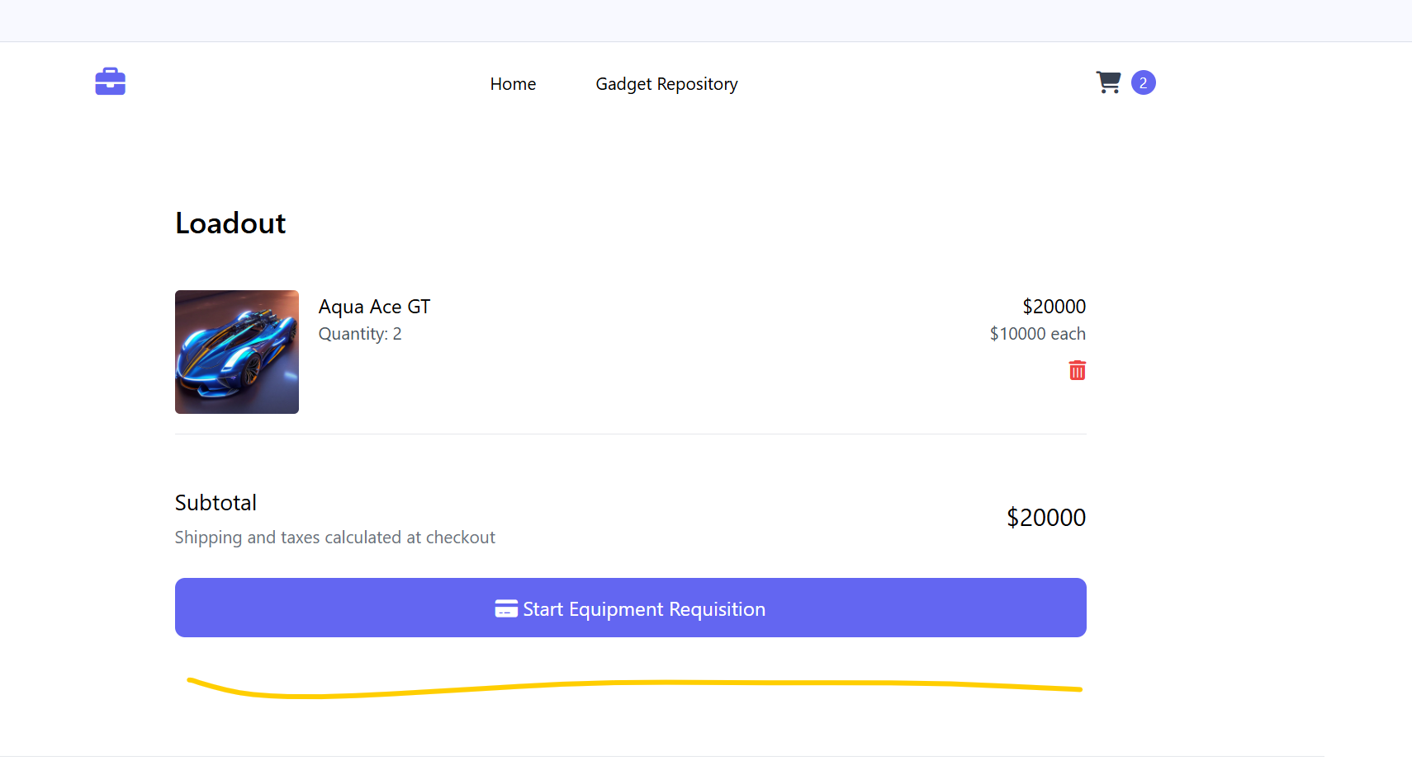

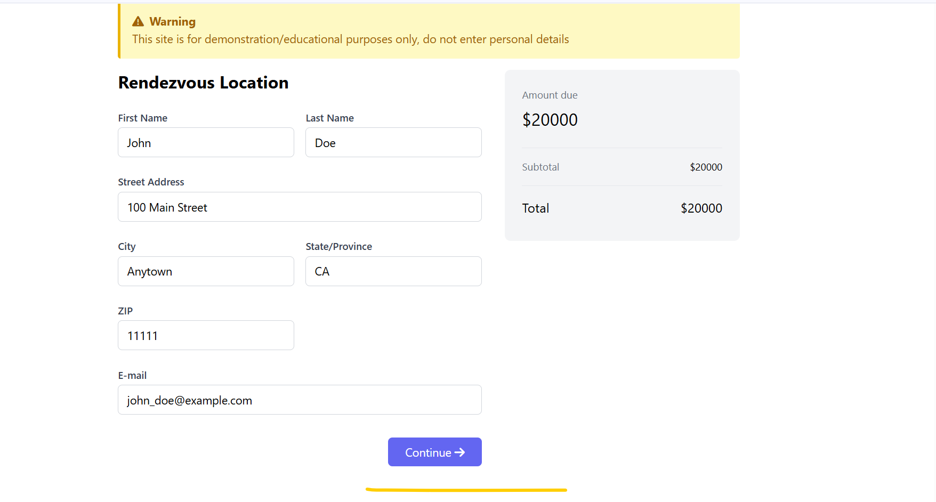
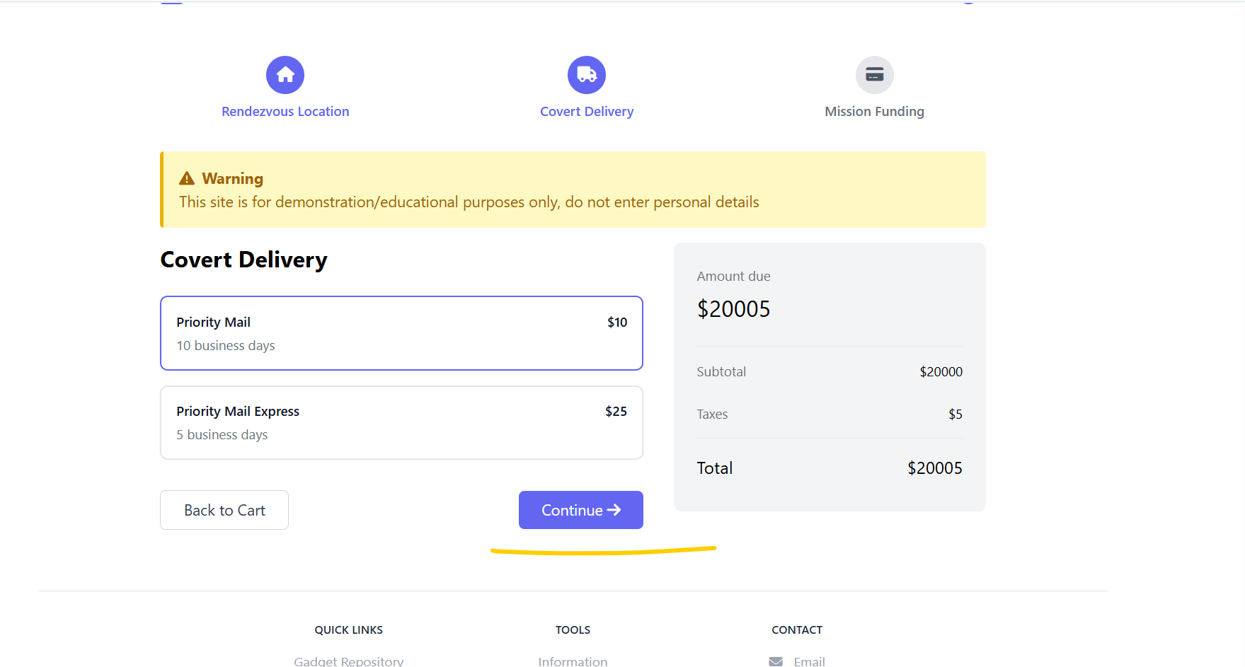
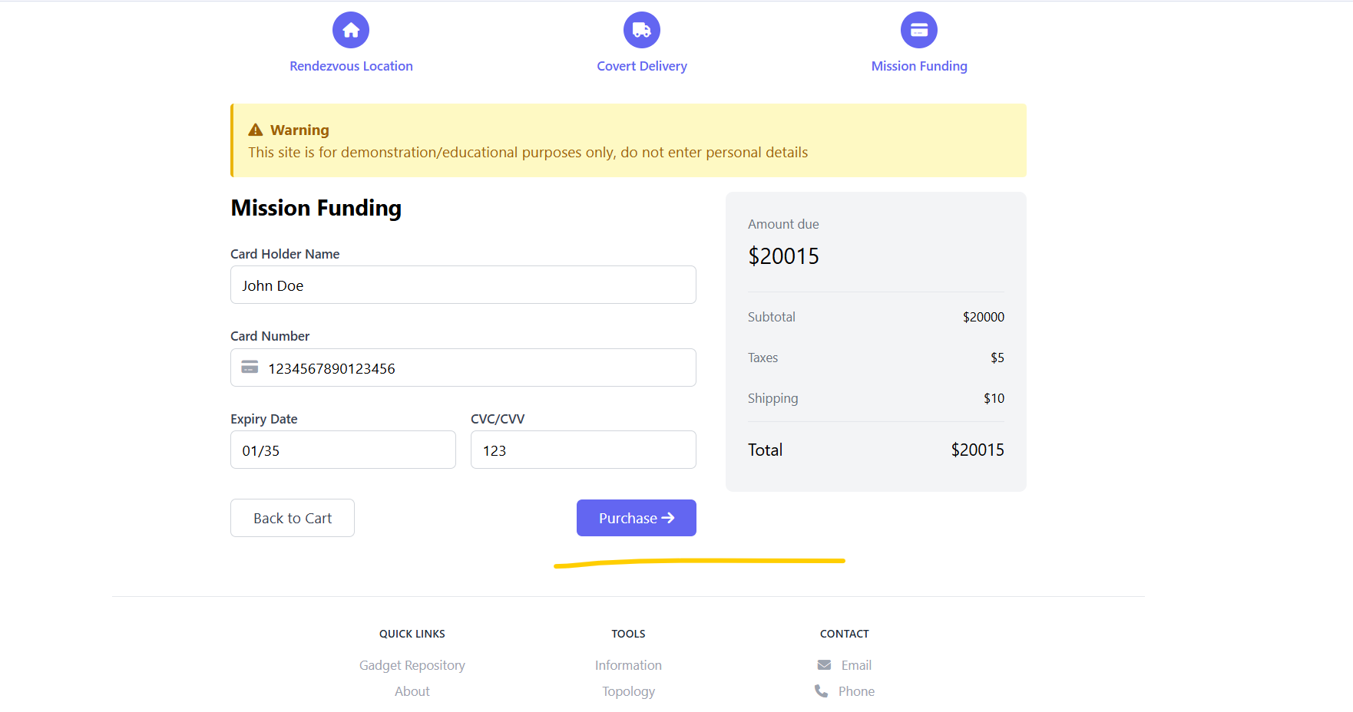
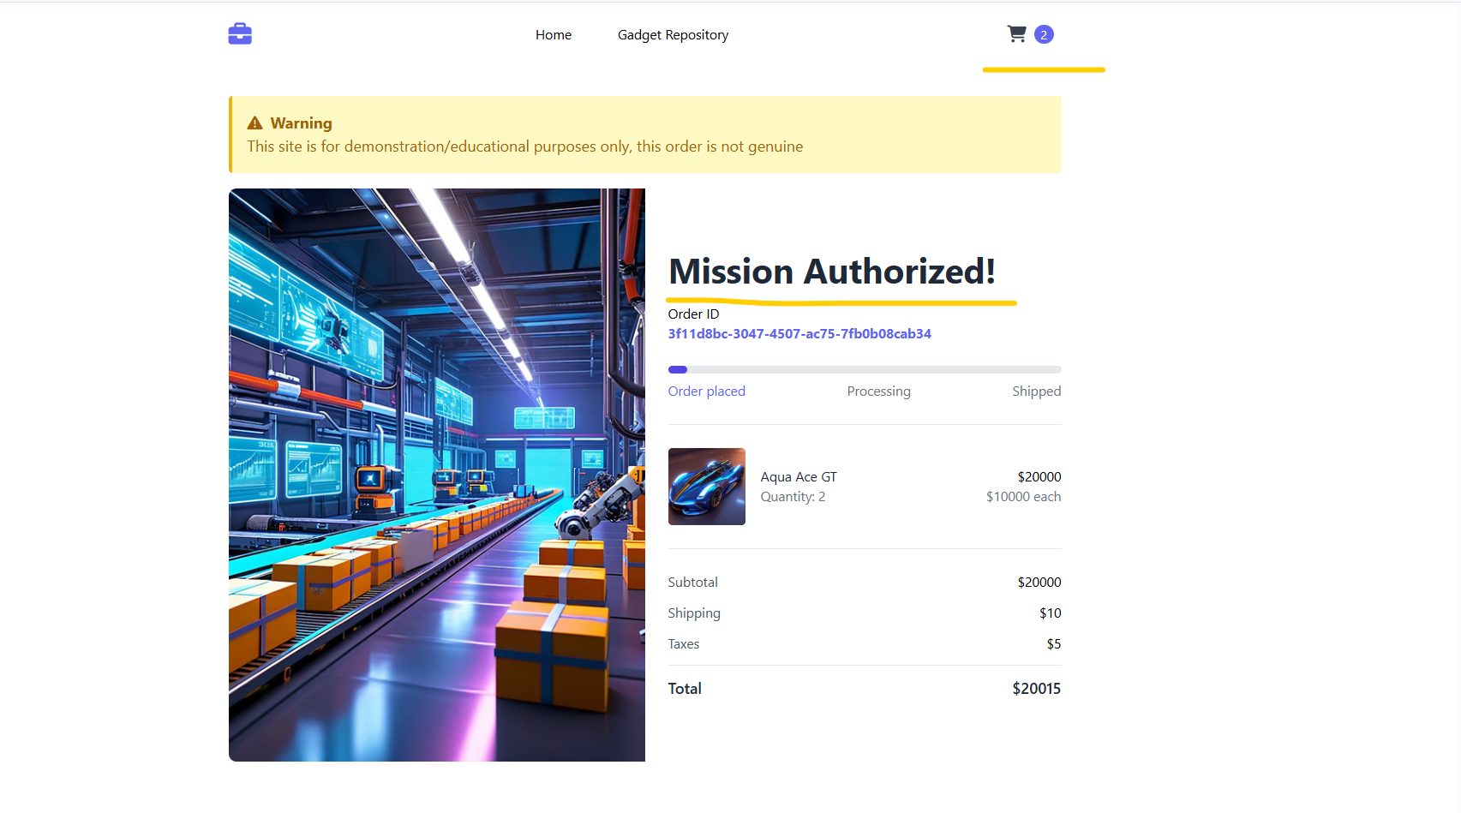
# Try accessing this ALB DNS name, retail-store-http-instance-mode with /topology endpoint from my system browser, and I am able to access it successfully
ALB DNS Link with /topology Endpoint:- http://retail-store-http-instance-mode-1058853945.ap-south-1.elb.amazonaws.com/topology

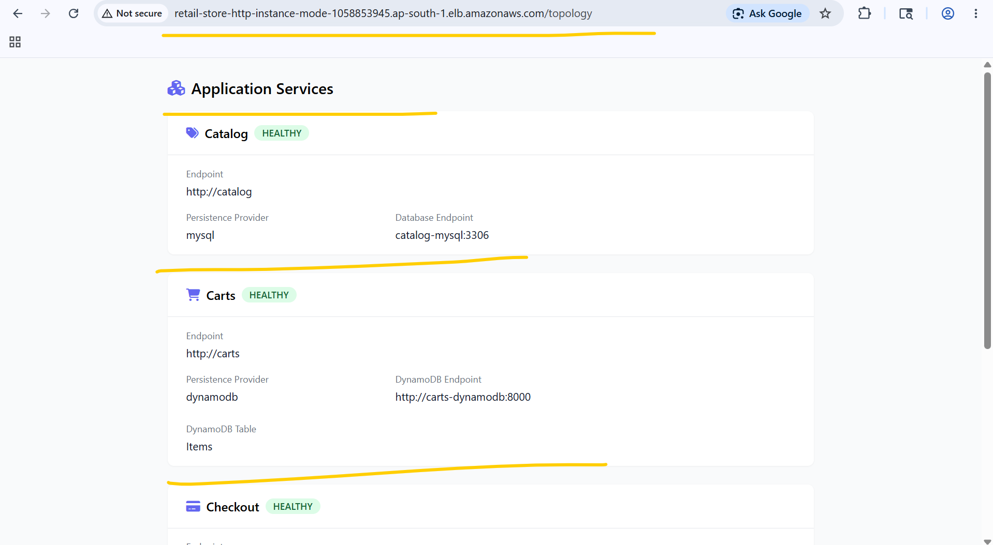
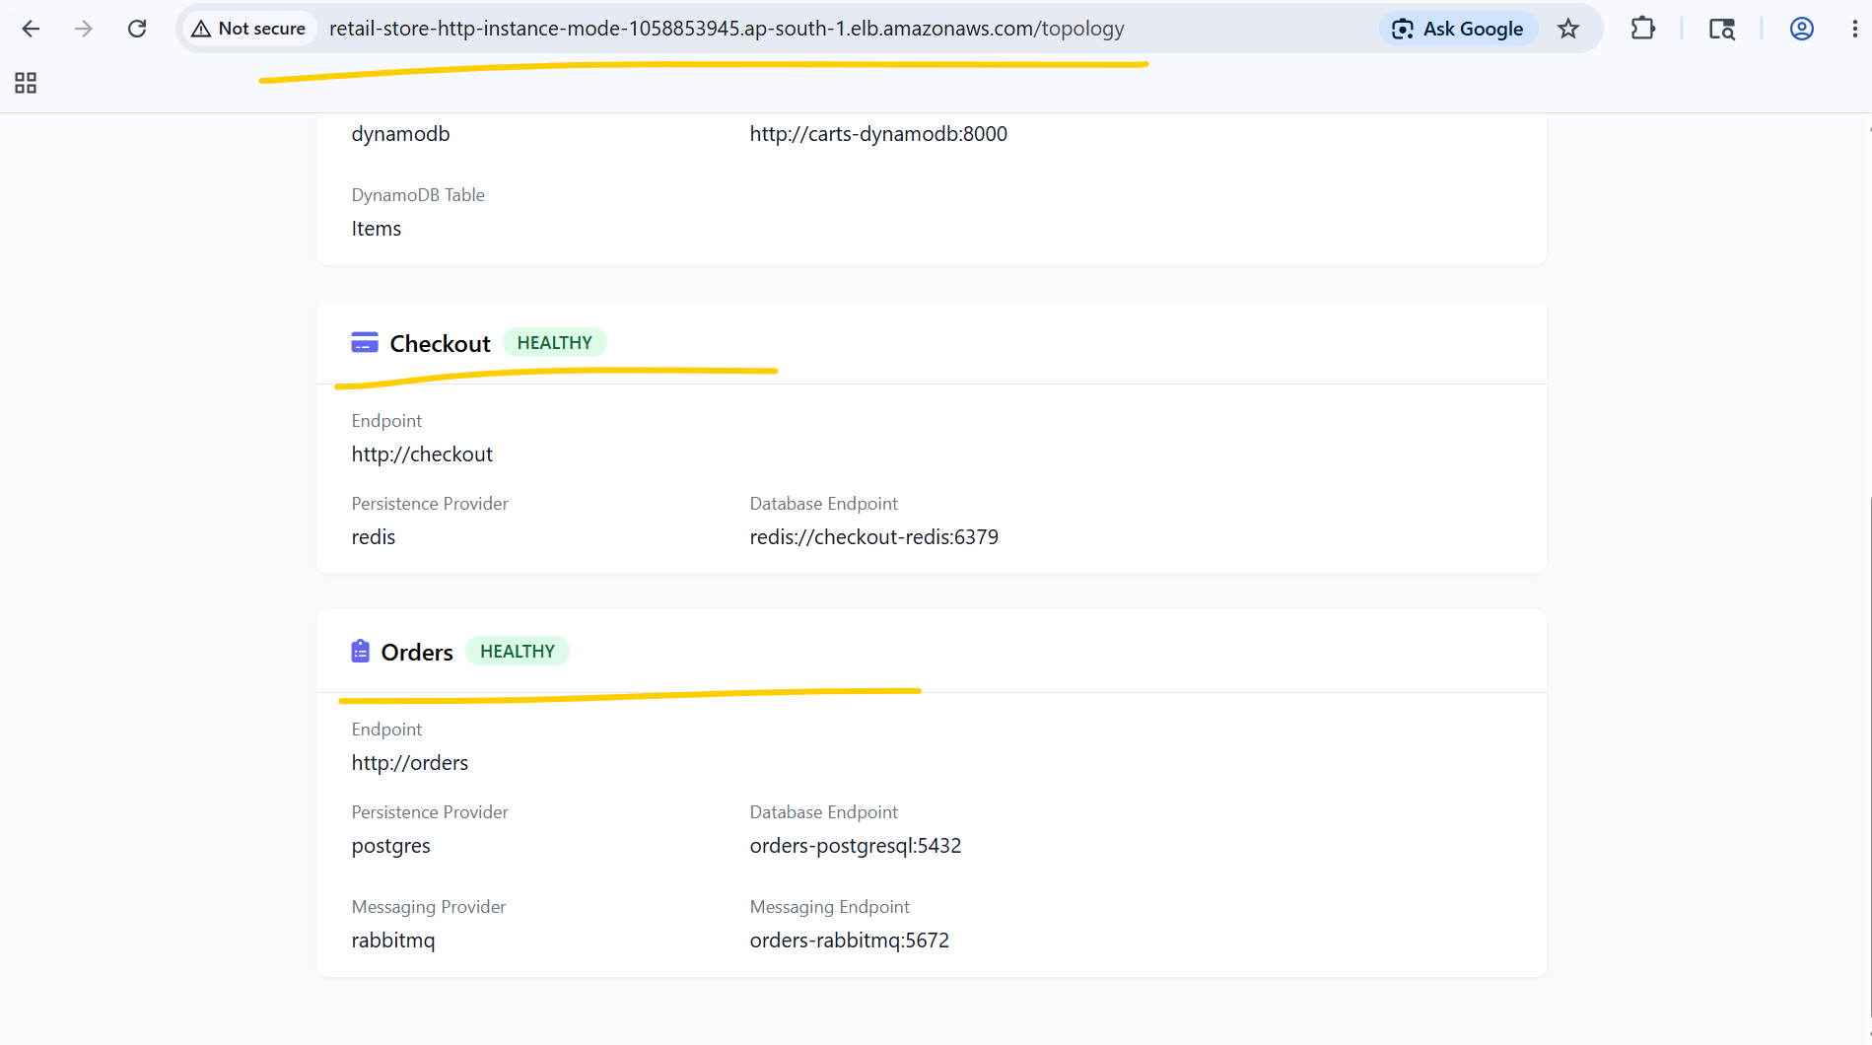

# # Try accessing this ALB DNS name, retail-store-http-ip-mode, from my system browser, and I am able to access it successfully.
ALB DNS Link :- http://retail-store-http-ip-mode-652160755.ap-south-1.elb.amazonaws.com/topology
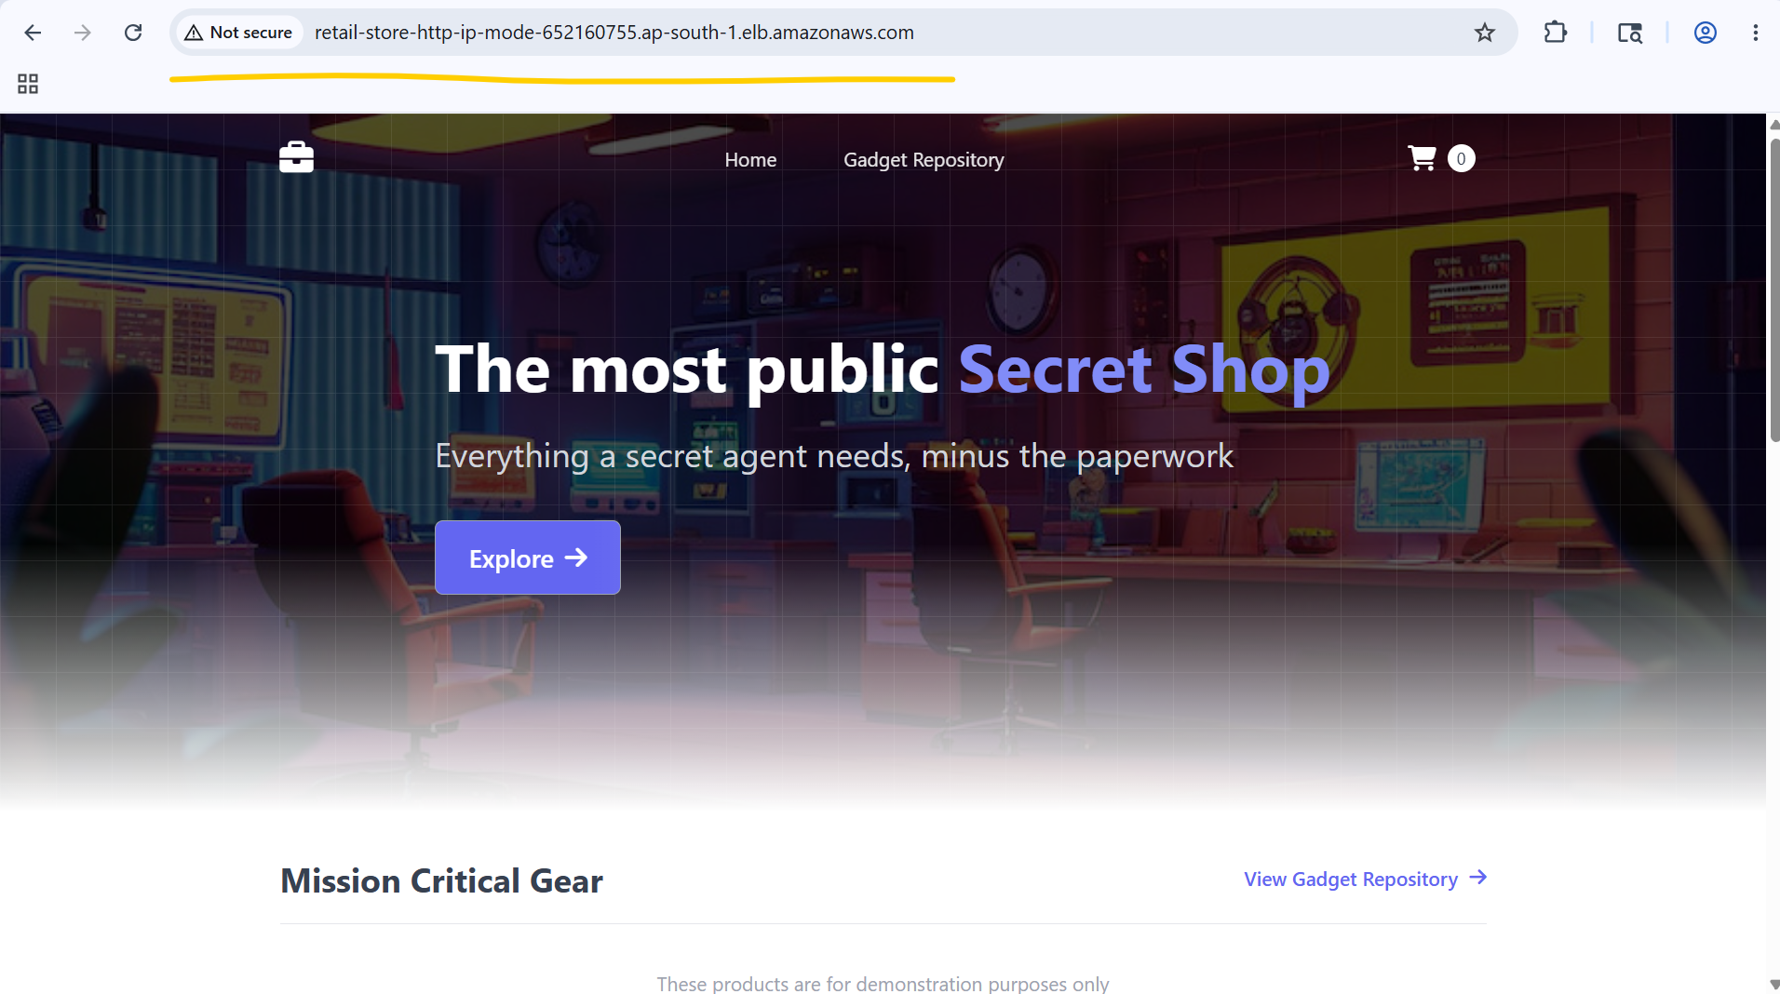

# Try accessing this ALB DNS name, retail-store-http-ip-mode, with /topology endpoint from my system browser, and I am able to access it successfully
ALB DNS Link with /topology Endpoint:- http://retail-store-http-ip-mode-652160755.ap-south-1.elb.amazonaws.com/topology

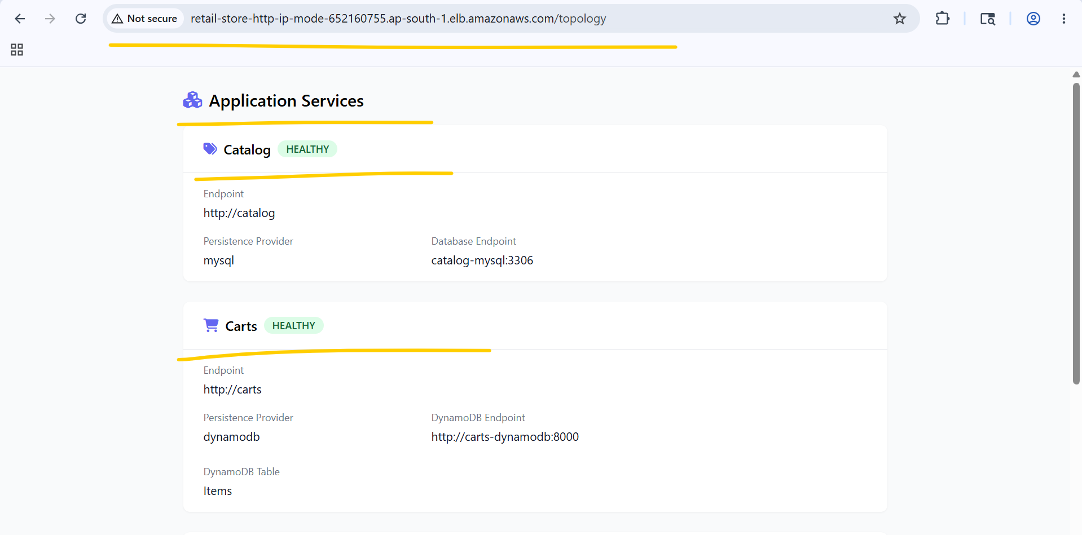

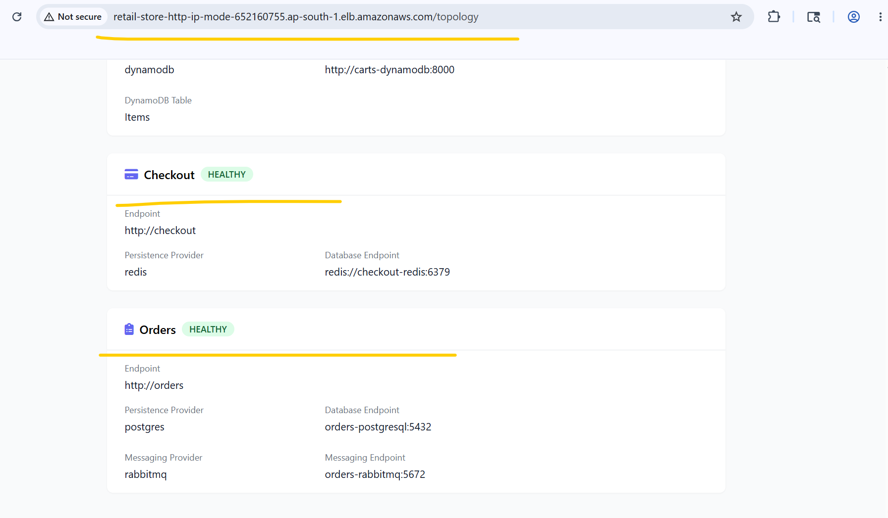

# Cleanup the MS stack
kubectl delete -R -f http_retail_store_k8s_manifests
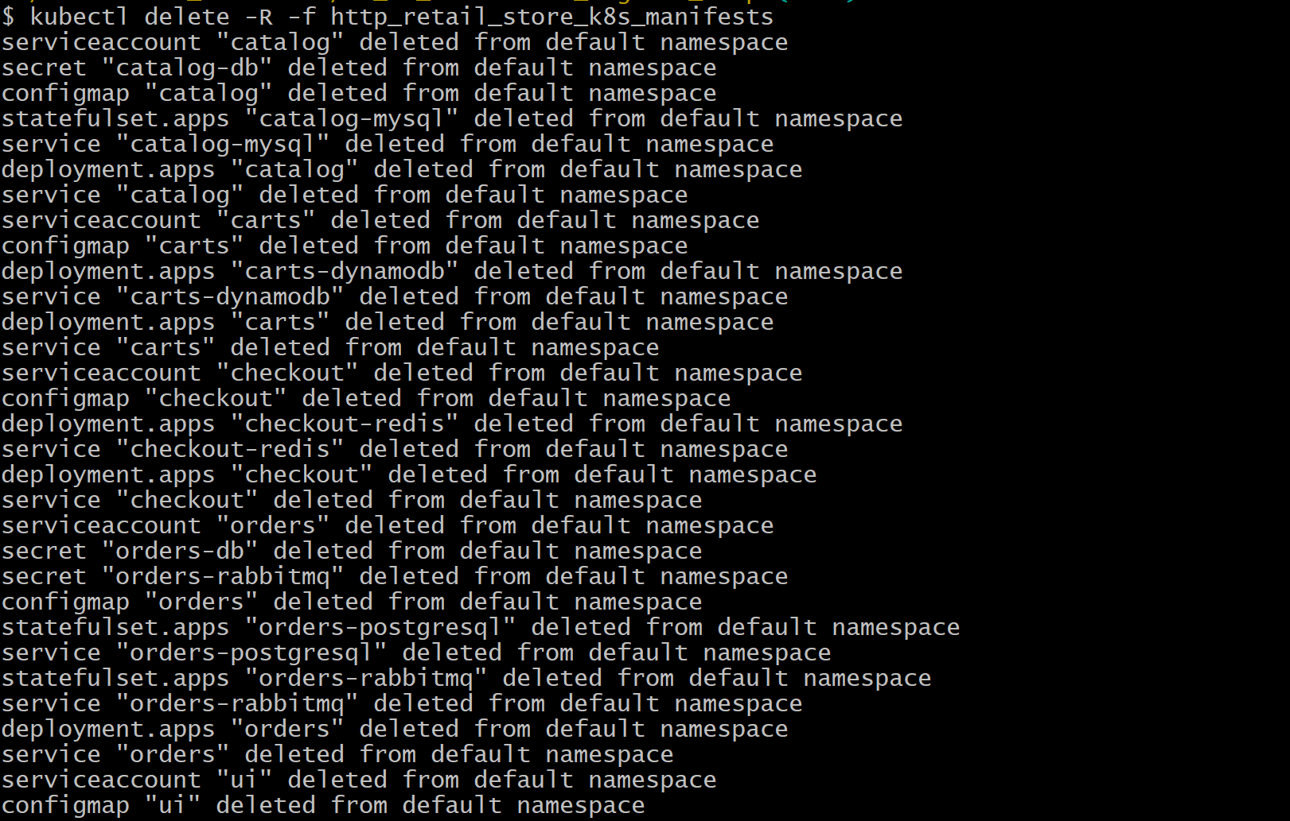
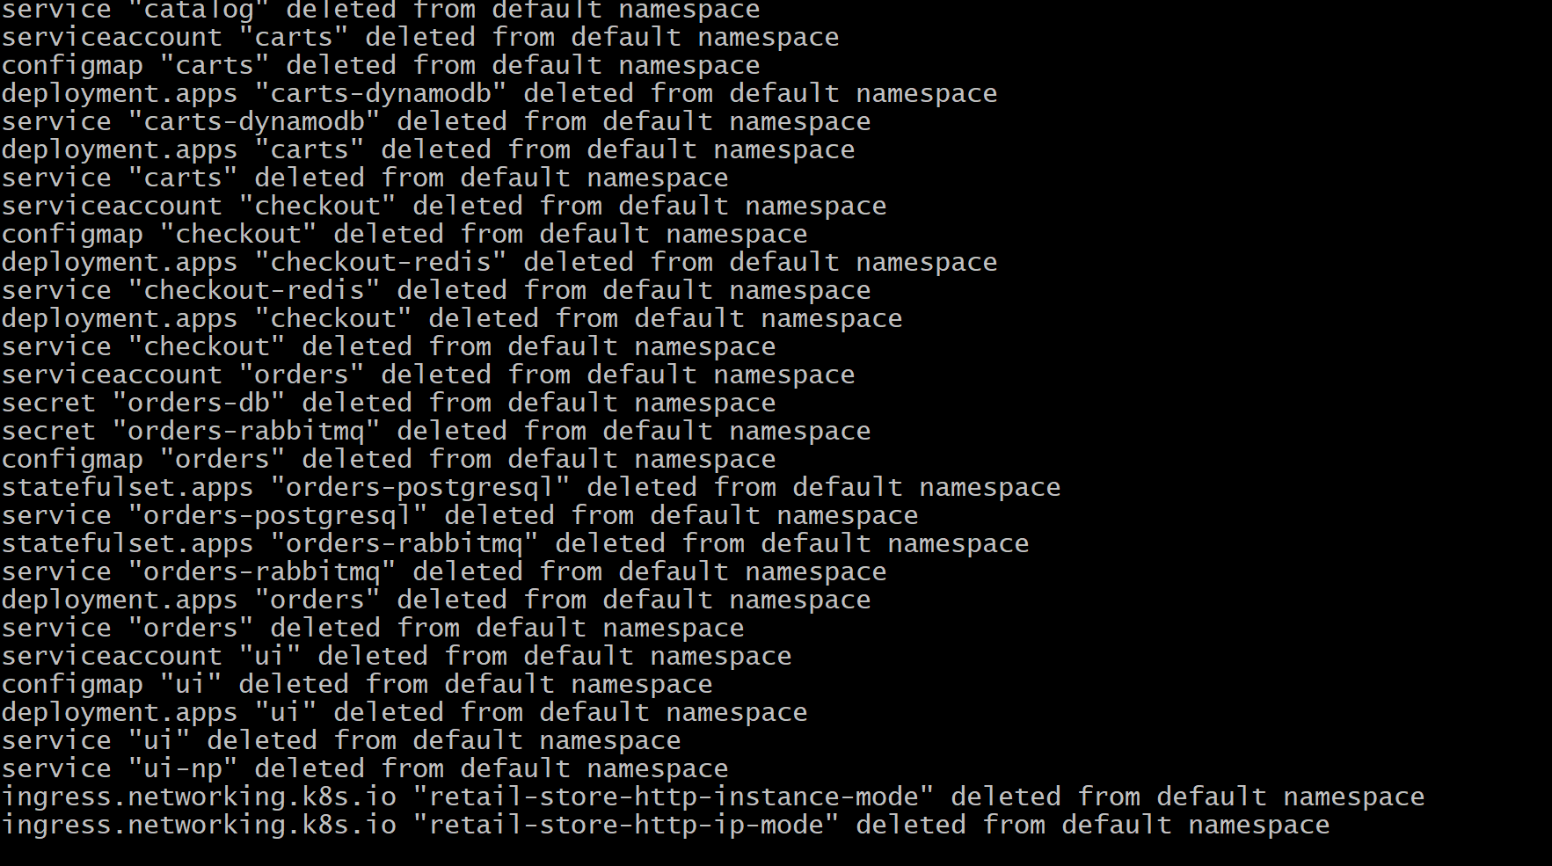

# Verify after deletion
Kubect get pods
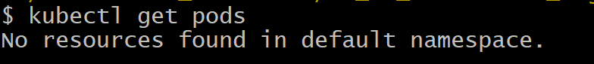

- Deleted EKS Cluster, Node group and Iam roles for through terraform destroy command.

