Steps:-
- Copied EKS terraform code from 22_05_2026 folder into 25_05_2026 this folder and added additional karpenter terraform configuration files from 22_05_2026 from this folder into 25_05_2026 this folder. Also copied RetailStore Application yaml Manifest files code from instructor code into 25_05_2026 this folder.
- Modified karpenter terraform configuration files as per requirements and merged that code with existing EKS terraform code.
Note:- 1. Since I did not deploy a private subnet due to the unavailability of a NAT Gateway, and creating my own NAT Gateway would incur additional costs, I chose not to create one for cost optimization purposes. As a result, I deployed my node group EC2 instances, Karpenter EC2 instance, RDS DB’s and ElastiCache resources in a public subnet.
2. I am also aware that, from a best practices and security perspective, node group EC2 instances, Karpenter EC2 instance, RDS DB’s and ElastiCache resources should be hosted in a private subnet rather than a public subnet. However, this is not a production-grade EKS cluster; I am deploying it only for practical testing purposes. Therefore, I hosted the node group EC2 instances, Karpenter EC2 instance, RDS DB’s and ElastiCache resources in a public subnet.
3. For my previous practical’s, I have also used only public subnets, and for upcoming practical’s, I will continue to use public subnets only.

- Run below mentioned terraform commands to deploy the EKS Cluster through terraform

terraform init
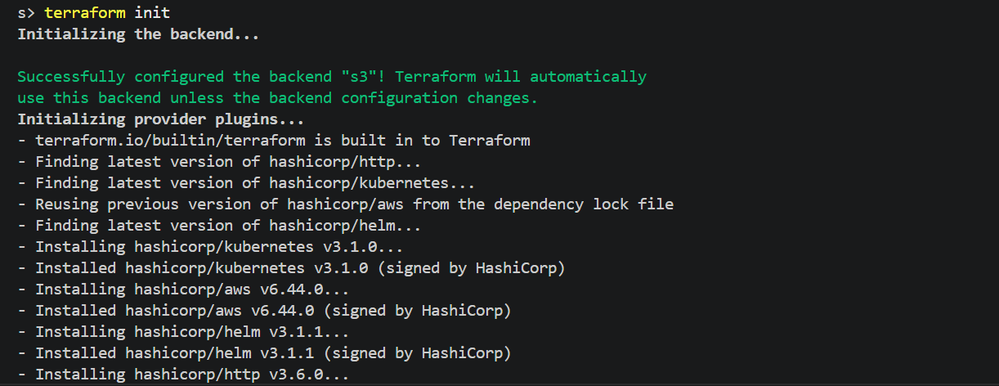

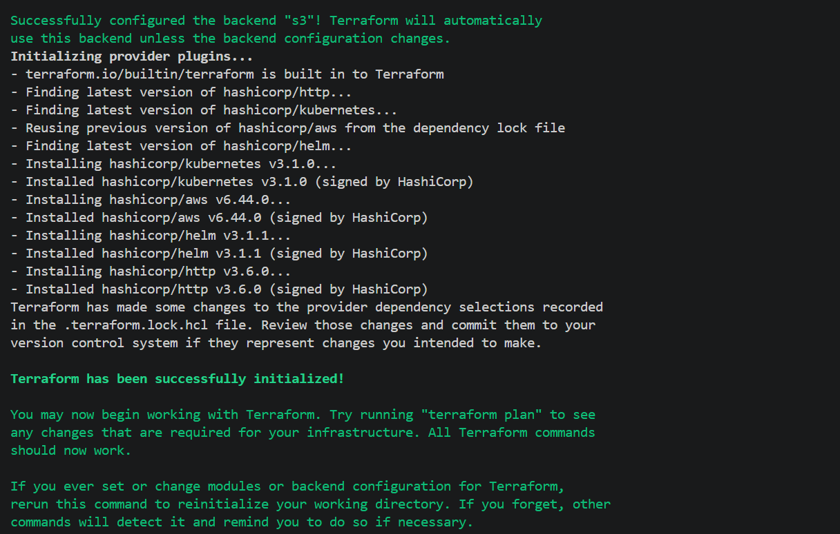

terraform validate

terraform plan
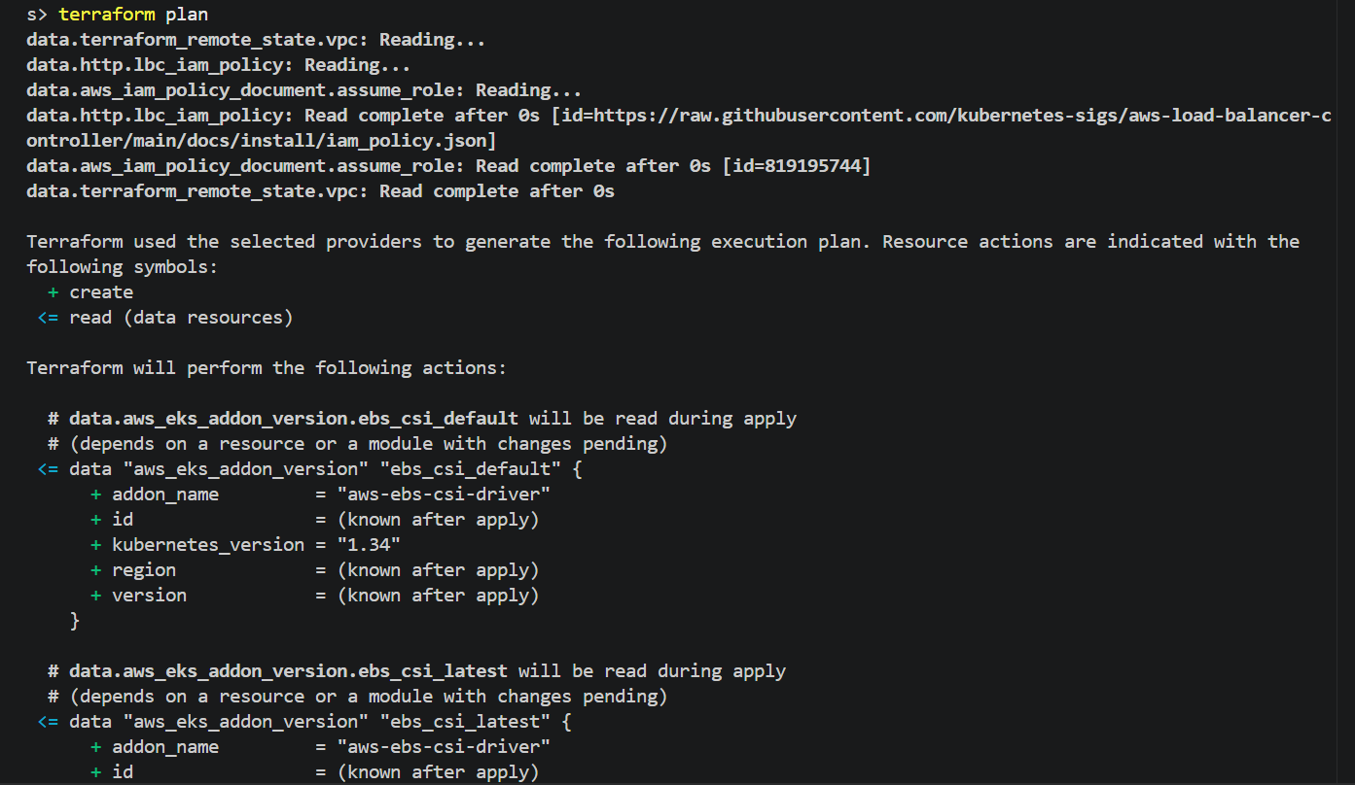

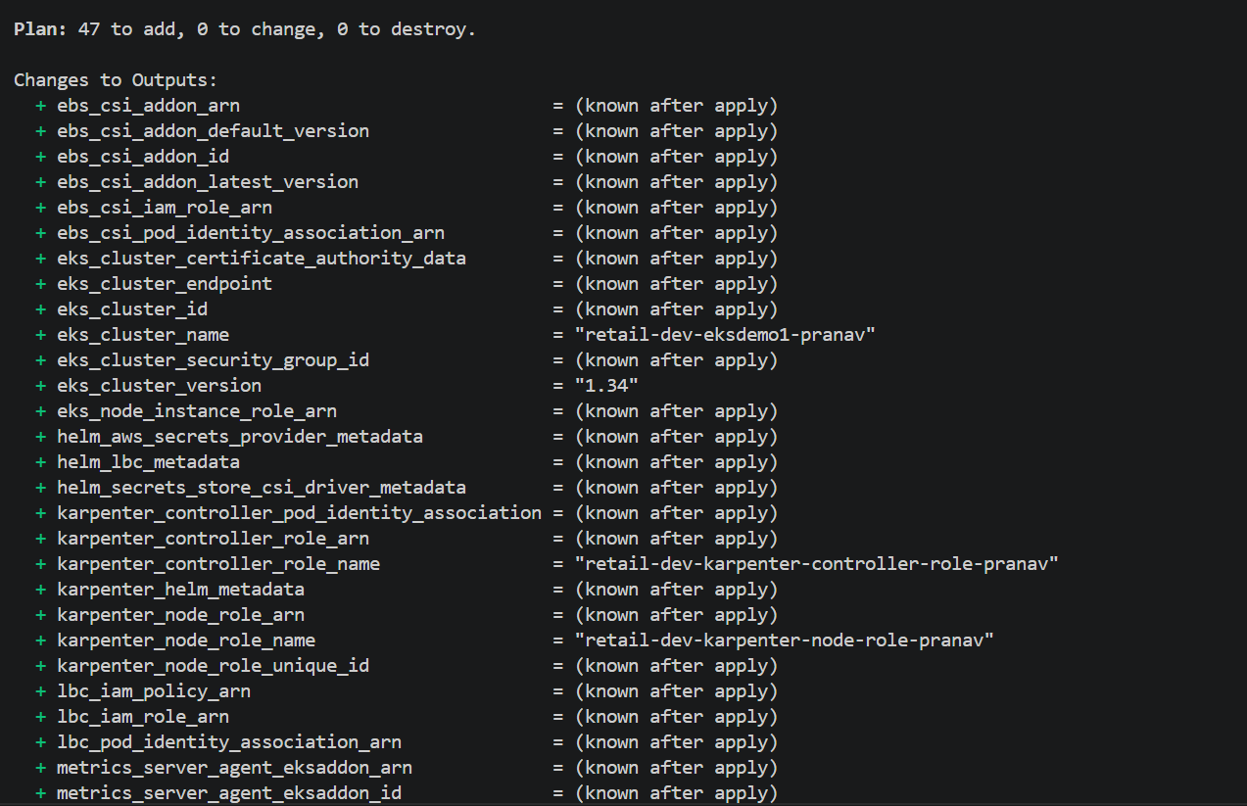
terraform apply –auto-approve
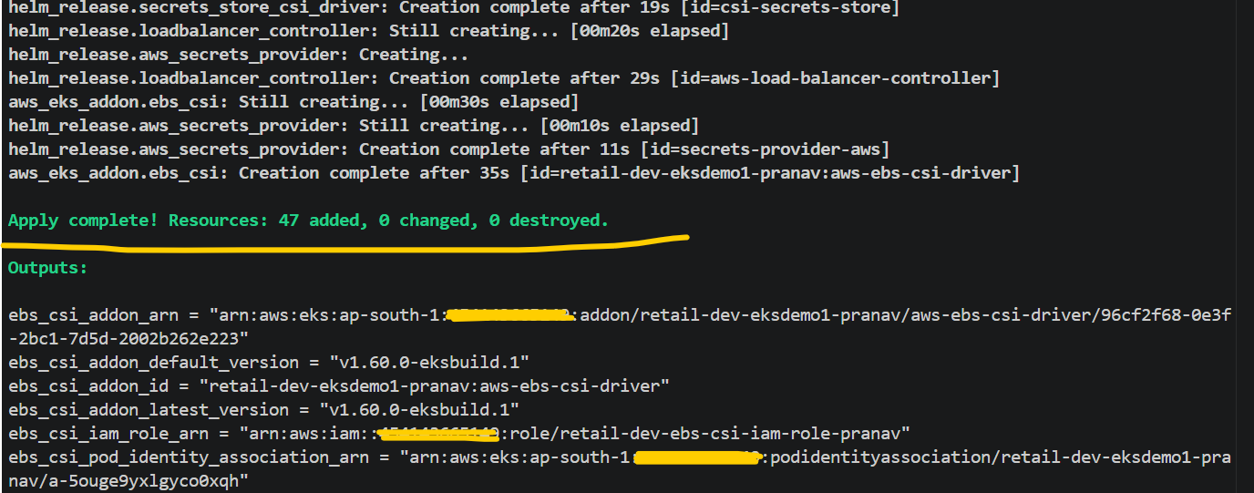

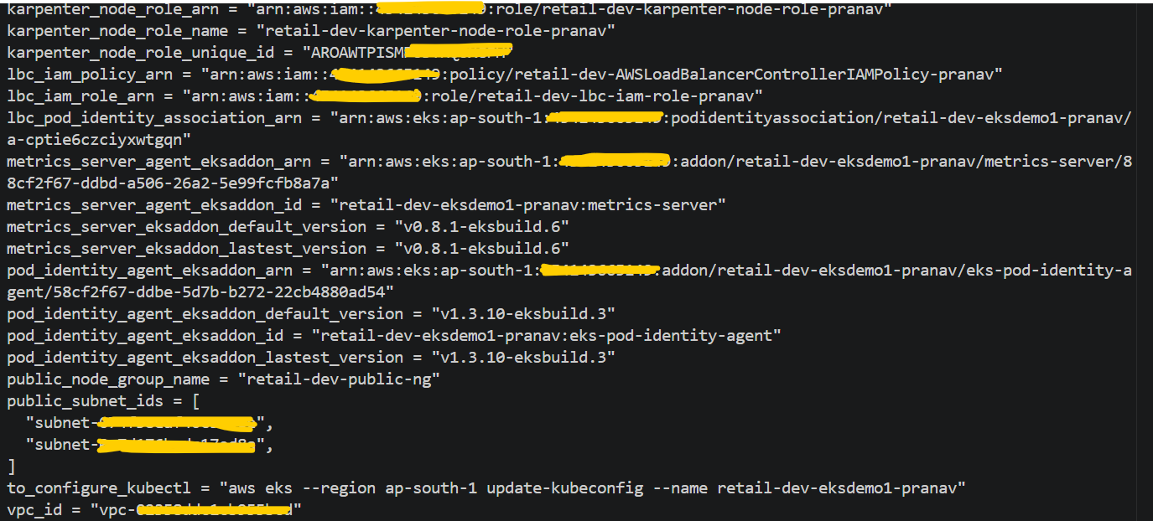
# Verified EKS Cluster and its configuration from AWS console
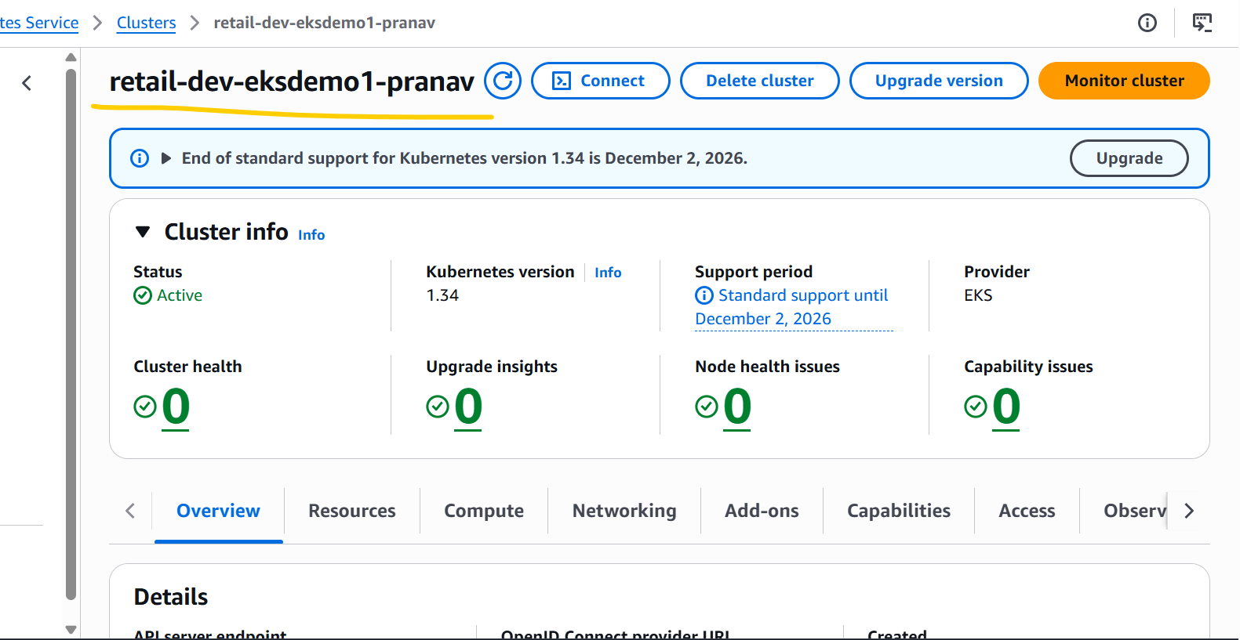

# EKS Node Group Instance Type Size

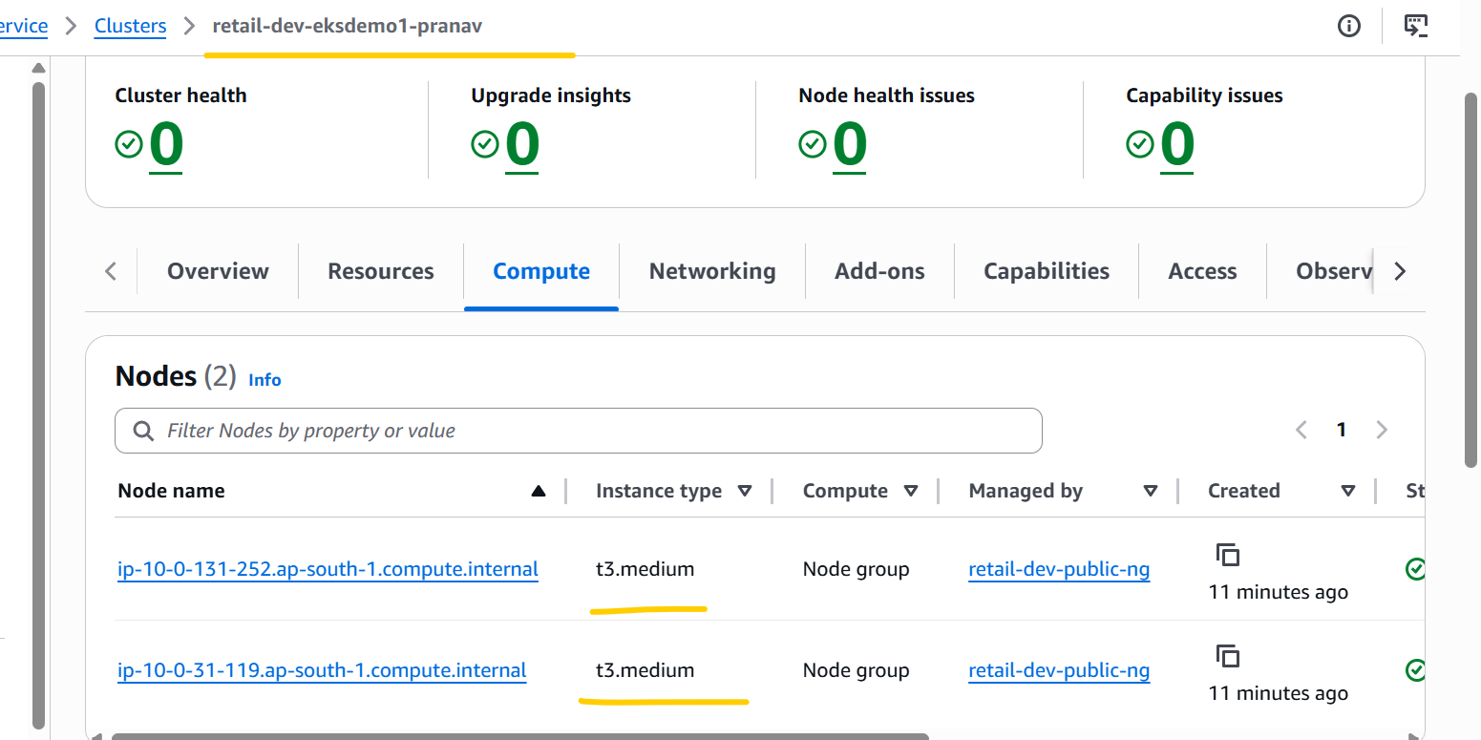

# EKS Cluster Add-ons.
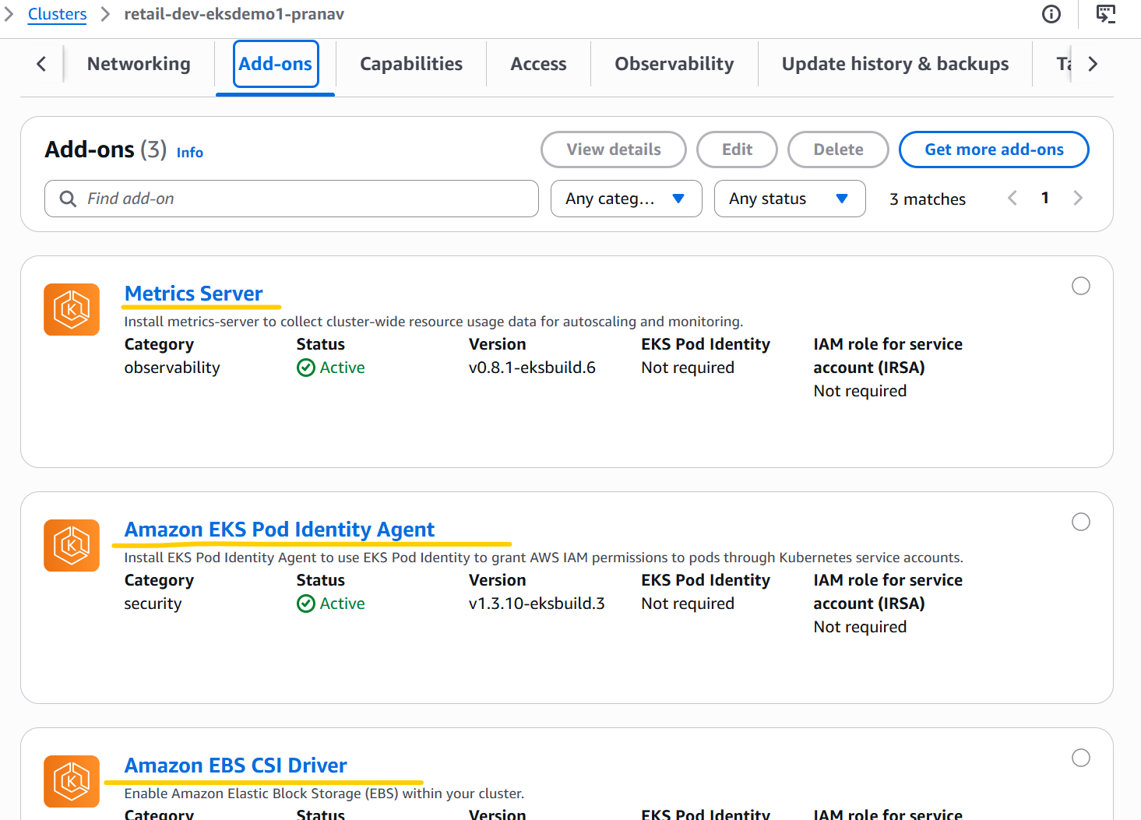

# EKS Cluster IAM access entries
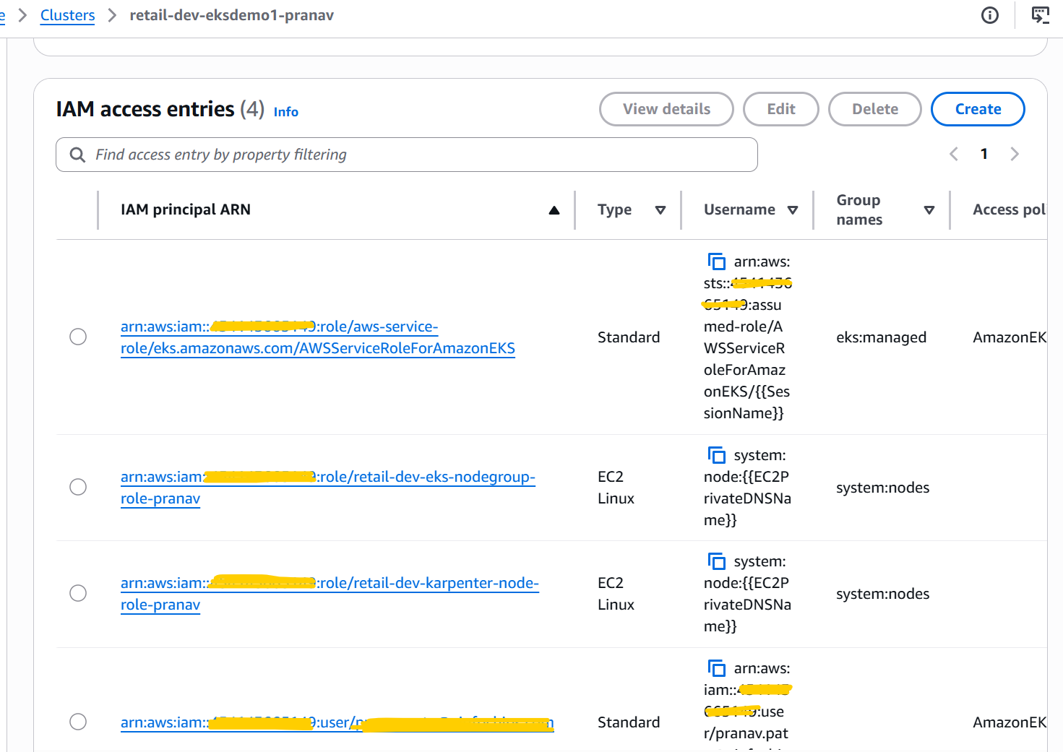

# EKS Cluster Pod Identity associations.
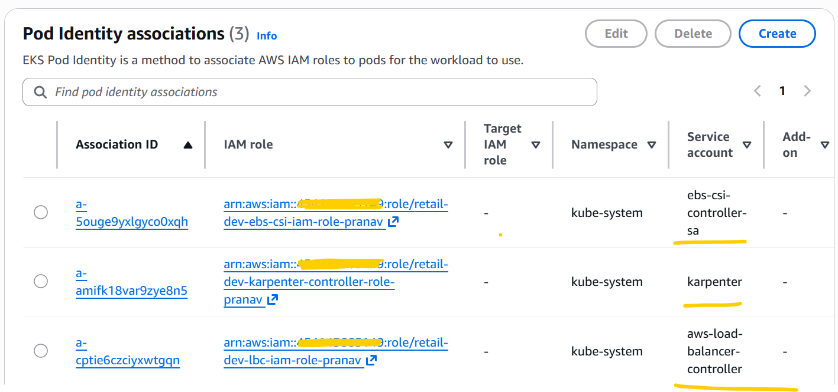

- Copy AWS Data plane terraform code as per from 22_05_2026 folder into 25_05_2026 this folder and run below terraform commands to deploy the AWS Data plane.
terraform init
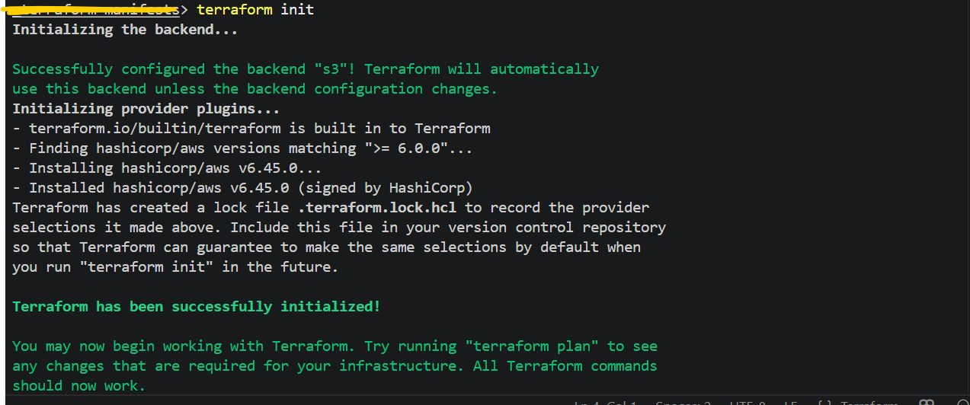
terraform validate
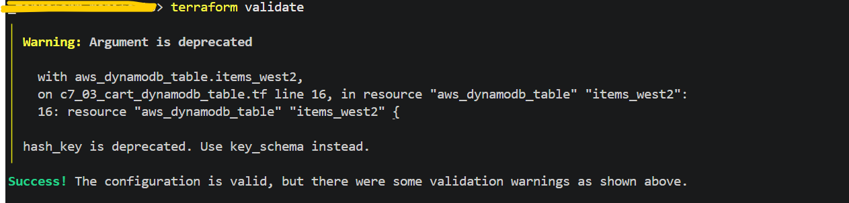
terraform plan
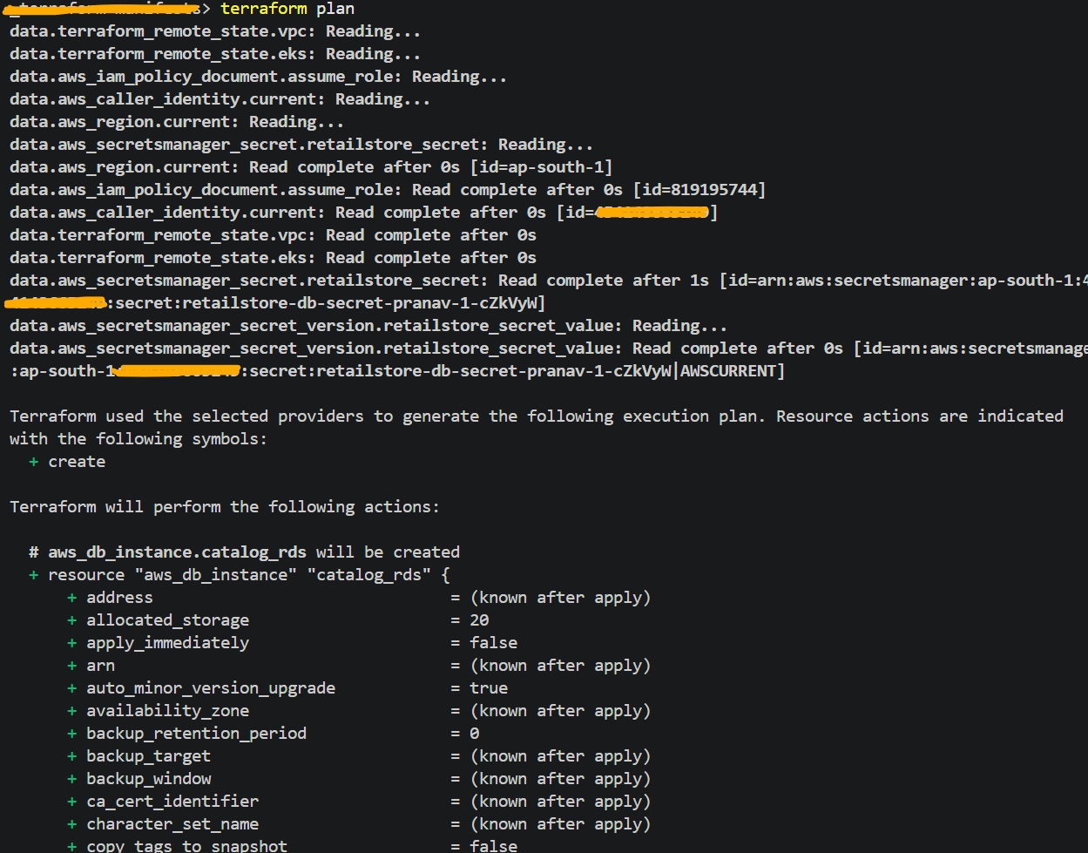
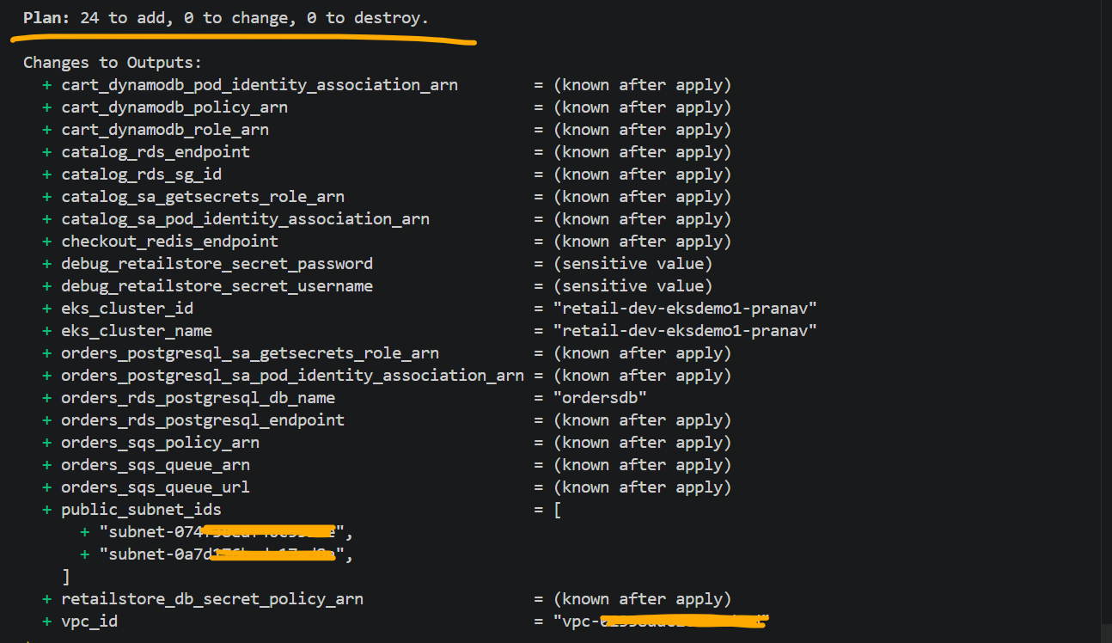
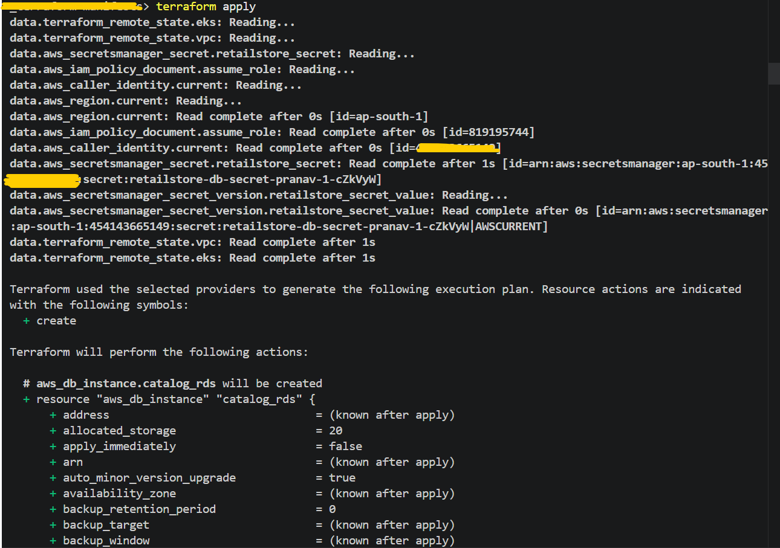
# AWS Data Plane related all the 24 resources are successfully deployed through terraform.
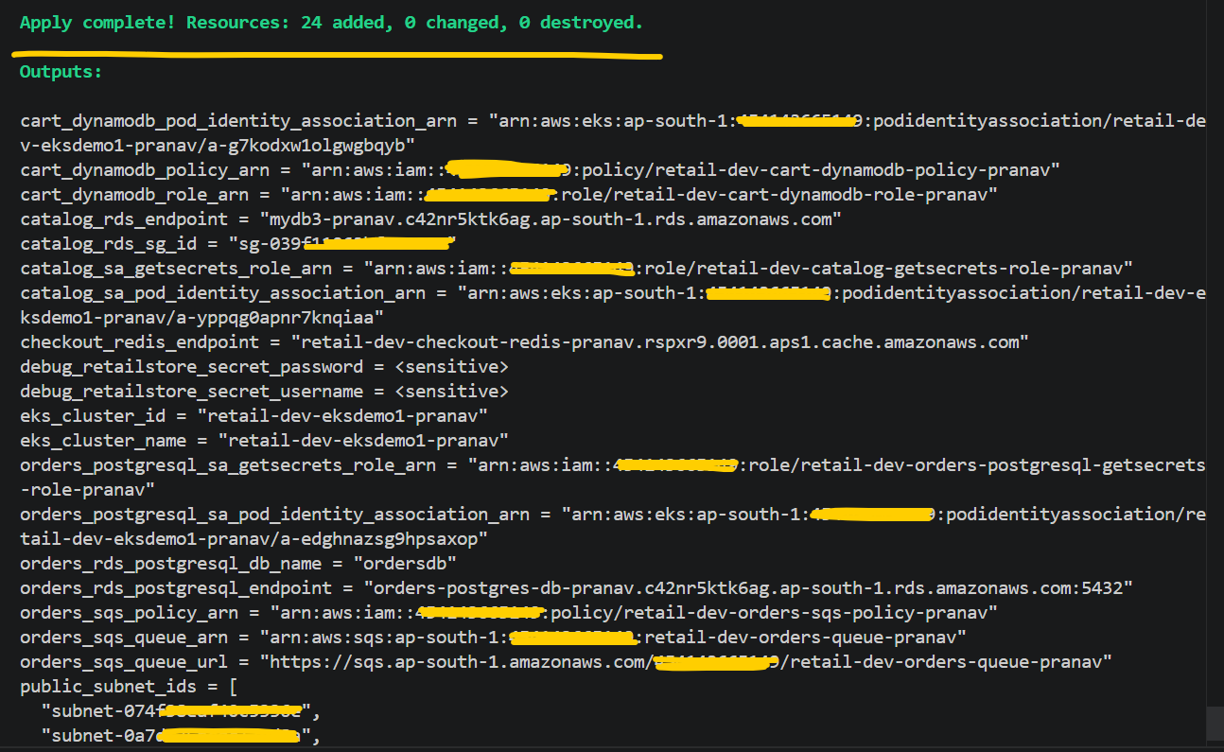

# Verify the AWS Data Plane resources from AWS Console.
Mysql and Postgresql RDS DB’s
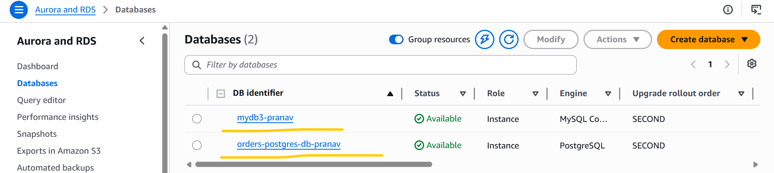

ElastiCache
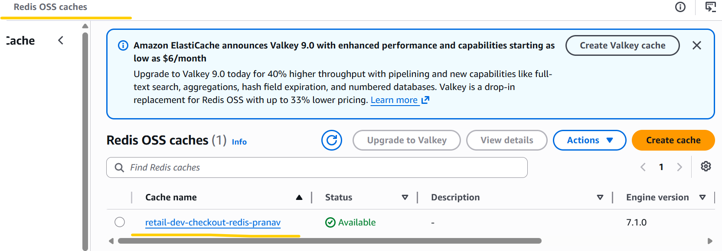
Dynamo DB Table
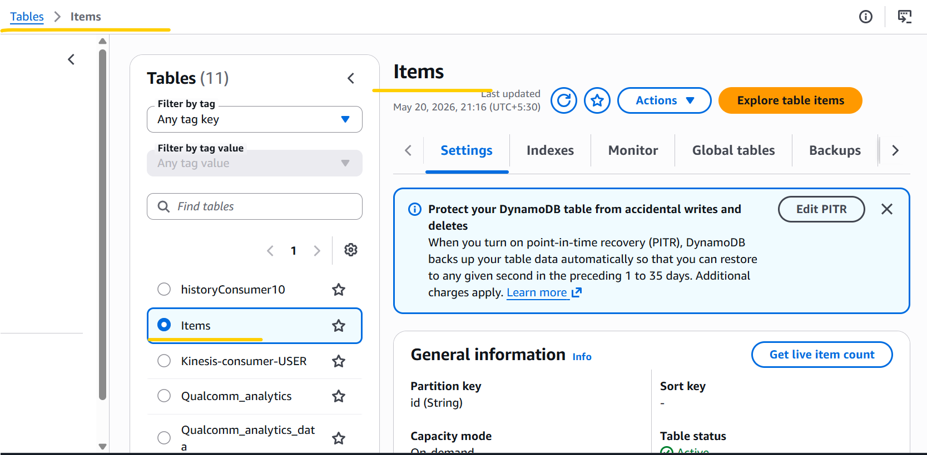

Amazon SQS
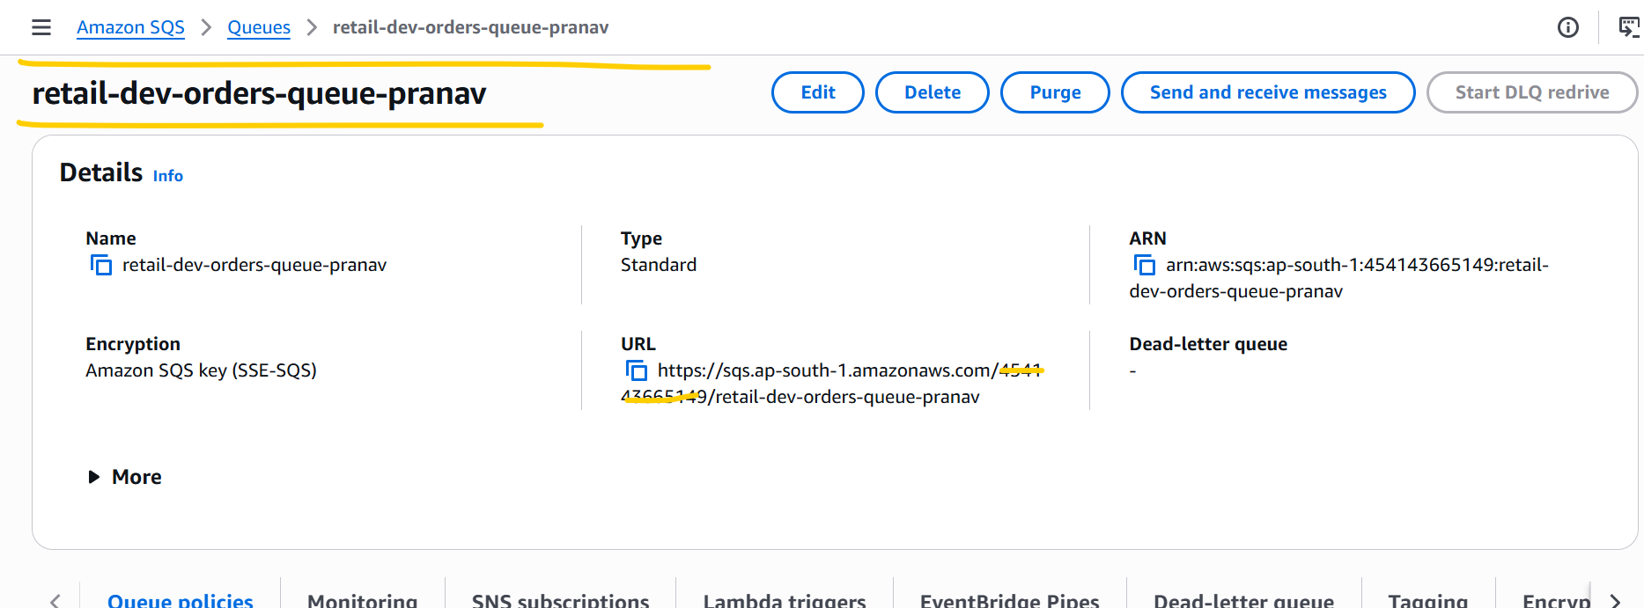

- Update RetailStore Application yaml manifest code as per requirements and deployed the same using below mentioned commands.

aws eks --region ap-south-1 update-kubeconfig --name retail-dev-eksdemo1-pranav

kubectl apply -f KARPENTER_k8s-manifests/
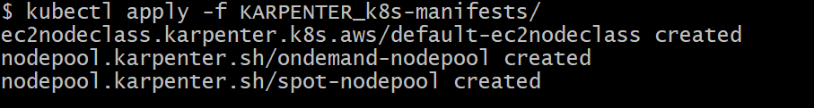

kubectl get ec2nodeclass
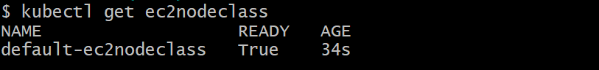

kubectl get nodepools
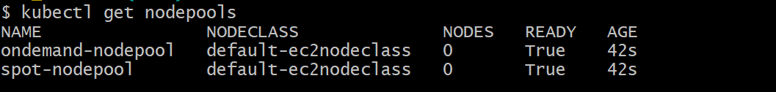

kubectl apply -f 01_secretproviderclass/
kubectl apply -f 04_RetailStore_k8s_manifests_with_Data_Plane_DoNotSchedule/03_ingress/

cd /04_RetailStore_k8s_manifests_with_Data_Plane_DoNotSchedule

kubectl apply -R -f 02_RetailStore_Microservices -f 04_HPA -f 05_PDB

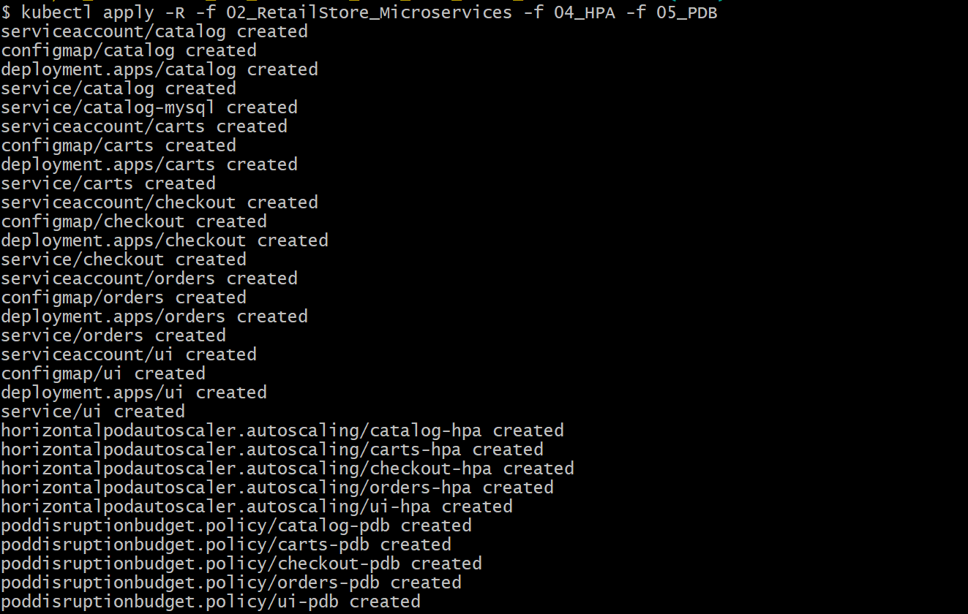

kubectl get pods

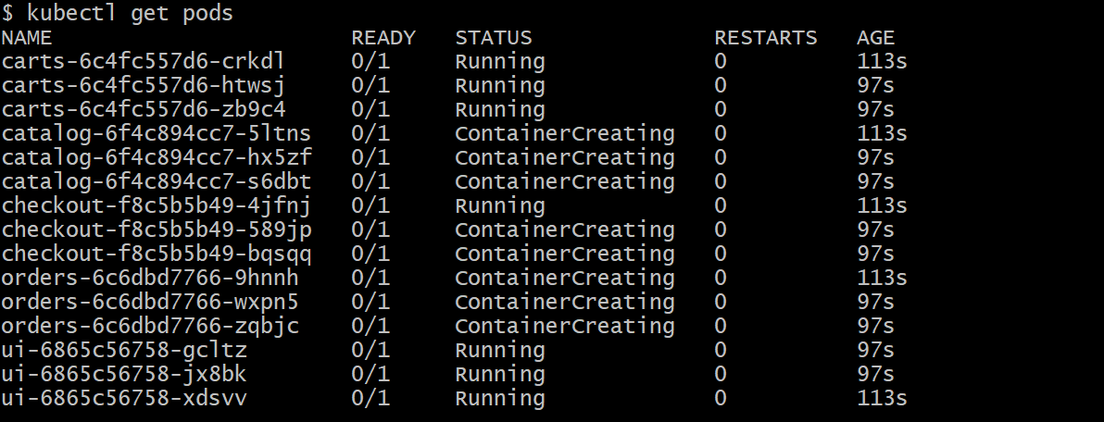

kubectl get nodeclaims

kubectl get pods

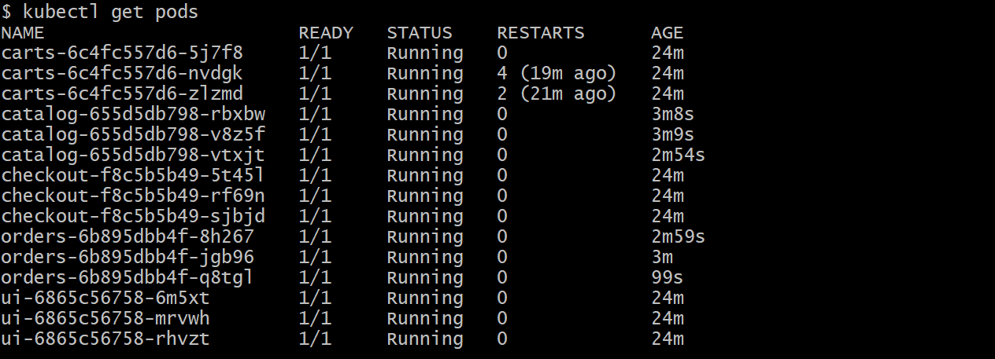

kubectl get ingress

kubectl get hpa

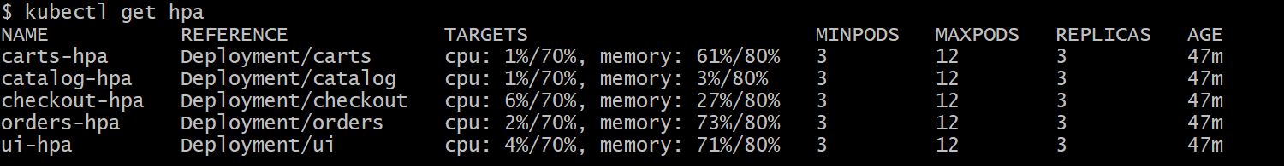

# I can be able to access ALB Link in my browser.

http://retail-store-http-ip-mode-pranav-1344508089.ap-south-1.elb.amazonaws.com/

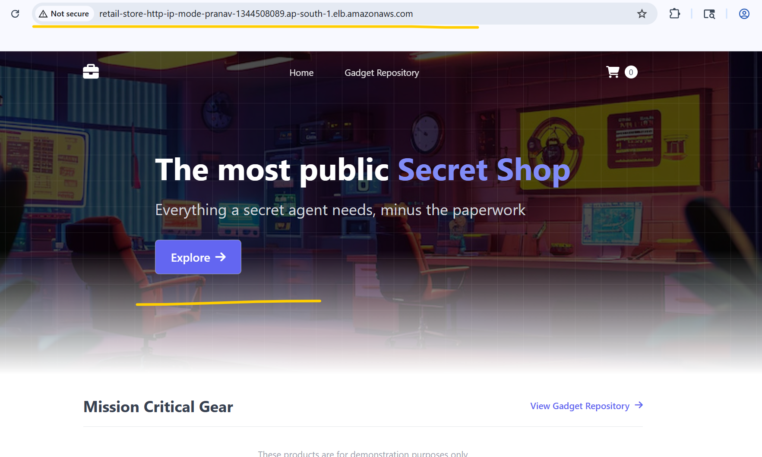

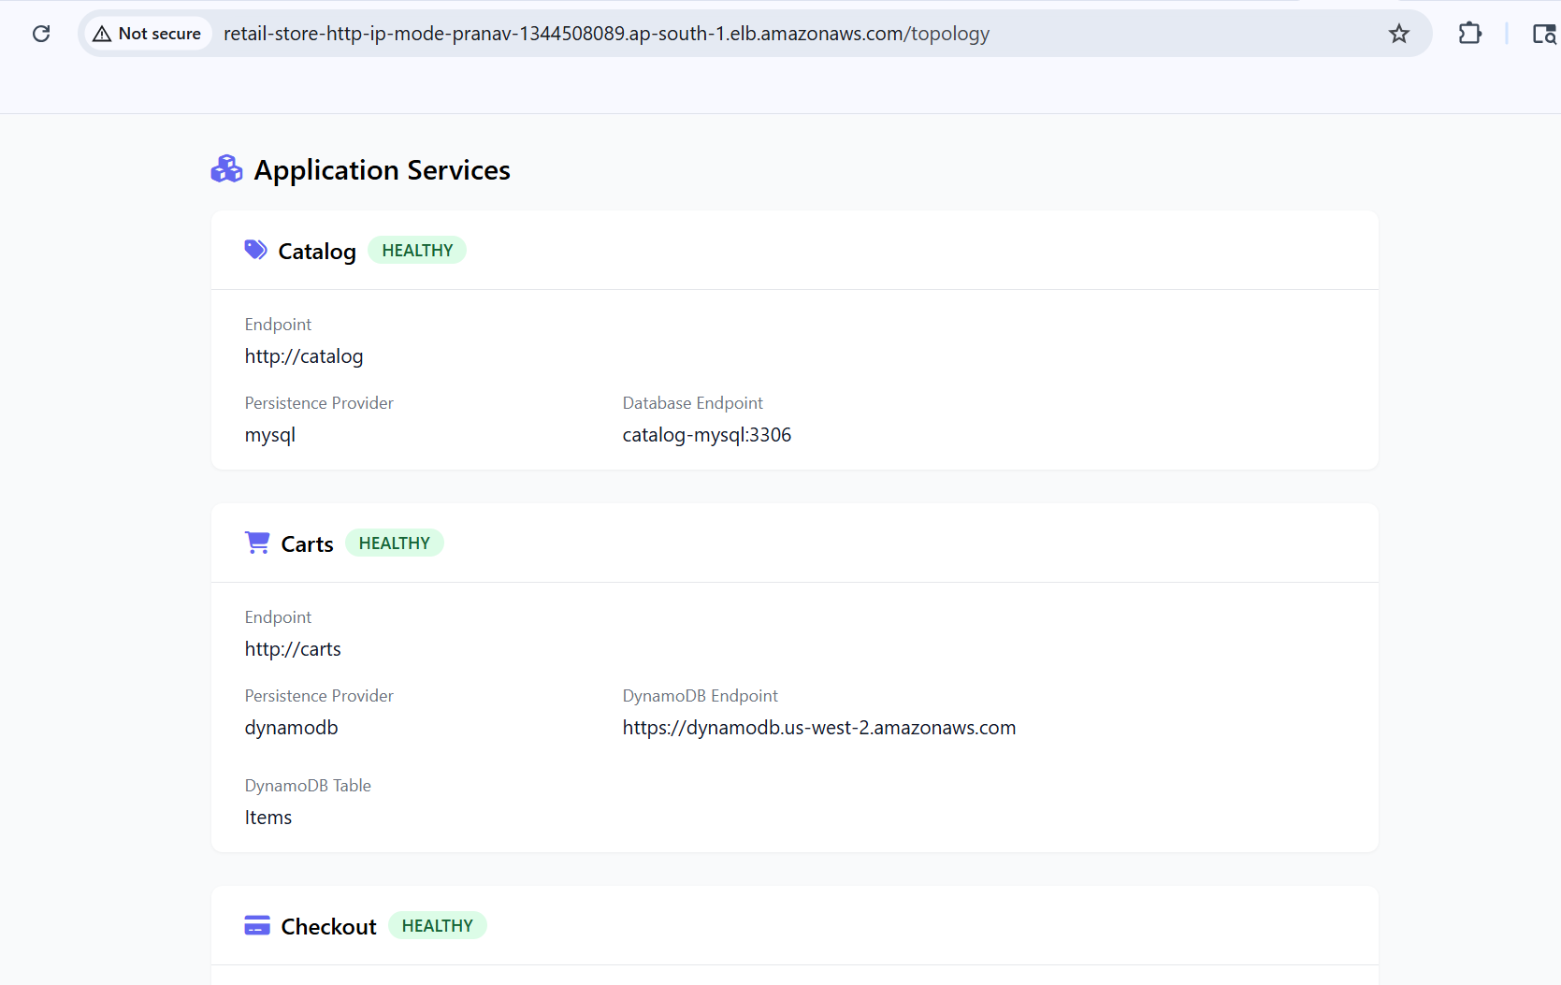
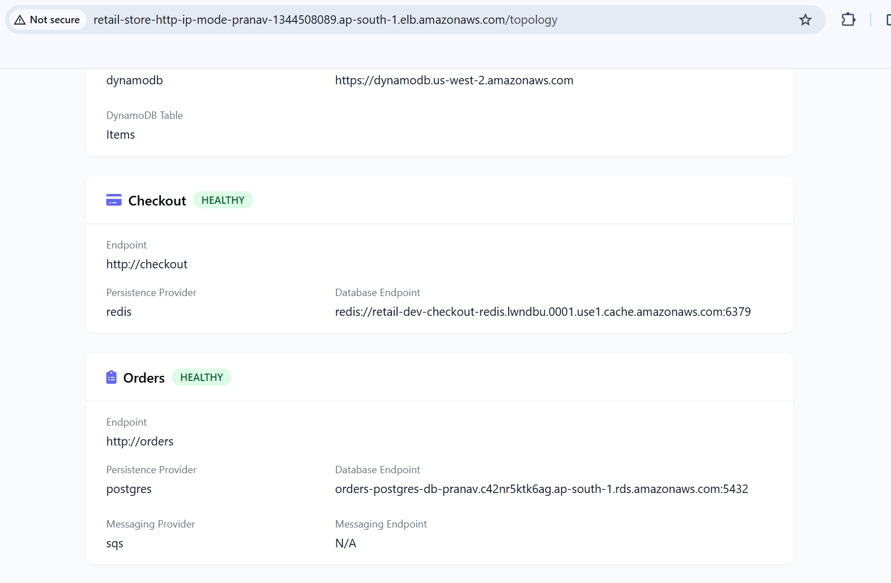

kubectl delete -R -f 02_RetailStore_Microservices -f 04_HPA -f 05_PDB

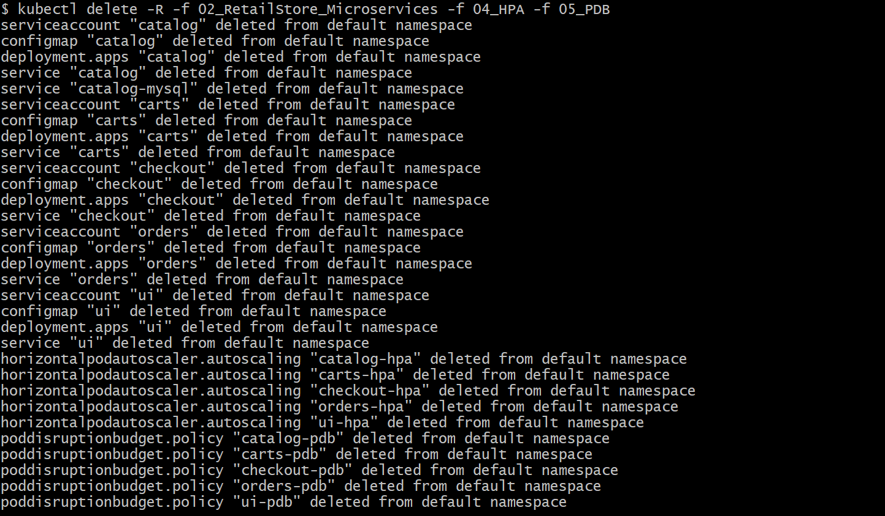

- Deleted AWS Data Plane Stack through terraform destroy –auto-approve command.

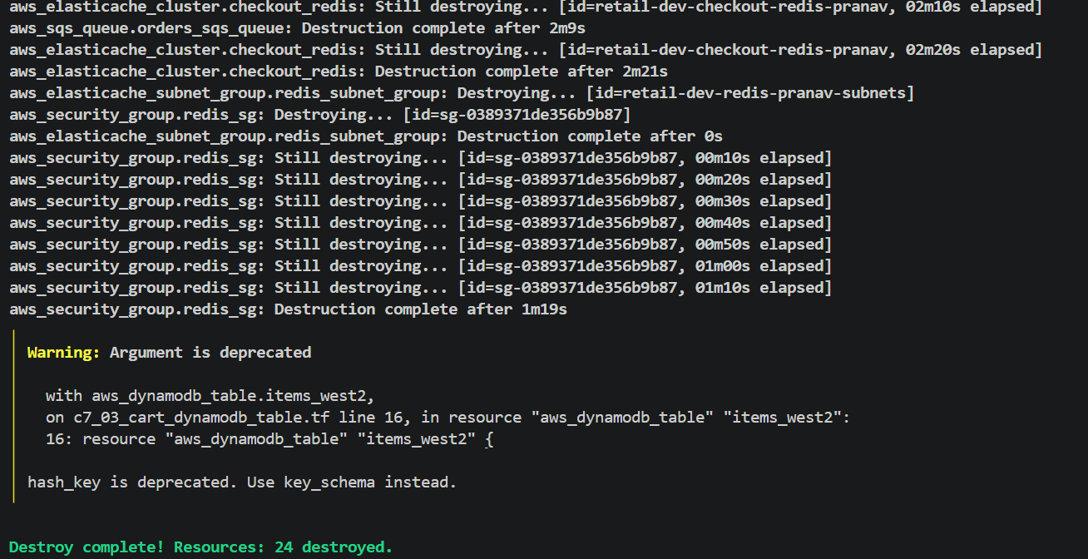

- Deleted EKS Cluster, Add ons, Node group, Iam roles for through terraform destroy –auto-approve command.

