Steps:-
- Verified my credentials or terraform profile using the following command:
aws sts get-caller-identity --profile <profile-name>
- Write the terraform code for this practical.
- Run terraform init command
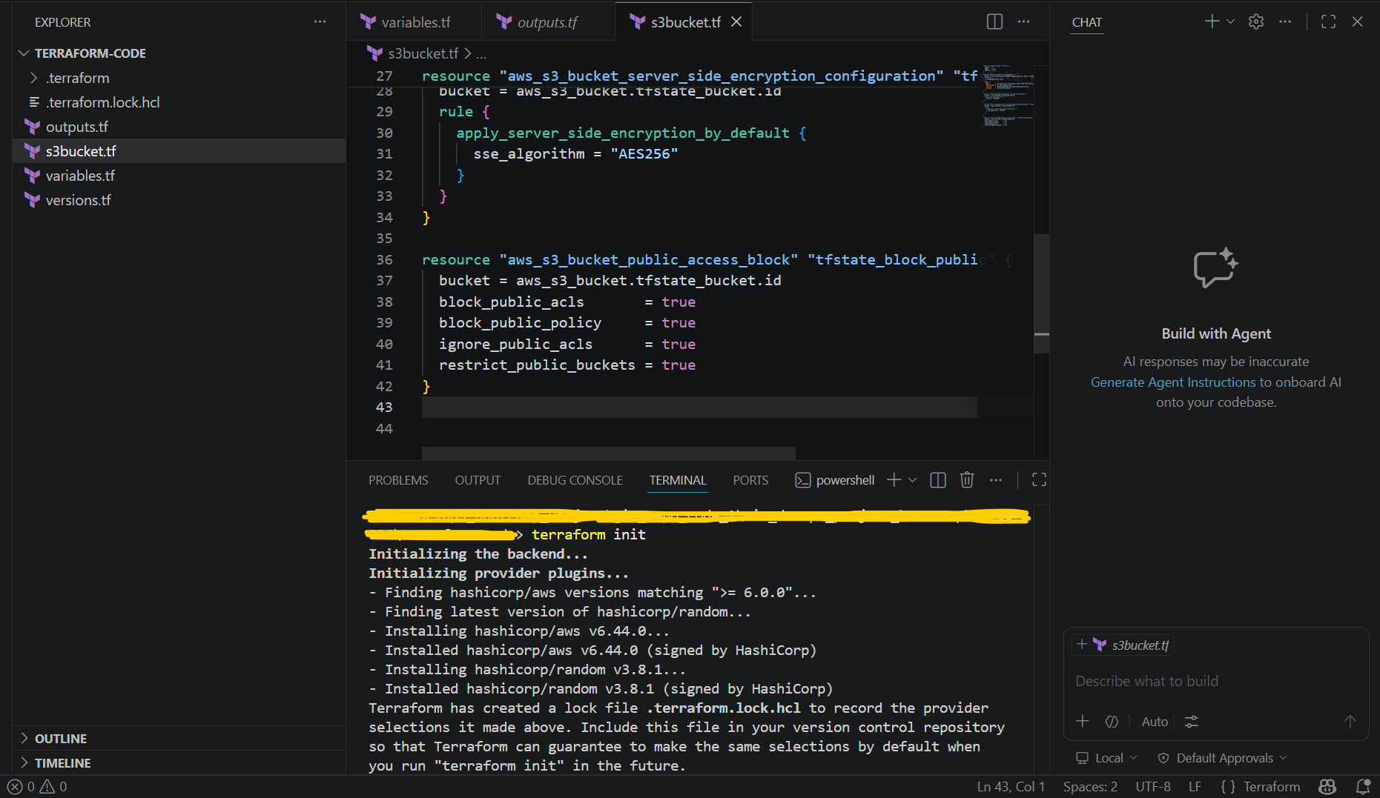

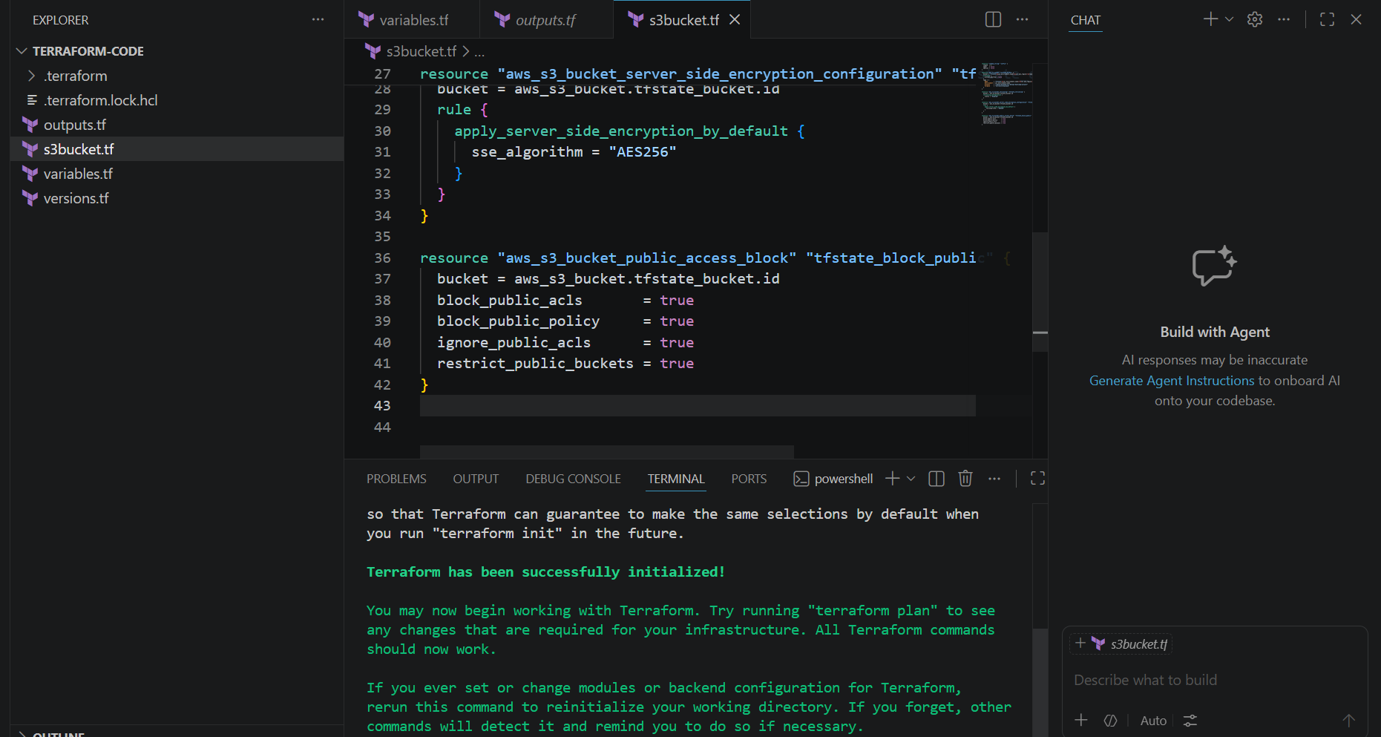
- Run terraform validate command
- Run terraform plan command
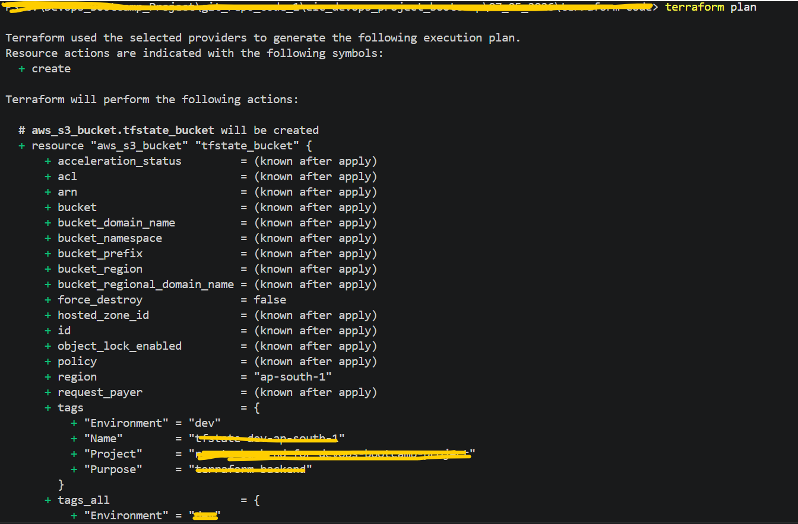
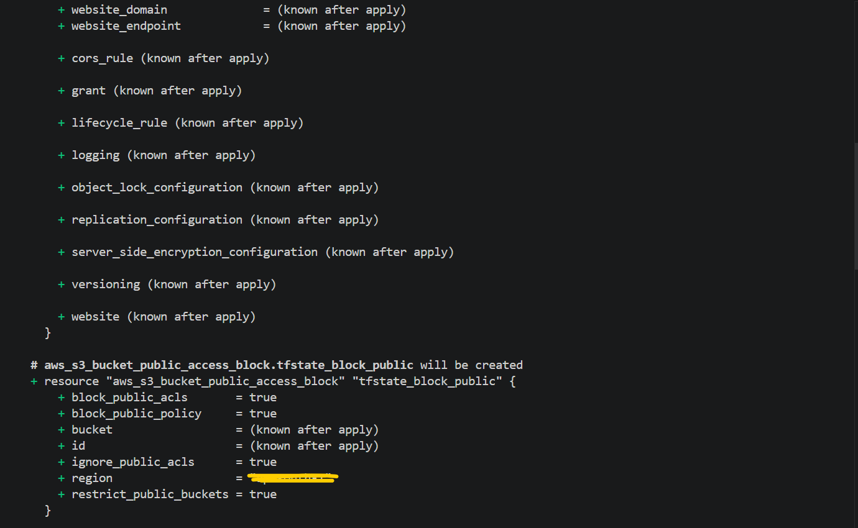

- Run terraform apply command
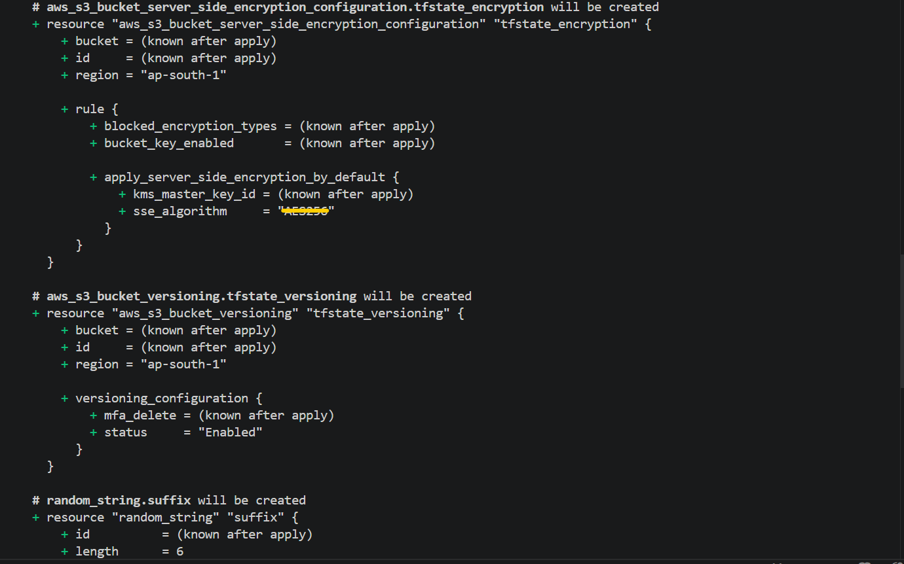

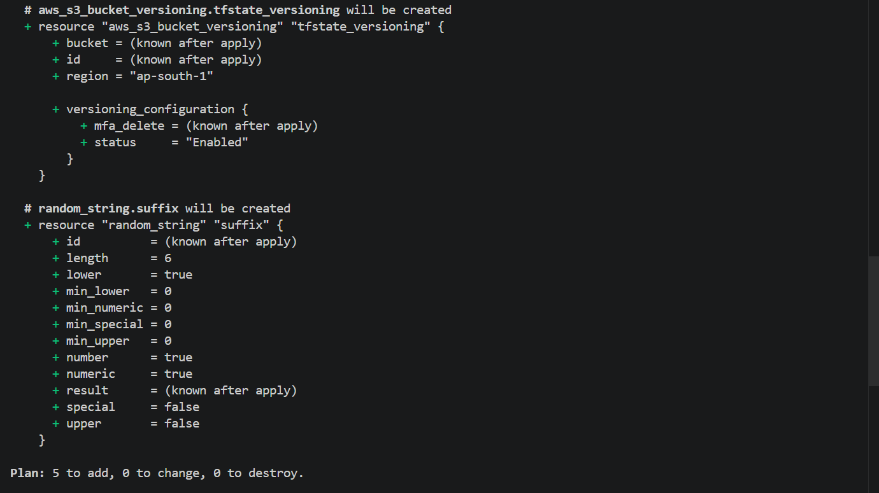

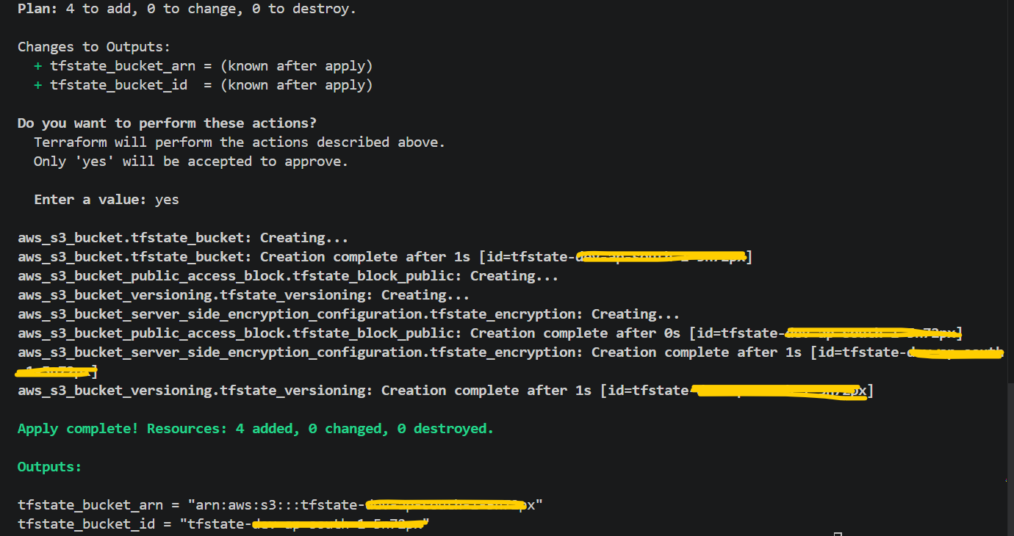
Note:- When I first ran the terraform apply command, I got a permission error for S3 bucket creation because my IAM user did not have the required S3 permissions assigned. Due to this, the terraform apply command was not successful, and only the random_string code block executed successfully during that run.
After that, I added the required S3 permissions to my IAM user and reran the terraform apply command. The second time, the command executed successfully, and the S3 bucket was created with the required configuration.
As I mentioned earlier, the random_string code block had already executed successfully during the previous terraform apply command. Because of that, in the last screenshot only 4 resources were added instead of 5 resources. However, in the previous screenshot, it was showing that 5 resources would be added.

