Steps:-
- Created EKS Cluster, Node group and require Iam roles for the same through terraform. To do the same copy terraform code from 11_05_2026 folder into 12_05_2026.

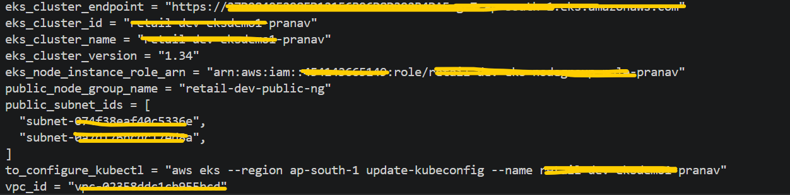

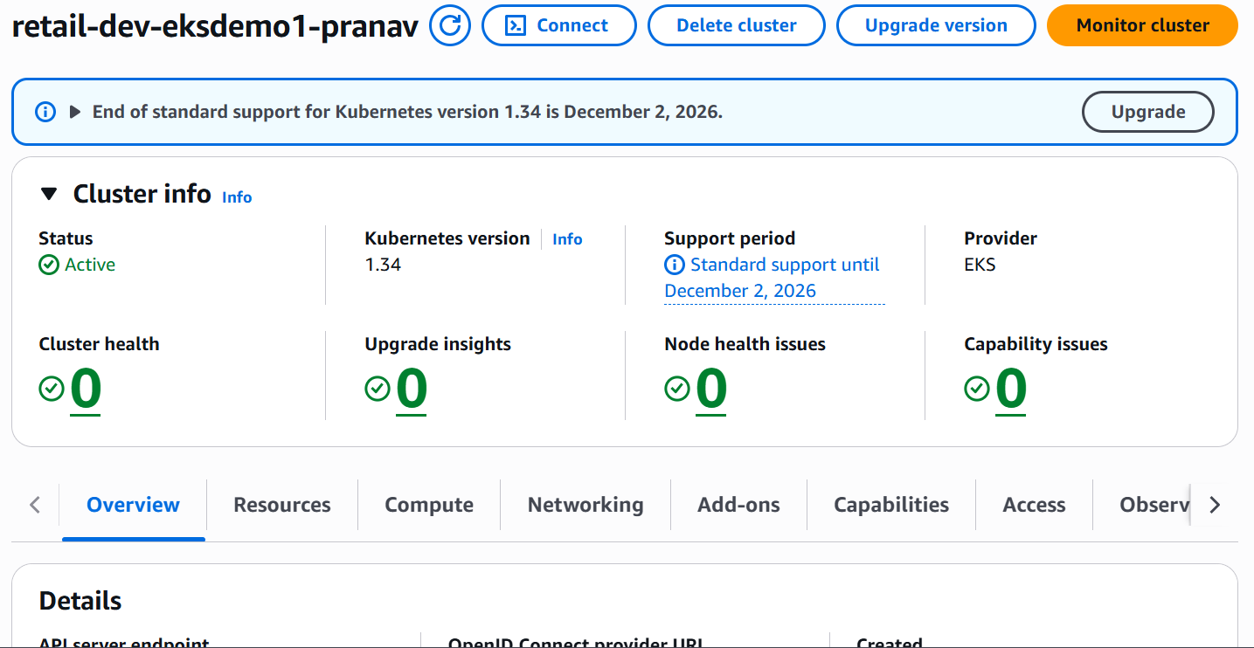

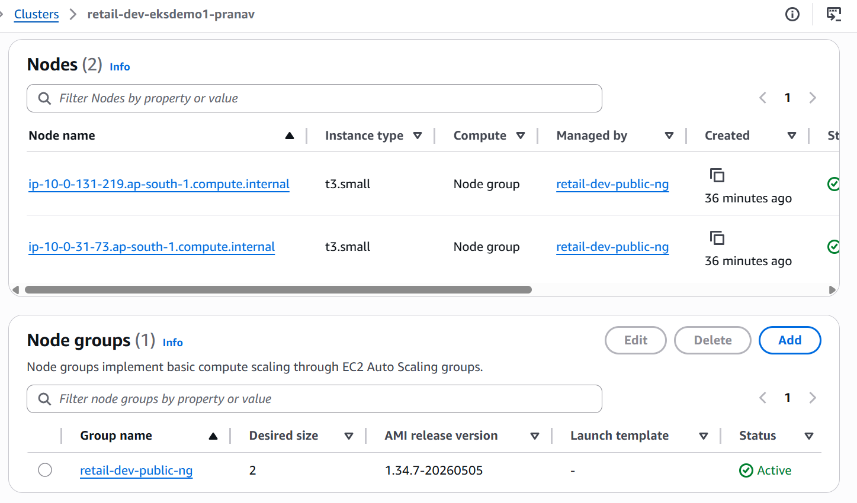

- Run below command to access EKS Cluster from my system / laptop.
aws eks --region ap-south-1 update-kubeconfig --name retail-dev-eksdemo1-pranav
- Run below commands one by one.
(Note:- Through kubectl apply -f catalog_k8s_manifests/ this command deployed deployment, cluster ip service, config map, stateful set, headless service.)

kubectl get nodes

kubectl get pods

kubectl apply -f catalog_k8s_manifests/

kubectl get deploy

kubectl get rs

kubectl get cm
kubectl get sts

kubectl get svc

kubectl get pods

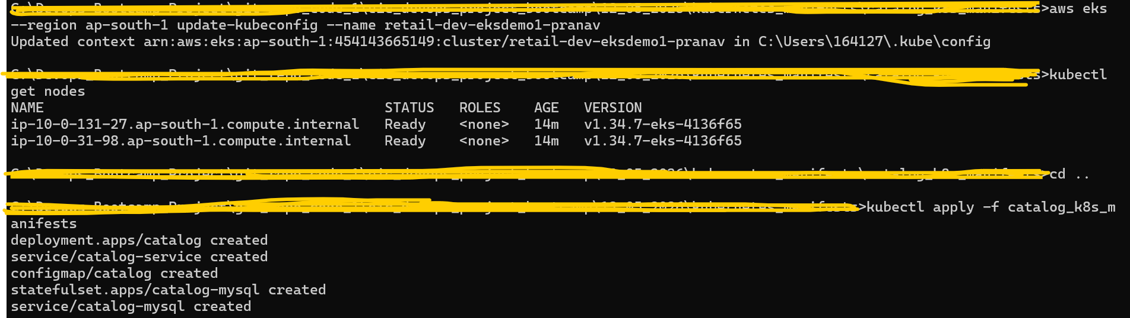

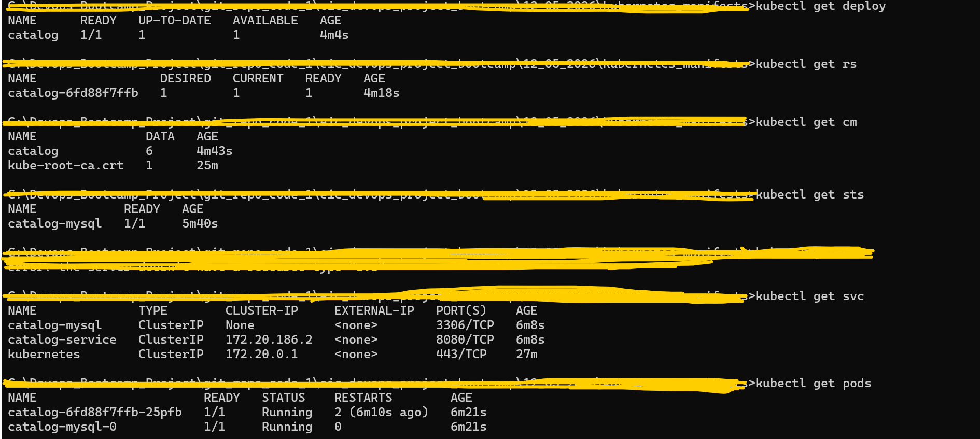

- kubectl get pods -o wide

- kubectl logs -f deploy/catalog

- kubectl port-forward svc/catalog-service 7080:8080

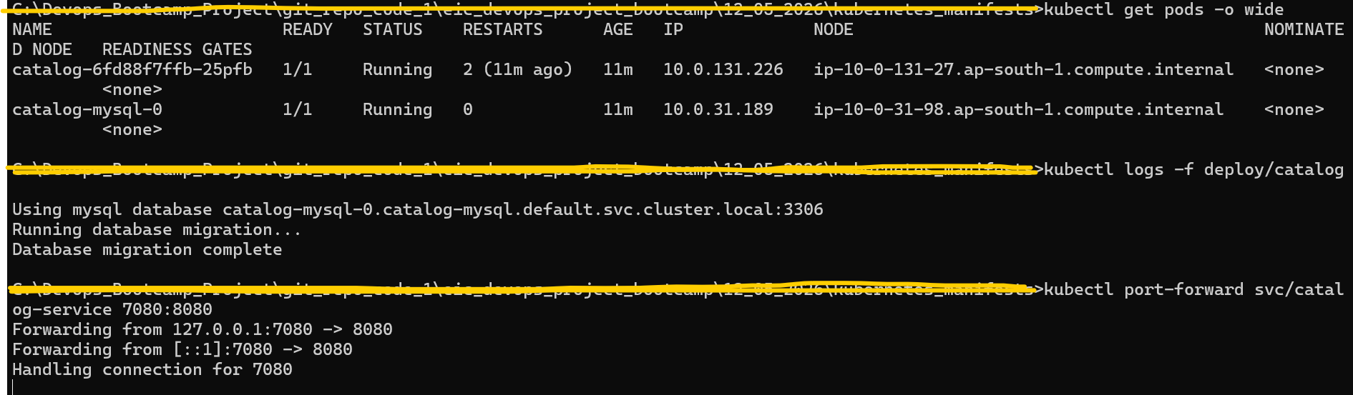

- Access below mentioned url’s from my system/laptop browser. I can be able to access those url’s successfully from my system/laptop browser.

Url:- http://localhost:7080/topology

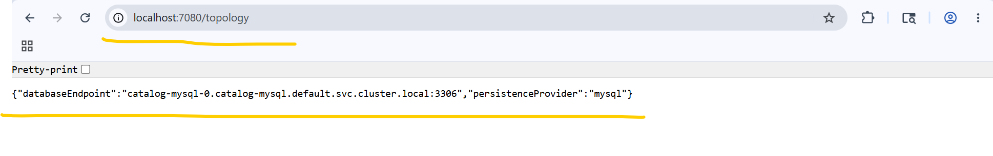
Url:- http://localhost:7080/products

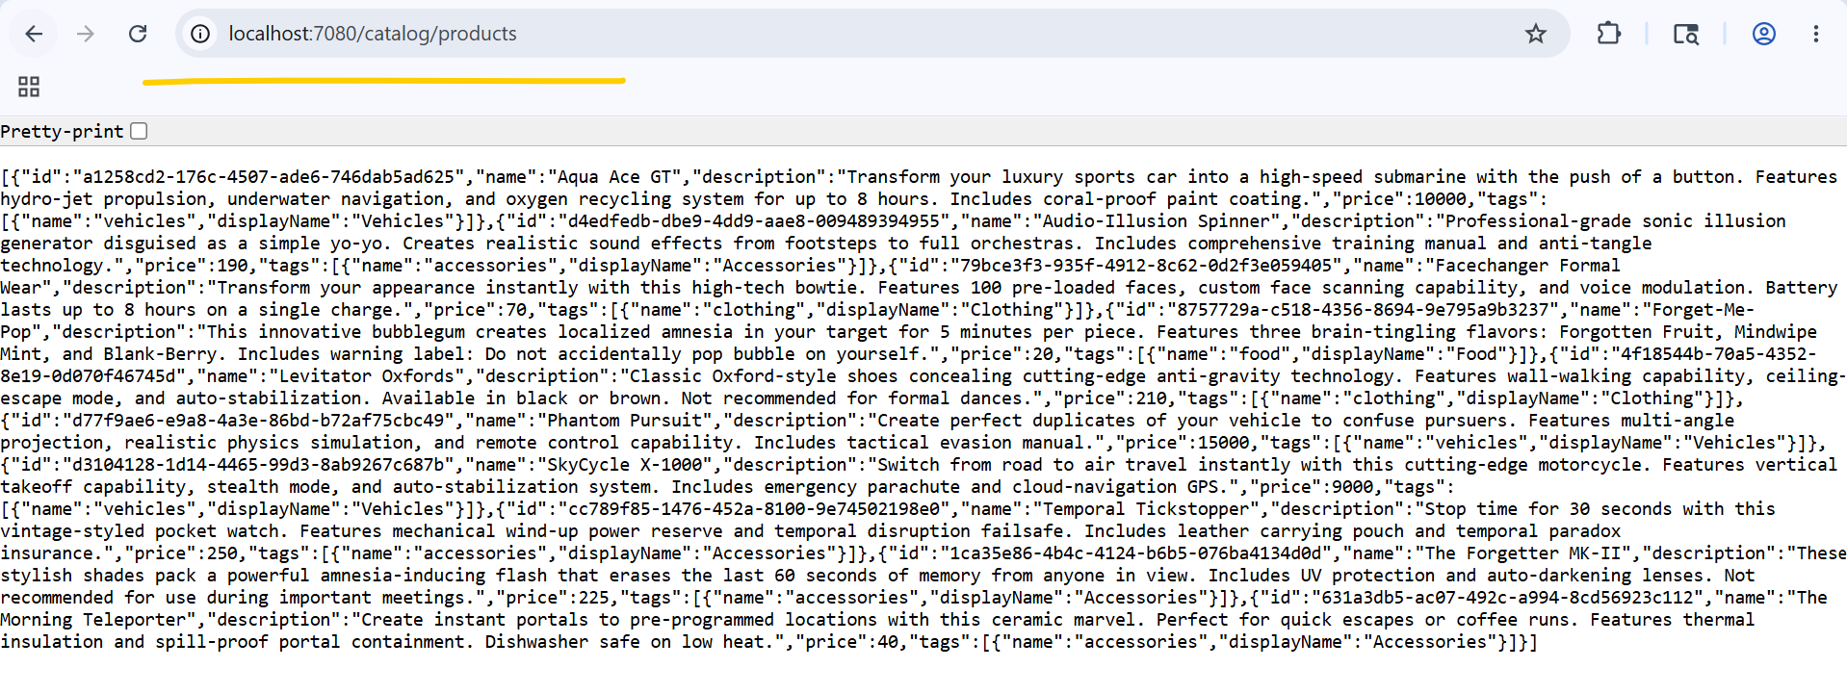
- kubectl scale statefulset catalog-mysql --replicas=3
kubectl get pods -w

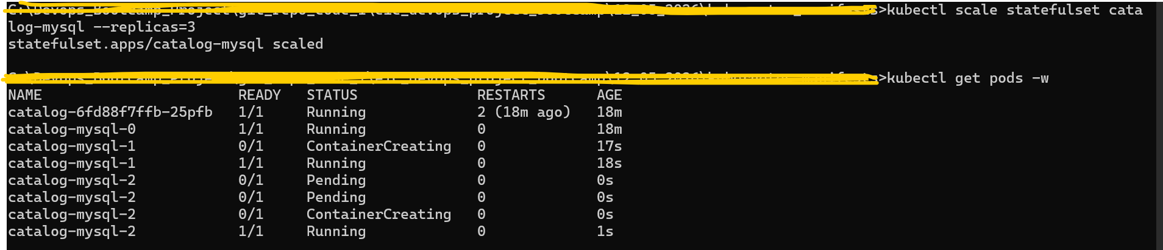

- kubectl scale statefulset catalog-mysql --replicas=1
kubectl get pods -w
kubectl get pods
kubectl delete pod catalog-mysql-0
kubectl get pods

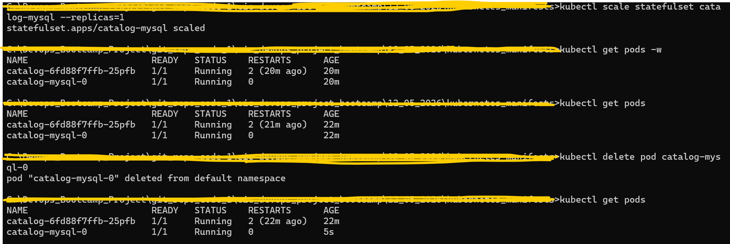

- kubectl run mysql-client --rm -it \
--image=mysql:8.0 \
--restart=Never \
-- mysql -h catalog-mysql -u catalog_user -p
Note:- During password prompted, enter the db password.

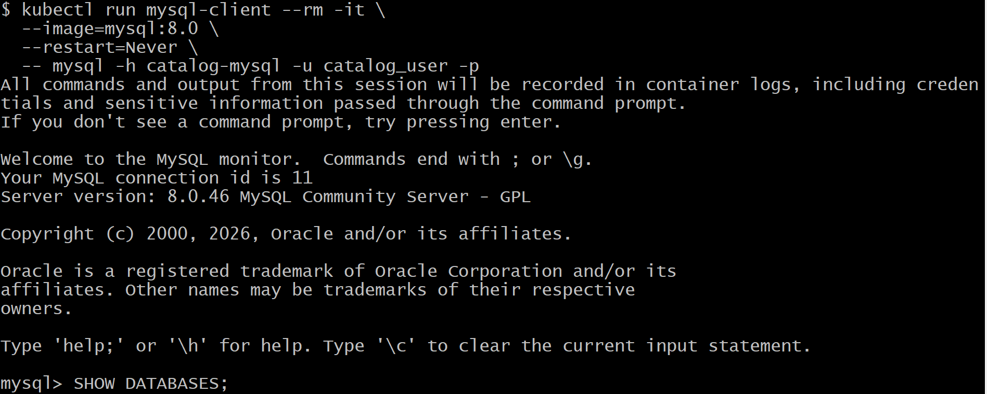

- Run below commands in Mysql console.

SHOW DATABASES;
USE catalogdb;
SELECT * FROM products;
SHOW TABLES;

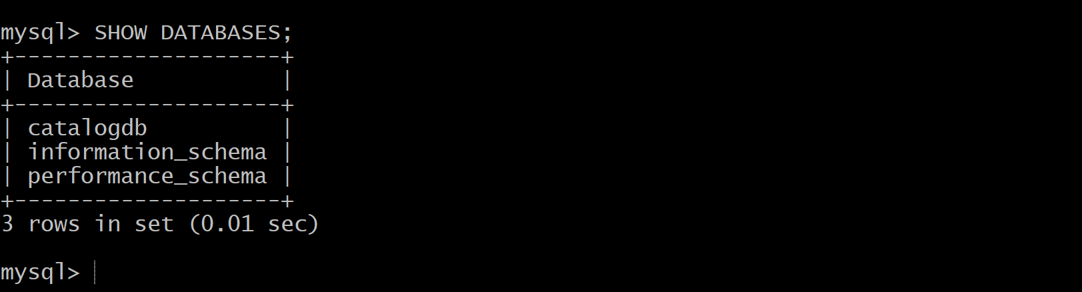

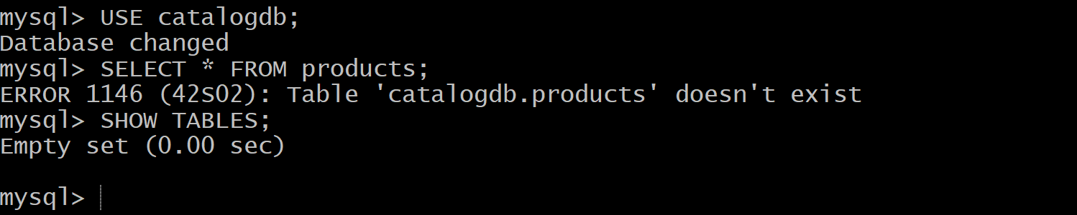

(Note:- For the SELECT * FROM products; command, I was getting an error stating that the catalogdb.products table does not exist. This error occurred because the database migration had already been completed, due to which the database did not contain the required data.
To resolve this issue, I deleted the catalog-mysql-0 pod using the kubectl delete pod catalog-mysql-0 command. After that, the StatefulSet recreated a new pod for catalog-mysql. Apart from that, I also ran the kubectl rollout restart deploy/catalog command to restart all pods of the catalog Deployment.
I executed these kubectl commands in the next steps.)

- kubectl delete pod catalog-mysql-0
kubectl rollout restart deploy/catalog

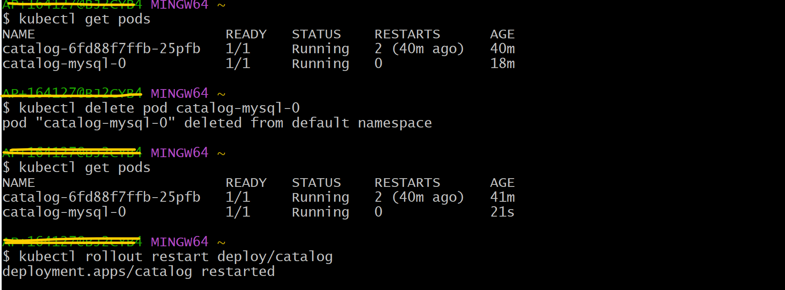

- kubectl run mysql-client --rm -it \
--image=mysql:8.0 \
--restart=Never \
-- mysql -h catalog-mysql -u catalog_user -p
Note:- During password prompted, enter the db password.

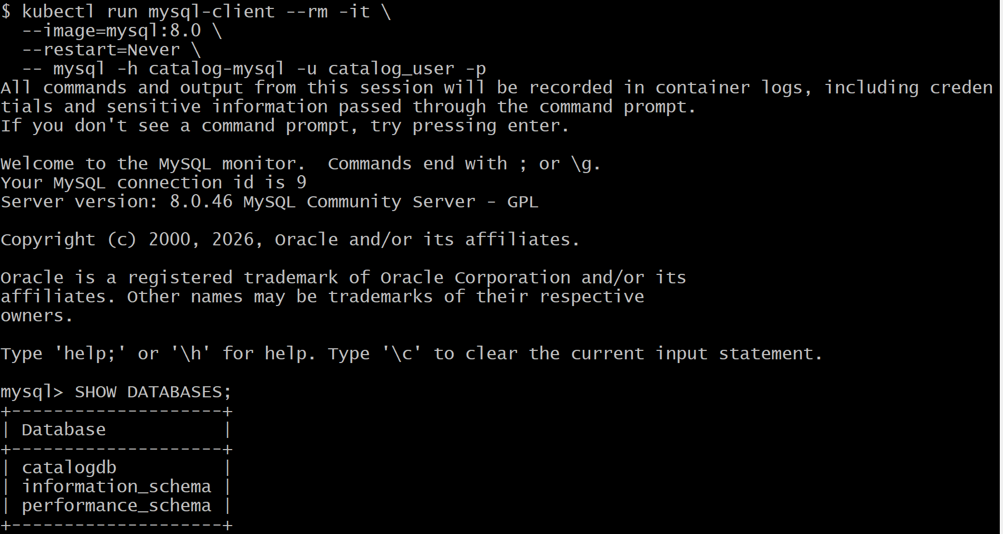

- Run below commands in Mysql console.
(Note:- This time, I did not get any errors for the SELECT * FROM products; command or any other SQL commands. All SQL commands ran successfully.)

SHOW DATABASES;
USE catalogdb;
SHOW TABLES;
SELECT * FROM products;
SELECT * FROM tags;
SELECT * FROM product_tags;
EXIT;

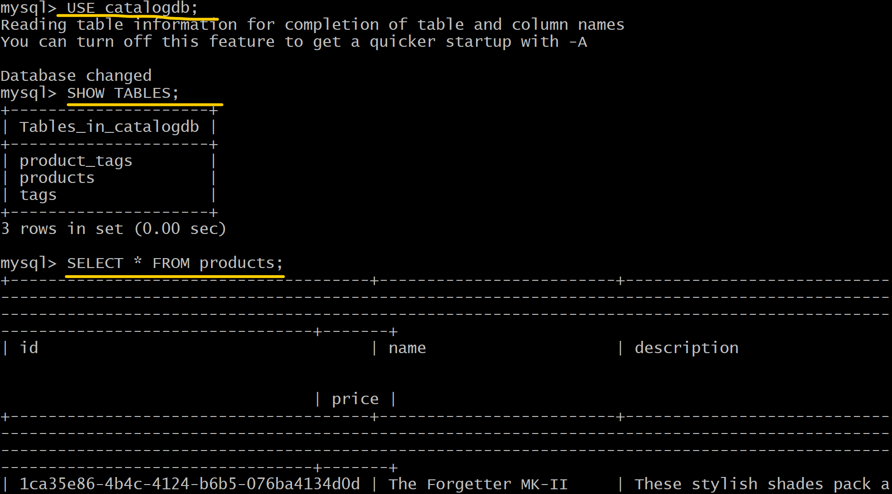

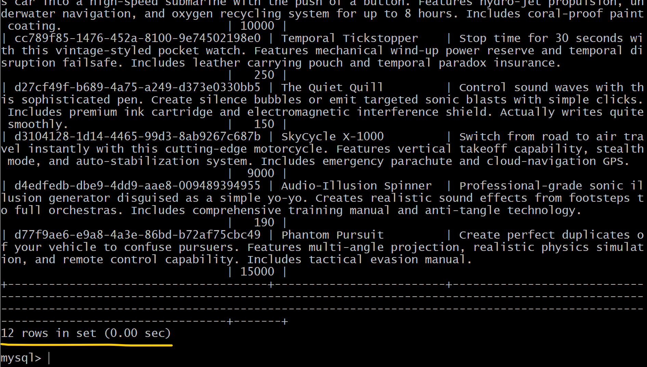

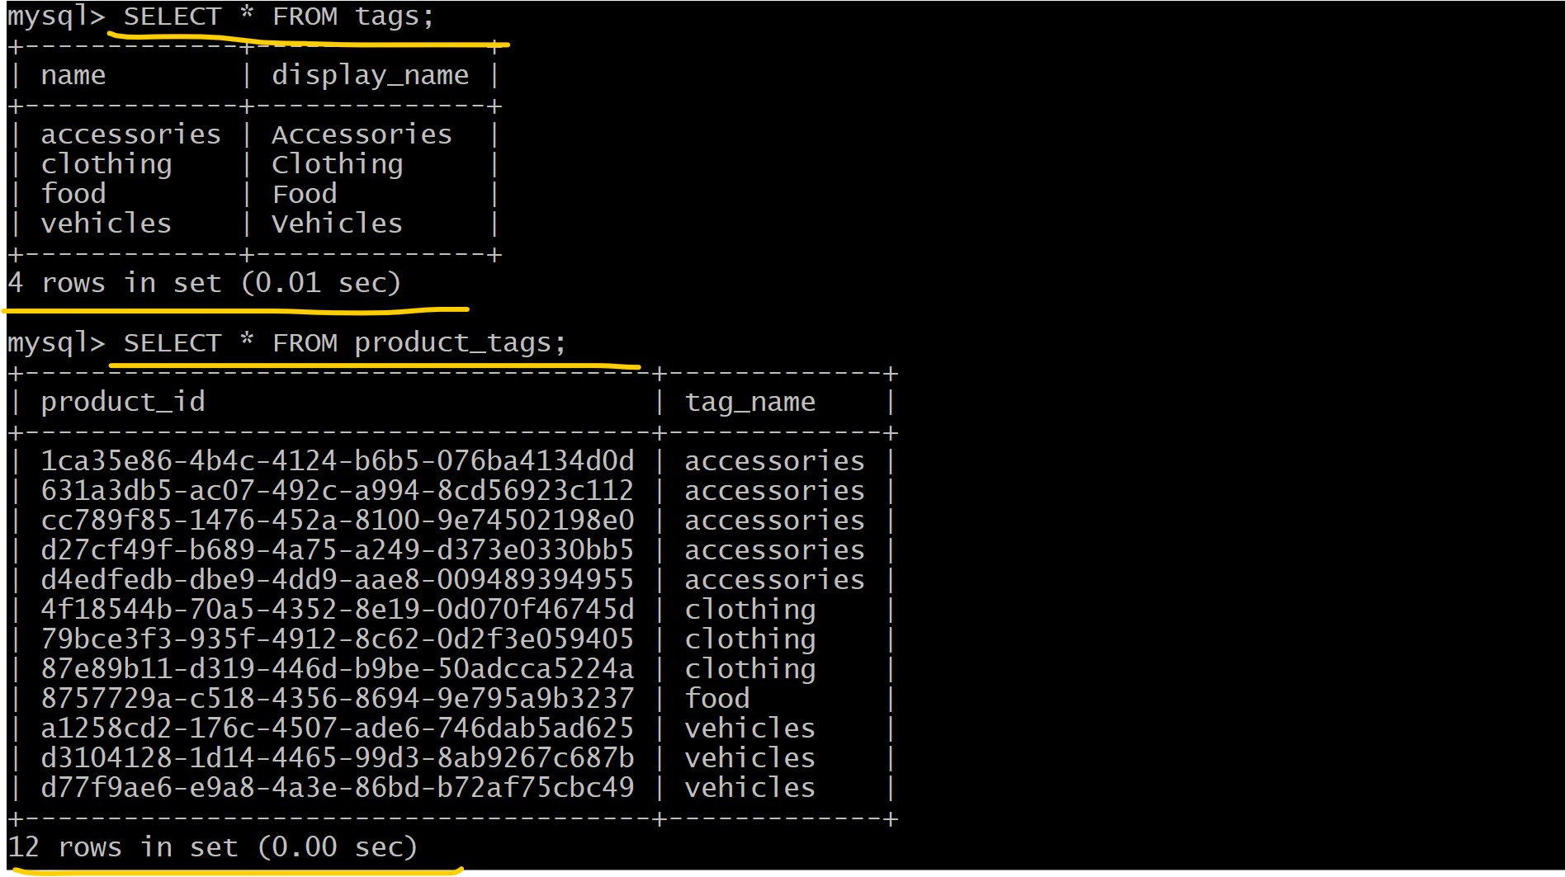

- Run kubectl delete -f catalog_k8s_manifests/ this command to delete deployment, cluster ip service, config map, stateful set, headless service.

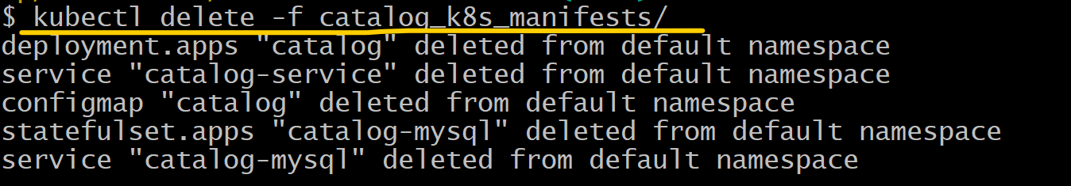

- Deleted EKS Cluster, Node group and Iam roles for through terraform destroy command.

