Steps:-
- Created EKS Cluster, Node group and require Iam roles for the same through terraform. To do the same copy terraform code from 15_05_2026 folder into 18_05_2026.

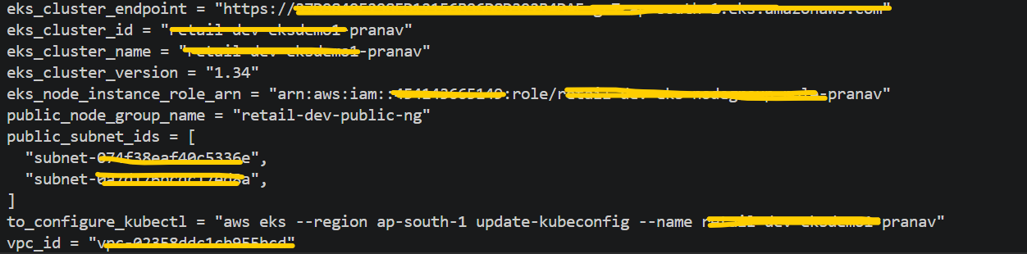

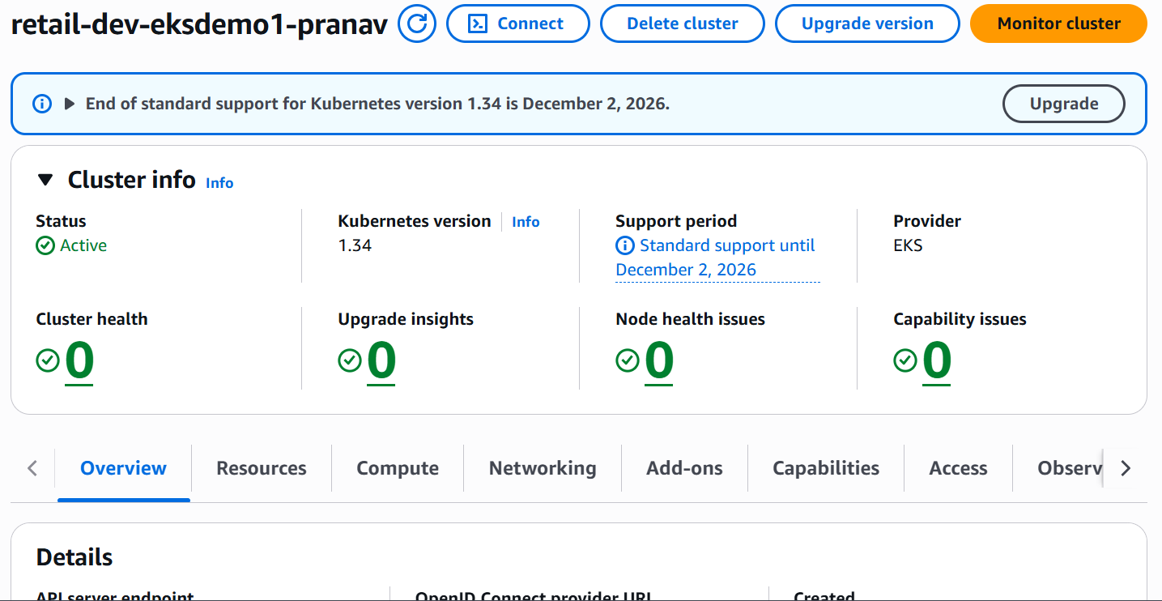

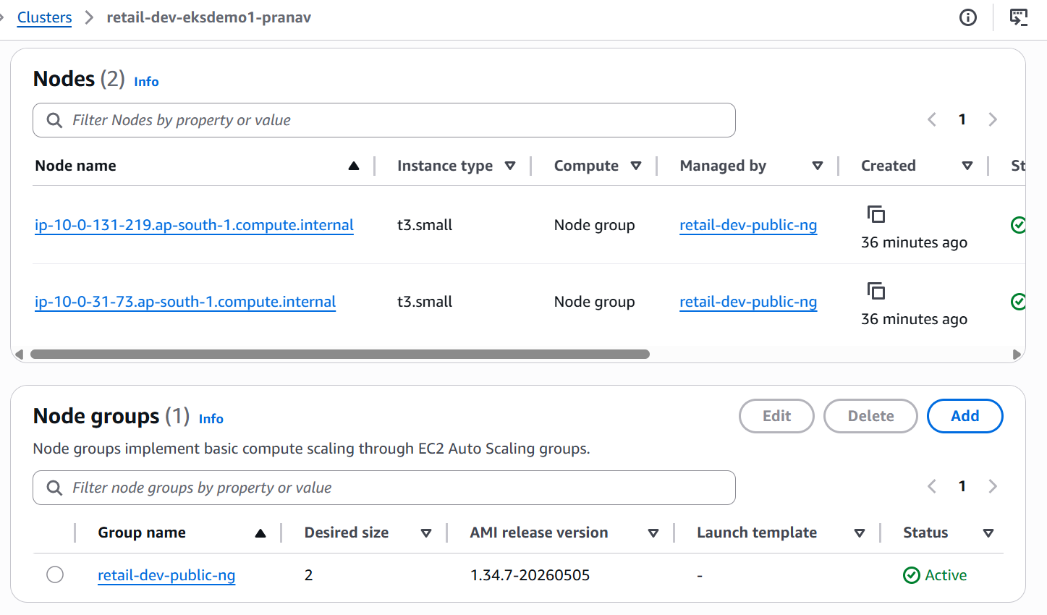

- Add below Add on in EKS Cluster.
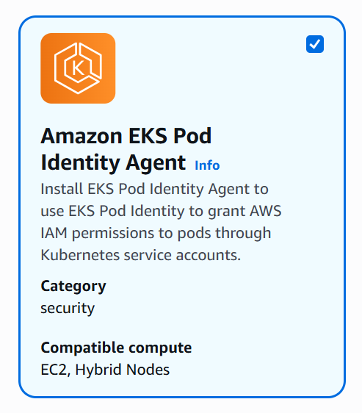

- Run below mentioned commands.
# Configure your local kubectl so it can connect to your AWS EKS cluster.
aws eks --region ap-south-1 update-kubeconfig --name retail-dev-eksdemo1-pranav

# Navigate to respective path through CD command.
cd kubernetes_manifests/12-04-Helm-Package-and-Publish/charts
# Pull the UI chart from ECR Public (OCI) and unpack it
helm pull oci://public.ecr.aws/aws-containers/retail-store-sample-ui-chart \
--version 1.3.0 \
--untar
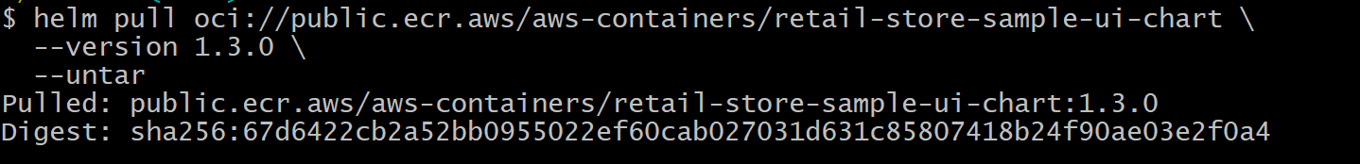
ll
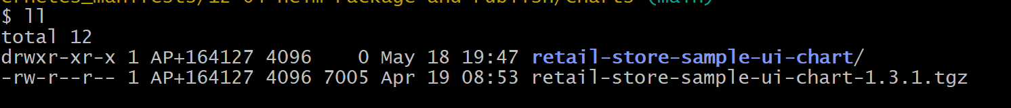
mv retail-store-sample-ui-chart ui
ll
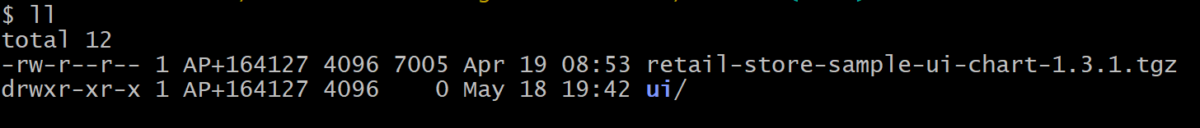
Edit `Chart.yaml` inside your chart (`ui/`)
# Bump version i.e. Chart version from 1.3.0 to 1.3.1
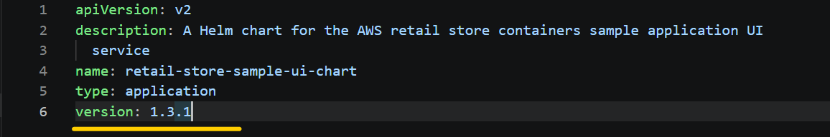
# Set Variables
REGION=ap-south-1
ACCOUNT_ID=$(aws sts get-caller-identity --query Account --output text)
REGISTRY="${ACCOUNT_ID}.dkr.ecr.${REGION}.amazonaws.com"

# Verify Variables
echo $REGION
echo $ACCOUNT_ID
echo $REGISTRY

# Login to ECR for Helm/OCI
aws ecr get-login-password --region "$REGION" \
| helm registry login -u AWS --password-stdin "$REGISTRY"

# Create flat repo (exactly chart name)
aws ecr create-repository \
--repository-name retail-store-sample-ui-chart-pranav \
--region "$REGION" || true
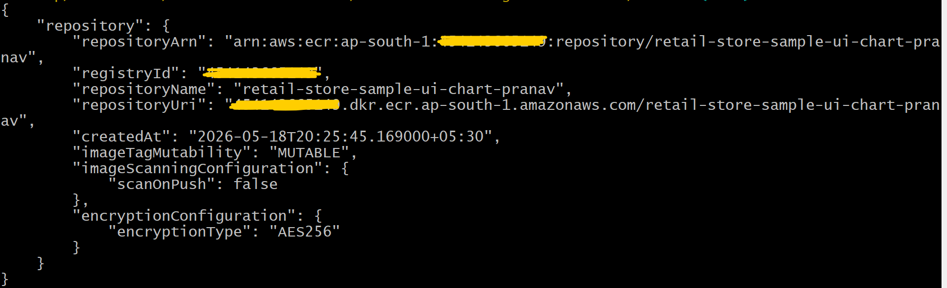
# After ECR repo creation, verified the same from AWS Console from ECR section.
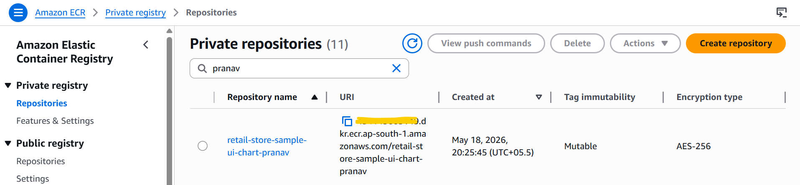
# Package chart (matches Chart.yaml)
helm package ./ui

# While pushing the Helm chart to my ECR repository, I encountered the following error. This happened because I created my ECR repository with the name retail-store-sample-ui-chart-pranav instead of retail-store-sample-ui-chart. The repository named retail-store-sample-ui-chart had already been created by someone else, so I created my repository with the name retail-store-sample-ui-chart-pranav due to that reason I was getting below mentioned error.
# To resolve this issue, I have Rename chart name in Chart.yaml as per below and deleted retail-store-sample-ui-chart-1.3.1.tgz this existing helm chart zip file and package chart again after that I pushed that helm chart into my ECR repo.
# Rename chart name in Chart.yaml from retail-store-sample-ui-chart to retail-store-sample-ui-chart-pranav this.
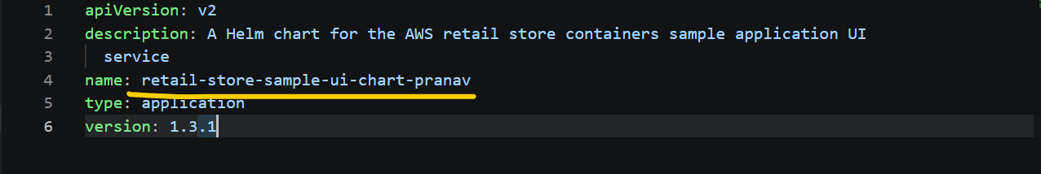
rm -rf retail-store-sample-ui-chart-1.3.1.tgz
helm package ./ui
# Now this time, my helm chart has been successfully pushed into my ECR repo.
helm push retail-store-sample-ui-chart-pranav-1.3.1.tgz oci://"$REGISTRY"
# Verified the same through aws cli as well as from AWS Console from ECR section.
$ aws ecr describe-images \
--repository-name retail-store-sample-ui-chart-pranav \
--region "$REGION" \
--query 'imageDetails[].imageTags'
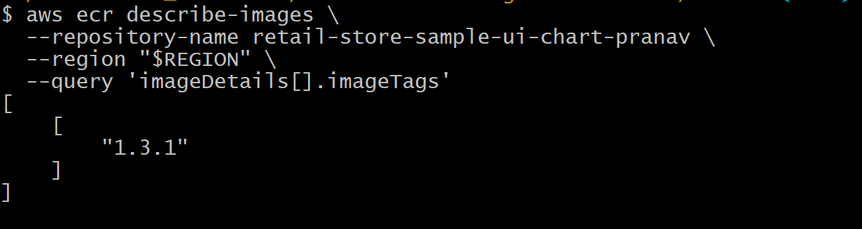

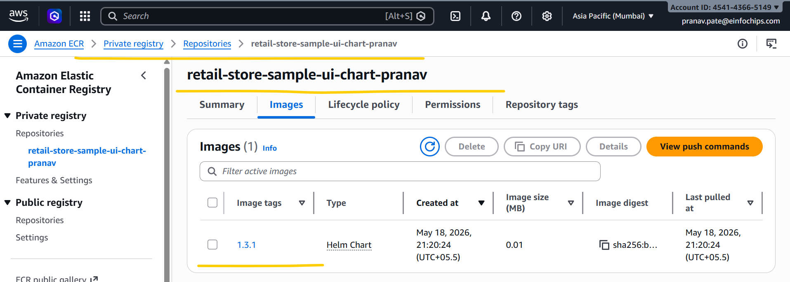
# Helm install
helm install retail-ui \
oci://"$REGISTRY"/retail-store-sample-ui-chart-pranav \
--version 1.3.1 \
-f ../retailstore-apps/values-ui.yaml
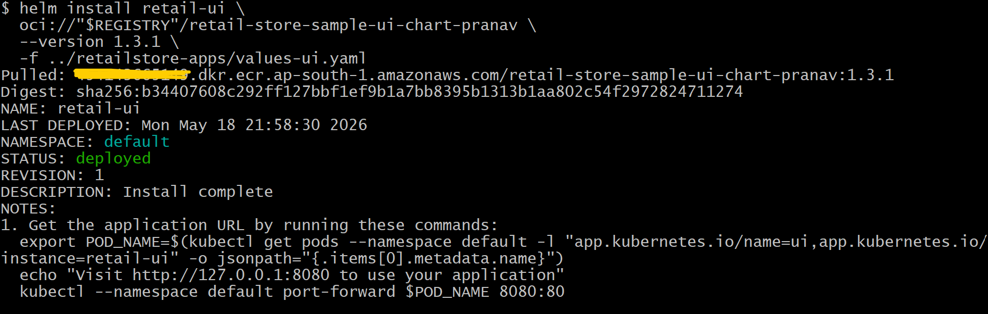
# List Helm Releases
helm list
# List Kubernetes Resources
helm status retail-ui
Note:- In my case my helm version is v4.1.4, due to that reason I was getting error for helm status retail-ui --show-resources this command, due to that reason I have used helm status retail-ui this command.
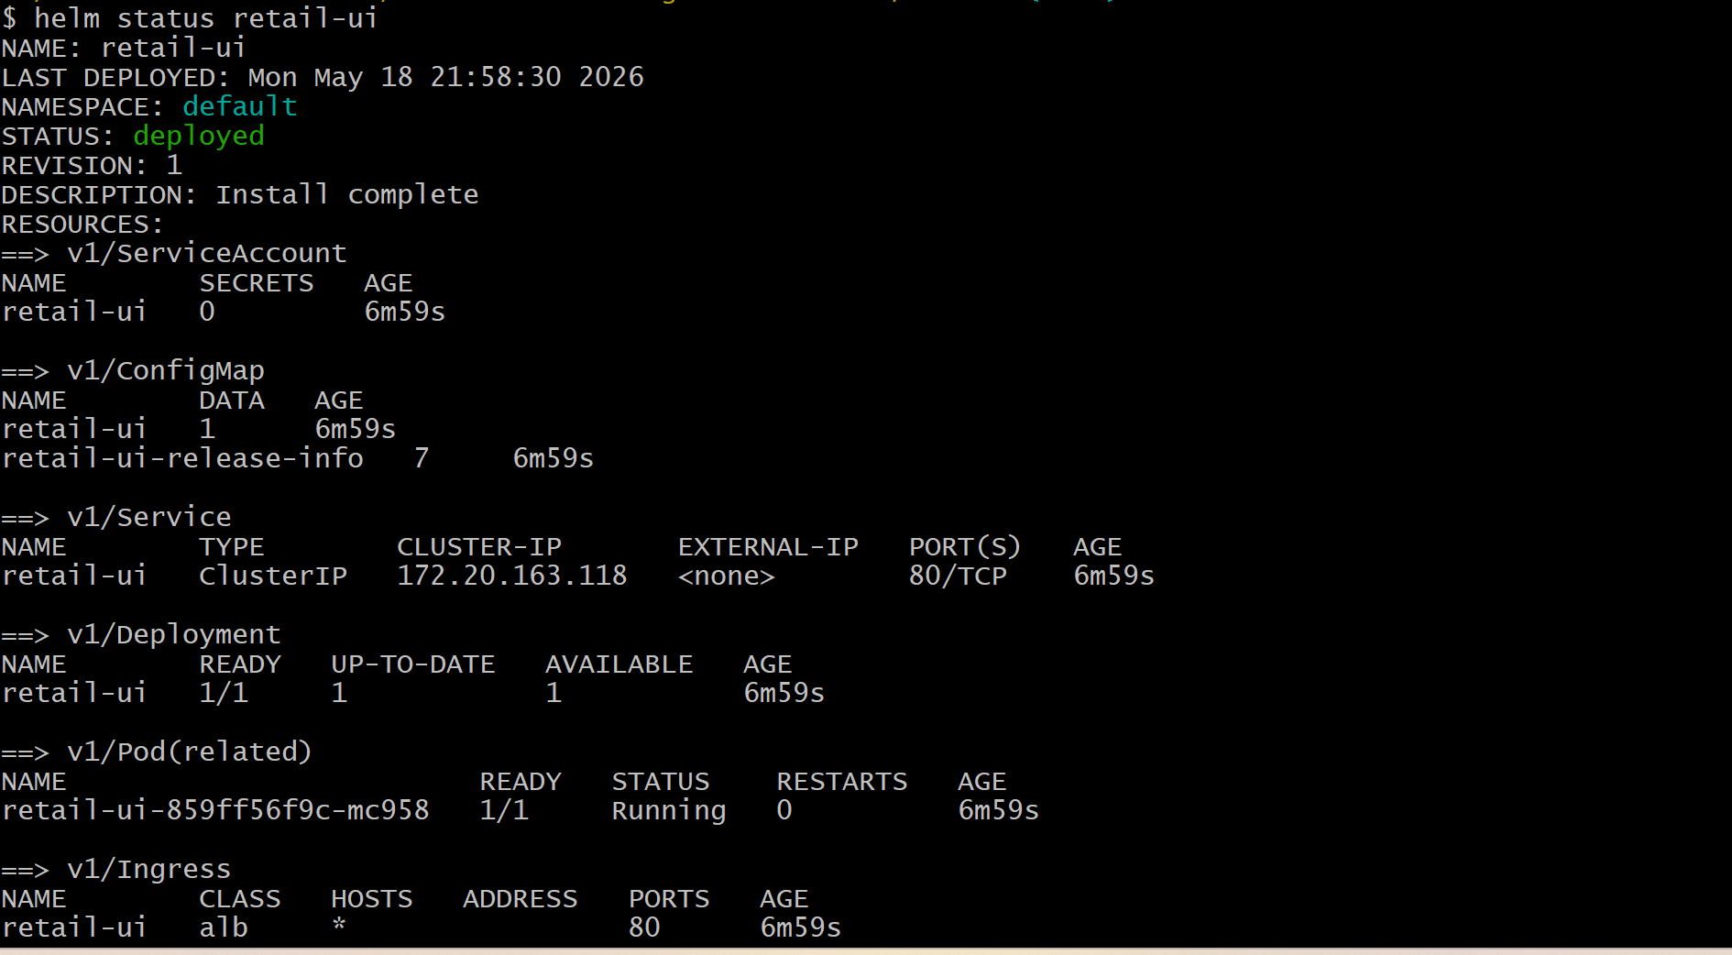
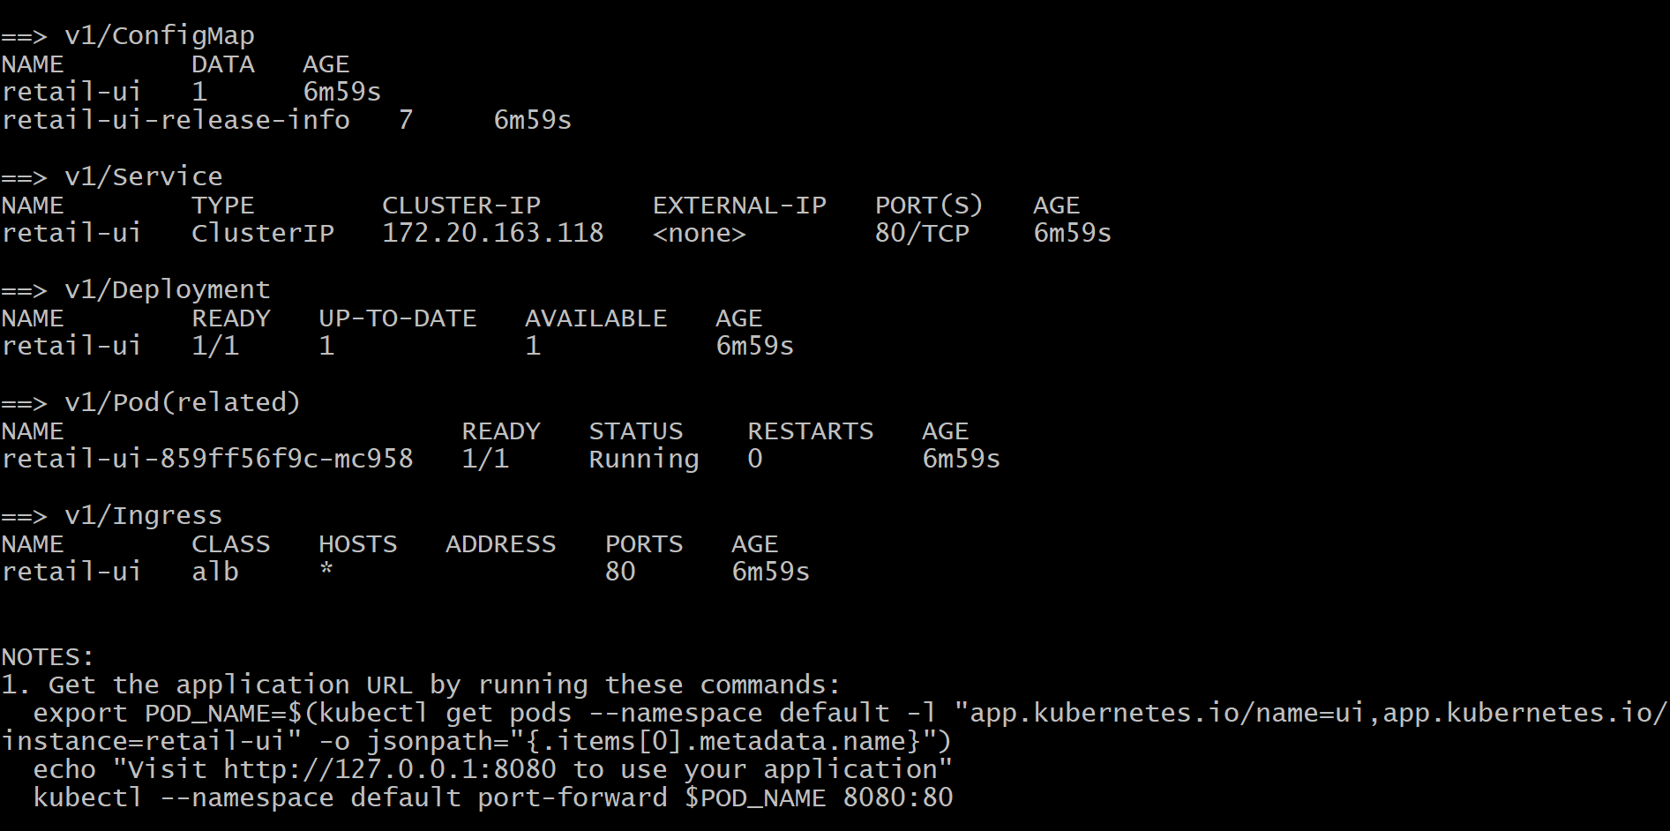

# Verify pods & service
kubectl get pods,svc
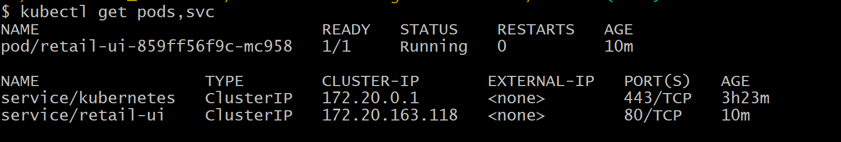

# Verify Release Info ConfigMap
kubectl get cm
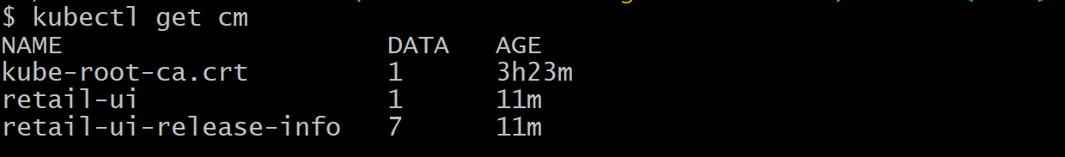
kubectl get cm retail-ui-release-info -o yaml
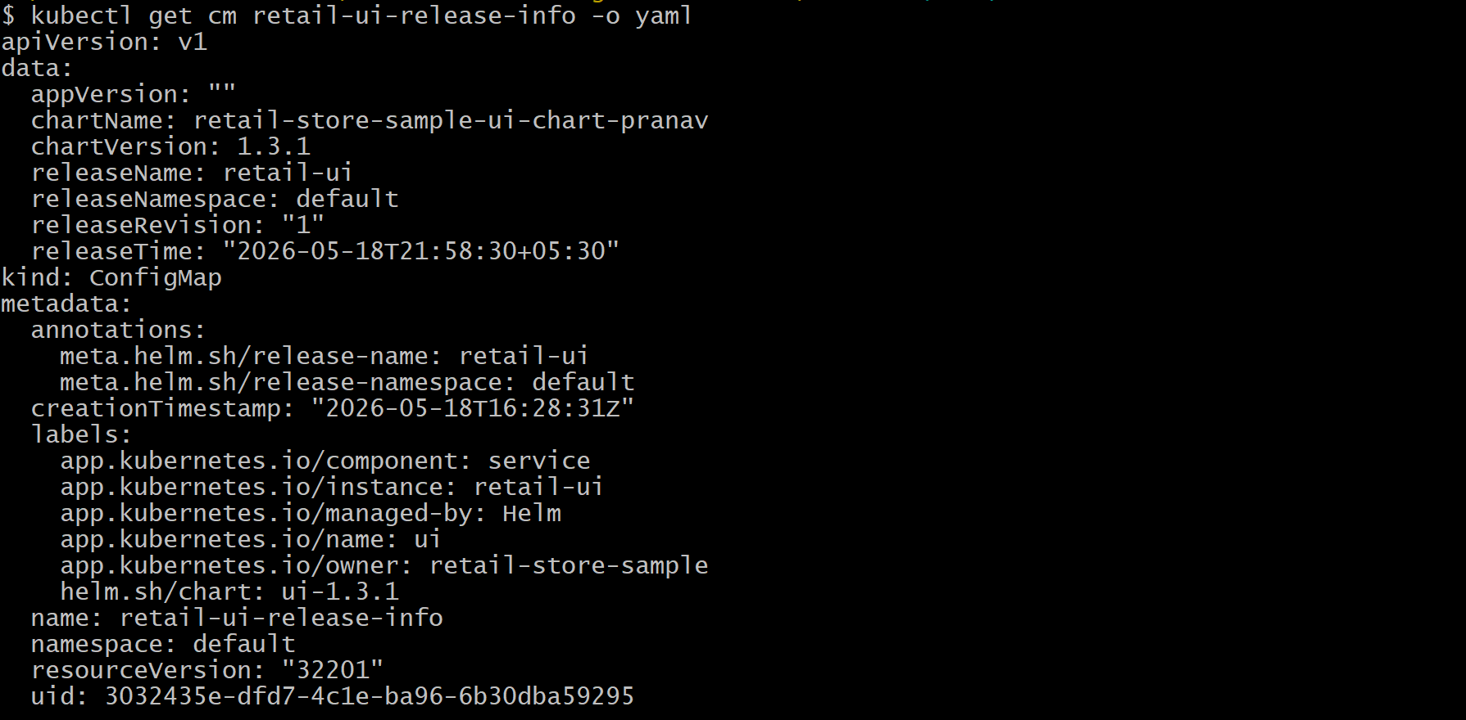
kubectl describe cm retail-ui-release-info
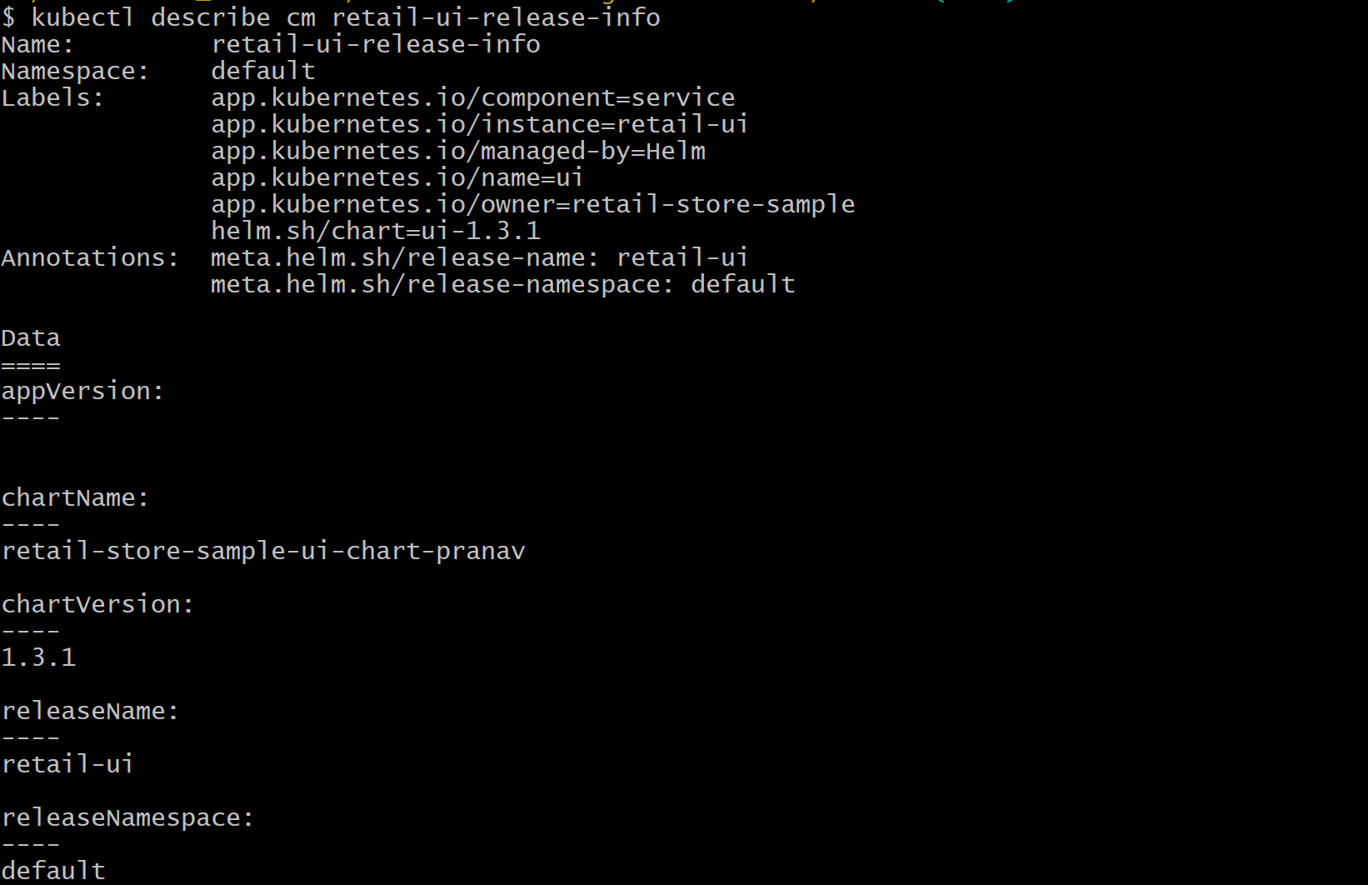
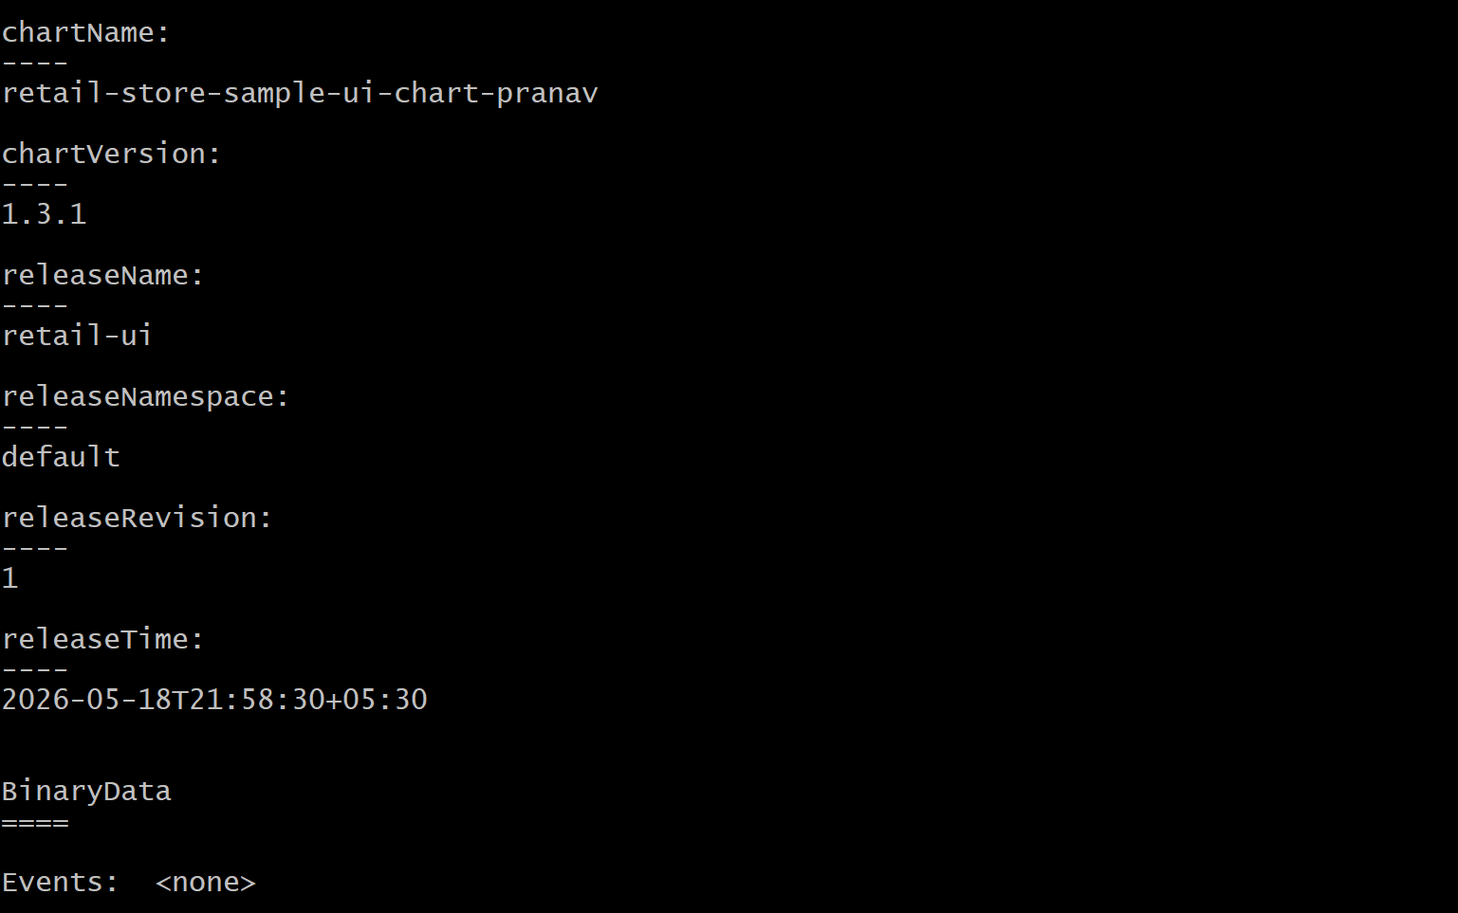
# Cleanup
helm uninstall retail-ui
# To completely remove the chart repository from ECR.
# Delete AWS ECR Repository
aws ecr delete-repository \
--repository-name retail-store-sample-ui-chart-pranav \
--region "$REGION" \
--force
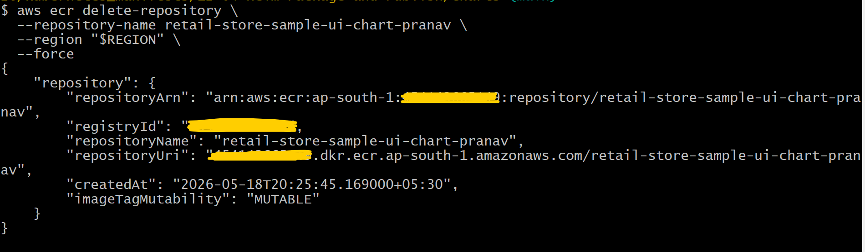
# Started the
sh download-and-untar-helm-charts.sh
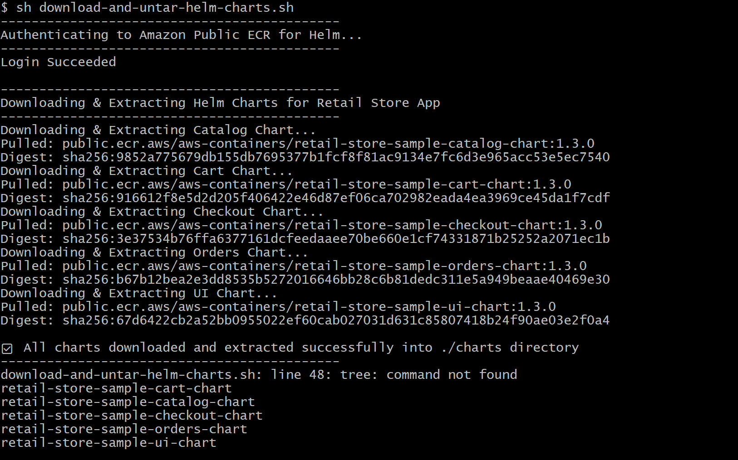
cd 12-05-Helm-Retail-Store/retailstore-apps
sh install-retail-apps.sh
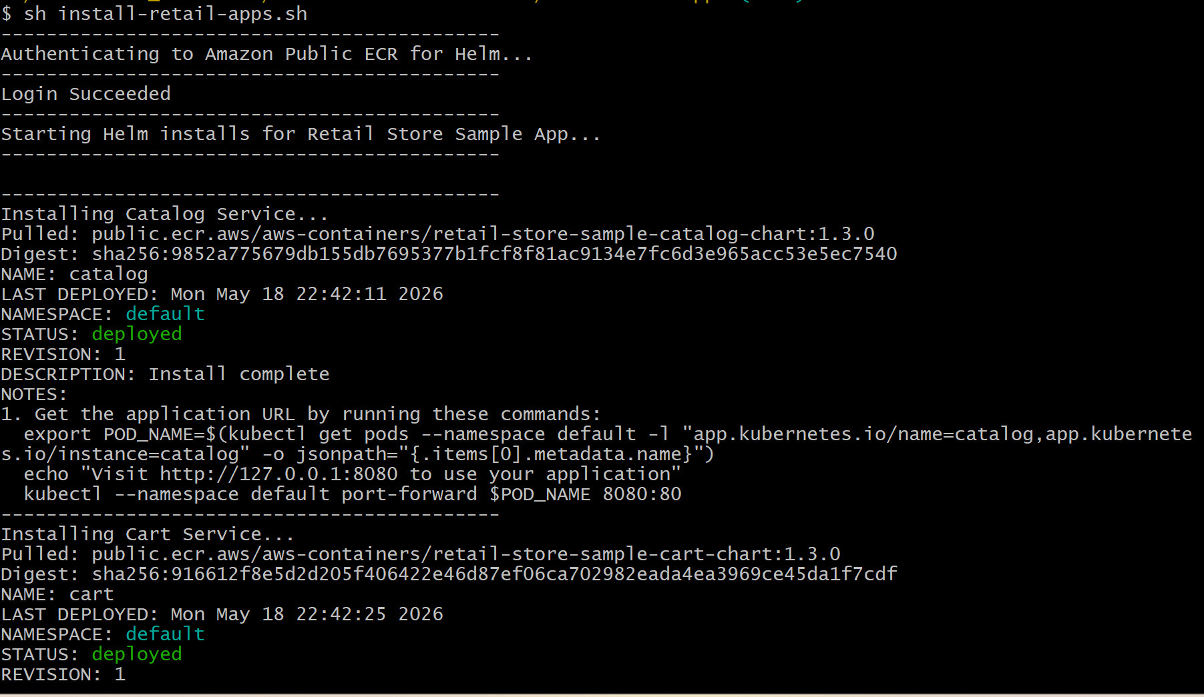
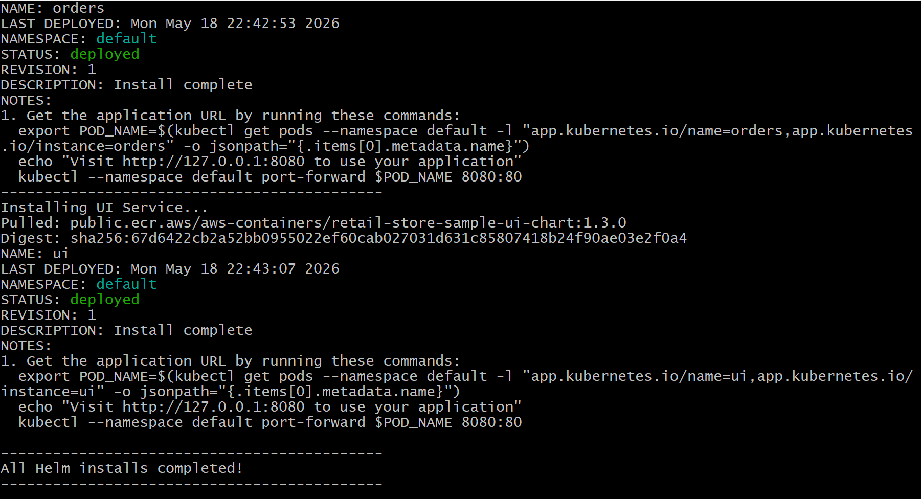
# Helm releases
helm list
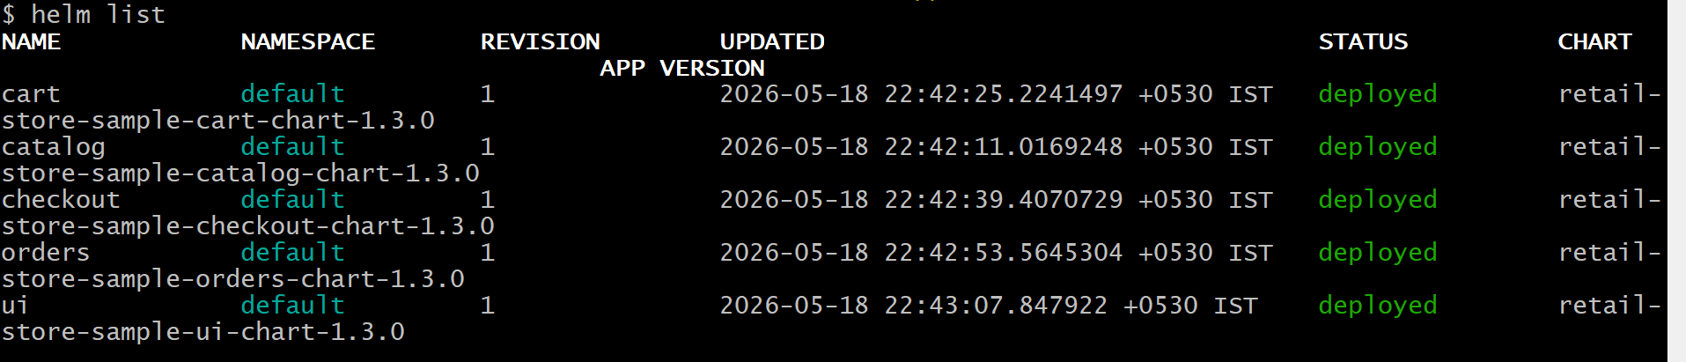
# Pods / Services / Ingress
kubectl get pods
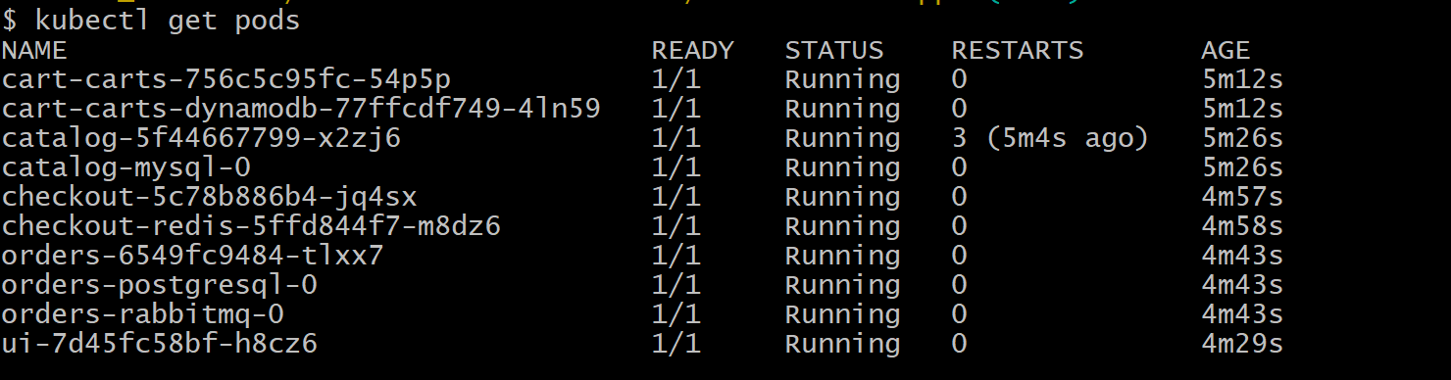
kubectl get svc
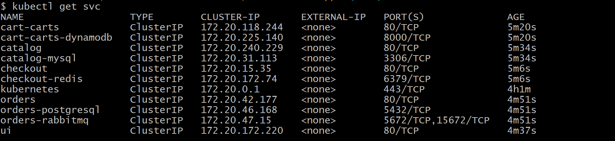
kubectl get ingress
helm status ui
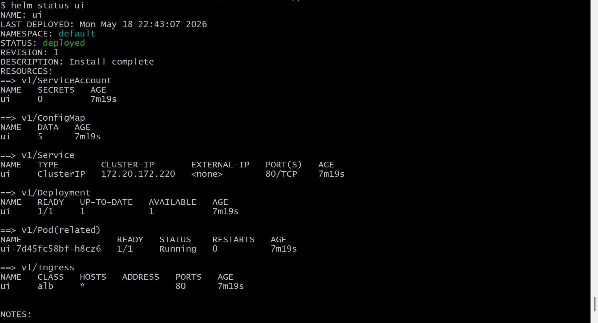

helm status catalog
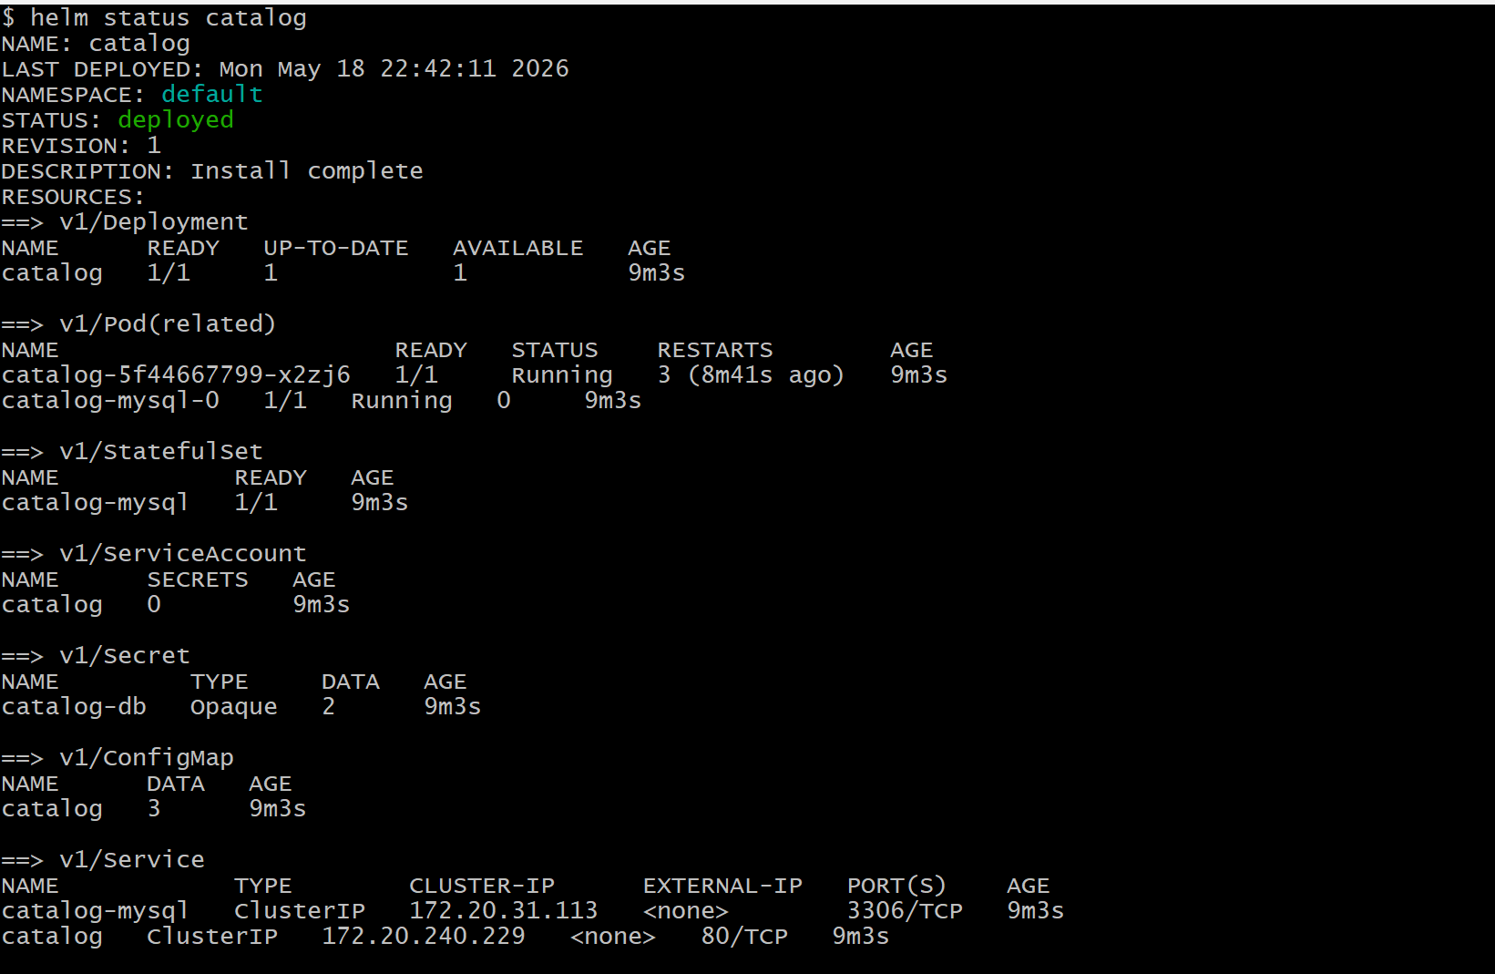
helm status cart
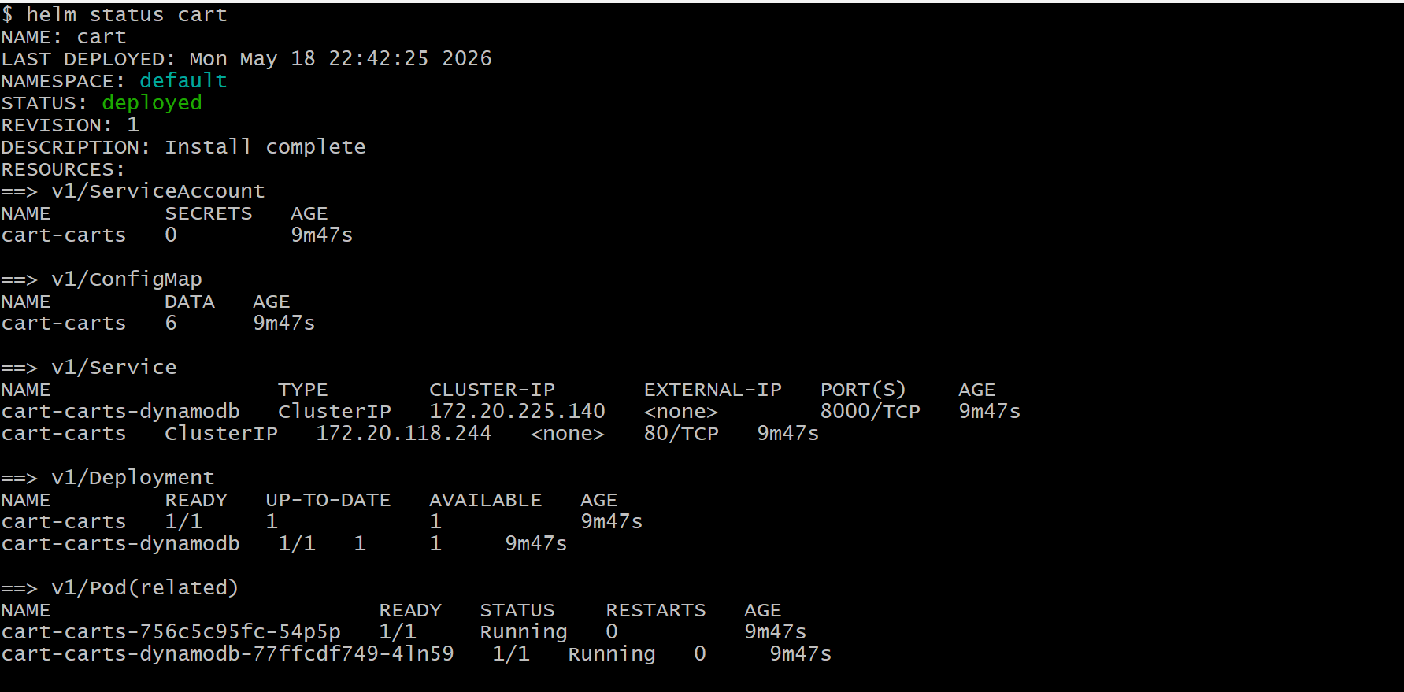
helm status checkout
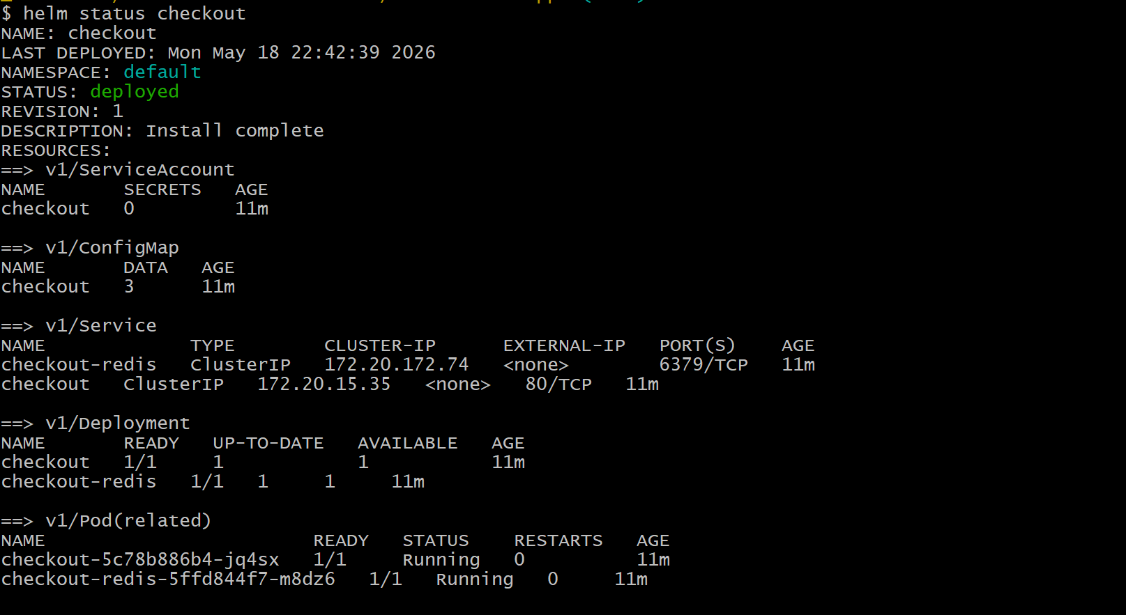
helm status orders
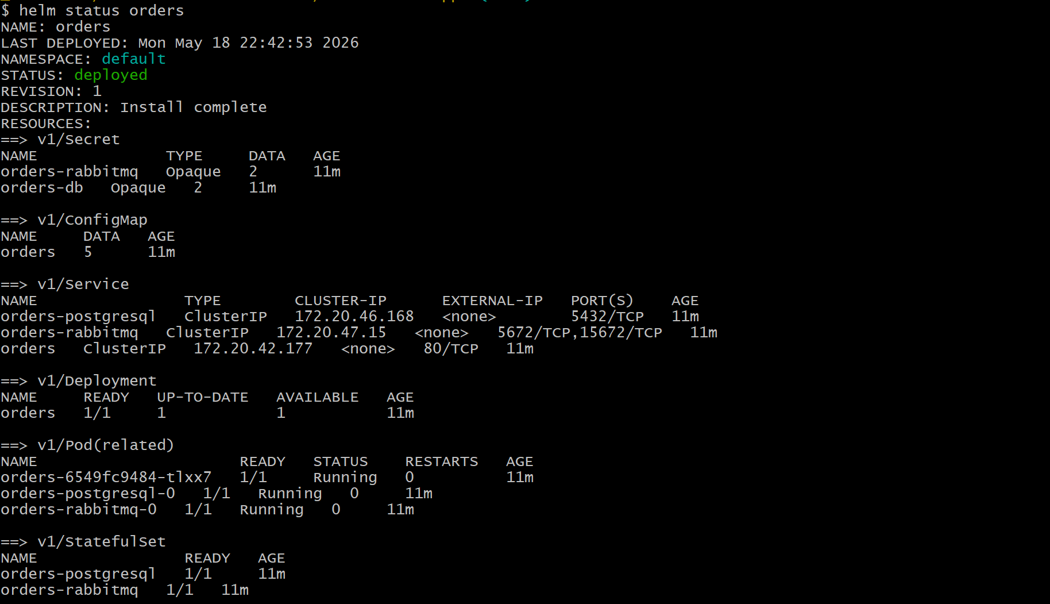
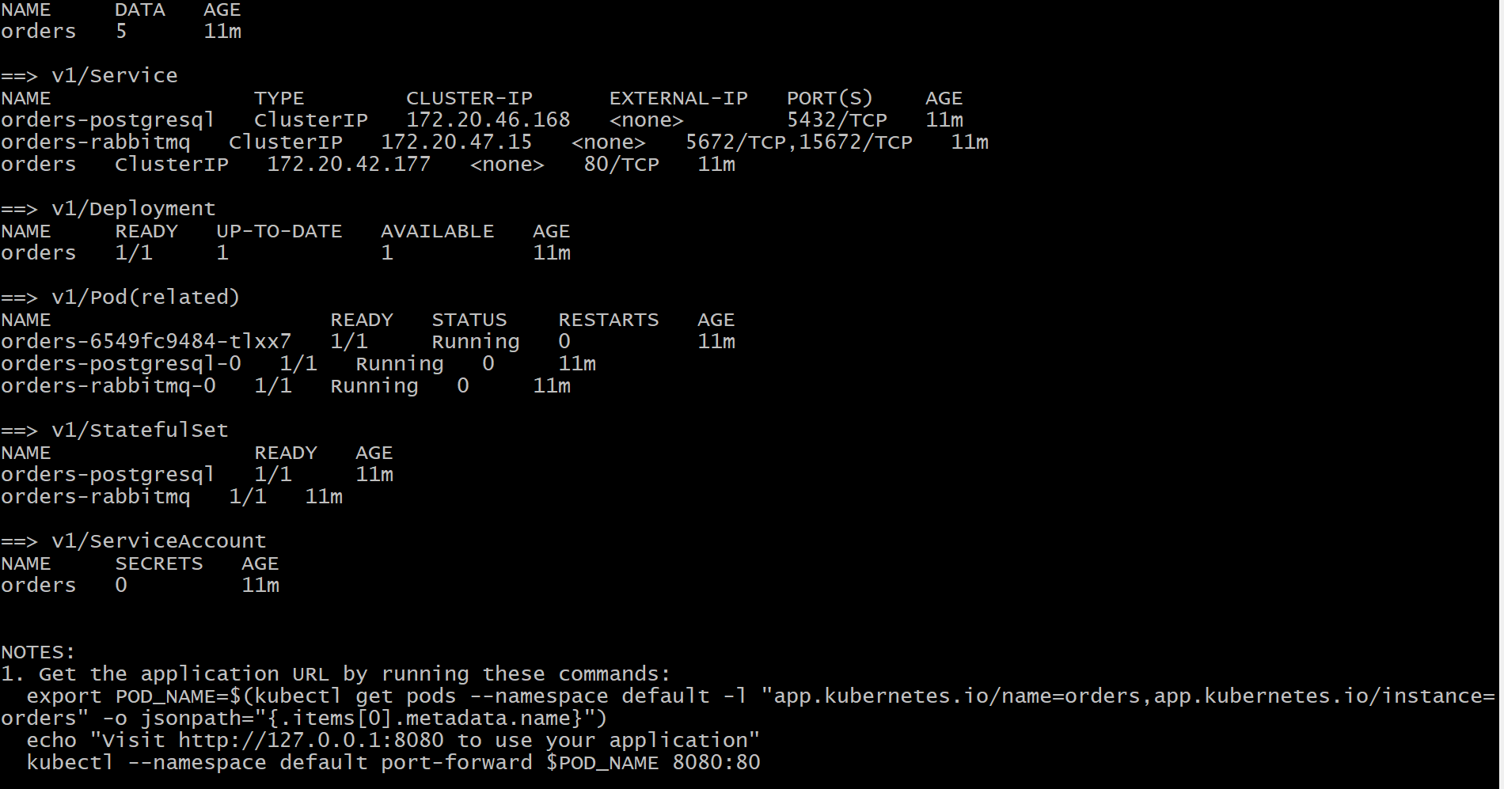
# Cleanup
sh uninstall-retail-apps.sh
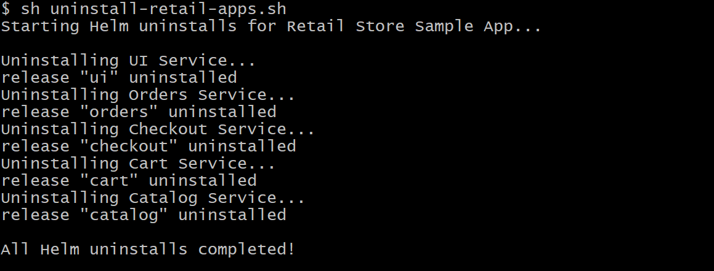

- Deleted EKS Cluster, Node group and Iam roles for through terraform destroy command.

