Steps:-
- Copy terraform code from 20_05_2026 folder into 22_05_2026 folder and added additional terraform and k8s configuration files from instructor code into 22_05_2026 this folder.
Note:- 1. Since I did not deploy a private subnet due to the unavailability of a NAT Gateway, and creating my own NAT Gateway would incur additional costs, I chose not to create one for cost optimization purposes. As a result, I deployed my node group EC2 instances, Karpenter EC2 instance resources in a public subnet.
2. I am also aware that, from a best practices and security perspective, node group EC2 instances, Karpenter EC2 instance should be hosted in a private subnet rather than a public subnet. However, this is not a production-grade EKS cluster; I am deploying it only for practical testing purposes. Therefore, I hosted the node group EC2 instances, Karpenter EC2 instance in a public subnet.
3. For my previous practical’s, I have also used only public subnets, and for upcoming practical’s, I will continue to use public subnets only.

- Run below mentioned terraform commands to deploy the EKS Cluster through terraform

terraform init
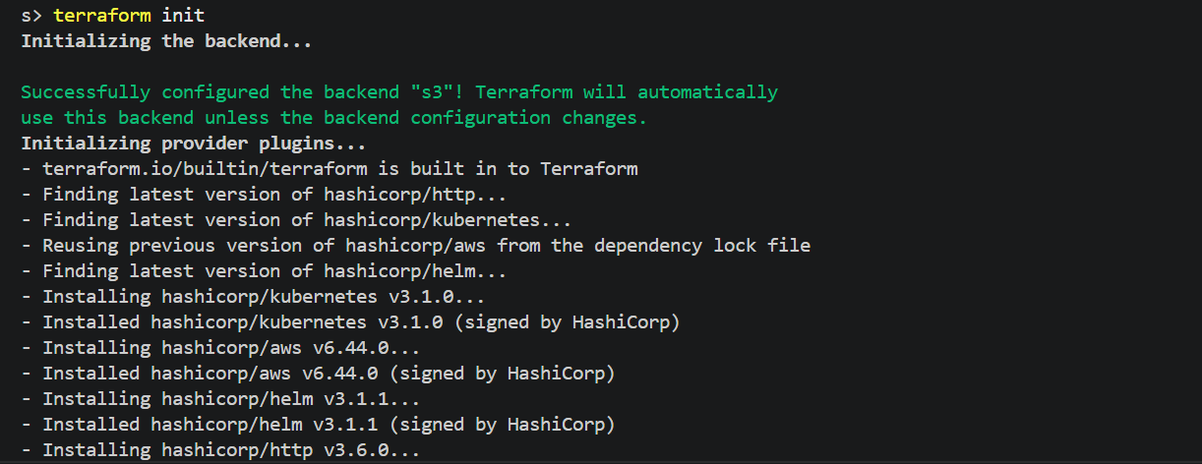

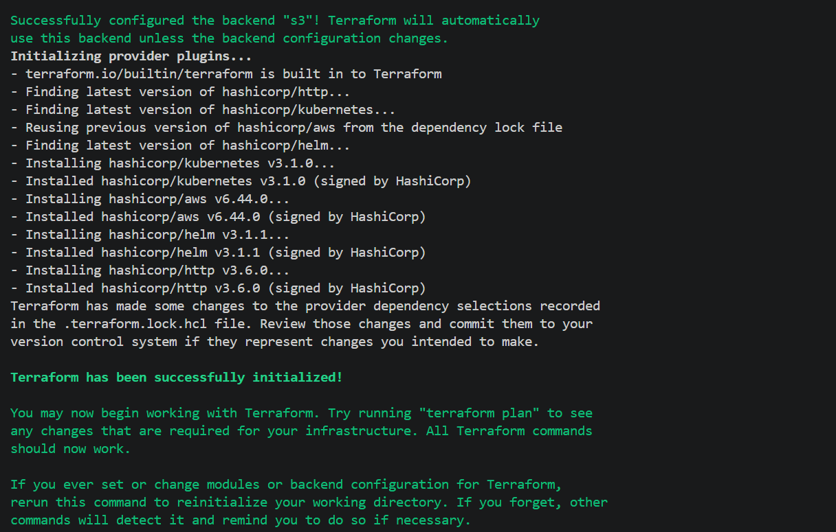

terraform validate

terraform plan
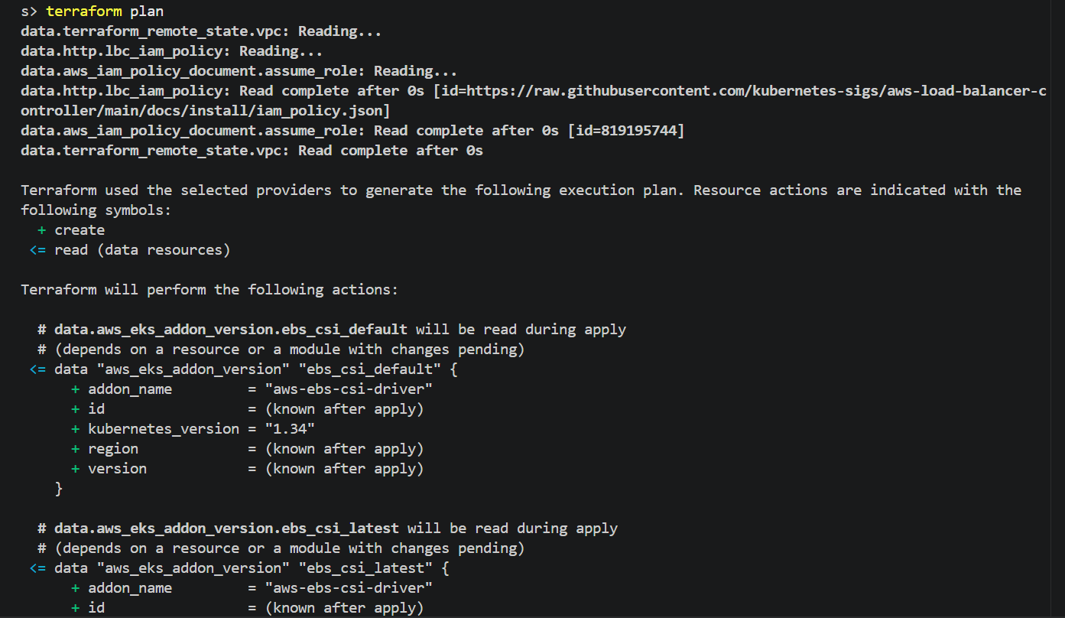

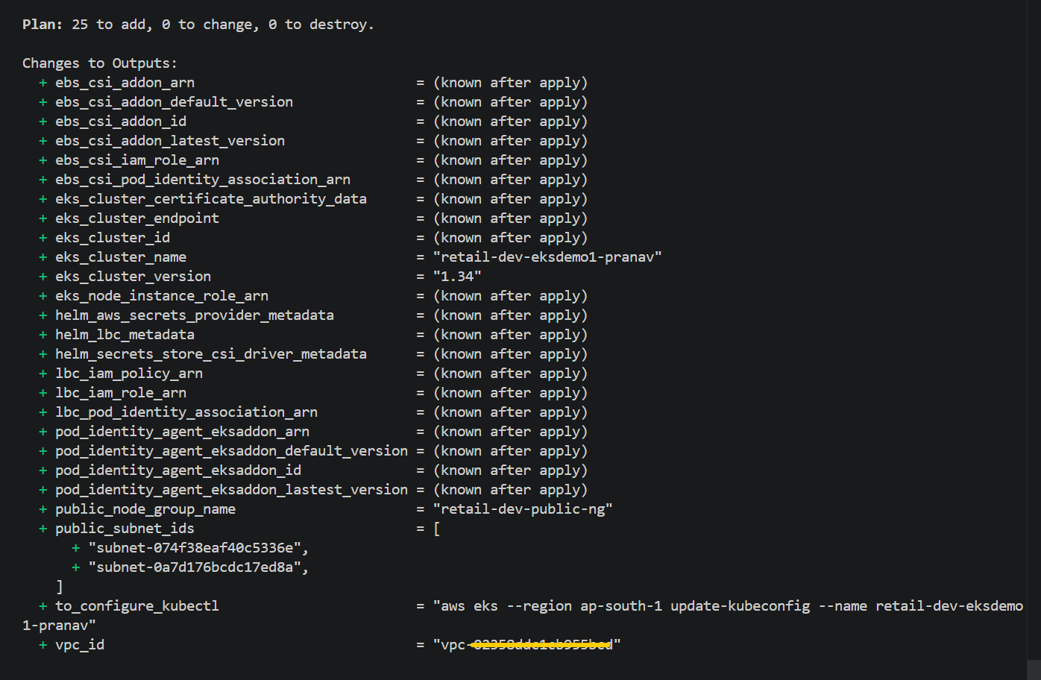
terraform apply –auto-approve
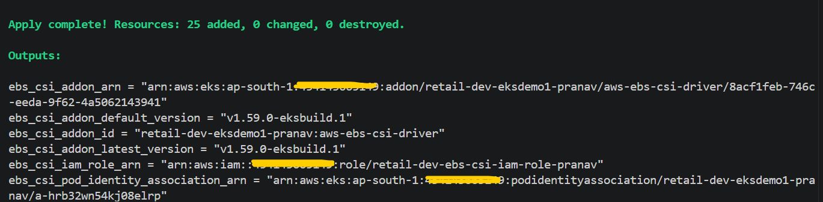
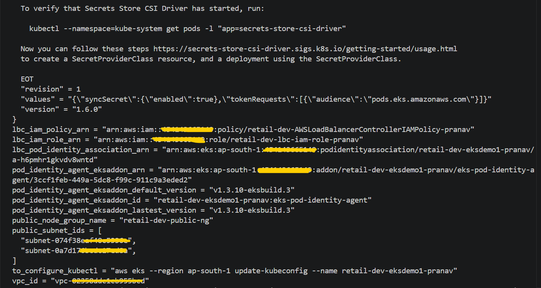
# Verified EKS Cluster and its configuration from AWS console
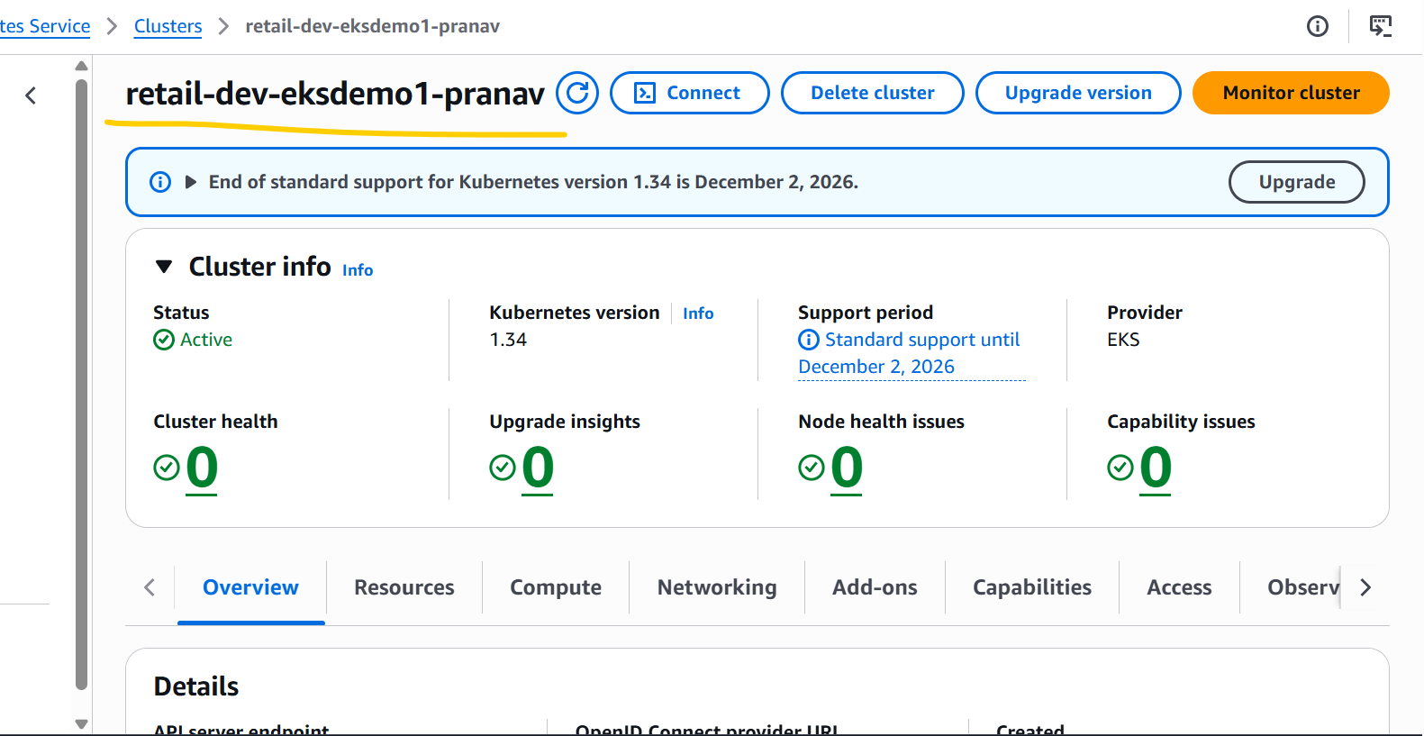

# EKS Node Group Instance Type Size

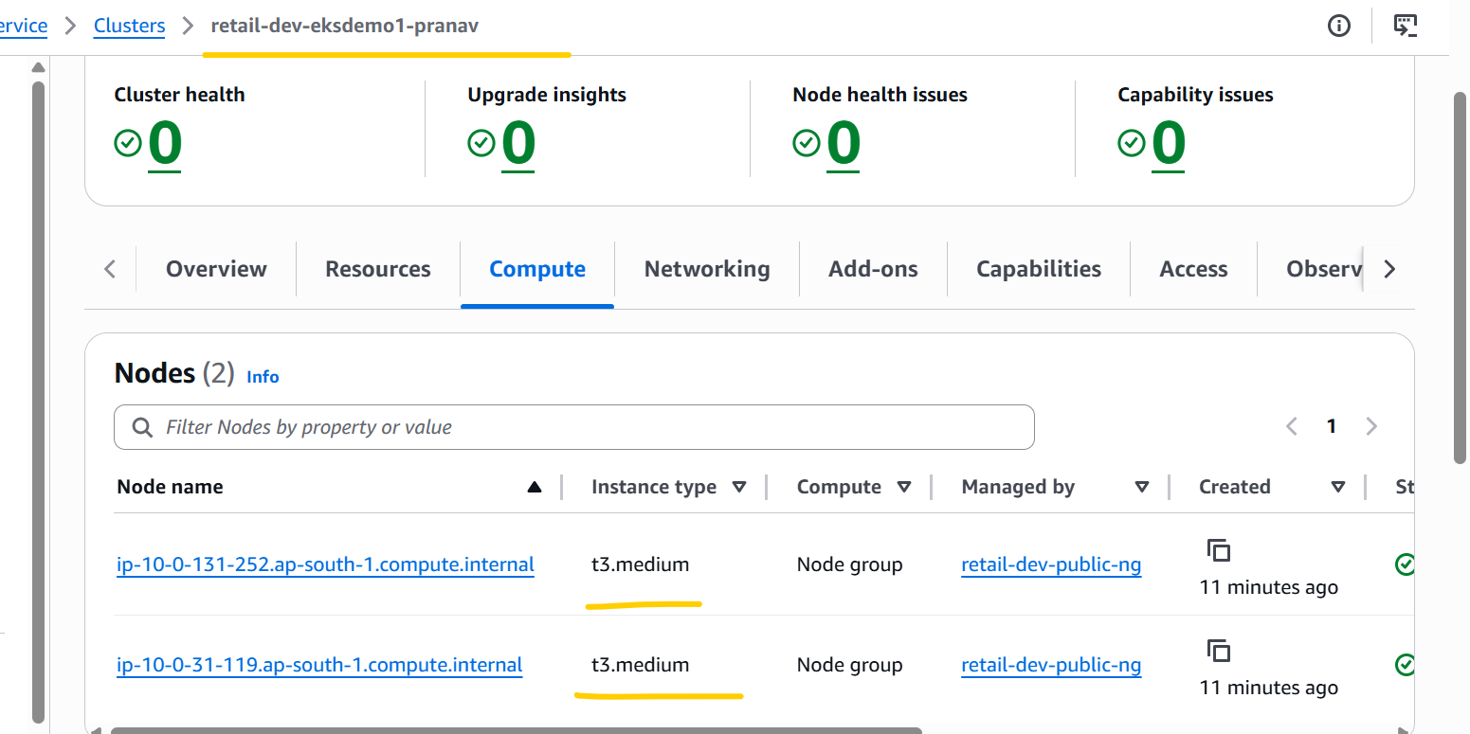

# EKS Cluster Add-ons.
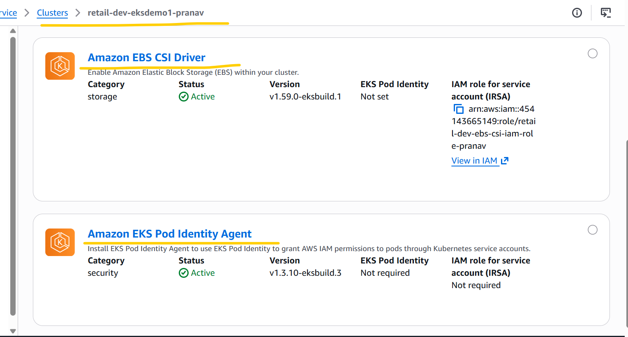

# EKS Cluster Pod Identity associations.

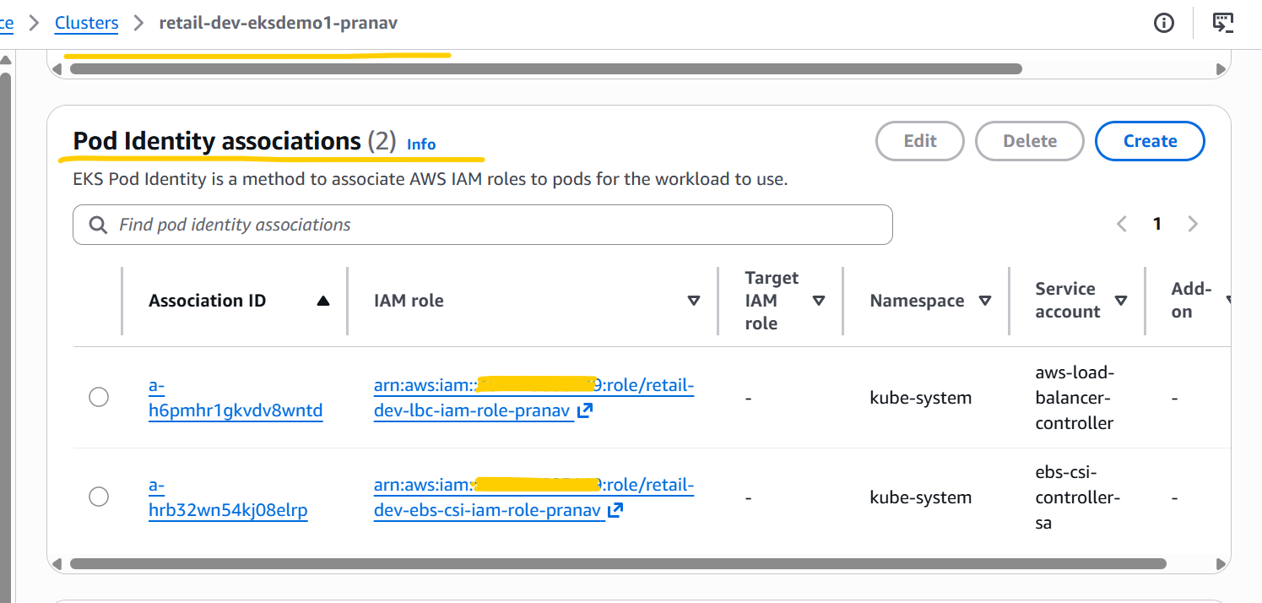

- Update tag value for EKS subnet from shared to owned in c5_eks_tags.tf this file of EKS terraform code as per requirement and run below terraform commands to update the same.
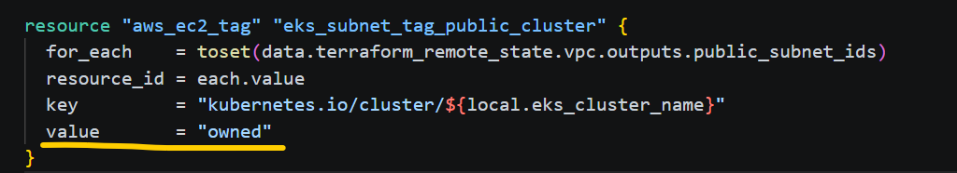
terraform init
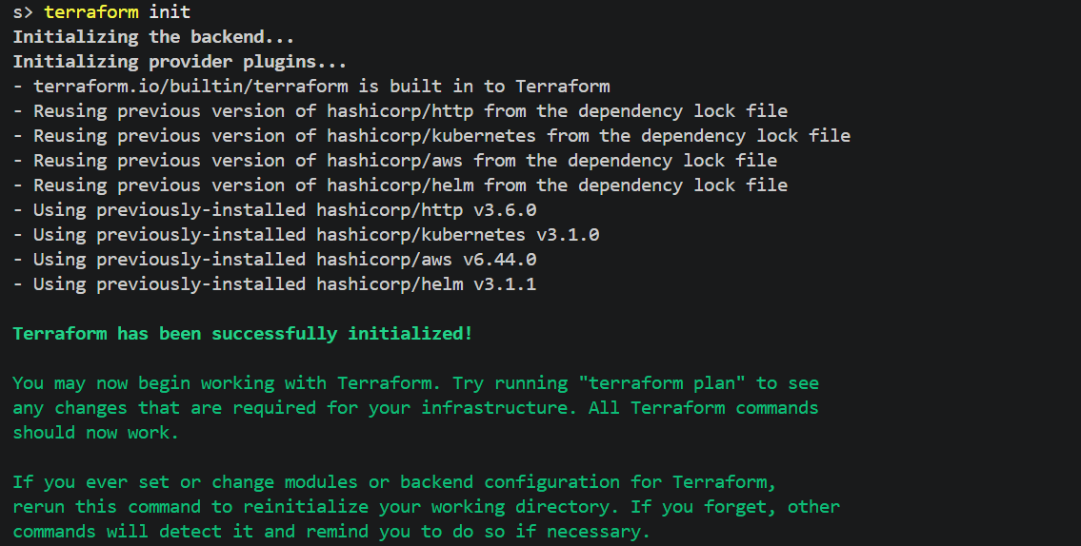
terraform state list
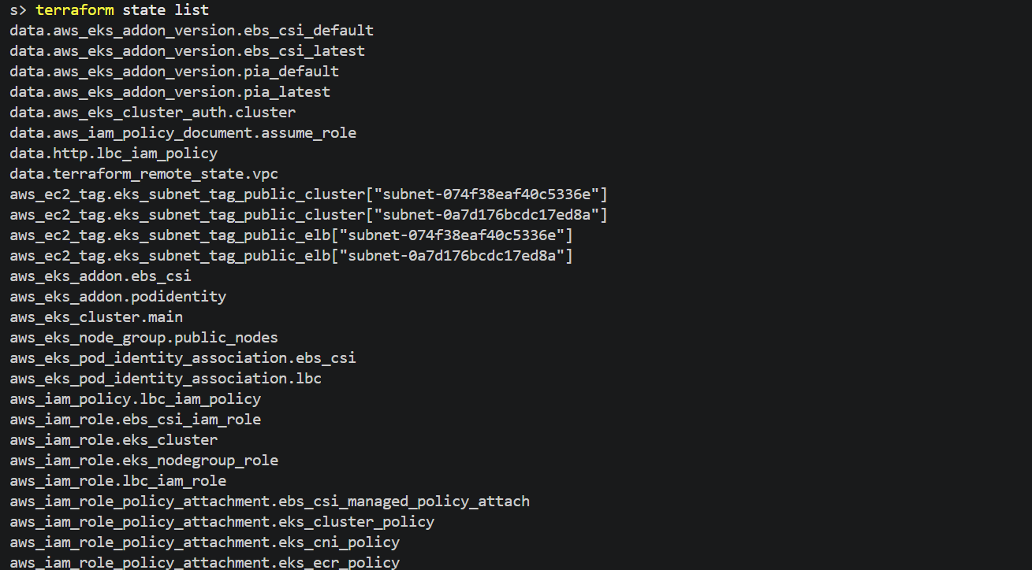

terraform output
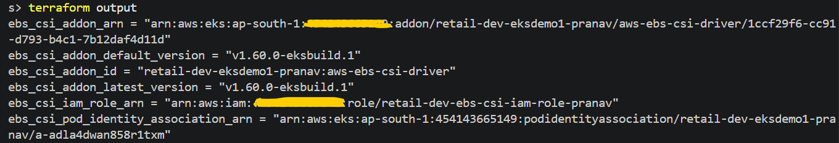
terraform validate
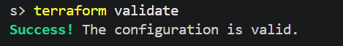
terraform plan
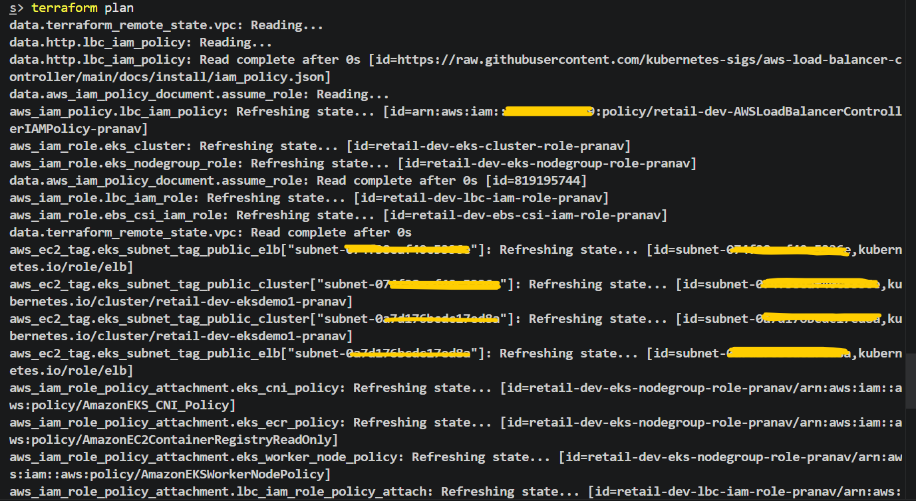
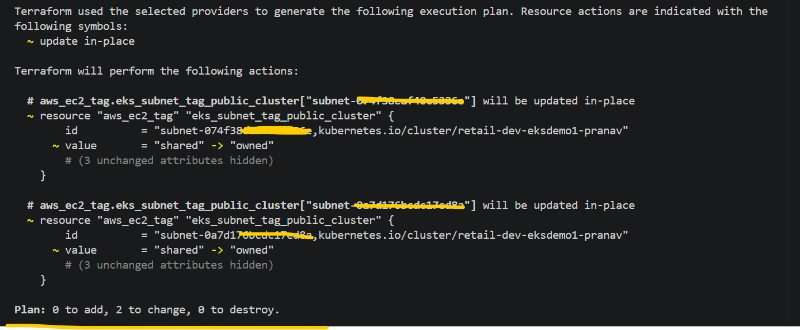

terraform apply –auto-approve
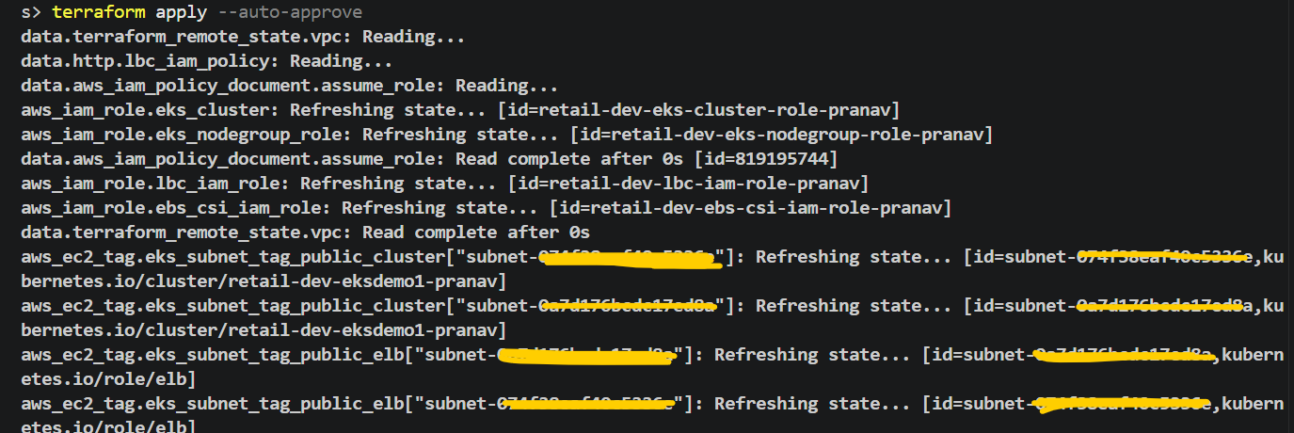
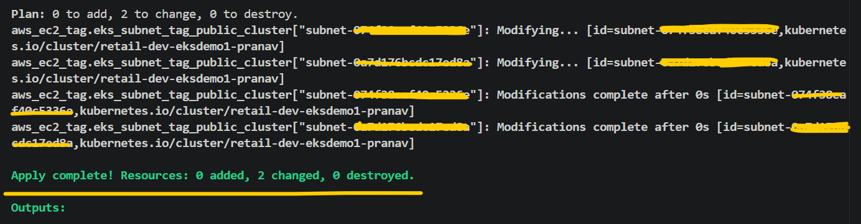
- Update the Karpenter terraform code as per requirements and deploy the same using terraform commands.
terraform init
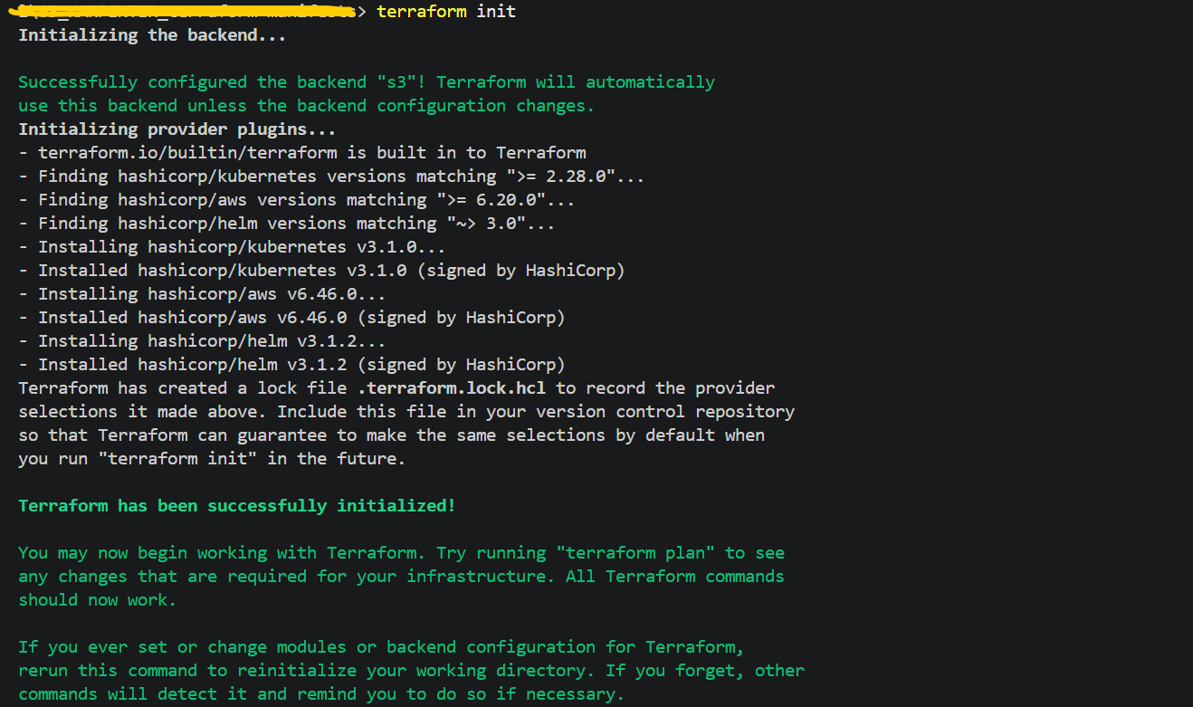

terraform validate
terraform plan
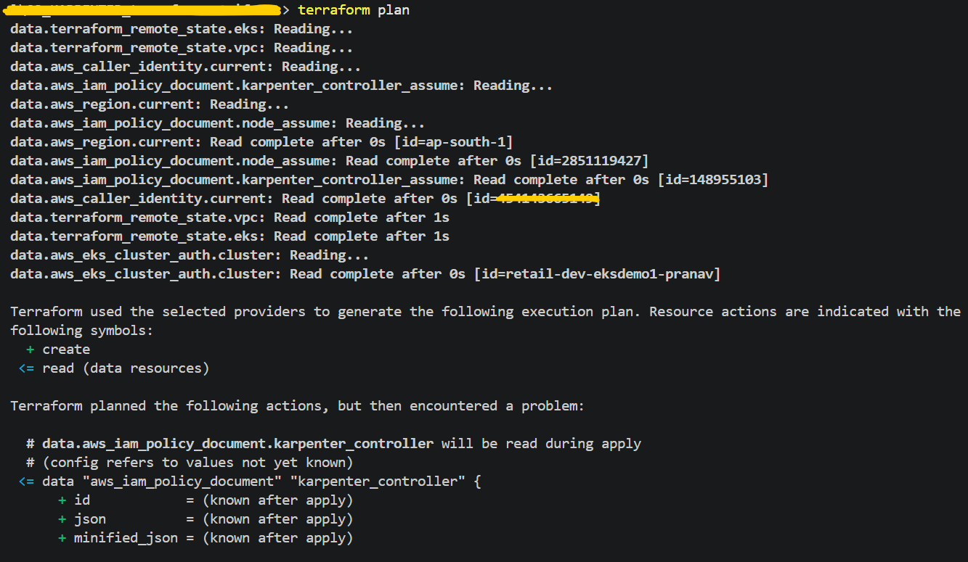
Got below mentioned error while running terraform plan command.
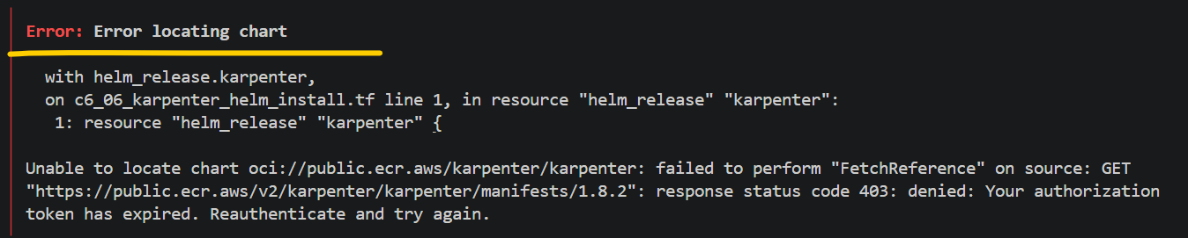
# Run the AWS CLI command mentioned below to authenticate Docker/Helm with Public ECR or resolve the issue mentioned above. After executing the command, run the terraform plan command again.
Note:- I have the AWS CLI command in Gitbash, because in powershell it was not working properly.
aws ecr-public get-login-password --region us-east-1 \
| helm registry login --username AWS --password-stdin public.ecr.aws
terraform plan

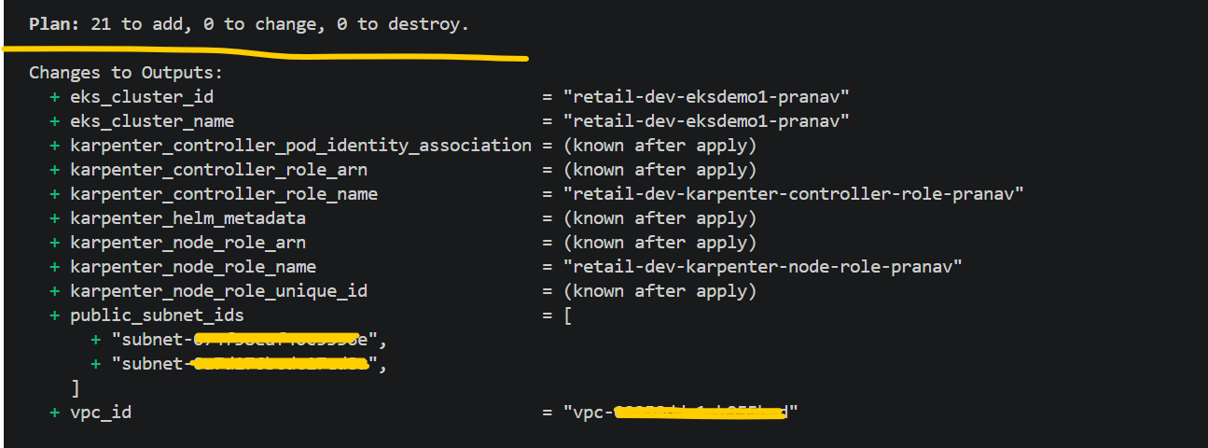
terraform - -apply-approve
# Getting the below error while running the terraform apply command during EventBridge Rule creation. This error occurred because my iam (Pranav) user did not have the required IAM permissions for EventBridge Rules.
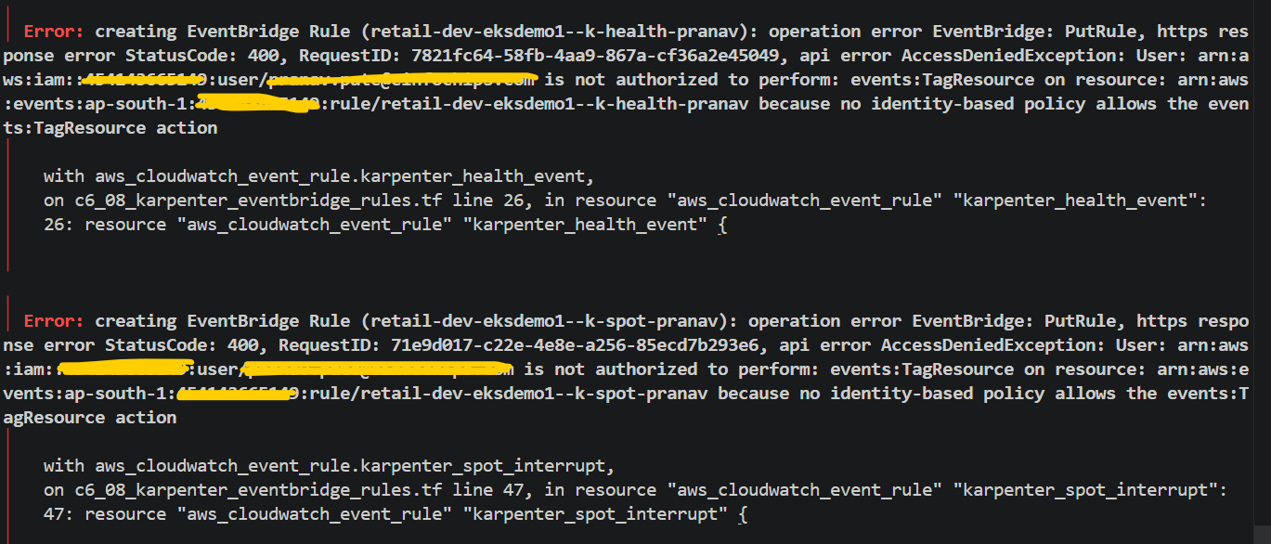
To resolve this issue, I added the required IAM permissions to my IAM user (Pranav).
Rerun terraform plan and apply commands and this time all resources have been created successfully without errors.
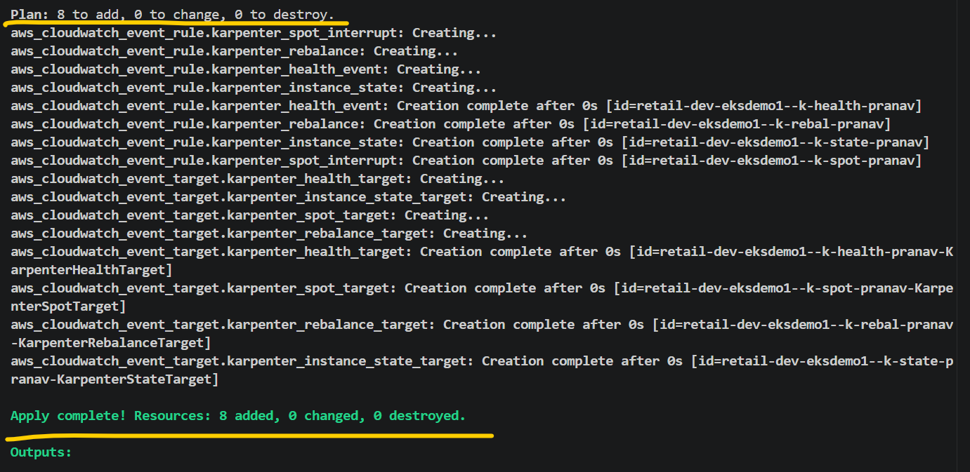
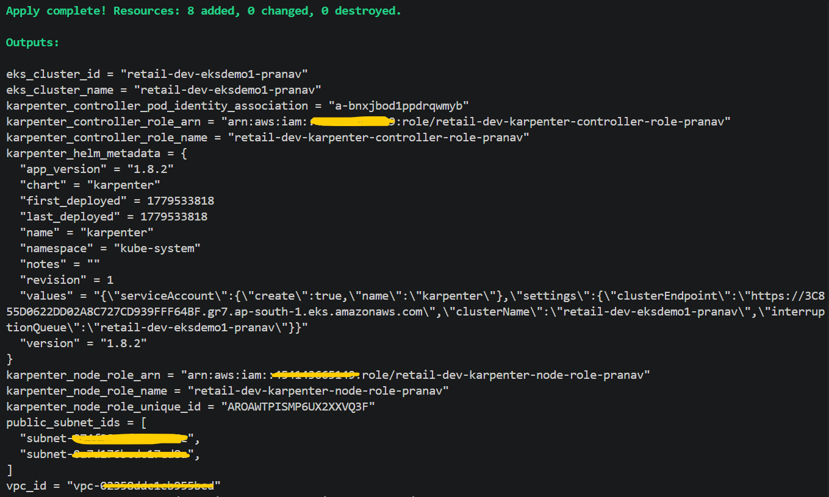
- Update the Karpenter k8s manifest code as per requirements and deploy the same using commands.
aws eks --region ap-south-1 update-kubeconfig --name retail-dev-eksdemo1-pranav
helm list -n kube-system
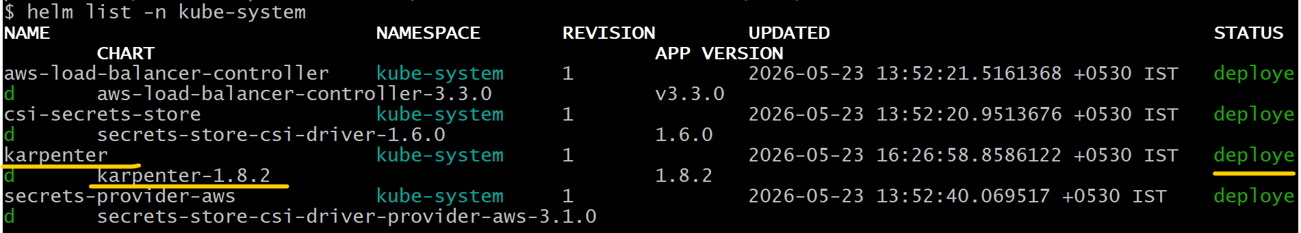

helm status karpenter -n kube-system
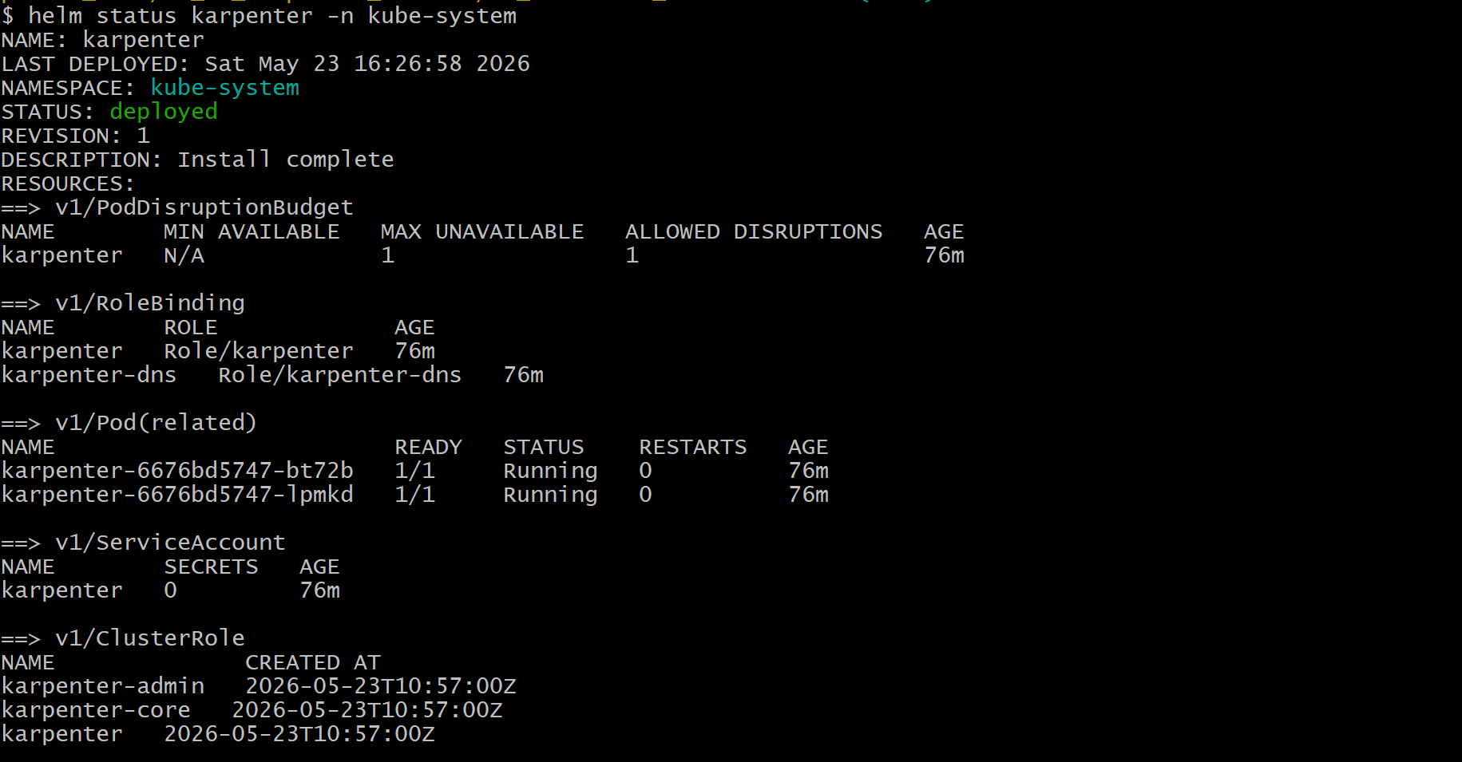
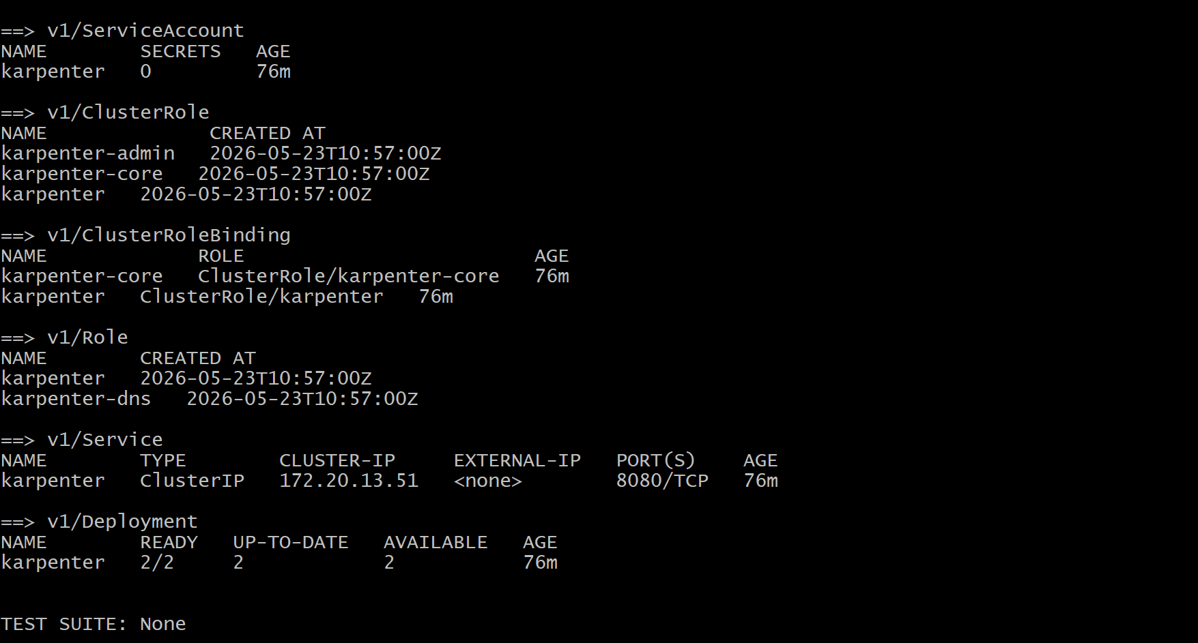
kubectl get pods -n kube-system -l app.kubernetes.io/name=karpenter
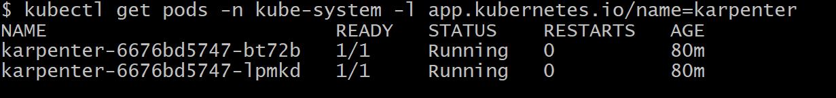

kubectl logs -n kube-system -l app.kubernetes.io/name=karpenter -f
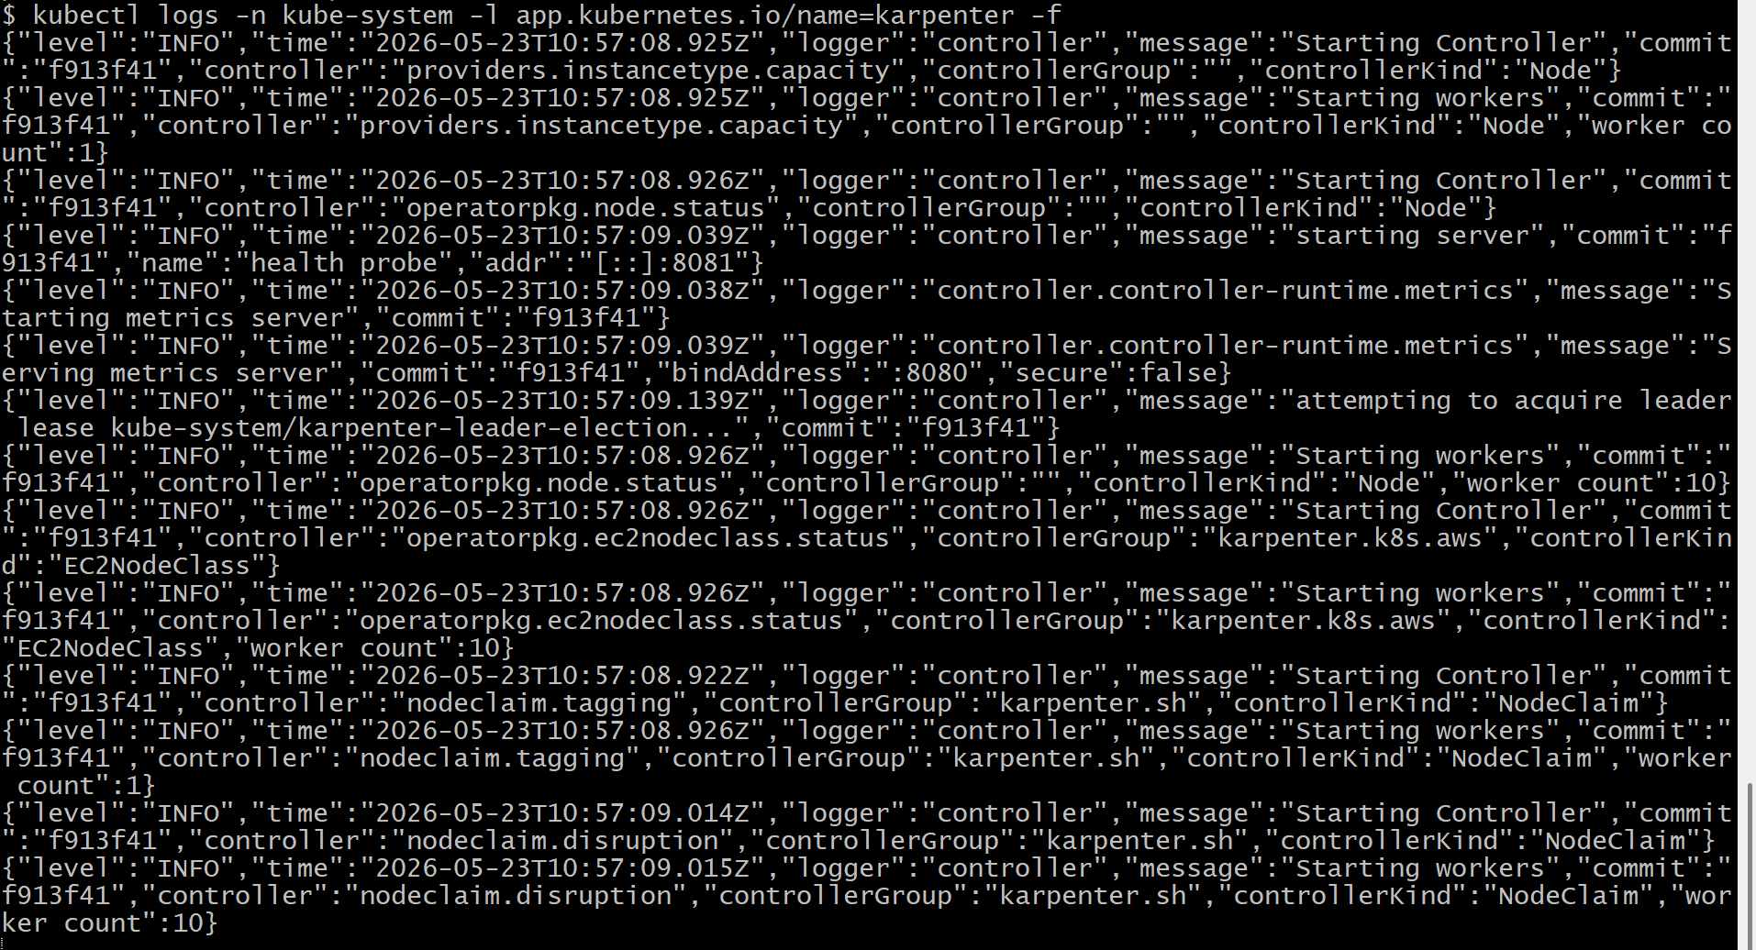
# Update Karpenter Configuration k8s-manifests file code as per requirements and then deploy the same.
# Apply Karpenter Configuration
kubectl apply -f 04_KARPENTER_k8s-manifests/
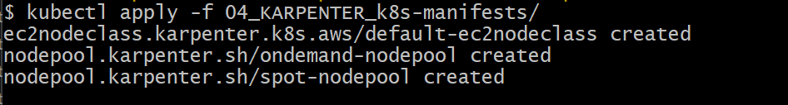
# Verify NodePools and EC2Nodeclass
kubectl get nodepools
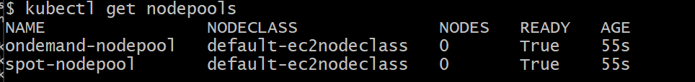
kubectl get ec2nodeclass
kubectl describe ec2nodeclass default-ec2nodeclass
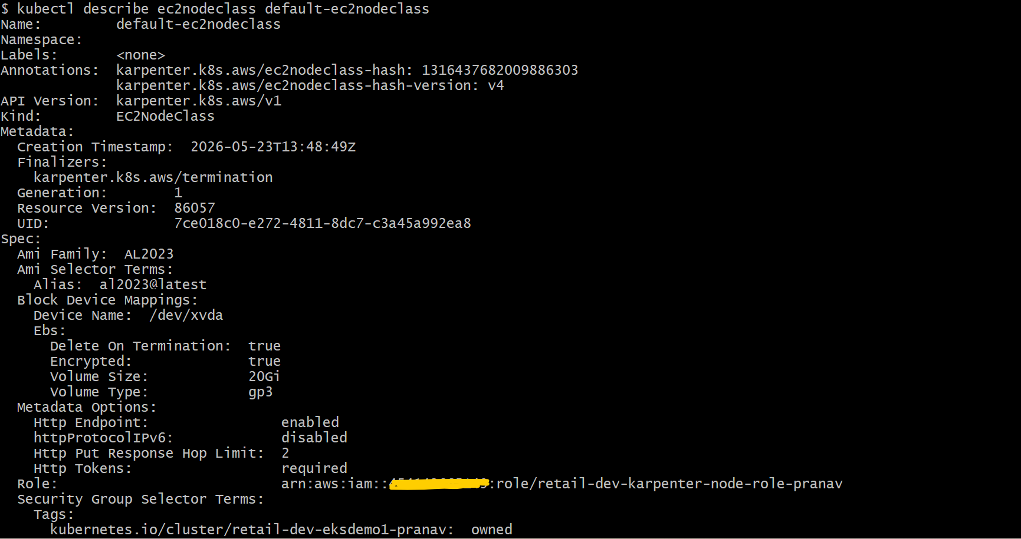
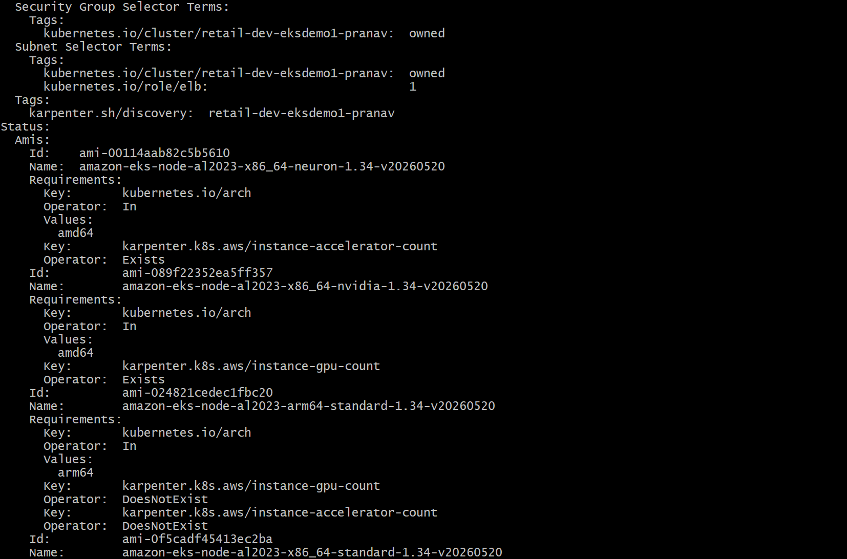
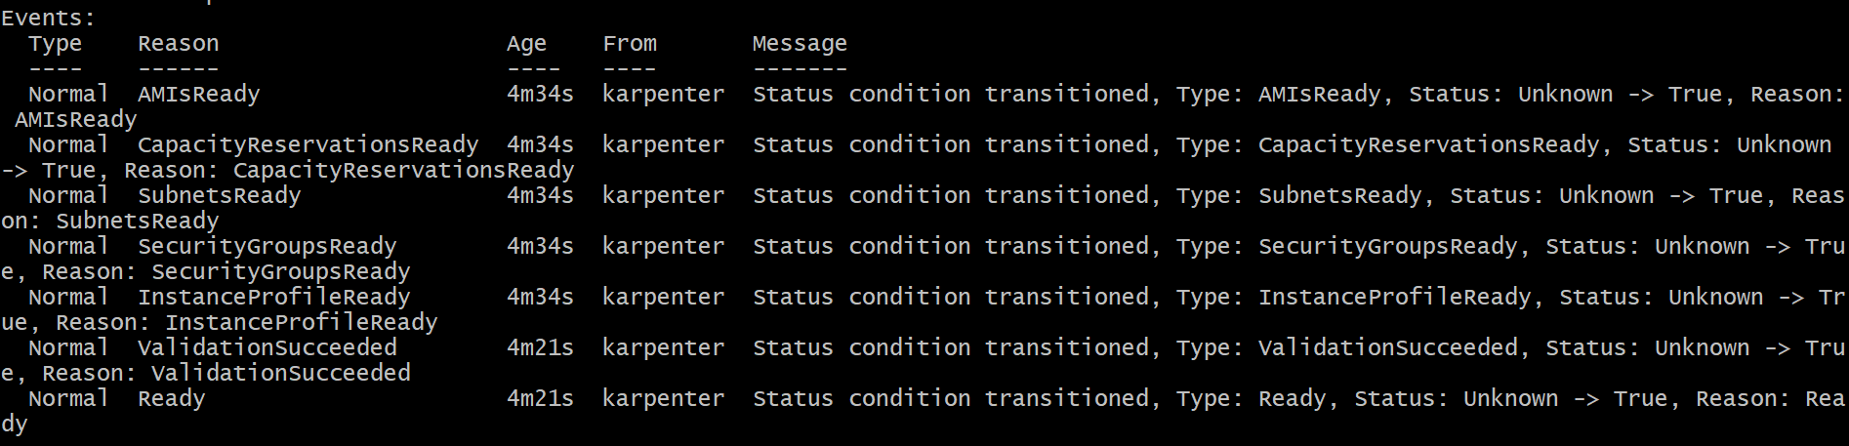

kubectl describe nodepool ondemand-nodepool
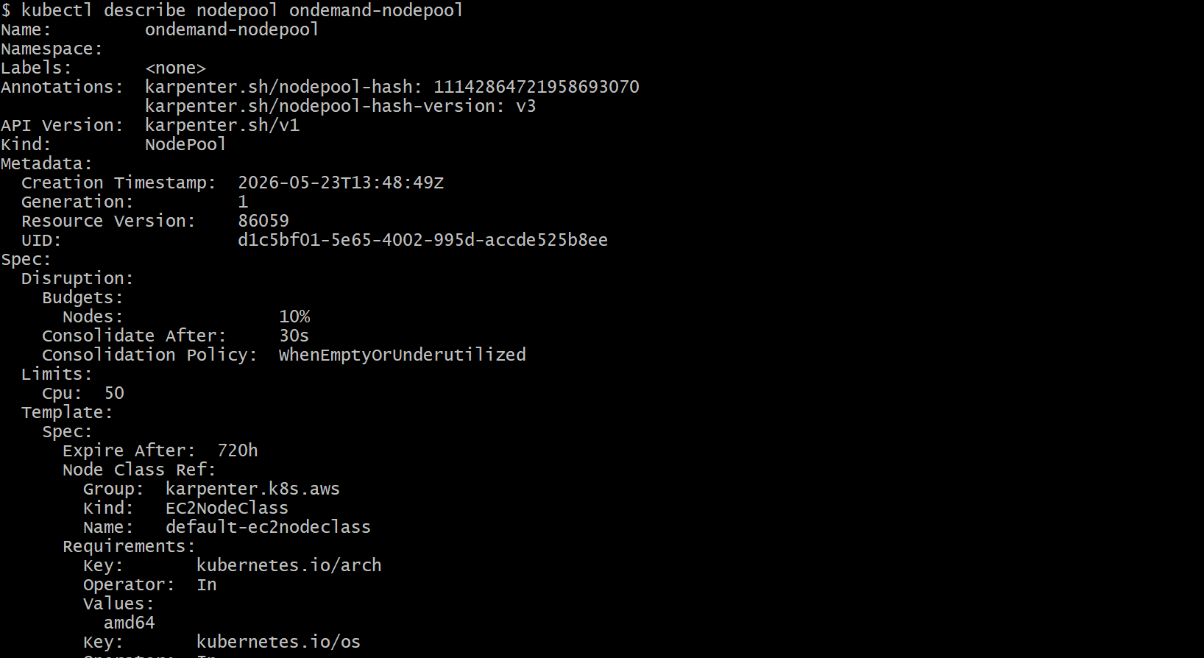
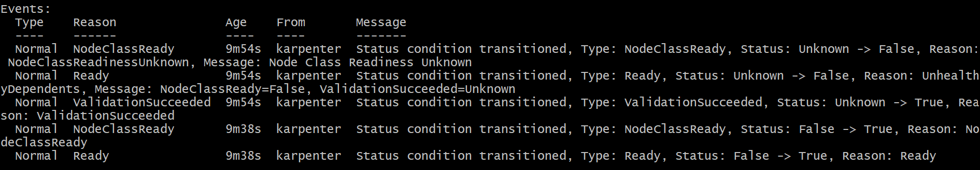
kubectl describe nodepool spot-nodepool
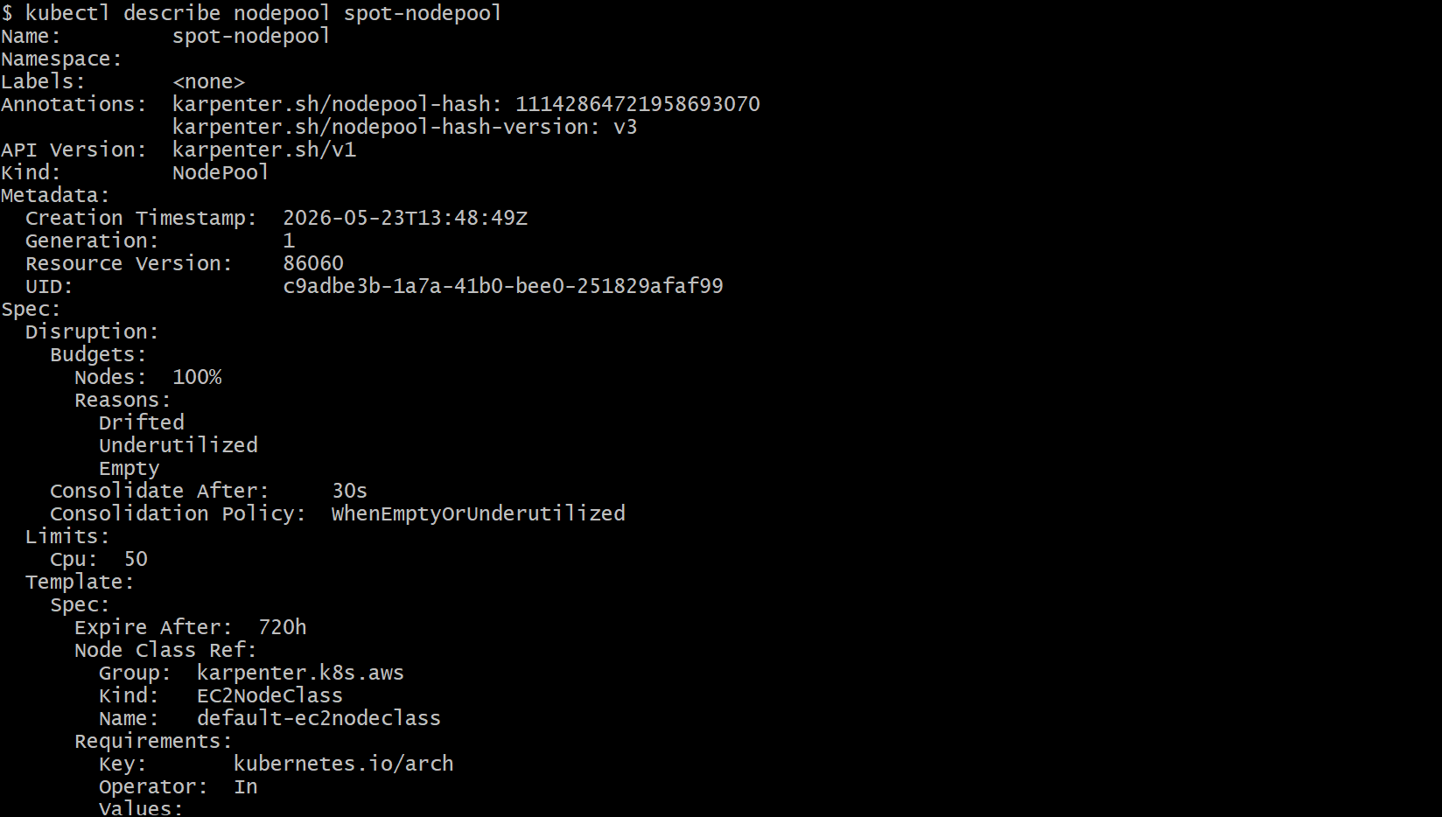
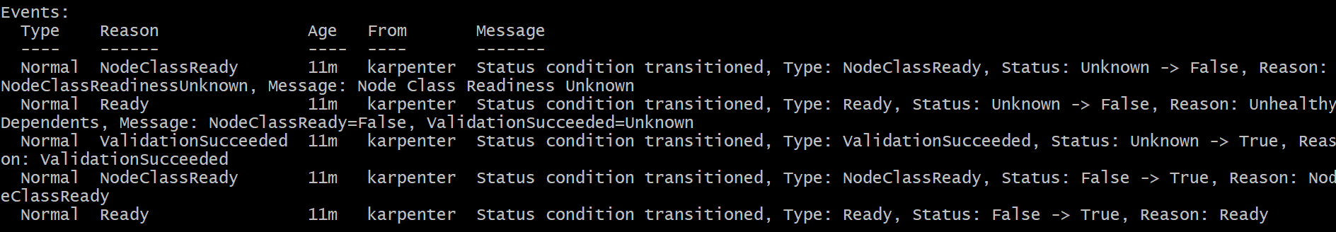

# Change to the project directory
cd 17_02_Karpenter_On-demand_Instances/
# Deploy the autoscaling test deployment
# Note:- Since my ec2 instance type is t3.medium due to that reason I have already update replica count in manifest file from 5 to 10 and after this changes is done in manifest file after that I have deployed the On-demand autoscaling test deployment.
kubectl apply -f kube-manifests-On-demand/On-demand_autoscaling_test.yaml
kubectl get pods
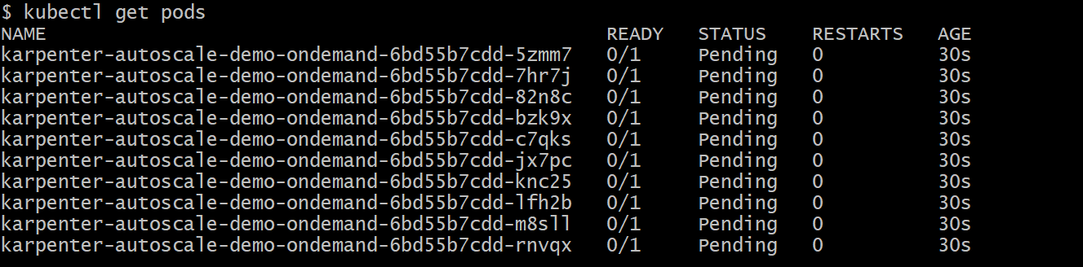
kubectl get nodeclaims
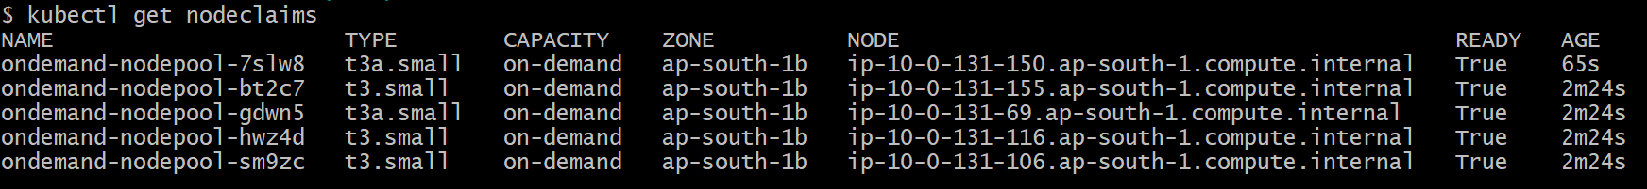
kubectl get nodes
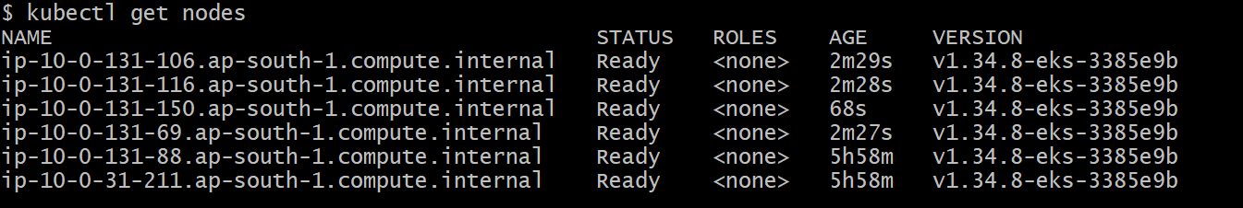

kubectl get pods
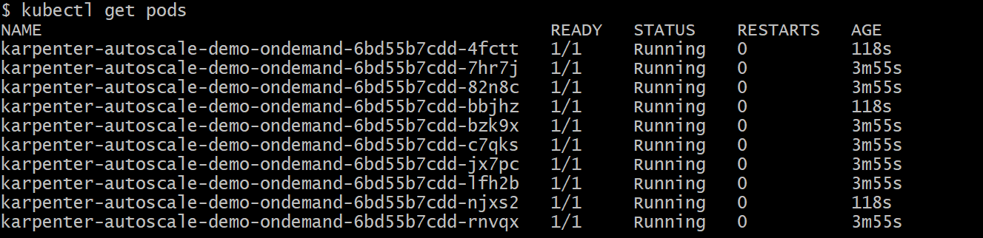
kubectl get nodepools
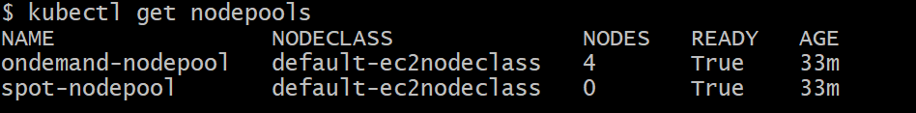
kubectl get deploy
kubectl scale deploy/karpenter-autoscale-demo-ondemand --replicas=5
kubectl get pods
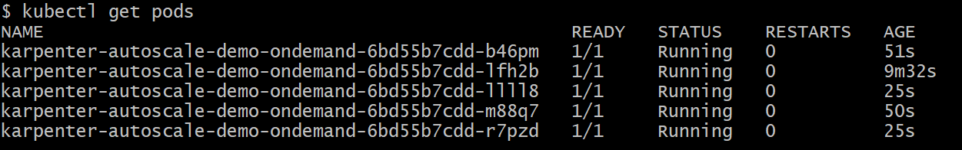
kubectl get nodeclaims
kubectl logs -n kube-system -l app.kubernetes.io/name=karpenter -f
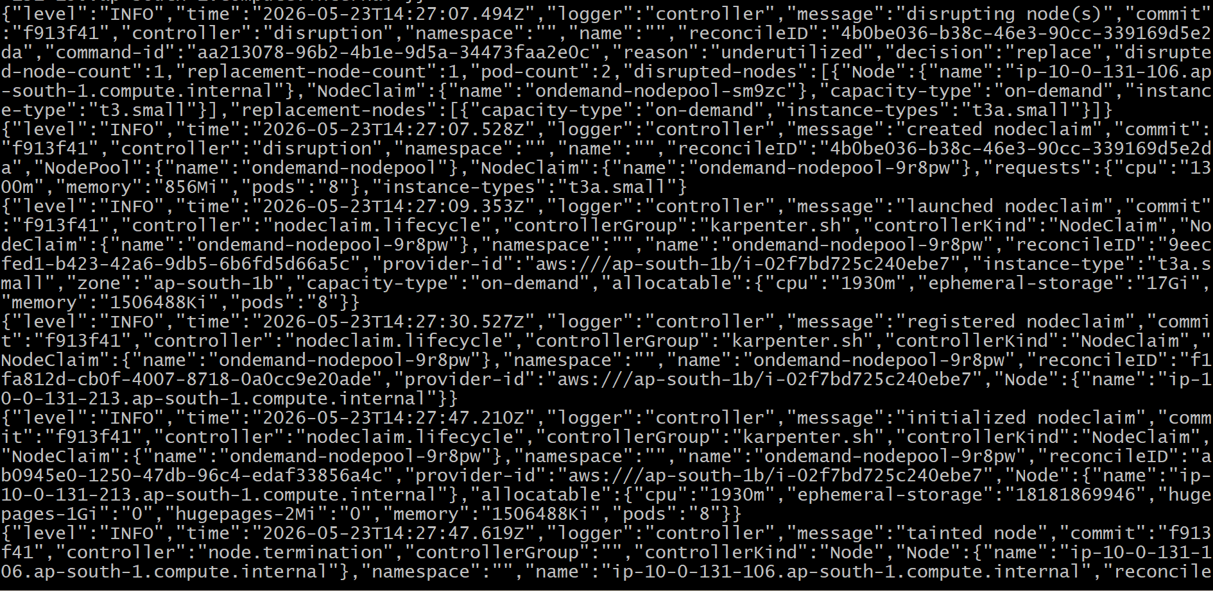
# Delete the deployment
kubectl delete -f kube-manifests-On-demand/
kubectl get nodeclaims
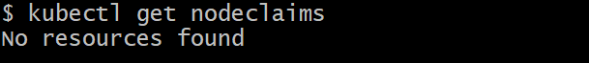
kubectl get pods
# Change to the project directory
cd ../17_03_Karpenter_Spot_Instances/
# Deploy the Spot autoscaling test deployment
kubectl apply -f kube-manifests-Spot/Spot_autoscaling_test.yaml
# Check pod status

kubectl get pods
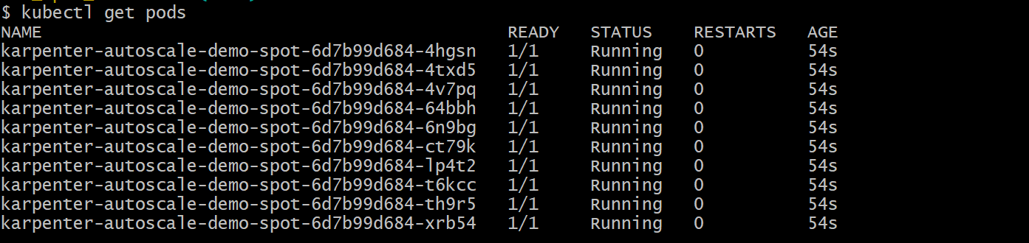
# Check the nodes created by Karpenter
kubectl get nodeclaims
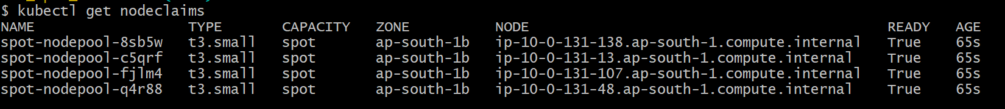
# Filter nodes by capacity-type=spot
kubectl get nodes --selector=karpenter.sh/capacity-type=spot
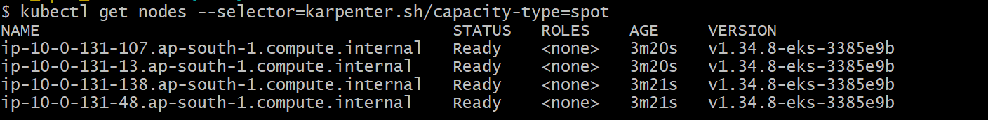
# Check karpenter logs
kubectl logs -n kube-system -l app.kubernetes.io/name=karpenter -f
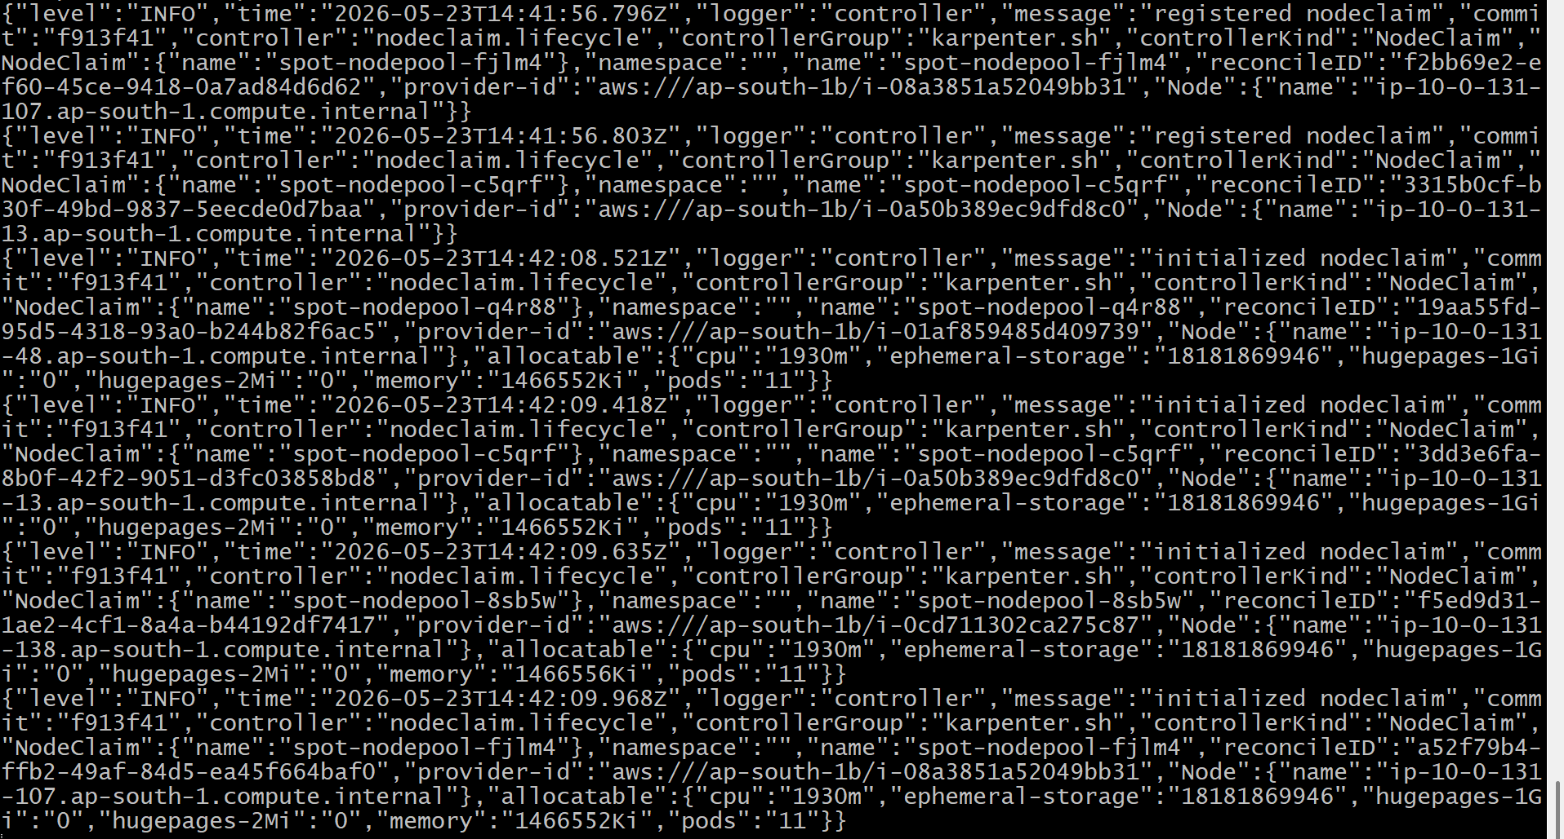
# Delete the deployment
kubectl delete -f kube-manifests-Spot/Spot_autoscaling_test.yaml
kubectl get nodeclaims

kubectl get pods
# Change to the project directory
cd ../17_04_Karpenter_Spot_Interruption_Handling/
# Check Karpenter is running
kubectl get pods -n kube-system -l app.kubernetes.io/name=carpenter
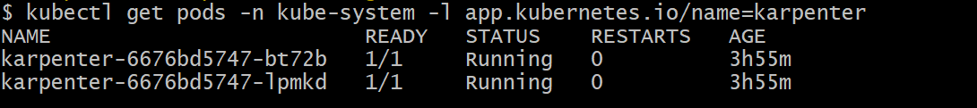
# Verify interruption queue configured
helm get values karpenter -n kube-system | grep interruptionQueue
# Expected: interruptionQueue: retail-dev-eksdemo1-pranav
# Check SQS queue exists
aws sqs list-queues | grep -i retail-dev-eksdemo1-pranav
# Deploy the test app
kubectl apply -f kube-manifests-Spot-Interruption-Handling/Spot_Interruption_Handling.yaml
kubectl get pods -l app=spot-test -o wide
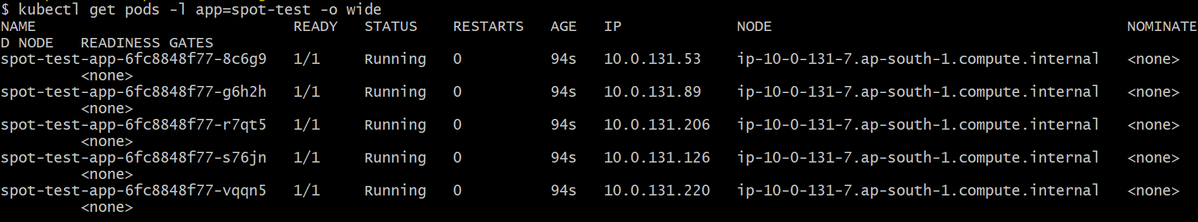
kubectl get nodeclaims
kubectl get nodes
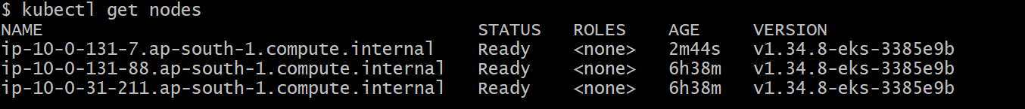
# Before triggering the interruption, open separate 4 terminal windows to check or monitor the logs and overall status.
# Terminal 1: Karpenter Logs (Filtered)
kubectl logs -n kube-system -l app.kubernetes.io/name=karpenter -f | \
grep -E "interrupt|cordon|drain"
# Terminal 2: Node Status
kubectl get nodes -l karpenter.sh/capacity-type=spot -w
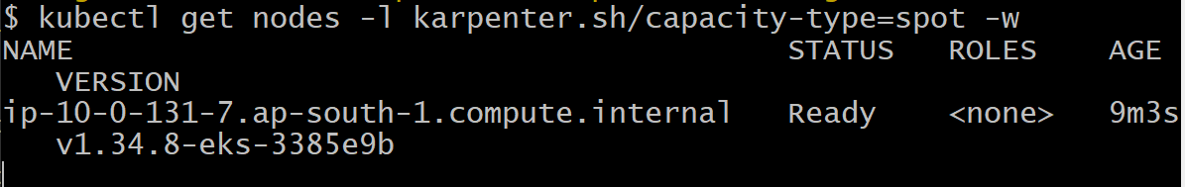

# Terminal 3: Pod Status
kubectl get pods -l app=spot-test -o wide -w
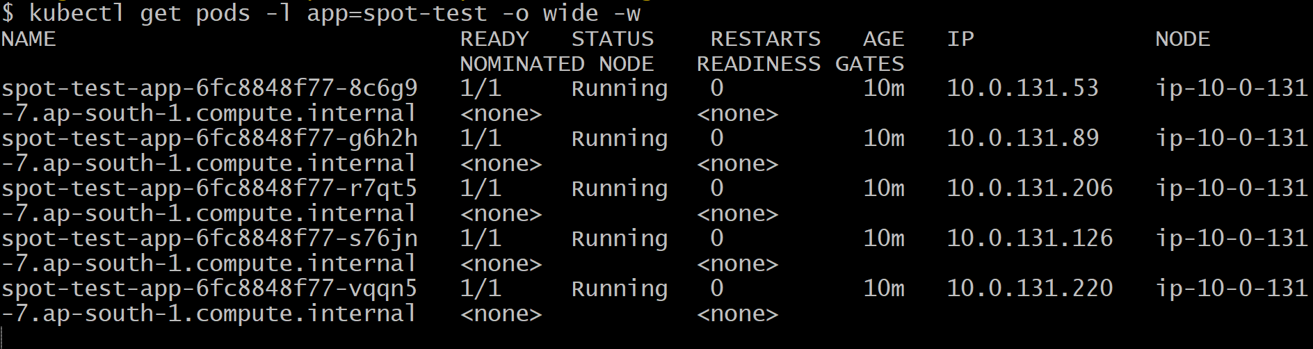

# Terminal 4: NodeClaims
kubectl get nodeclaims -w
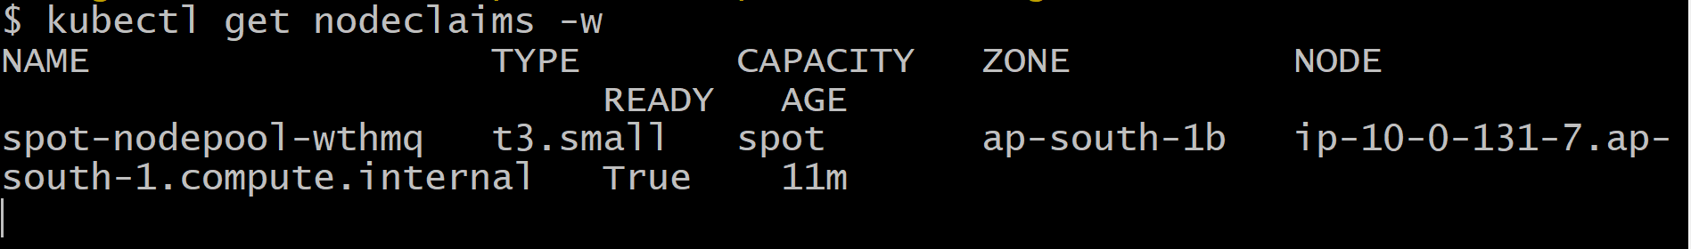
# Get the Spot instance ID
SPOT_INSTANCE_ID=$(kubectl get nodes -l karpenter.sh/capacity-type=spot -o json | \
jq -r '.items[0].spec.providerID' | cut -d'/' -f5)
echo "Target Instance: $SPOT_INSTANCE_ID"

# Get SQS queue URL
CLUSTER_NAME="retail-dev-eksdemo1-pranav"
QUEUE_URL=$(aws sqs get-queue-url --queue-name $CLUSTER_NAME --query QueueUrl --output text)

echo $CLUSTER_NAME
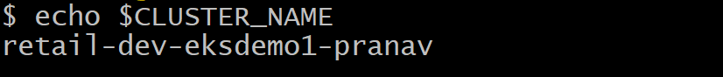
echo $QUEUE_URL
# Send interruption message
aws sqs send-message \
--queue-url "$QUEUE_URL" \
--message-body "{
\"version\": \"0\",
\"id\": \"test-interrupt-$(date +%s)\",
\"detail-type\": \"EC2 Spot Instance Interruption Warning\",
\"source\": \"aws.ec2\",
\"account\": \"123456789012\",
\"time\": \"$(date -u +%Y-%m-%dT%H:%M:%SZ)\",
\"region\": \"ap-south-1\",
\"resources\": [
\"arn:aws:ec2:us-east-1:123456789012:instance/$SPOT_INSTANCE_ID\"
],
\"detail\": {
\"instance-id\": \"$SPOT_INSTANCE_ID\",
\"instance-action\": \"terminate\"
}
}"
Note:- For security reason I have replaced aws account id with dummy id in the above-mentioned AWS CLI command.
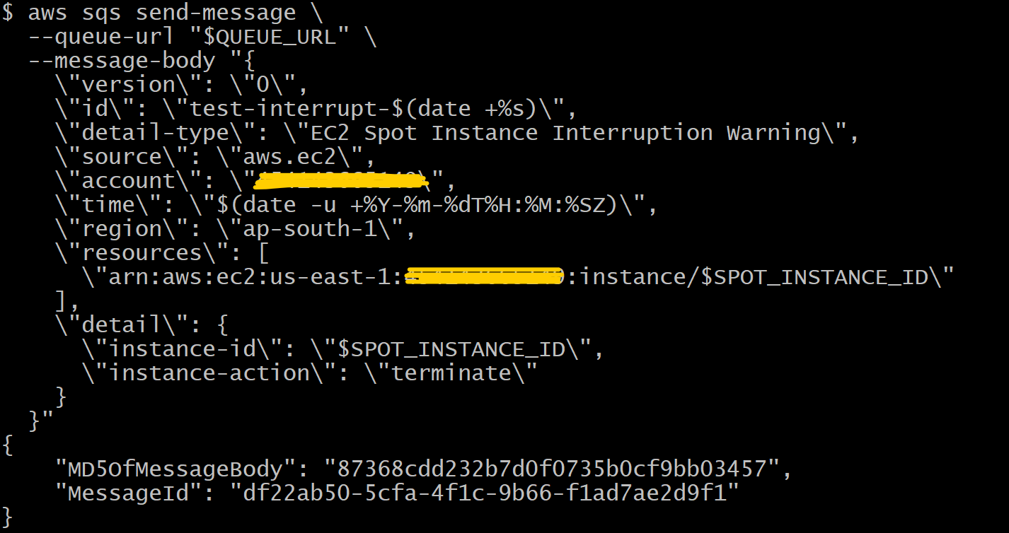

kubectl logs -n kube-system -l app.kubernetes.io/name=karpenter -f | \
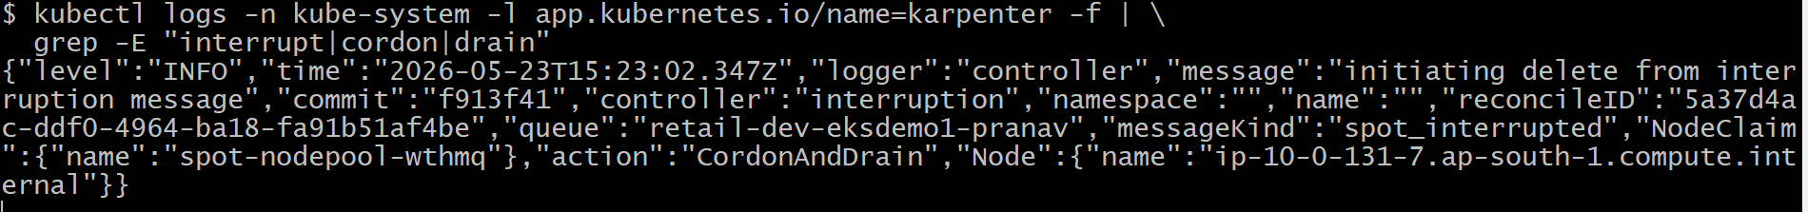
kubectl get nodes -l karpenter.sh/capacity-type=spot -w
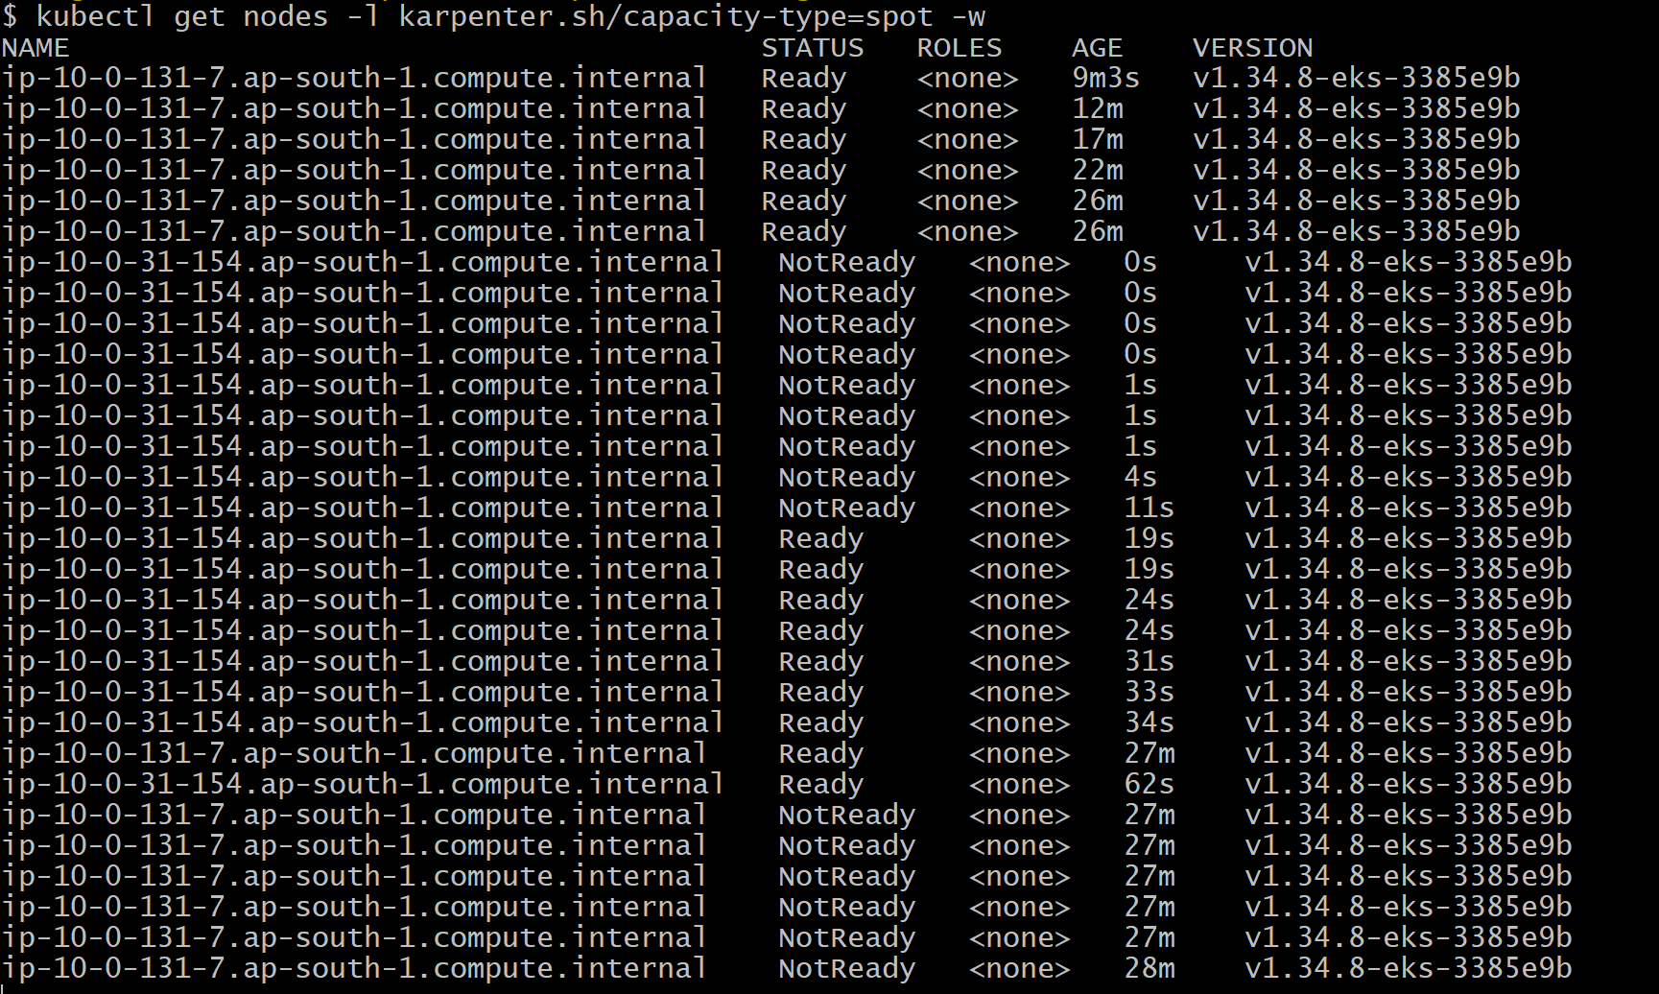

kubectl get pods -l app=spot-test -o wide -w
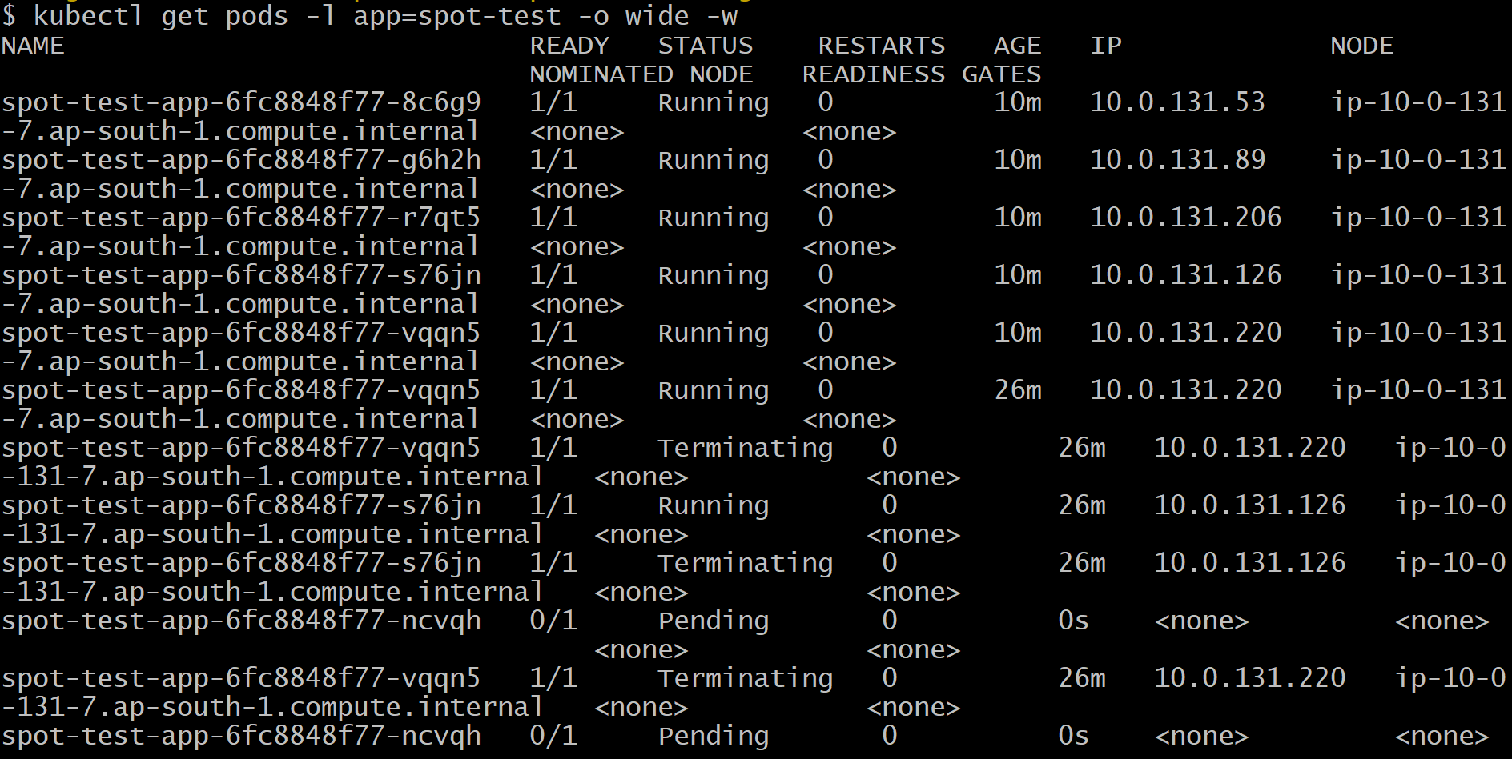
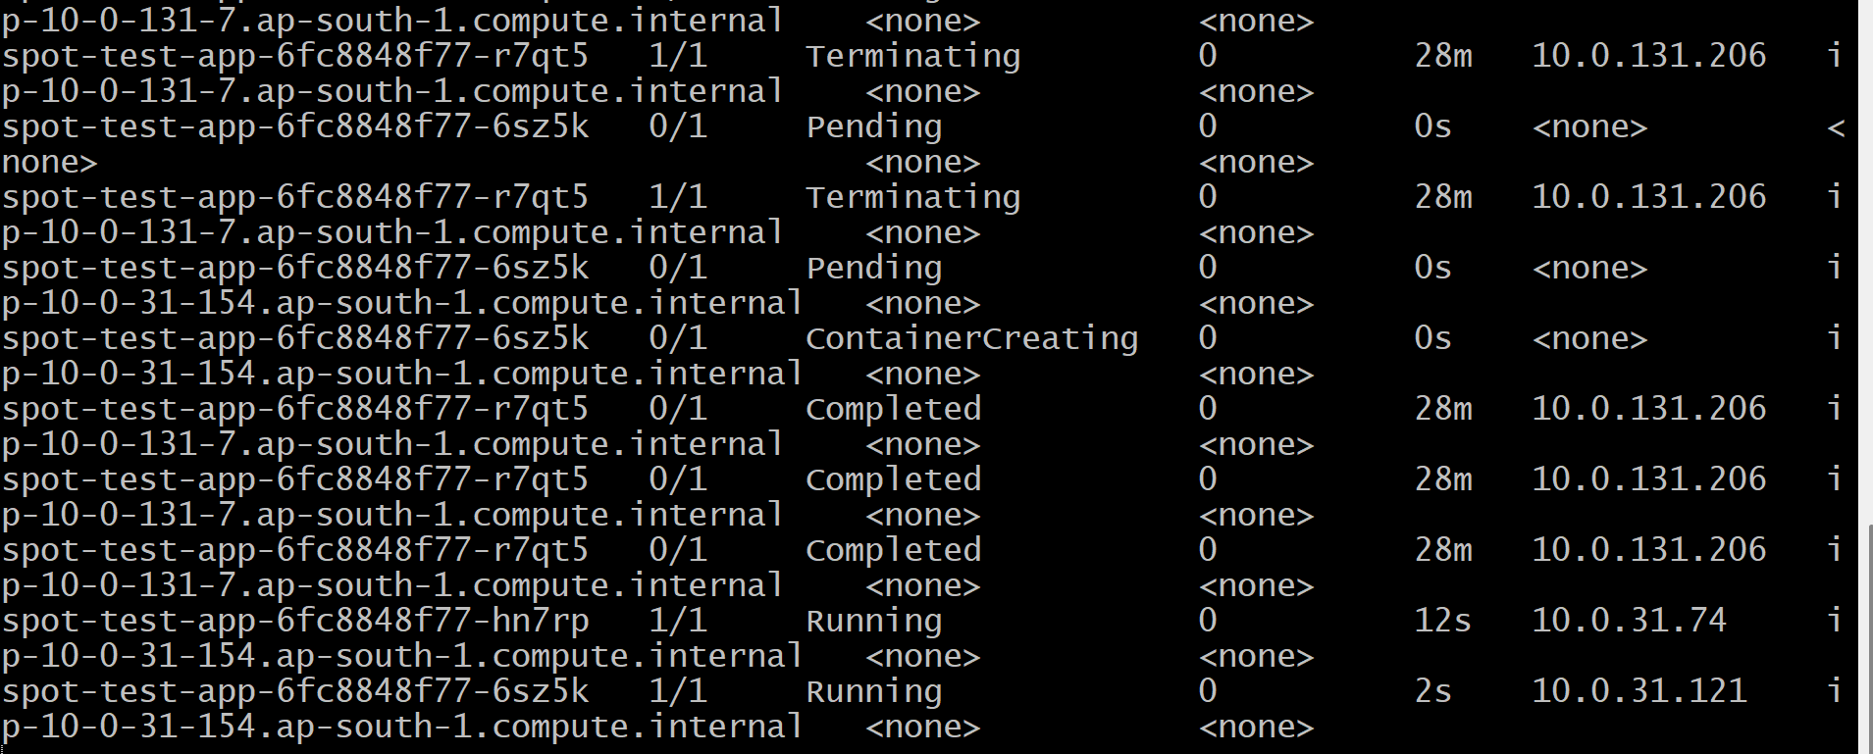
kubectl get pods
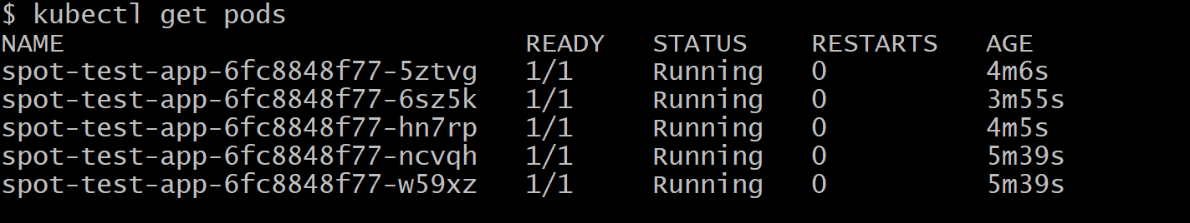
kubectl get pods -l app=spot-test -o wide
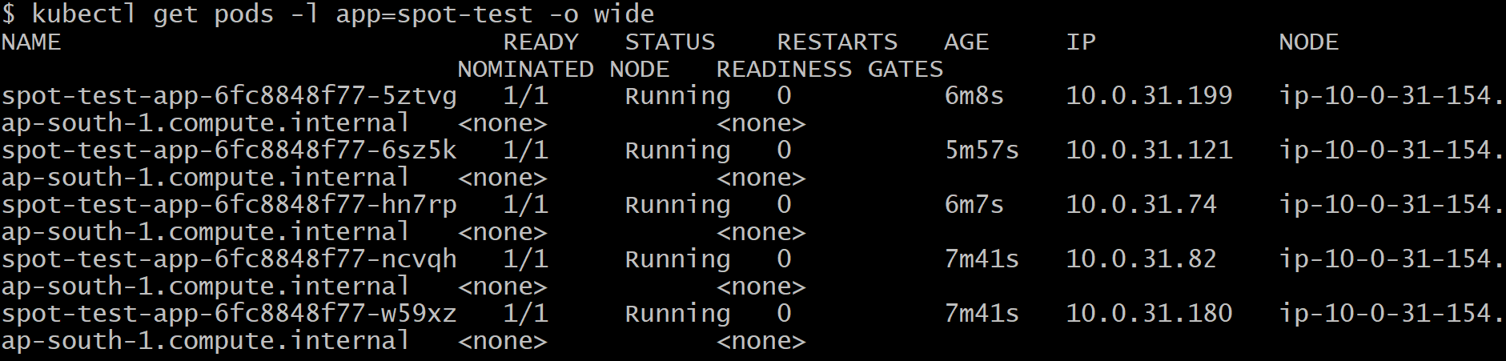
kubectl get nodeclaims -w
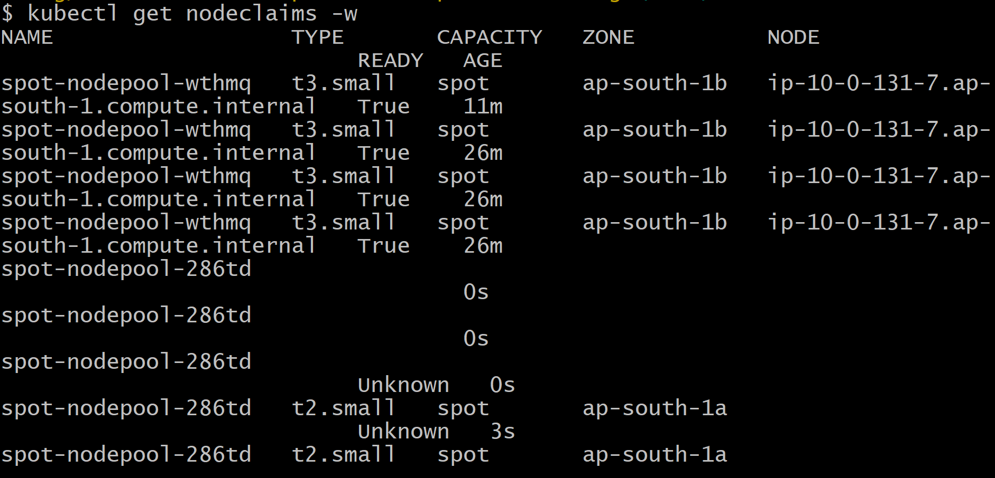
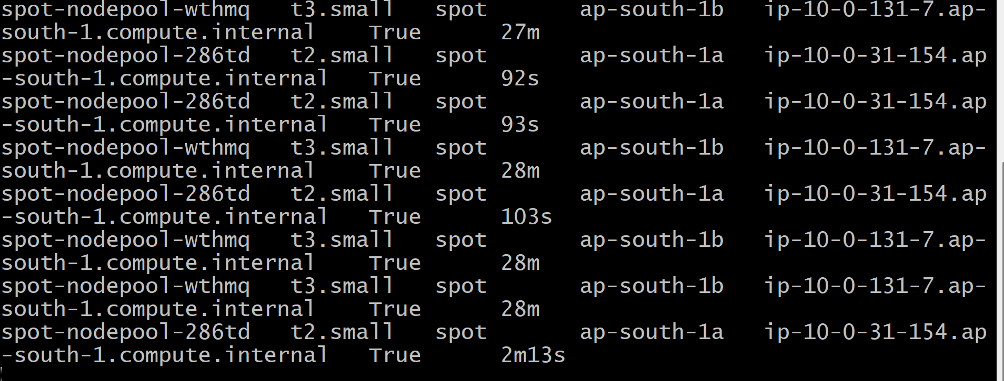
kubectl get nodeclaims

# Delete the test deployment
kubectl delete -f kube-manifests-Spot-Interruption-Handling/Spot_Interruption_Handling.yaml
kubectl get nodeclaims
kubectl get pods
# Step 1: Delete Karpenter nodes first (optional but cleaner)
kubectl delete nodepools –all
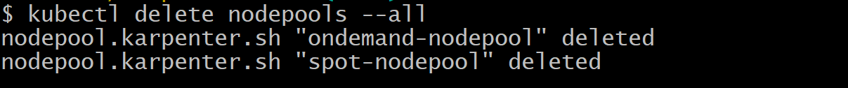
## Verify all Karpenter nodes are terminated
kubectl get nodes -l karpenter.sh/nodepool
- Destroy Karpenter infrastructure
cd ../03_KARPENTER_terraform-manifests
terraform destroy -auto-approve
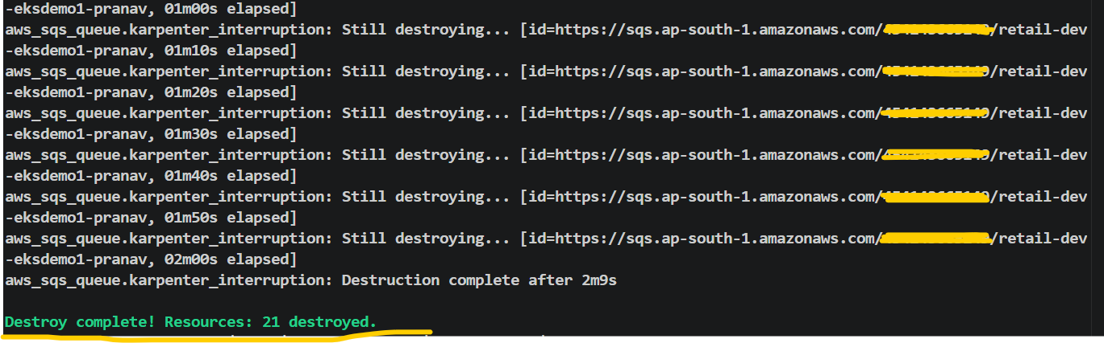

- Deleted EKS Cluster, Add ons, Node group, Iam roles for through terraform destroy –auto-approve command.

