Steps:-
- Copy terraform code from 18_05_2026 folder into 19_05_2026 folder and added additional terraform configuration files from instructor code into 19_05_2026 this folder.
- Update the Terraform code as per the requirements, such as updating the node_instance_types size from t3.small to t3.medium in the terraform.tfvars file. Also, update my current ISP IP in the cluster_endpoint_public_access_cidrs section of the c2_variables.tf Terraform file.
Additionally, update the IAM role and policy names in the c14-02-lbc-iam-policy-and-role.tf and c15-01-ebscsi-iam-policy-and-role.tf Terraform files.
Also, update the node group configuration aws_eks_node_group.private_nodes in the below mentioned Terraform files.

c14-04-lbc-helm-install.tf
c15-03-ebscsi-eksaddon.tf
c16-01-secretstorecsi-helm-install.tf
c16-02-secretstorecsi-ascp-helm-install.tf
Note:- 1. Since I did not deploy a private subnet due to the unavailability of a NAT Gateway, and creating my own NAT Gateway would incur additional costs, I chose not to create one for cost optimization purposes. As a result, I deployed my node group EC2 instances in a public subnet.
2. I am also aware that, from a best practices and security perspective, node group EC2 instances should be hosted in a private subnet rather than a public subnet. However, this is not a production-grade EKS cluster; I am deploying it only for practical testing purposes. Therefore, I hosted the node group EC2 instances in a public subnet.
3. For my previous practical’s, I have also used only public subnets, and for upcoming practical’s, I will continue to use public subnets only.

- Run below mentioned terraform commands to deploy the EKS Cluster through terraform

terraform init
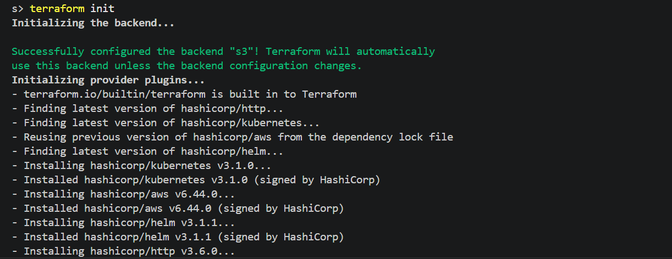

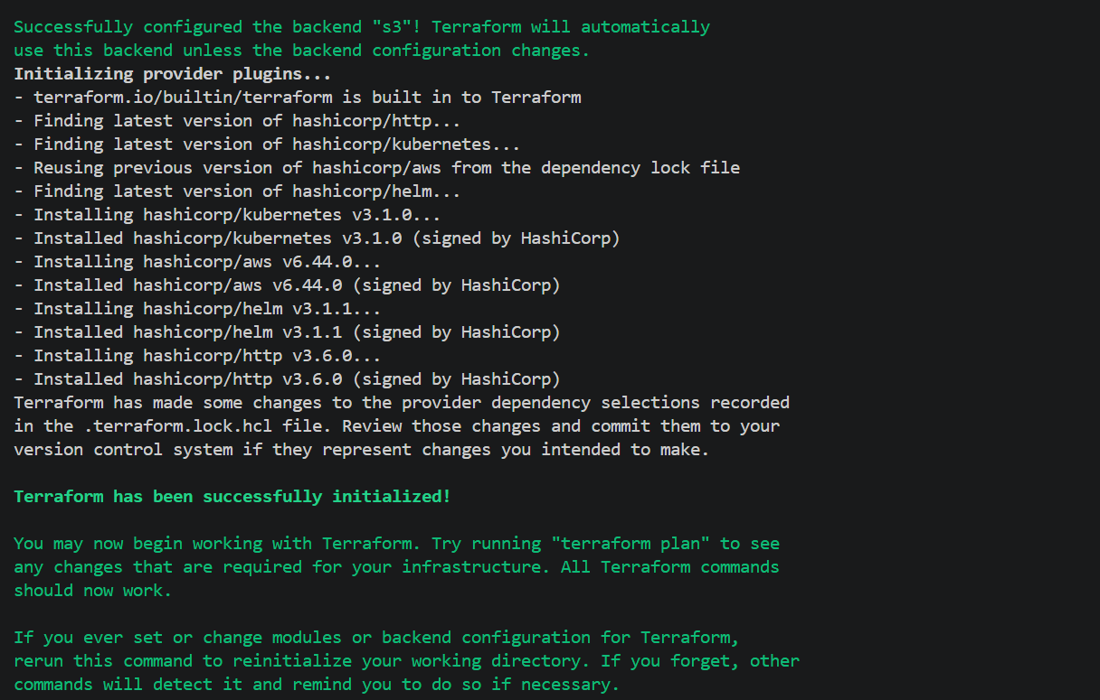

terraform validate

terraform plan
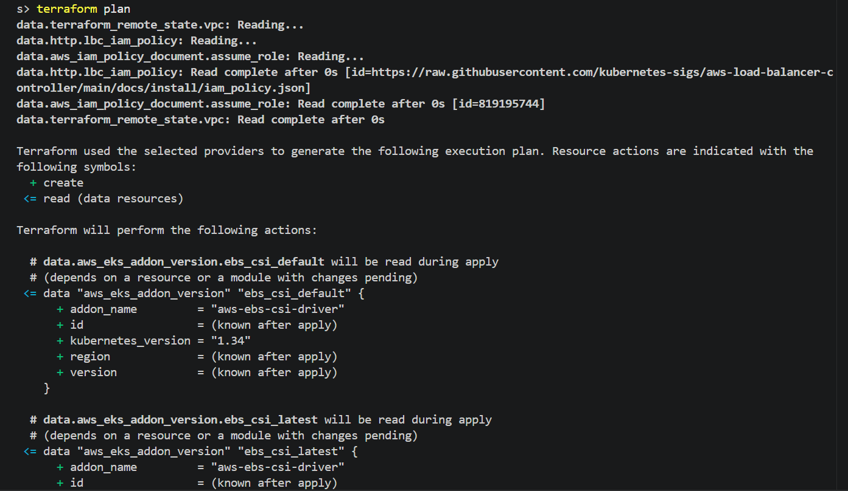

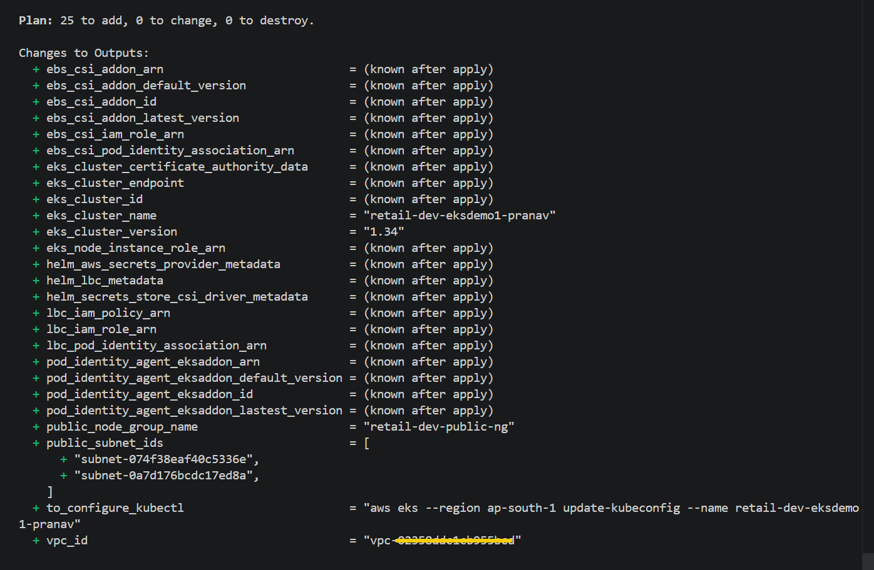
terraform apply –auto-approve
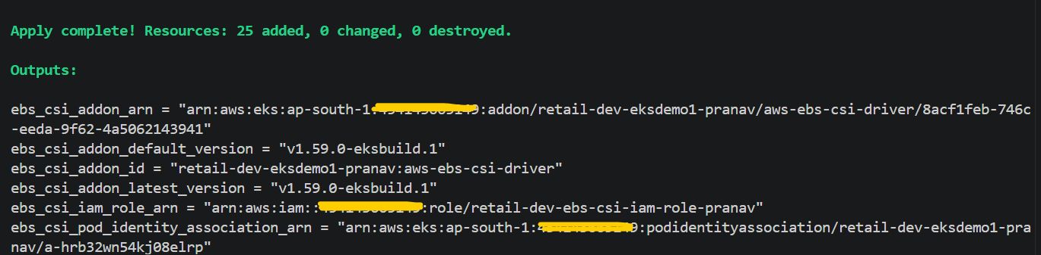
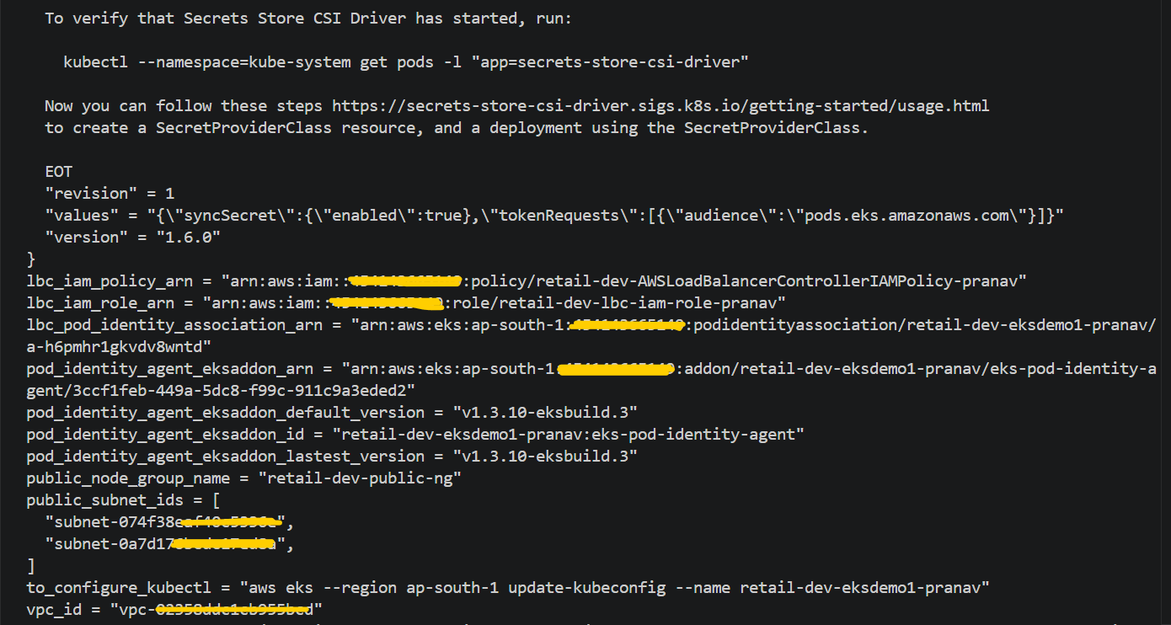
# Verified EKS Cluster and its configuration from AWS console
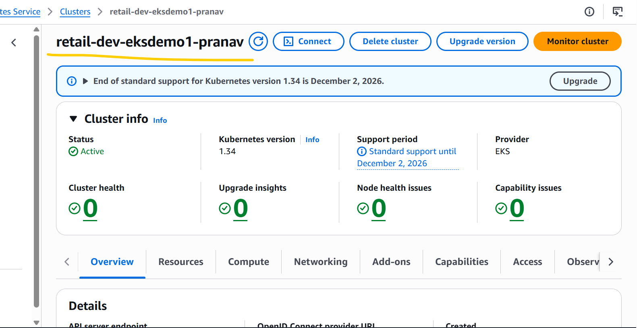

# EKS Node Group Instance Type Size

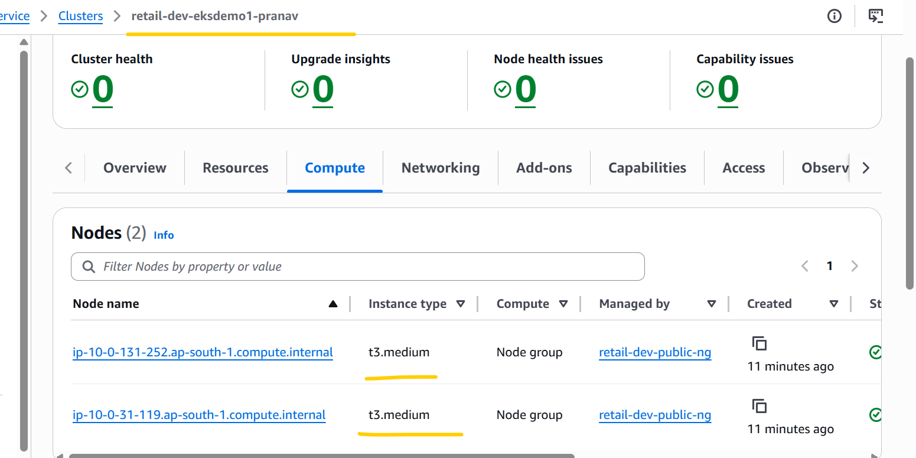

# EKS Cluster Add-ons.

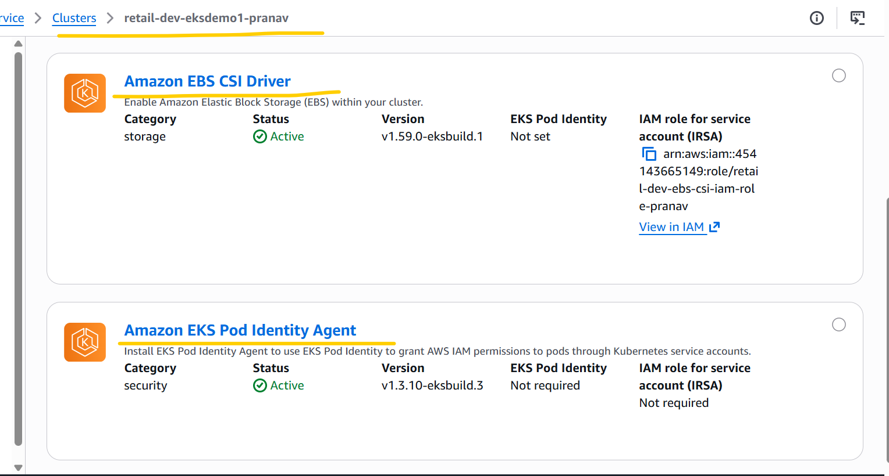

# EKS Cluster Pod Identity associations.

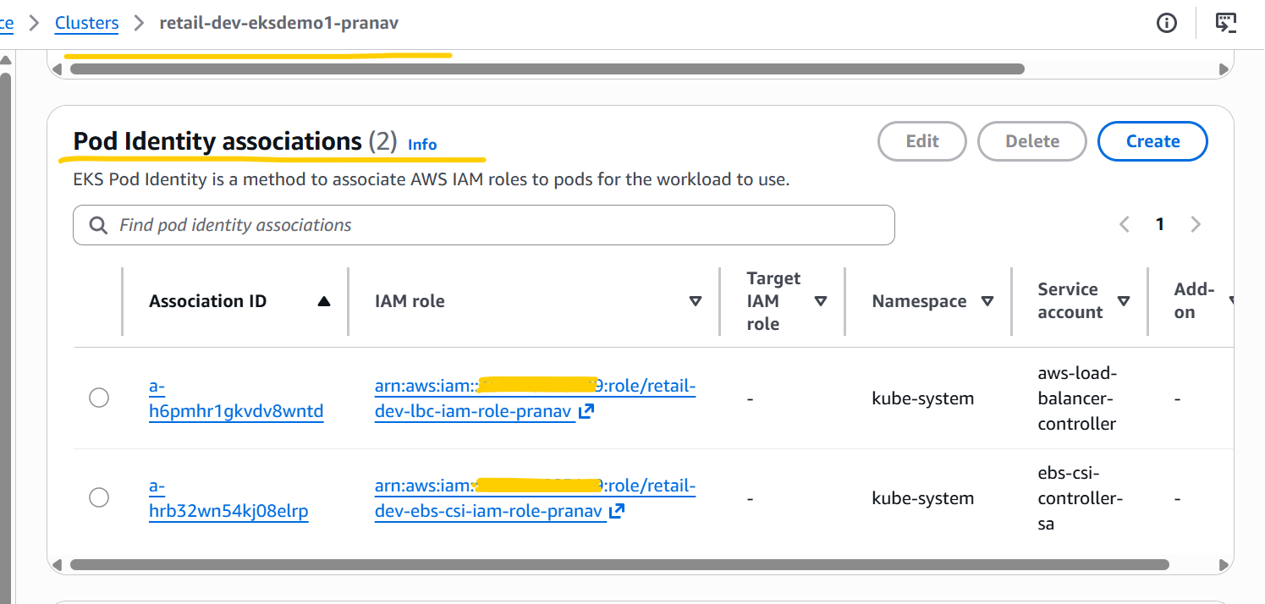

- Deleted EKS Cluster, Add ons, Node group, Iam roles for through terraform destroy –auto-approve command.

