Steps:-
- Created EKS Cluster, Node group and require Iam roles for the same through terraform. To do the same copy terraform code from 08_05_2026 folder into 11_05_2026.

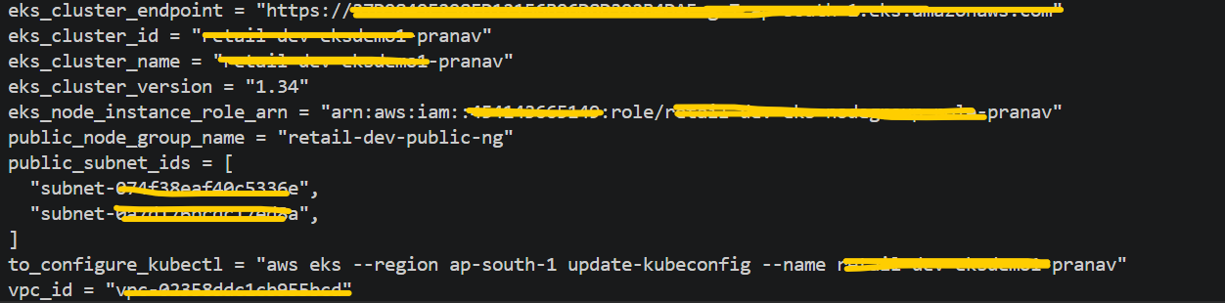

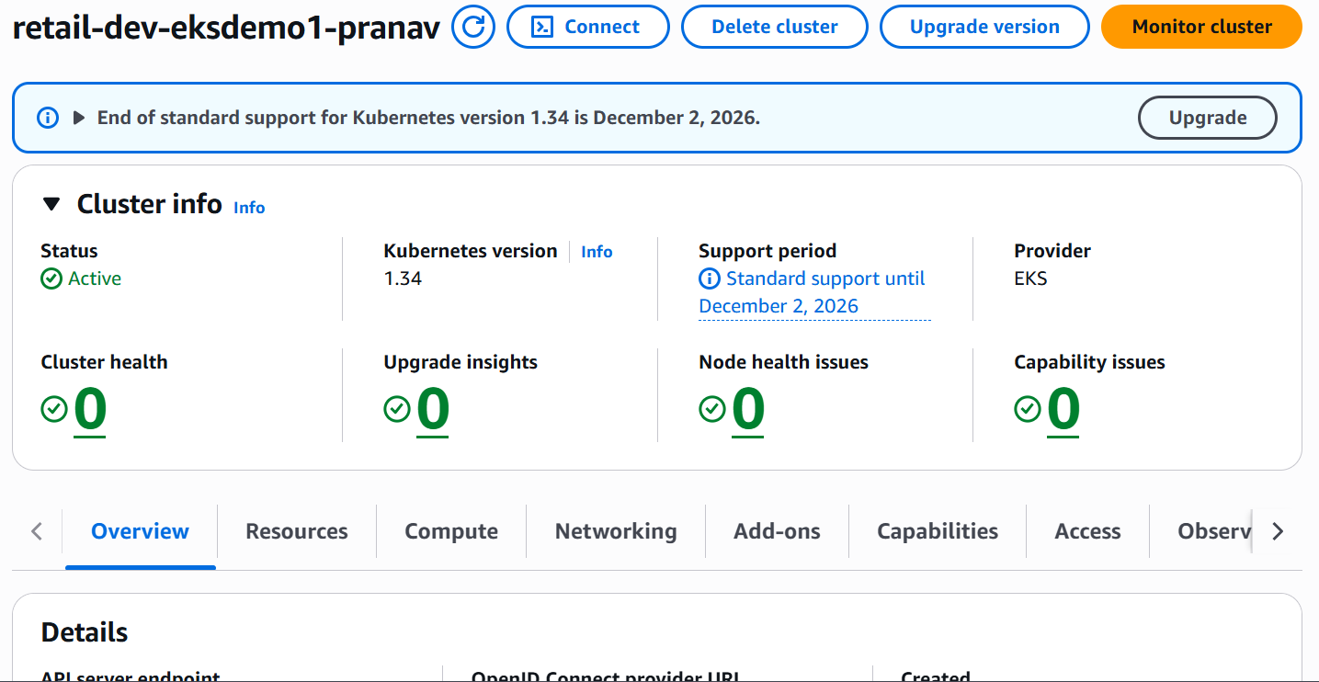

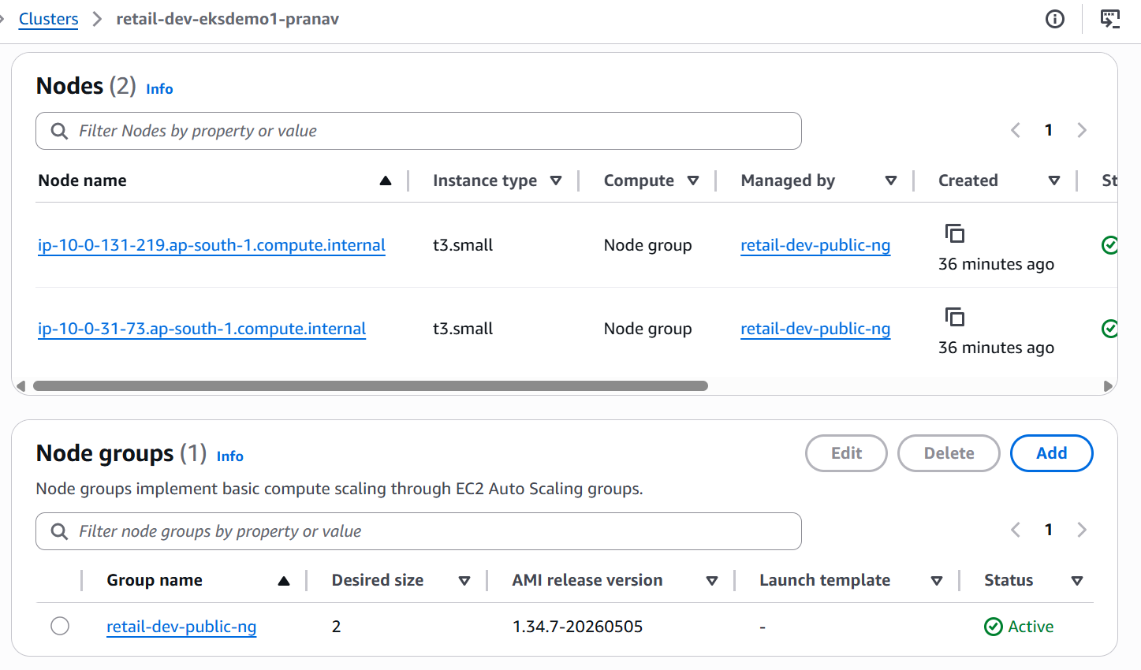

- Run below command to verify whether kubectl command is working or not and verify kubectl version.
kubectl version --client
- Run below command to access EKS Cluster from my system / laptop.
aws eks --region ap-south-1 update-kubeconfig --name retail-dev-eksdemo1-pranav
- Run below commands one by one.
Through kubectl apply -f catalog_k8s_manifests/ this command deployed deployment, service and config map.

kubectl get nodes

kubectl get pods

kubectl apply -f catalog_k8s_manifests/

kubectl get deploy

kubectl get rs

kubectl get cm

kubectl get pods

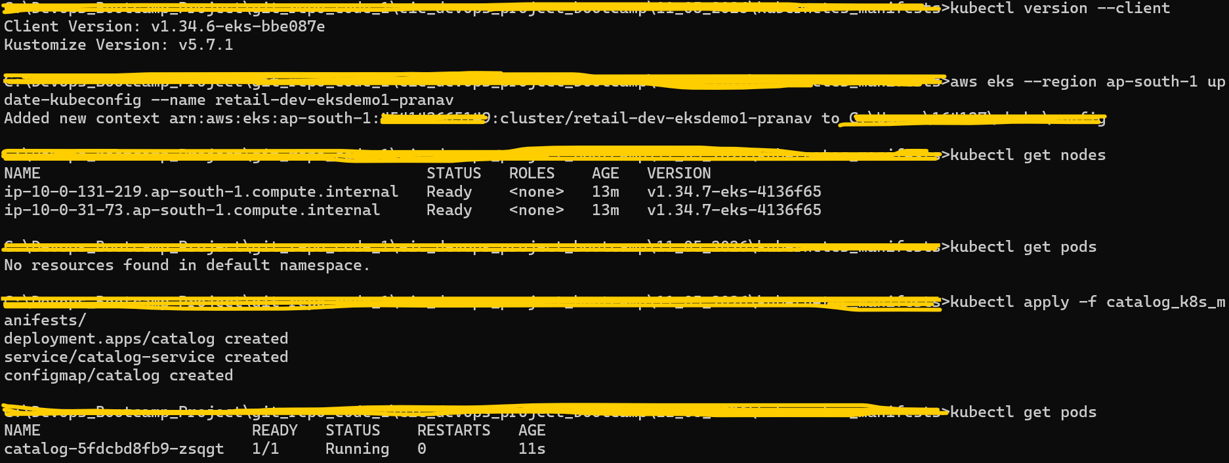

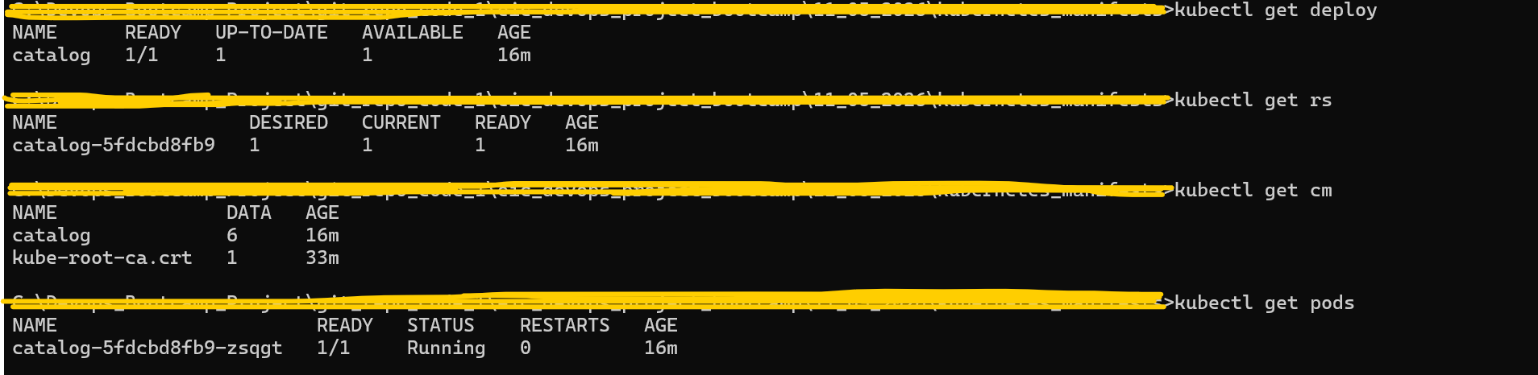

- Run kubectl exec -it catalog-5fdcbd8fb9-zsqgt – env this command to check environment variables from catalog-5fdcbd8fb9-zsqgt this pod.

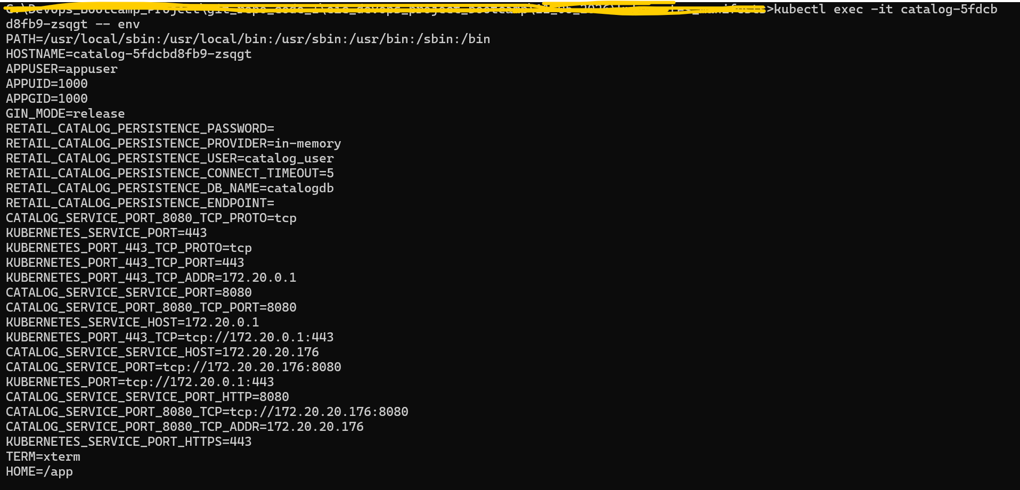

- Run kubectl delete -f catalog_k8s_manifests/ this command to delete deployment, service and config map.

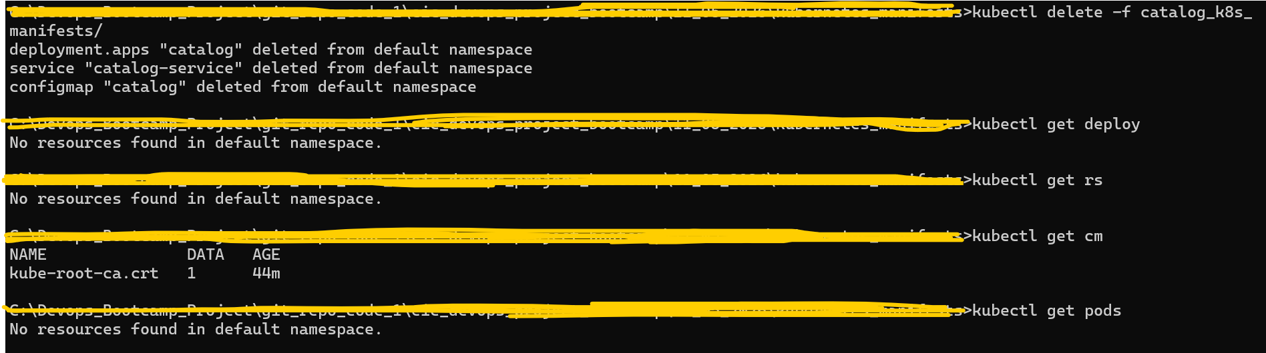

- Deleted EKS Cluster, Node group and Iam roles for through terraform destroy command.

