Steps:-
- Copied EKS and AWS Data Plane terraform code from 25_05_2026 this folder into 26_05_2026 this folder.
Note:- 1. Since I did not deploy a private subnet due to the unavailability of a NAT Gateway, and creating my own NAT Gateway would incur additional costs, I chose not to create one for cost optimization purposes. As a result, I deployed my node group EC2 instances, Karpenter EC2 instance, RDS DB’s and ElastiCache resources in a public subnet.
2. I am also aware that, from a best practices and security perspective, node group EC2 instances, Karpenter EC2 instance, RDS DB’s and ElastiCache resources should be hosted in a private subnet rather than a public subnet. However, this is not a production-grade EKS cluster; I am deploying it only for practical testing purposes. Therefore, I hosted the node group EC2 instances, Karpenter EC2 instance, RDS DB’s and ElastiCache resources in a public subnet.
3. For my previous practical’s, I have also used only public subnets, and for upcoming practical’s, I will continue to use public subnets only.

- Run below mentioned terraform commands to deploy the EKS Cluster through terraform

terraform init
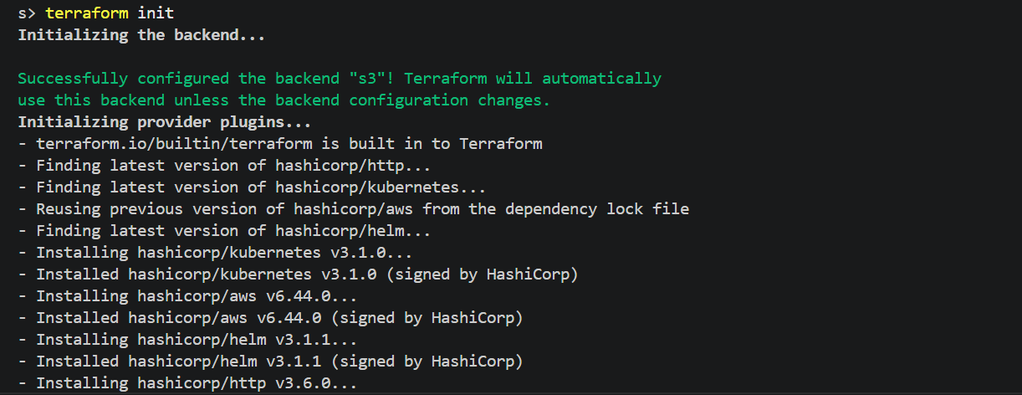

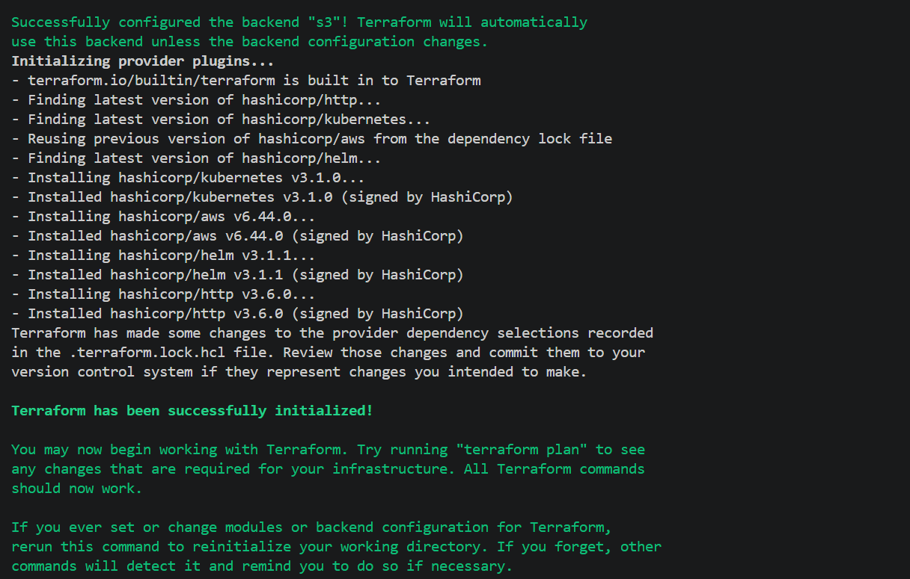

terraform validate

terraform plan
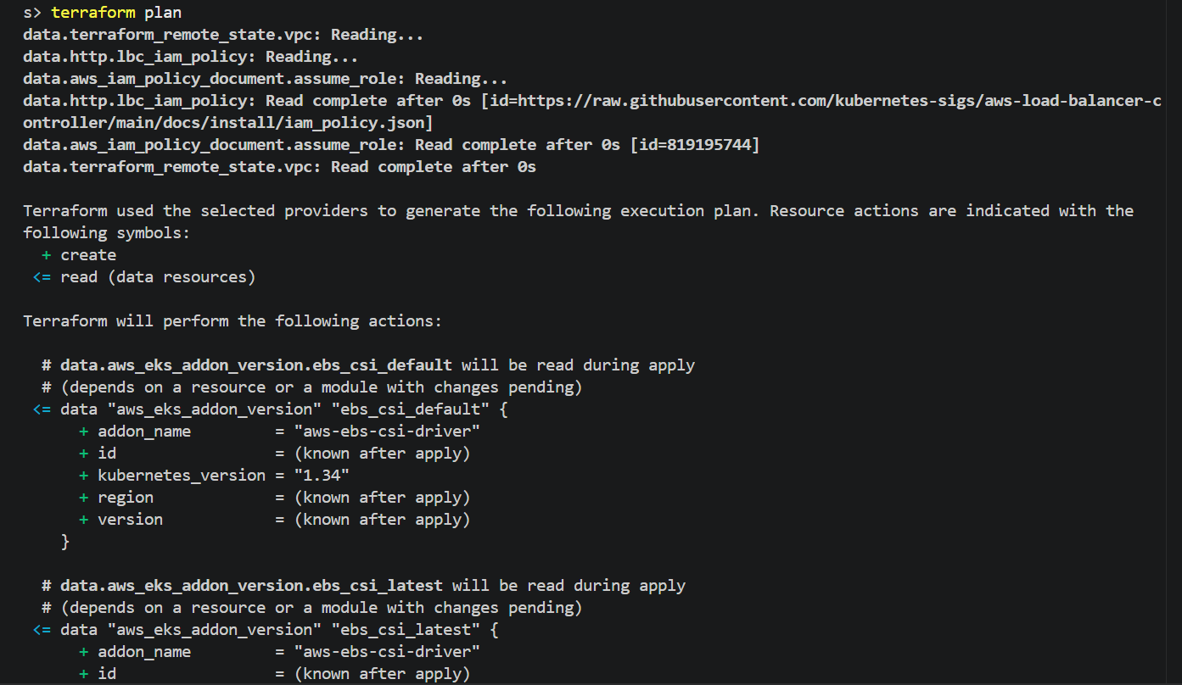

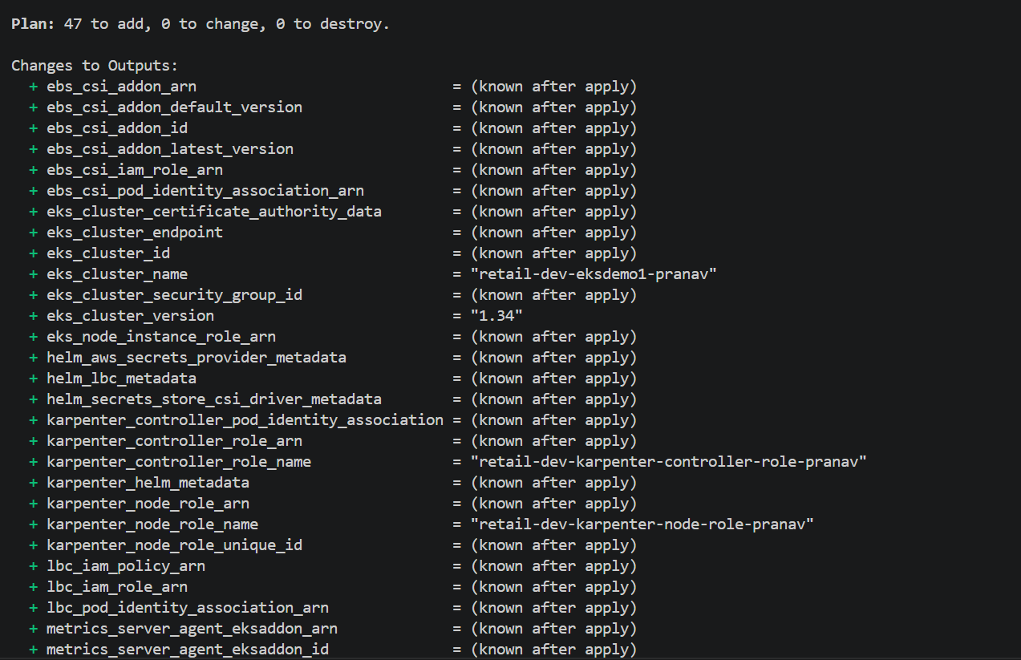
terraform apply –auto-approve
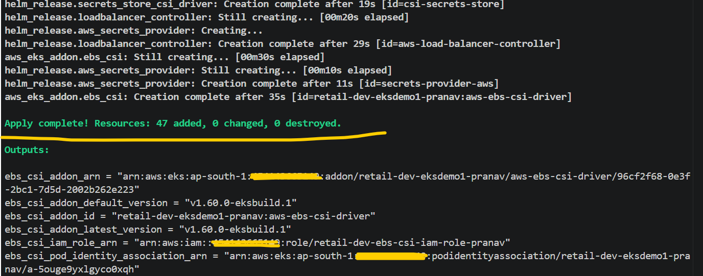

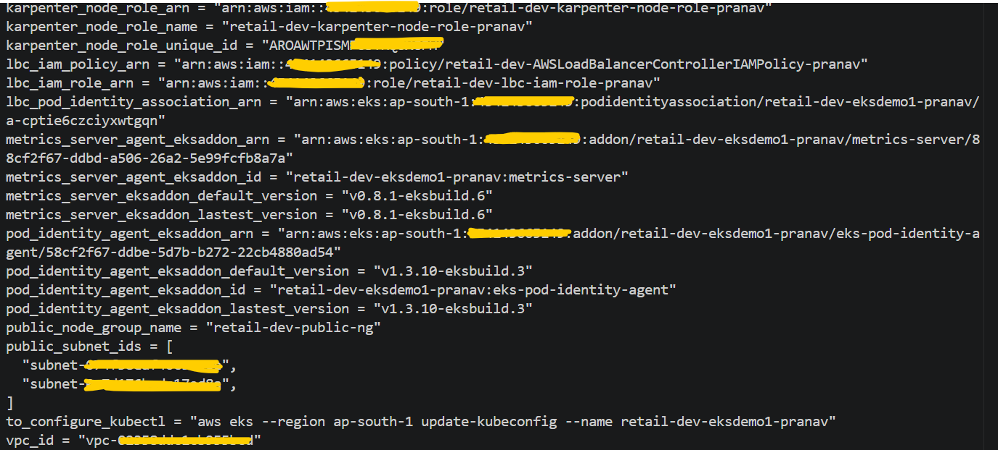
# Verified EKS Cluster and its configuration from AWS console
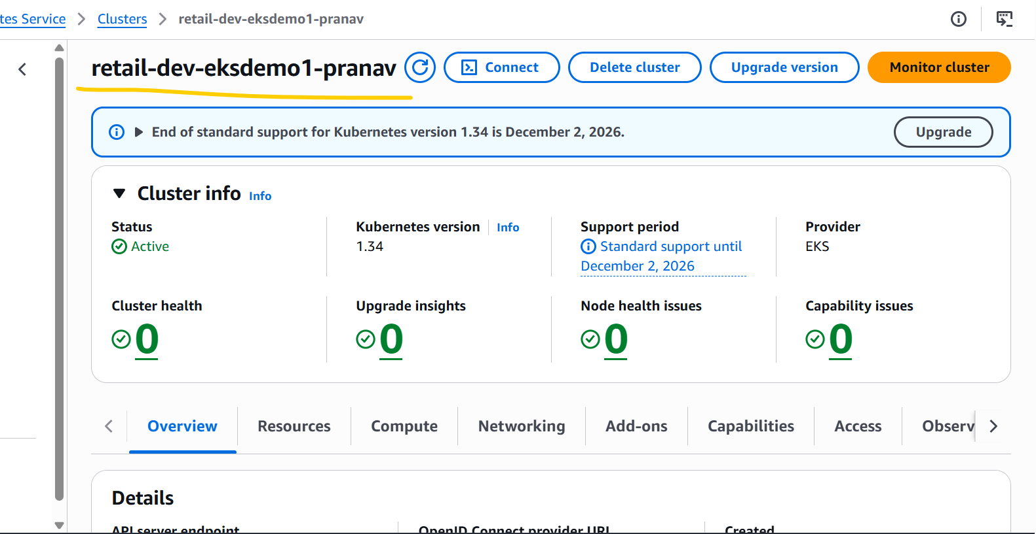

# EKS Node Group Instance Type Size

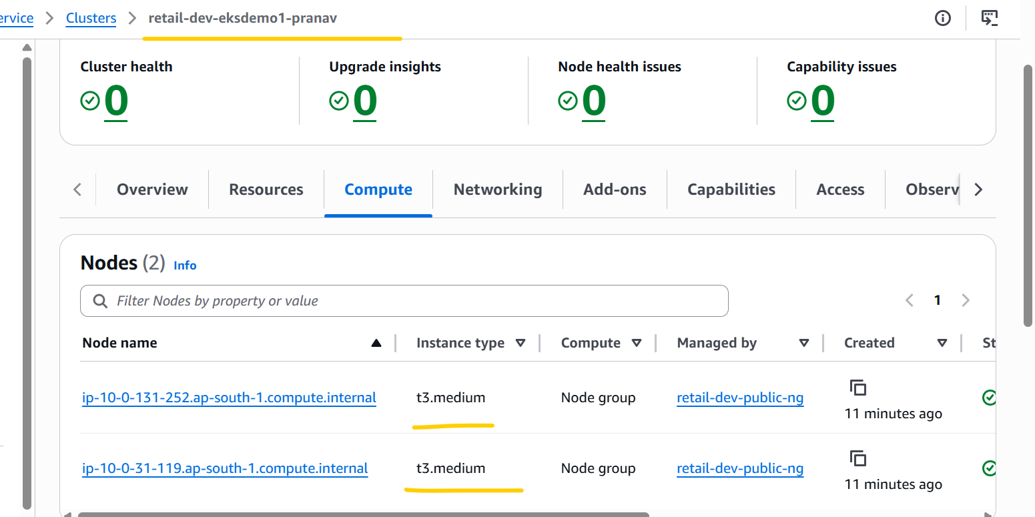

# EKS Cluster Add-ons.
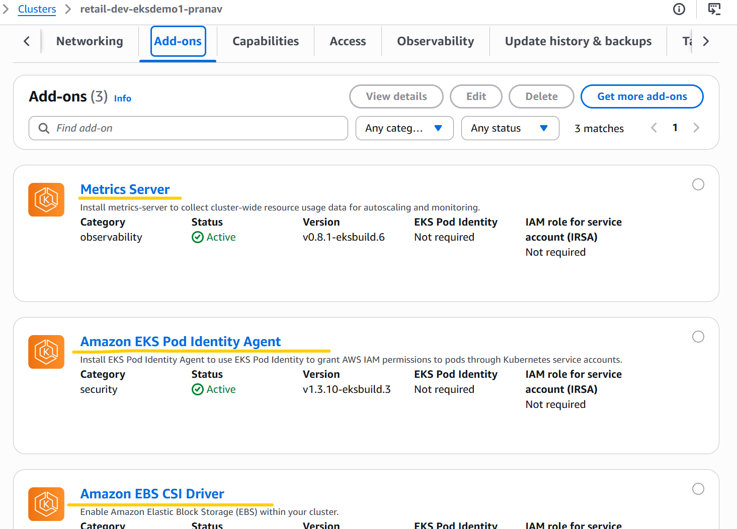

# EKS Cluster IAM access entries
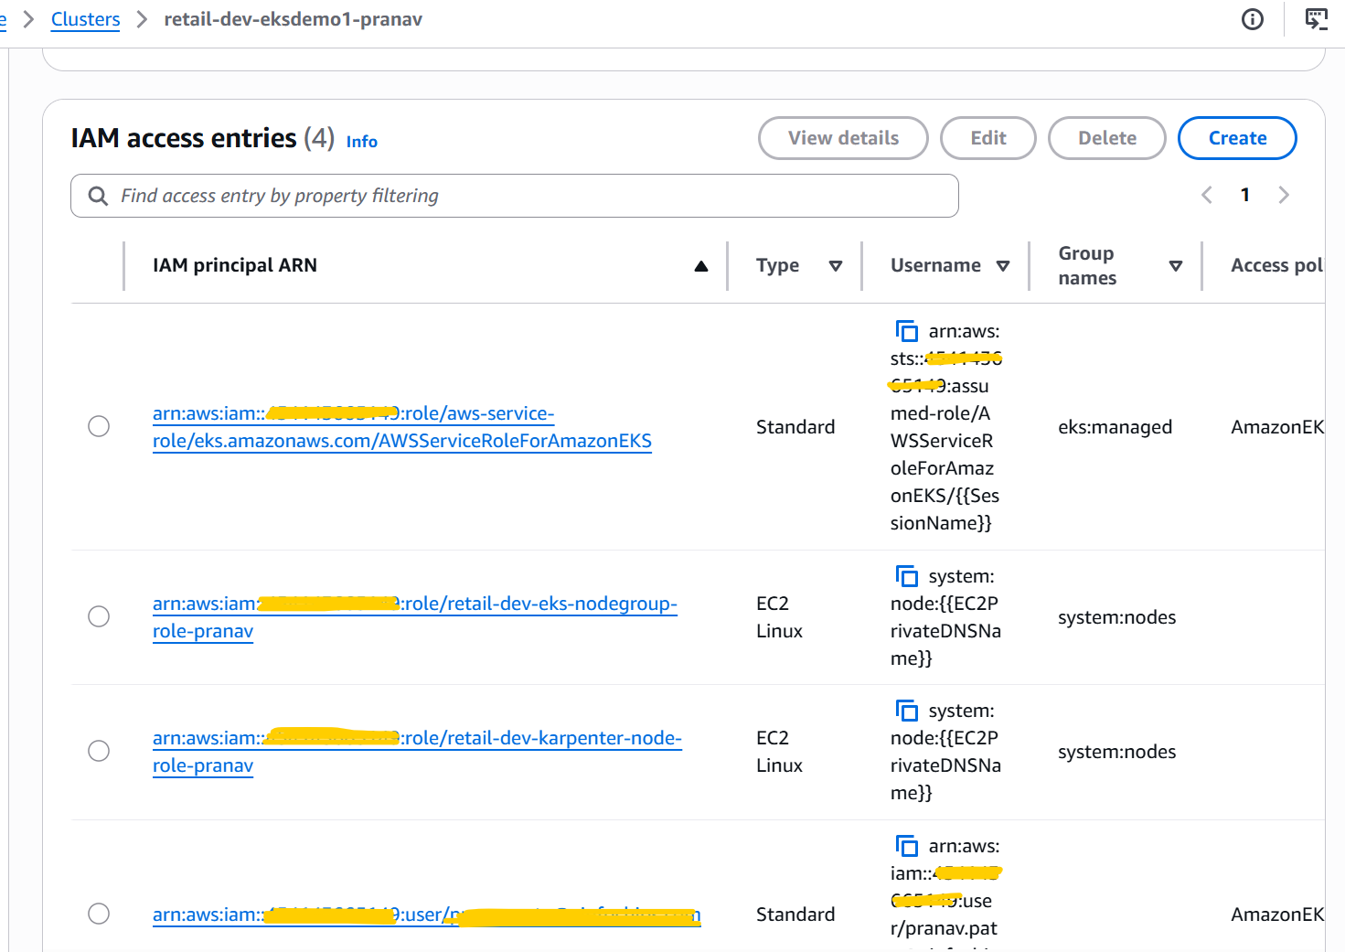

# EKS Cluster Pod Identity associations.
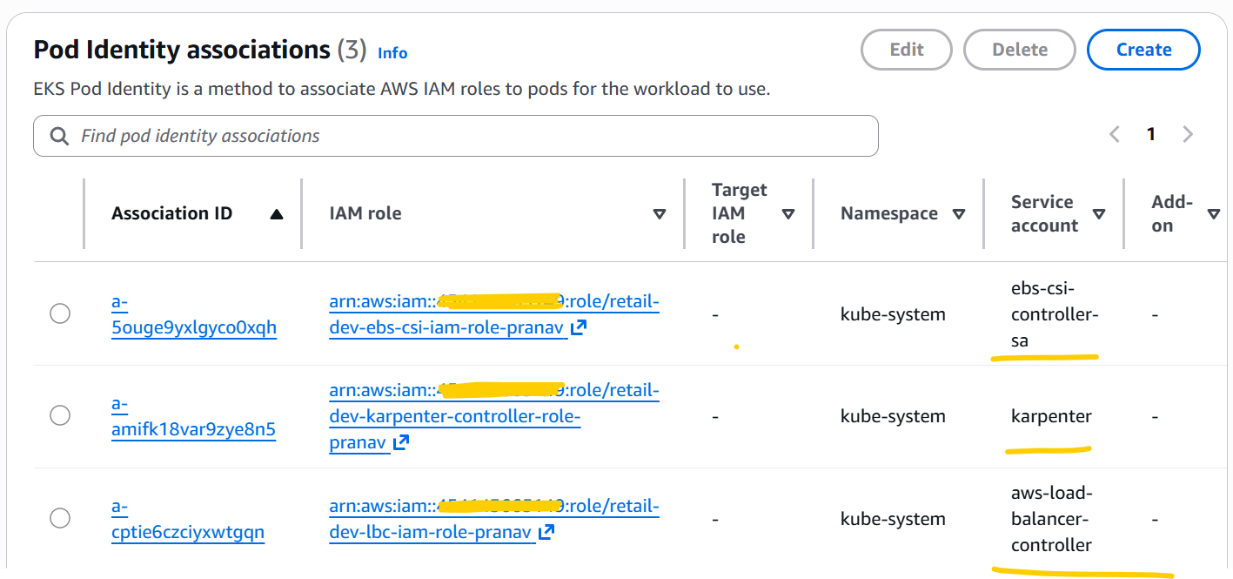

- Copied OPENTELEMTRY_terraform_manifests terraform configuration files from instructor code into 26_05_2026 this folder and update OPENTELEMTRY terraform configuration files as per requirements and run below terraform commands to deploy the same.
Note:- When I requested access from Maharshi for the AWS IAM Identity Center service to use or access Amazon Grafana service, he refused to provide access because our organization cannot use SSO, and therefore IAM Identity Center is not required. Due to this reason, I excluded all three Grafana-related Terraform configuration files from the OPENTELEMETRY_terraform_manifests this terraform project and deployed the OPENTELEMTRY related remaining resources through terraform.
terraform init
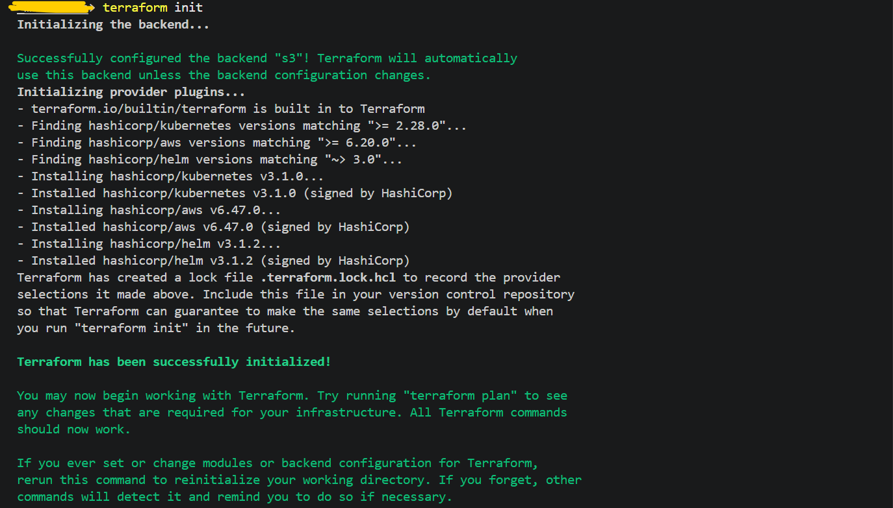
terraform validate
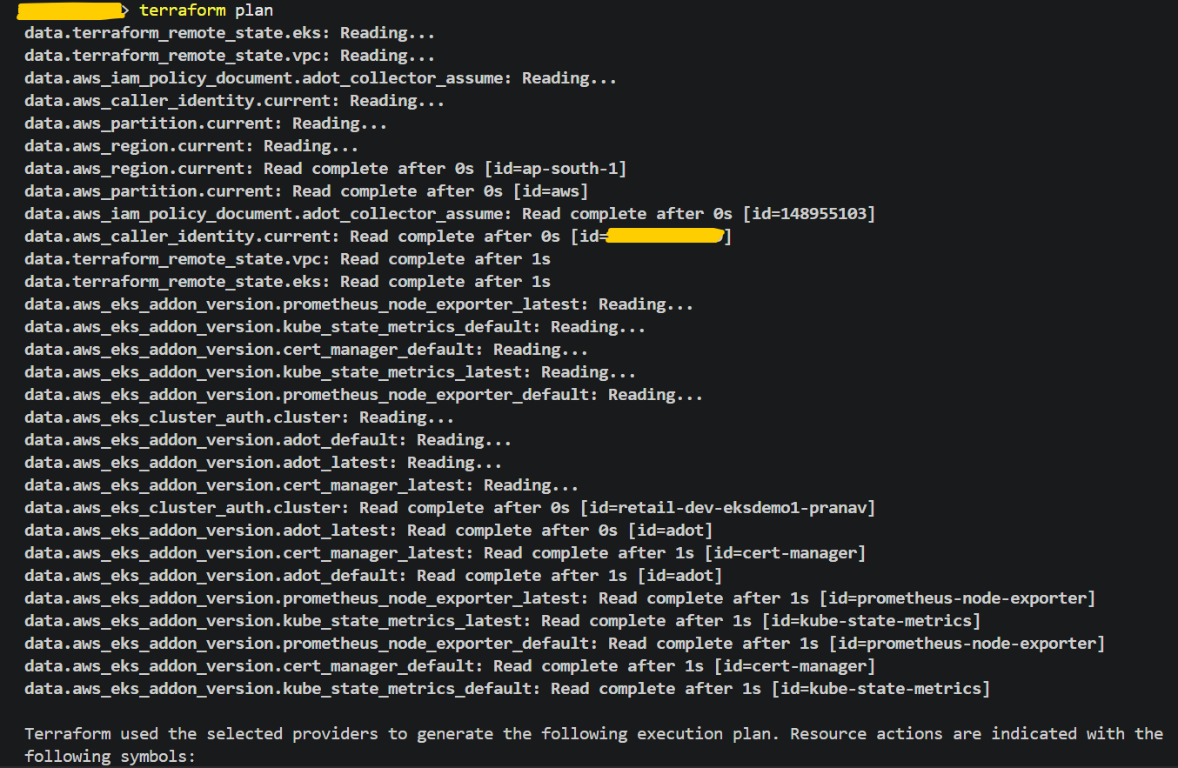
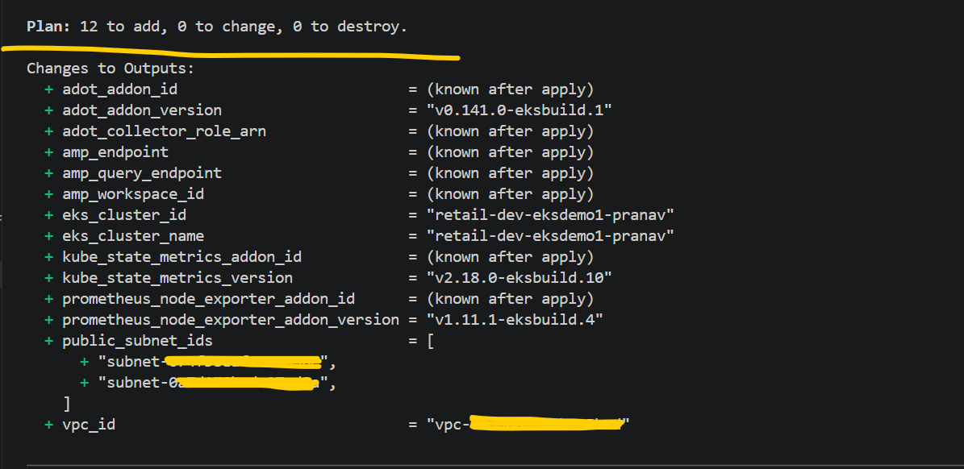
# I was getting below error while creating the Amazon Prometheus workspace, AWS is trying to apply tags to the workspace resource, but my IAM user does not have permission for the same. To resolve this issue, I have assigned necessary my permissions IAM user.
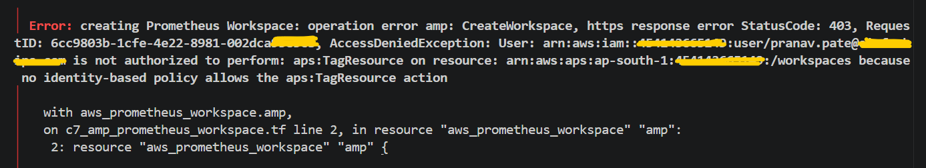
# After assigning the necessary IAM permissions to my IAM user, I reran the terraform plan and terraform apply --auto-approve commands. This time, all my pending resources were successfully created.
Note:- Nine resources were already created during my earlier terraform apply --auto-approve command. Therefore, when I ran terraform apply a second time, it showed only 3 resources being created.
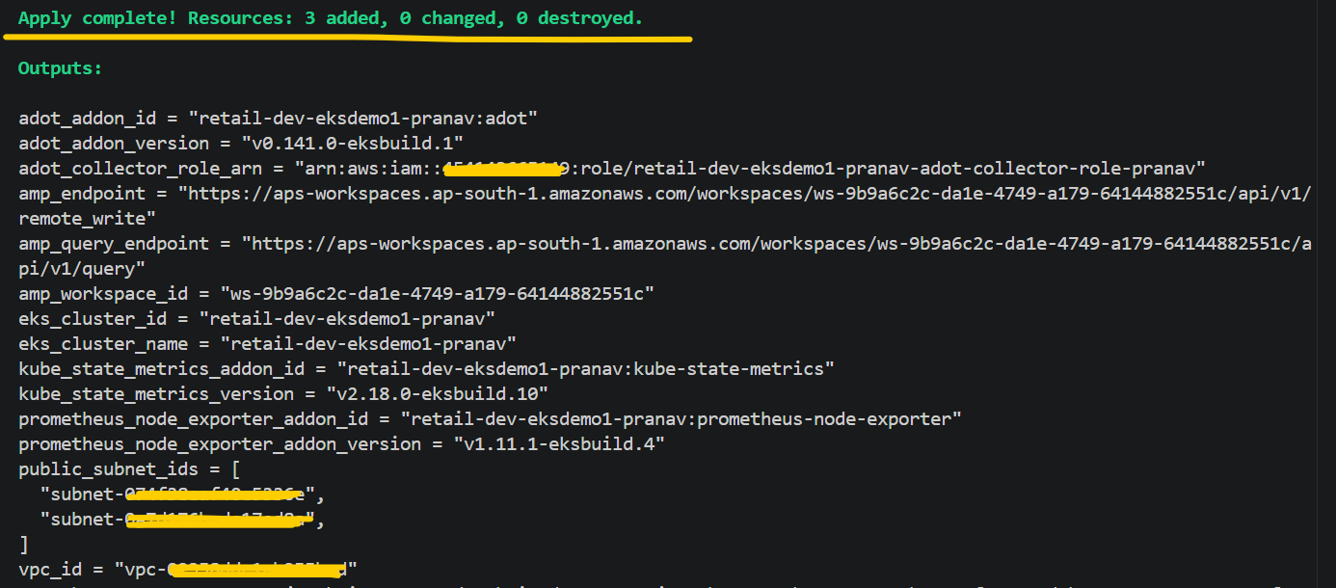
# Verify EKS Add on’s from AWS Console.
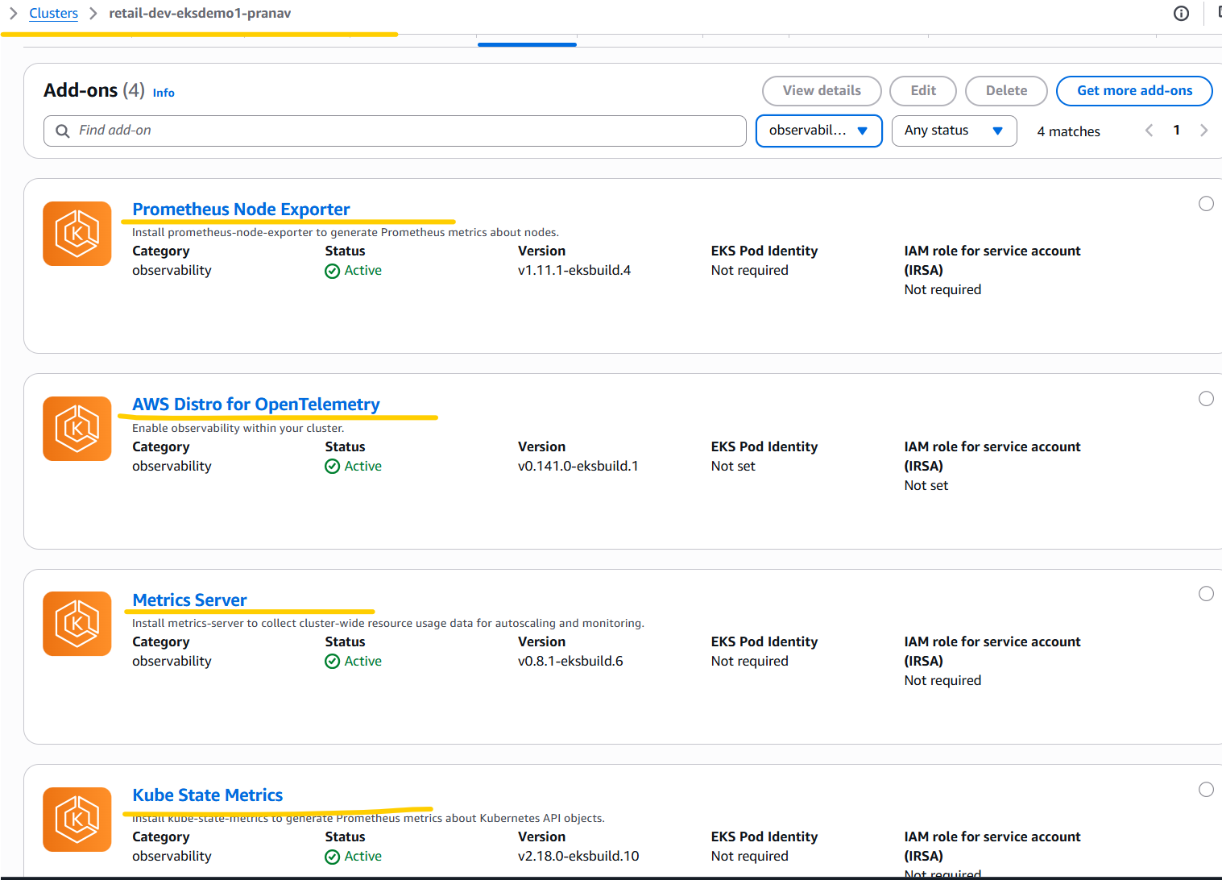
# Verified Amazon Prometheus Workspace from AWS Console.
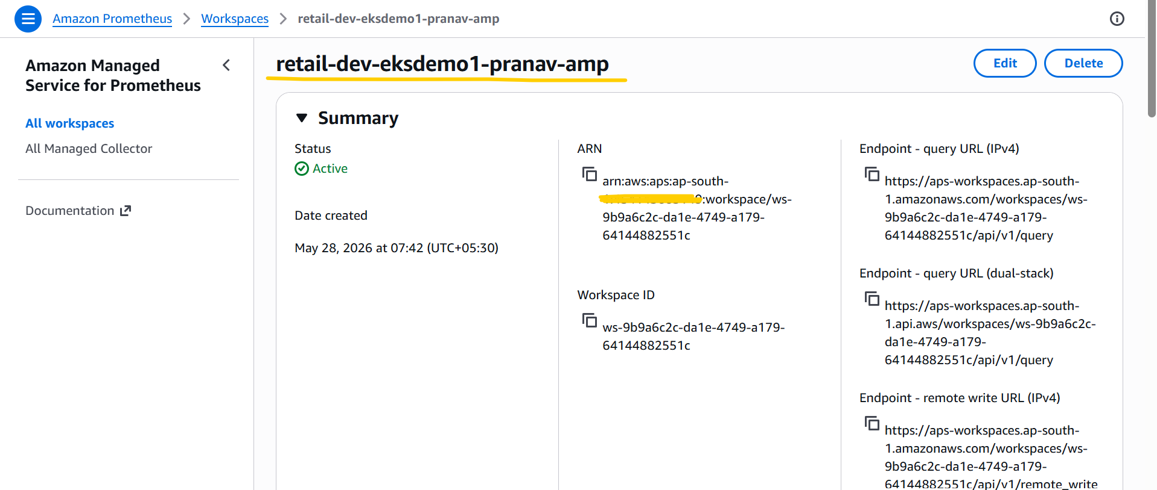

- Run below terraform commands to deploy the AWS Data plane.
terraform init
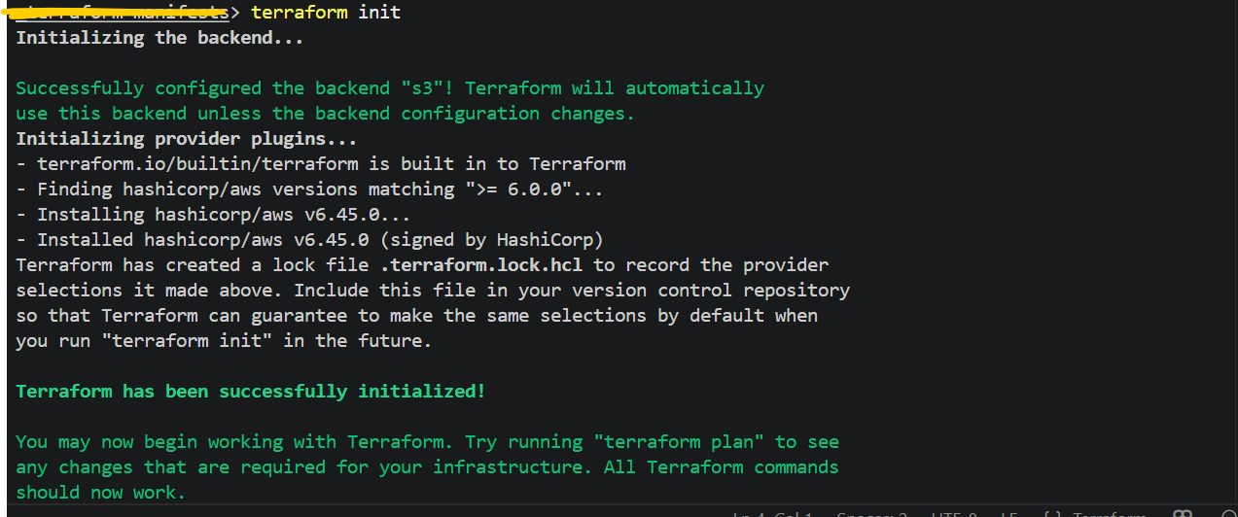
terraform validate
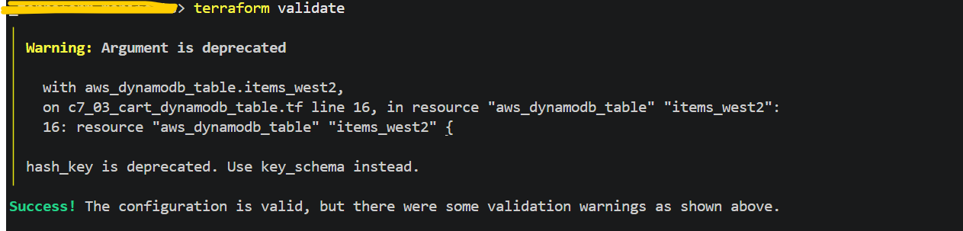

terraform plan
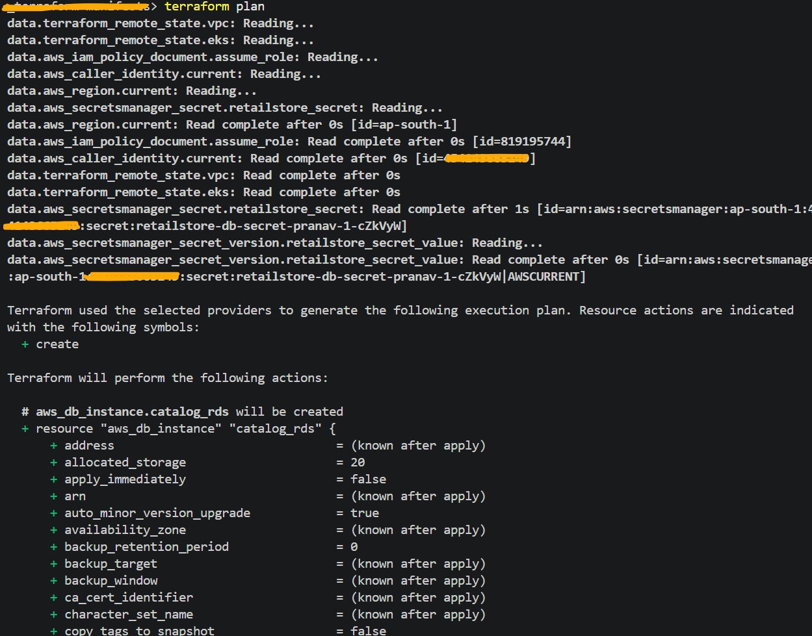
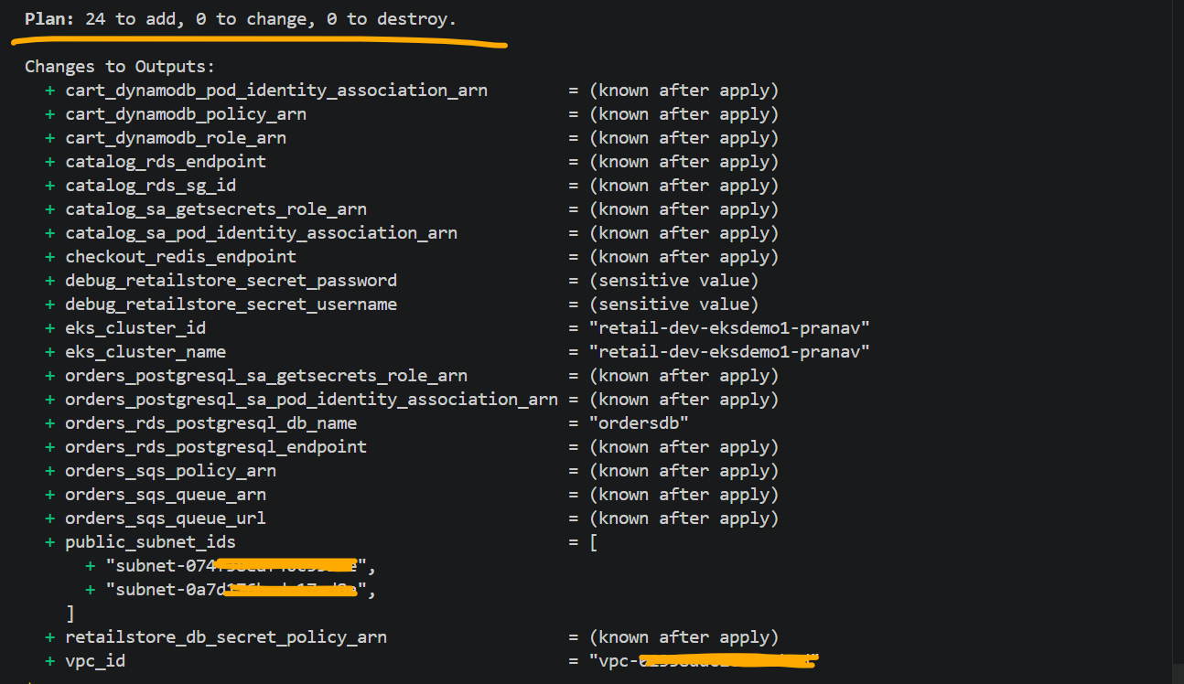
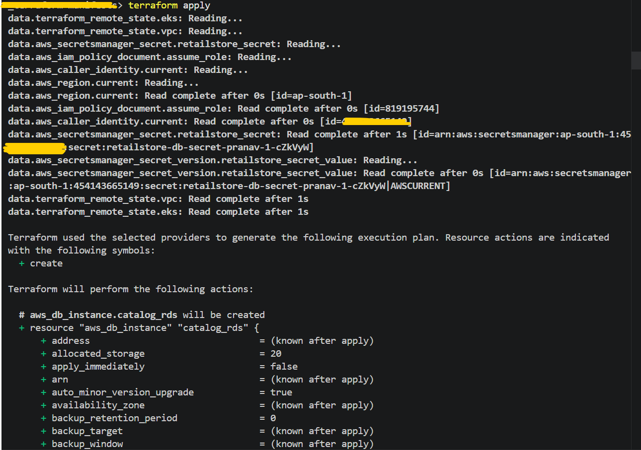

# AWS Data Plane related all the 24 resources are successfully deployed through terraform.
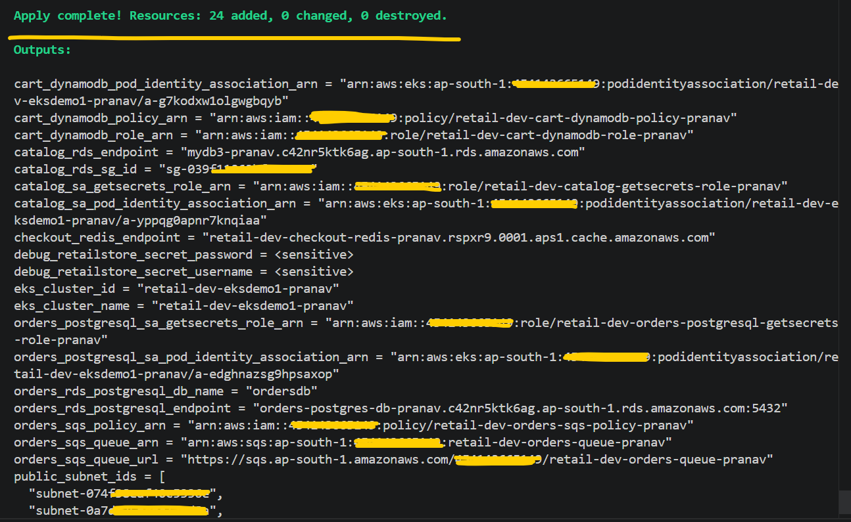

# Verify the AWS Data Plane resources from AWS Console.
Mysql and Postgresql RDS DB’s
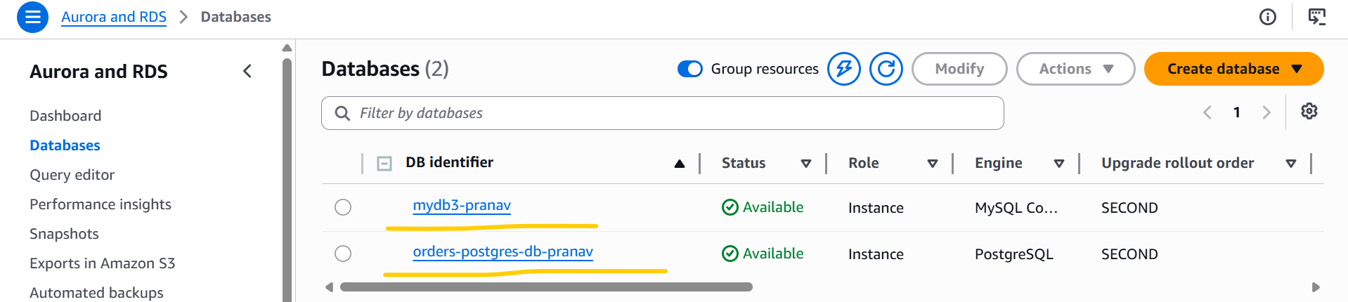

ElastiCache
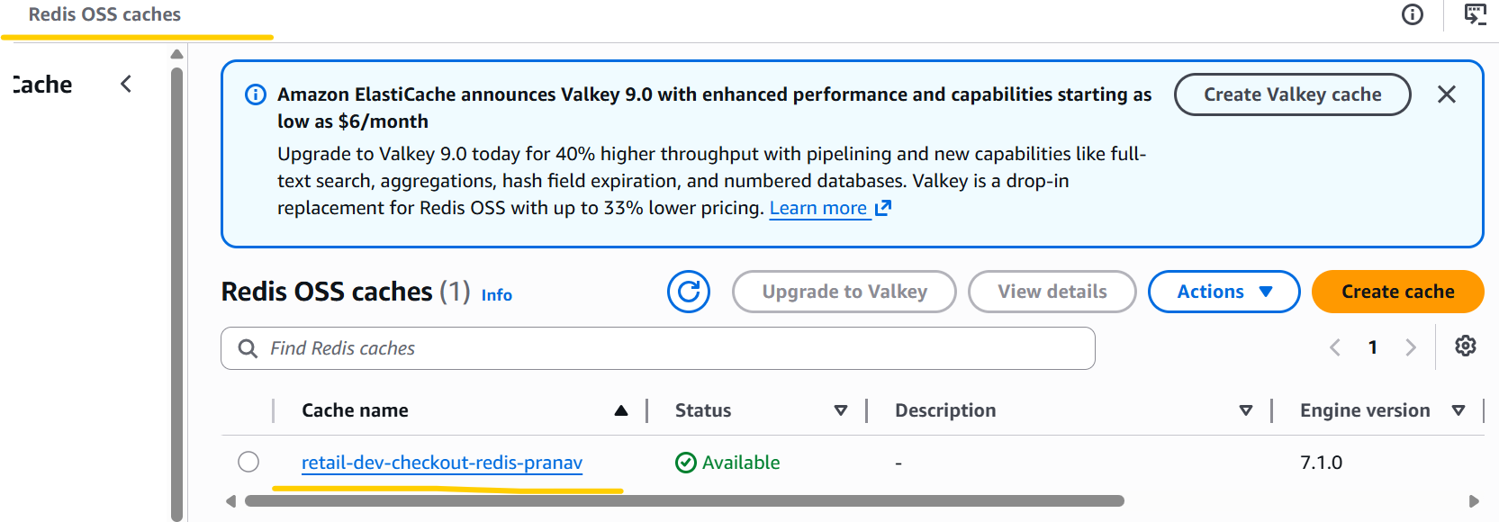
Dynamo DB Table
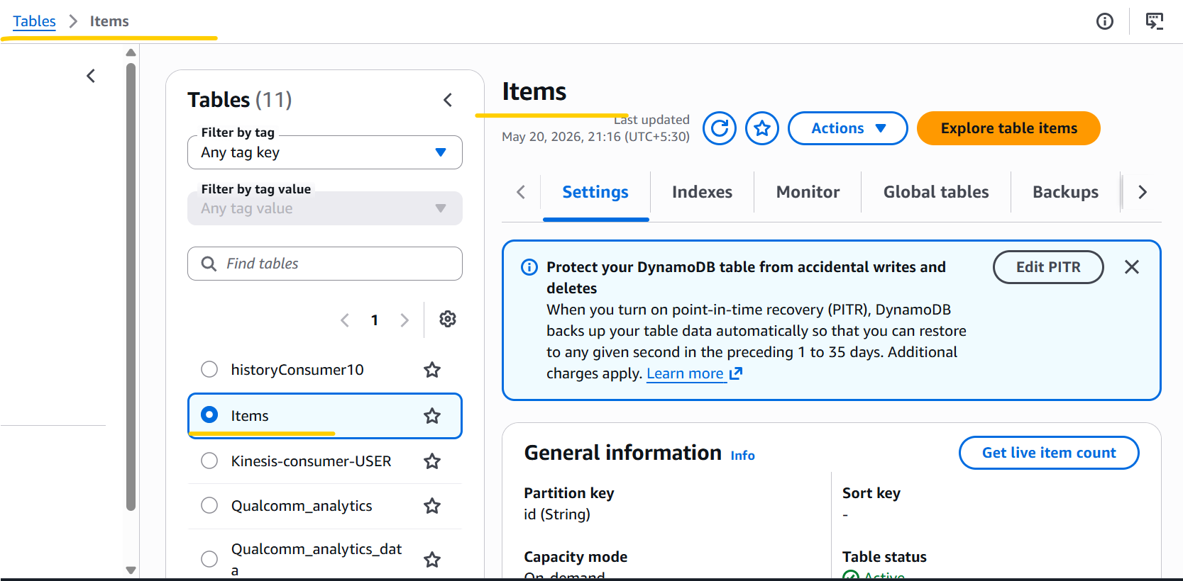

Amazon SQS
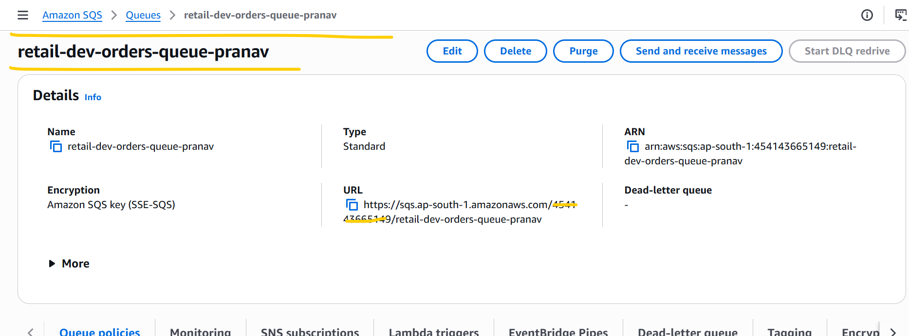

- Copied the ADOT manifest files, application-related Helm manifest files, and scripts from the instructor’s code into the 26_05_2026 folder and updated all the required values in the Kubernetes manifest files (application helm manifest files and ADOT manifest files) before deployment.

aws eks --region ap-south-1 update-kubeconfig --name retail-dev-eksdemo1-pranav

kubectl apply -f KARPENTER_k8s-manifests/
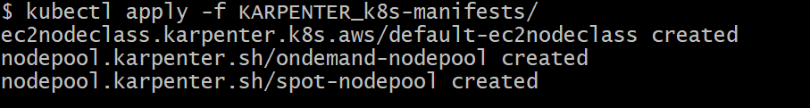

kubectl get ec2nodeclass
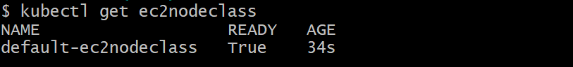

kubectl get nodepools
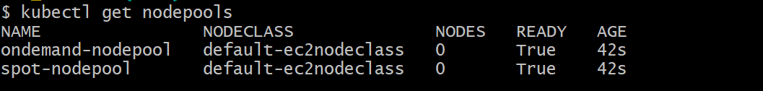

kubectl apply -f 01_secretproviderclass/

cd 03_HOW_COST_retailstore_HELM/
sh 05-v2.0.0-install-remote-helm-charts.sh
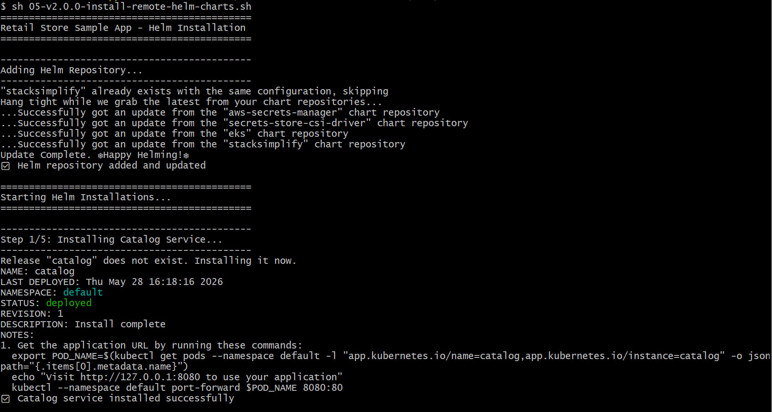

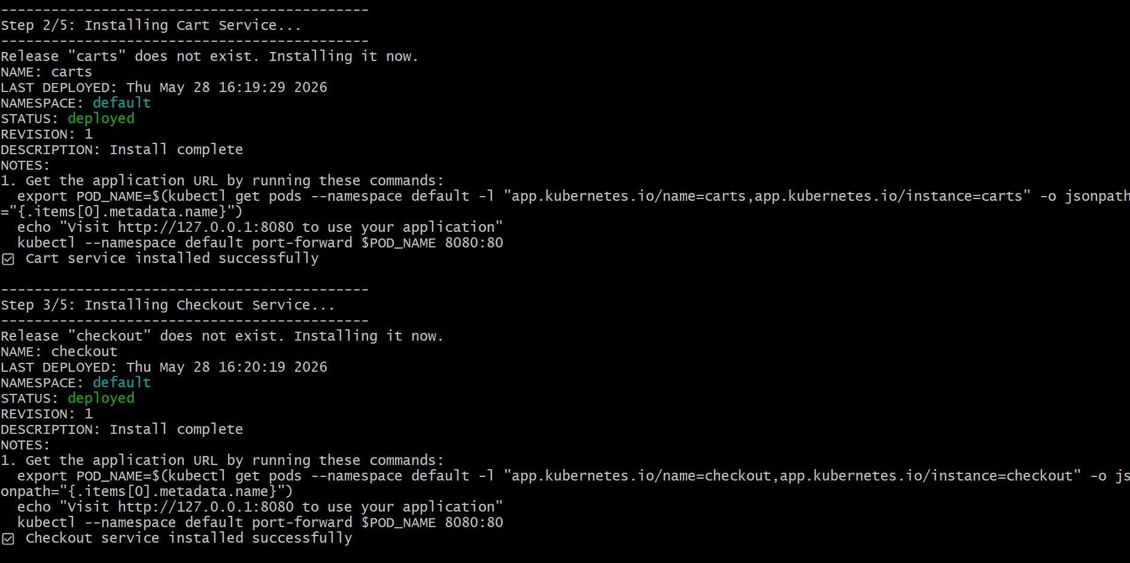

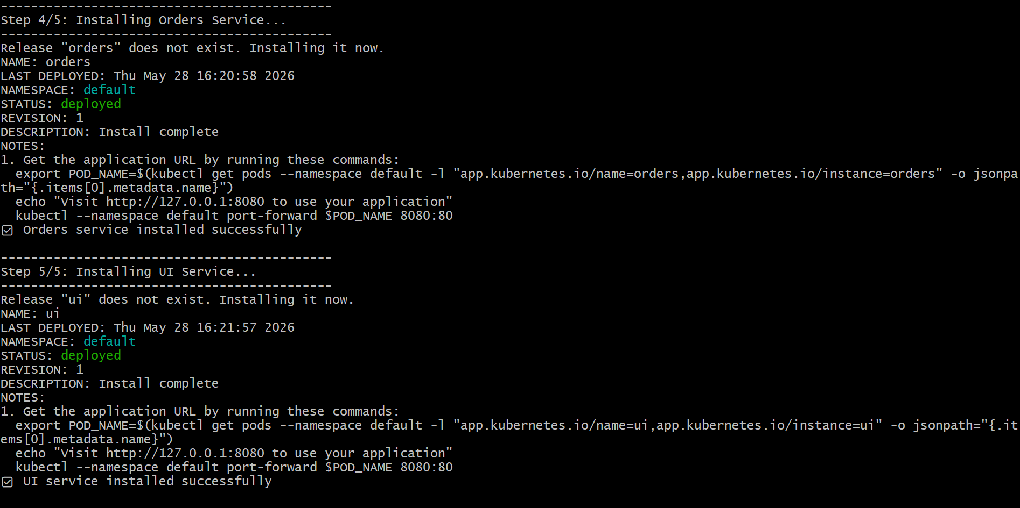

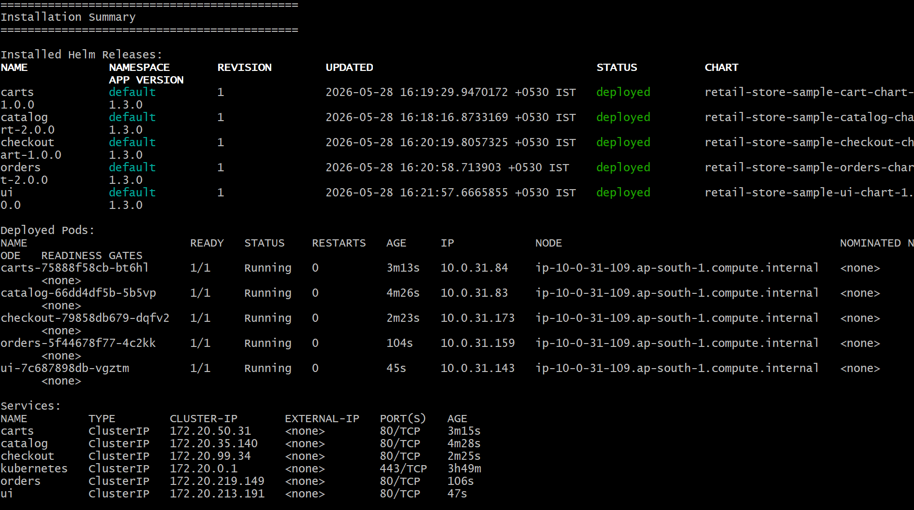

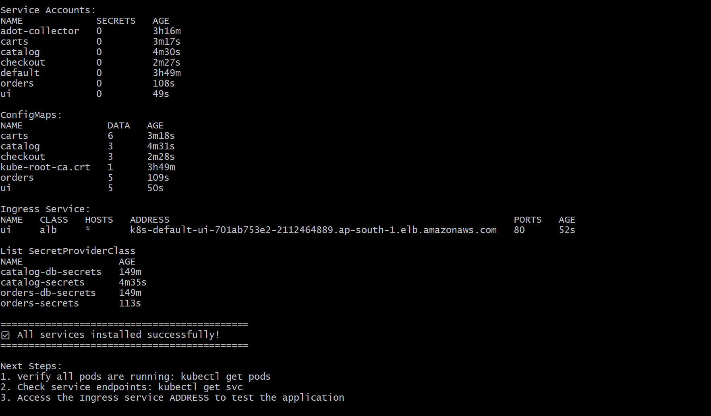

kubectl get pods

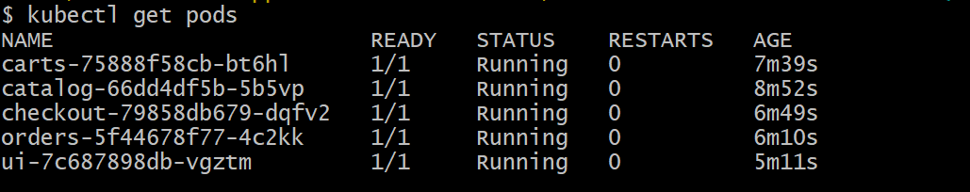
kubectl get hpa
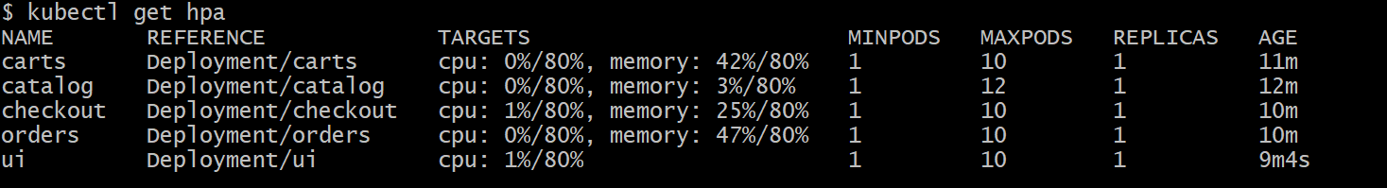
kubectl get nodeclaims

# I can be able to access ALB Link in my browser.

k8s-default-ui-701ab753e2-2112464889.ap-south-1.elb.amazonaws.com

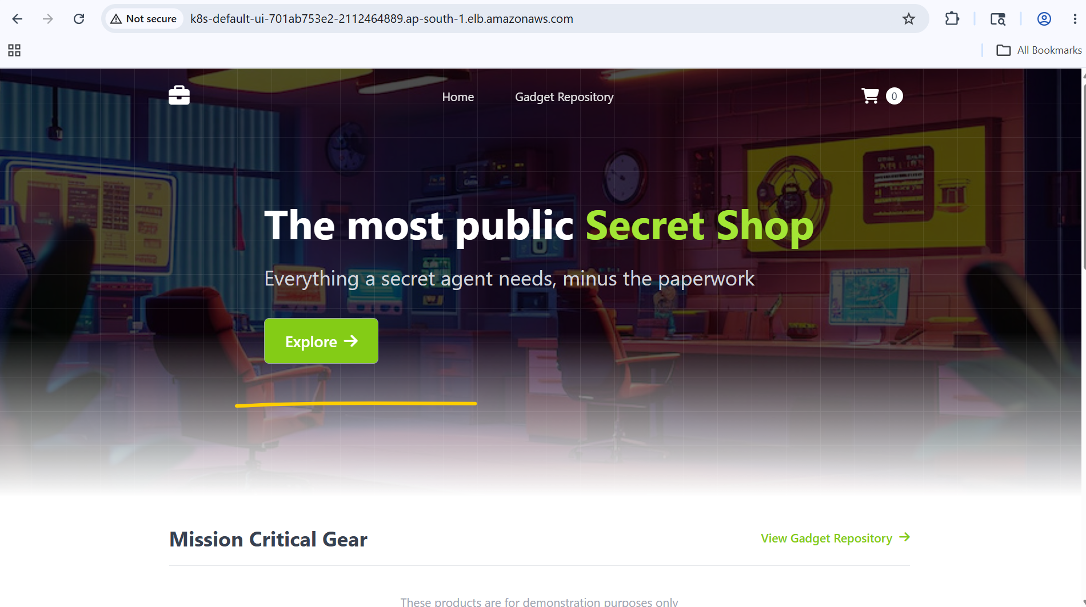
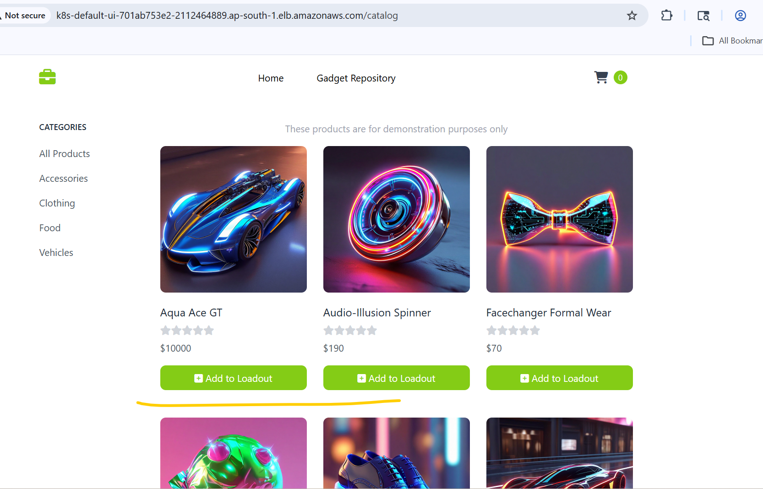
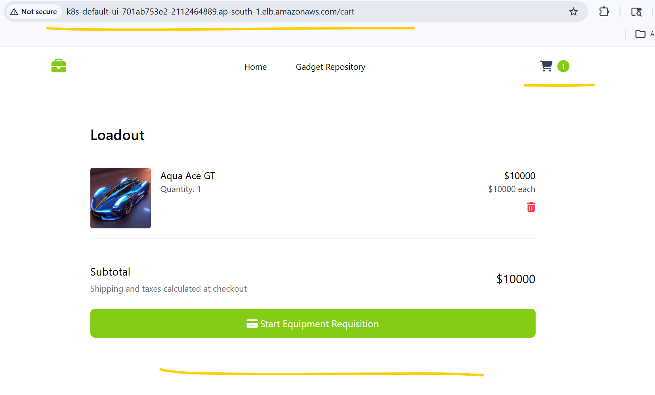
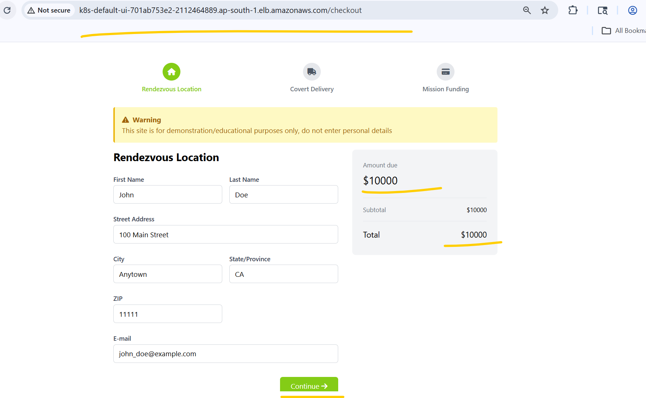
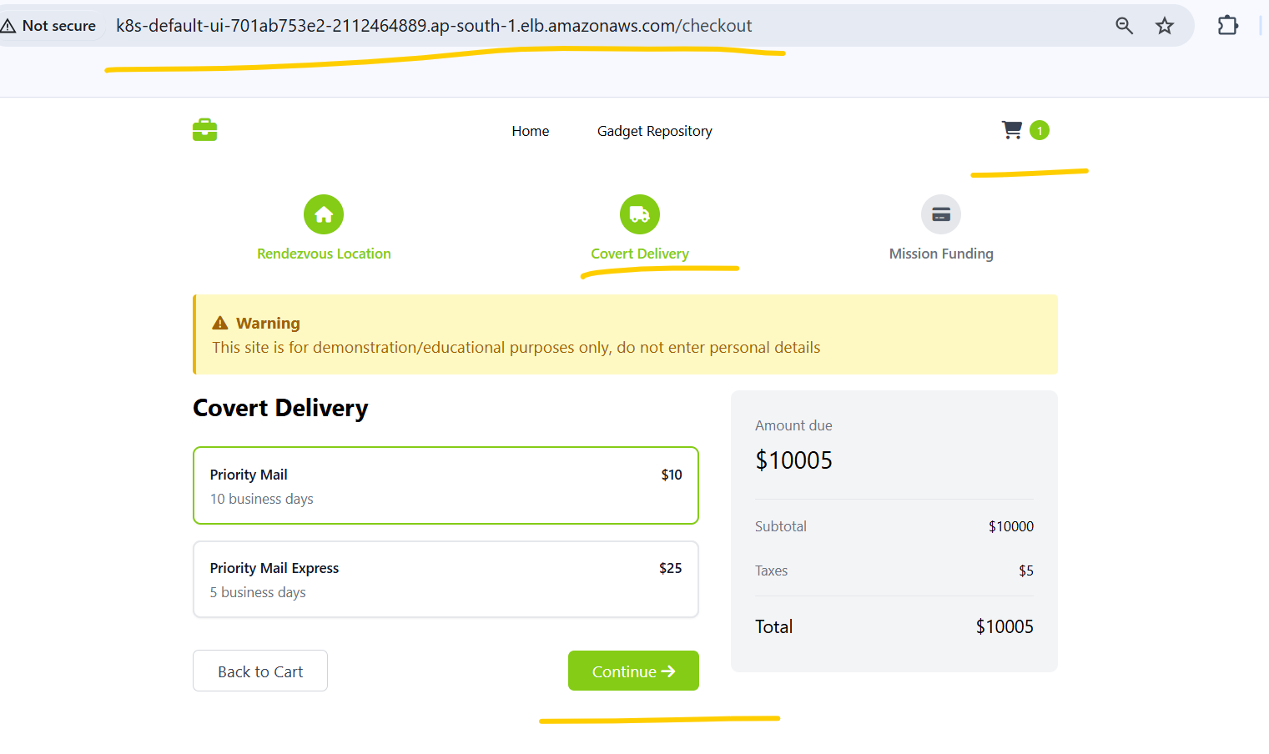
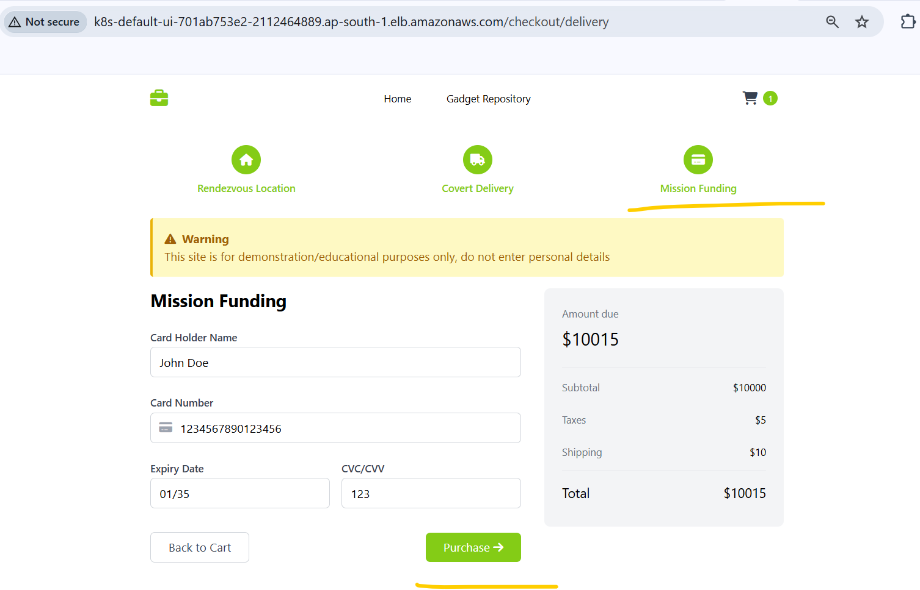
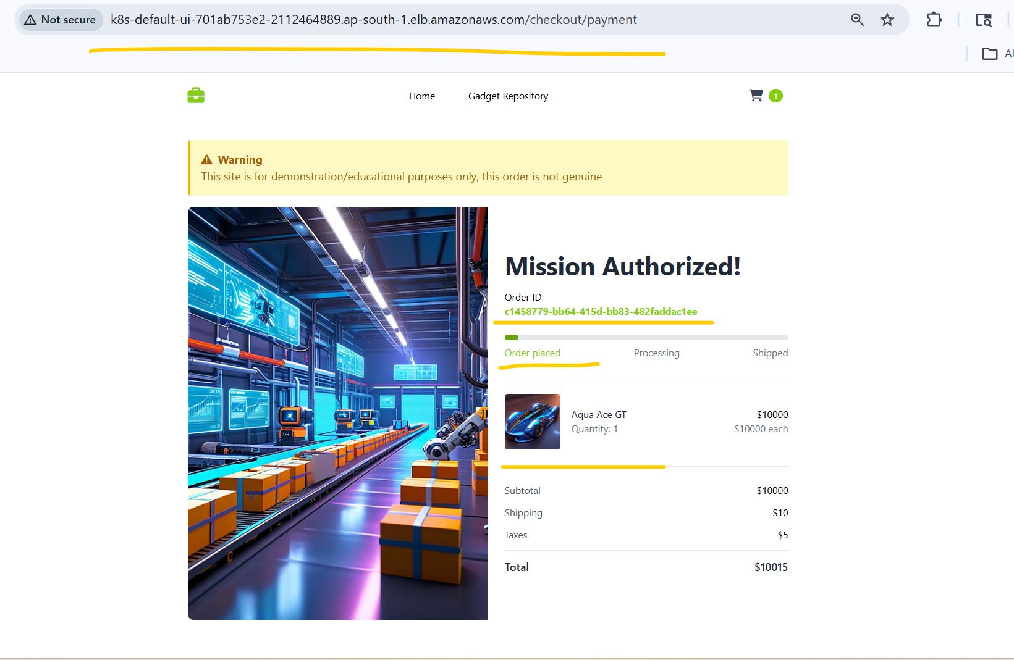

# I can perform transaction successfully through the ALB link.
# All services are showing healthy in /topology.

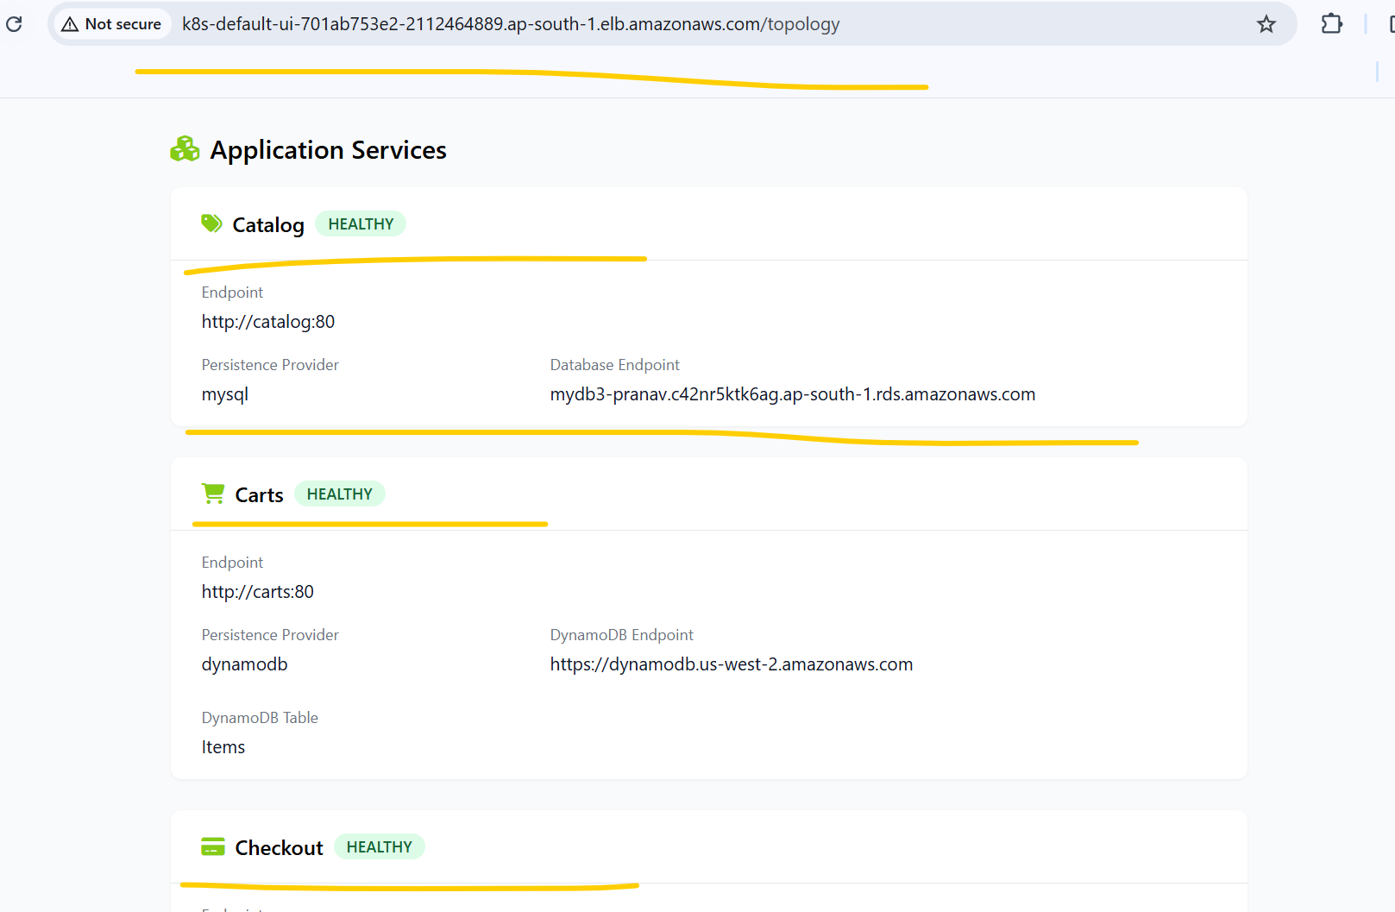
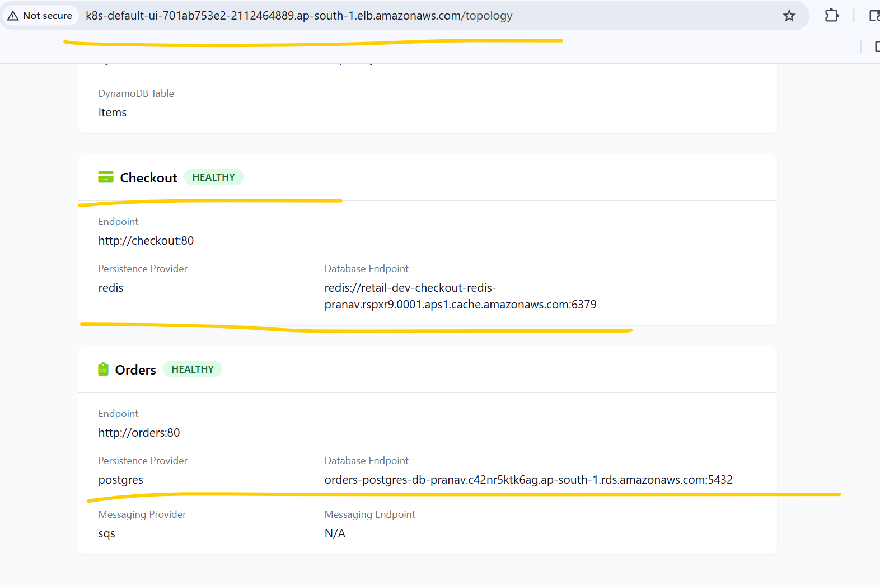

# Verify the Prometheus and instrumentation annotations for carts deployment
kubectl get deploy carts -o yaml
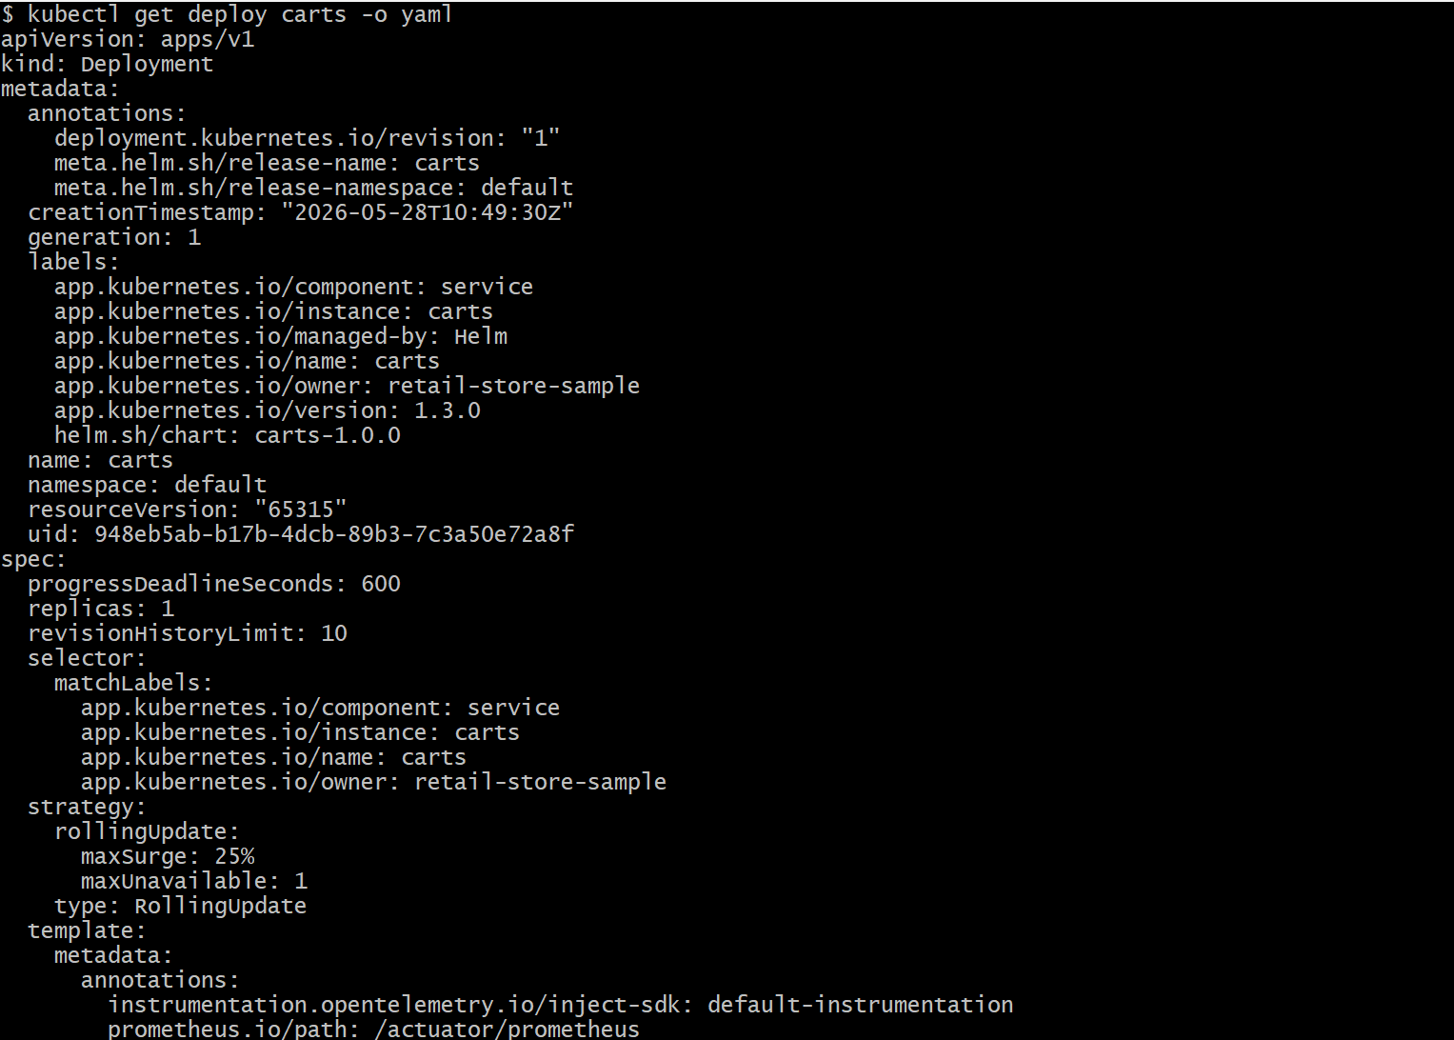
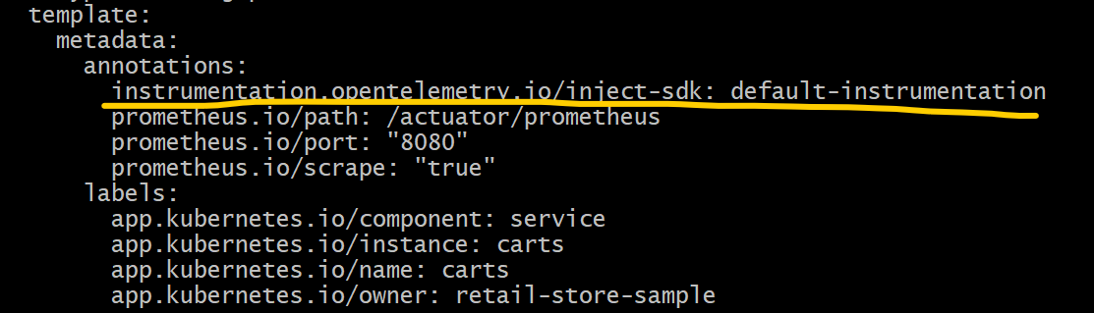

cd 20_02_OpenTelemetry_Traces
kubectl apply -f 01_adot_collector_traces.yaml

kubectl get pods
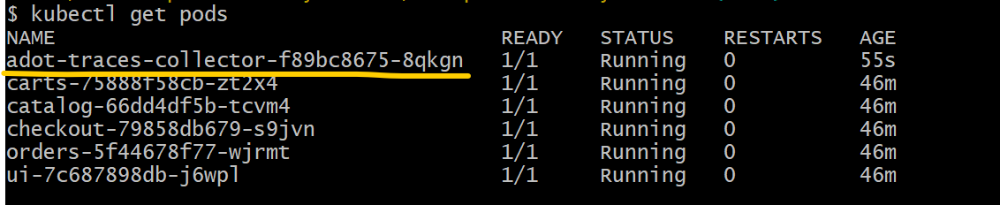
kubectl get opentelemetrycollector
kubectl get deploy
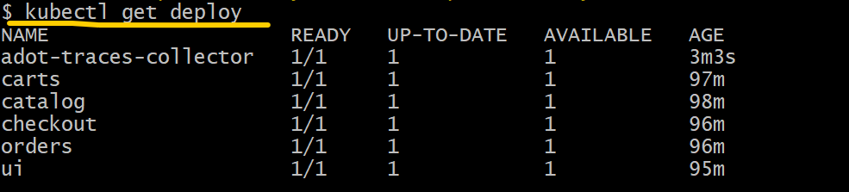
kubectl describe deploy adot-traces-collector
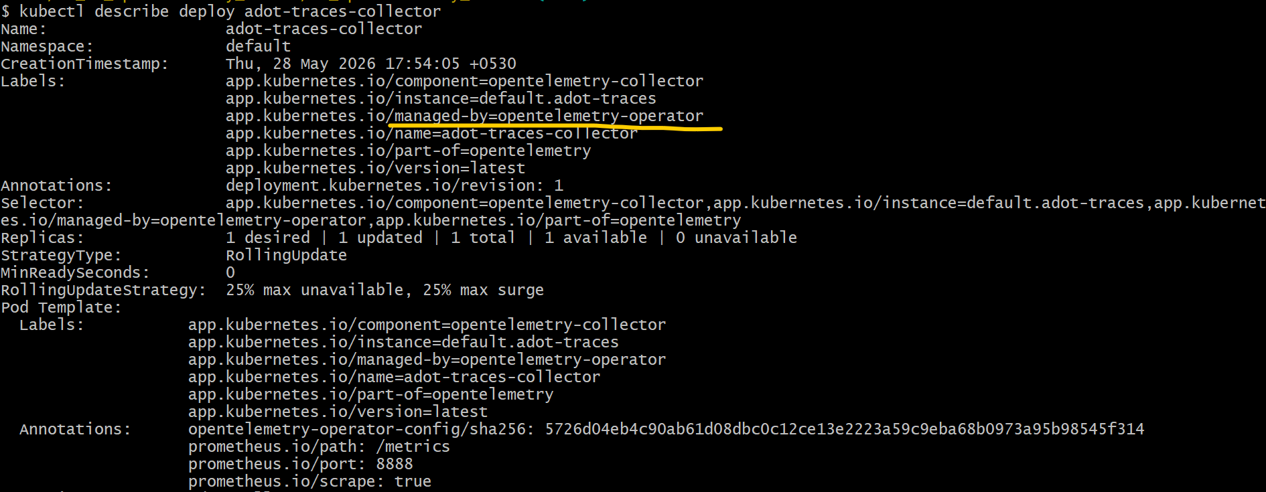

kubectl get ns
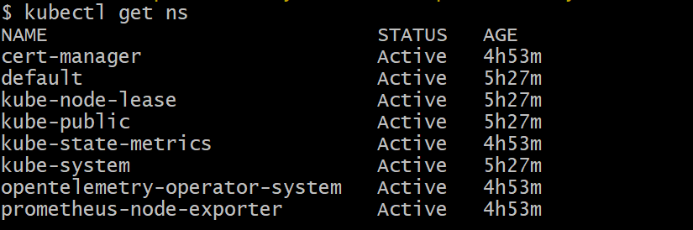
kubectl get deploy -n opentelemetry-operator-system
kubectl get pods -n opentelemetry-operator-system
kubectl logs -f opentelemetry-operator-6699c79fbb-t4xf2 -n opentelemetry-operator-system
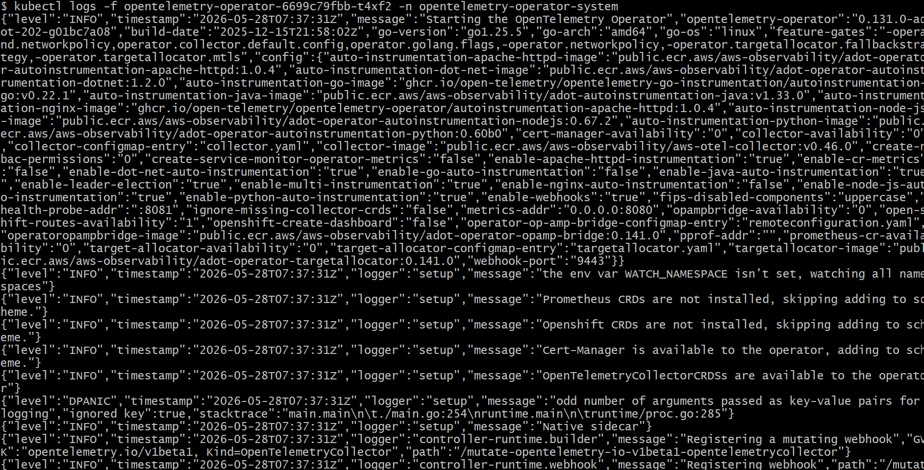

kubectl logs -f adot-traces-collector-f89bc8675-8qkgn
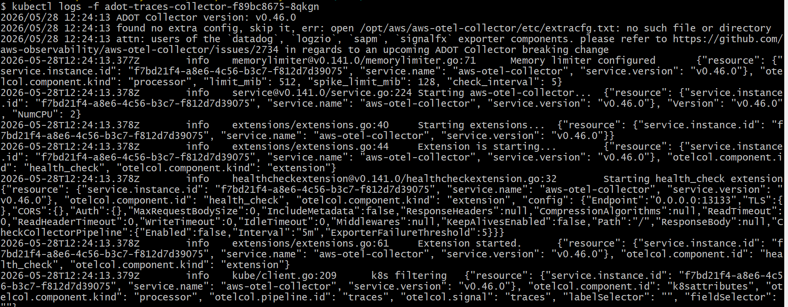
kubectl apply -f 02_adot_instrumentation_traces.yaml
kubectl get instrumentation
cd ..
sh restart-retailapp.sh
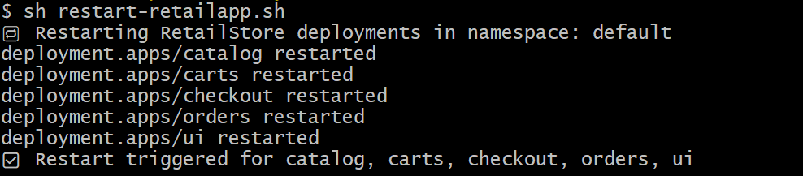
kubectl get pods
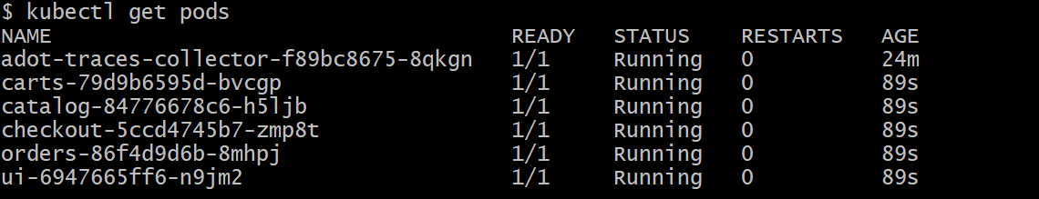

kubectl logs -f adot-traces-collector-f89bc8675-8qkgn
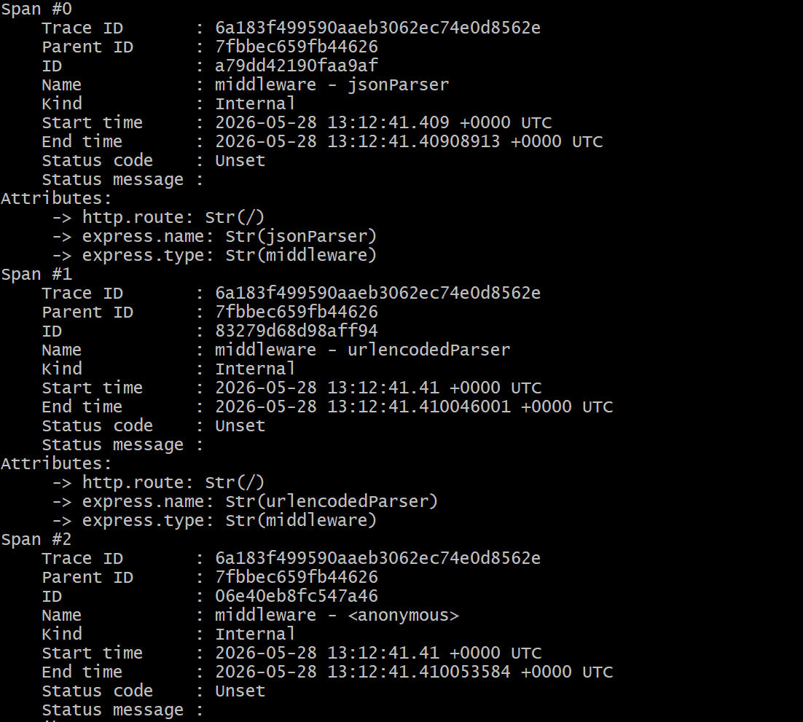
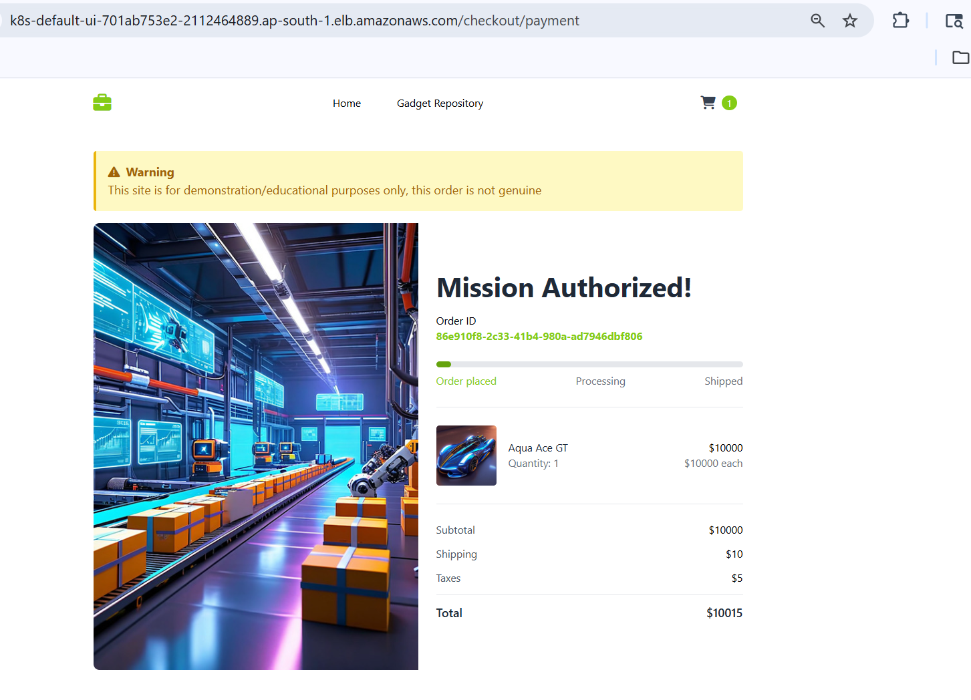
# I performed one more transaction to verify the details in the traces within CloudWatch.

# Navigate to CloudWatch service and click on Traces from APM.

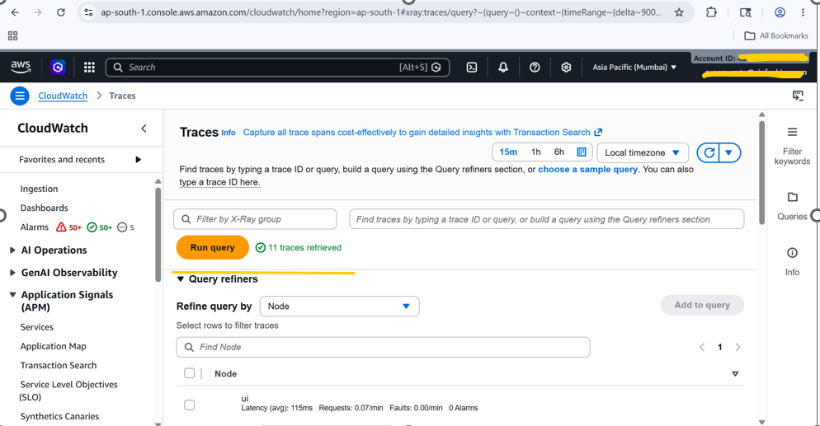
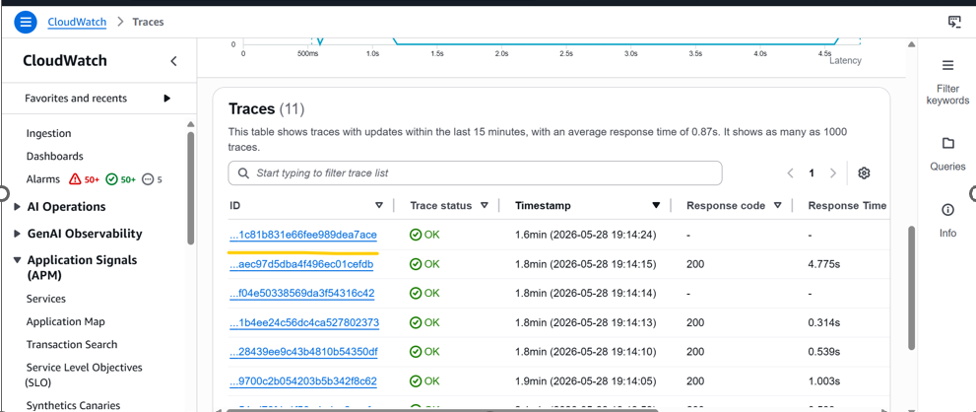

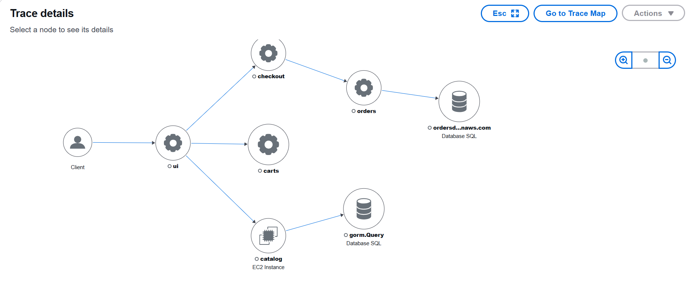
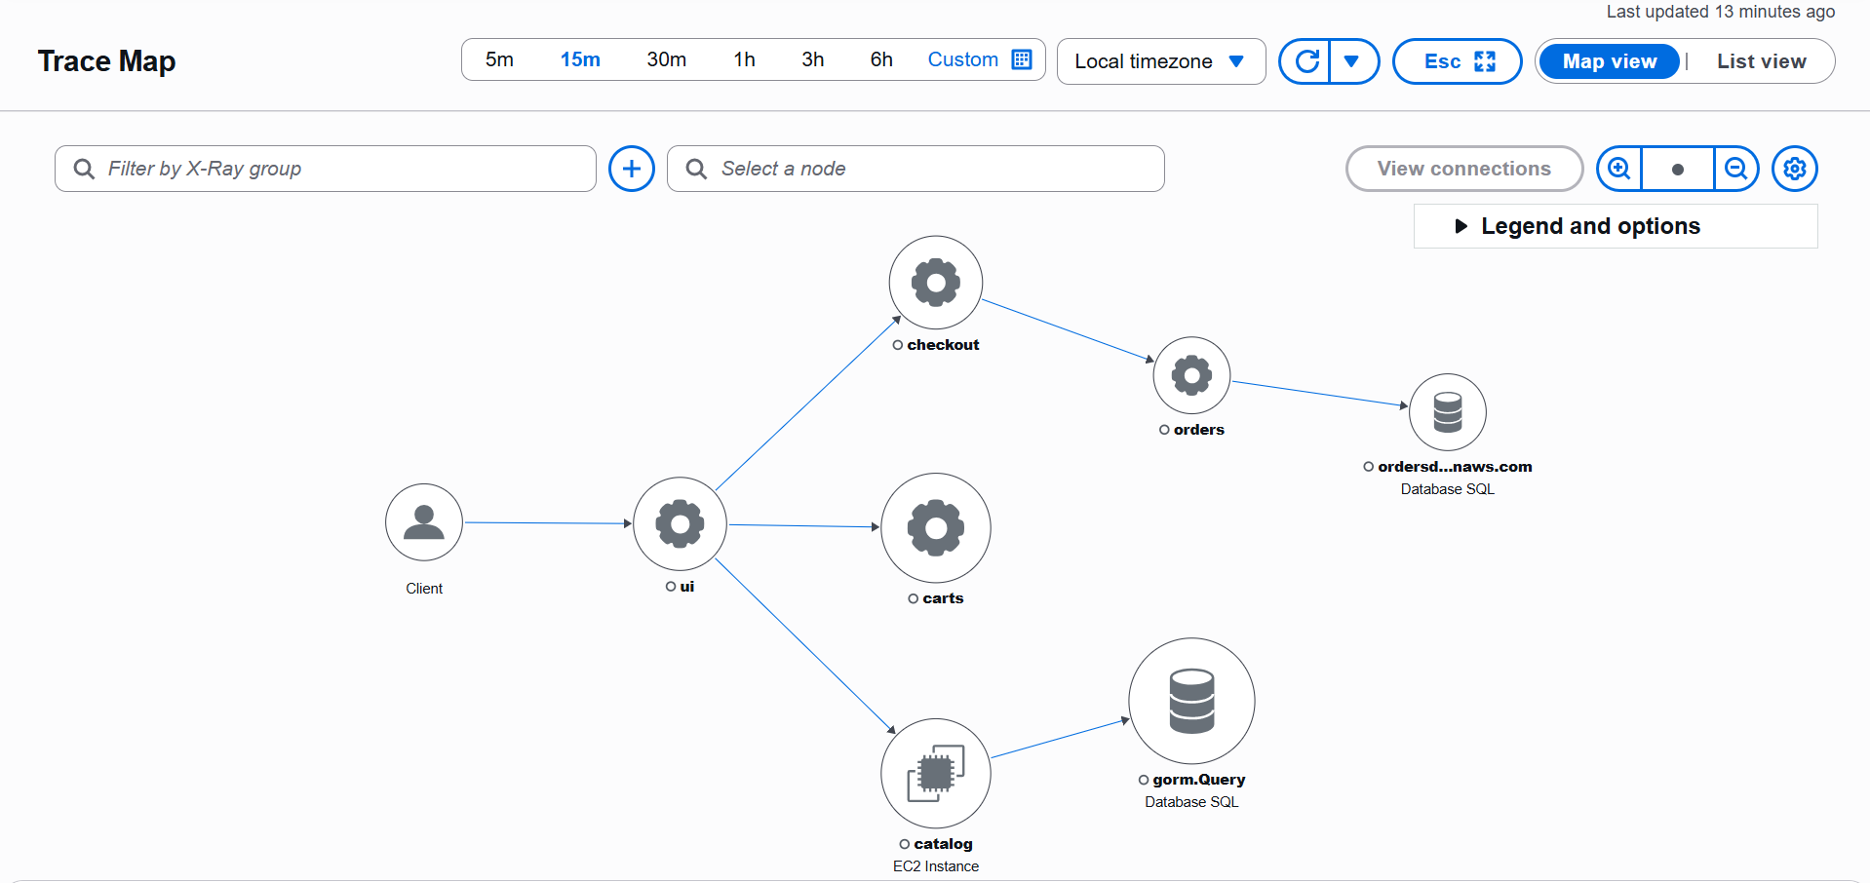

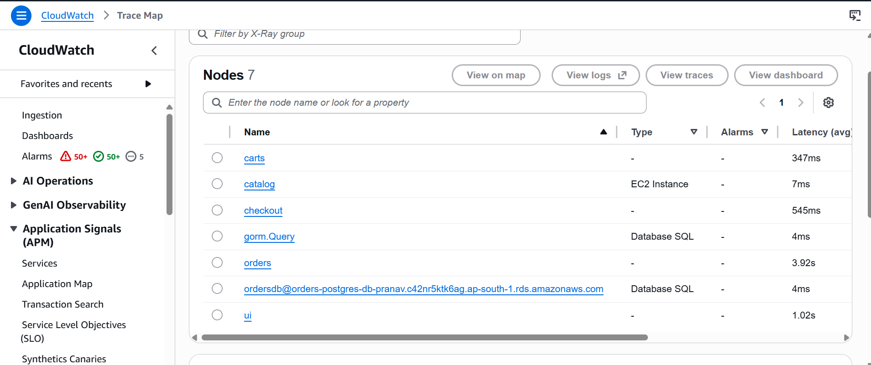

- Clean up all resources.
cd 01_OpenTelemetry_Traces/
# Delete Instrumentation
kubectl delete -f 02_adot_instrumentation_traces.yaml
# Delete Traces Collector
kubectl delete -f 01_adot_collector_traces.yaml
cd 03_HOW_COST_retailstore_HELM/
sh 01-uninstall-retail-apps.sh
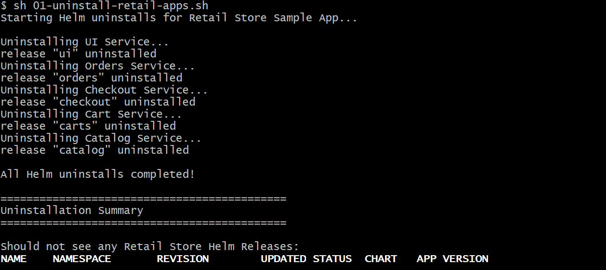
- Deleted AWS Data Plane Stack through terraform destroy –auto-approve command.

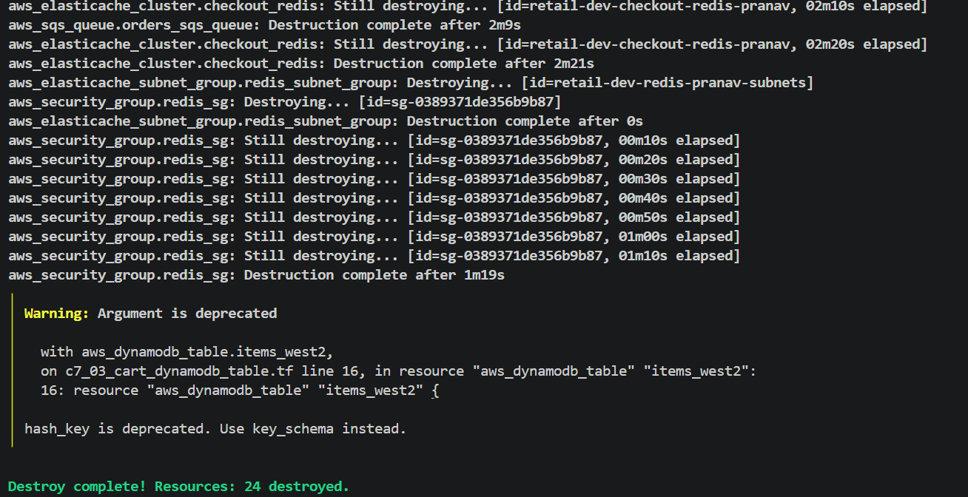

- Deleted OPENTELEMTRY stack through terraform destroy –auto-approve command.
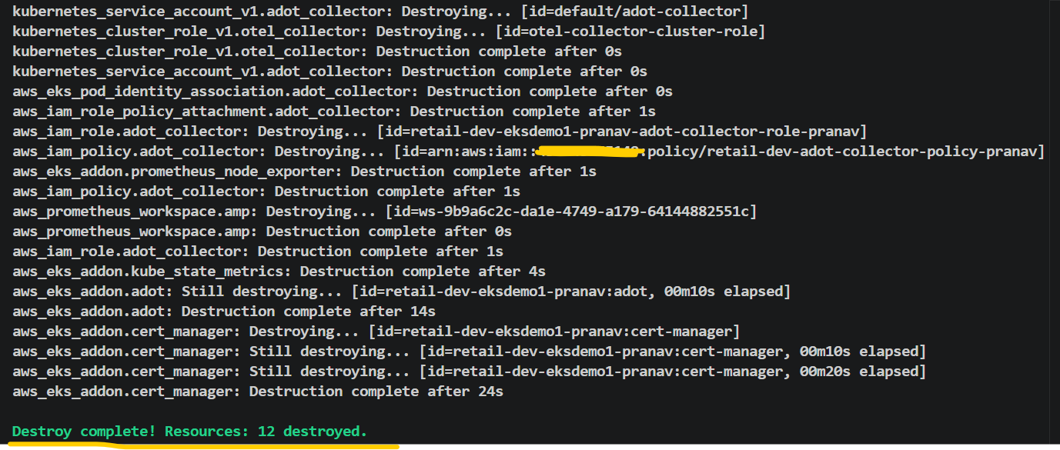

- Deleted EKS Cluster, Karpenter, all the Add ons, Node group, Iam roles for through terraform destroy –auto-approve command.
