Steps:-
- Created SSH Key Pair for EC2 Instance.
- Created EC2 Instance as per below mentioned configuration.
Setting Value
AMI :- Amazon Linux 2023
Instance Type :- t3.large
Storage :- 30 GB
Key Pair :- Created new pair and used the same
Security Group :- Allowed SSH (port 22) and (port 80, 8080) these TCP ports from my laptop Ip.
Region :- ap-south-1

- Taken EC2 instance ssh access from gitbash through ssh keypair, which is created for this practical. Ssh command is given below.
Note:- While attempting to access EC2 from CloudShell, I encountered the permission error mentioned below. Therefore, I used Git Bash to establish an SSH connection to the EC2 instance.
ssh -i your-key.pem ec2-user@<your-ec2-public-ip>

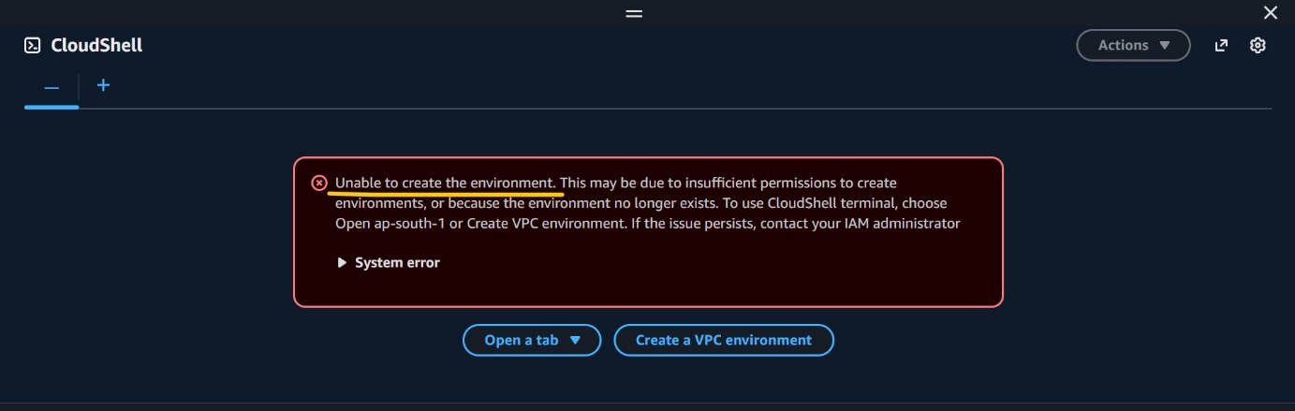

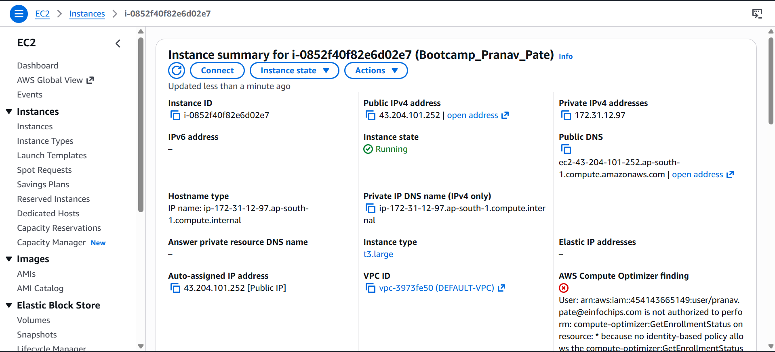
- Install Docker on Amazon Linux 2023 with below mentioned commands.
sudo dnf update -y
sudo dnf install docker -y
sudo systemctl enable docker
sudo systemctl start docker
sudo usermod -aG docker ec2-user
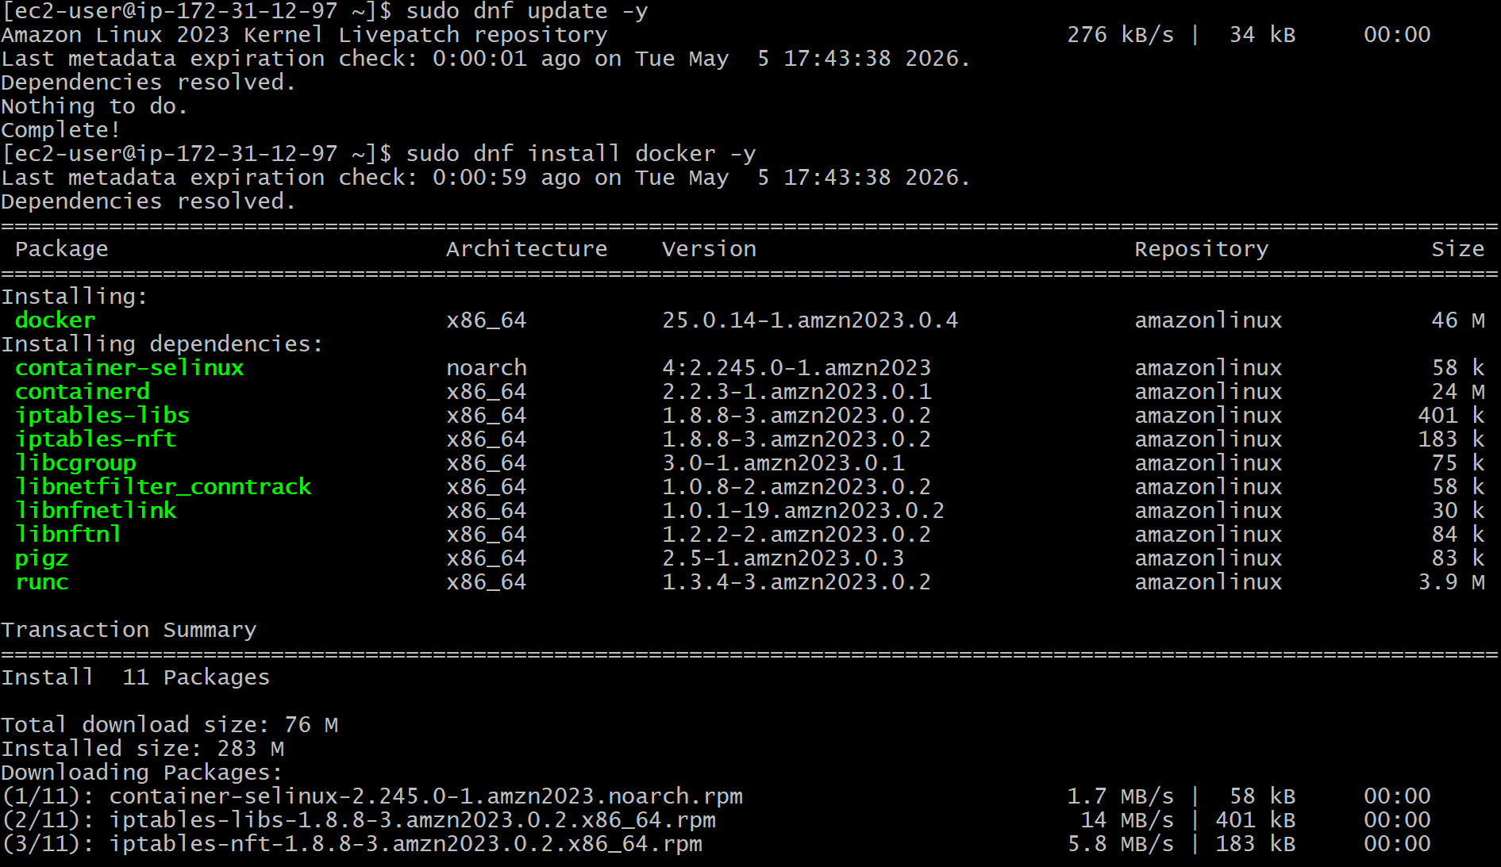

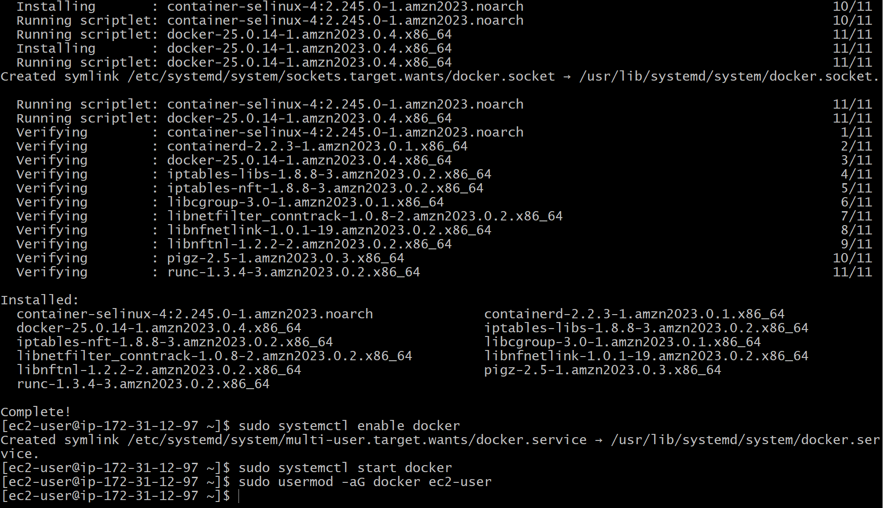
- Logout and reconnect to apply the docker group permissions.
- Test Docker with below mentioned commands.

# Check Docker version
docker version
# List Docker images (should be empty initially)
docker images
# Run a test container
docker run hello-world
# List images again (should now include hello-world)
docker images

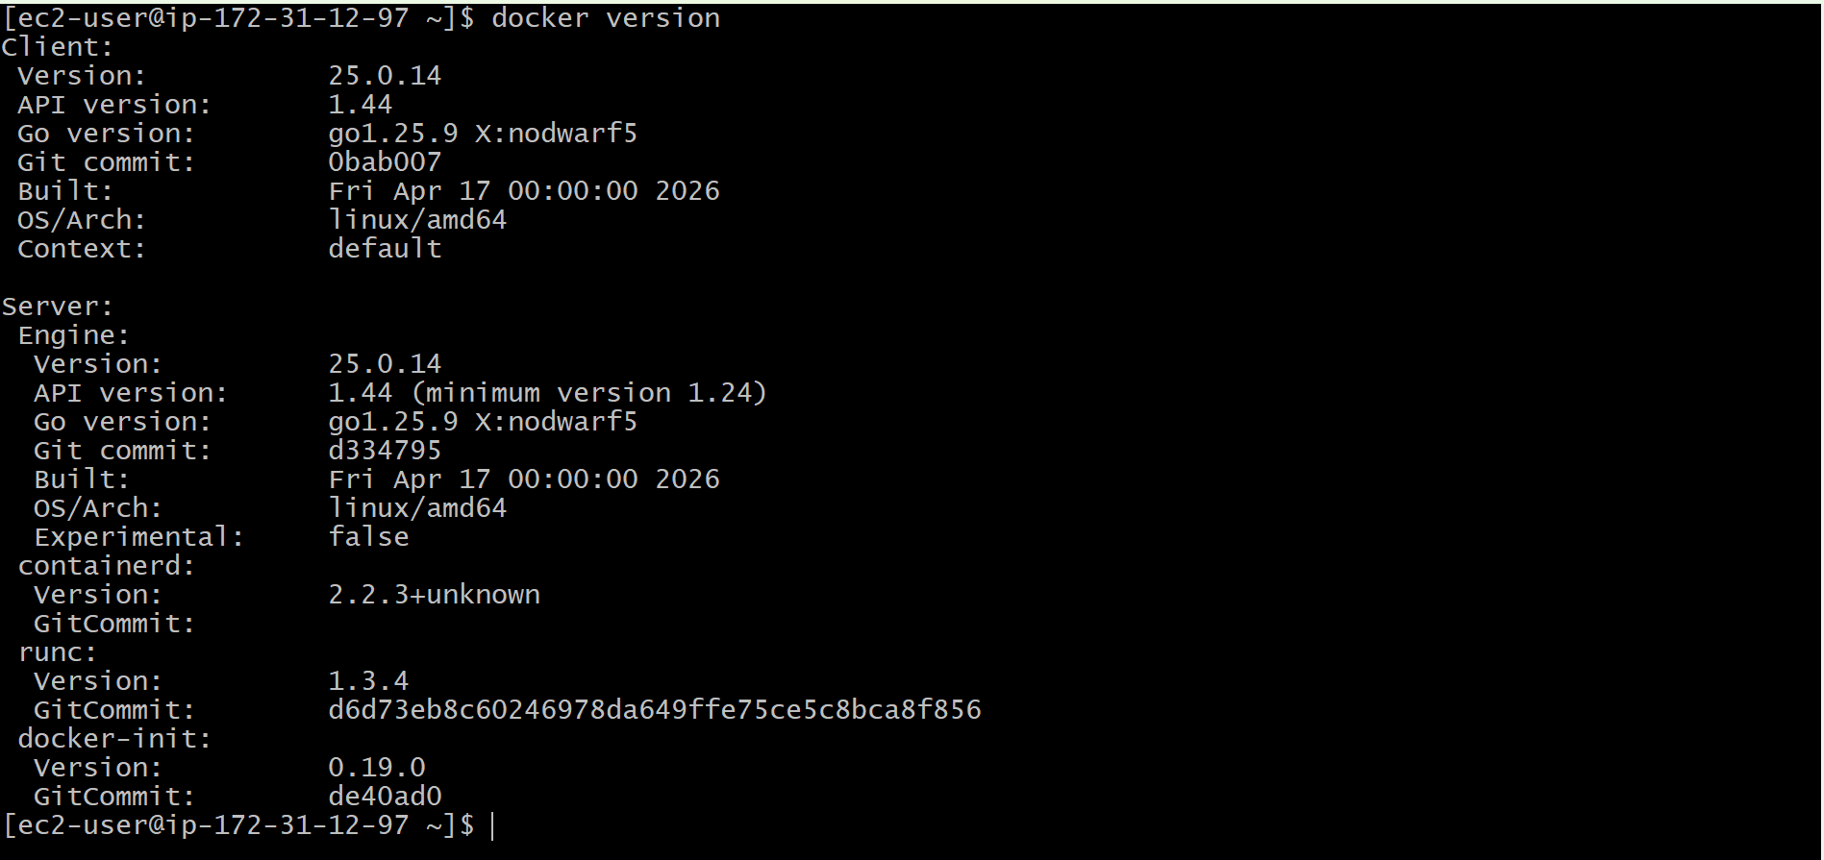
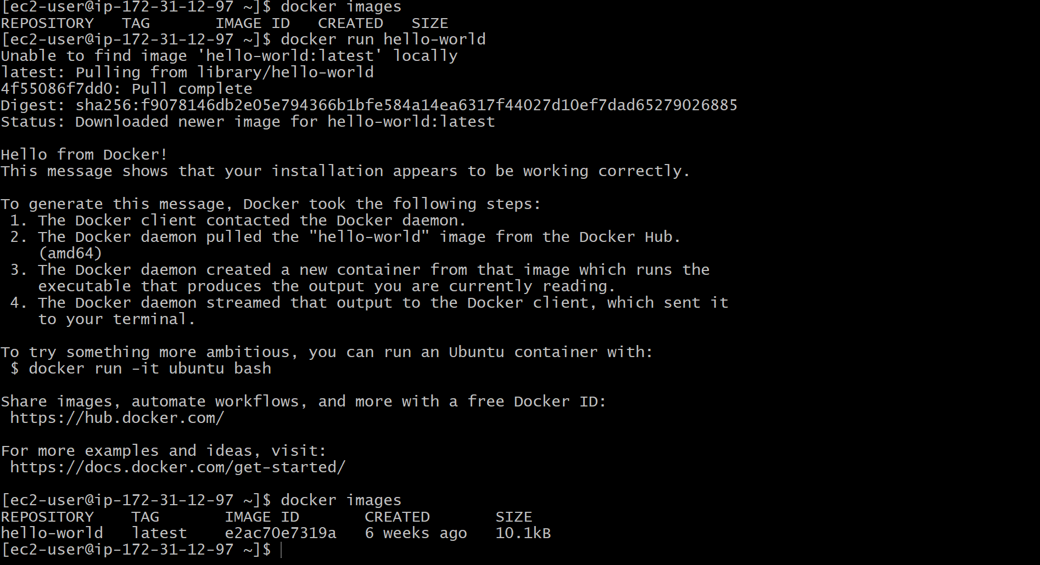
docker ps -a
- Performed the Clean Up with below mentioned commands.
# Remove the stopped container
docker rm $(docker ps -aq)

# Remove the image
docker rmi hello-world
After cleaning up docker image and container, verified the same with docker images command and docker ps -a command. Run these commands before cleaning up and after cleaning up also.
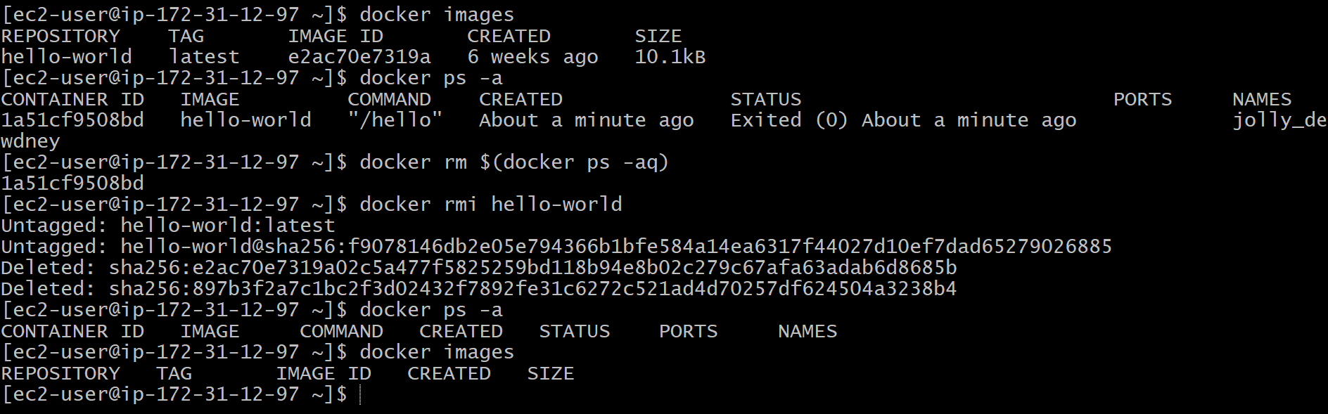
- After performing practical, stopped the EC2 instance.
