Steps:-
- Copy terraform code from 19_05_2026 folder into 20_05_2026 folder and added additional terraform configuration files from instructor code into 20_05_2026 this folder.
Note:- 1. Since I did not deploy a private subnet due to the unavailability of a NAT Gateway, and creating my own NAT Gateway would incur additional costs, I chose not to create one for cost optimization purposes. As a result, I deployed my node group EC2 instances, RDS DB’s and ElastiCache resources in a public subnet.
2. I am also aware that, from a best practices and security perspective, node group EC2 instances, RDS DB’s and ElastiCache resources should be hosted in a private subnet rather than a public subnet. However, this is not a production-grade EKS cluster; I am deploying it only for practical testing purposes. Therefore, I hosted the node group EC2 instances and other resources in a public subnet.
3. For my previous practical’s, I have also used only public subnets, and for upcoming practical’s, I will continue to use public subnets only.
4. I have added EKS Cluster Security Group Id output configuration in EKS cluster terraform code output.tf file, so that I can use the same for my AWS_Data_Plane practical.
2) Created Retail store db secret in Secret Manager service through AWS cli command.
Note:- For security POV, the AWS CLI command is not mentioned below. Instead, a screenshot for the same has been directly included below.
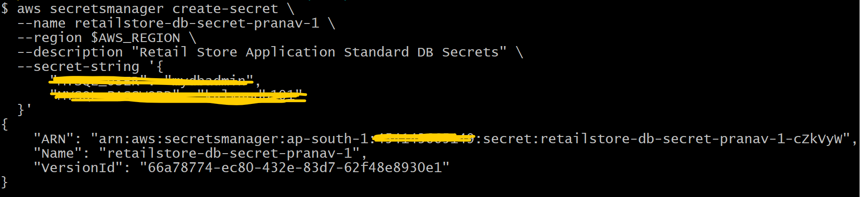
- Run below mentioned terraform commands to deploy the EKS Cluster through terraform

terraform init
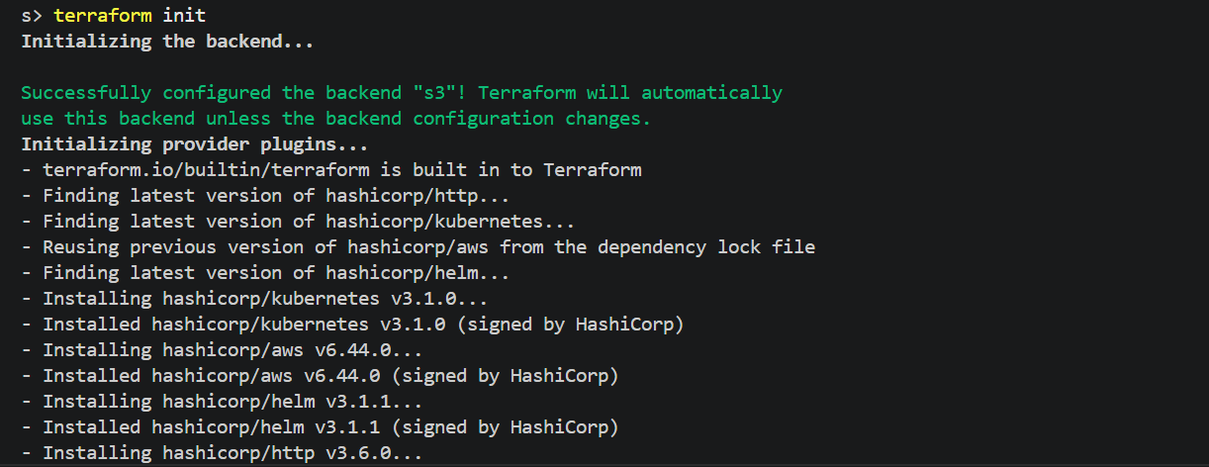

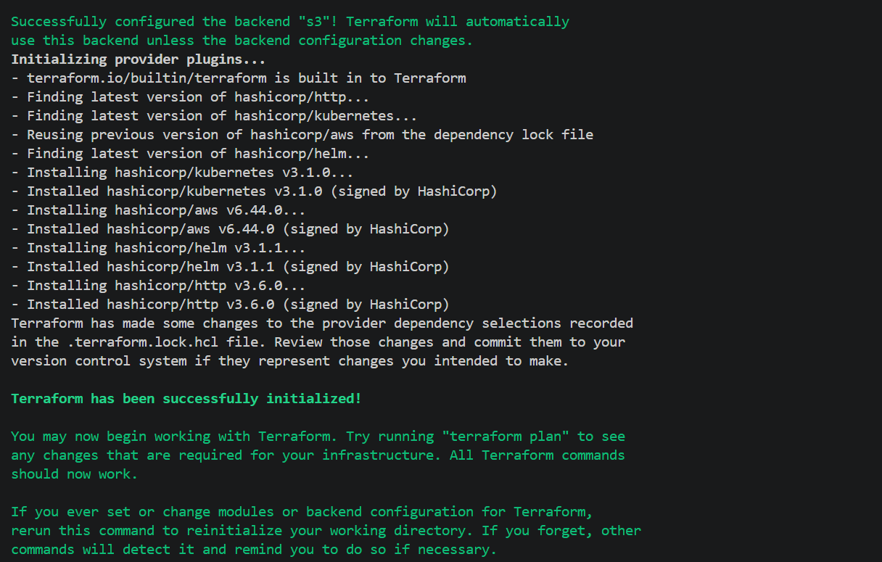

terraform validate

terraform plan
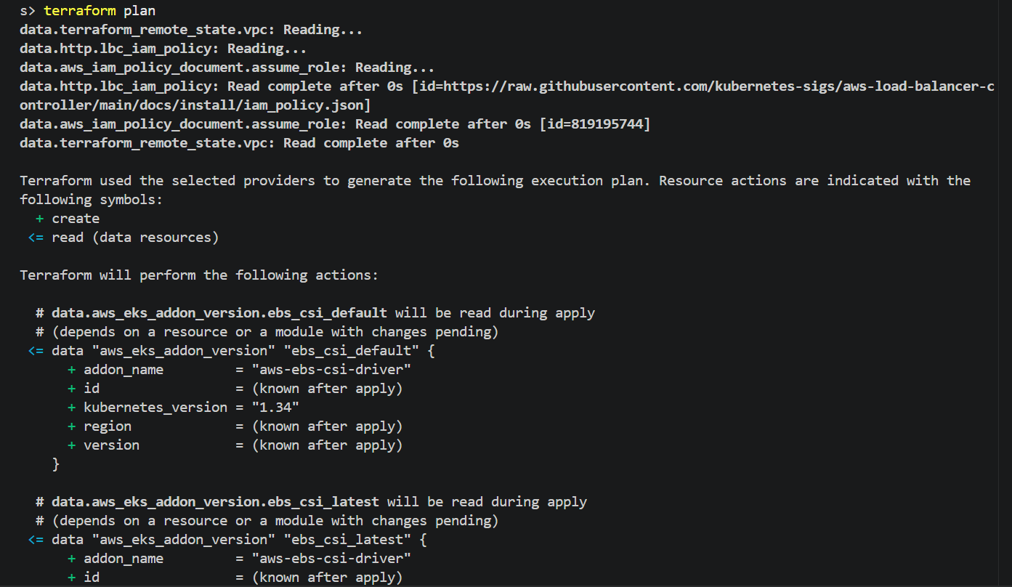

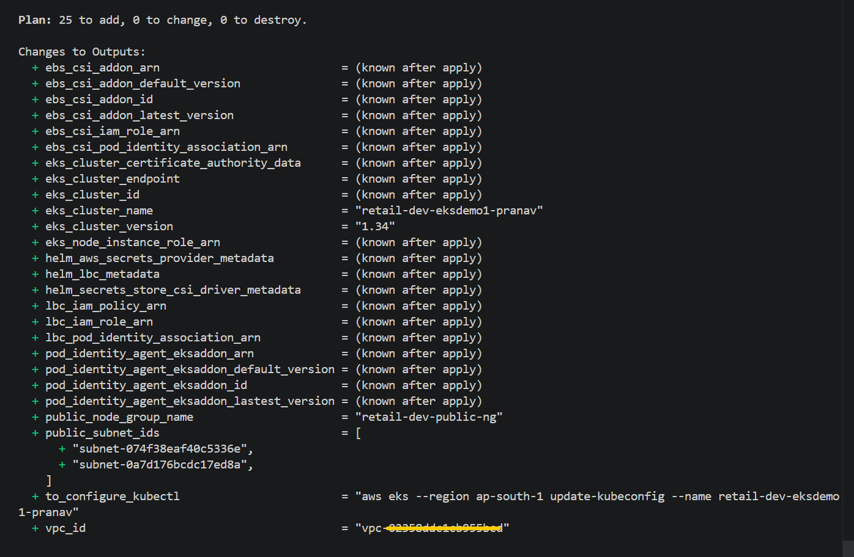
terraform apply –auto-approve
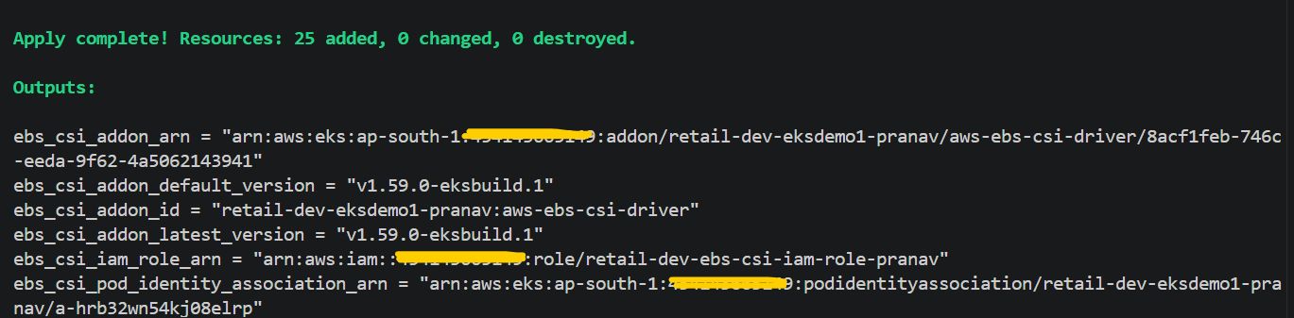
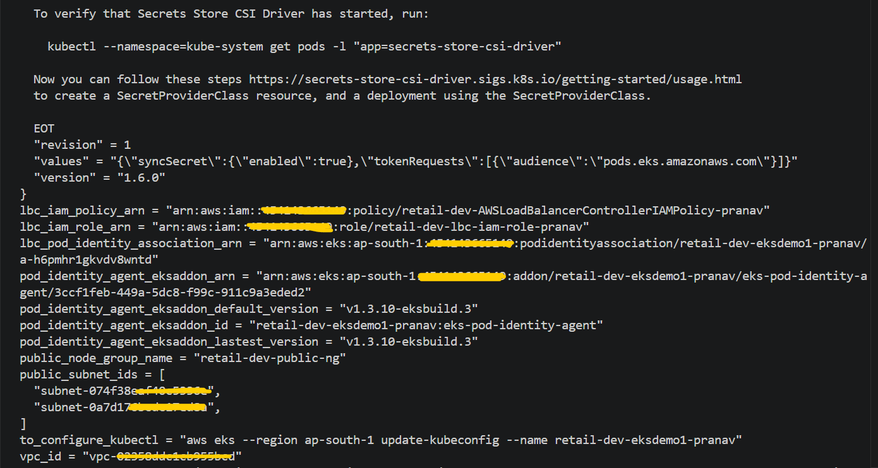
# Verified EKS Cluster and its configuration from AWS console
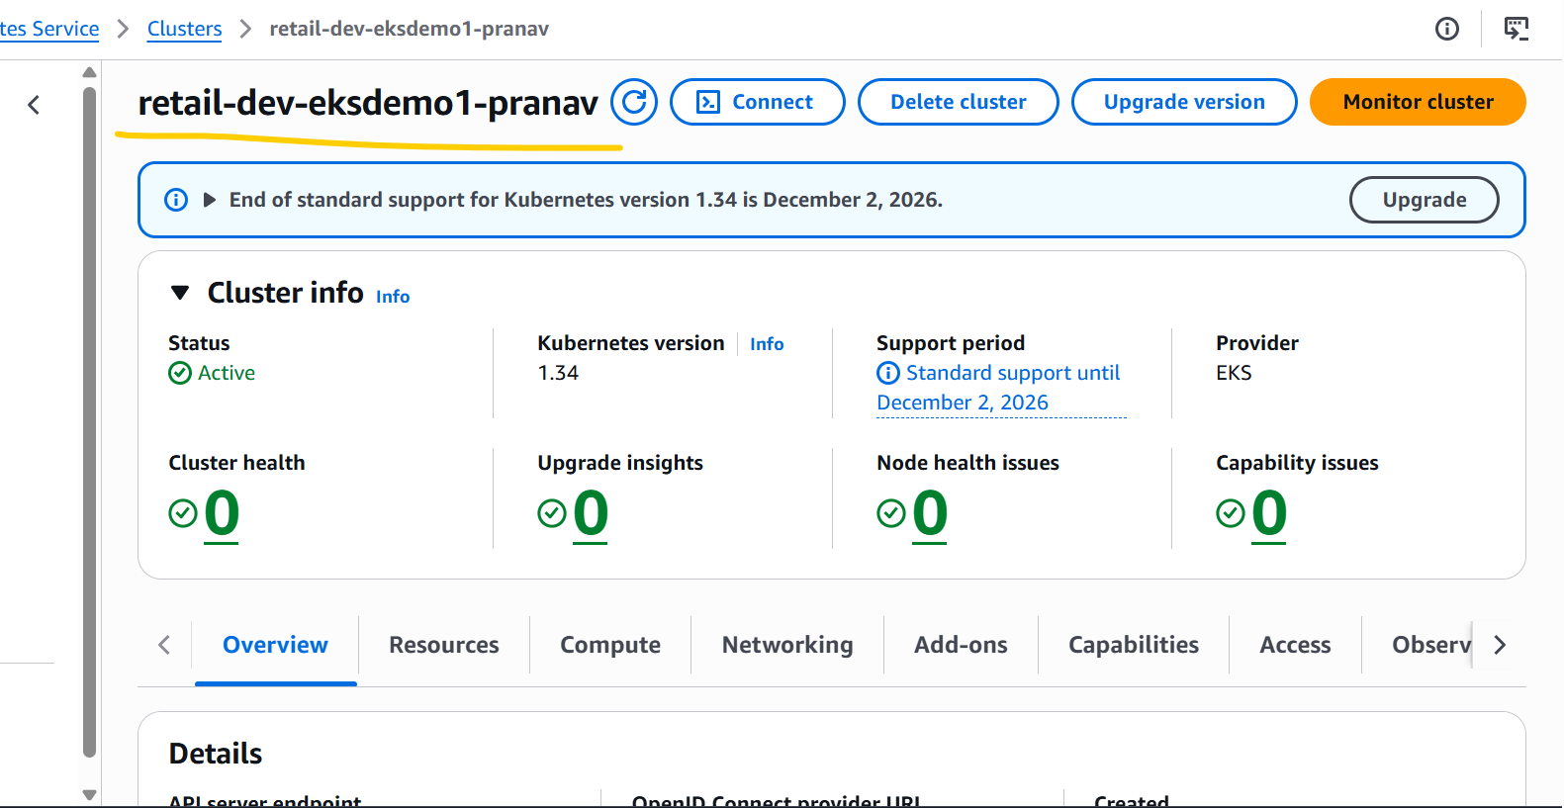

# EKS Node Group Instance Type Size

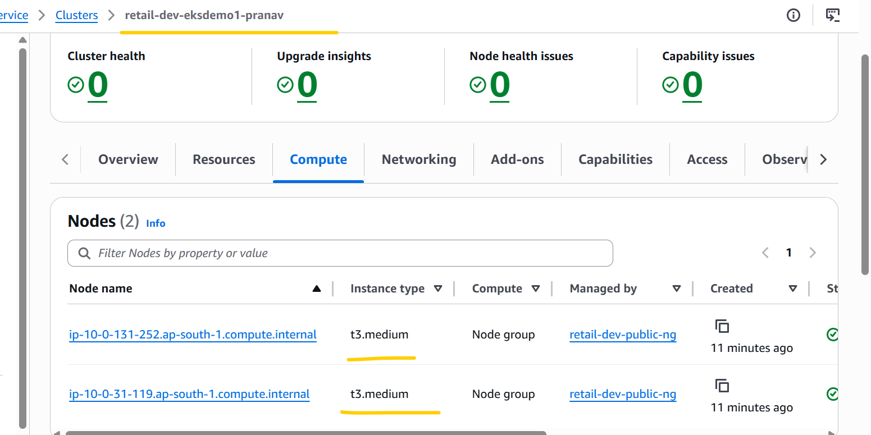

# EKS Cluster Add-ons.

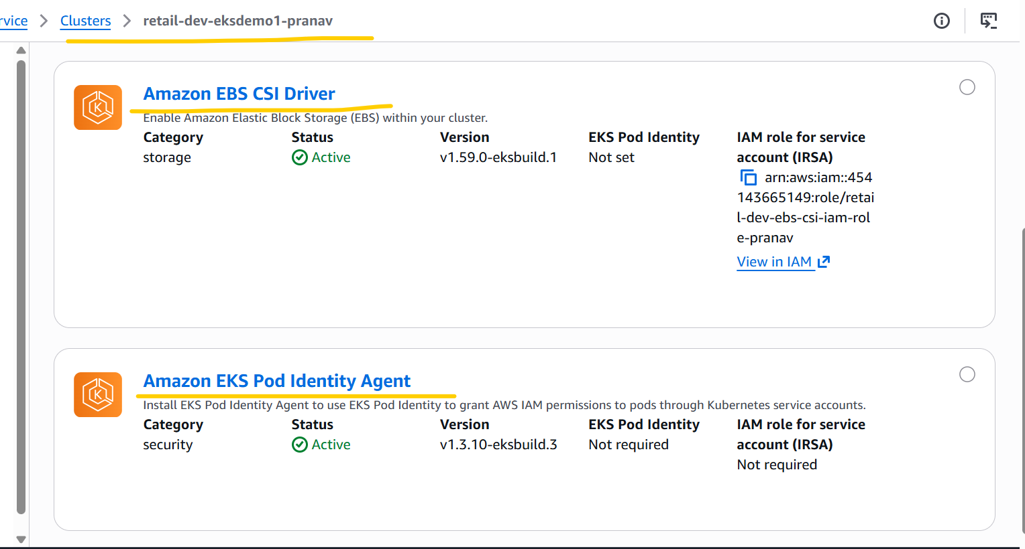

# EKS Cluster Pod Identity associations.

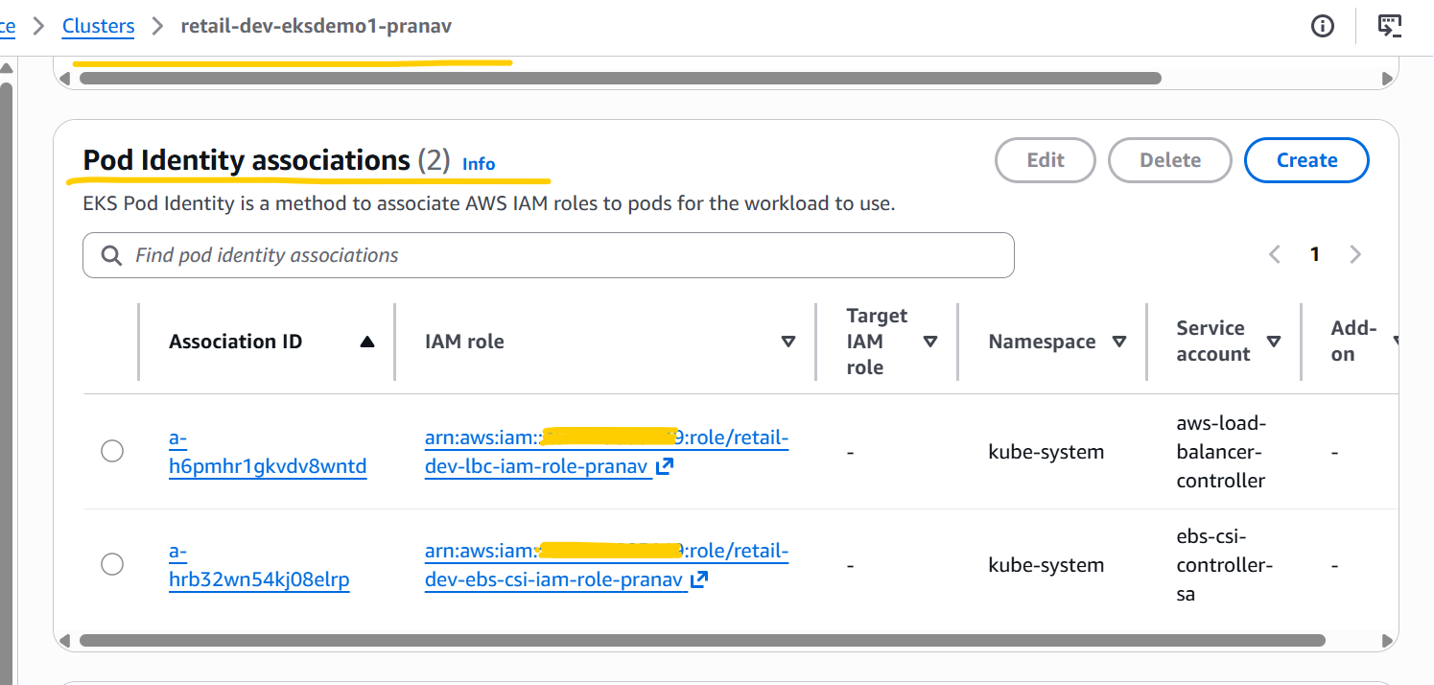

- Update AWS Data plane terraform code as per requirements and run below terraform commands to deploy the AWS Data plane.
terraform init
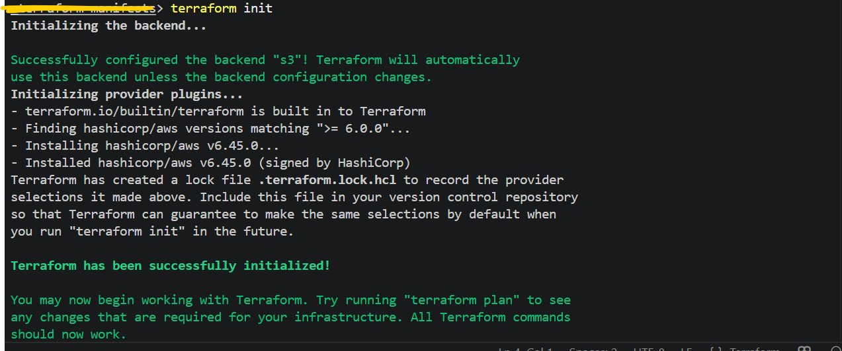
terraform validate
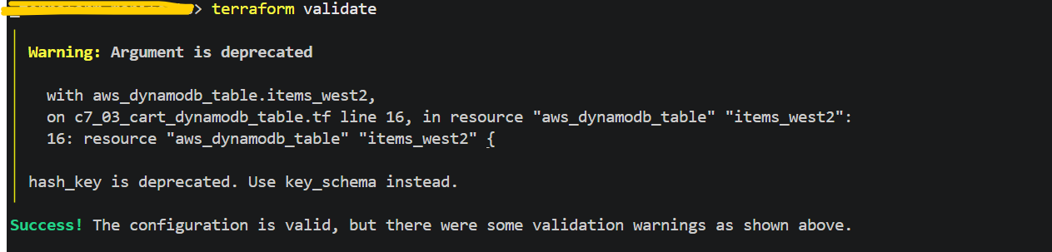
terraform plan
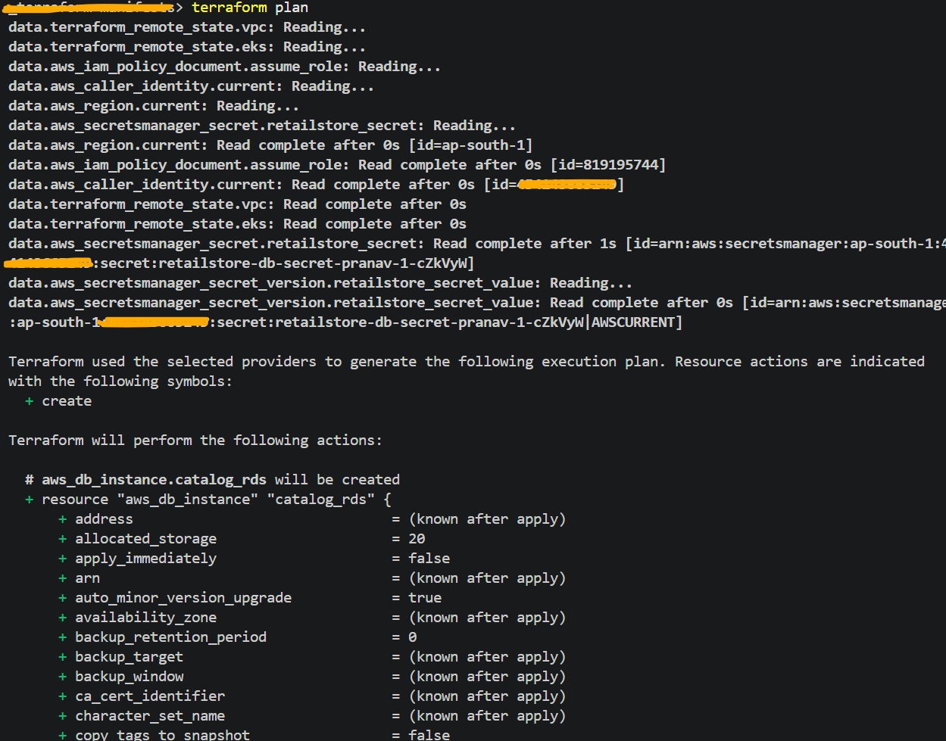
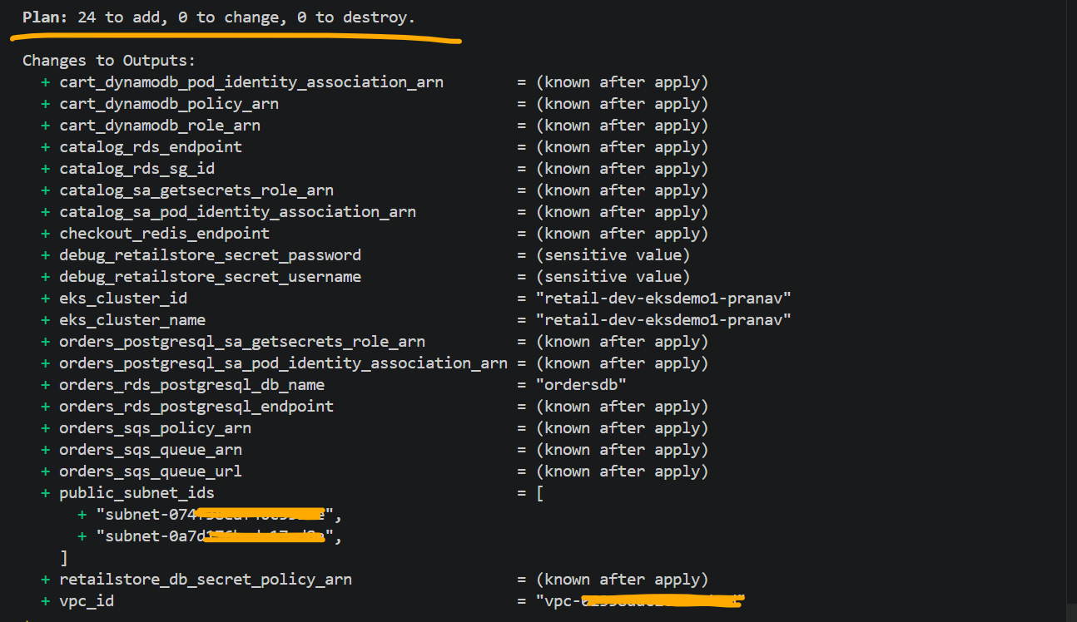
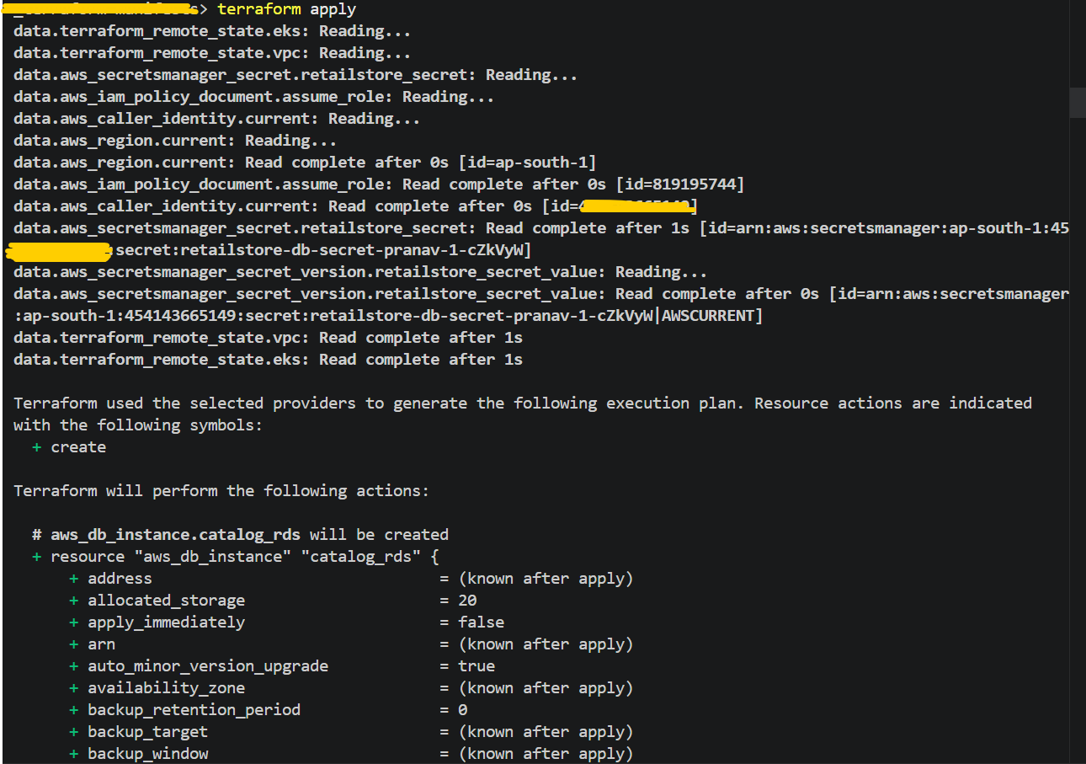
# AWS Data Plane related all the 24 resources are successfully deployed through terraform.
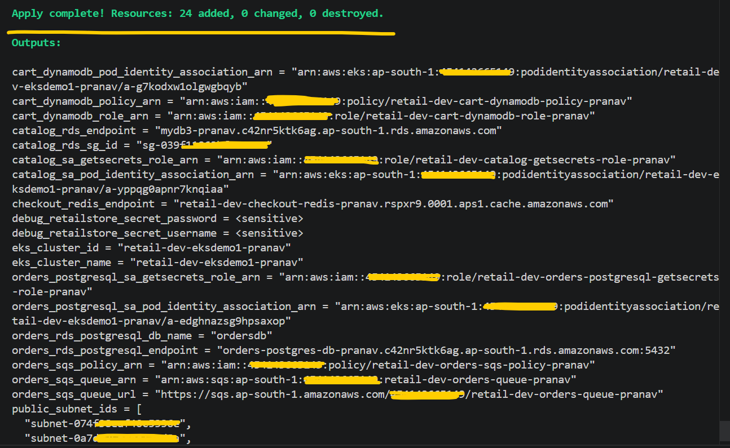

# Verify the AWS Data Plane resources from AWS Console.
Mysql and Postgresql RDS DB’s
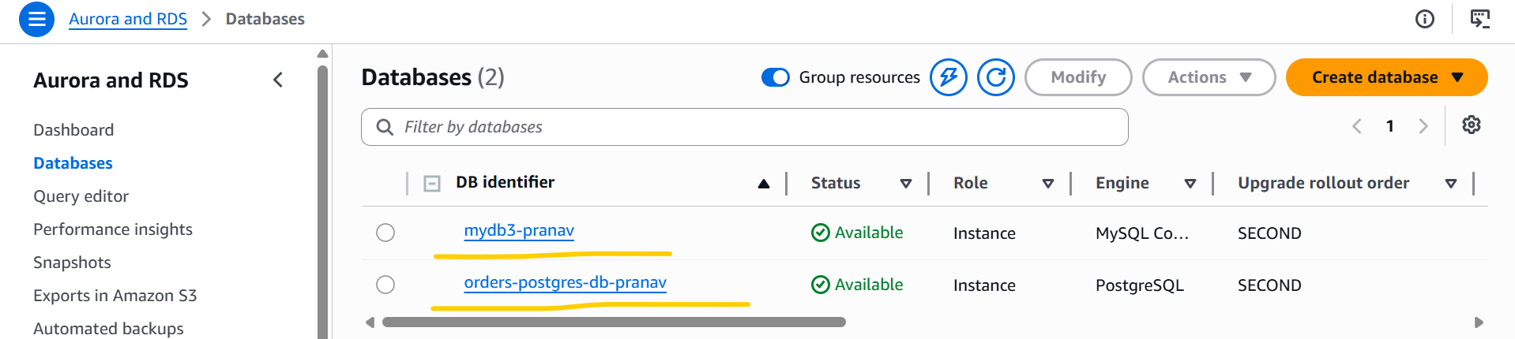

ElastiCache
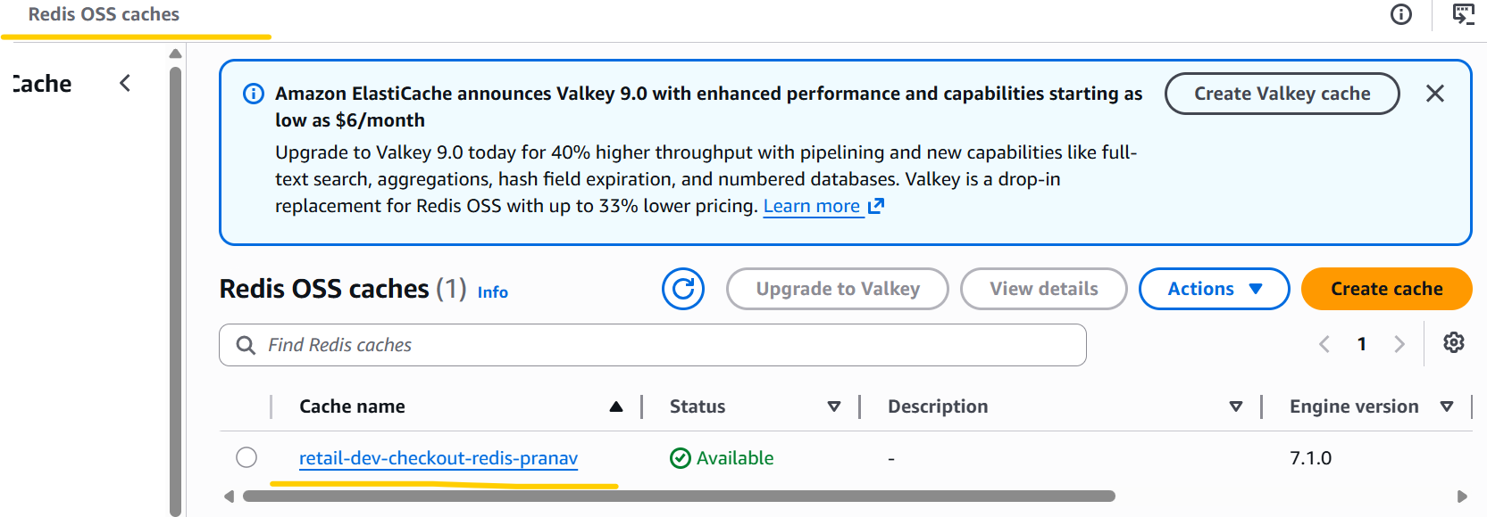
Dynamo DB Table
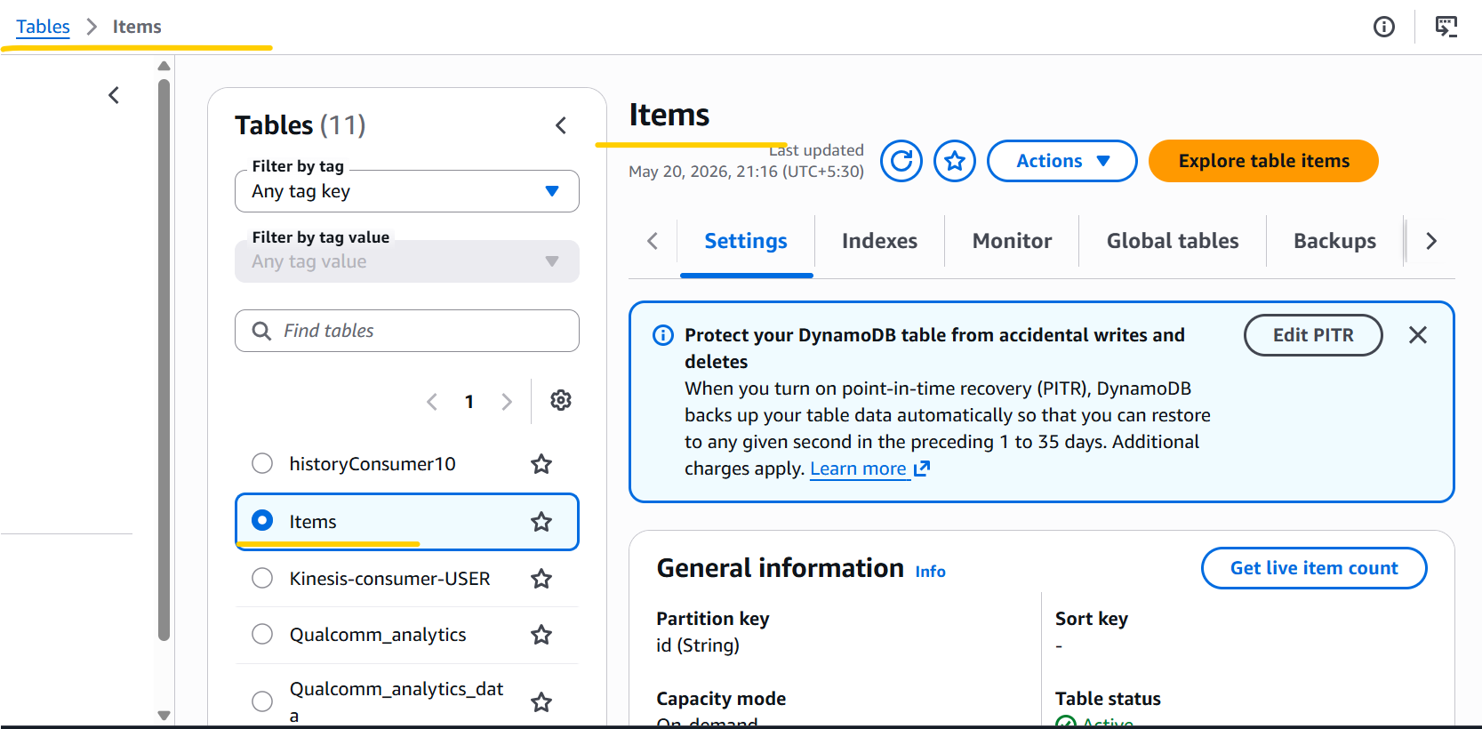

Amazon SQS
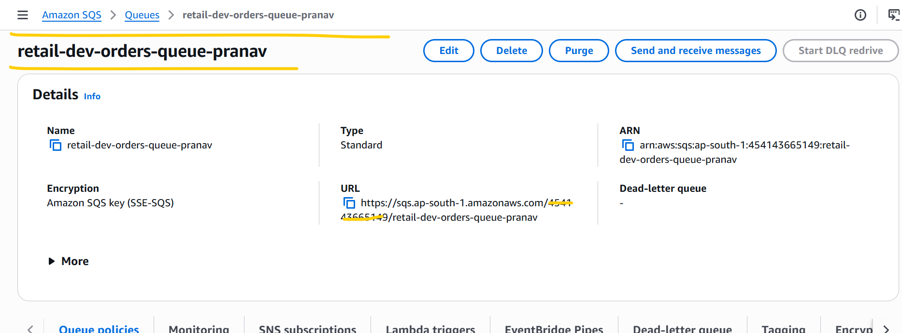

- Deployed Retail Store Application Microservices Stack.
aws eks --region ap-south-1 update-kubeconfig --name retail-dev-eksdemo1-pranav
# Change Directory
cd RetailStore_k8s_manifests_with_Data_Plane
# Deploy
kubectl apply -f 01_secretproviderclass/
kubectl get secretproviderclass
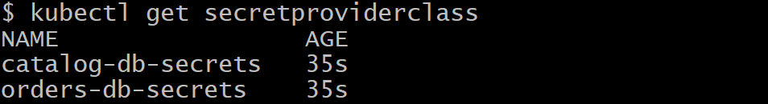
# Check the pod and ingress status before deploying the microservices and ingress. No existing pods are present.
kubectl get pods
kubectl get ingress

# Deploy
kubectl apply -f 02_RetailStore_Microservices/05_ui/
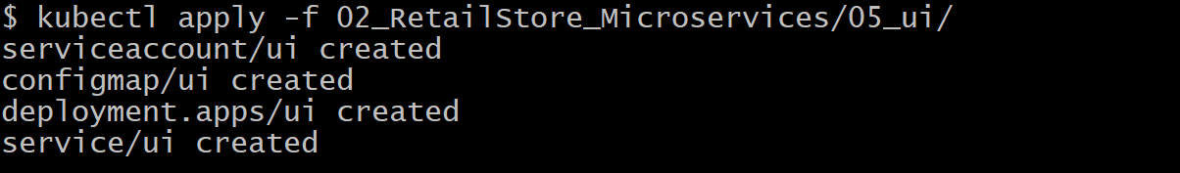
kubectl apply -f 03_ingress/
# Verify the pod and ingress status after deploying the ui microservice and ingress.
kubectl get pods
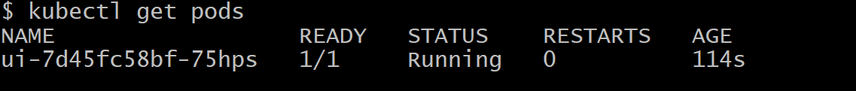
kubectl get ingress
# Verify the ALB from AWS Console.
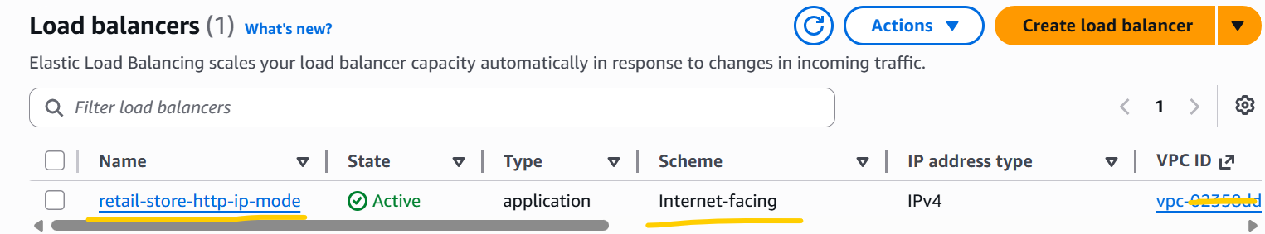
# Access the ALB Link from system browser.
ALB Link:- http://retail-store-http-ip-mode-1305655714.ap-south-1.elb.amazonaws.com/
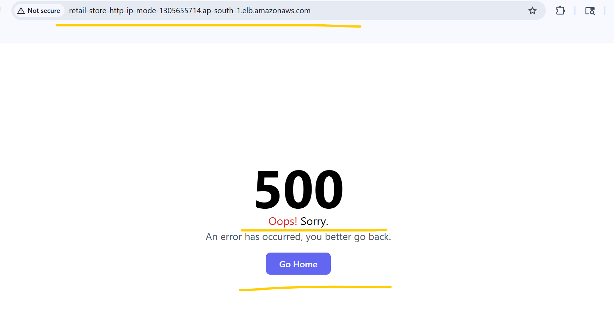
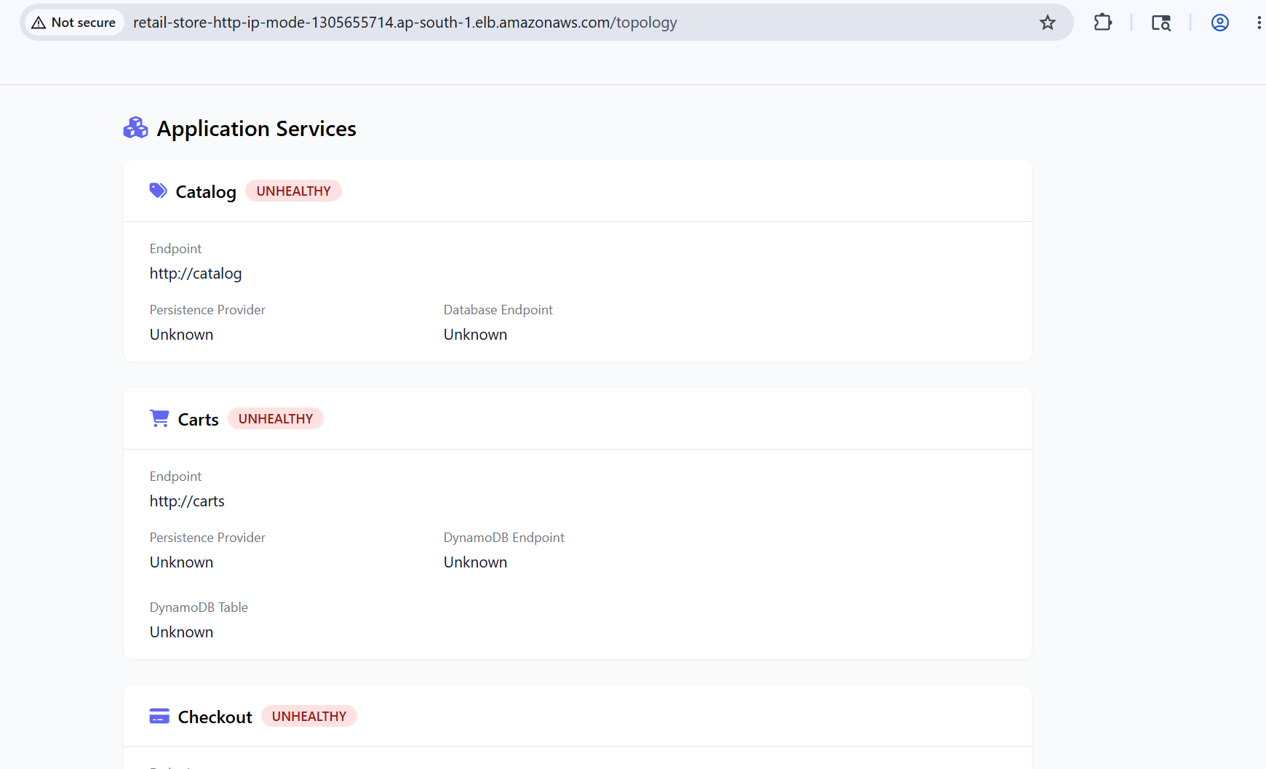
Note:- The 500 error and the unhealthy status of all microservices shown in /topology are expected at this stage. This is because the other endpoints or microservices have not been deployed yet. Due to this, the error occurs and all microservices are shown as unhealthy. Once all the services are deployed, the status of all microservices will change to healthy.

Update the mysql DB endpoint in 05_catalog_mysql_externalname_service this file.
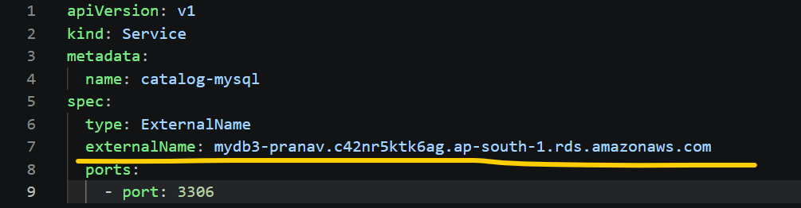
# Deploy
kubectl apply -f 02_RetailStore_Microservices/01_catalog/
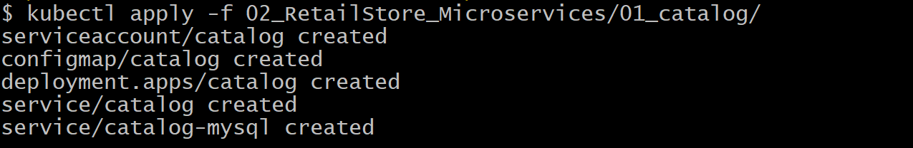
kubectl get pods
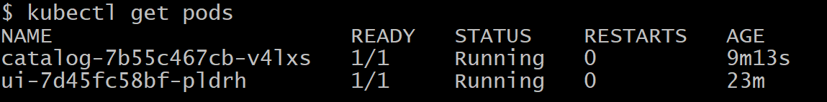
kubectl get secret
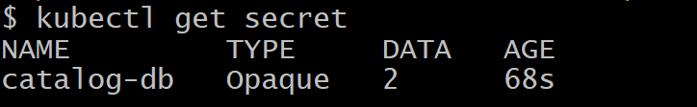
kubectl logs -f catalog-7b55c467cb-v4lxs
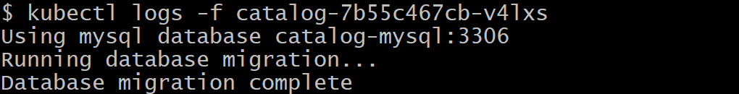
# Run the MySQL client pod to validate database connectivity and product data:
kubectl apply -f 04_Verification_Pods/01_catalog_mysql_client_pod.yaml

kubectl get pods
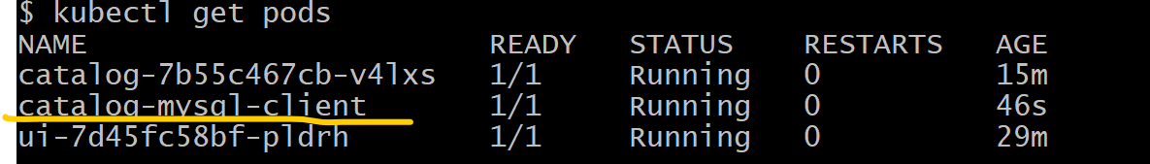
# Step-02: Connect to Pod
kubectl exec -it catalog-mysql-client -- bash
# Step-03: Verify Environment Variables
env
env | grep MYSQL
echo $MYSQL_HOST
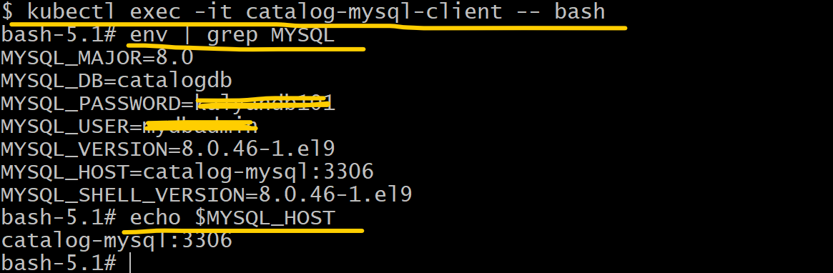
# Connect to MySQL DB
mysql -h $(echo $MYSQL_HOST | cut -d: -f1) -u $MYSQL_USER -p$MYSQL_PASSWORD
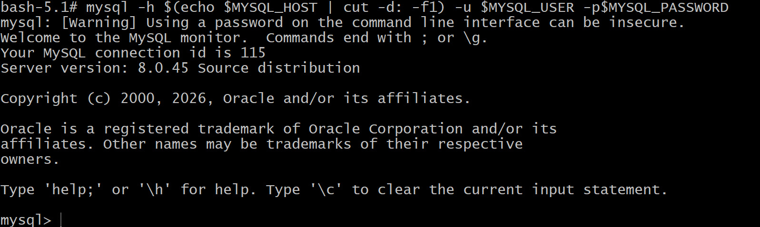
# Verify Data
SHOW DATABASES;
USE catalogdb;
SHOW TABLES;
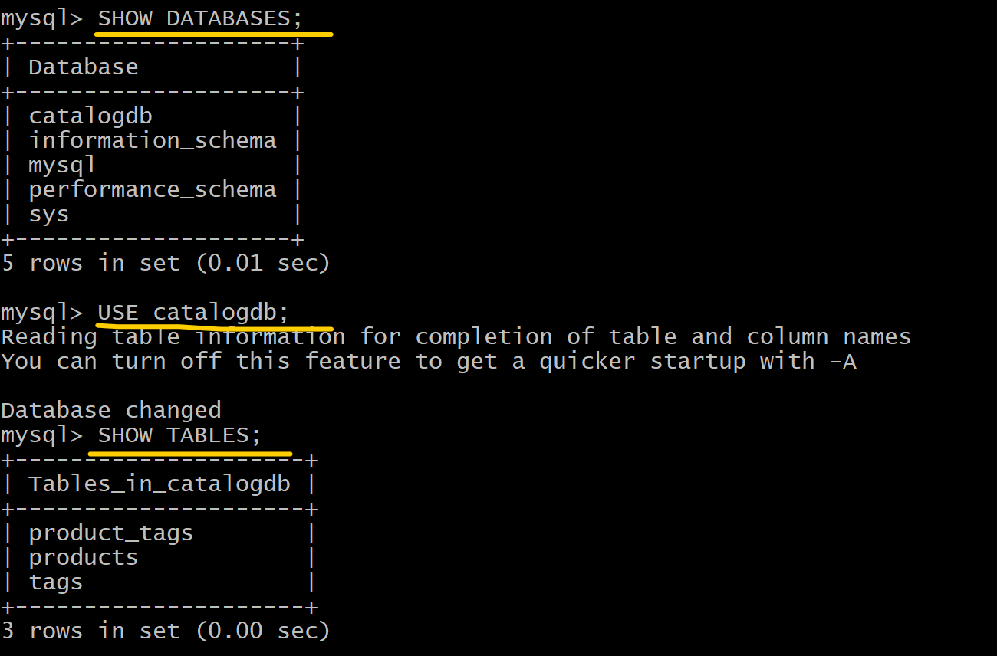
SELECT * FROM products;
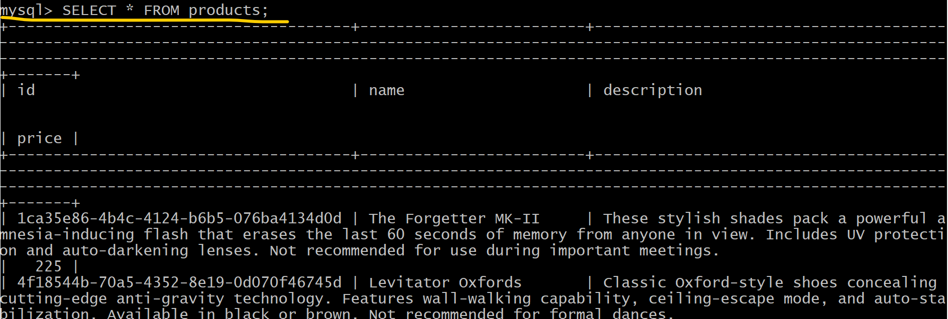
EXIT
exit
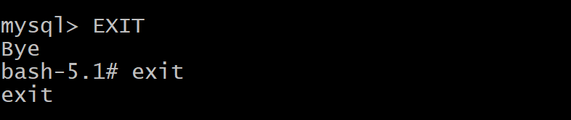
# Delete Mysql Client Verification Pod

kubectl delete -f 04_Verification_Pods/01_catalog_mysql_client_pod.yaml

# Deploy
kubectl apply -f 02_RetailStore_Microservices/02_cart/
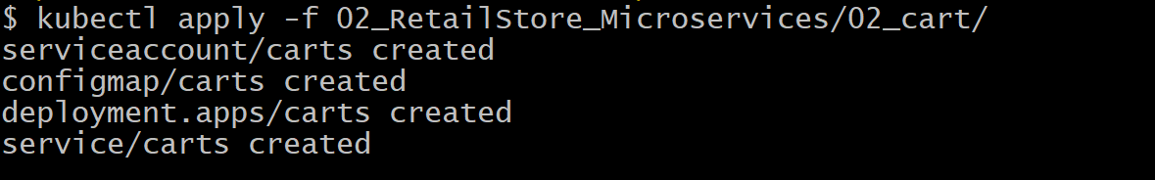
kubectl get pods
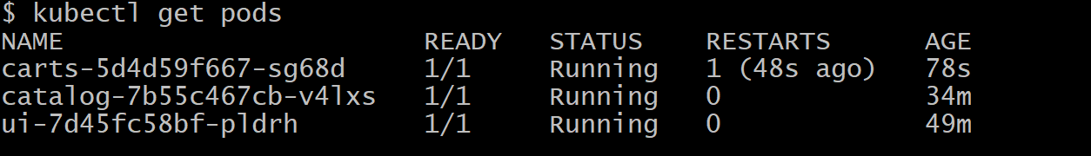
# Verify 2 microservices status from below link. Catalog and Carts both Microservices are healthy.
Topology Link:-
http://retail-store-http-ip-mode-1908876819.ap-south-1.elb.amazonaws.com/topology
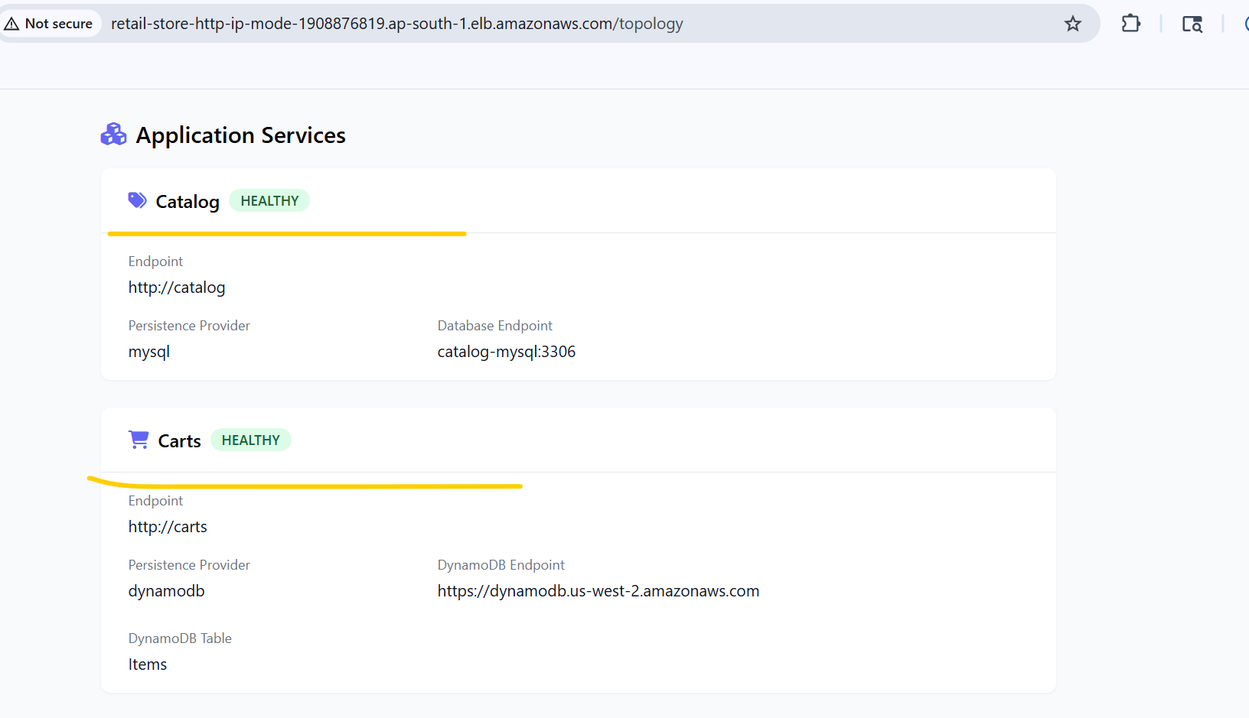

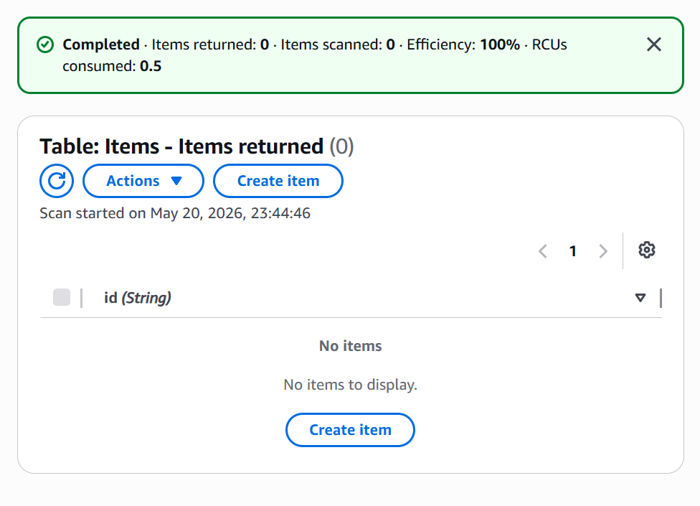
No table items in Dynamo DB Items table, as soon as we add any product any car through below mentioned ALB link, after that table items will appear in Item table.
ALB Link:-
http://retail-store-http-ip-mode-1908876819.ap-south-1.elb.amazonaws.com/
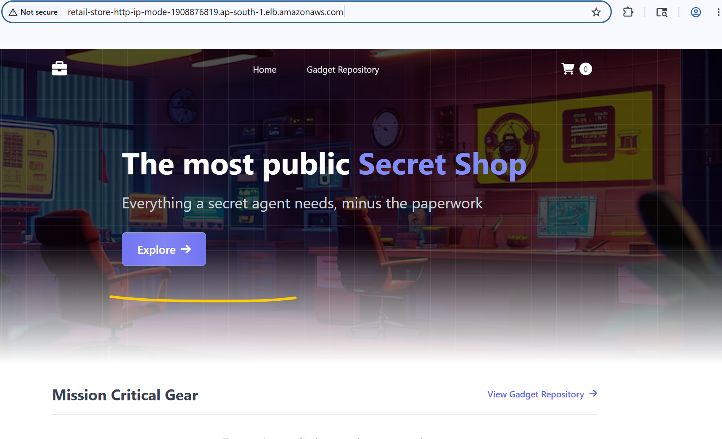
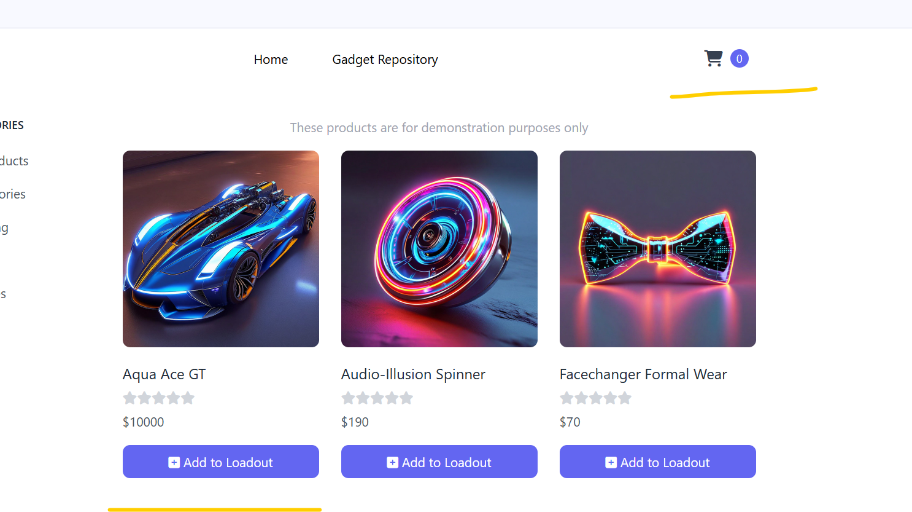
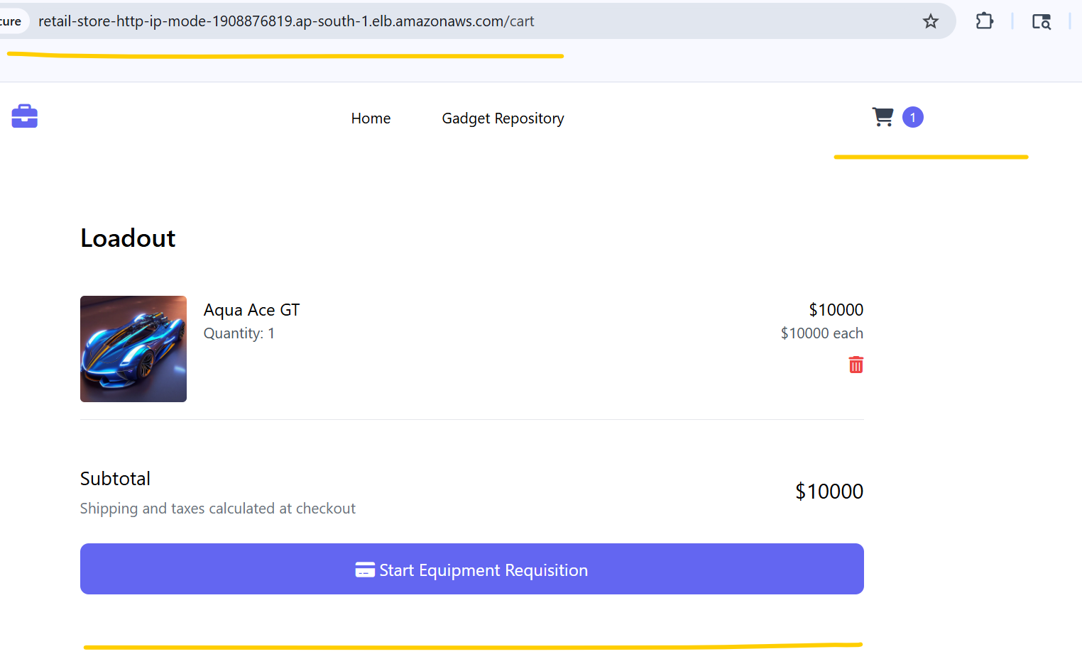
# Verify Dynamo DB table items for Items table, now 1 item is showing in table items.

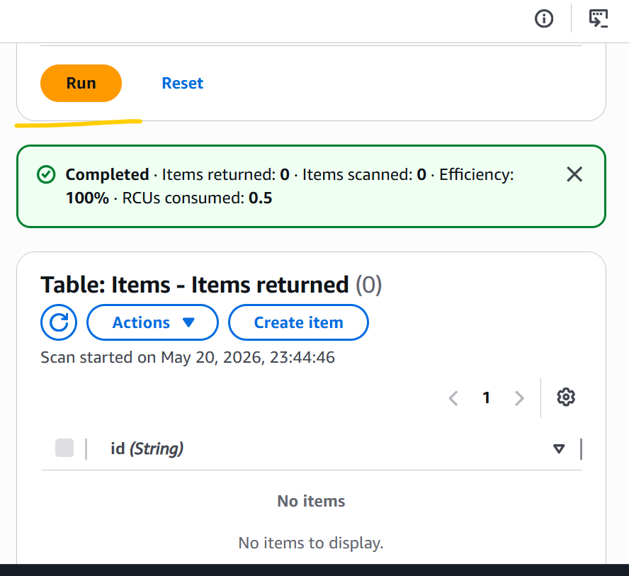
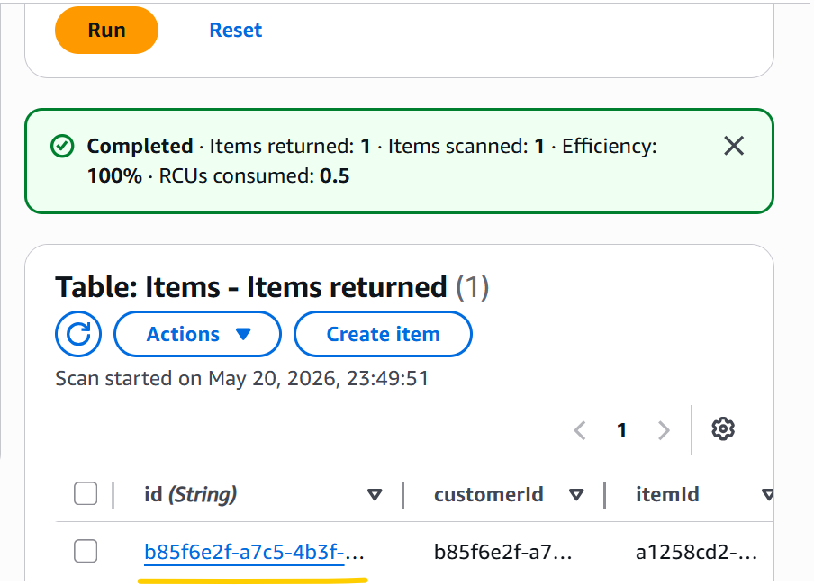

# Update Redis endpoint in 02_checkout_configmap this Kubernetes manifest file. To deploy checkout Microservice.
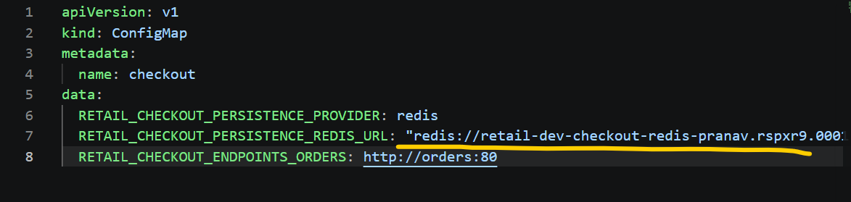
# Deploy
kubectl apply -f 02_RetailStore_Microservices/03_checkout/
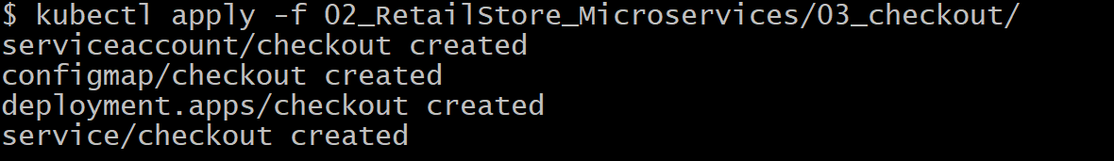
kubectl get pods
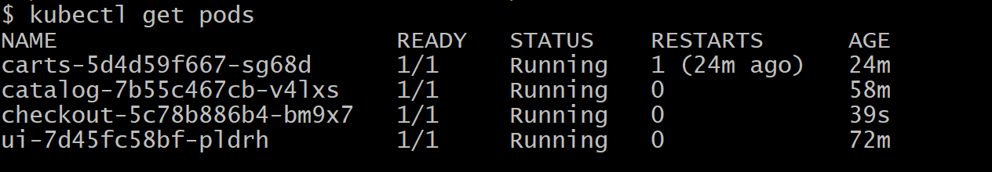
# Update RDS PostgreSQL endpoint and Sqs Topic name in 02_orders_configmap this Kubernetes manifest file. To deploy orders Microservice.
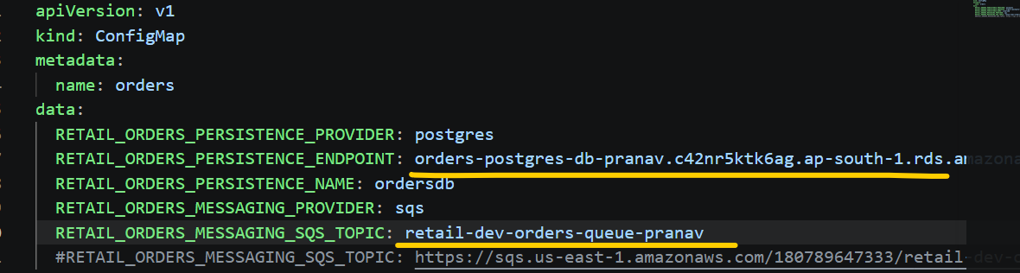
# Deploy
kubectl apply -f 02_RetailStore_Microservices/04_orders/
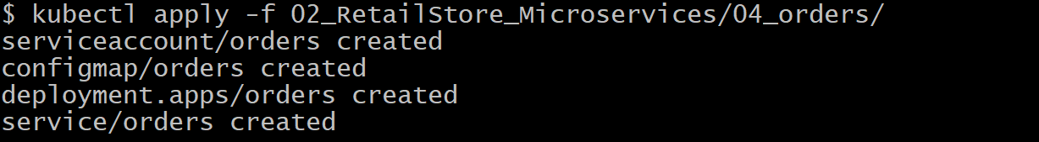
kubectl get pods
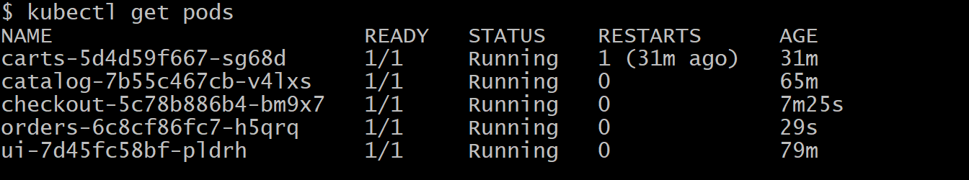

# All microservices are deployed successfully and their status are also showing healthy in /topology.

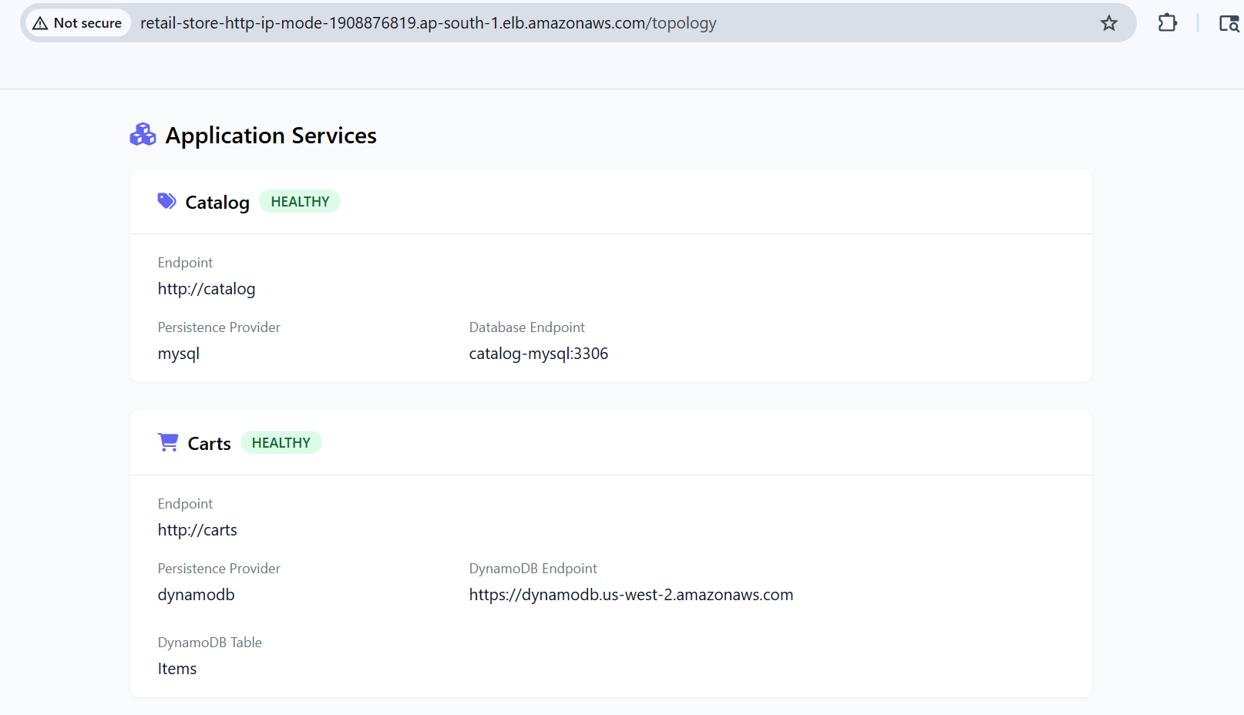

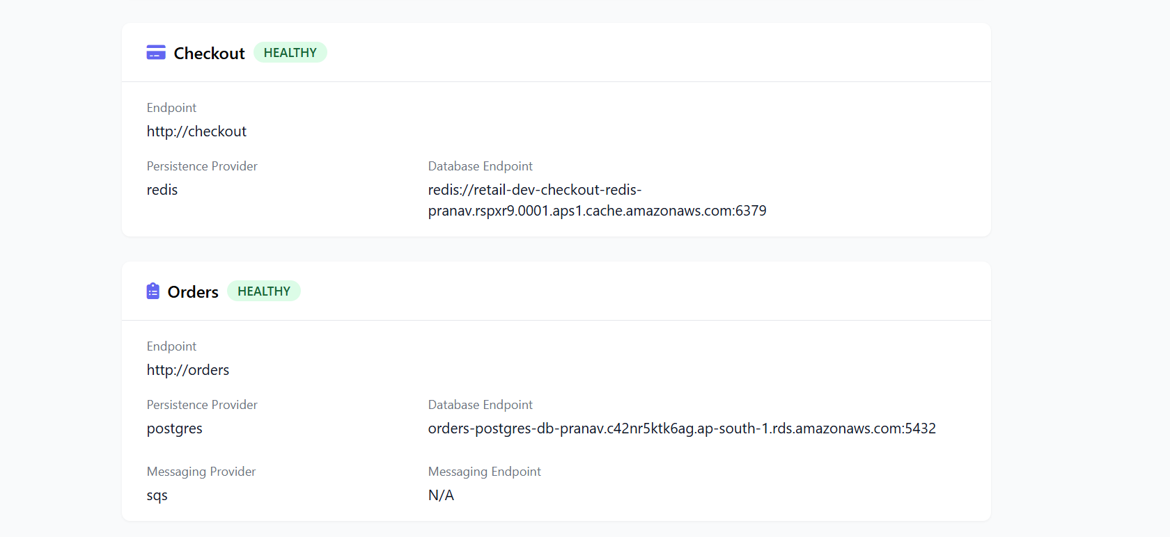
I can able to perform transaction successfully by accessing below mentioned ALB Link.
ALB Link:- http://retail-store-http-ip-mode-1908876819.ap-south-1.elb.amazonaws.com/checkout/payment
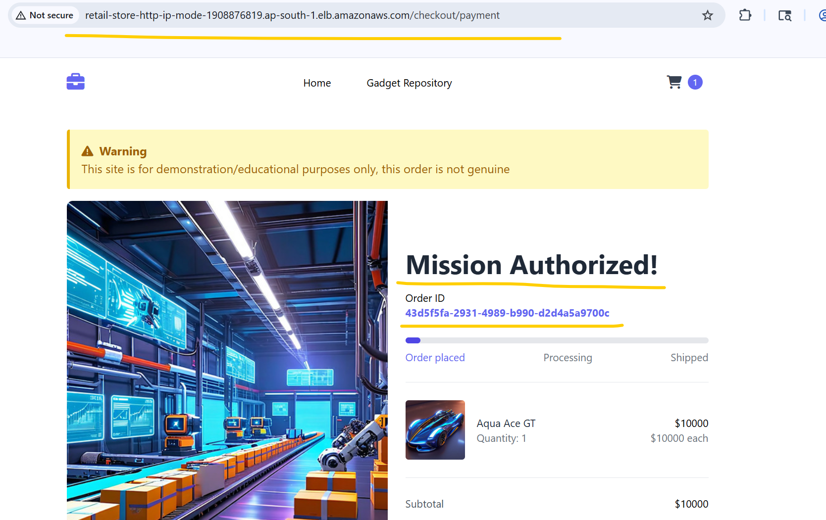

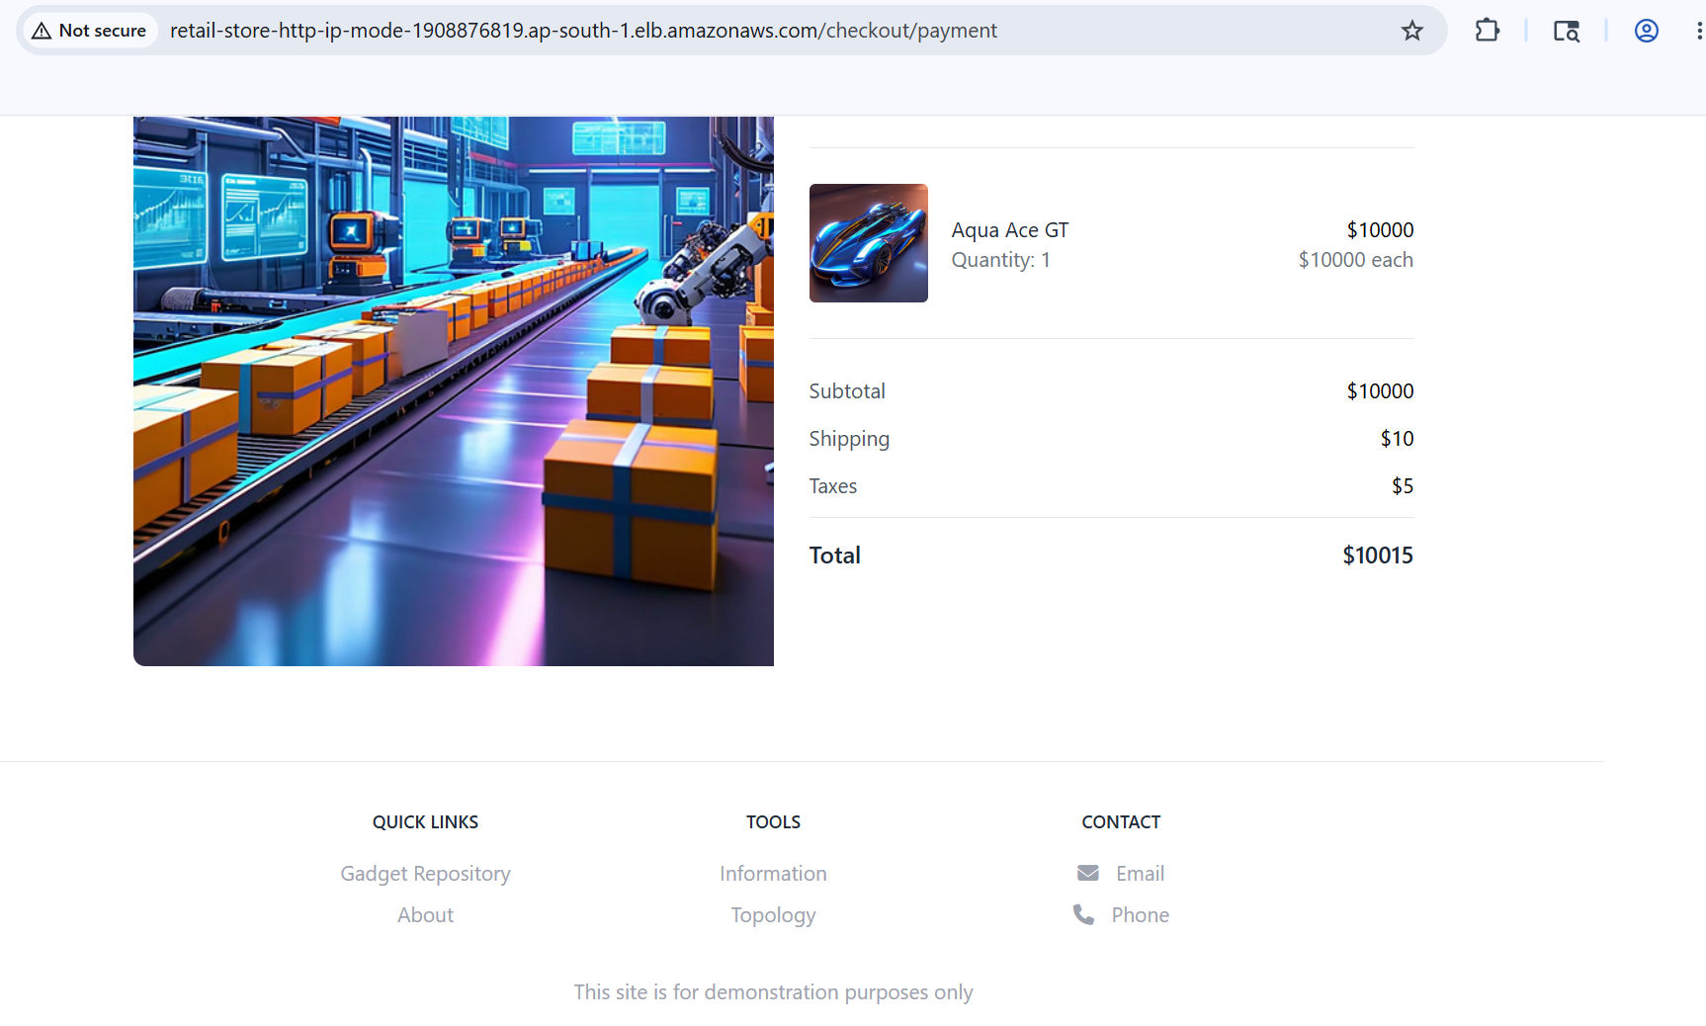

- Deleted Kubernetes Resources and AWS Data Plane Stack.
# Delete Kubernetes Resources.
kubectl delete -f 02_RetailStore_Microservices/04_orders/
kubectl delete -f 02_RetailStore_Microservices/03_checkout/
kubectl delete -f 02_RetailStore_Microservices/02_cart/
kubectl delete -f 02_RetailStore_Microservices/01_catalog/
kubectl delete -f 02_RetailStore_Microservices/05_ui/
kubectl delete -f 03_ingress/
kubectl delete -f 01_secretproviderclass/
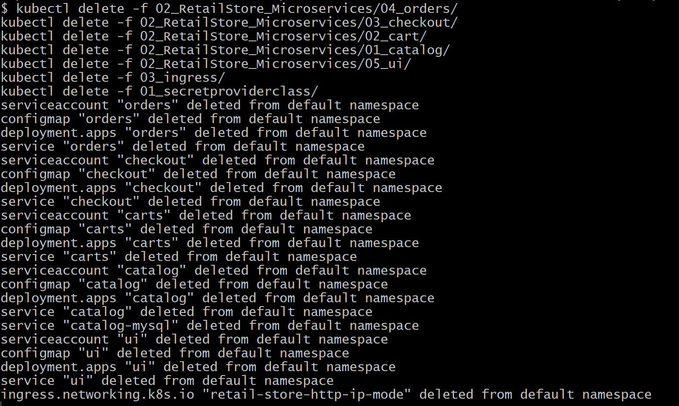
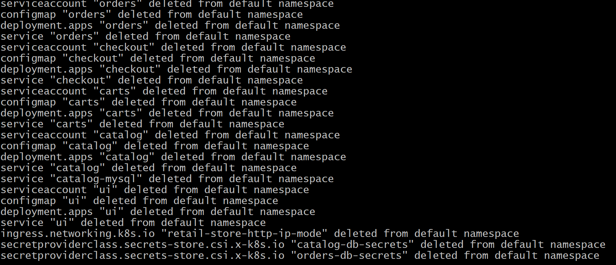
# Deleted AWS Data Plane Stack through terraform destroy –auto-approve command.

- Deleted EKS Cluster, Add ons, Node group, Iam roles for through terraform destroy –auto-approve command.

