Steps:-
- Created EKS Cluster, Node group and require Iam roles for the same through terraform. To do the same copy terraform code from 13_05_2026 folder into 14_05_2026.

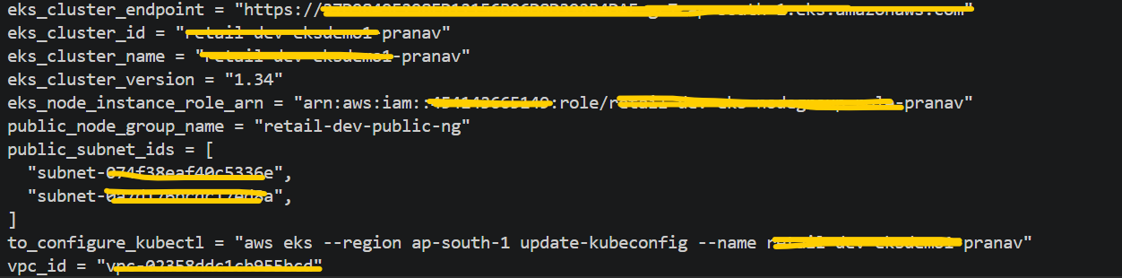

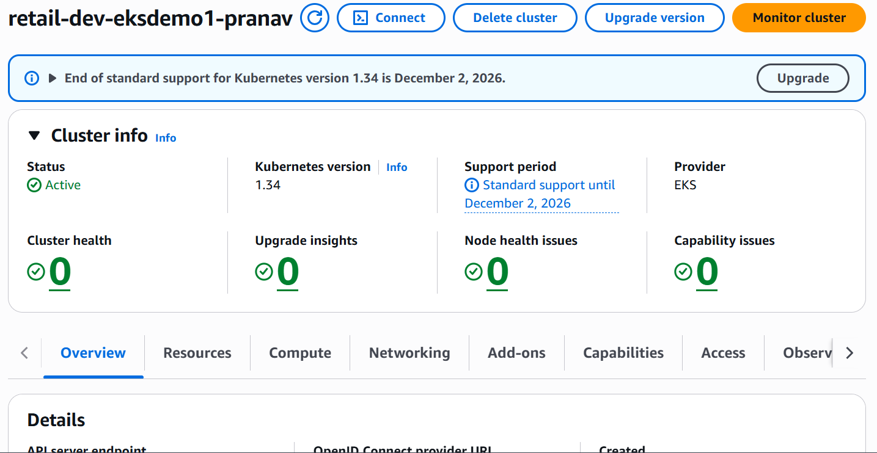

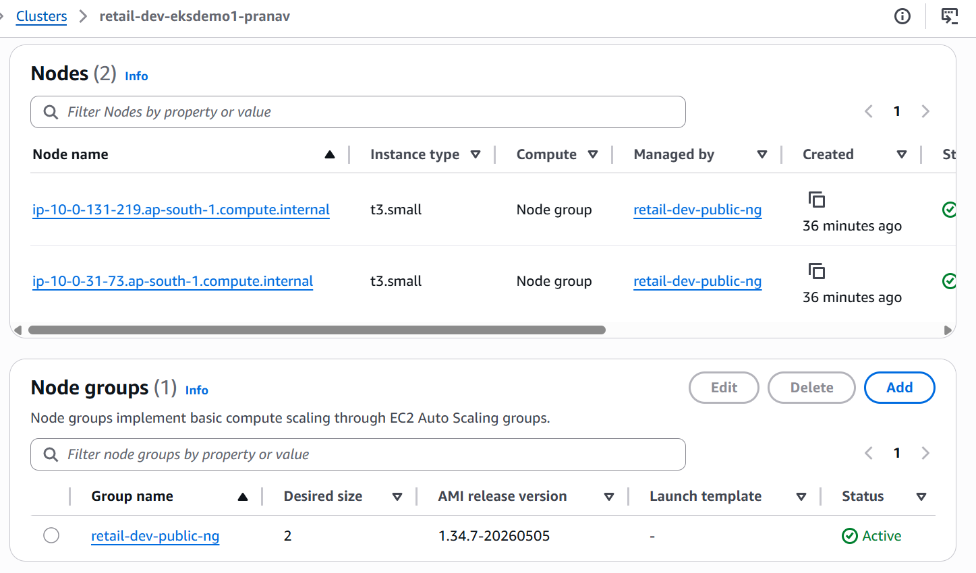

- Add below Add on in EKS Cluster.
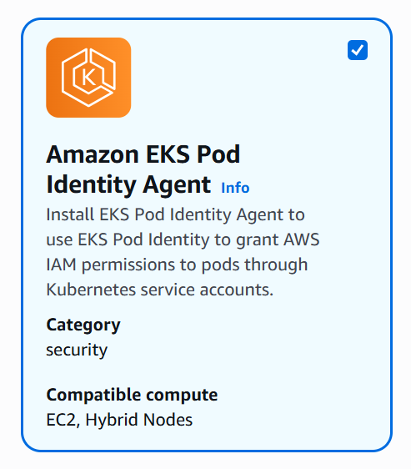

- Run below mentioned commands.
export AWS_REGION="ap-south-1"
export EKS_CLUSTER_NAME="retail-dev-eksdemo1-pranav"
export AWS_ACCOUNT_ID=$(aws sts get-caller-identity --query Account --output text)

echo $AWS_REGION
echo $EKS_CLUSTER_NAME
echo $AWS_ACCOUNT_ID

cat <<EOF > ebs-csi-driver-trust-policy.json
{
"Version": "2012-10-17",
"Statement": [
{
"Effect": "Allow",
"Principal": {
"Service": "pods.eks.amazonaws.com"
},
"Action": [
"sts:AssumeRole",
"sts:TagSession"
]
}
]
}
EOF

# Create IAM Role
aws iam create-role \
--role-name AmazonEKS_EBS_CSI_DriverRole_${EKS_CLUSTER_NAME} \
--assume-role-policy-document file://ebs-csi-driver-trust-policy.json
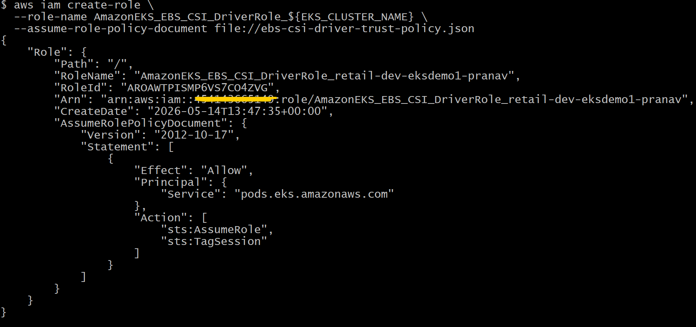

# Attach IAM Policy to IAM Role

aws iam attach-role-policy \
--role-name AmazonEKS_EBS_CSI_DriverRole_${EKS_CLUSTER_NAME} \
--policy-arn arn:aws:iam::aws:policy/service-role/AmazonEBSCSIDriverPolicy
# Verified Iam role
aws iam list-attached-role-policies \
--role-name AmazonEKS_EBS_CSI_DriverRole_${EKS_CLUSTER_NAME}
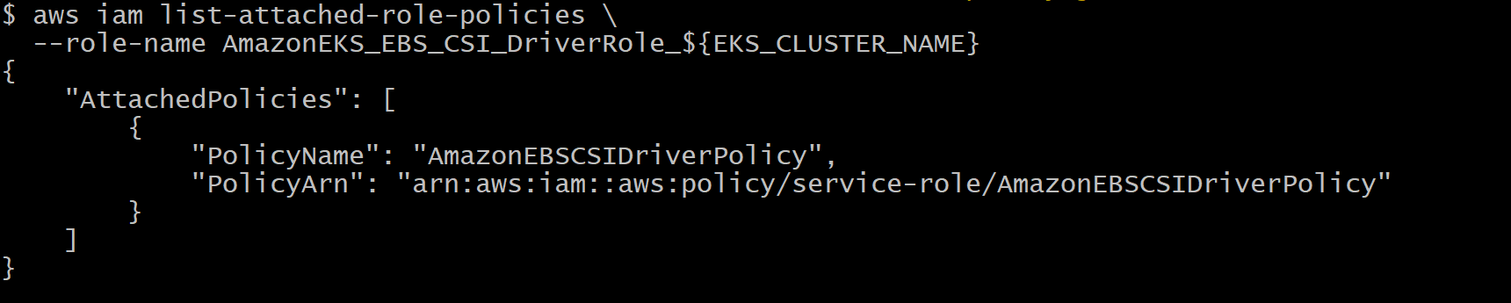
# Create EKS Pod Identity Assocication
aws eks create-pod-identity-association \
--cluster-name ${EKS_CLUSTER_NAME} \
--namespace kube-system \
--service-account ebs-csi-controller-sa \
--role-arn arn:aws:iam::${AWS_ACCOUNT_ID}:role/AmazonEKS_EBS_CSI_DriverRole_${EKS_CLUSTER_NAME}
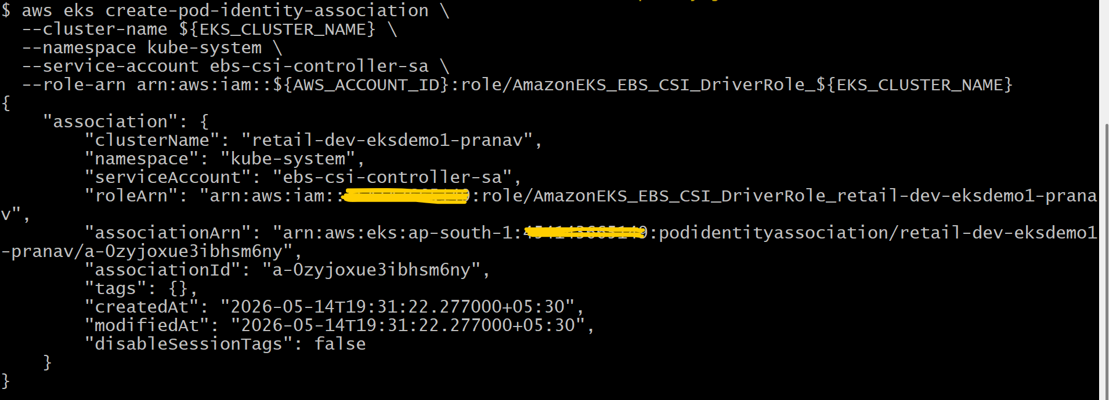
# Verified the PIA association in the AWS Console for the EKS cluster
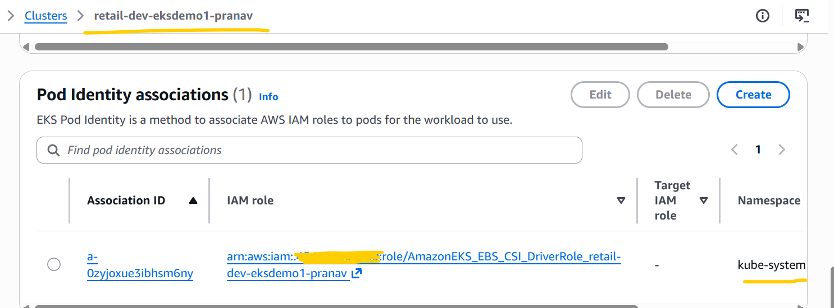

# List existing EKS add-ons
aws eks list-addons --cluster-name ${EKS_CLUSTER_NAME}
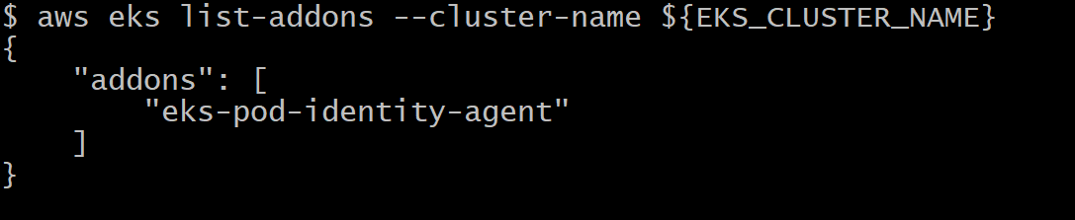

# Install EKS EBS CSI Addon
aws eks create-addon \
--cluster-name ${EKS_CLUSTER_NAME} \
--addon-name aws-ebs-csi-driver \
--service-account-role-arn arn:aws:iam::${AWS_ACCOUNT_ID}:role/AmazonEKS_EBS_CSI_DriverRole_${EKS_CLUSTER_NAME}

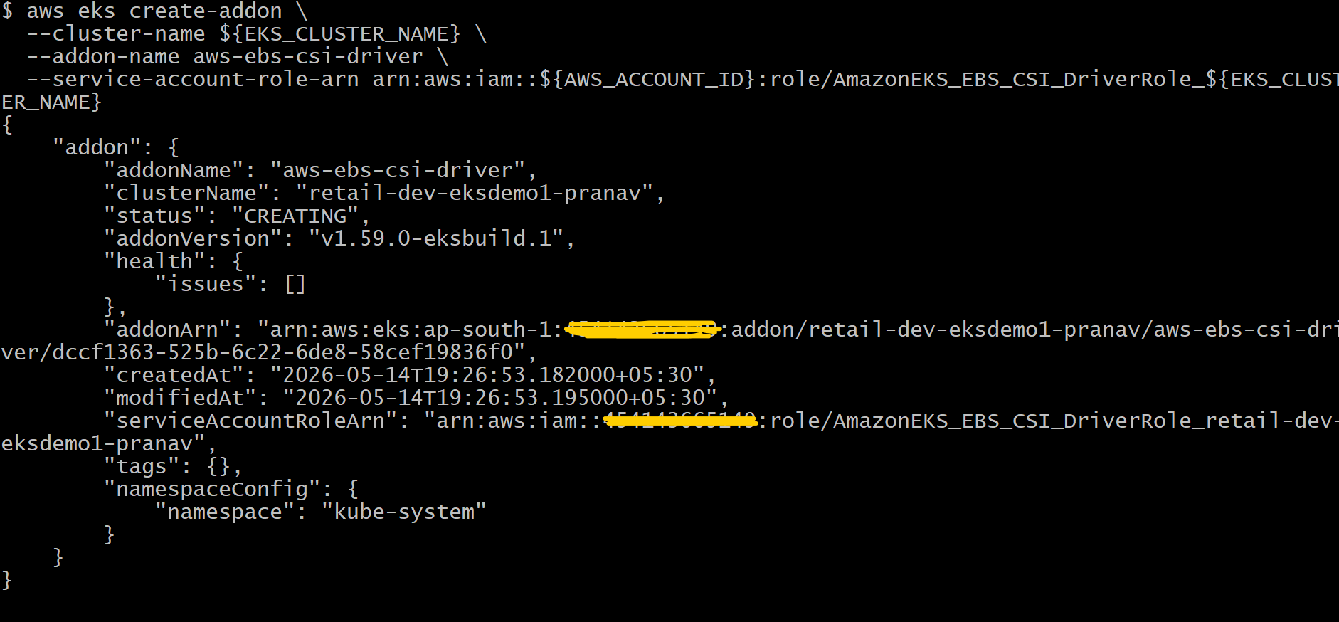
# List EKS add-ons (after install)
aws eks list-addons --cluster-name ${EKS_CLUSTER_NAME}
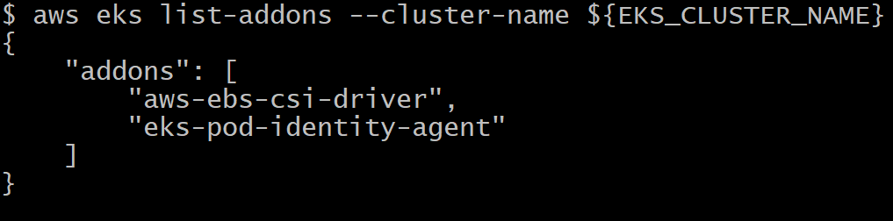
# Describe Addon - Verify Status
aws eks describe-addon \
--cluster-name ${EKS_CLUSTER_NAME} \
--addon-name aws-ebs-csi-driver \
--query "addon.status" --output text
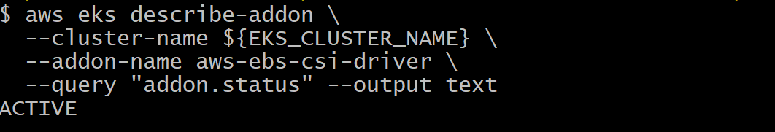
kubectl get pods -n kube-system | grep ebs-csi
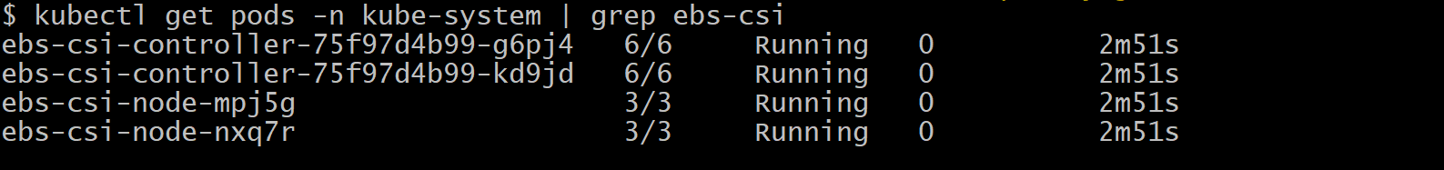
kubectl get ds -n kube-system | grep ebs-csi
kubectl get deploy -n kube-system | grep ebs-csi
kubectl apply -f 01_secretproviderclass/
Note :- Getting error after running above command, run below commands to resolve this issue.
kubectl get crd | grep secretprovider
helm repo list
helm install csi-secrets-store \
secrets-store-csi-driver/secrets-store-csi-driver \
-n kube-system
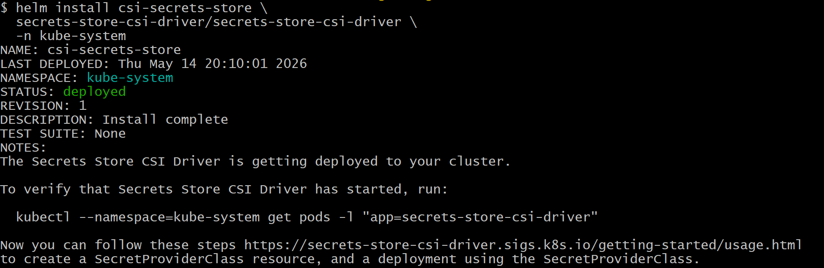
kubectl get crd | grep secretprovider
kubectl apply -f 01_secretproviderclass/
Note:- This time above command has been successfully run.
kubectl apply -f 02_catalog_k8s_manifests/
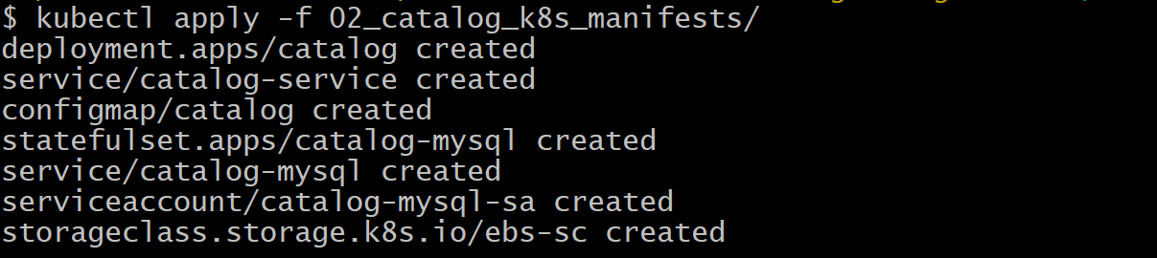
kubectl get sc
kubectl get pvc,pv
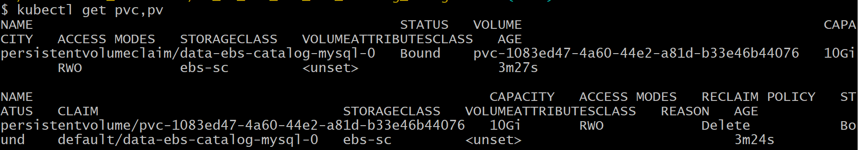
kubectl get pods
Note:- In first attempt Pods are not getting deployed or created due to unavailability of PIA association for catalog-mysql-sa for catalog-db-secrets-role-pranav this iam role. So, to resolve that issue, I have created require iam policy and iam role and attached iam policy to iam role and run aws eks create-pod-identity-association this command after that Pod creation issue has been resolved.

kubectl port-forward svc/catalog-service 7080:8080
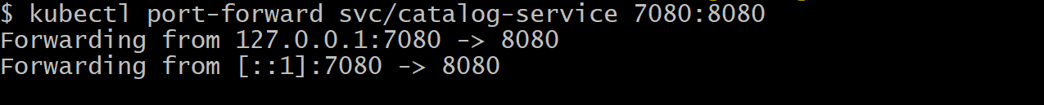

Check below mentioned endpoints, from my system browser, I can able to access those endpoints successfully.
http://localhost:7080/health
http://localhost:7080/catalog/products

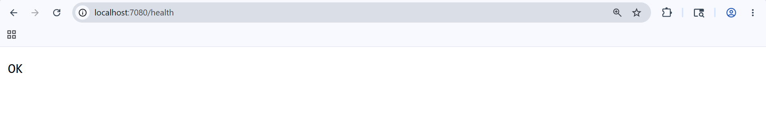

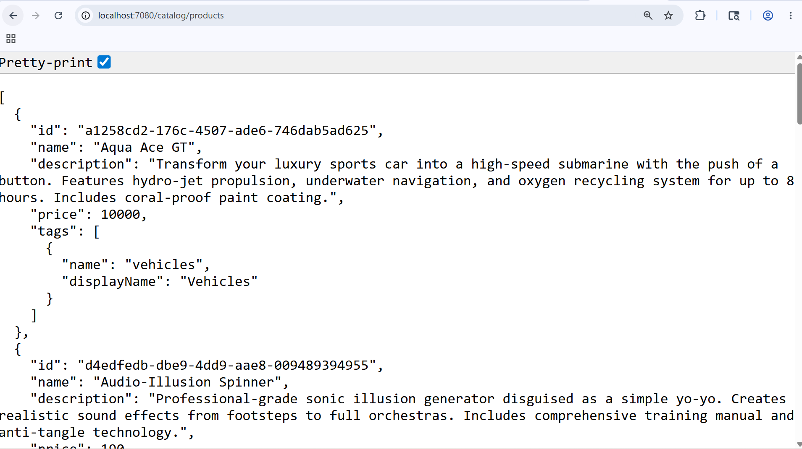

kubectl run mysql-client --rm -it \
--image=mysql:8.0 \
--restart=Never \
-- mysql -h catalog-mysql -u mydbadmin -p
During passport prompt, enter the db password and press enter.

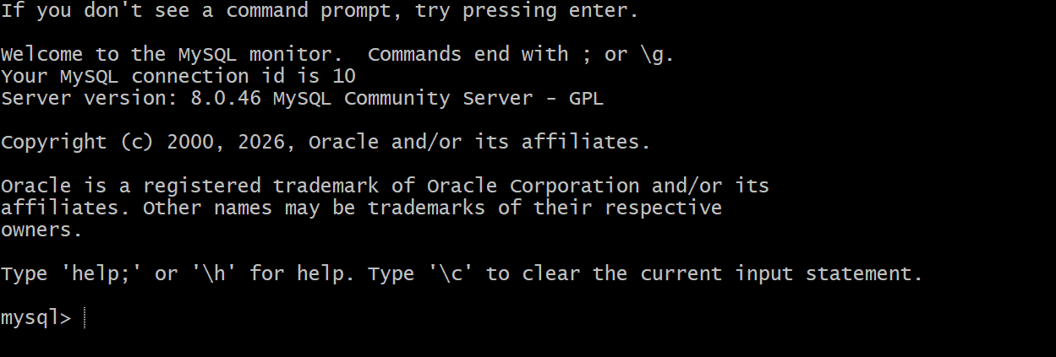

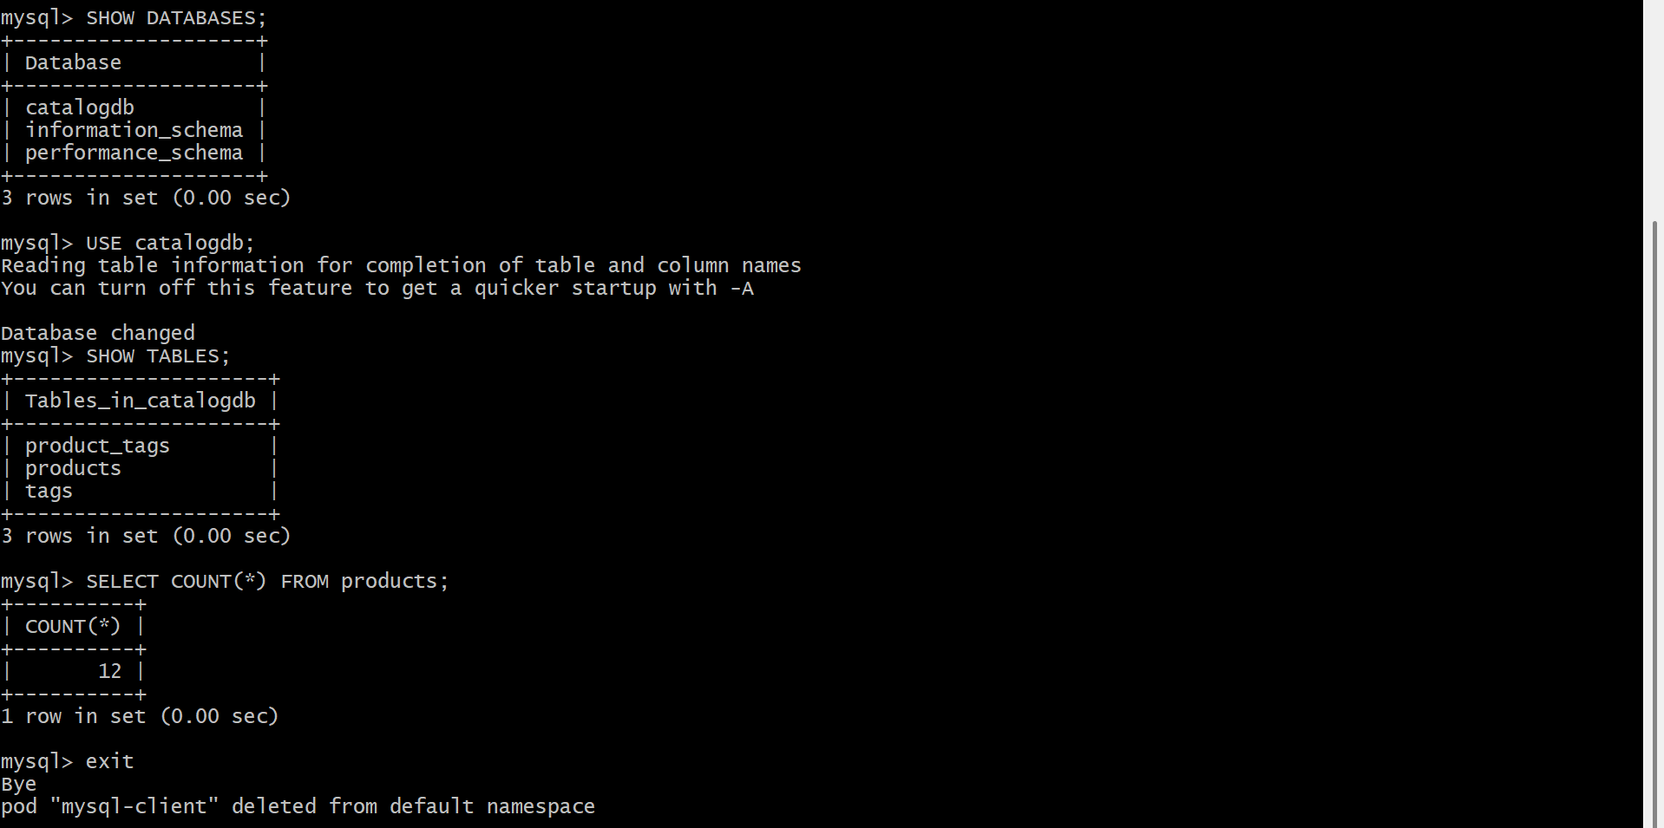
# Delete Pod and Verify Data Persistence
kubectl delete pod catalog-mysql-0
kubectl get pods -w
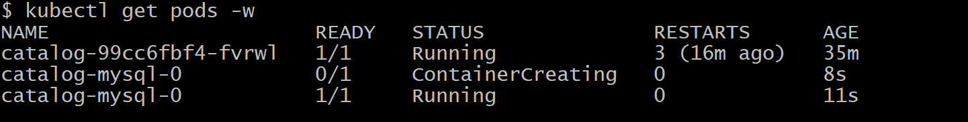

# Delete Kubernetes resources
kubectl delete -f 02_catalog_k8s_manifests/
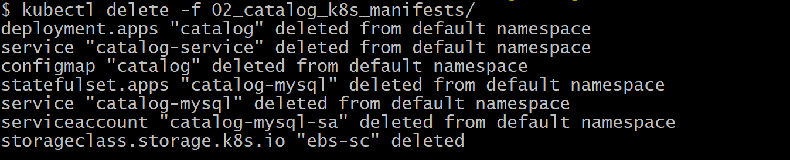
kubectl delete -f 01_secretproviderclass/
# Check PVC & PV
kubectl get pvc
kubectl get pv
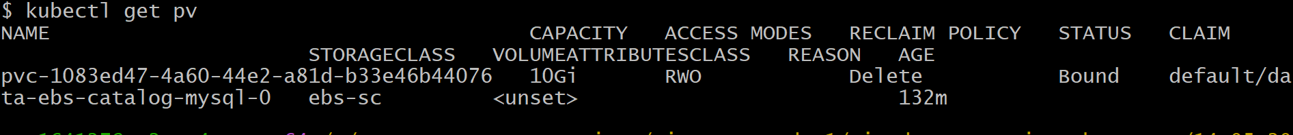
# Delete PVC manually
kubectl delete pvc data-ebs-catalog-mysql-0

aws ec2 describe-volumes \
--filters "Name=size,Values=10" \
--query "Volumes[*].{ID:VolumeId,State:State,Size:Size}" \
--output table
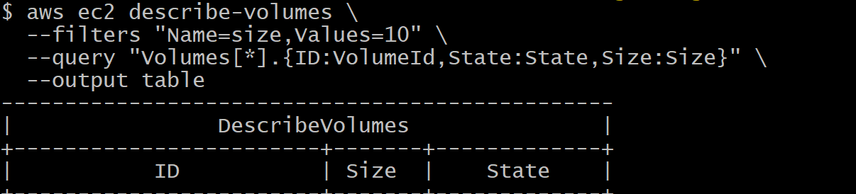
Volume disappears EBS cleanup confirmed.
# Created SG for for RDS
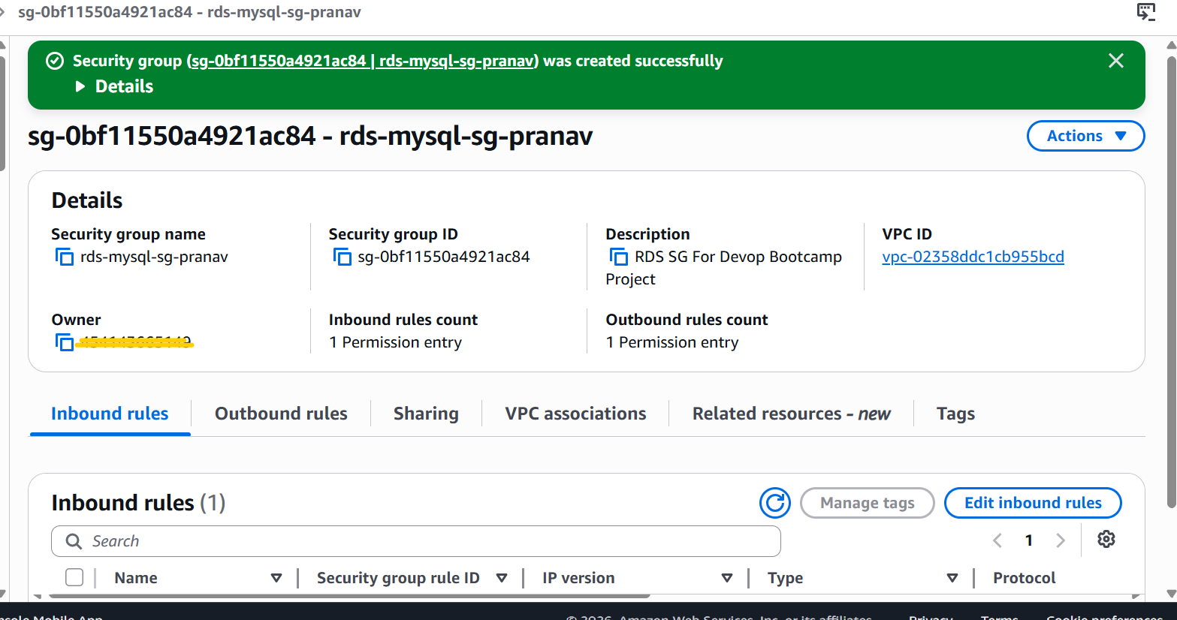
# Created Subnet Group for for RDS
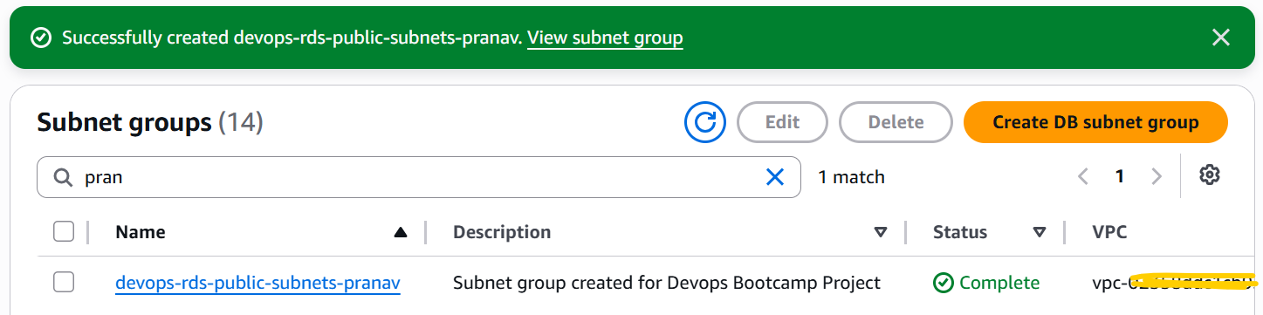

# Created Mysql RDS
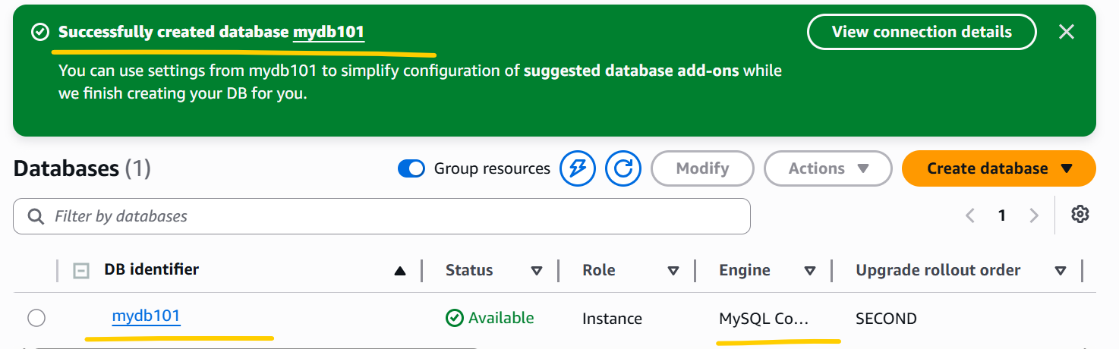

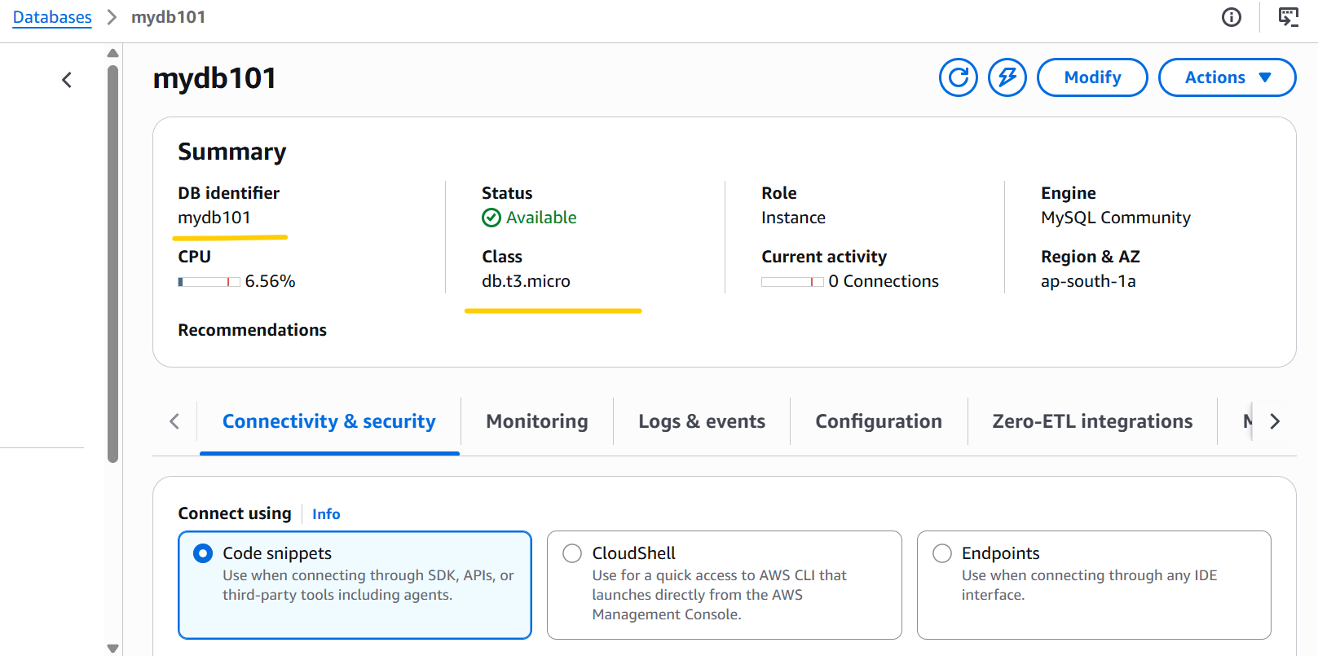
Run below command to connect to RDS DB.
kubectl run mysql-client --rm -it \
--image=mysql:8.0 \
--restart=Never \
-- mysql -h mydb101.c42nr5ktk6ag.ap-south-1.rds.amazonaws.com -u mydbadmin -p
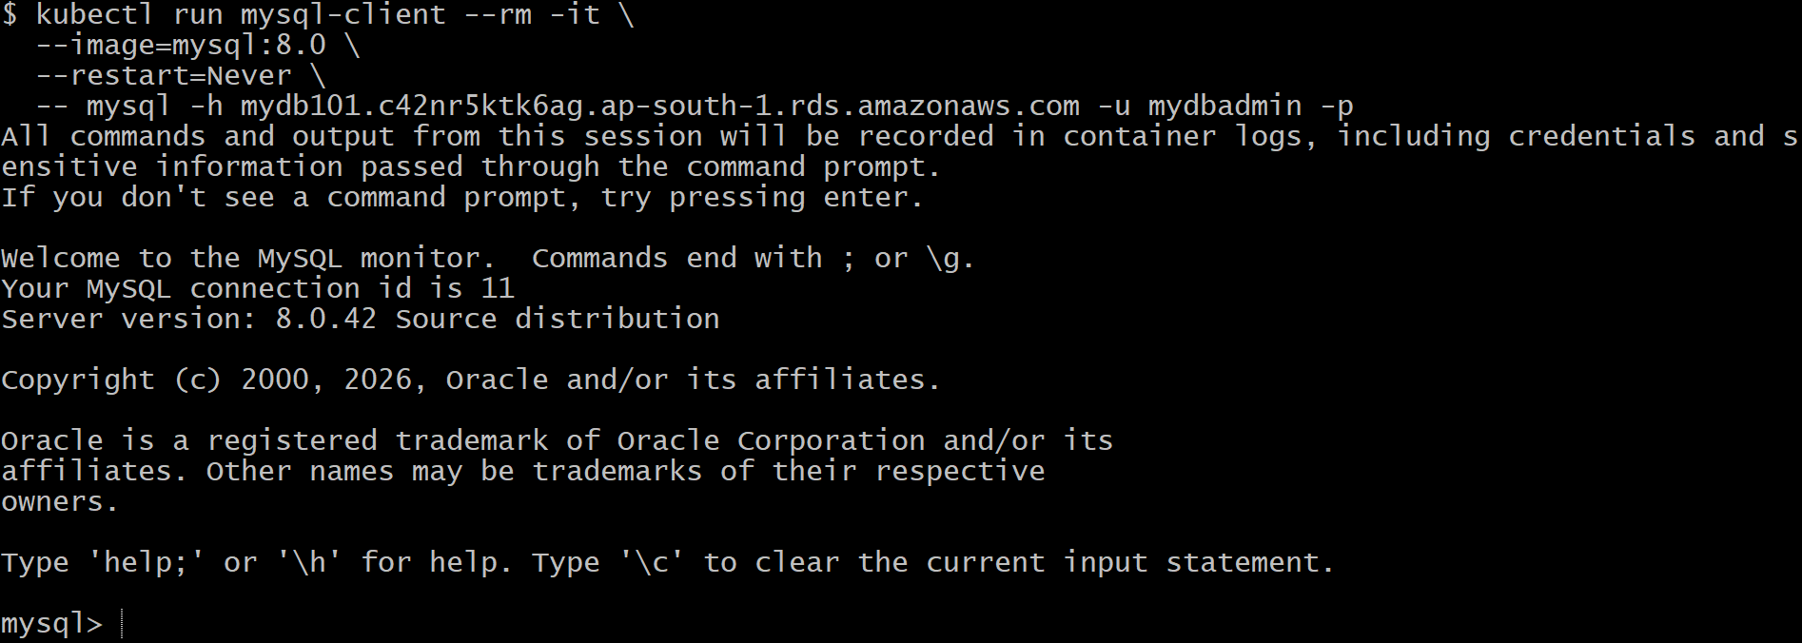
show schemas;
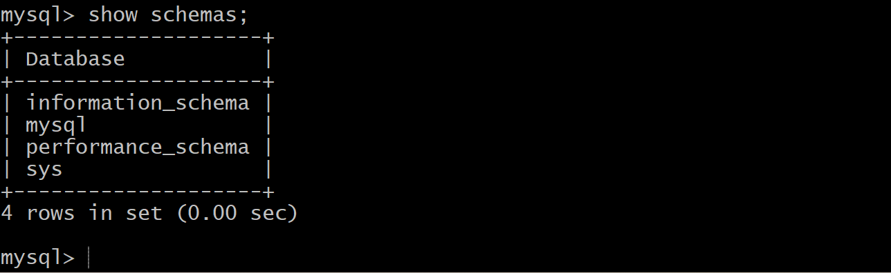
SHOW DATABASES;
EXIT;
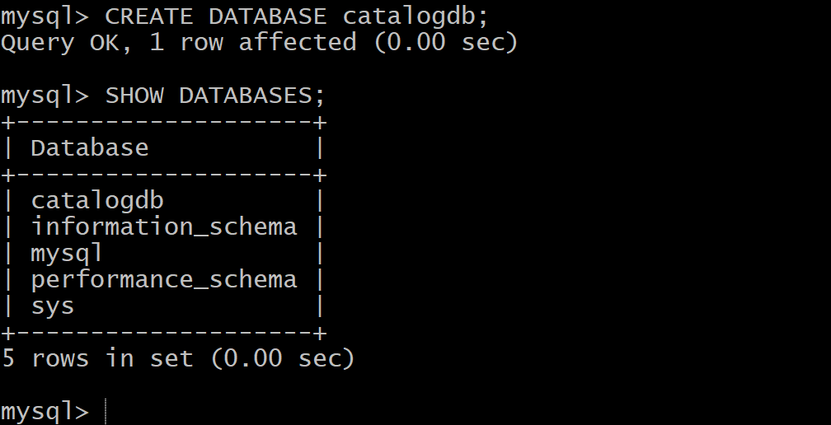
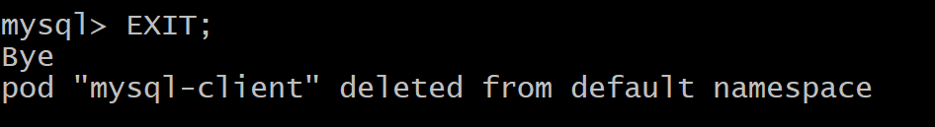
kubectl apply -f 01_secretproviderclass/
kubectl apply -f 02_catalog_k8s_manifests
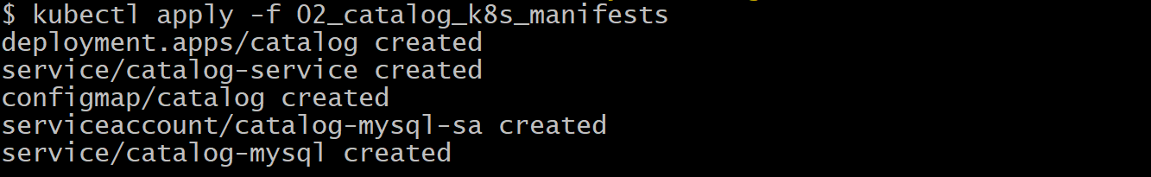
Kubectl get pods
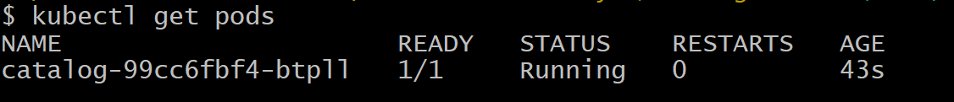
kubectl logs -f catalog-99cc6fbf4-btpll
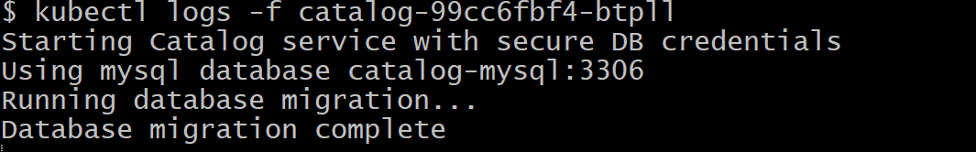
kubectl port-forward svc/catalog-service 7080:8080
Check below mentioned endpoints, from my system browser, I can able to access those endpoints successfully.
http://localhost:7080/health
http://localhost:7080/catalog/products
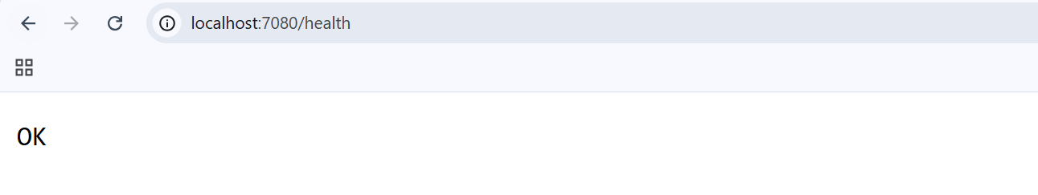
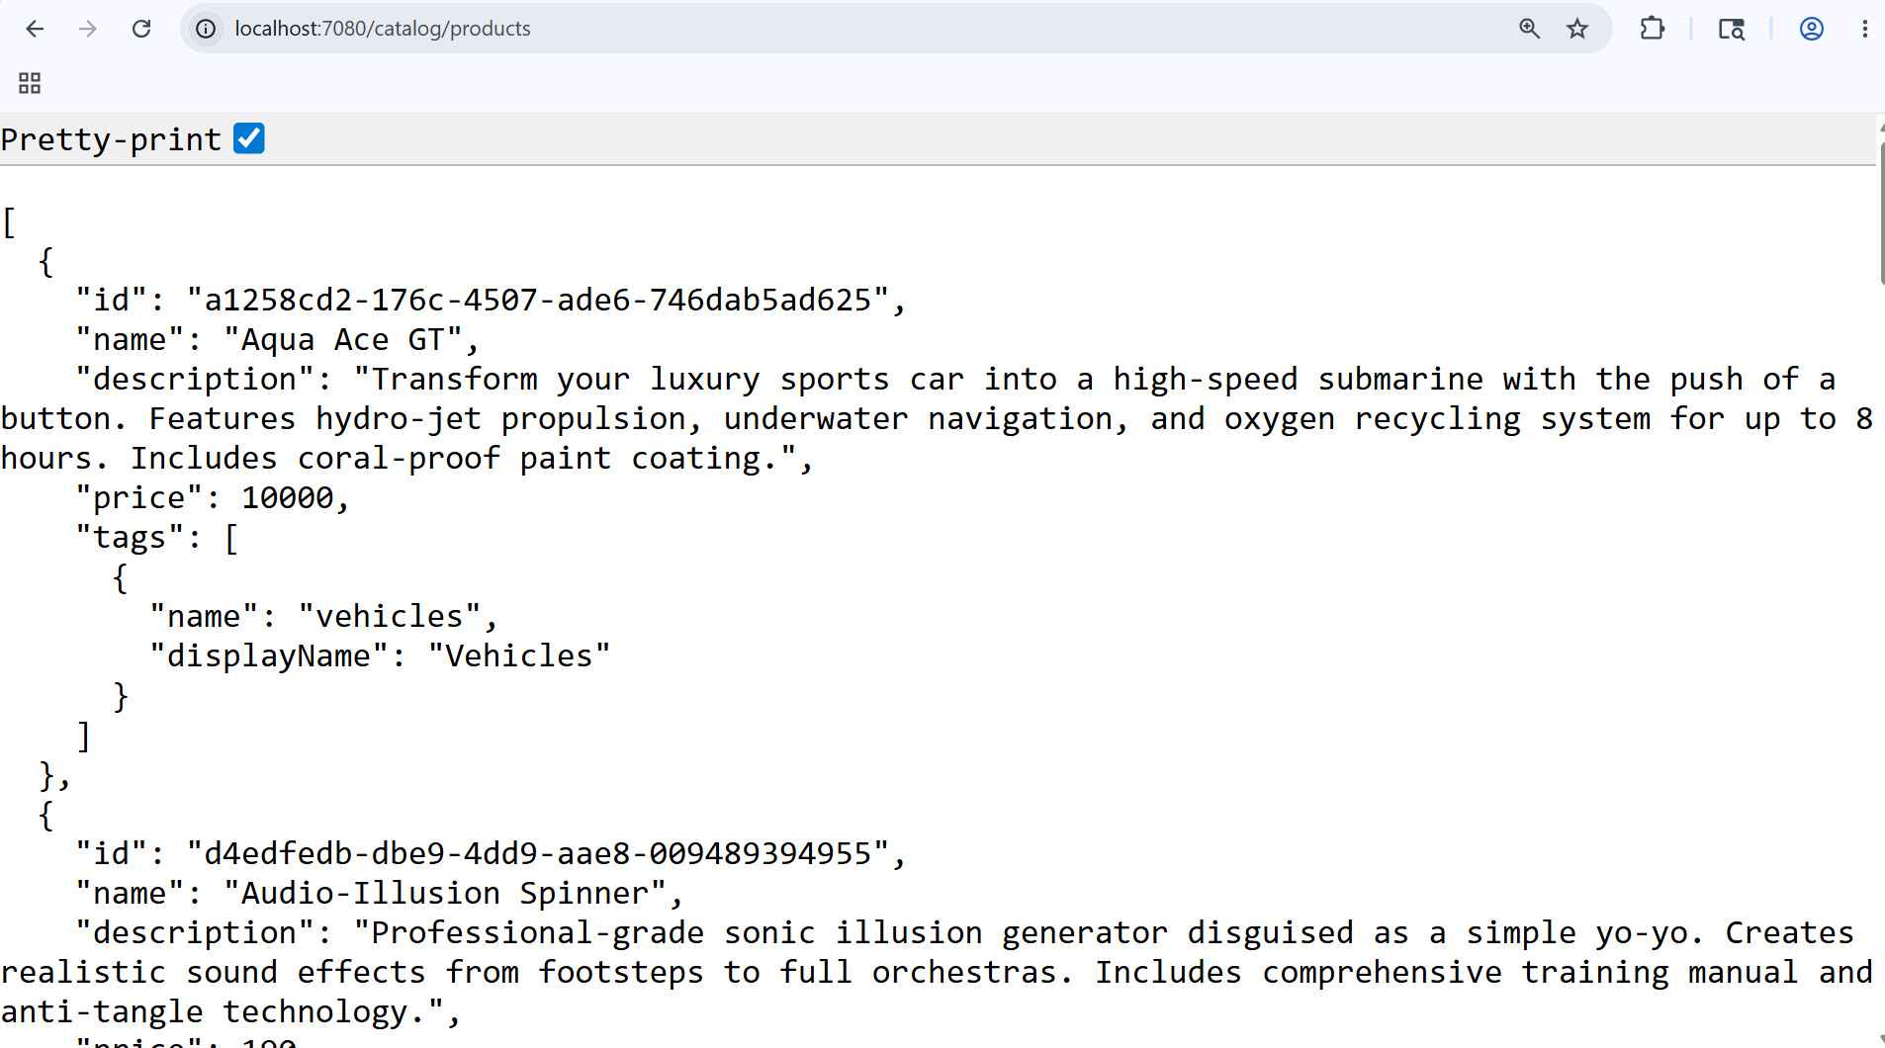
kubectl run mysql-client --rm -it \
--image=mysql:8.0 \
--restart=Never \
-- mysql -h mydb101.c42nr5ktk6ag.ap-south-1.rds.amazonaws.com -u mydbadmin -p

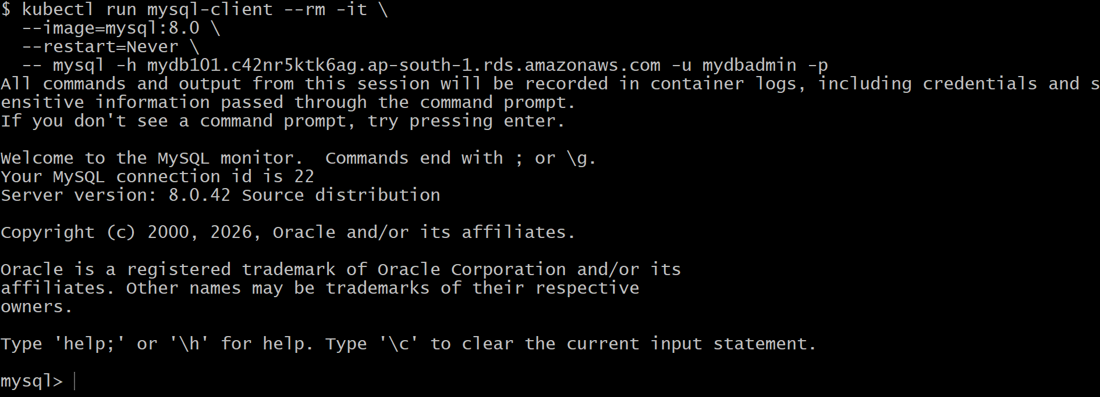
USE catalogdb;
SHOW TABLES;
SELECT * FROM products;

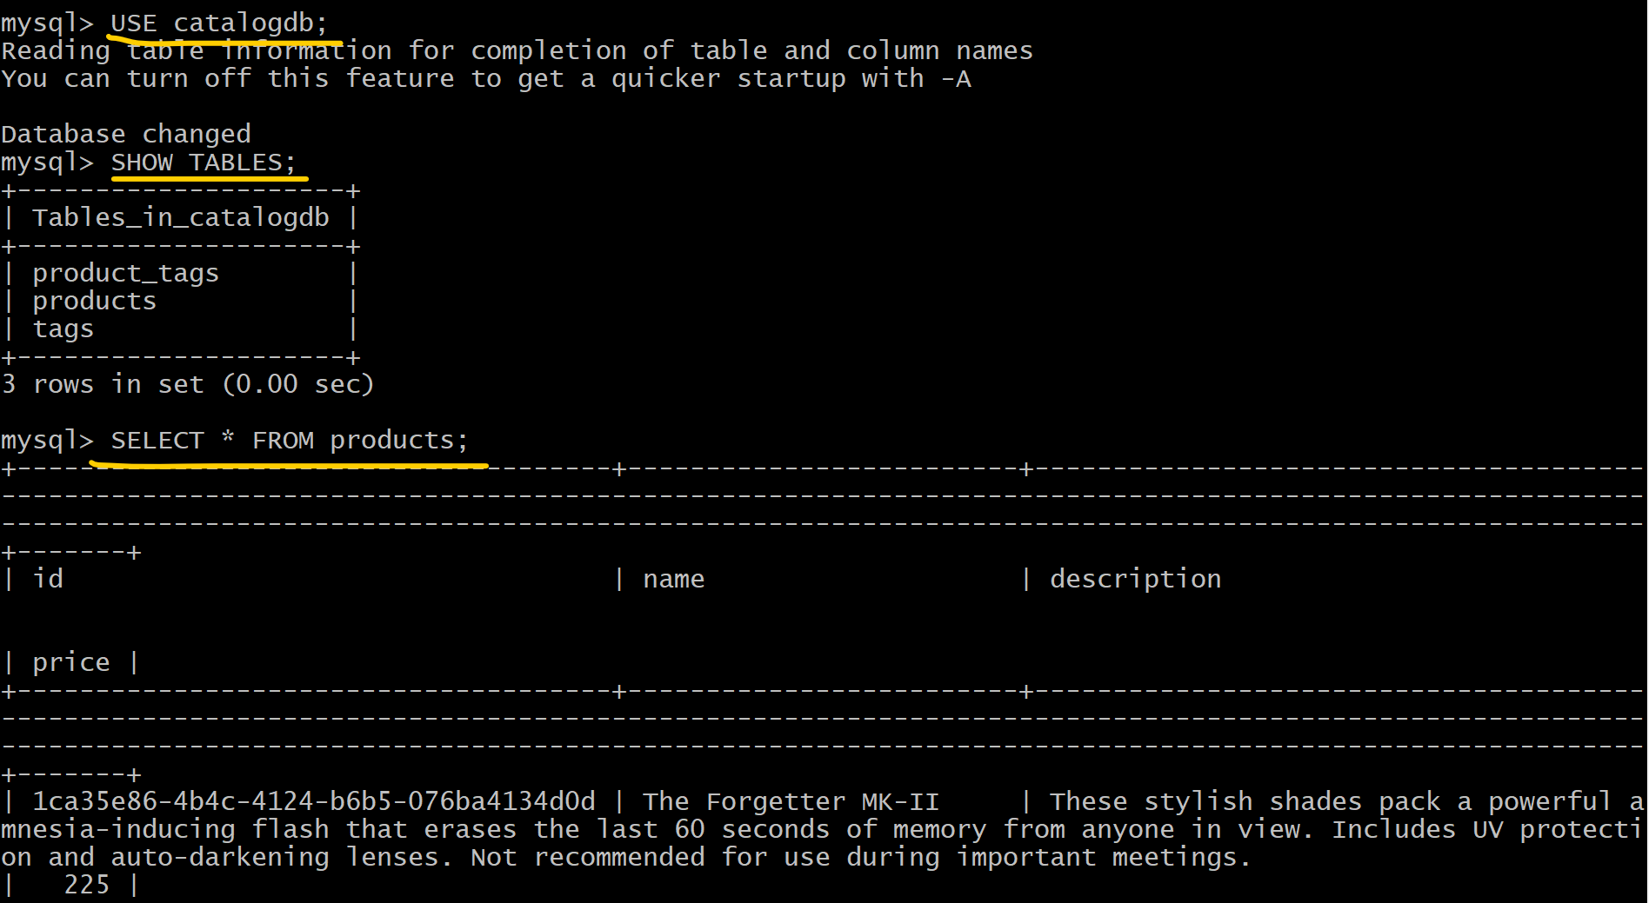
EXIT;
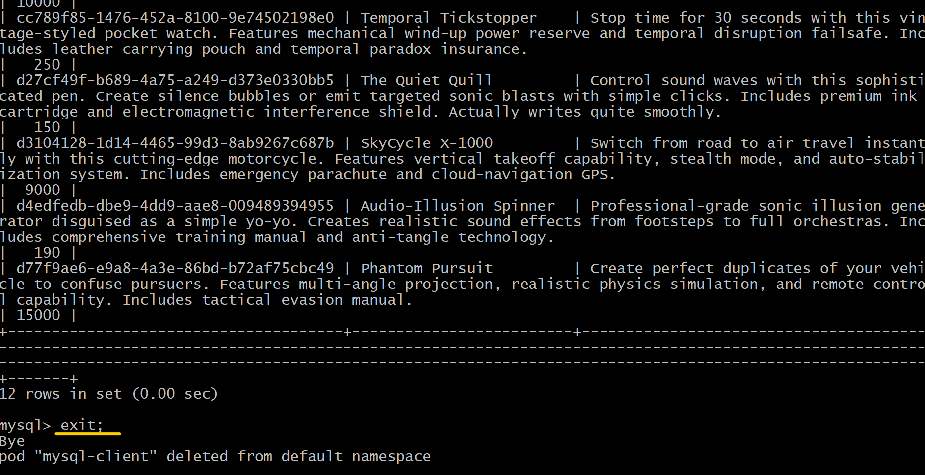
# Deleted Catalog Application
kubectl delete -f 02_catalog_k8s_manifests
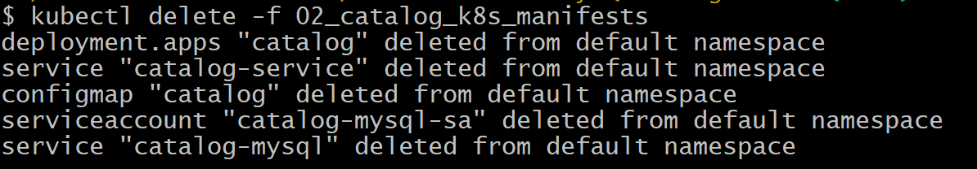

# Deleted Secret Provider Class
kubectl delete -f 01_secretproviderclass/

# Deleted RDS DB

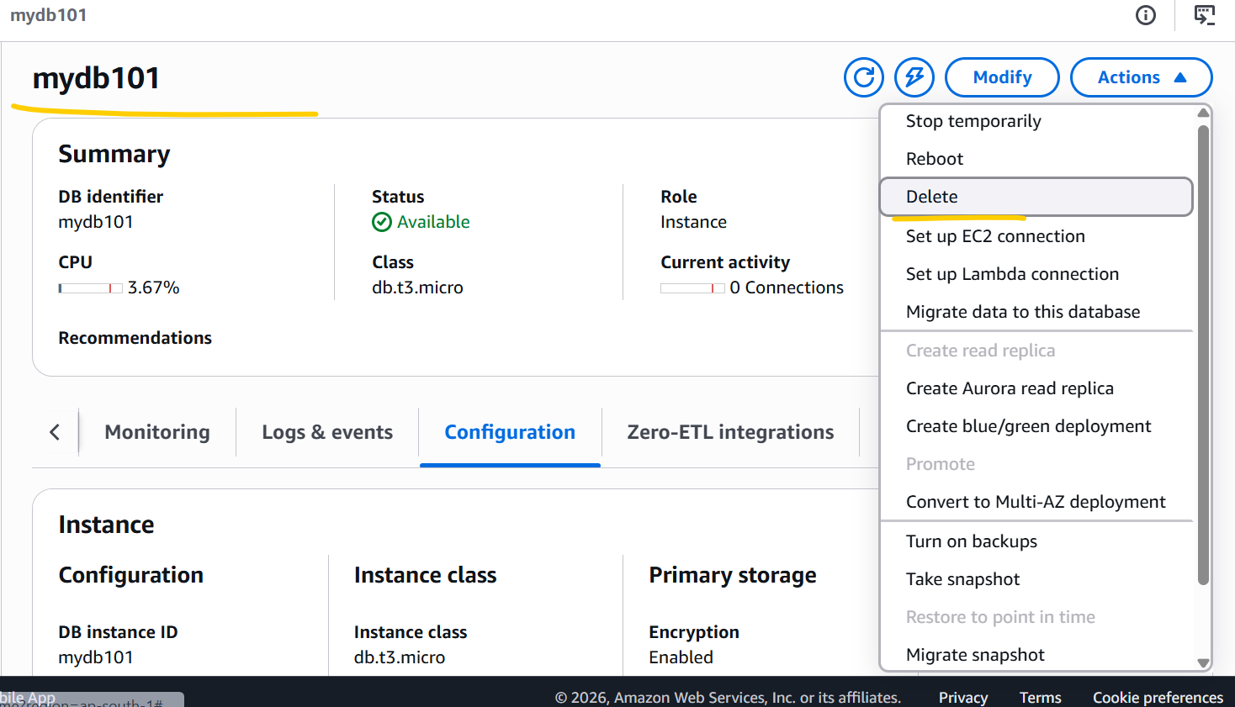
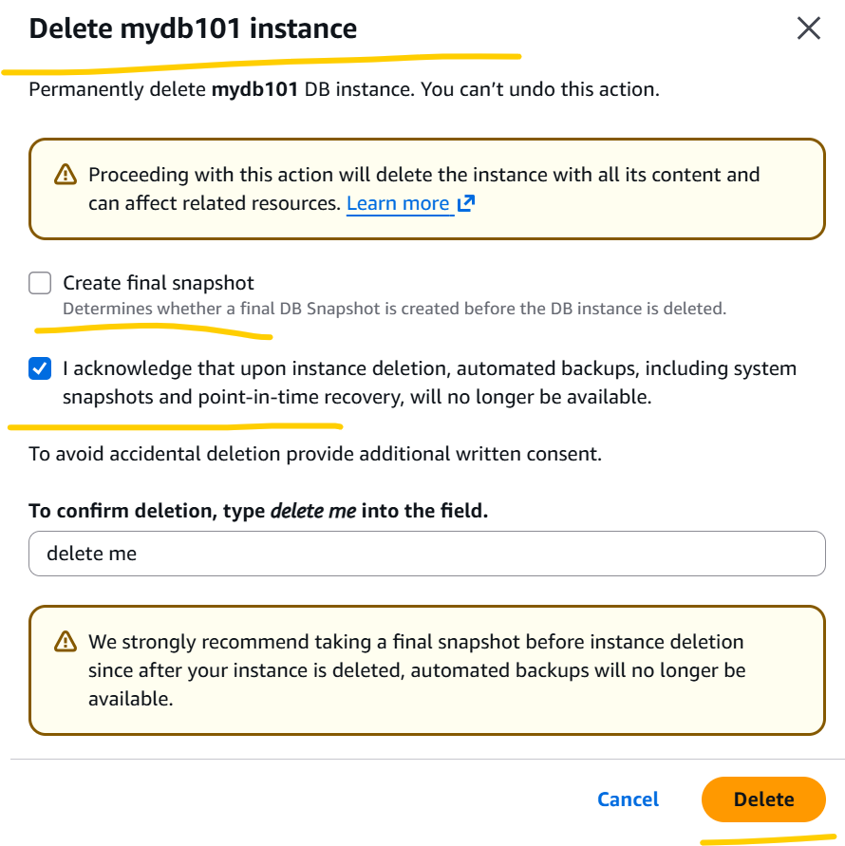
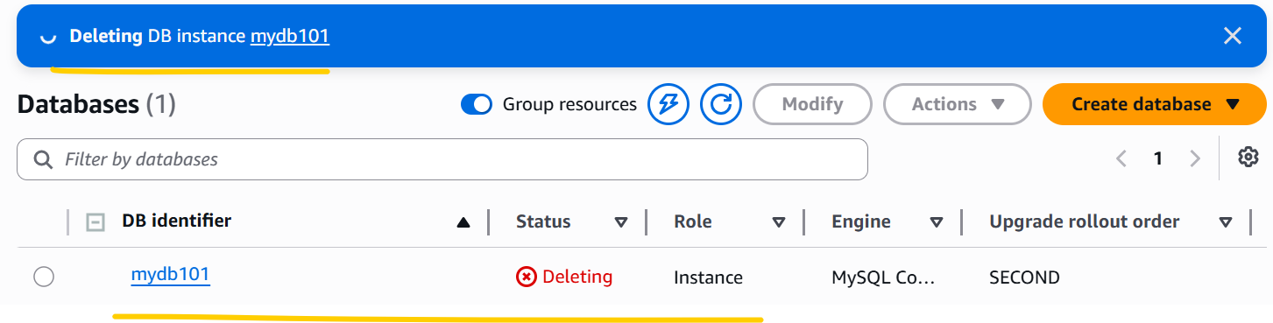
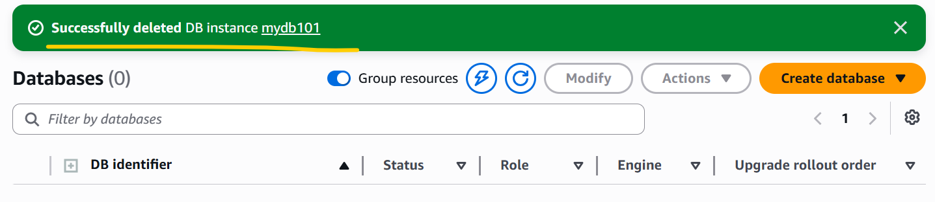

- Deleted EKS Cluster, Node group and Iam roles for through terraform destroy command.

