Steps:-
- Created EKS Cluster, Node group and require Iam roles for the same through terraform. To do the same copy terraform code from 12_05_2026 folder into 13_05_2026.

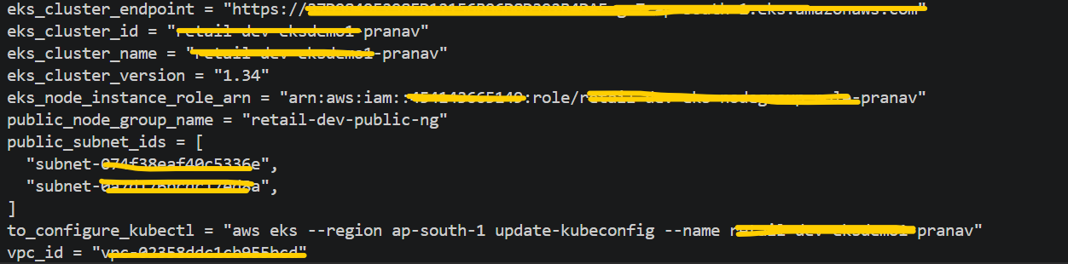

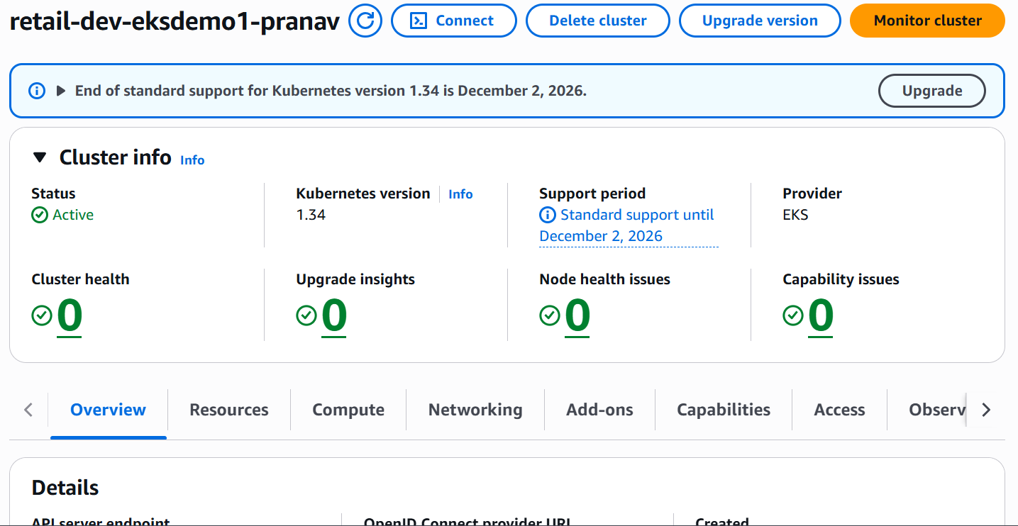

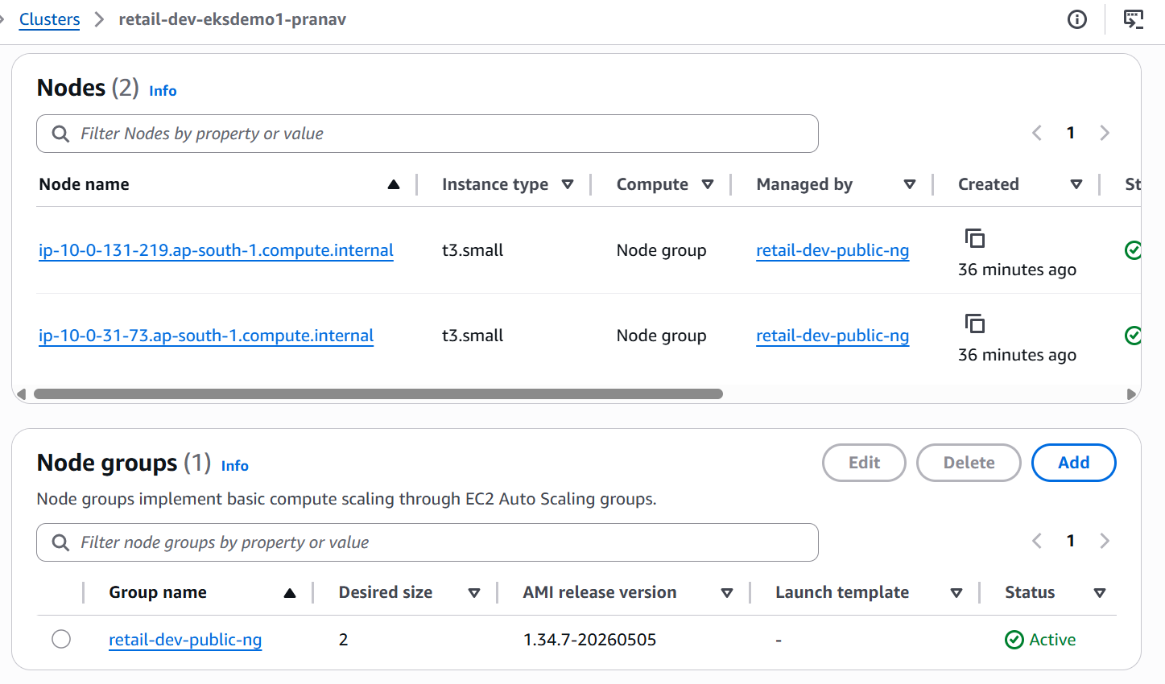

- Add below Add ons in EKS Cluster.

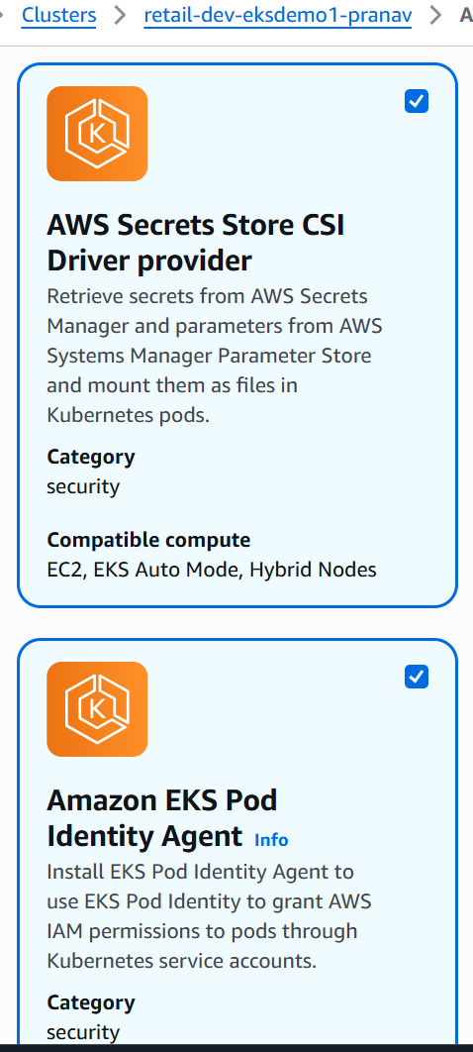

- Run below mentioned kubectl commands.
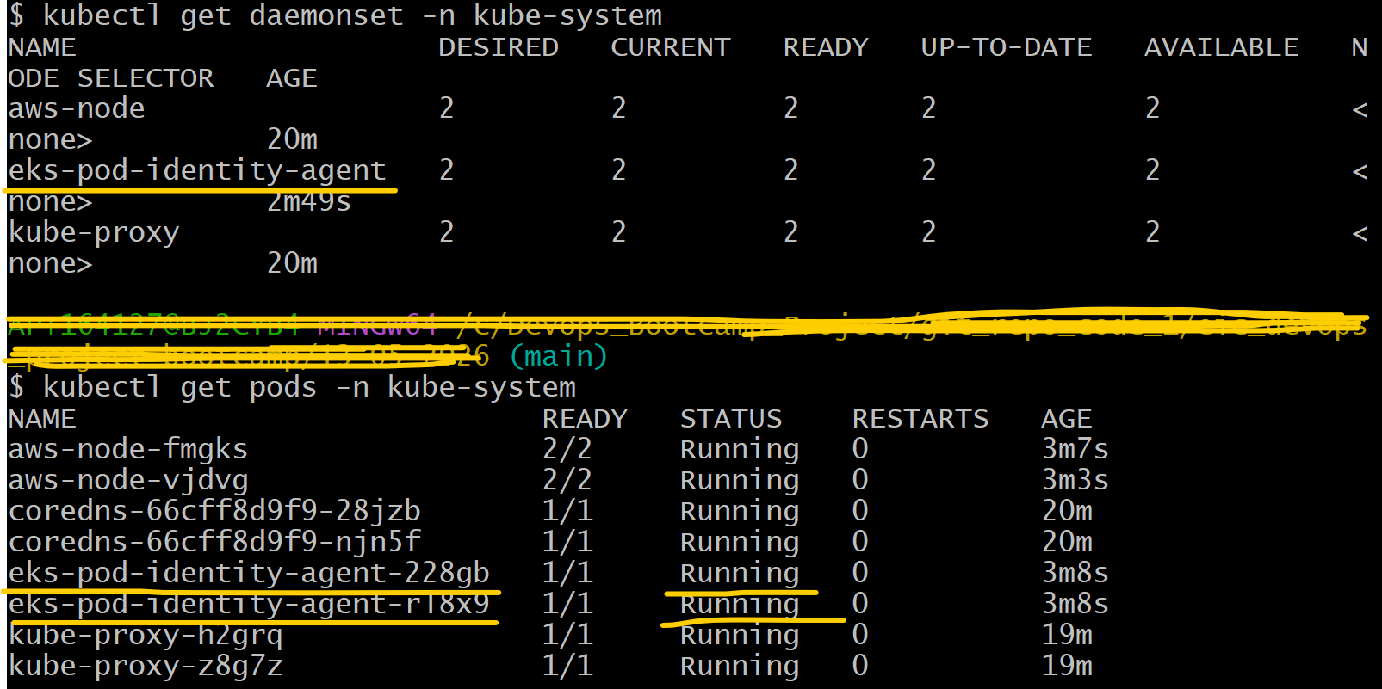
Run below mentioned kubectl apply -f kube-manifests command to install aws-cli pod.
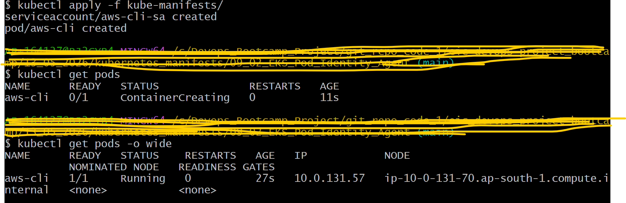
Getting error for aws cli pod and not able to access s3 bucket, because require Iam role was not created. Created the require iam role in next steps.
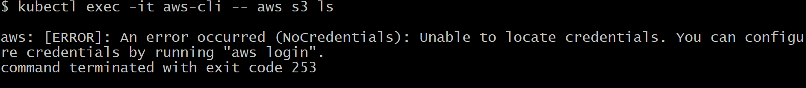
- Create below mentioned iam role to access s3 bucket from Pod.
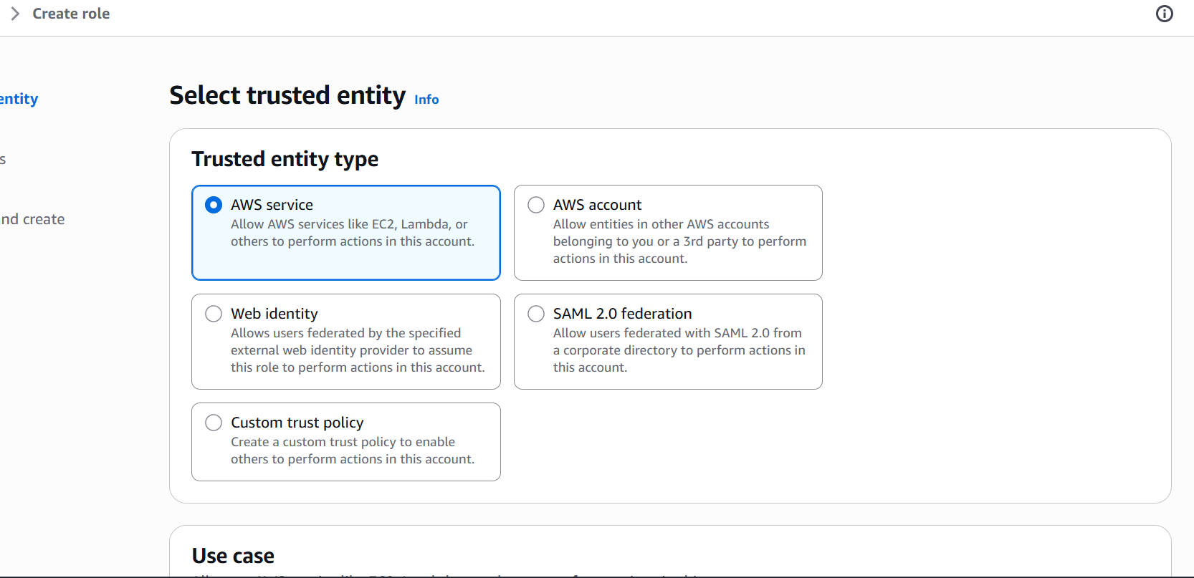

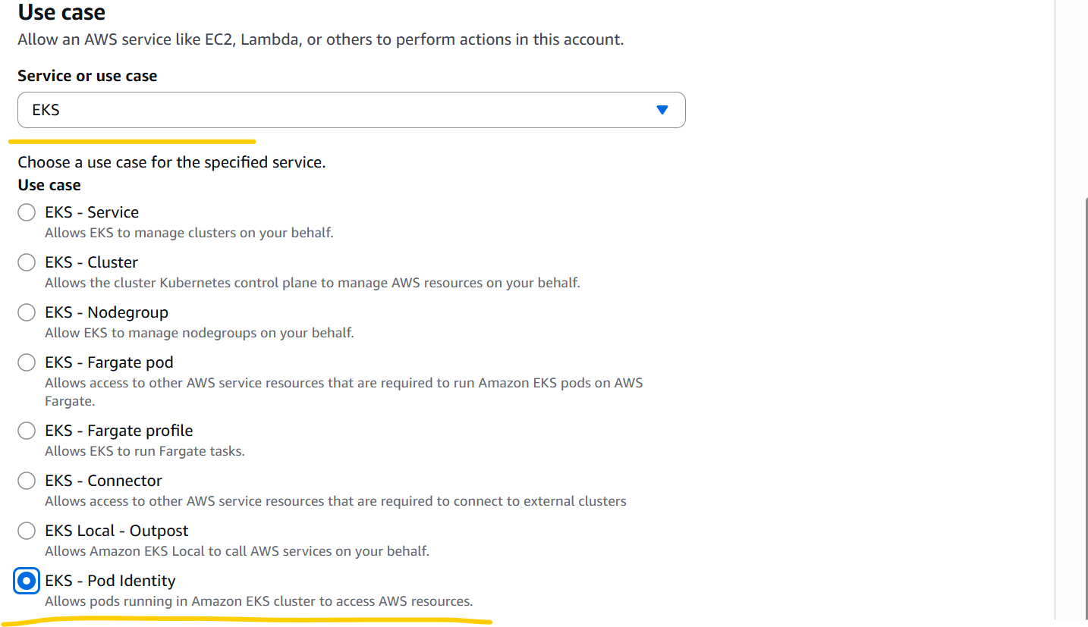
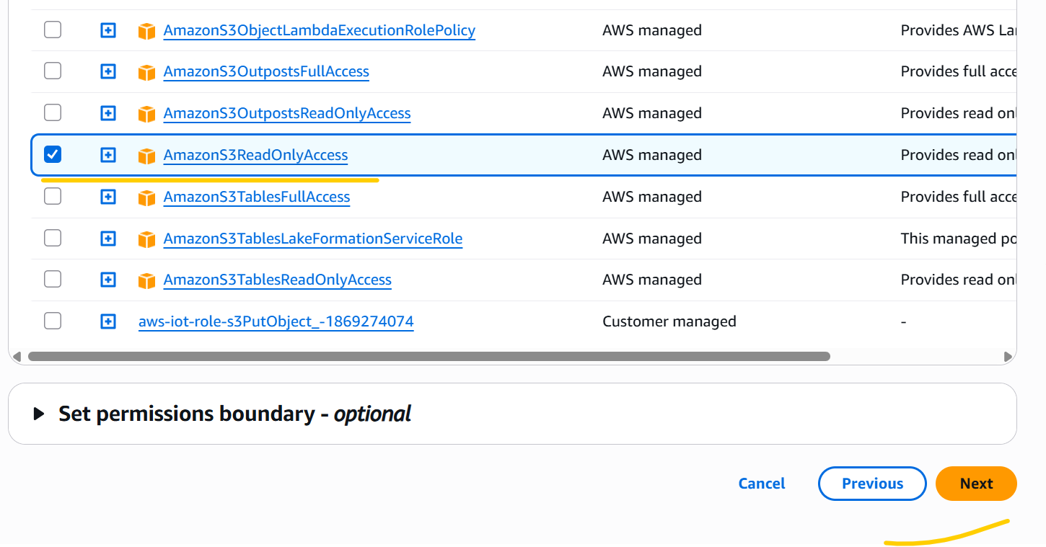
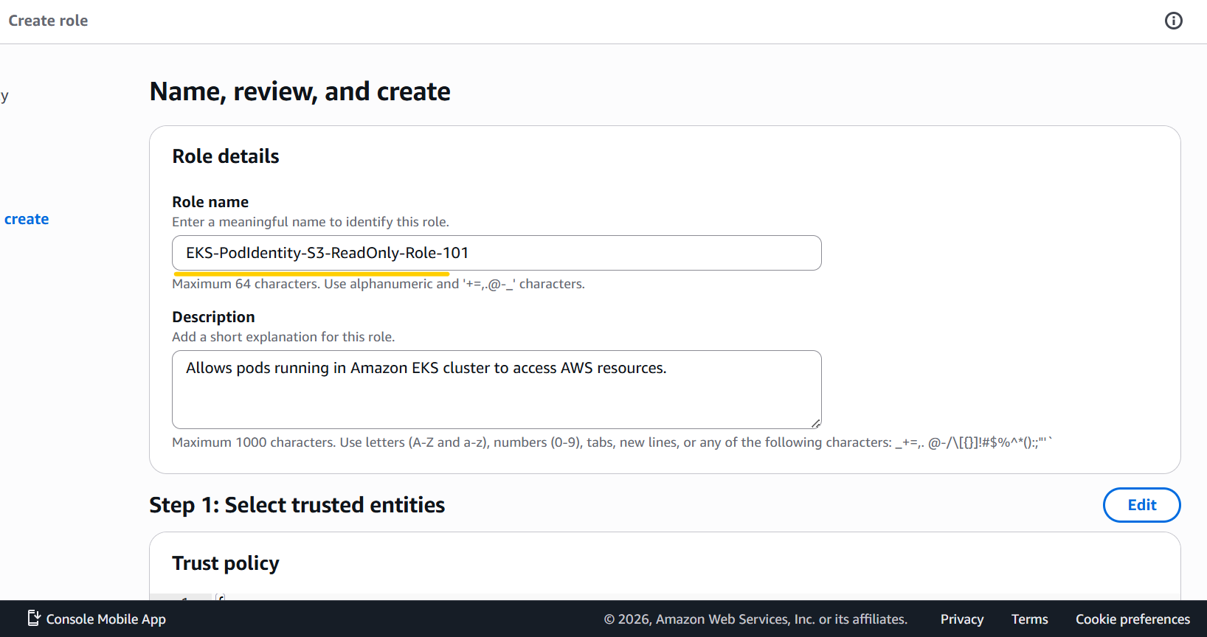

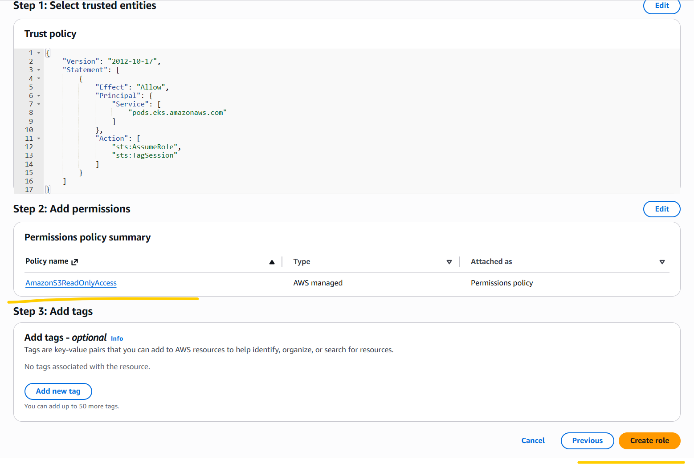
- Configure Pod identity association.

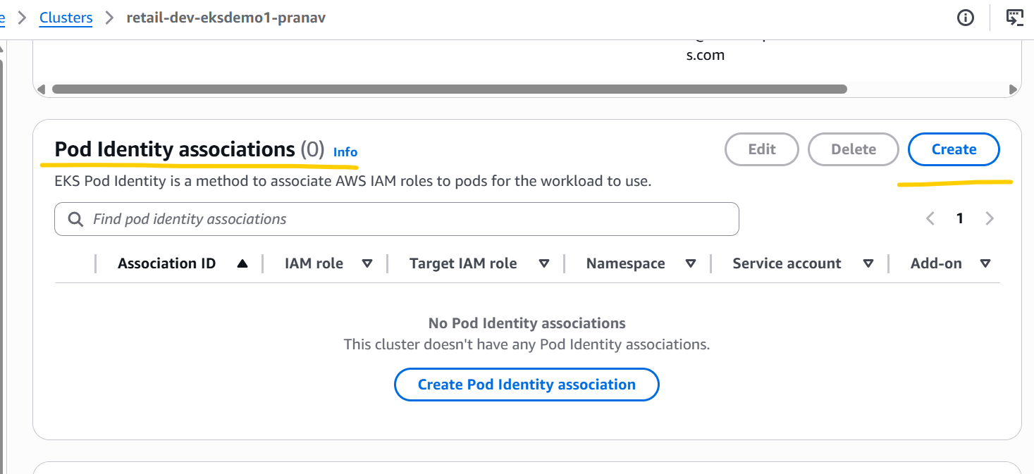

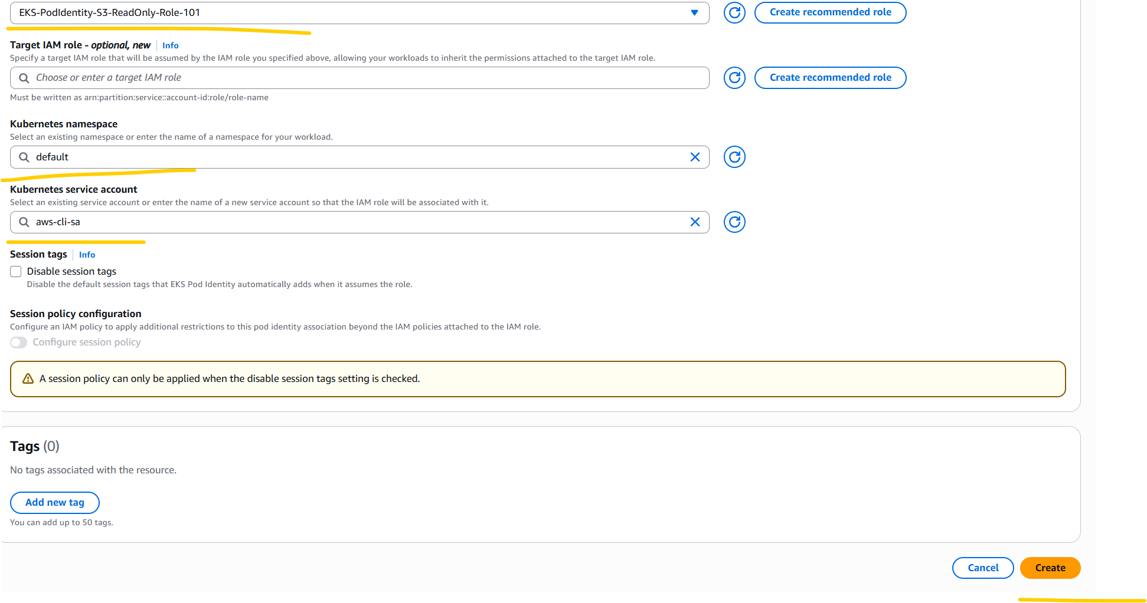
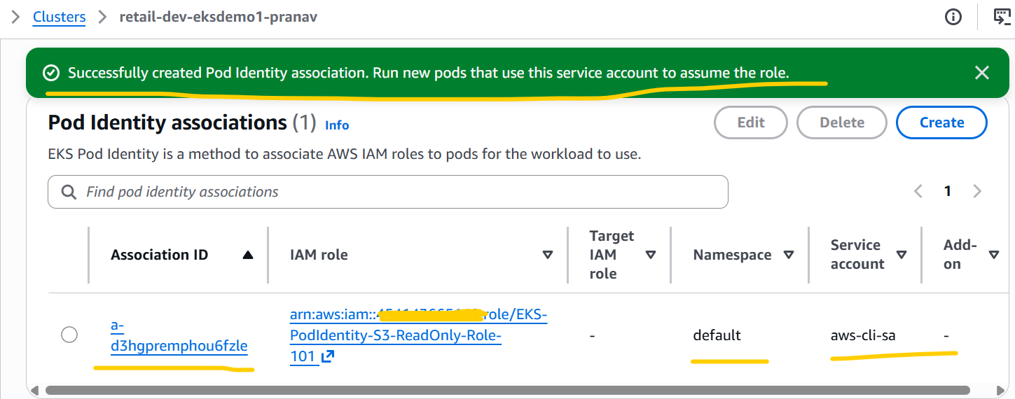
- Deleted aws-cli pod and recreated the same and then try to access s3 bucket from aws-cli pod and this time I can be able to access s3 buckets successfully.

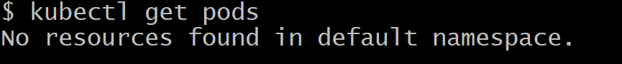
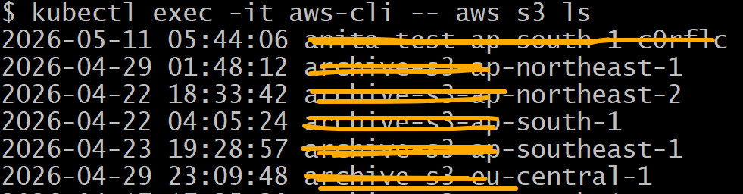
- Deleted the pod identity association.
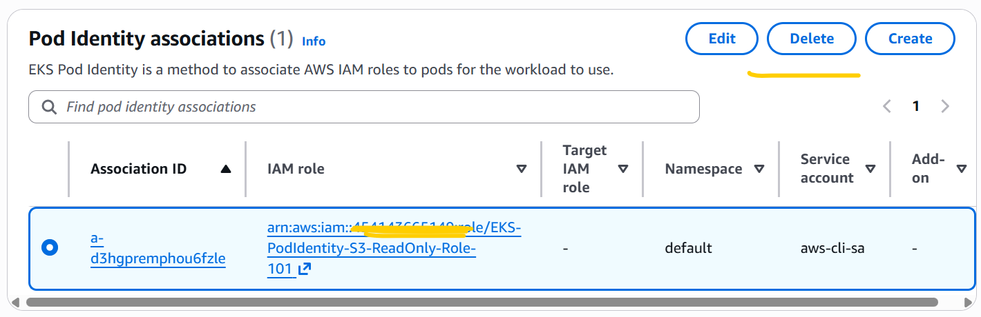
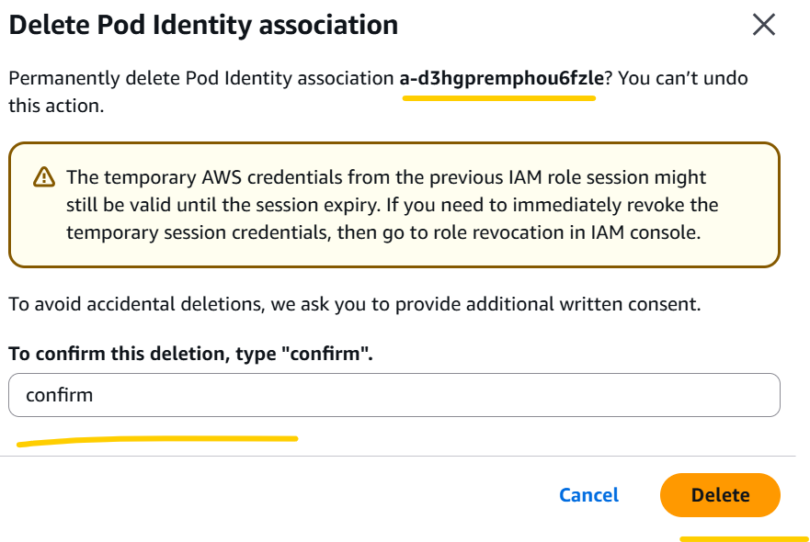
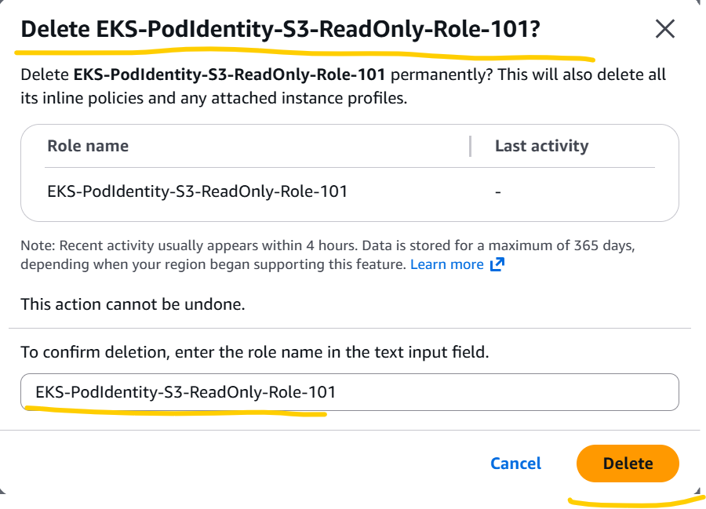

Run below mentioned helm commands.

helm version
helm repo add secrets-store-csi-driver https://kubernetes-sigs.github.io/secrets-store-csi-driver/charts
helm repo add aws-secrets-manager https://aws.github.io/secrets-store-csi-driver-provider-aws
helm repo update
helm repo list

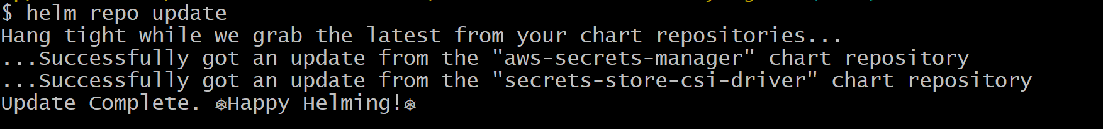
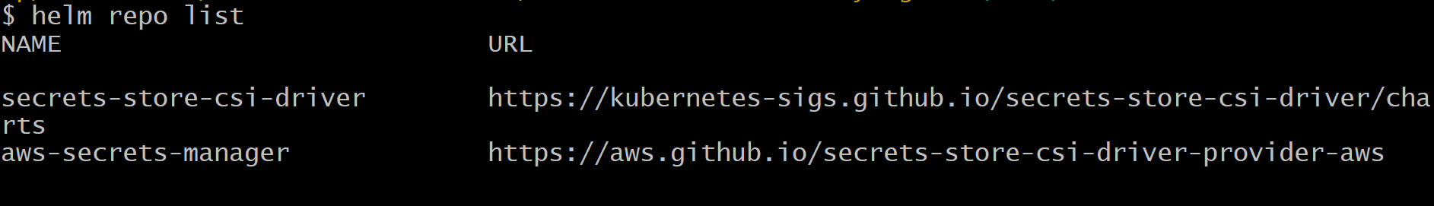
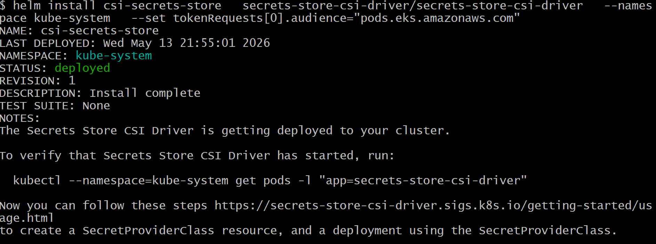
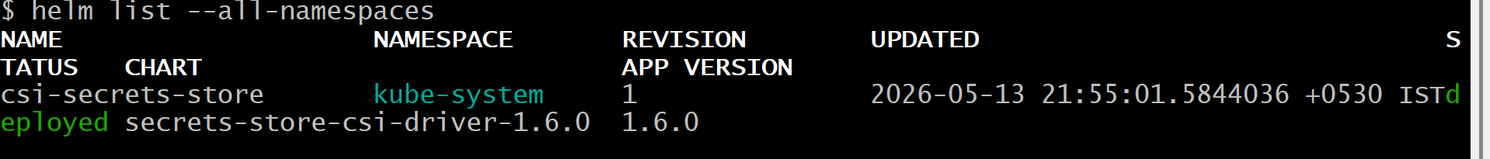
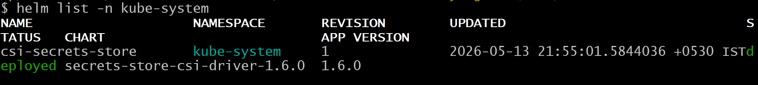
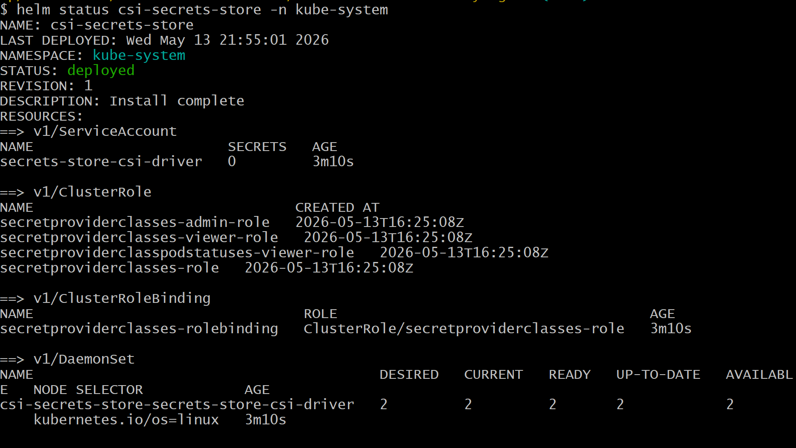
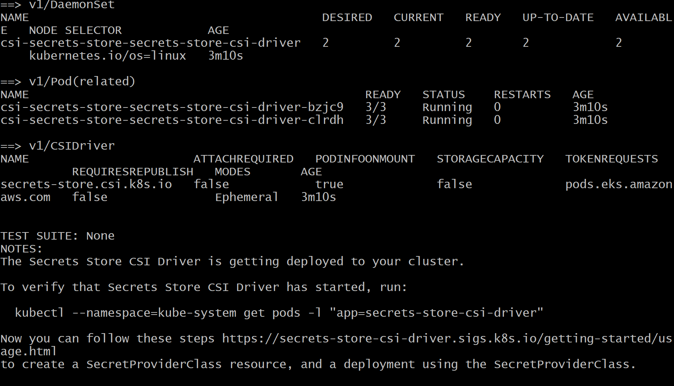
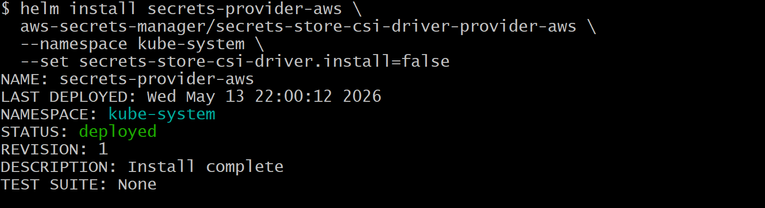
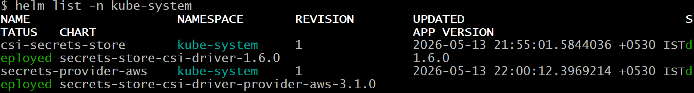
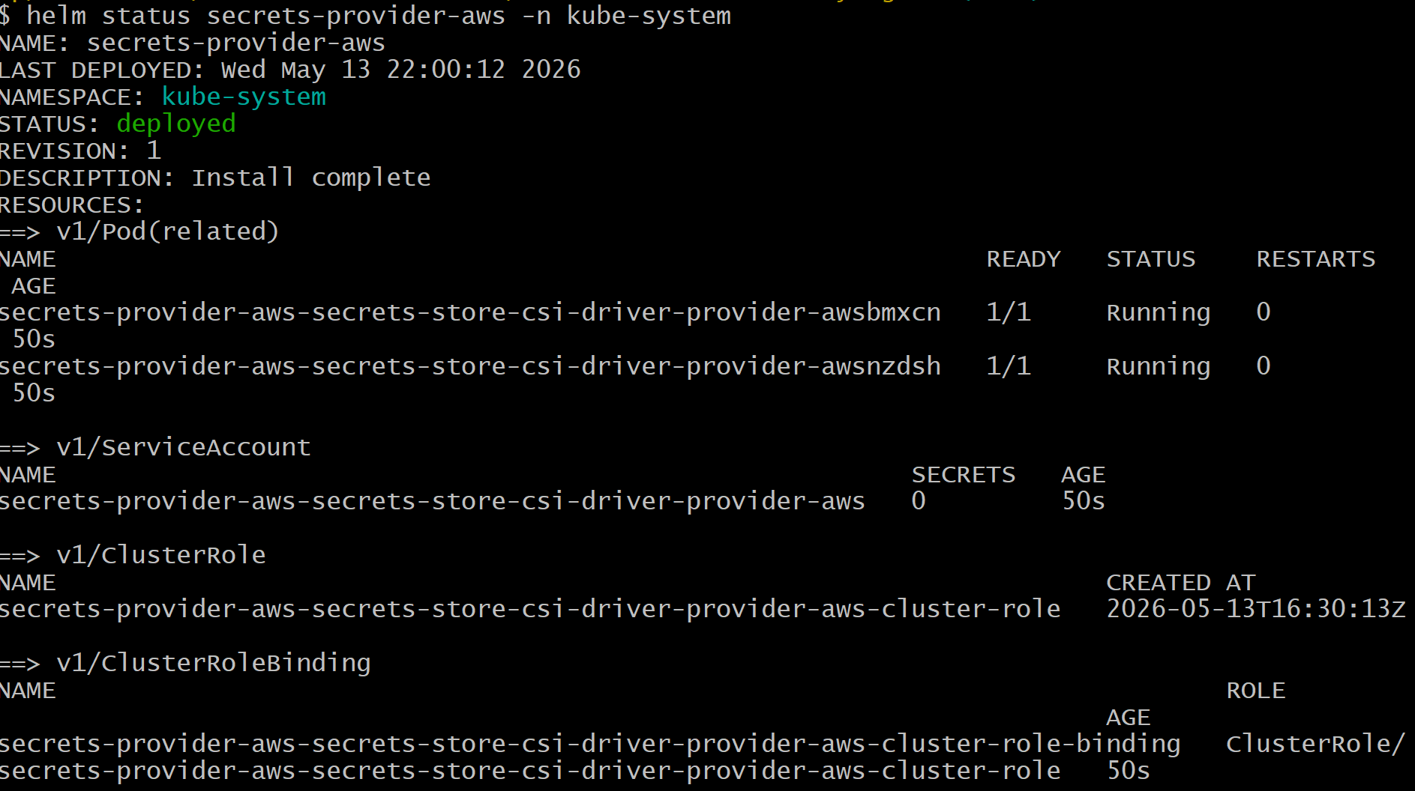
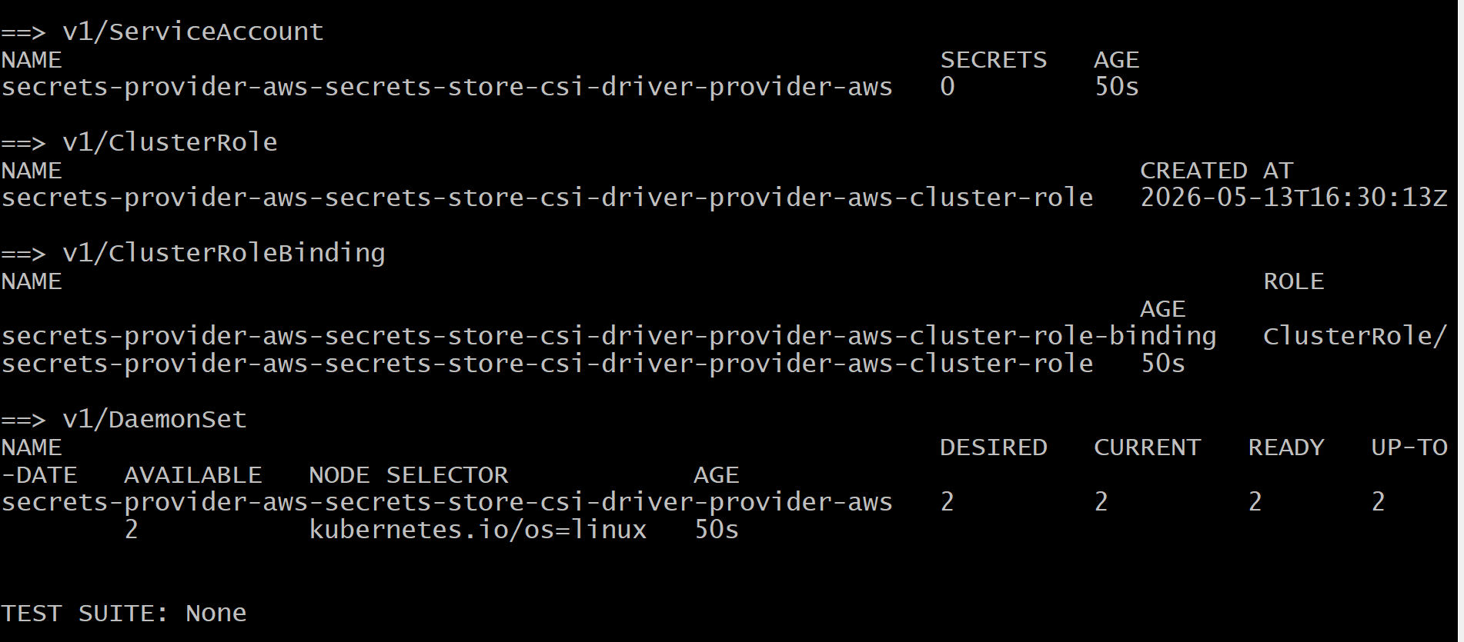
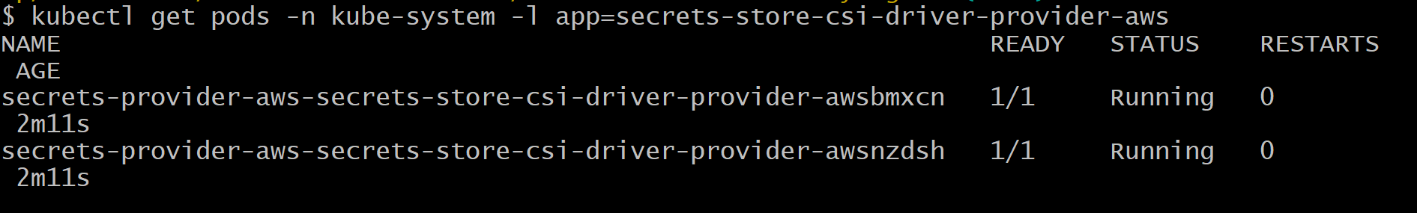
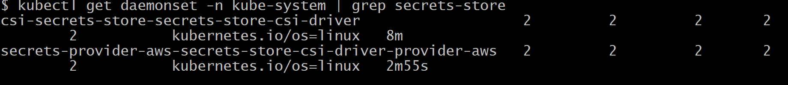
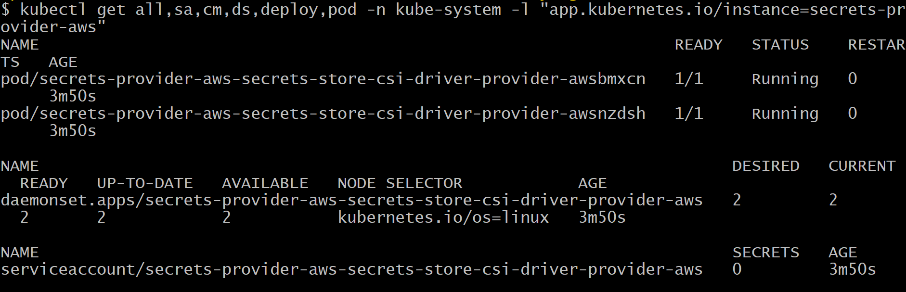

- Performed below mentioned all steps to Integrate AWS Secrets Manager with Catalog Microservice (EKS Pod Identity), before that performed require prerequisites configuration for the same.

export AWS_REGION="ap-south-1"
export EKS_CLUSTER_NAME="retail-dev-eksdemo1-pranav"
export AWS_ACCOUNT_ID=$(aws sts get-caller-identity --query Account --output text)

echo $AWS_REGION
echo $EKS_CLUSTER_NAME
echo $AWS_ACCOUNT_ID

cat <<EOF > catalog-db-secret-policy.json
{
"Version": "2012-10-17",
"Statement": [
{
"Effect": "Allow",
"Action": [
"secretsmanager:GetSecretValue",
"secretsmanager:DescribeSecret"
],
"Resource": "arn:aws:secretsmanager:${AWS_REGION}:${AWS_ACCOUNT_ID}:secret:catalog-db-secret*"
}
]
}
EOF

cat catalog-db-secret-policy.json

aws iam create-policy \
--policy-name catalog-db-secret-policy-pranav \
--policy-document file://catalog-db-secret-policy.json

aws iam create-role \
--role-name catalog-db-secrets-role-pranav \
--assume-role-policy-document file://trust-policy.json

aws iam attach-role-policy \
--role-name catalog-db-secrets-role-pranav \
--policy-arn arn:aws:iam::${AWS_ACCOUNT_ID}:policy/catalog-db-secret-policy-pranav

aws iam list-attached-role-policies --role-name catalog-db-secrets-role-pranav

aws eks list-addons --cluster-name ${EKS_CLUSTER_NAME}

aws eks create-pod-identity-association \
--cluster-name ${EKS_CLUSTER_NAME} \
--namespace default \
--service-account catalog-mysql-sa \
--role-arn arn:aws:iam::${AWS_ACCOUNT_ID}:role/catalog-db-secrets-role-pranav

Verify the same from AWS console EKS Cluster from Pod Identity associations section, as well as from below mentioned command.
aws eks list-pod-identity-associations --cluster-name ${EKS_CLUSTER_NAME}

Below mentioned screenshot from AWS console EKS Cluster from Pod Identity associations section.

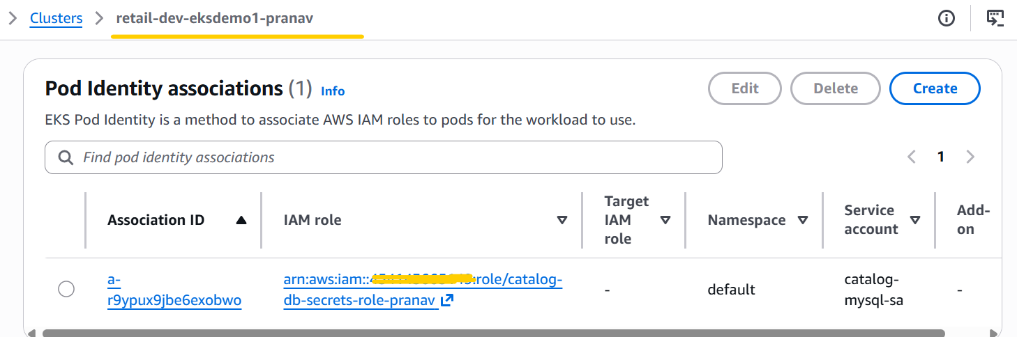

Create secret in AWS Secrets Manager service through below mentioned aws cli command.
aws secretsmanager create-secret \
--name catalog-db-secret-pranav \
--region $AWS_REGION \
--description "MySQL credentials for Catalog microservice" \
--secret-string '{
"MYSQL_USER": "mydbadmin",
"MYSQL_PASSWORD": ""
}'

Note:- For security purpose remove the db password from above command.

List all secrets in your account (filtered by my secret name)
aws secretsmanager list-secrets --region $AWS_REGION --query "SecretList[?contains(Name, 'catalog-db-secret-pranav')].[Name,ARN]" --output table

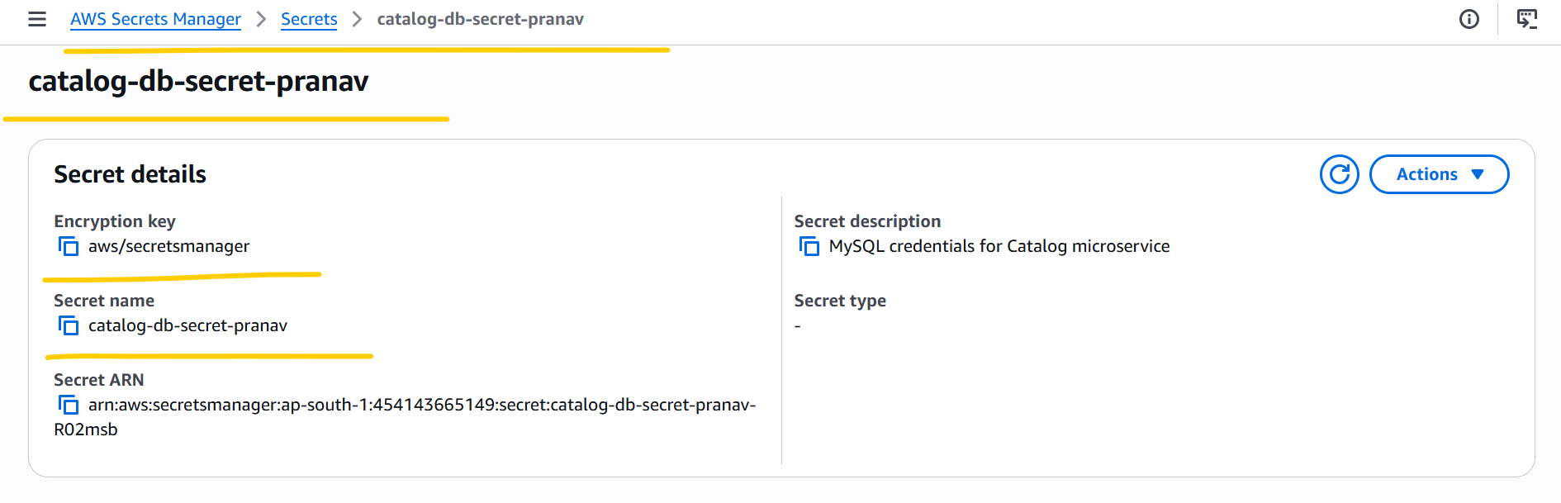

Describe the Secret for Details
aws secretsmanager describe-secret \
--secret-id catalog-db-secret-pranav \
--region $AWS_REGION

Retrieve Secret Value (for testing only)
aws secretsmanager get-secret-value \
--secret-id catalog-db-secret-pranav \
--region $AWS_REGION \
--query SecretString --output text

Update my secret name in 01_catalog_secretproviderclass.yaml this file in object name section

Navigate to respective folder where 01_secretproviderclass, 02_catalog_k8s_manifests these folders are present and one by one run below mentioned kubectl commands.

# To check whether any pods are running or not.
kubectl get pods
# First: Deploy Secret Provider Class
kubectl apply -f 01_secretproviderclass
# Verify the same below mentioned command.
kubectl get secretproviderclass
# Second: Deploy all our Catalog k8s Manifests
kubectl apply -f 02_catalog_k8s_manifests

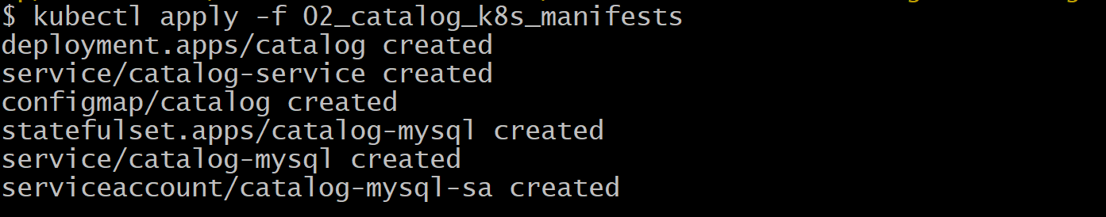
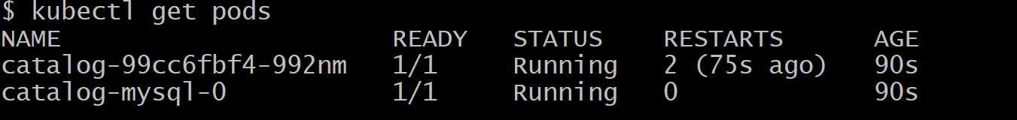
# Verify if Secrets mounted in pods or not
# MySQL Pod
kubectl exec -it catalog-mysql-0 -- ls mnt/secrets-store
kubectl exec -it catalog-mysql-0 -- cat mnt/secrets-store/MYSQL_USER
kubectl exec -it catalog-mysql-0 -- cat mnt/secrets-store/MYSQL_PASSWORD

# Catalog Pod
kubectl exec -it catalog-99cc6fbf4-992nm – bash
Run commands inside pod which are mentioned below screenshot.
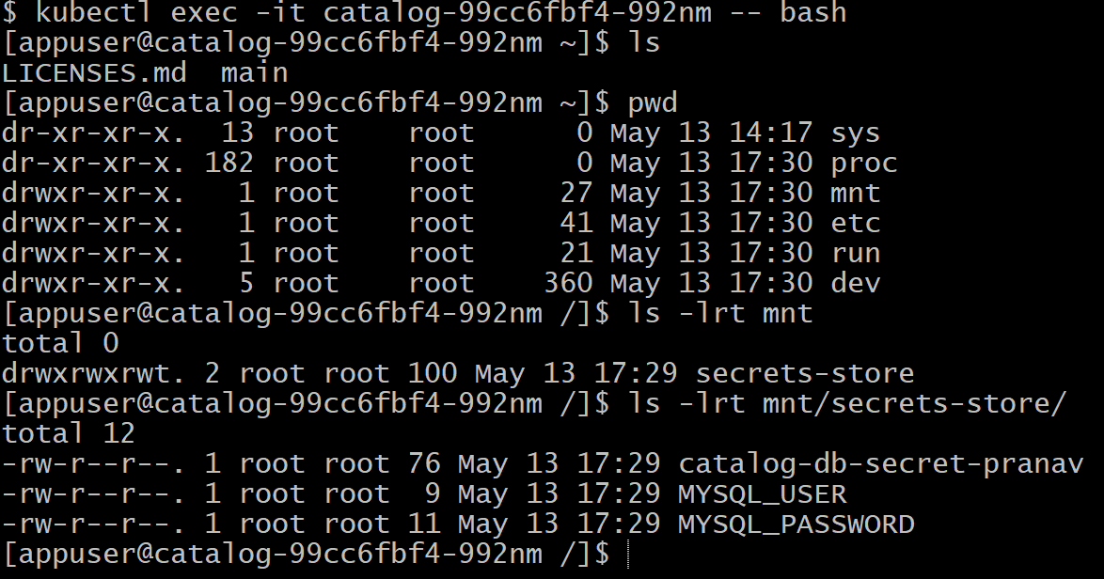
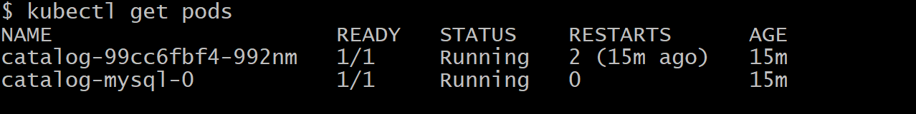
kubectl port-forward svc/catalog-service 7080:8080
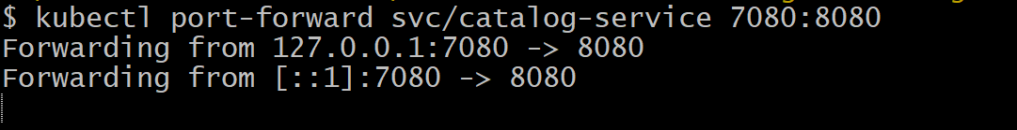
# Acess Catalog Endpoints from My Laptop Browser.
http://localhost:7080/topology
http://localhost:7080/health
http://localhost:7080/catalog/products
http://localhost:7080/catalog/size
http://localhost:7080/catalog/tags
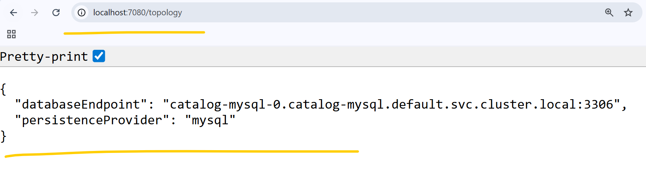

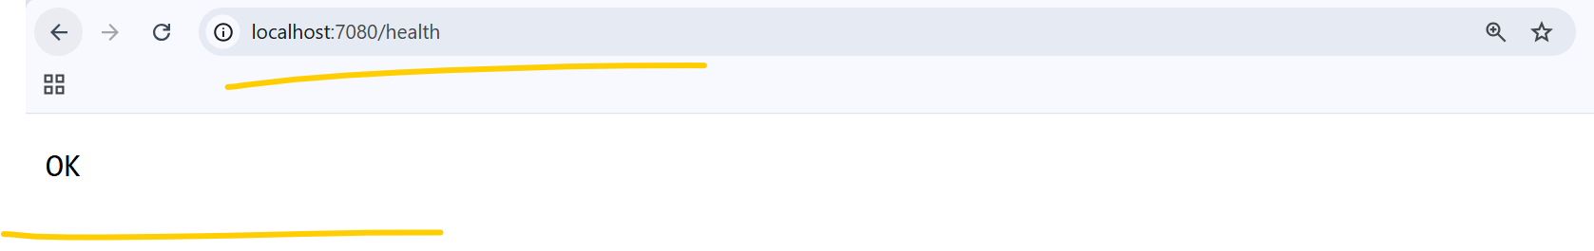

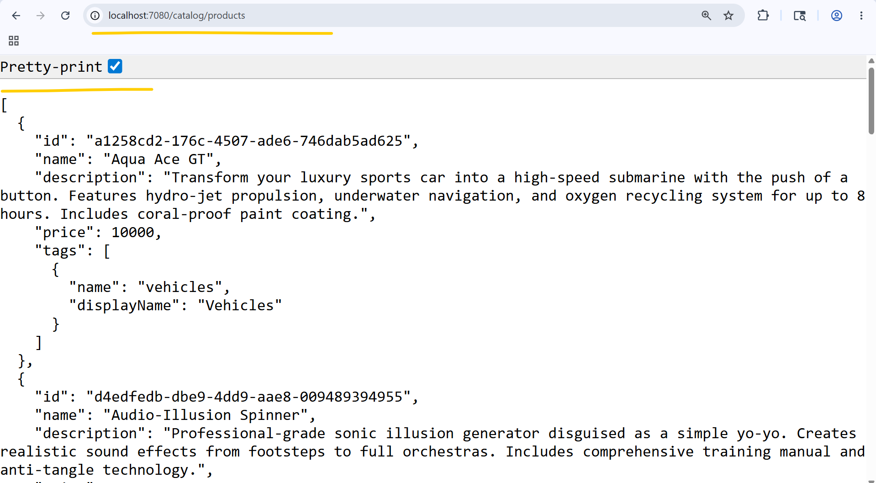

Note:- For reference purpose 3 screenshots Catalog Endpoints are enough, hence not added remaining 2 catalog endpoint screenshots.

- Deleted all the Kubetnetes and other resources which are created for this practical.
# Delete Kubetnetes Resources
kubectl delete -f 02_catalog_k8s_manifests
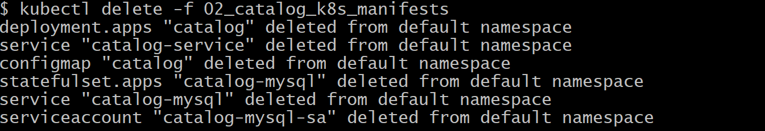
# Delete Secret Provider class
kubectl delete -f 01_secretproviderclass

Deleted iam role, policy, secrets from secret manager service from AWS console.

- Deleted EKS Cluster, Node group and Iam roles for through terraform destroy command.

