Steps:-
- Copied EKS and AWS Data Plane terraform code from 26_05_2026 this folder into 27_05_2026 this folder.
Note:- 1. Since I did not deploy a private subnet due to the unavailability of a NAT Gateway, and creating my own NAT Gateway would incur additional costs, I chose not to create one for cost optimization purposes. As a result, I deployed my node group EC2 instances, Karpenter EC2 instance, RDS DB’s and ElastiCache resources in a public subnet.
2. I am also aware that, from a best practices and security perspective, node group EC2 instances, Karpenter EC2 instance, RDS DB’s and ElastiCache resources should be hosted in a private subnet rather than a public subnet. However, this is not a production-grade EKS cluster; I am deploying it only for practical testing purposes. Therefore, I hosted the node group EC2 instances, Karpenter EC2 instance, RDS DB’s and ElastiCache resources in a public subnet.
3. For my previous practical’s, I have also used only public subnets, and for upcoming practical’s, I will continue to use public subnets only.

- Run below mentioned terraform commands to deploy the EKS Cluster through terraform

terraform init
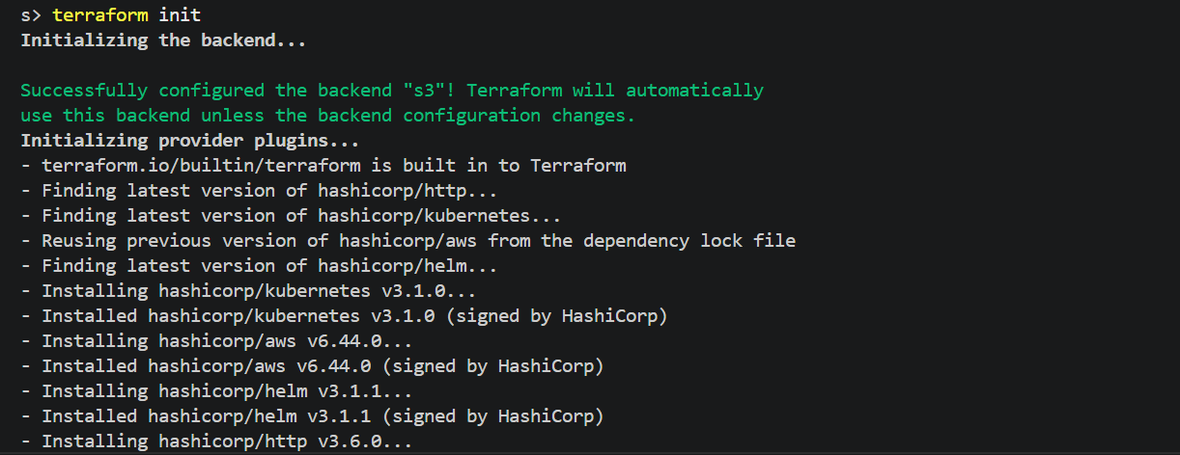

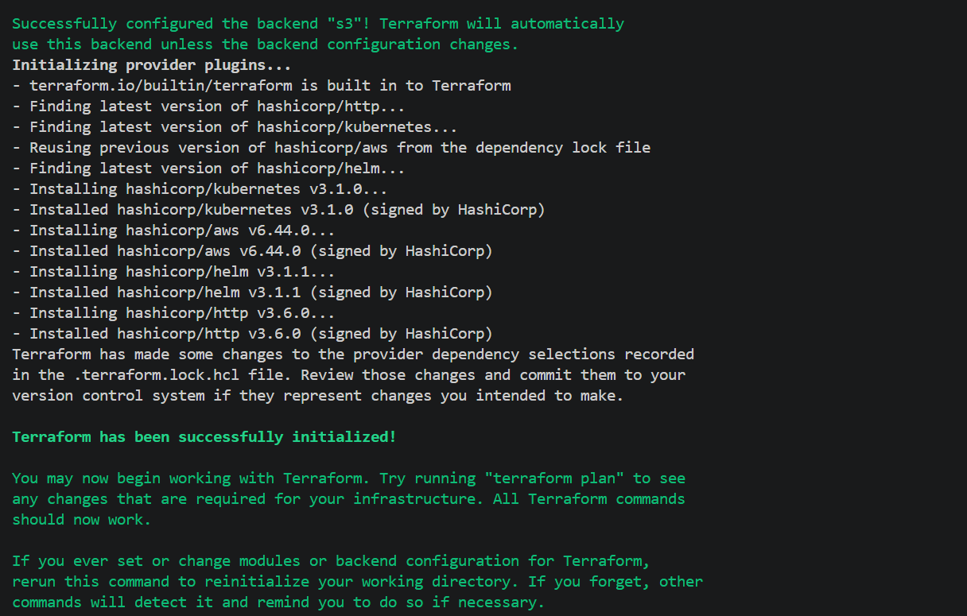

terraform validate

terraform plan
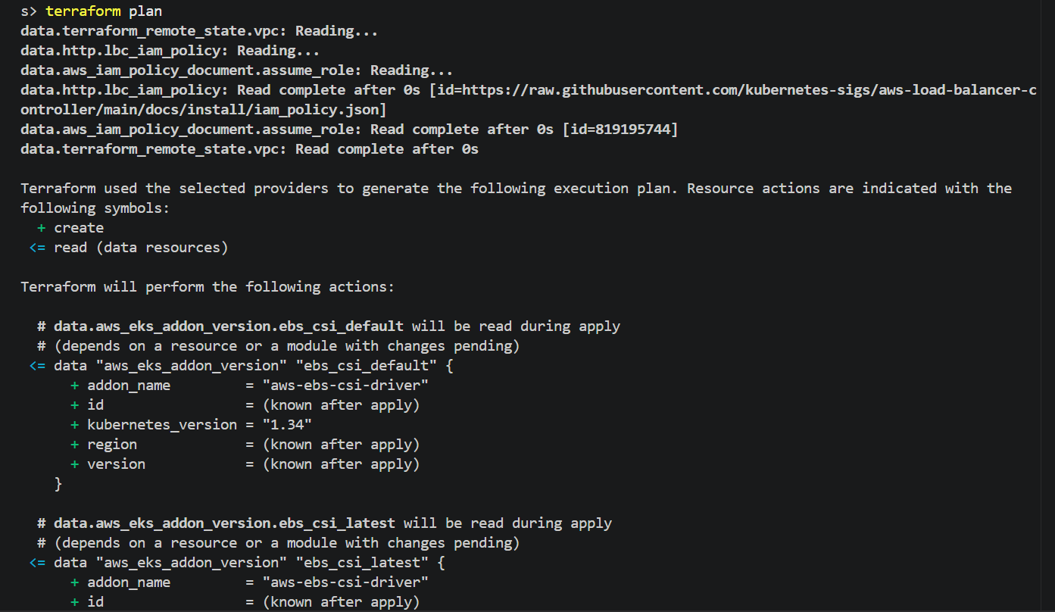

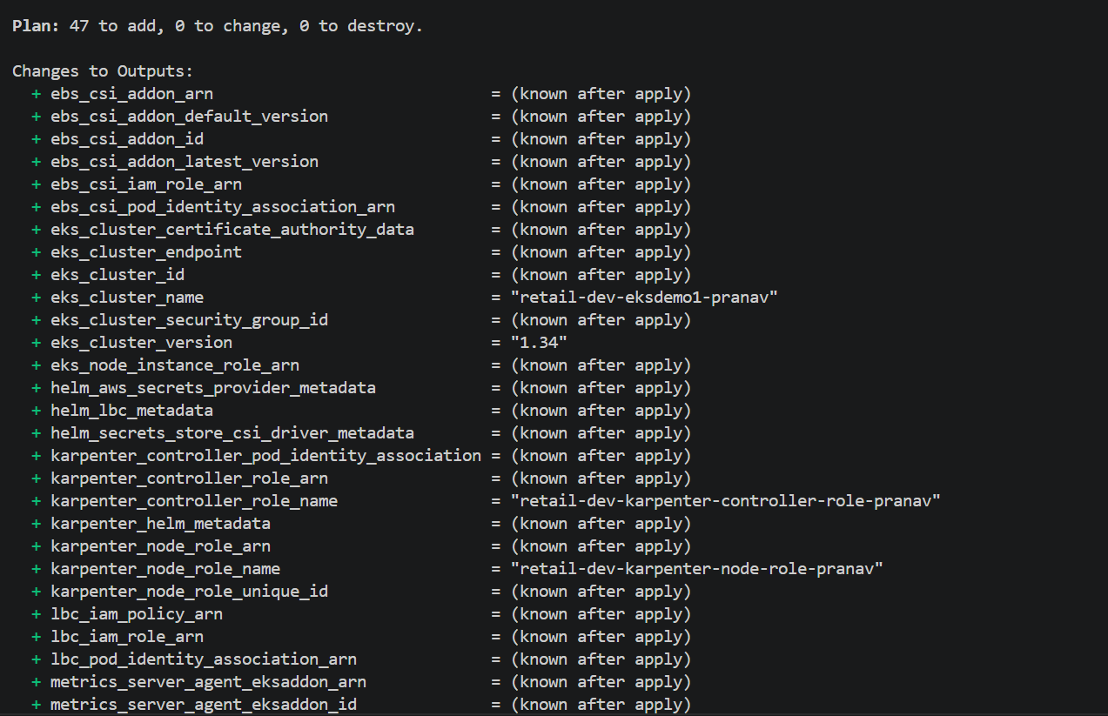
terraform apply –auto-approve
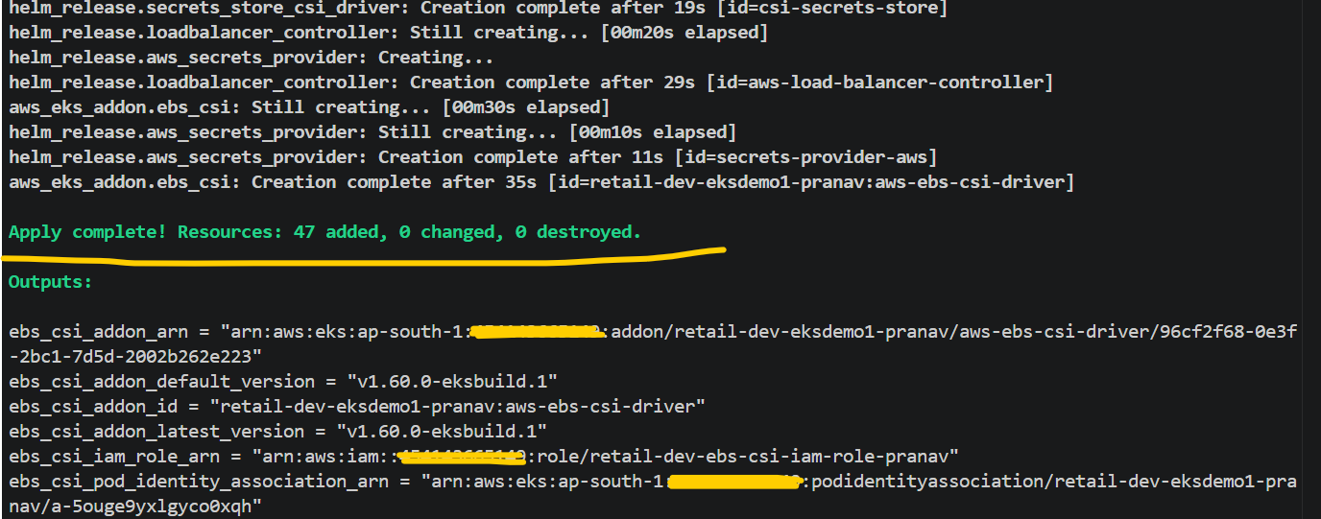

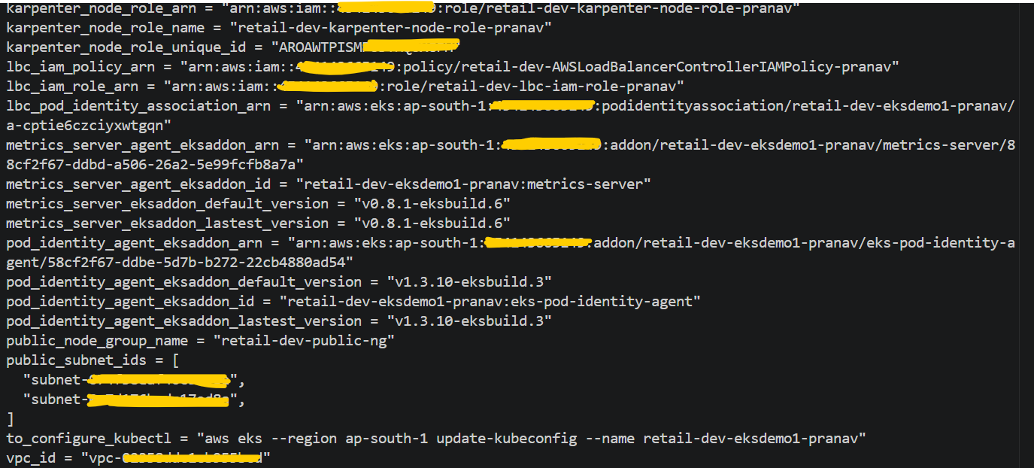

# Verified EKS Cluster and its configuration from AWS console
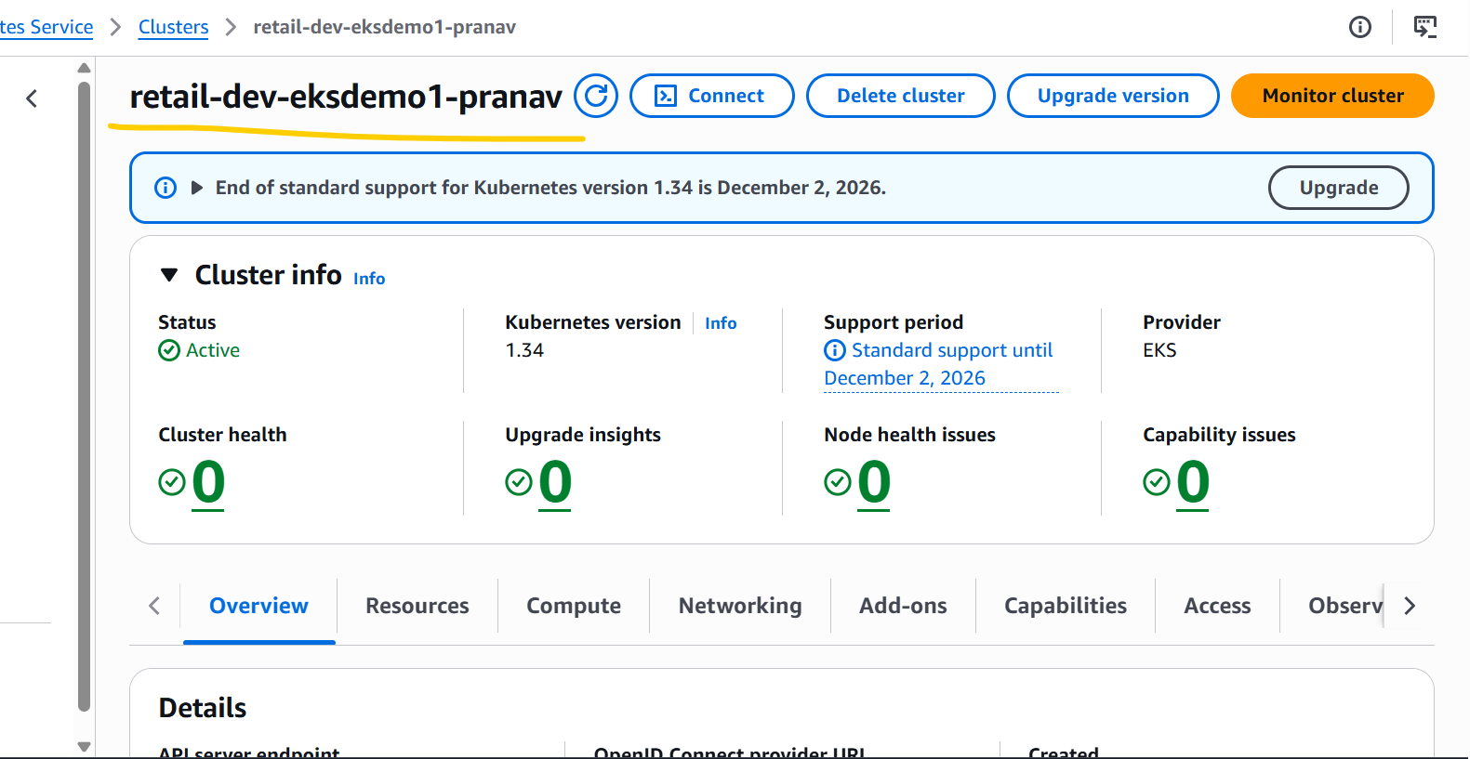

# EKS Node Group Instance Type Size

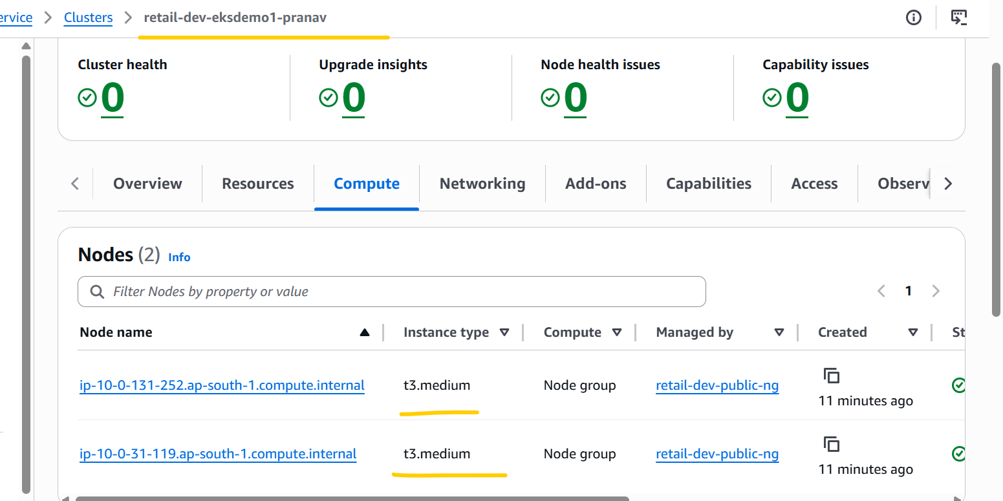

# EKS Cluster Add-ons.
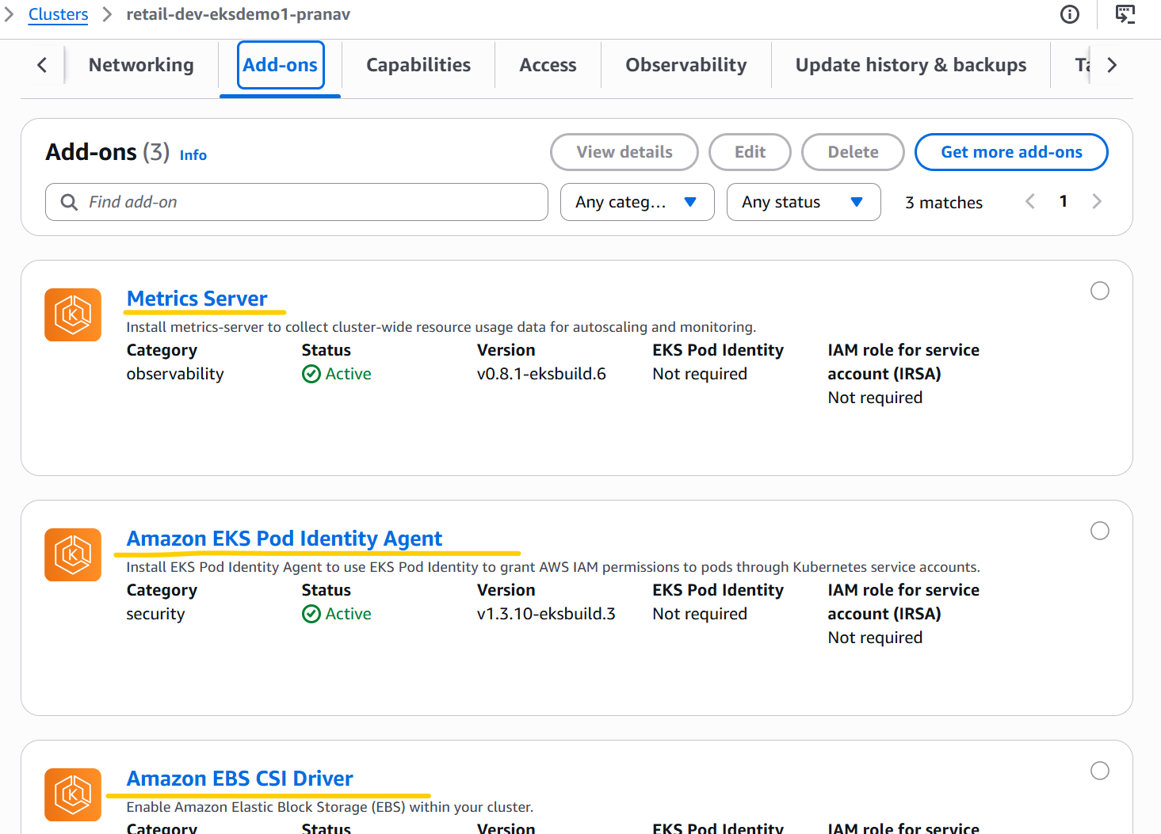

# EKS Cluster IAM access entries
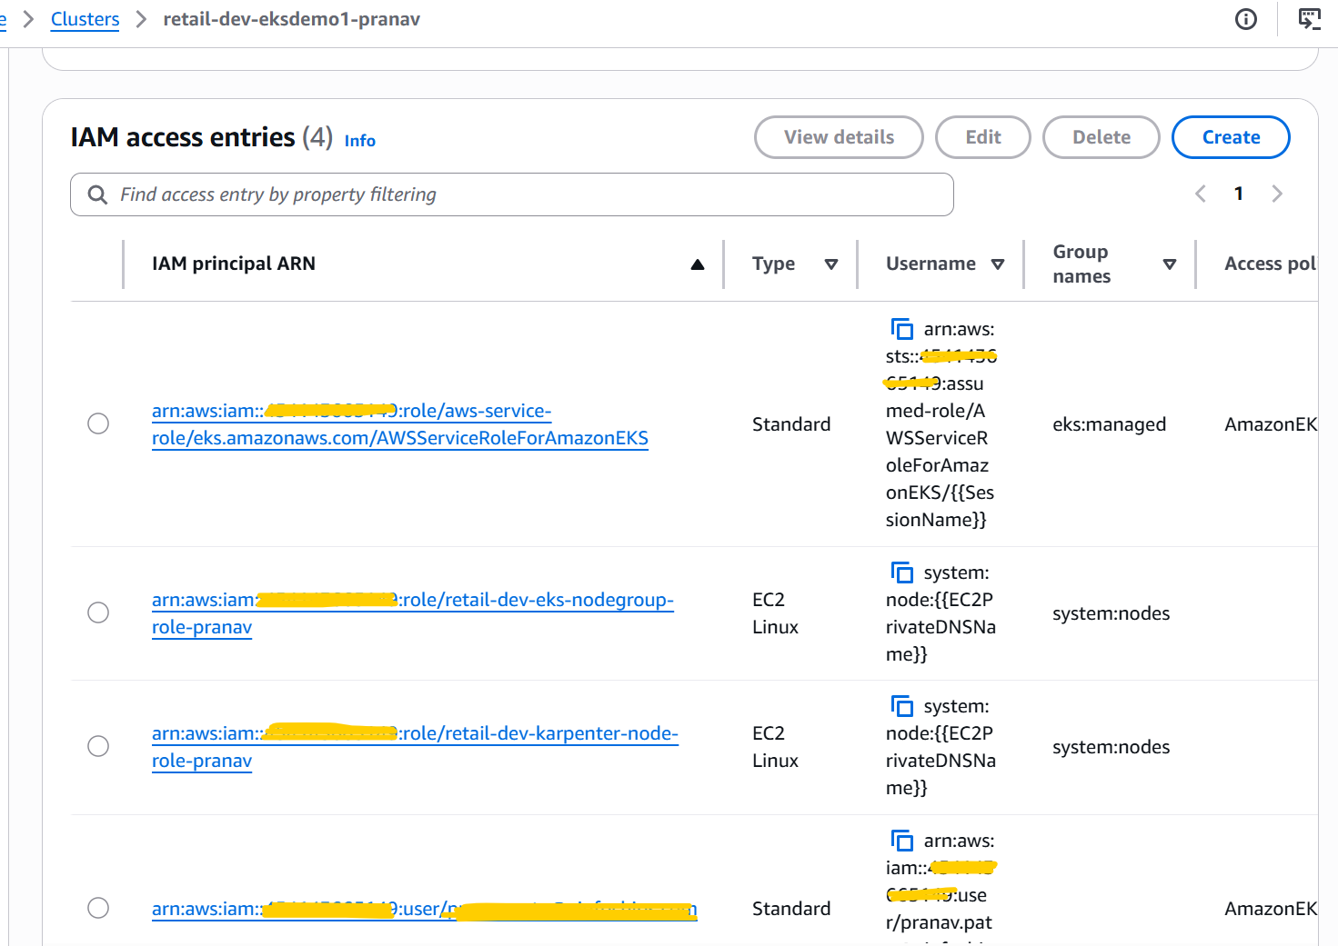

# EKS Cluster Pod Identity associations.
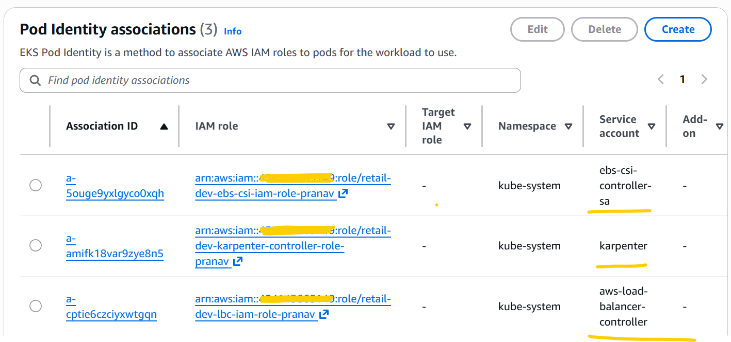

- Run below terraform commands to deploy the AWS Data plane.
terraform init
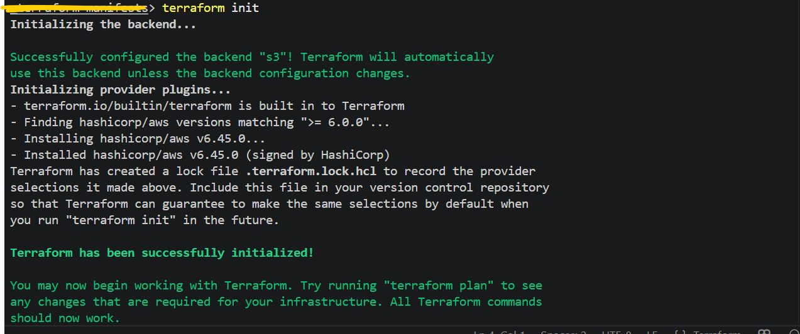
terraform validate
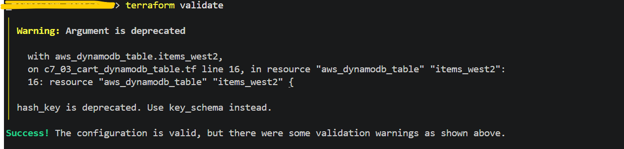

terraform plan
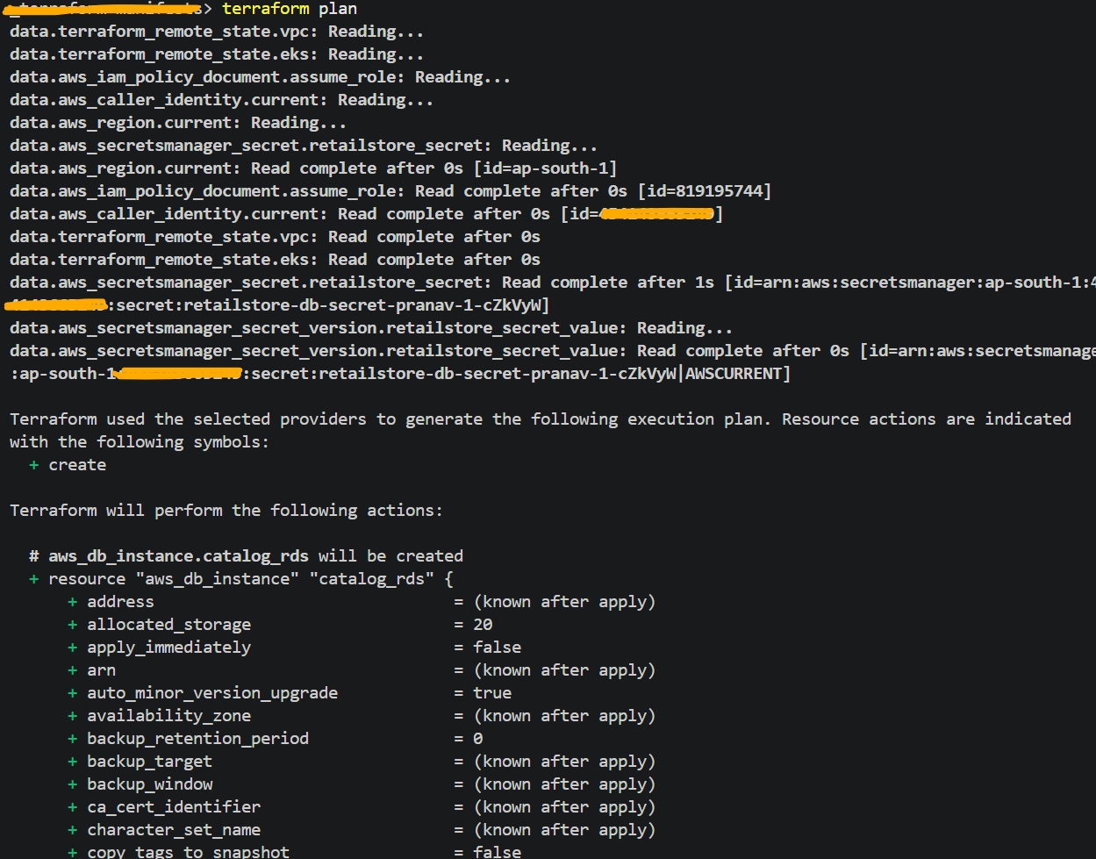
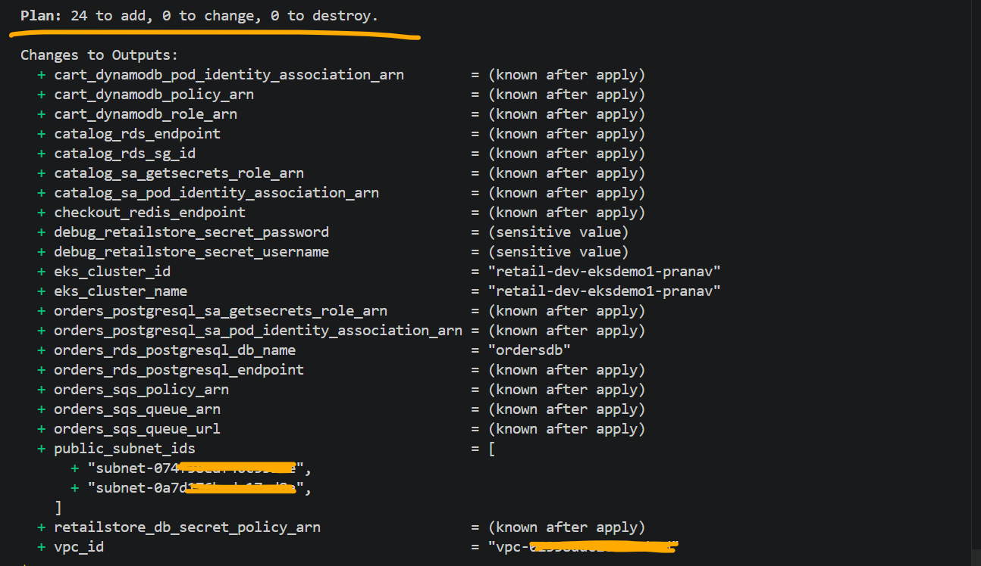
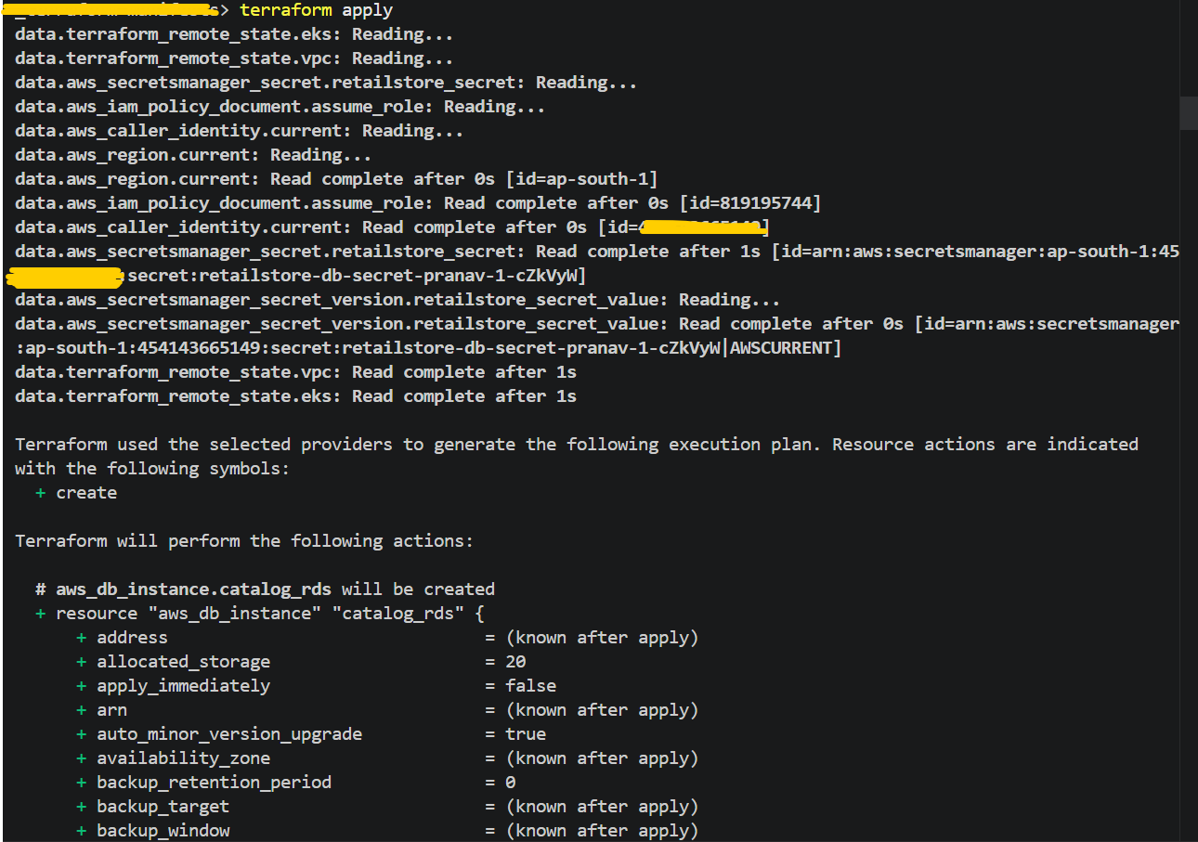

# AWS Data Plane related all the 24 resources are successfully deployed through terraform.
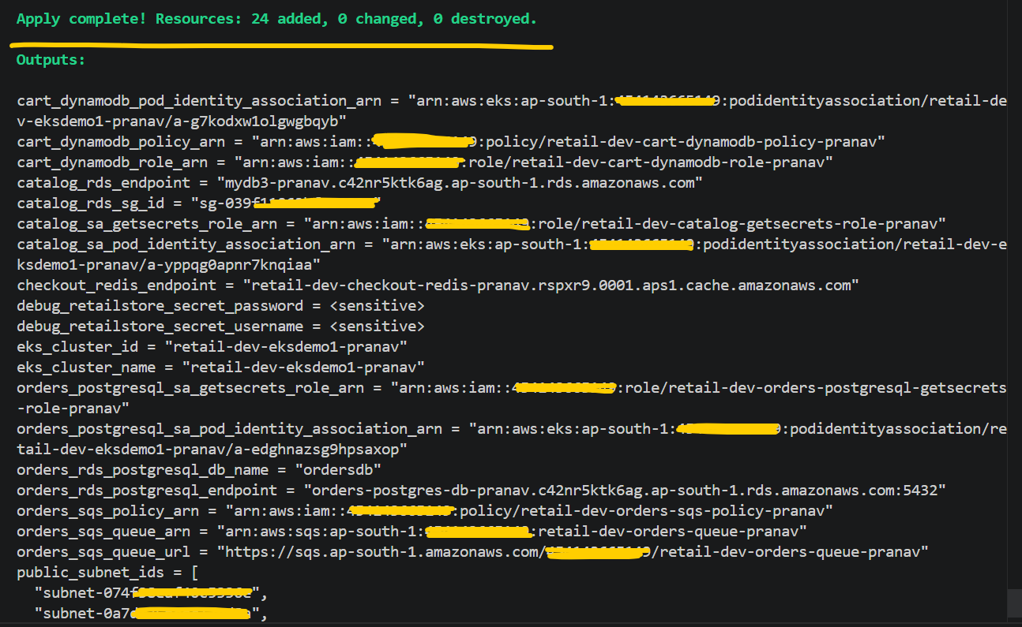

# Verify the AWS Data Plane resources from AWS Console.
Mysql and Postgresql RDS DB’s
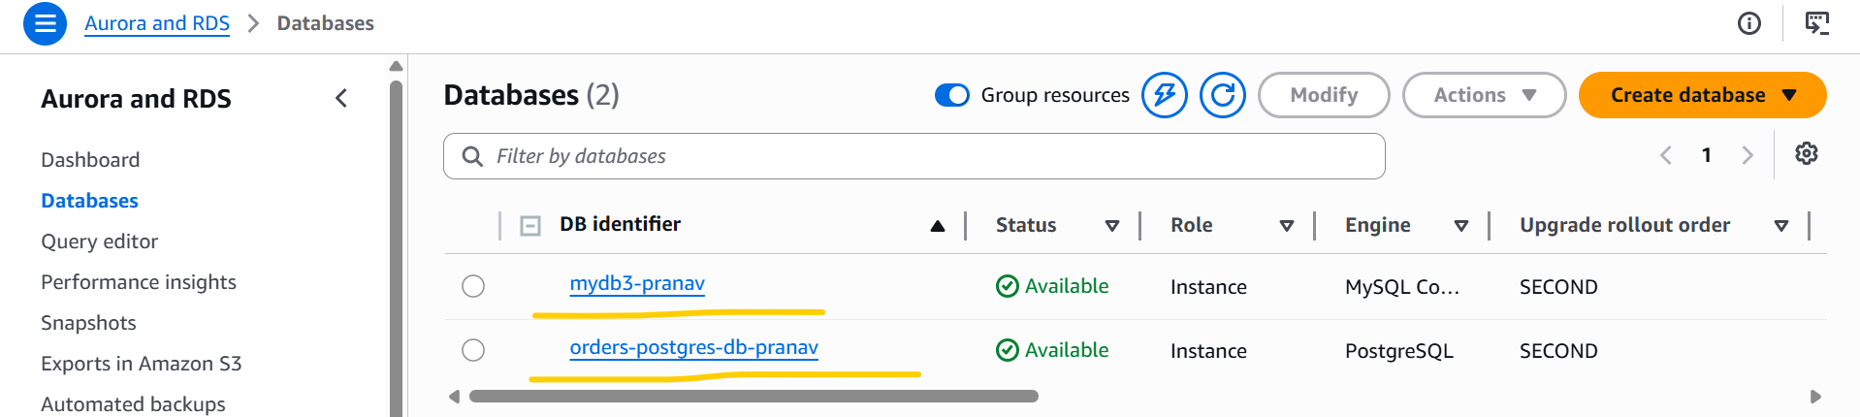

ElastiCache
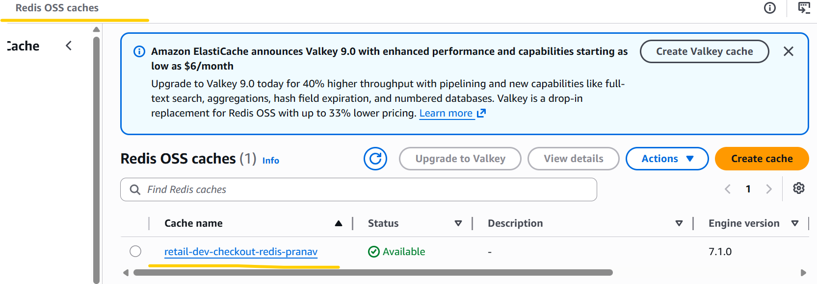
Dynamo DB Table
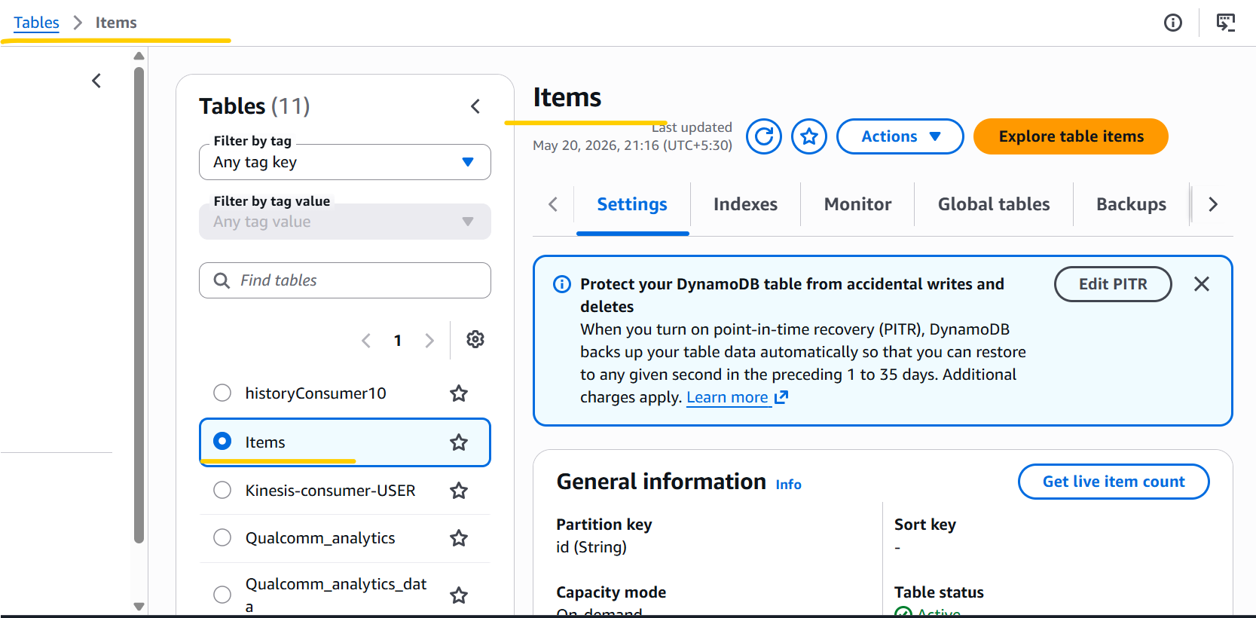

Amazon SQS
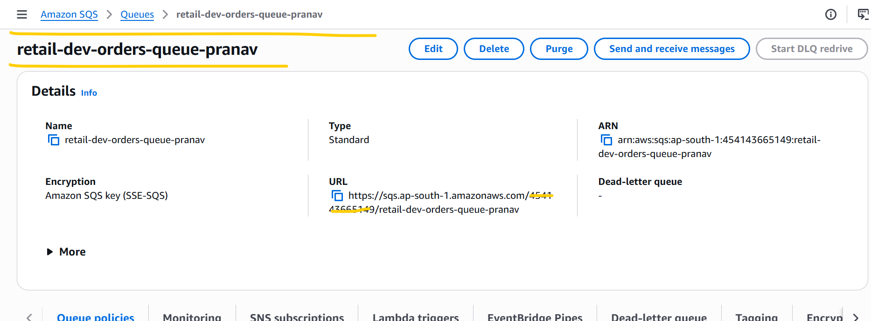

- Copied the Devops manifest files and scripts from the instructor’s code into the 27_05_2026 this folder and updated all the required values in the Devops manifest files) before deployment.

aws eks --region ap-south-1 update-kubeconfig --name retail-dev-eksdemo1-pranav

kubectl apply -f KARPENTER_k8s-manifests/
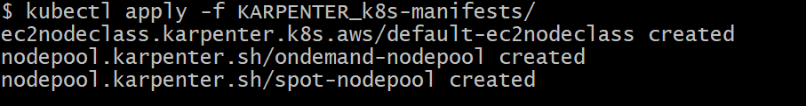

kubectl get ec2nodeclass
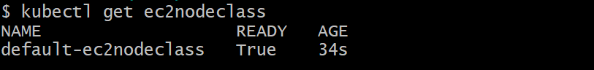

kubectl get nodepools
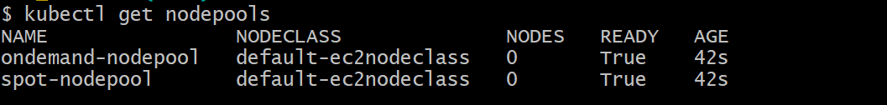

kubectl apply -f 01_secretproviderclass/

# Create ECR repository for UI microservice

aws ecr create-repository \
--repository-name retail-store/ui \
--region ap-south-1

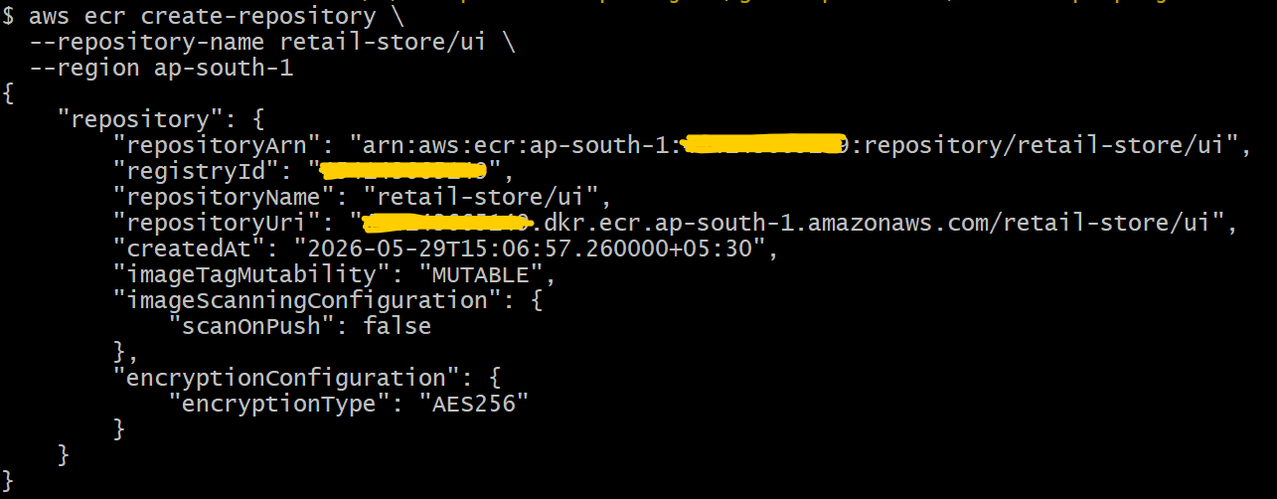

# Set env variables

AWS_REGION="ap-south-1"
ACCOUNT_ID=$(aws sts get-caller-identity --query Account --output text)
GITHUB_REPO="pranavpate/aws-devops-github-actions-ecr-argocd"
ROLE_NAME="github-actions-oidc-role-ui-pranav"

# Verify variables are set correctly
echo "AWS Region: $AWS_REGION"
echo "Account ID: $ACCOUNT_ID"
echo "GitHub Repo: $GITHUB_REPO"
echo "IAM Role Name: $ROLE_NAME"

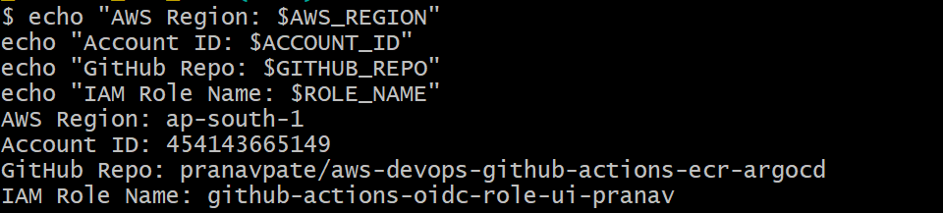

cat > trust-policy.json <<EOF
{
"Version": "2012-10-17",
"Statement": [
{
"Effect": "Allow",
"Principal": {
"Federated": "arn:aws:iam::${ACCOUNT_ID}:oidc-provider/token.actions.githubusercontent.com"
},
"Action": "sts:AssumeRoleWithWebIdentity",
"Condition": {
"StringLike": {
"token.actions.githubusercontent.com:sub": "repo:${GITHUB_REPO}:*"
}
}
}
]
}
EOF
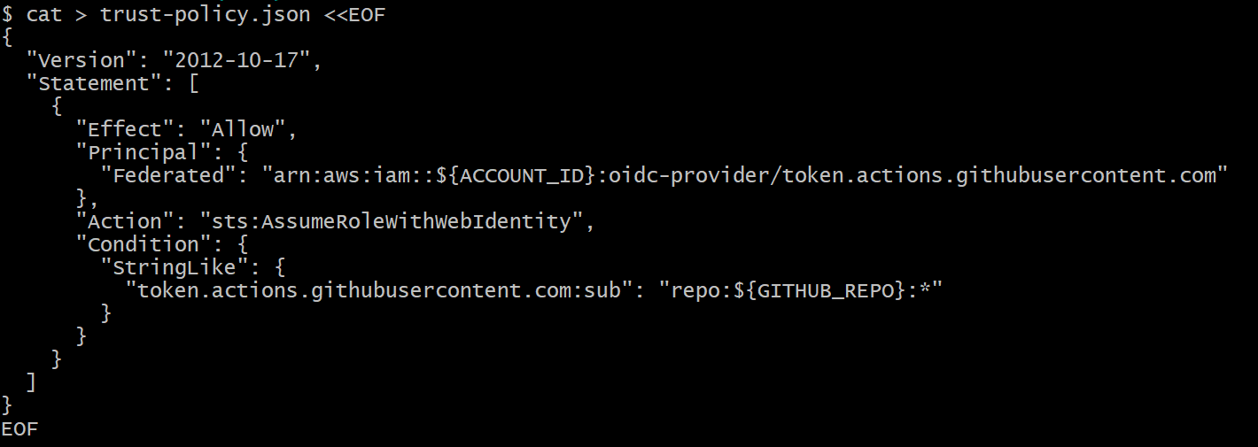

cat trust-policy.json
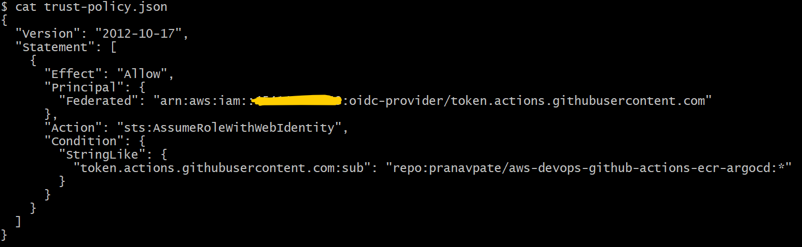

# Create the IAM role
aws iam create-role \
--role-name $ROLE_NAME \
--assume-role-policy-document file://trust-policy.json
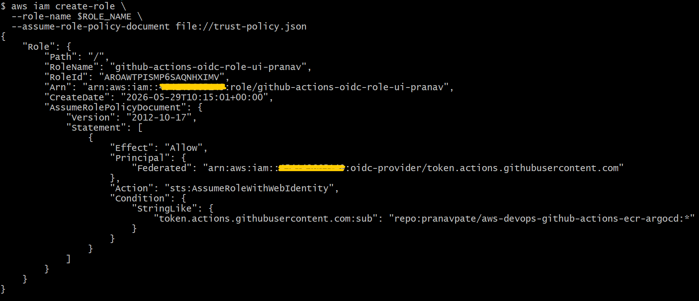

# Attach AWS managed policy for ECR push/pull access

aws iam attach-role-policy \
--role-name $ROLE_NAME \
--policy-arn arn:aws:iam::aws:policy/AmazonEC2ContainerRegistryPowerUser

# Verify policy is attached

aws iam list-attached-role-policies --role-name $ROLE_NAME

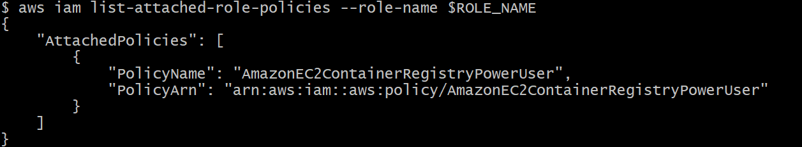

# List OIDC Providers
aws iam list-open-id-connect-providers
Note:- There are already multiples open-id-connect-providers are present.

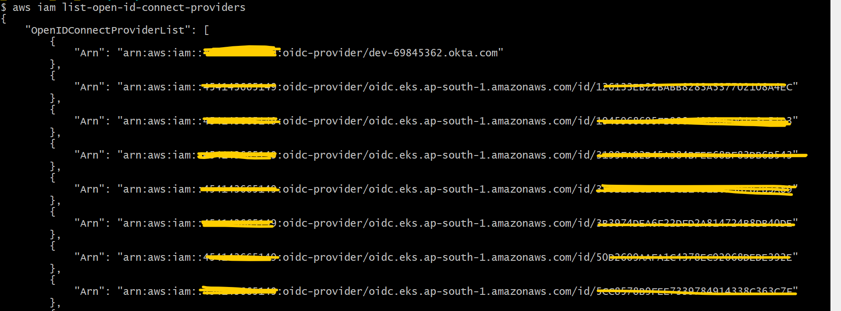

# Create OIDC Provider

aws iam create-open-id-connect-provider \
--url https://token.actions.githubusercontent.com \
--client-id-list sts.amazonaws.com

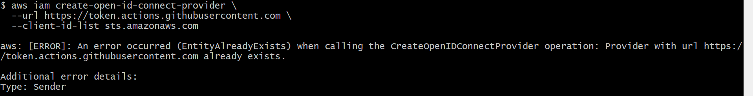

Note:- 1) Since the same OIDC Provider is already present, due to that reason my above command got failed during creation of open id connect provider.
2) Since the same OIDC Provider is already present or exist, so in this case OIDC Provider creation is not required. GitHub Action will automatically detect this while running the workflow.

# Created aws-devops-github-actions-ecr-argocd this repository in my personal Github account.
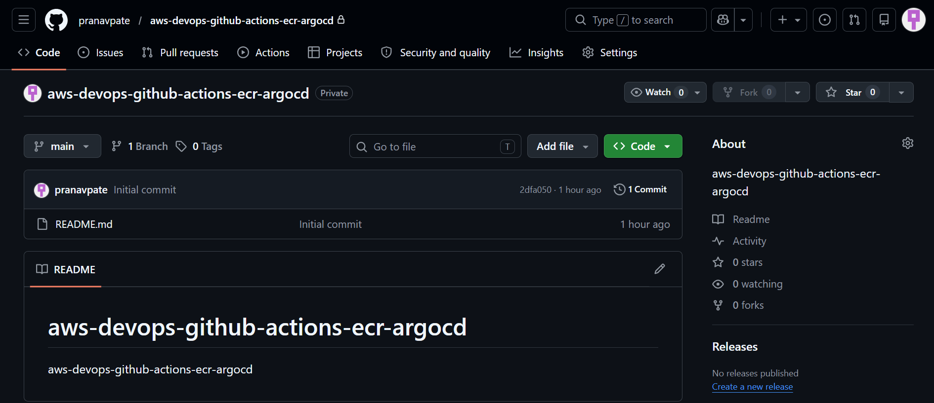
# Copied all the files and folders from DevOps_CICD\21_01_CI_github_actions_AWS_ECR\github-files this path into
aws-devops-github-actions-ecr-argocd this local repository which I cloned locally in my system.
git status
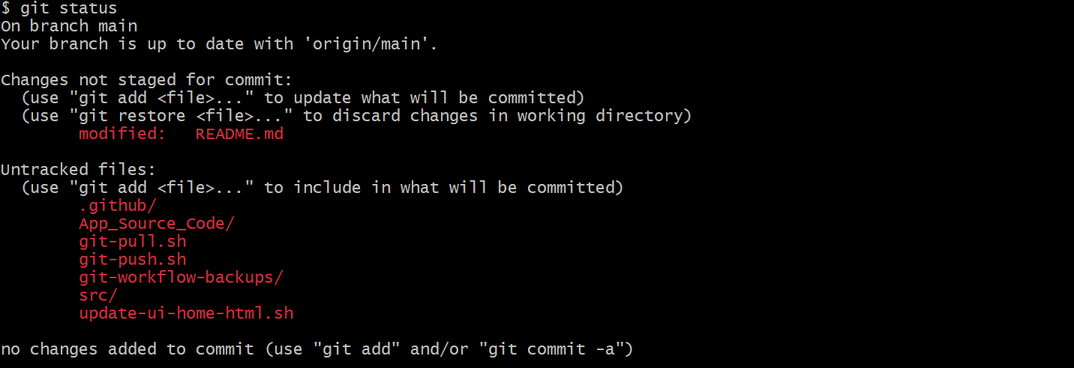
sh git-push.sh
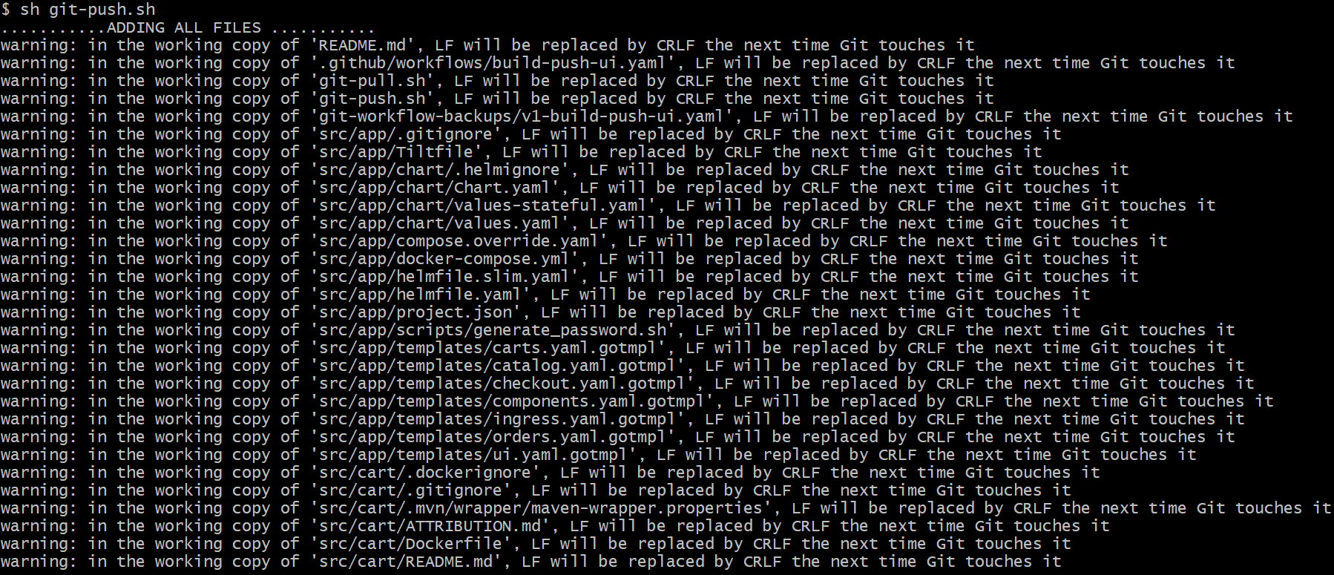
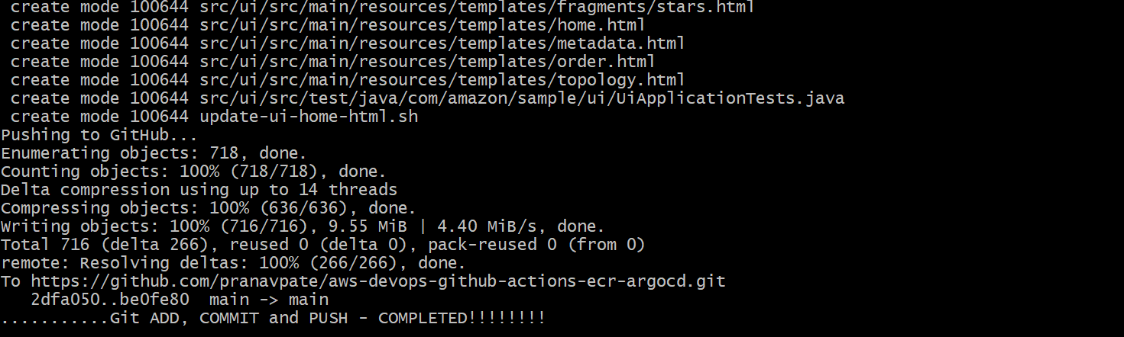
# Note:- Code has been successfully pushed into my aws-devops-github-actions-ecr-argocd this repository. Below mentioned is screenshot of my repository.
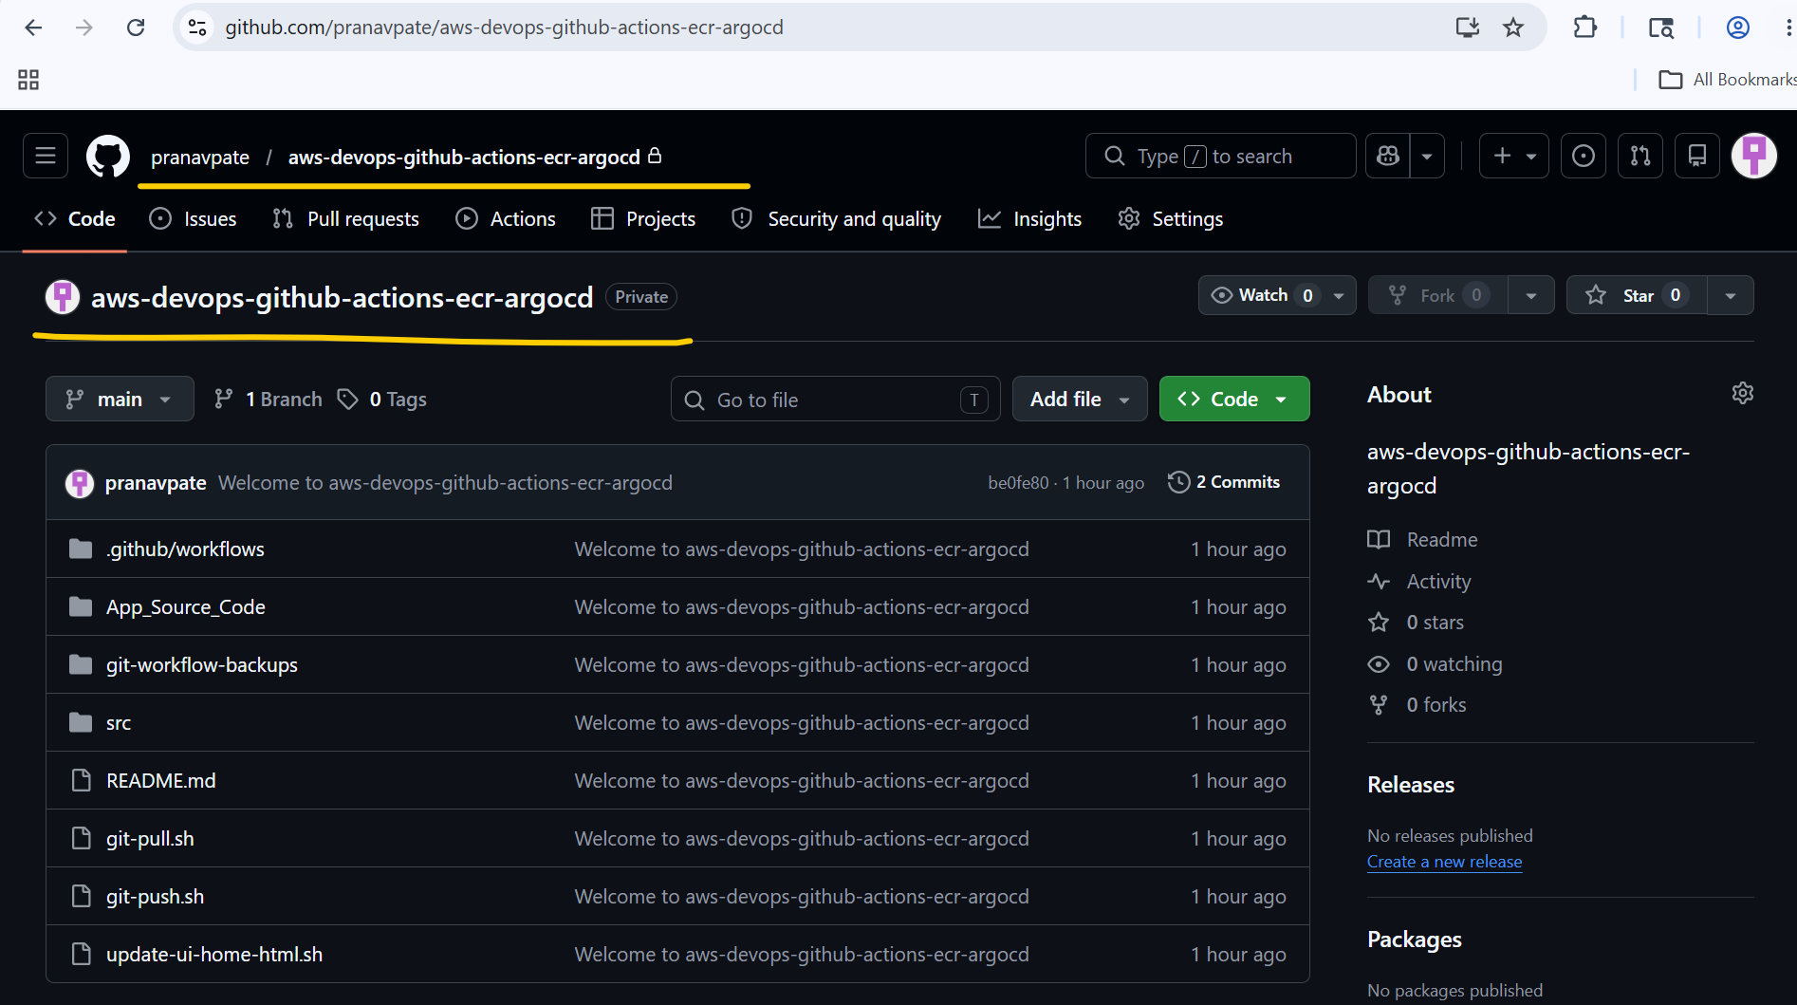
# Run the update-ui-home-html.sh shell script to update the version number in the home.html file located at src/ui/src/main/resources/templates/
sh update-ui-home-html.sh v801
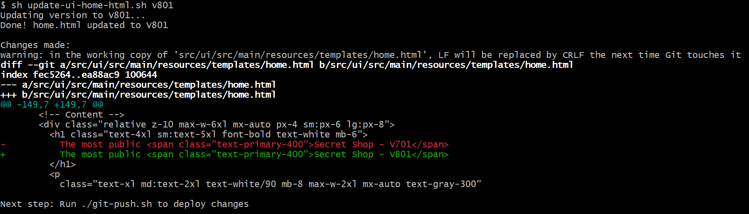
# Note:- Below mentioned is the screenshot of home.html file, highlighted V801 number is updated by above mentioned shell script.
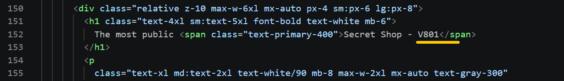
git status
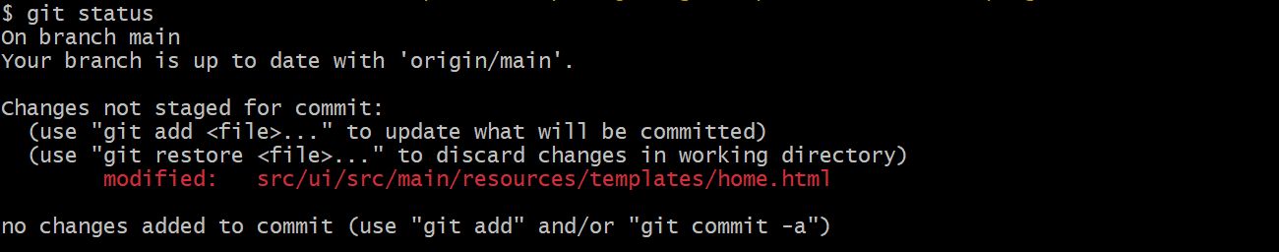
sh git-push.sh
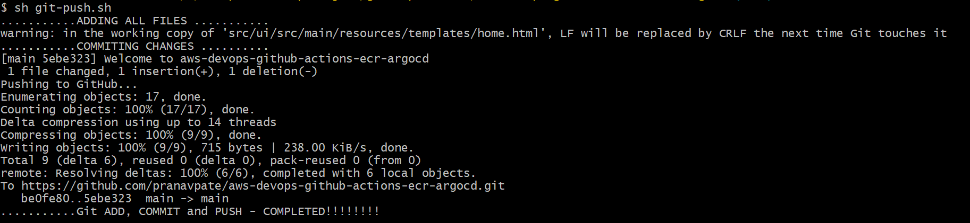
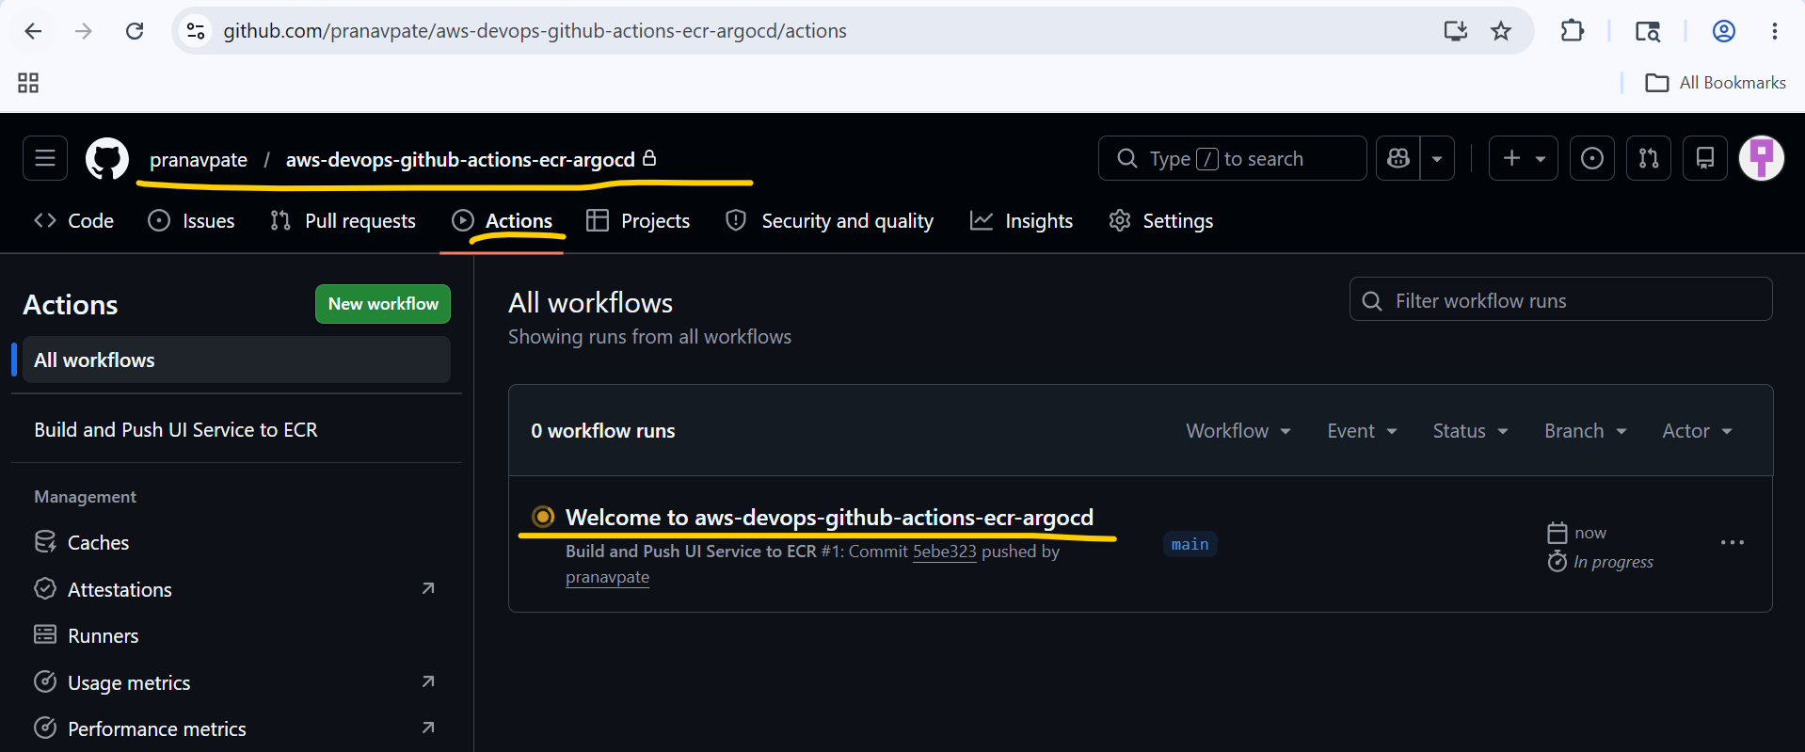

# The GitHub workflow job failed during the Build and push Docker images step because of a Permission denied error when attempting to execute the mvn file.

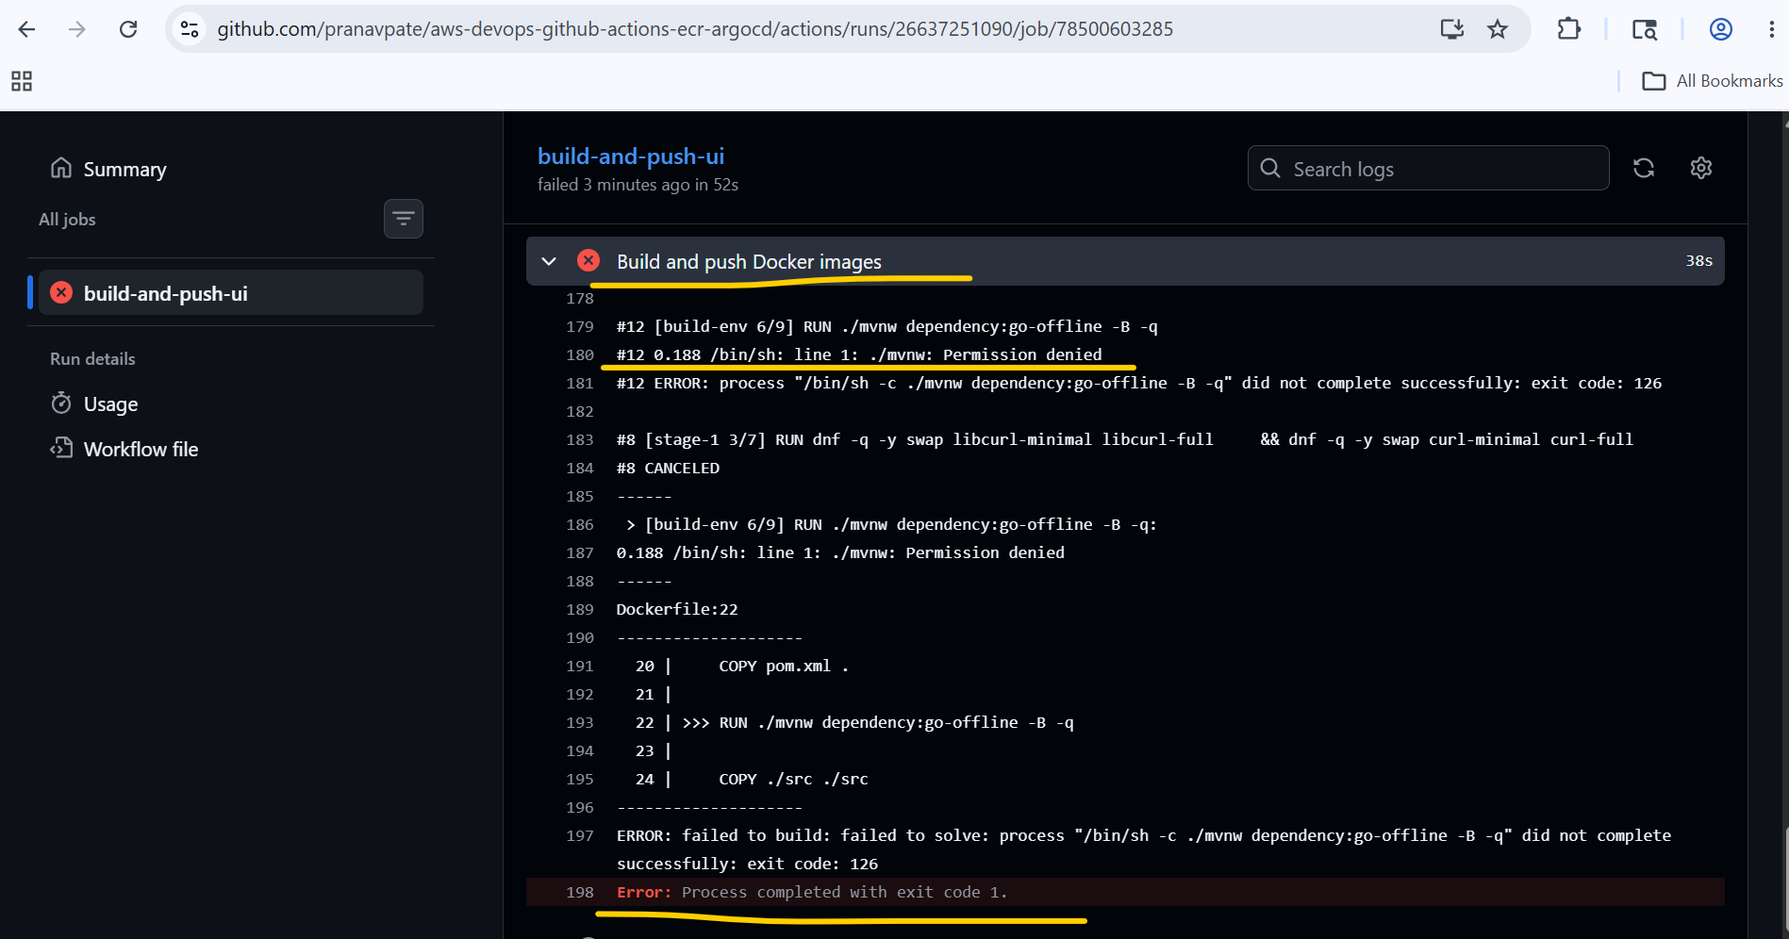
# To Resolve this issue, I have added RUN chmod +x mvnw this instruction in Dockerfile and rerun update-ui-home-html.sh this shell script with v901 this argument and run git add. git commit and git push commands to push my changes into my remote repository.
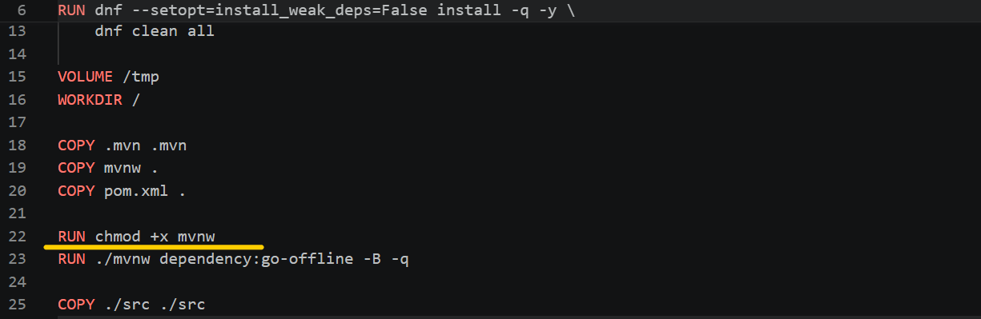

# After pushing the changes, now this time my Github Workflow job has been run successfully.
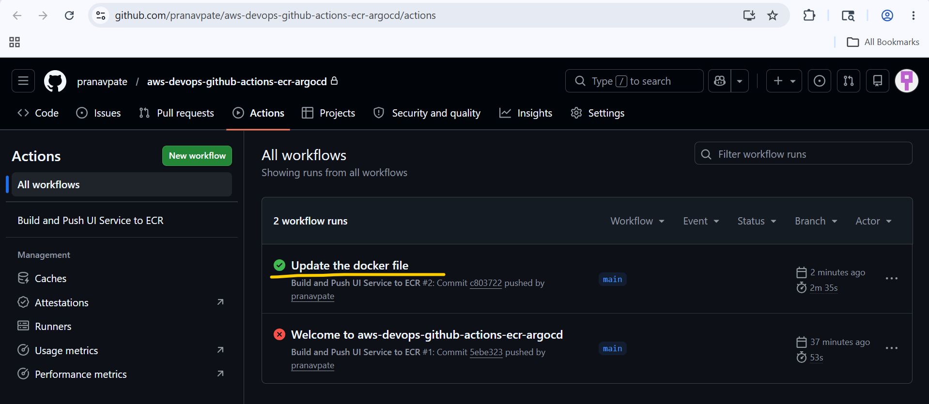
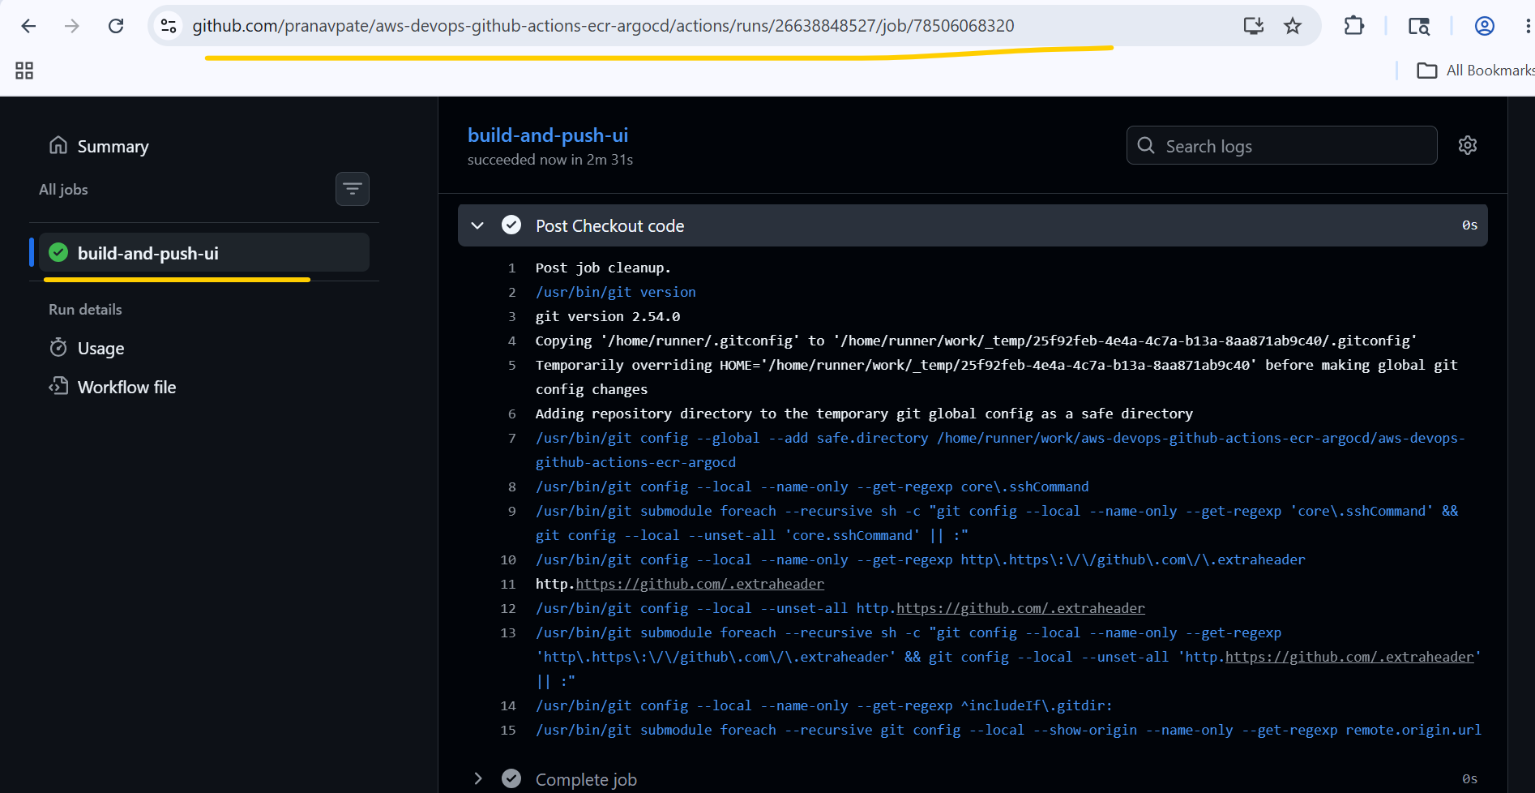

# Verified Docker image in ECR repo from AWS Console.
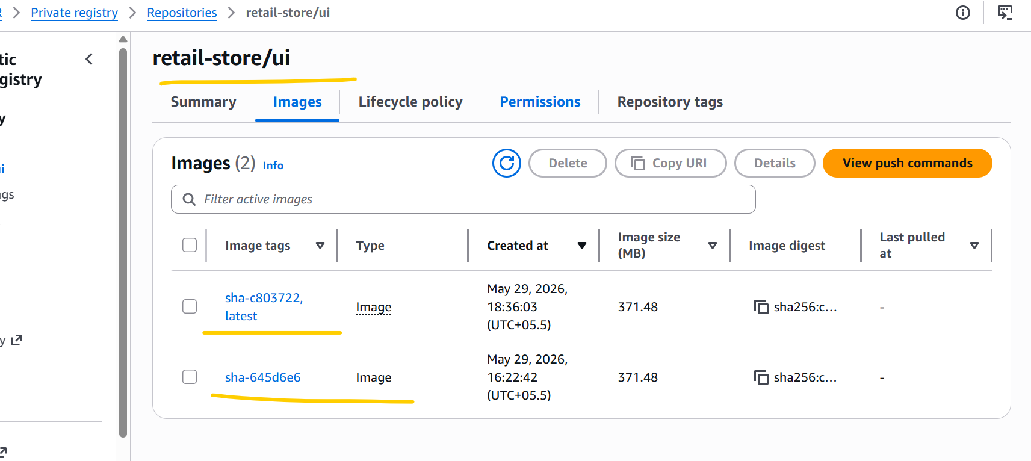

# Verified Image Tag
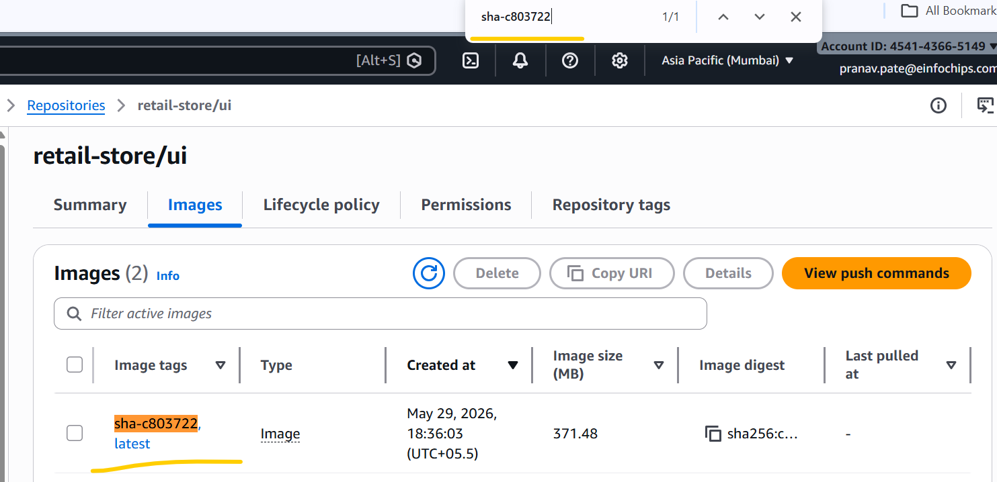
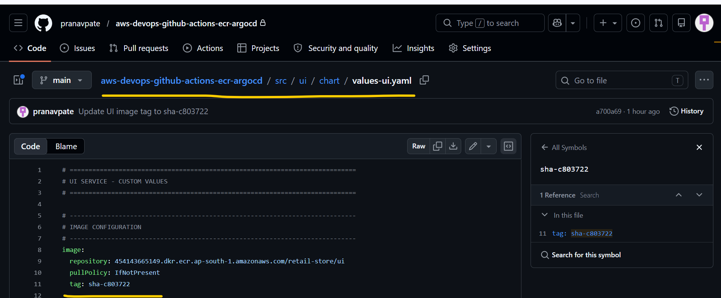
sh git-pull.sh
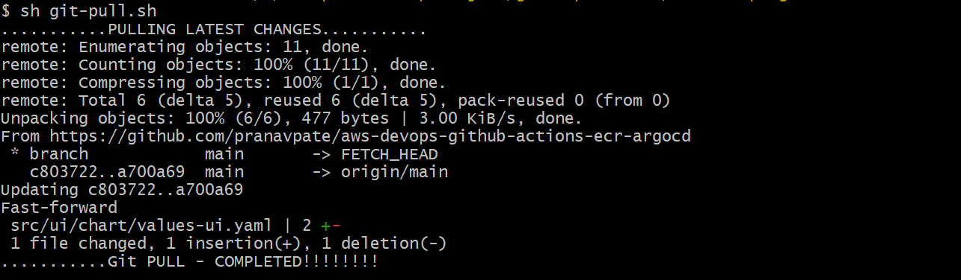
# Update version again in home.html file to push to new image.
sh update-ui-home-html.sh V802
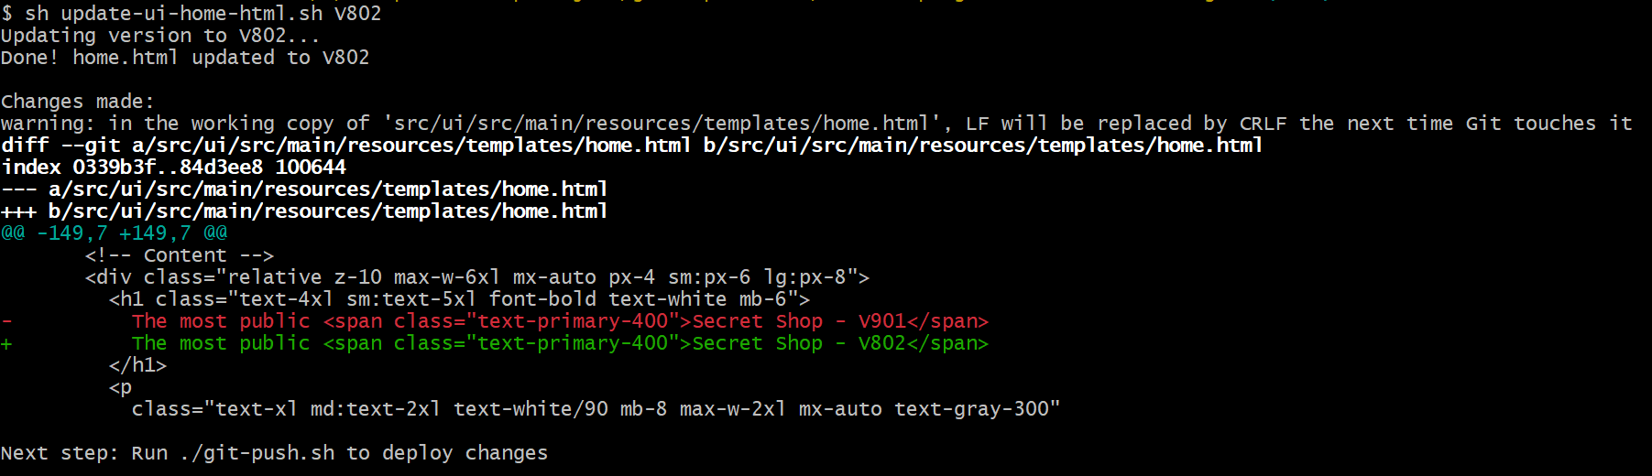
$ sh git-push.sh
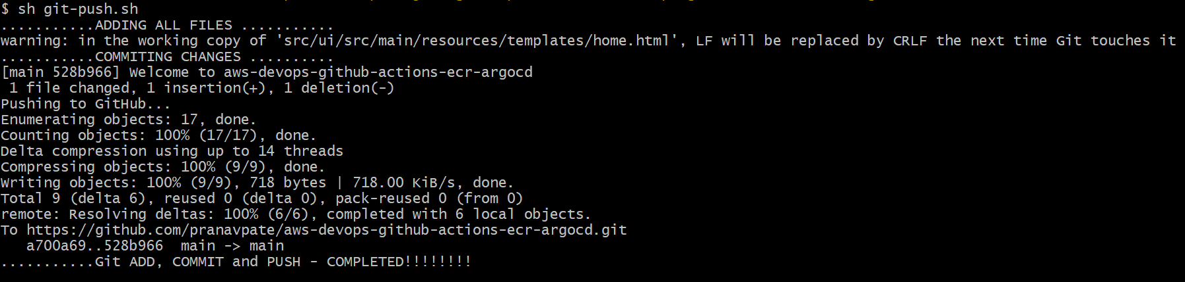
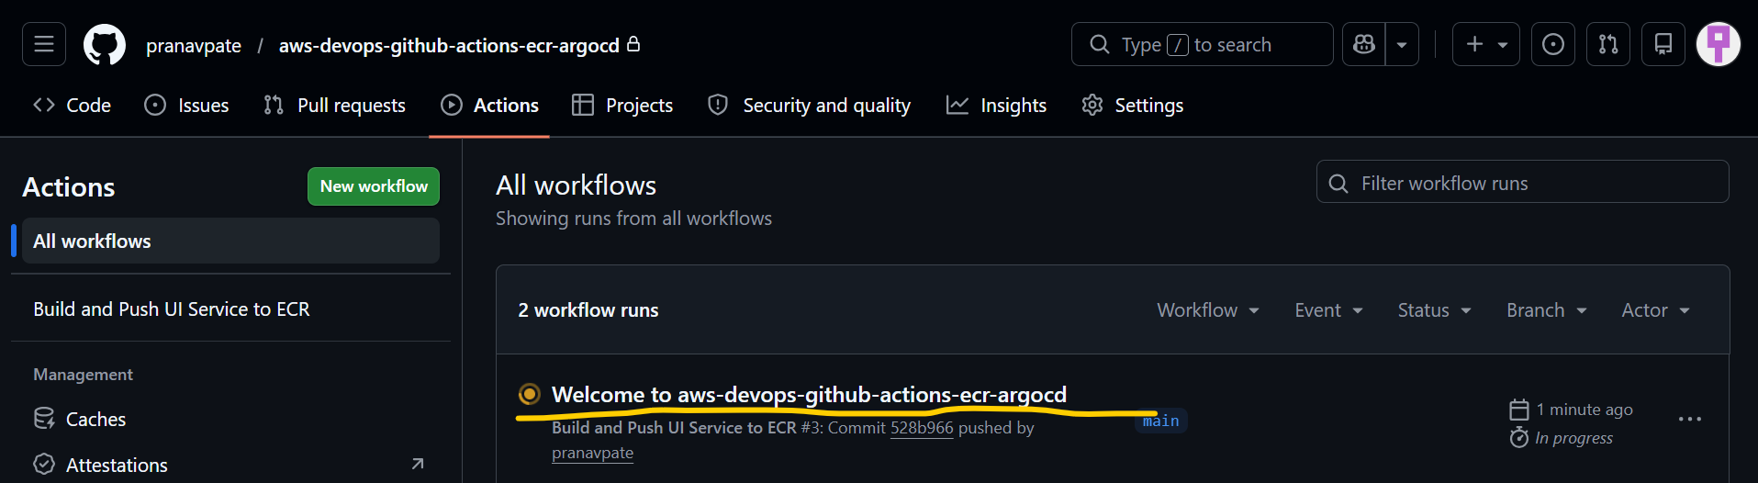
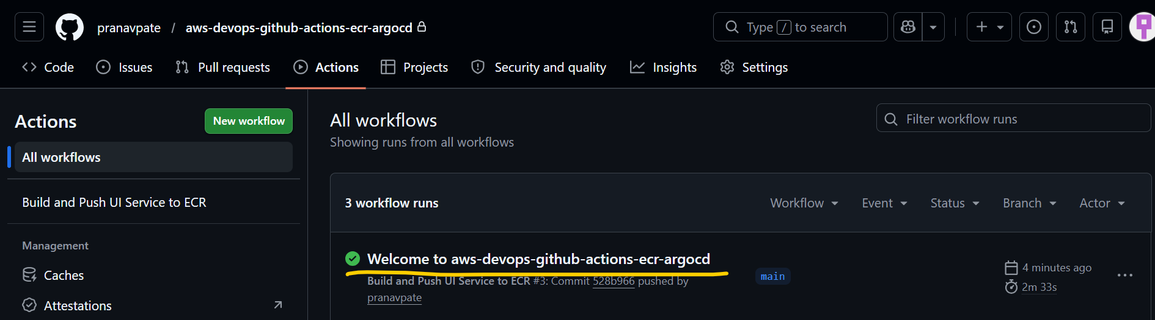
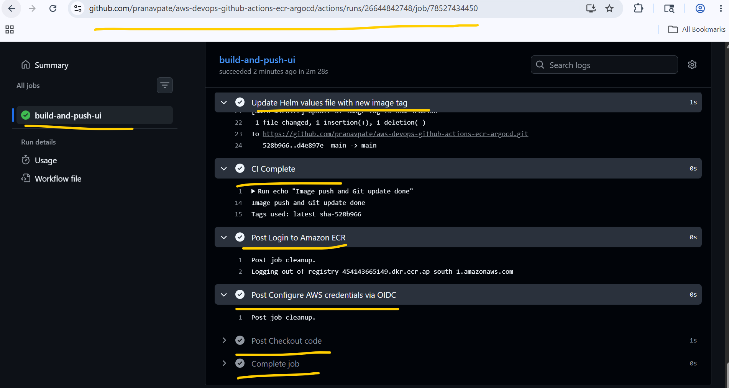
# New Image is pushed in ECR repo.
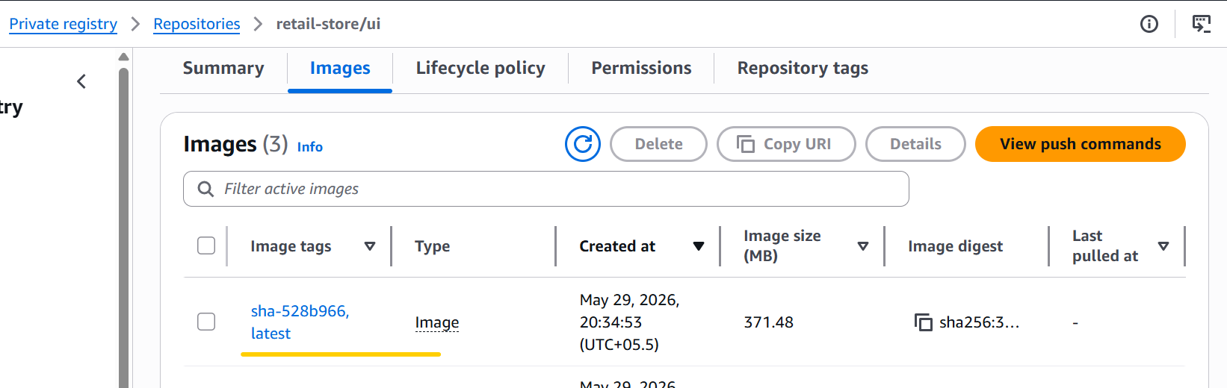
sh git-pull.sh
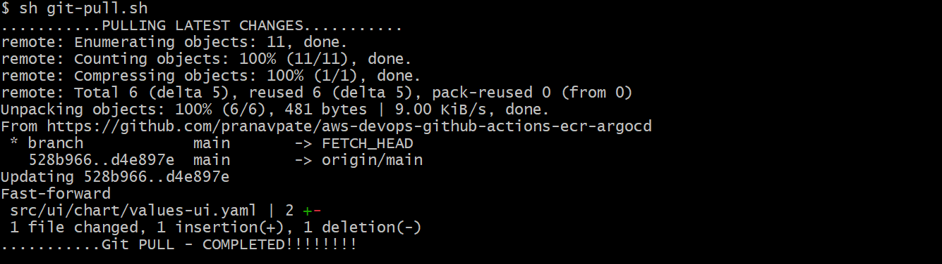
cd ../21_02_CD_ArgoCD_Install/
sh install-argocd.sh
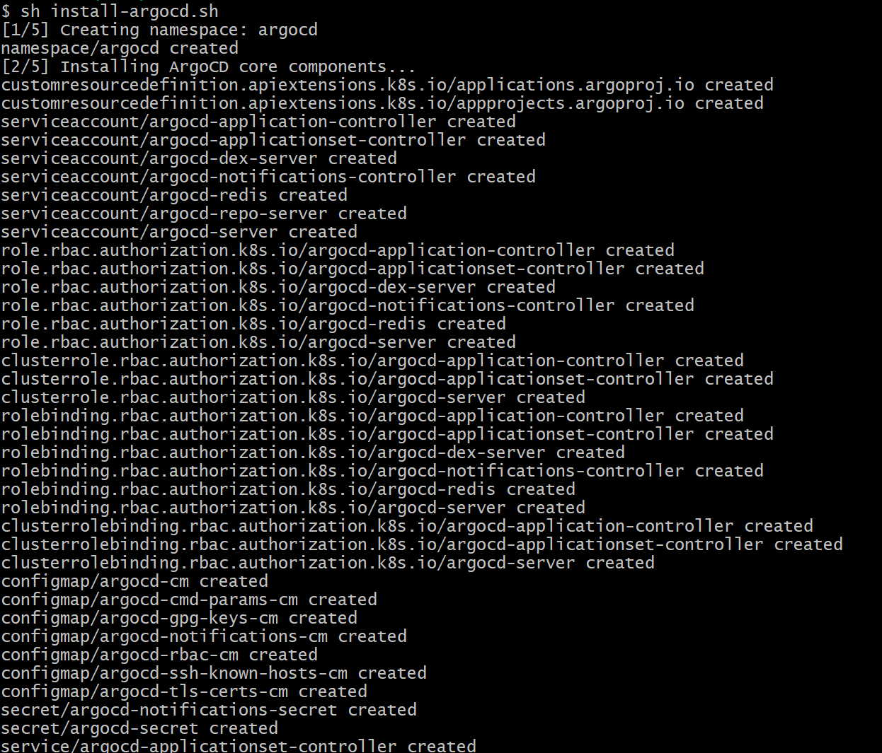
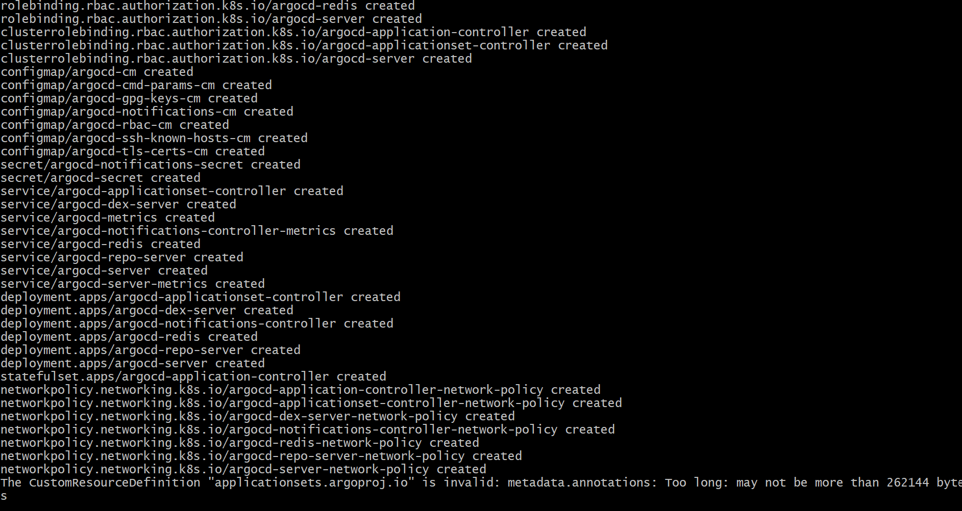
kubectl get pods -n argocd
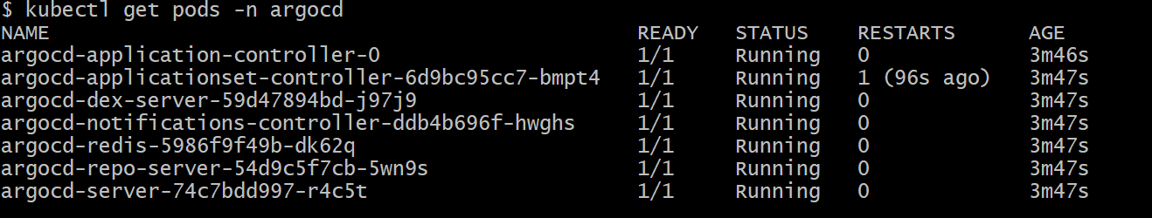
kubectl get svc -n argocd
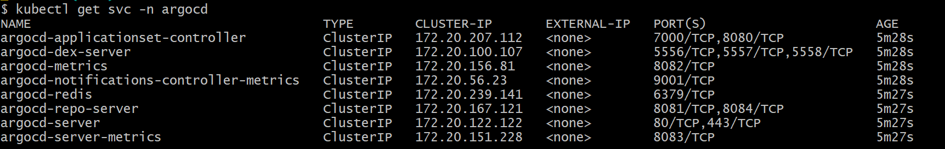
kubectl get secret argocd-initial-admin-secret -n argocd -o jsonpath="{.data.password}" | base64 --decode
kubectl port-forward svc/argocd-server -n argocd 8080:443

# Open https://localhost:8080 in browser

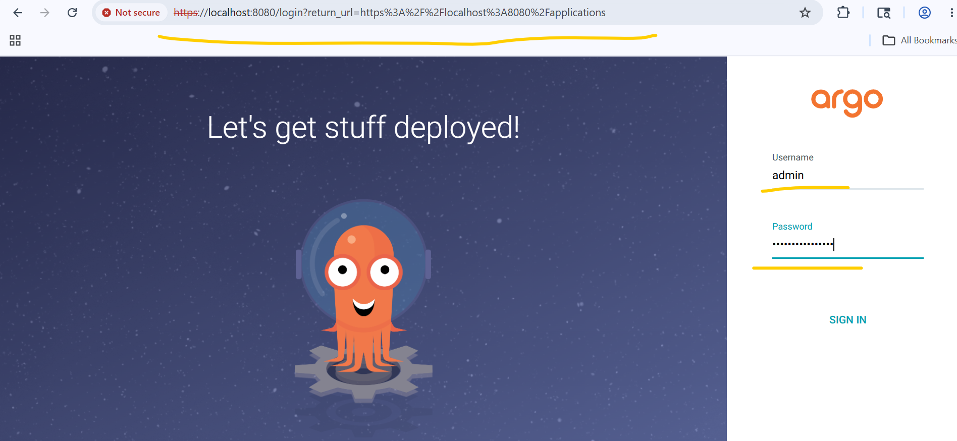
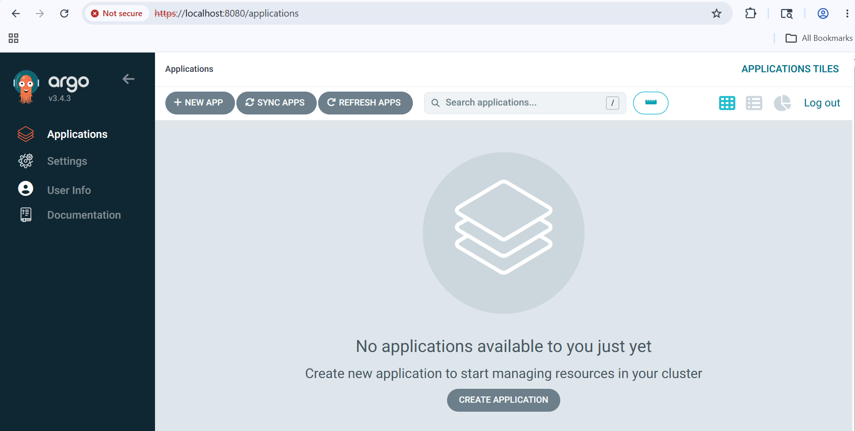
# Install Argo CD CLI through below mentioned Power shell command.
# Note:- I have directly downloaded the Argo CD Windows binary into a directory that is already in my PATH, so I don't need to add the Argo CD binary to the PATH environment variable, which would require administrator privileges.
$version = (Invoke-RestMethod https://api.github.com/repos/argoproj/argo-cd/releases/latest).tag_name
$url = "https://github.com/argoproj/argo-cd/releases/download/" + $version + "/argocd-windows-amd64.exe"
$output = "argocd.exe"

Invoke-WebRequest -Uri $url -OutFile $output

# Login to ArgoCD
argocd login localhost:8080 --username admin --password <copied-password> --insecure
# Verify argocd version
argocd version
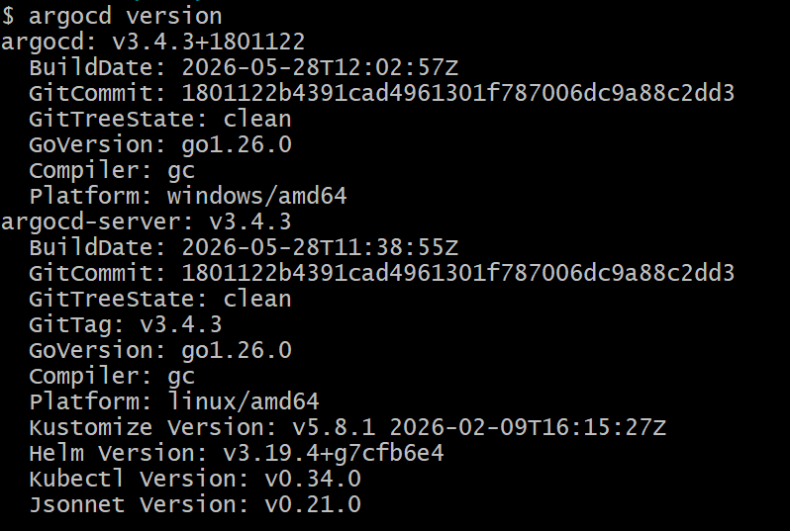
# Created PAT (Personal Access Token) in my personal GitHub account.
# Register Your GitHub Repo with ArgoCD
argocd repo add https://github.com/pranavpate/aws-devops-github-actions-ecr-argocd \
--username <your-github-username> \
--password <your-personal-access-token> \
--name aws-devops-github-actions-ecr-argocd
Note:- For security reasons, I have not disclosed my username and PAT in the command shown above. For the same reason, I have masked these details in the screenshot below.
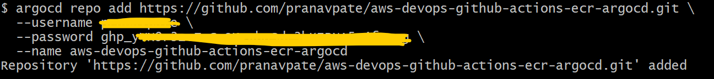
# Verified GitHub Repo From ARGO CD UI Console.
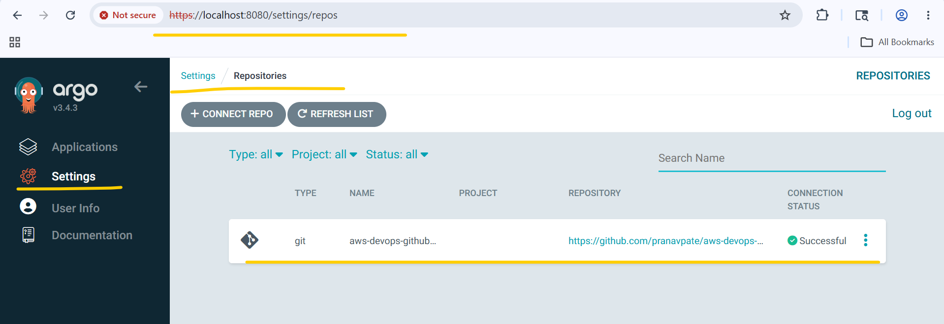
# Deploy ArgoCD Application
kubectl apply -f argocd-manifests/application-ui.yaml
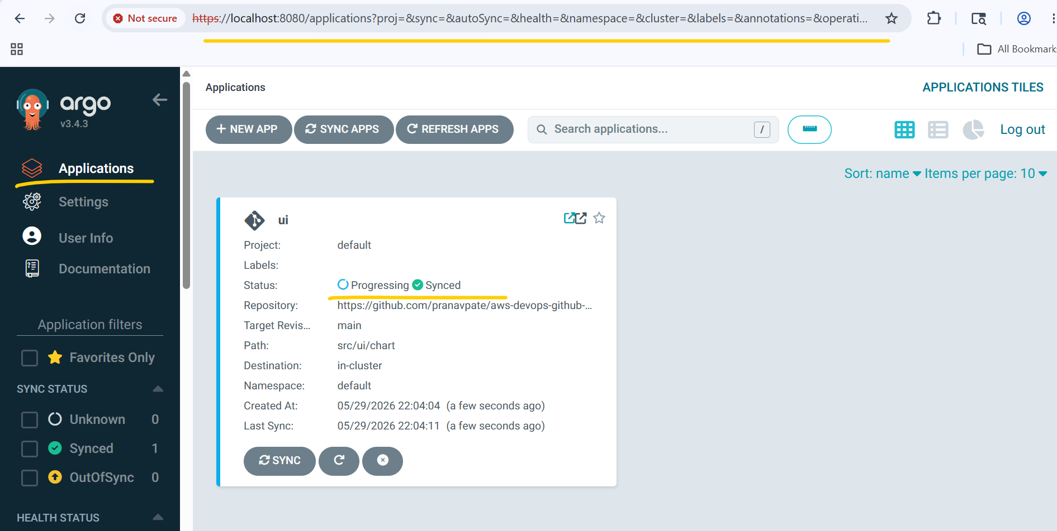
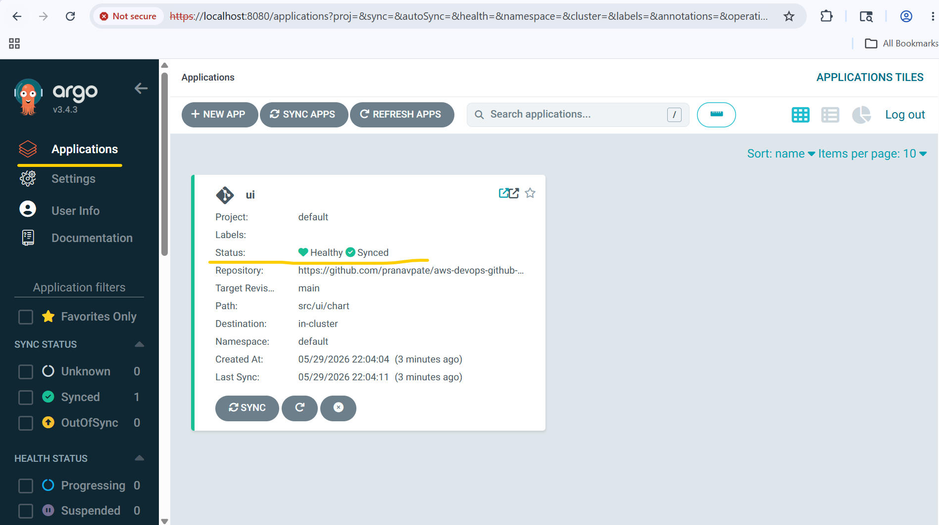
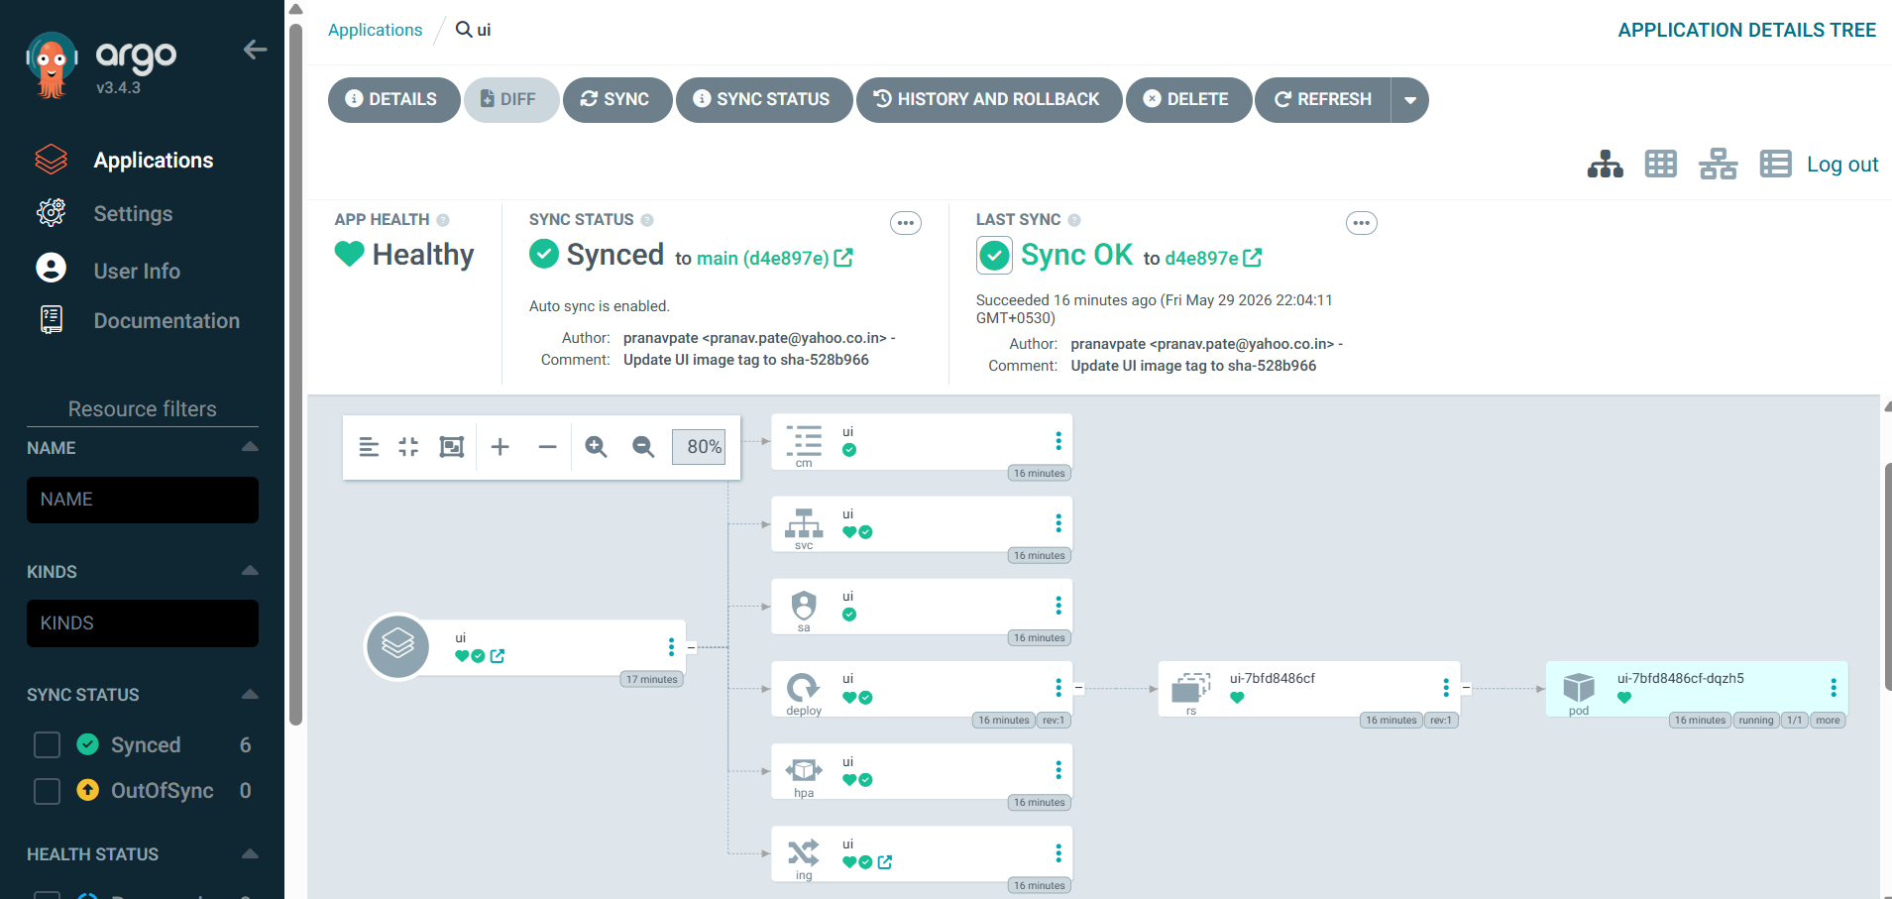
kubectl get pods
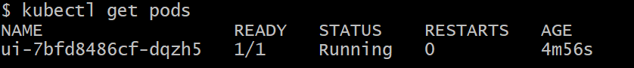
kubectl get nodeclaims
# Verified whether the ECR image ID of the UI pod matches the ECR image ID in the repository. It was concluded that both image IDs are the same, which confirms a successful match.
kubectl describe pod ui-7bfd8486cf-dqzh5
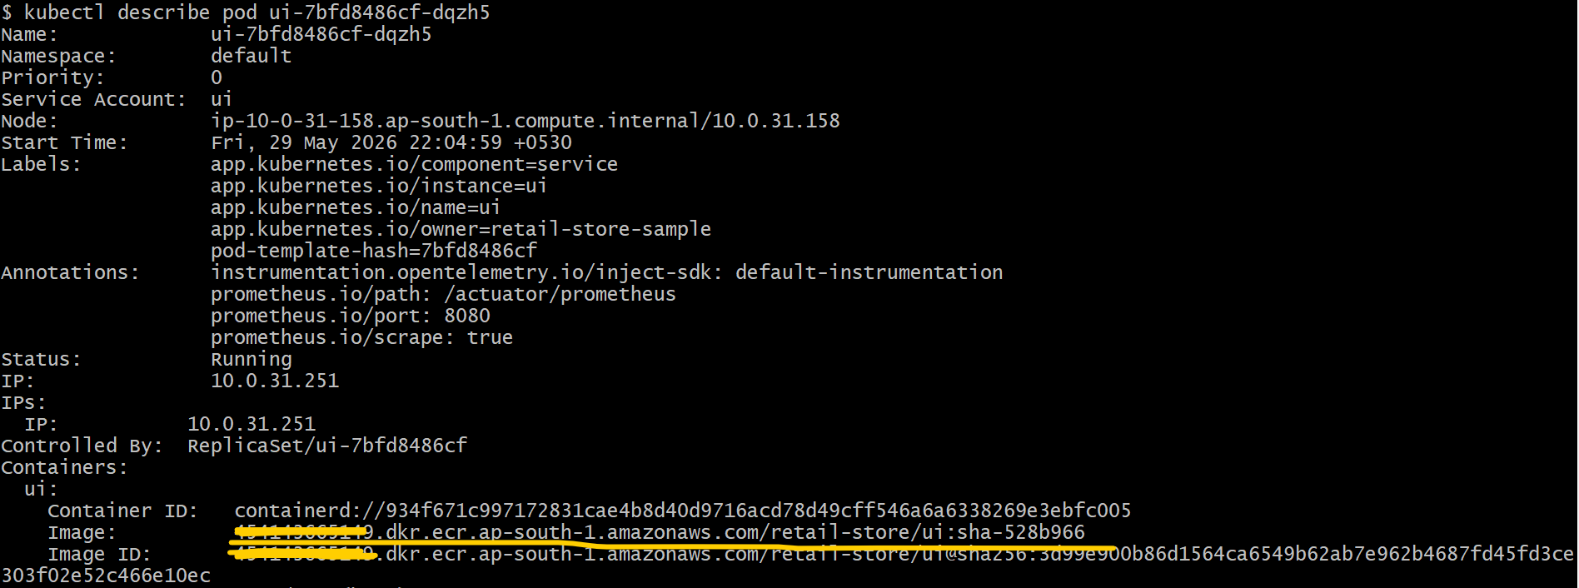

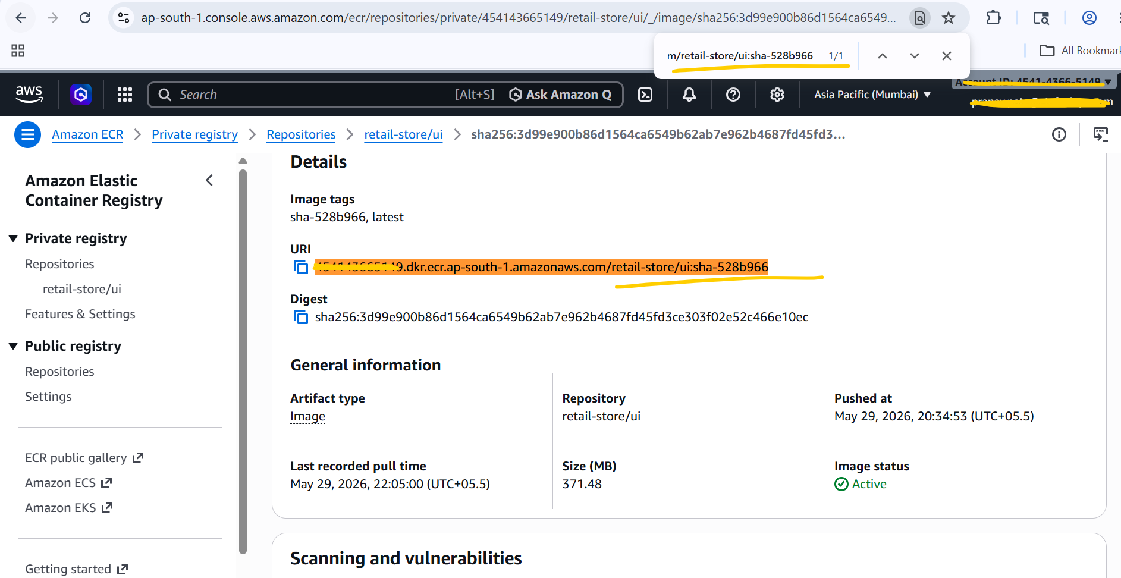

cd ../21_04_CI_CD_Full_Flow_Test/
sh 05-v2.0.0-install-remote-helm-charts.sh

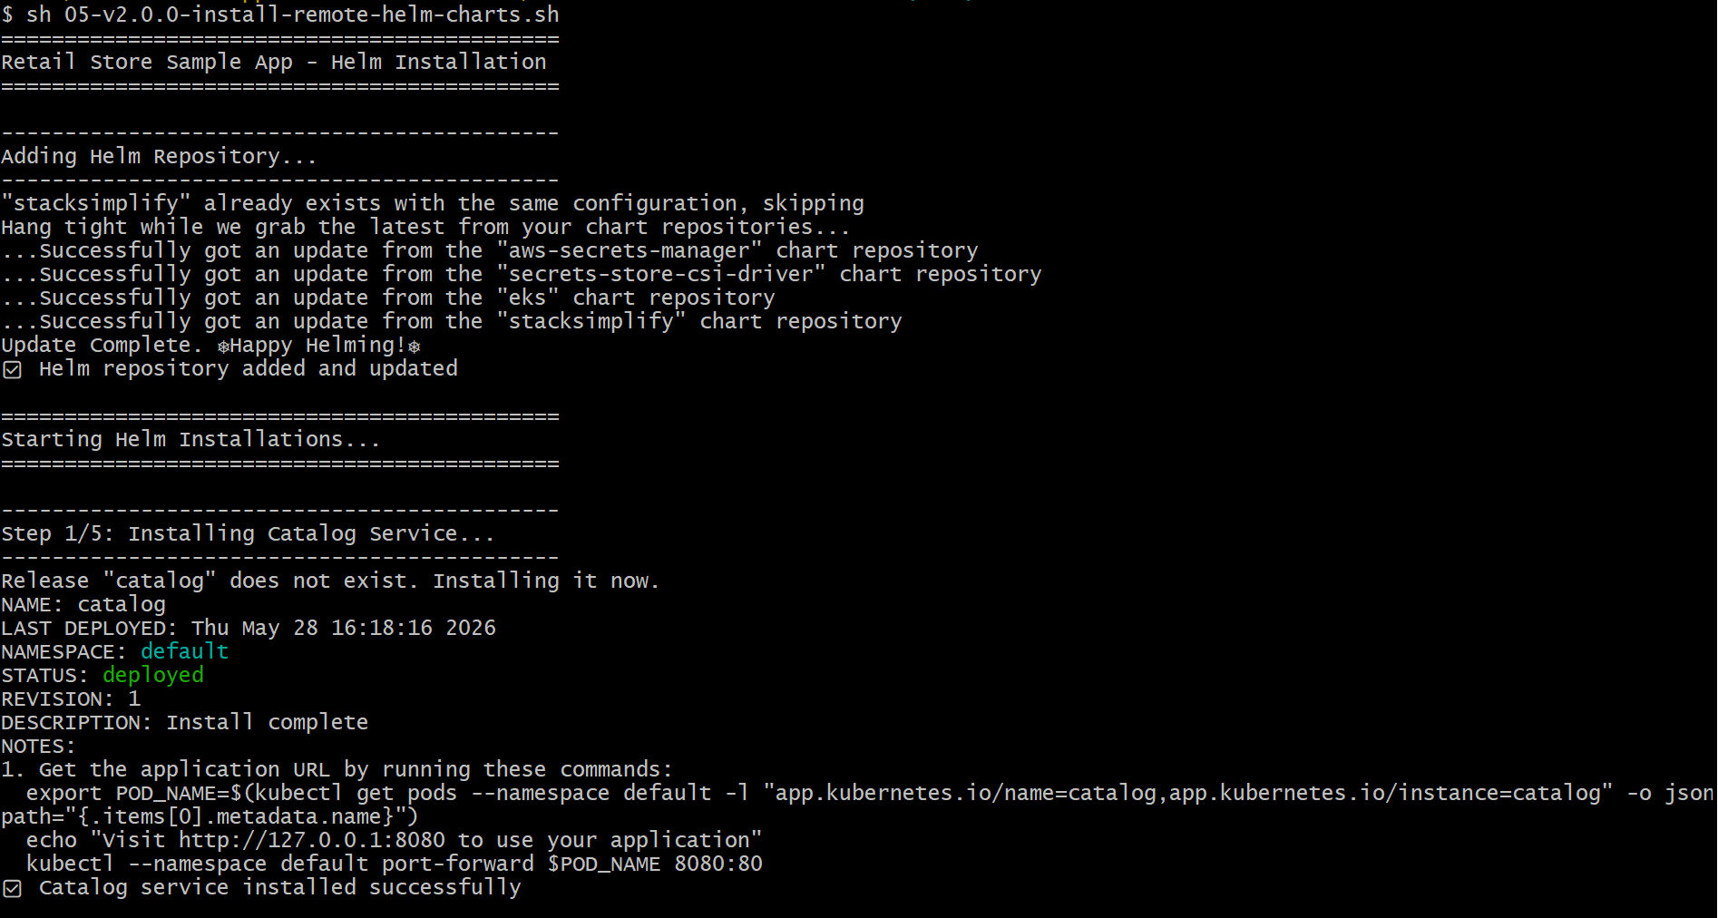

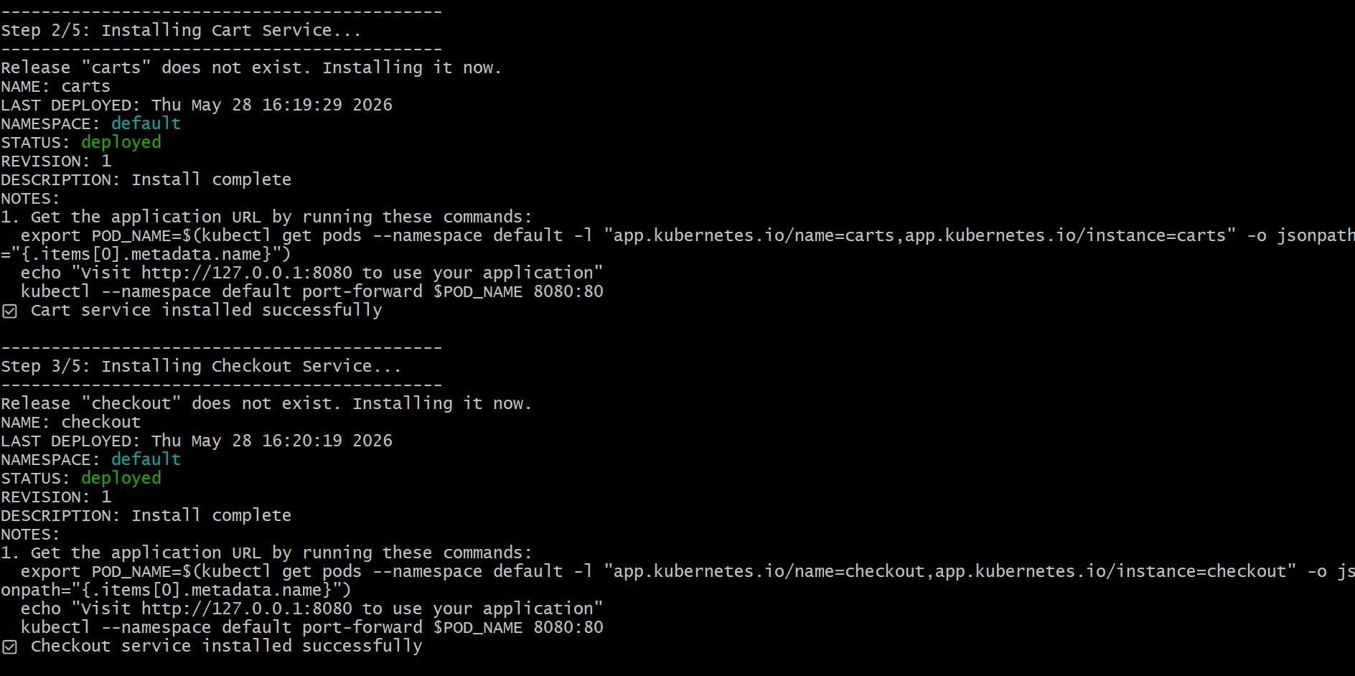

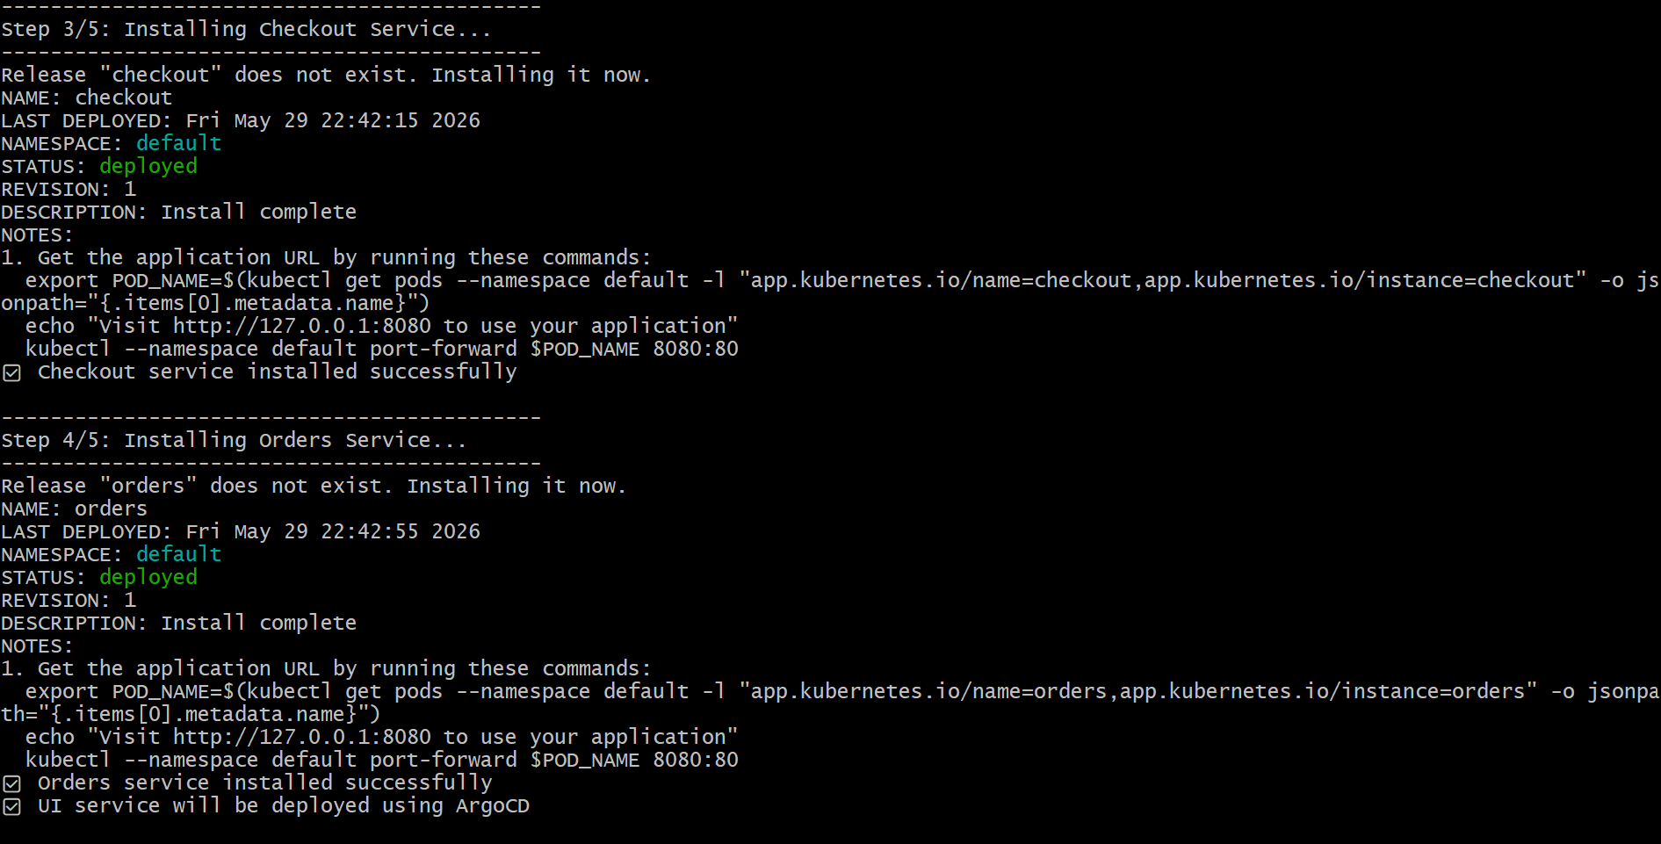

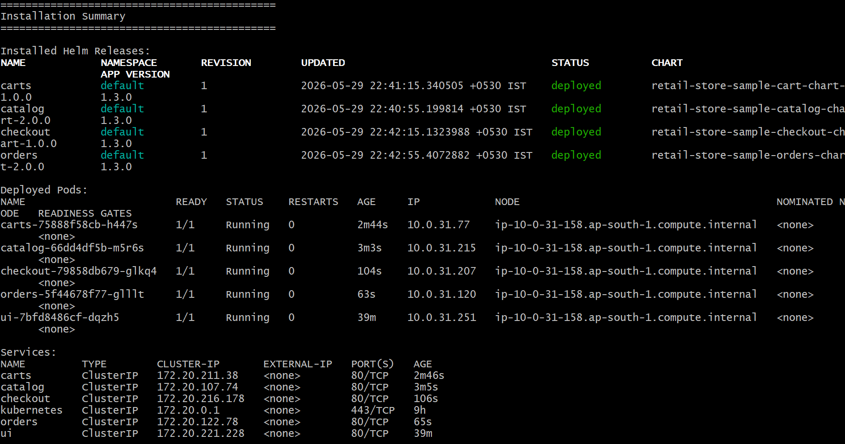

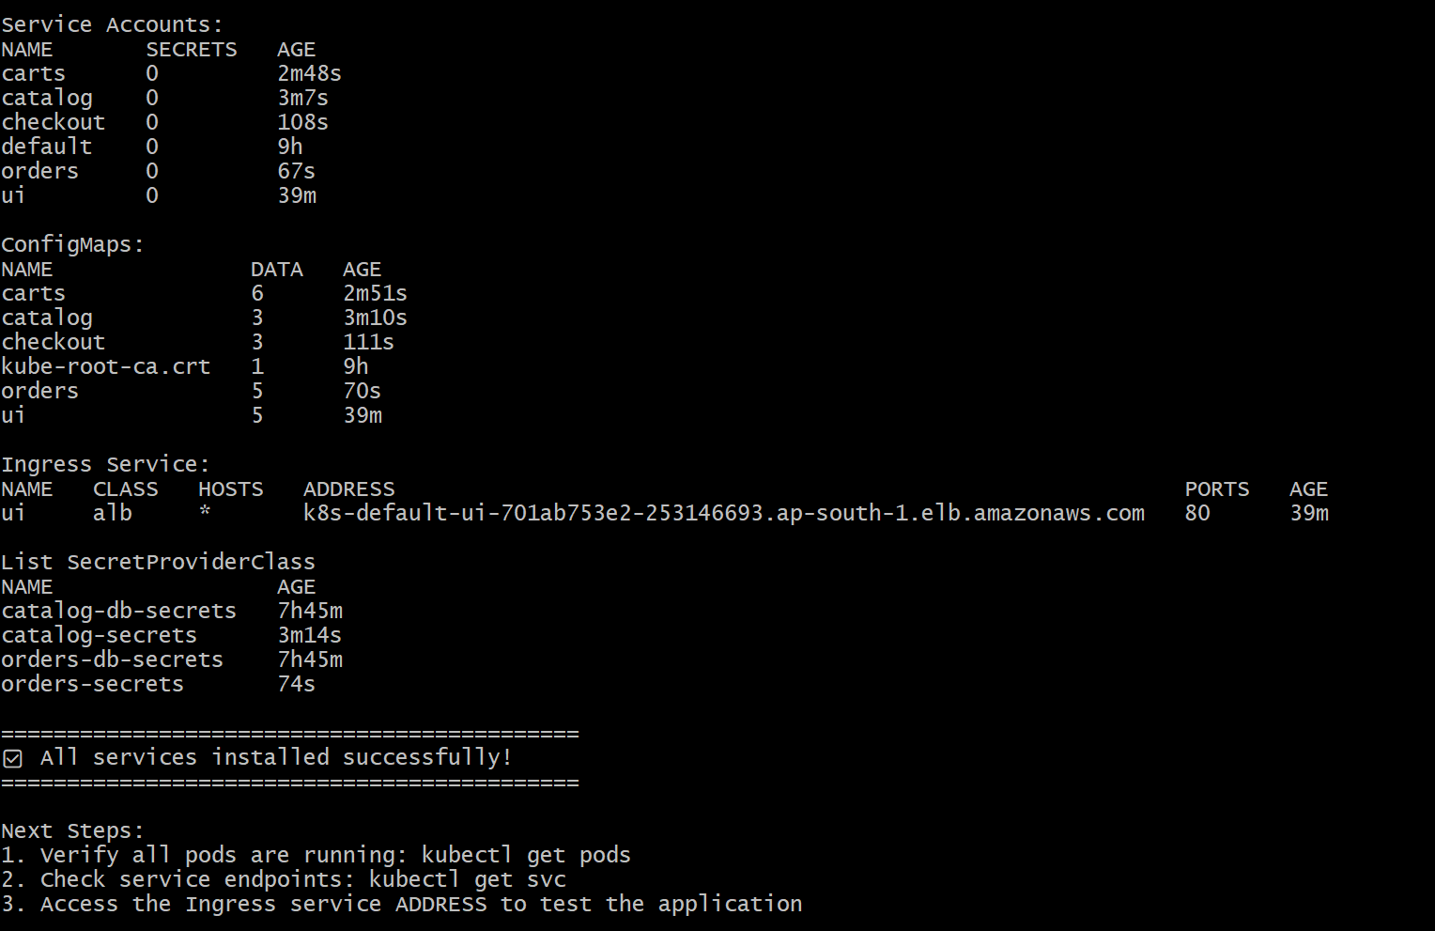
kubectl get pods
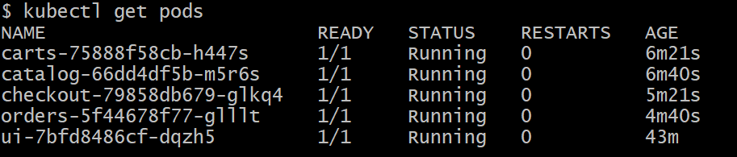
kubectl get ingress
kubectl get hpa
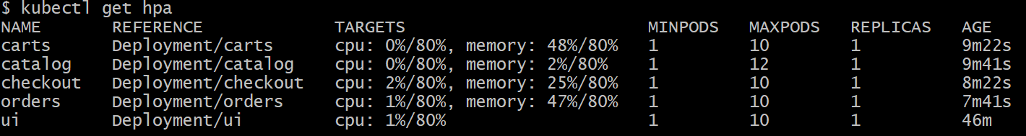
kubectl get nodeclaims

# I can be able to access ALB Link in my browser.

k8s-default-ui-701ab753e2-253146693.ap-south-1.elb.amazonaws.com

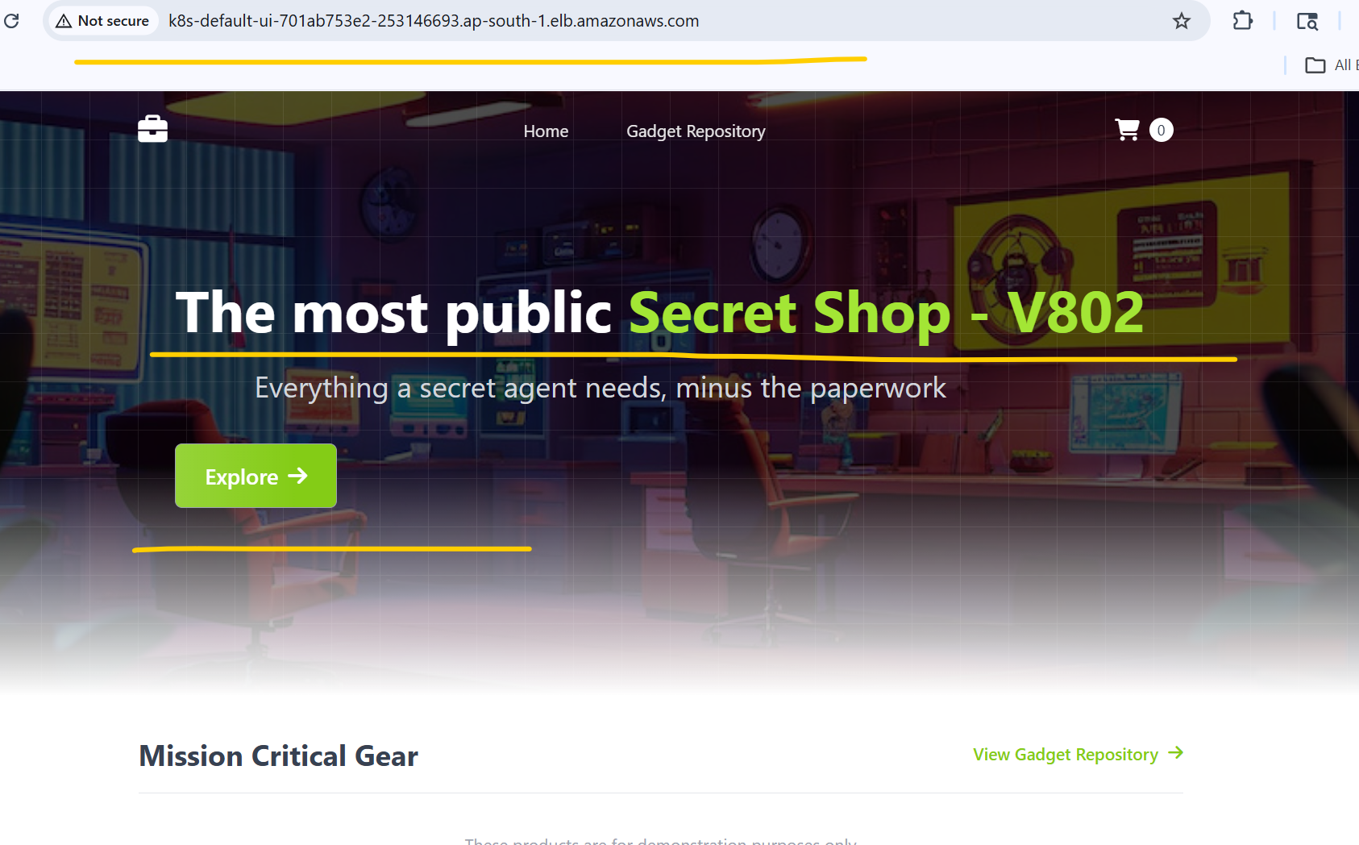
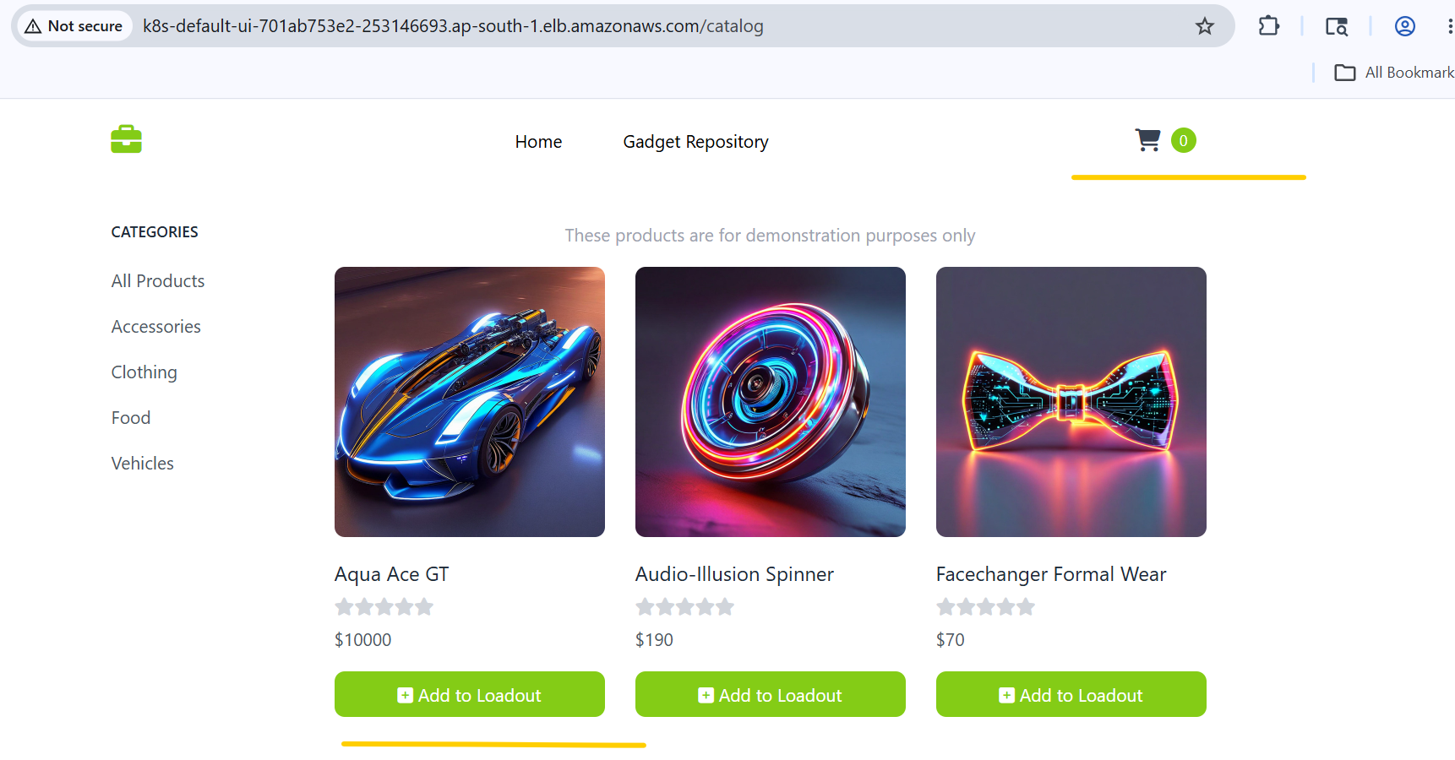

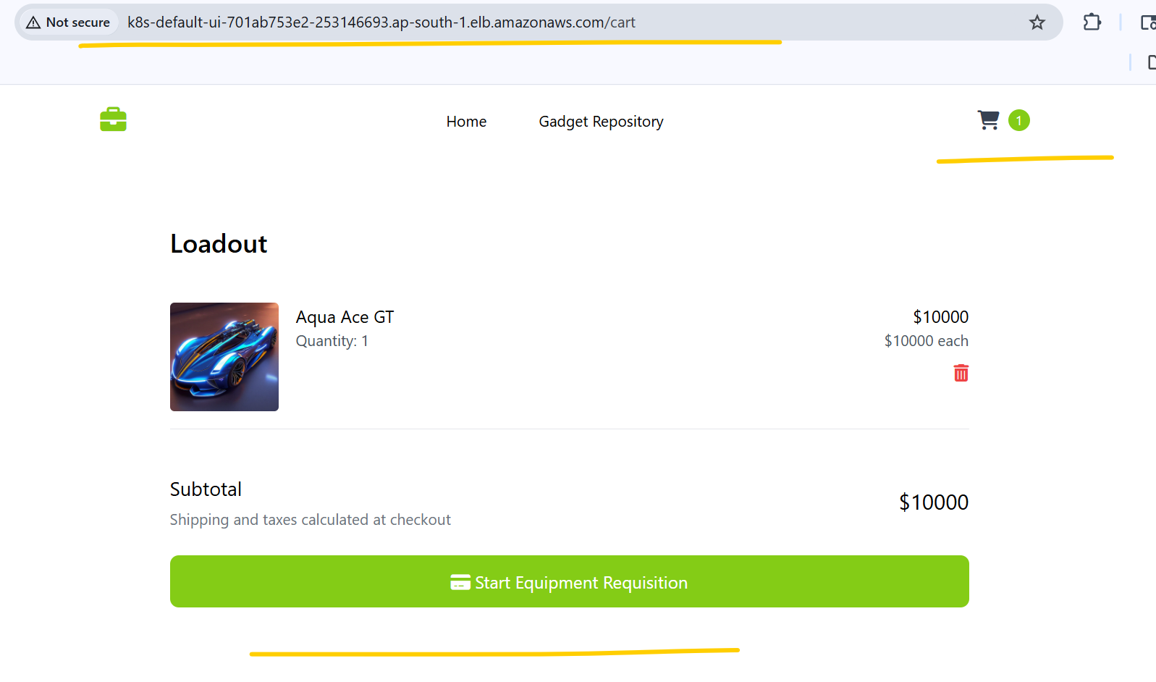

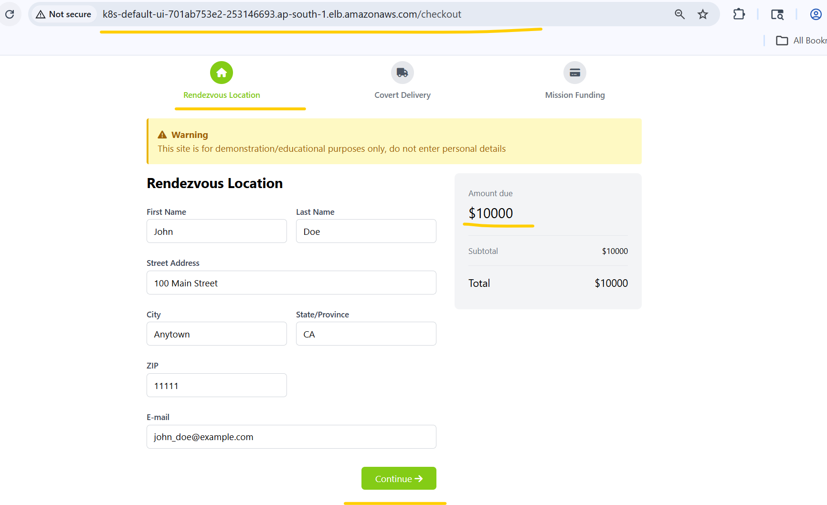

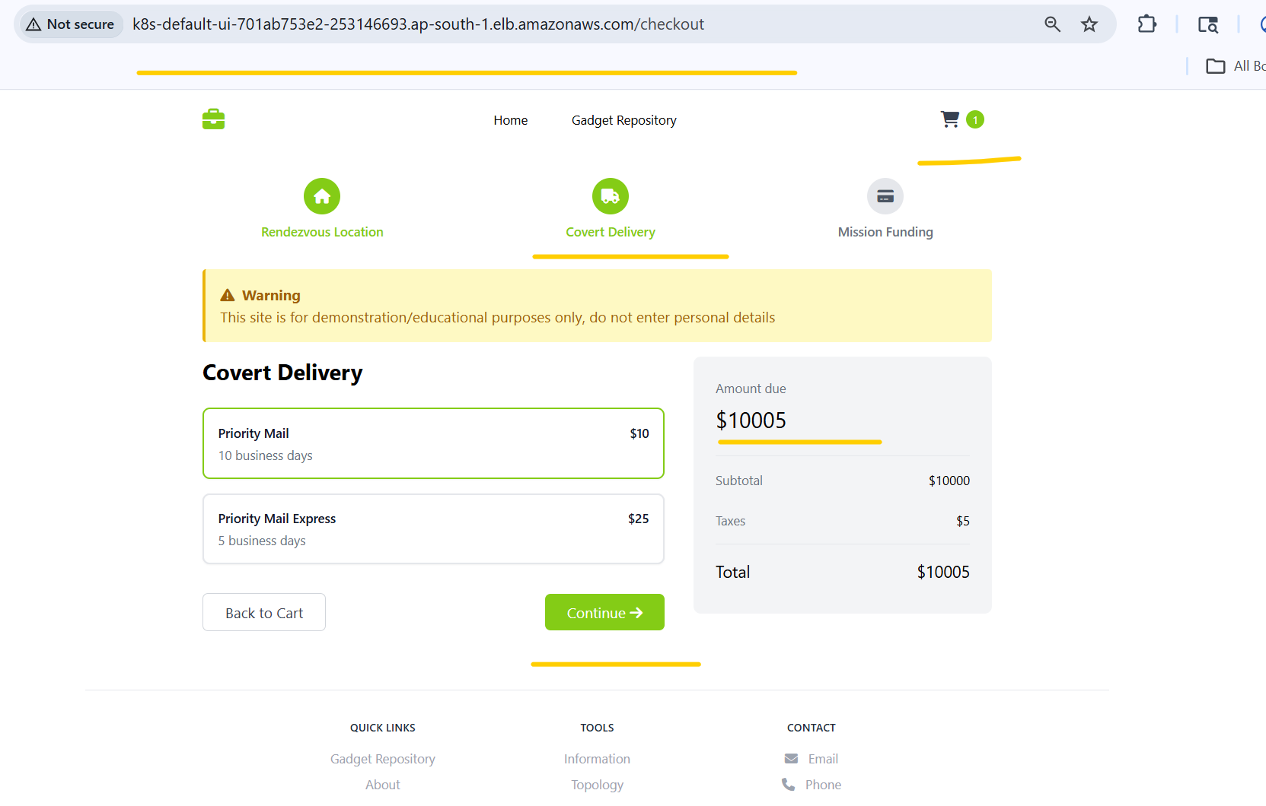

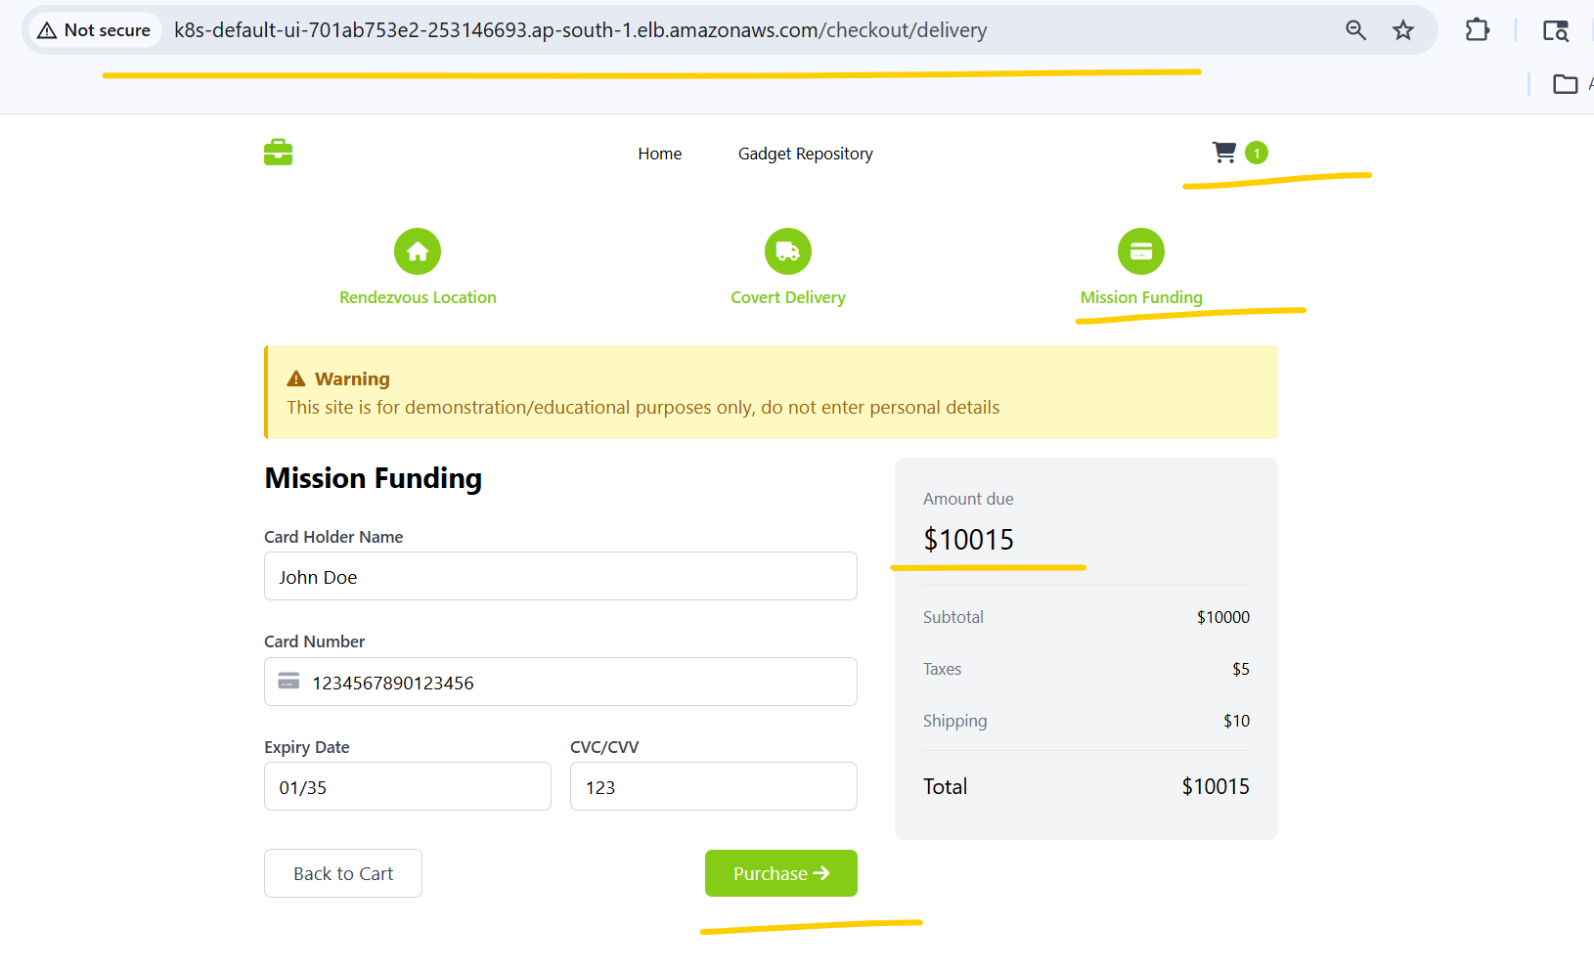

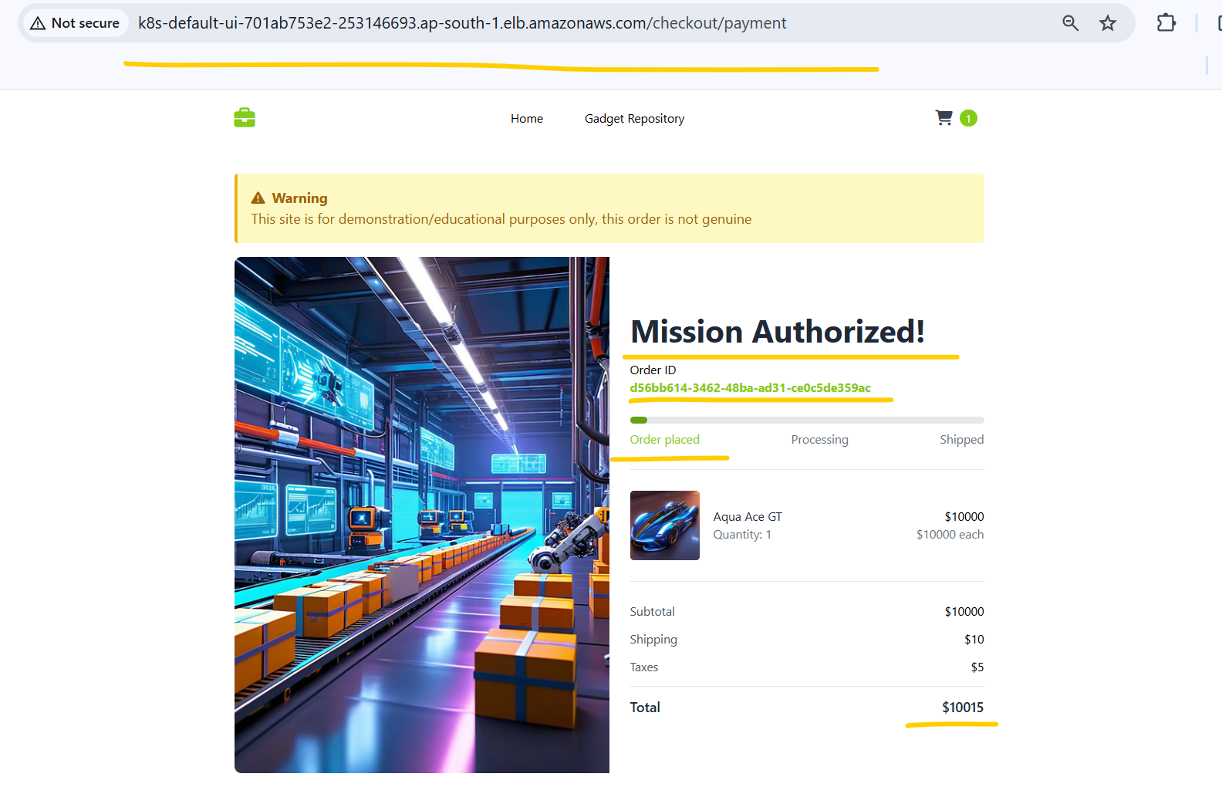

# I can perform transaction successfully through the ALB link.
# All services are showing healthy in /topology.
http://k8s-default-ui-701ab753e2-253146693.ap-south-1.elb.amazonaws.com/topology

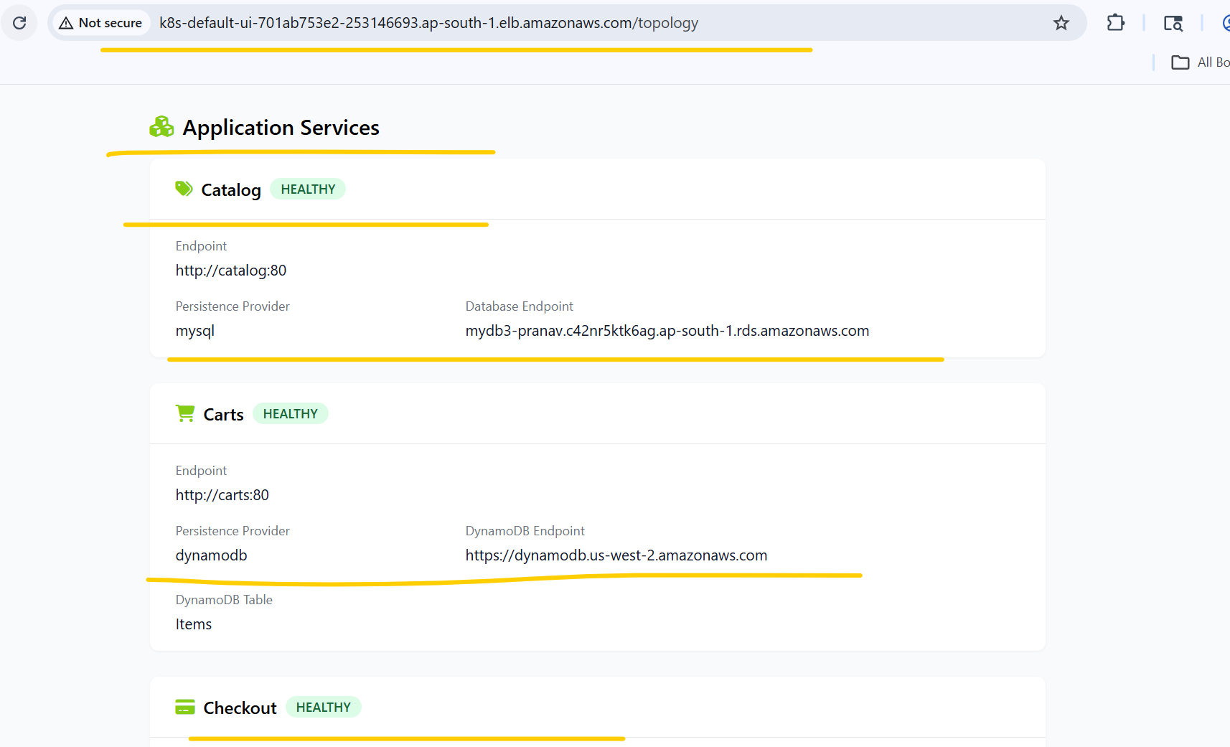
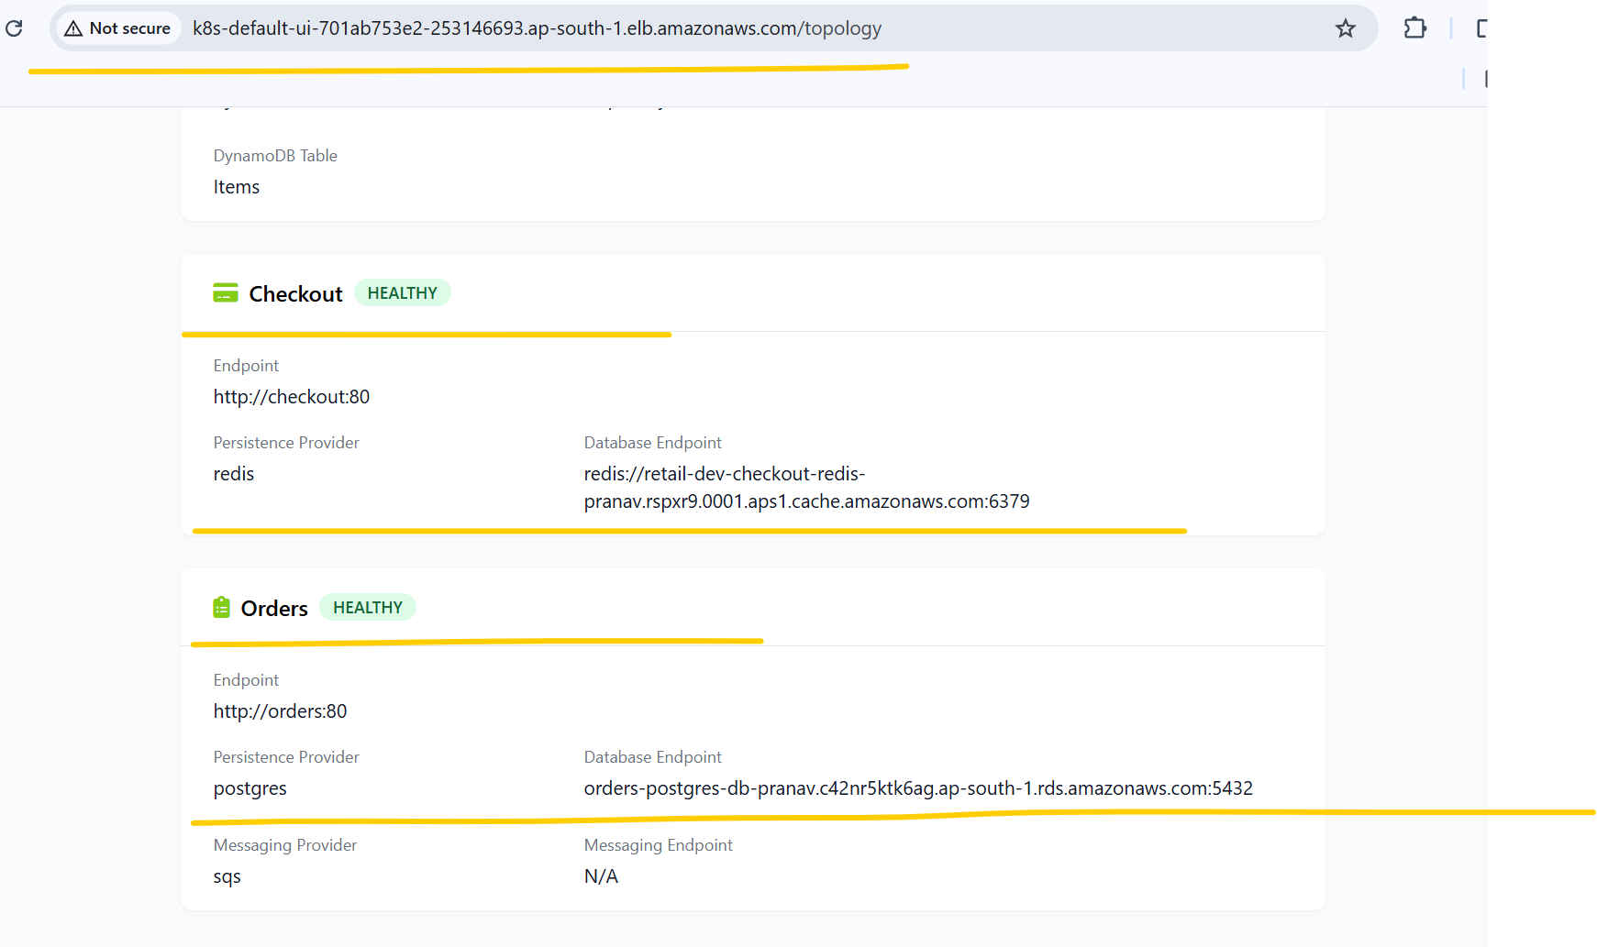

sh git-pull.sh
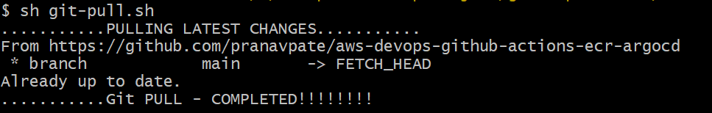
sh update-ui-home-html.sh V904
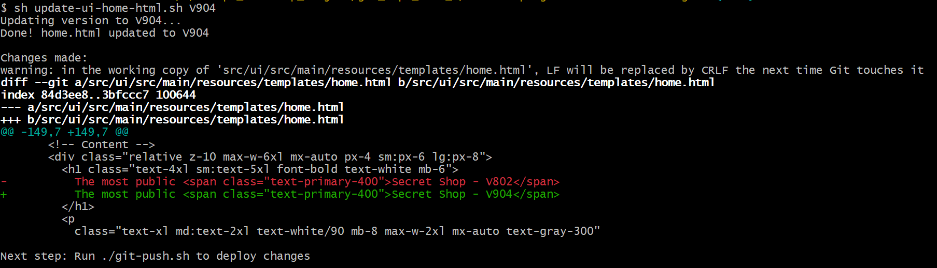
sh git-push.sh V904-Commit
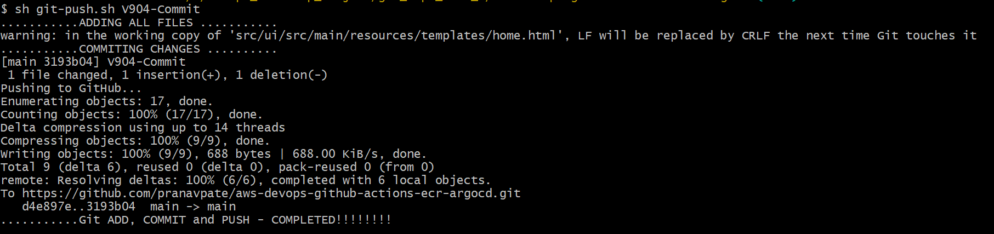
# Verified GitHub Workflow status
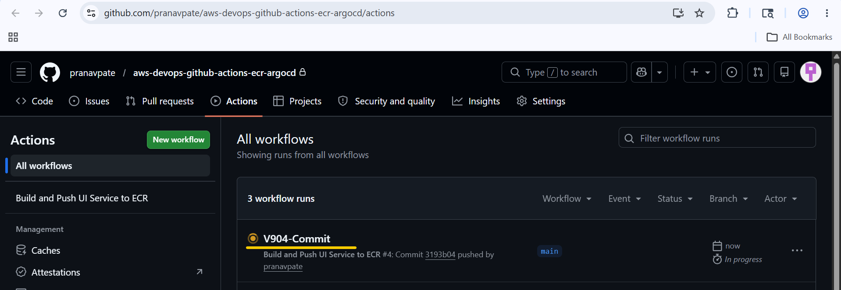
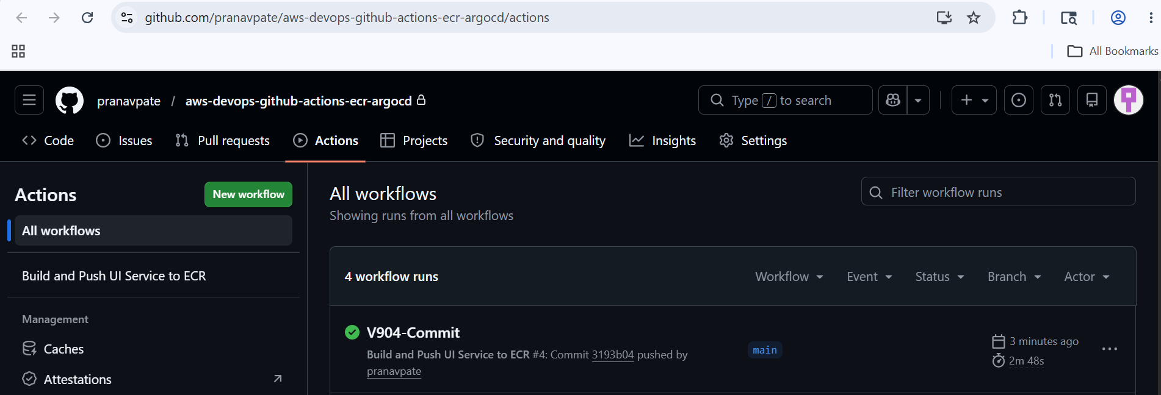
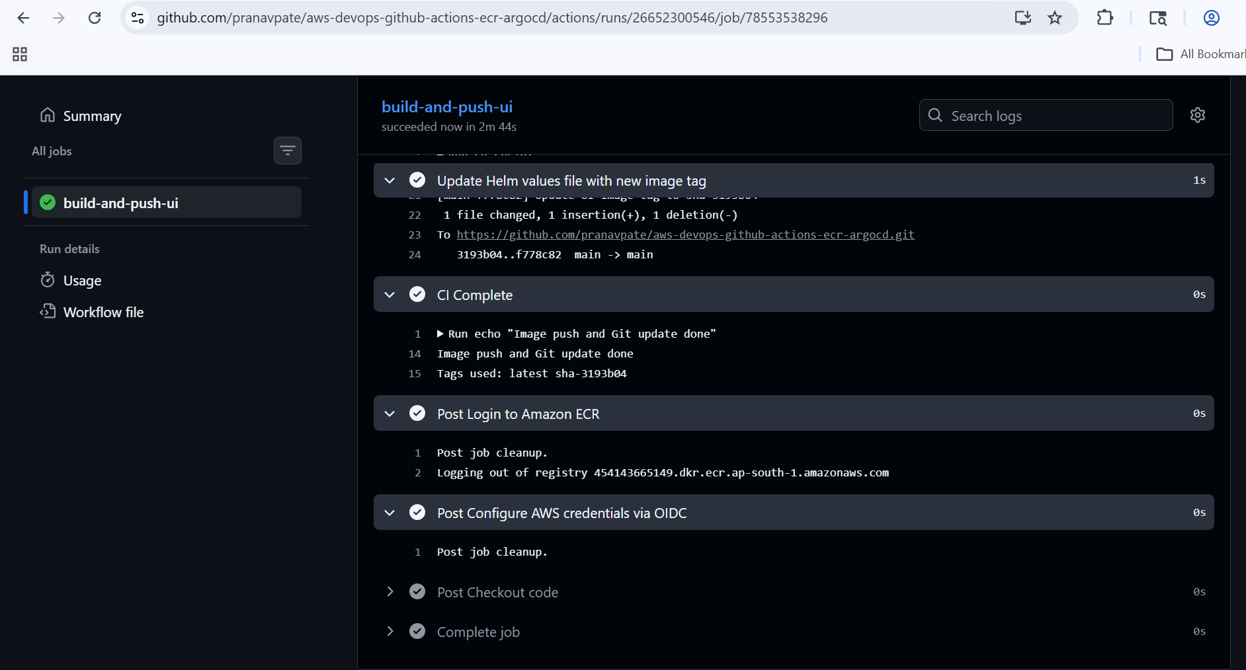
# GitHub Workflow successfully run.
# Below mentioned new Image has been pushed into ECR repo.
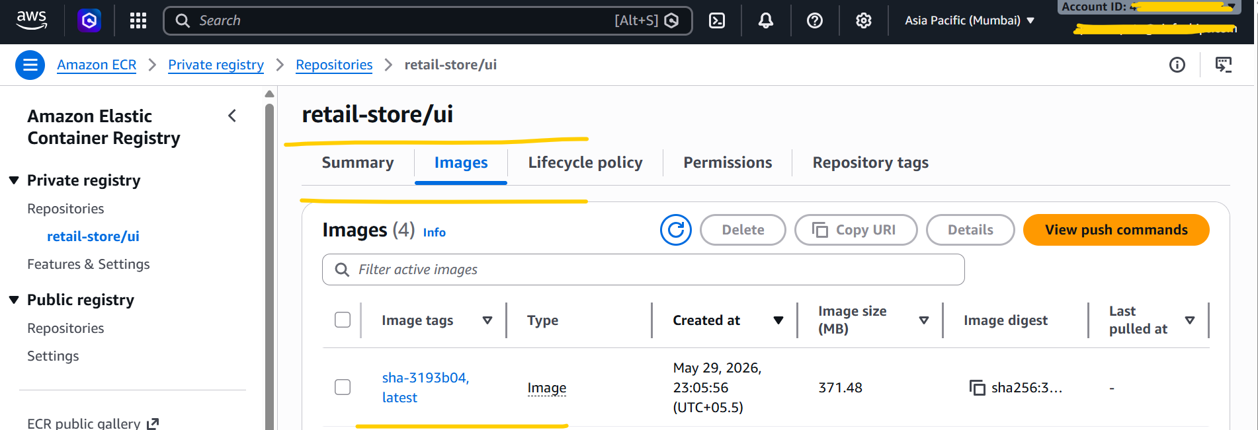

# New Image has been successfully deployed by ARGO CD
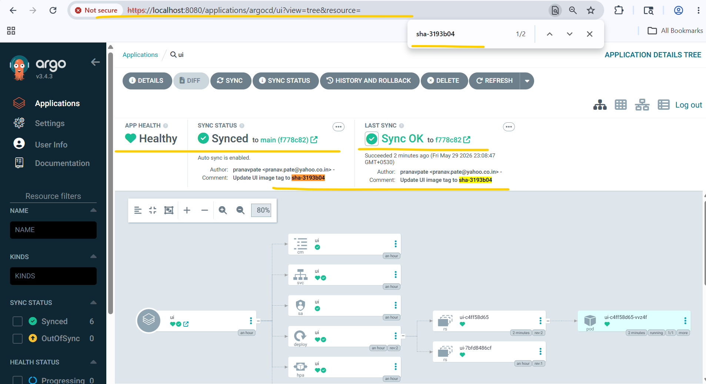
# Try to access application again and it’s concluded that new version i.e. V904 has been successfully updated on home page.
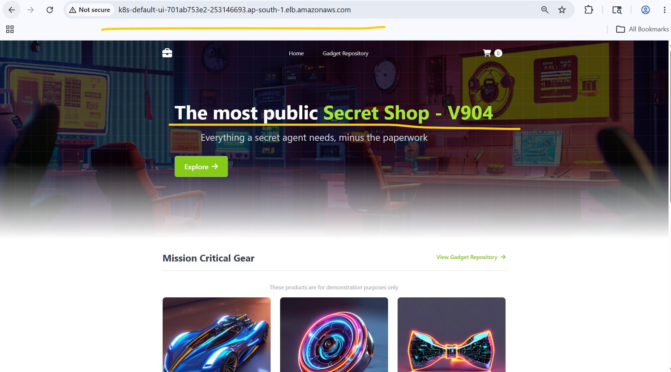
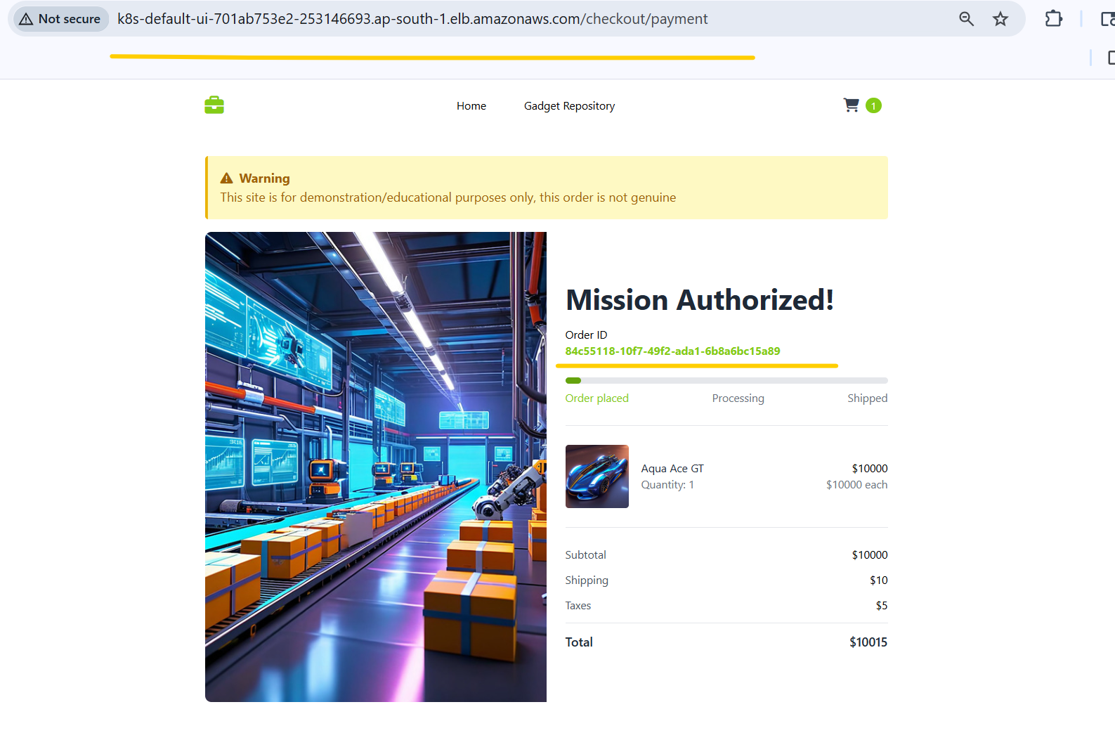
# I performed one more transaction to verify whether application is working properly or not and it’s concluded that application has been working properly.

- Clean up all resources.
# Delete Application from ArgoCD
Go to ArgoCD UI -> Delete UI Application
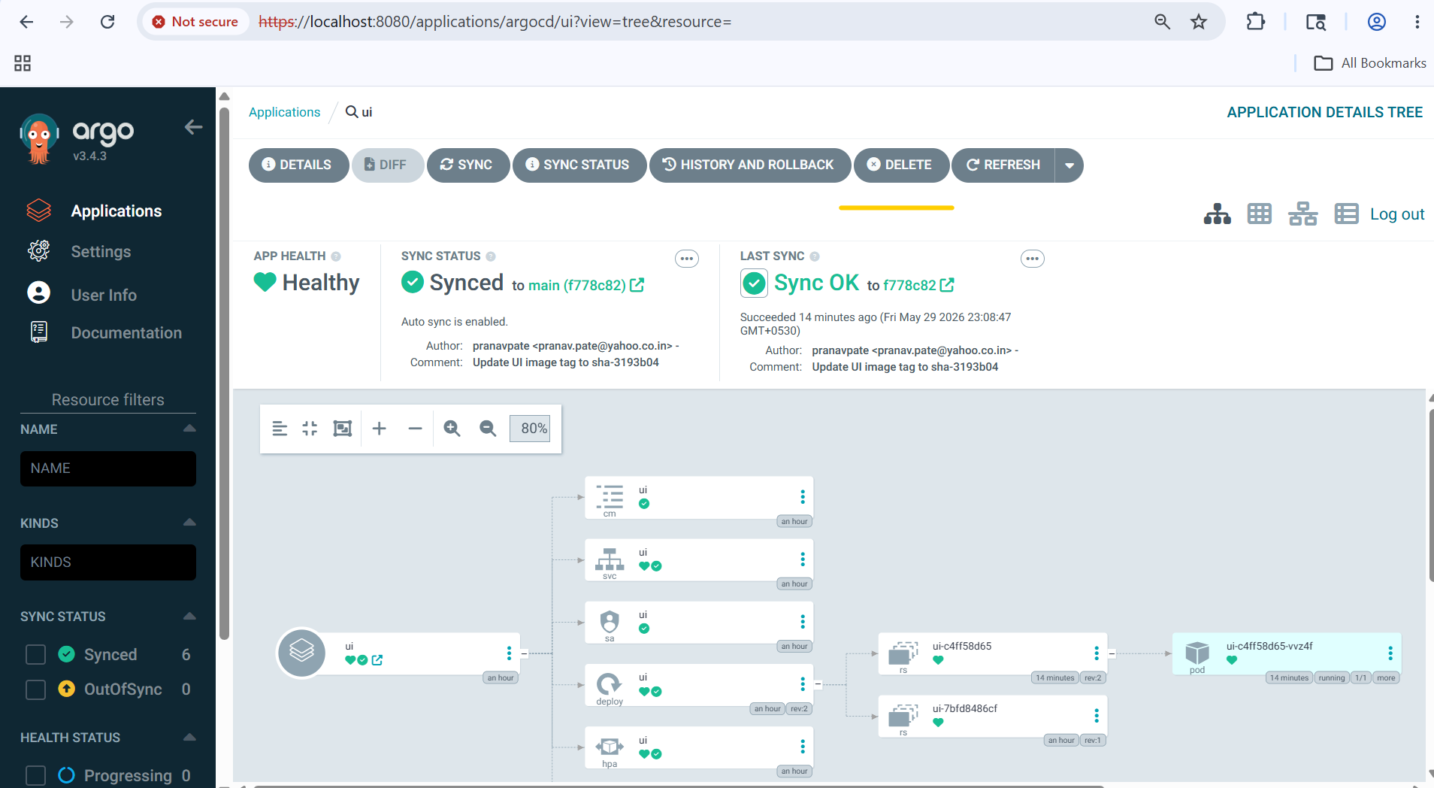
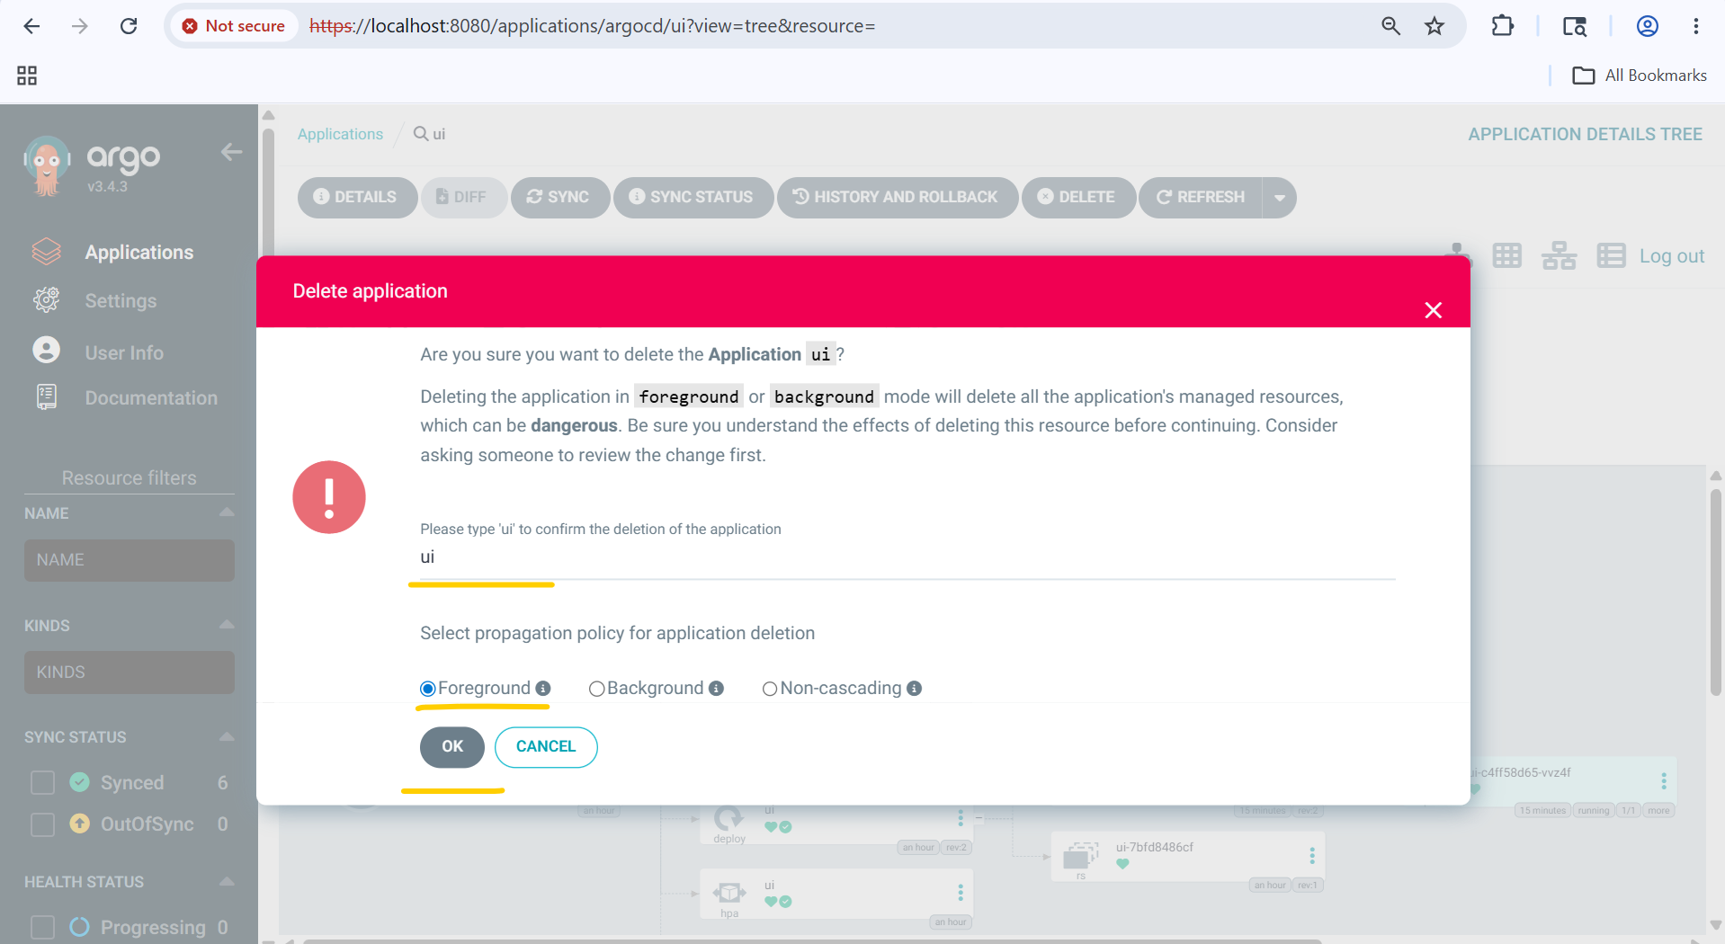
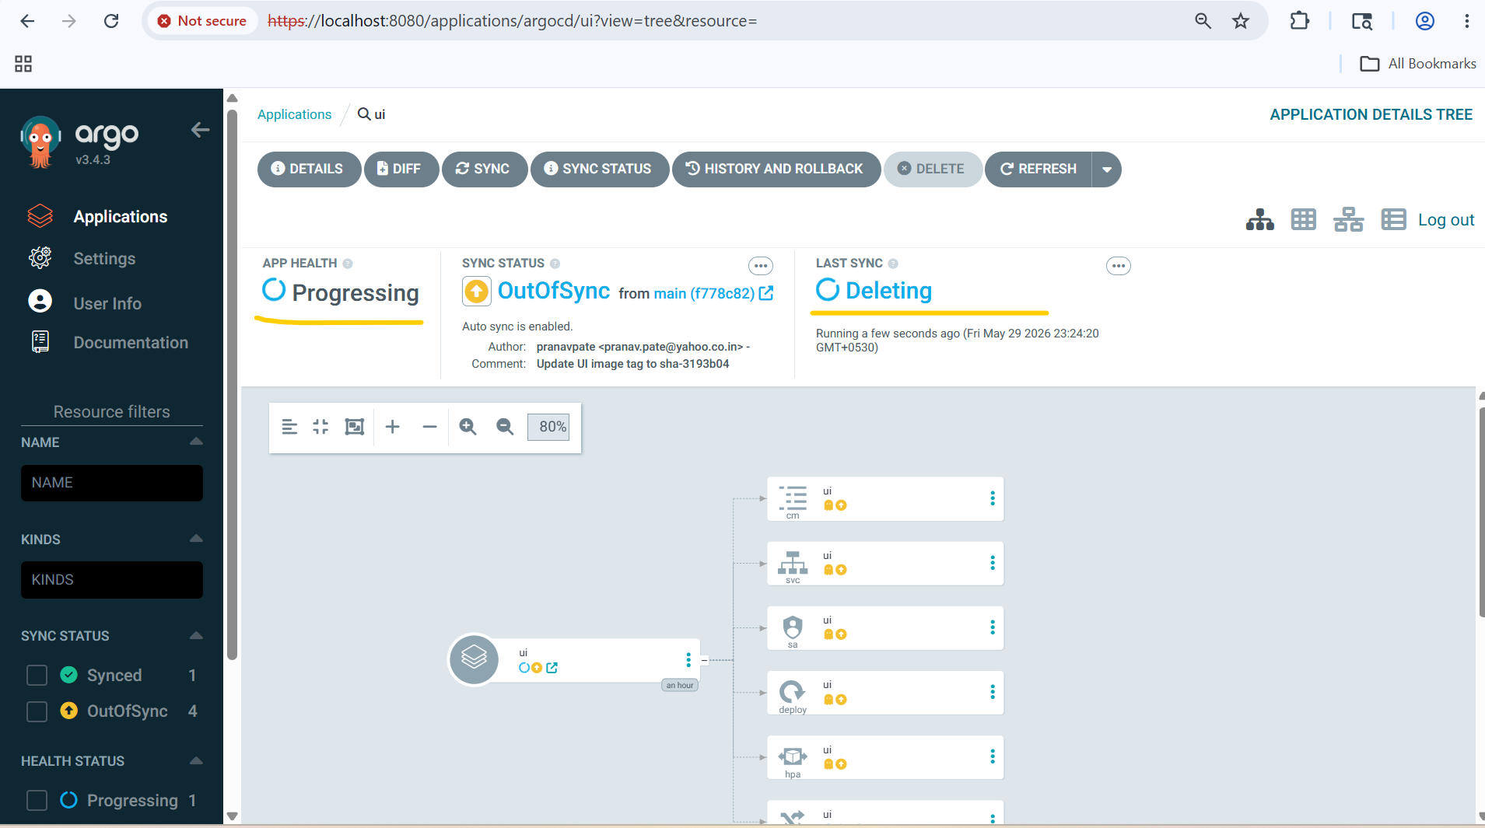
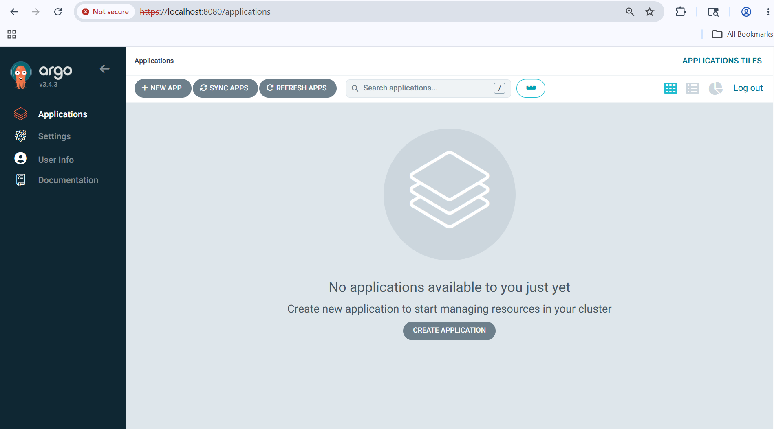
kubectl get pods
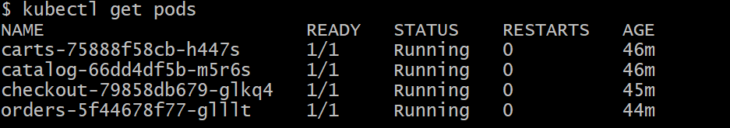
kubectl get ingress
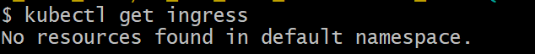
sh 01-uninstall-retail-apps.sh
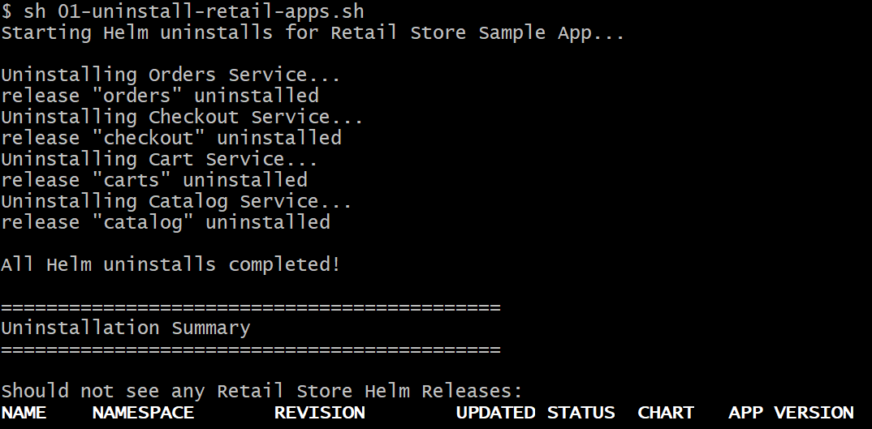
# Deleted all Docker Images from ECR repo and Deleted ECR repo also.
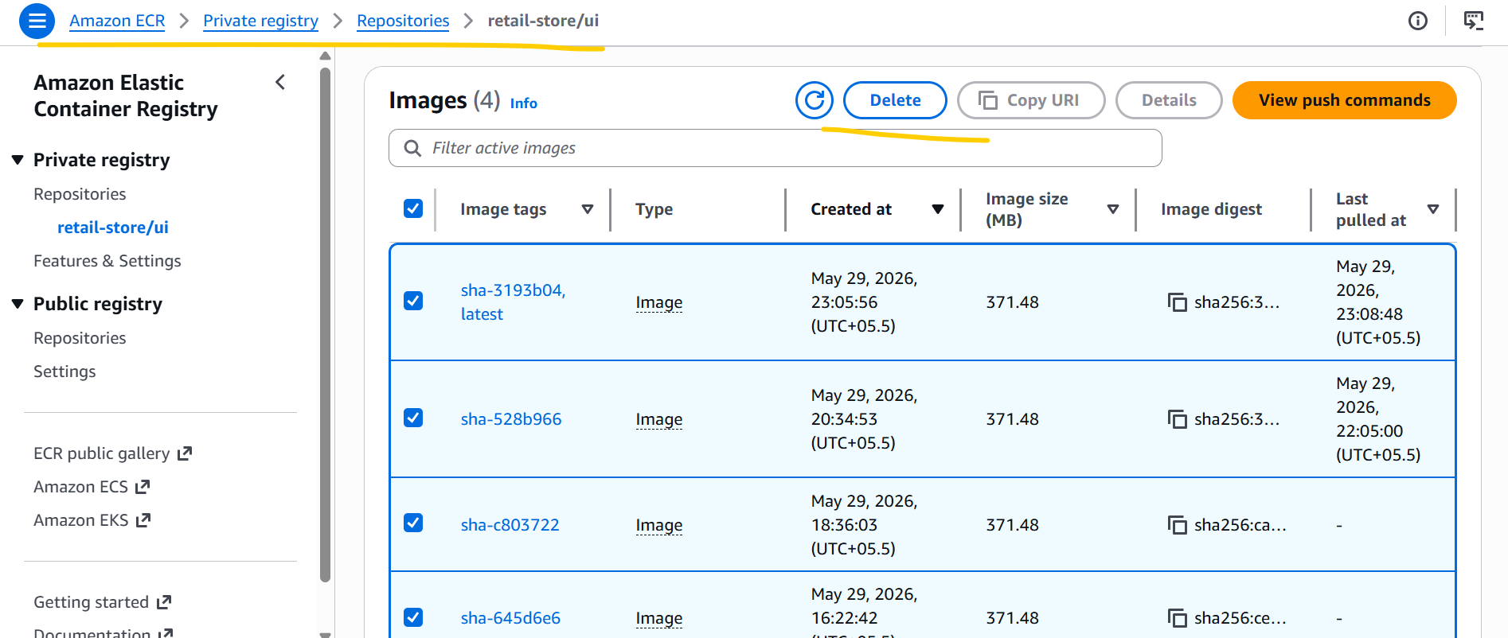
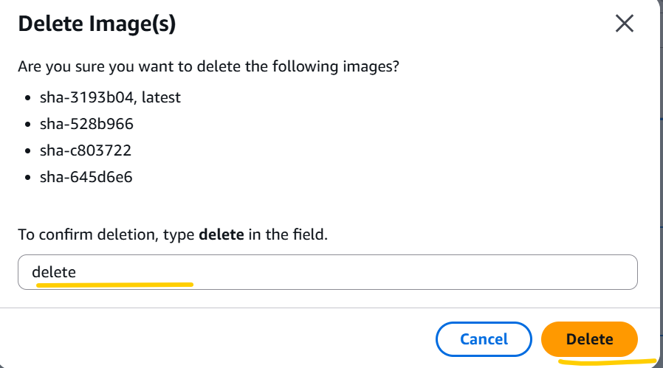

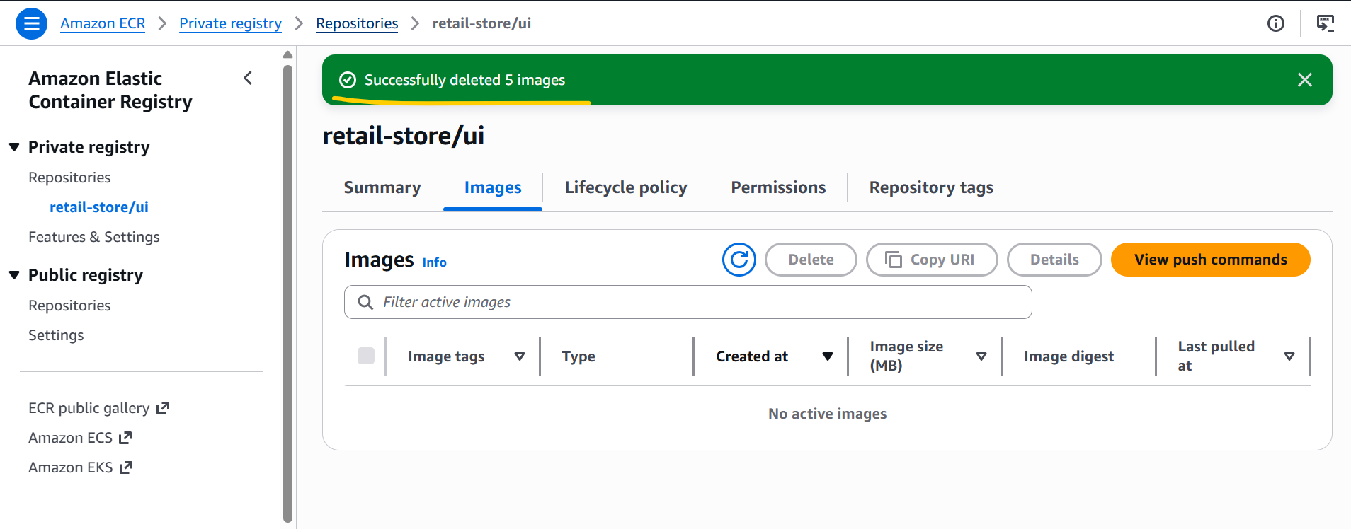

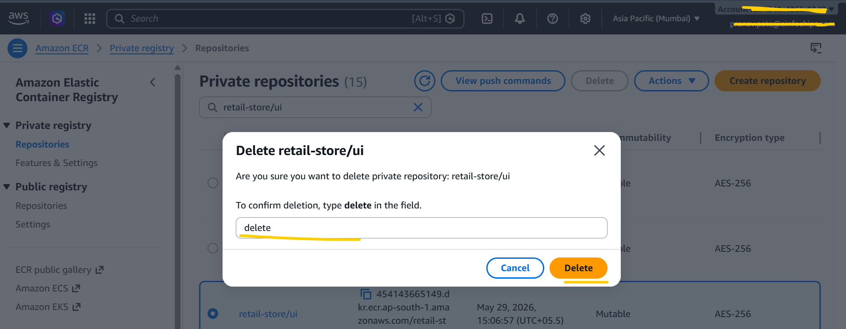

- Deleted AWS Data Plane Stack through terraform destroy –auto-approve command.
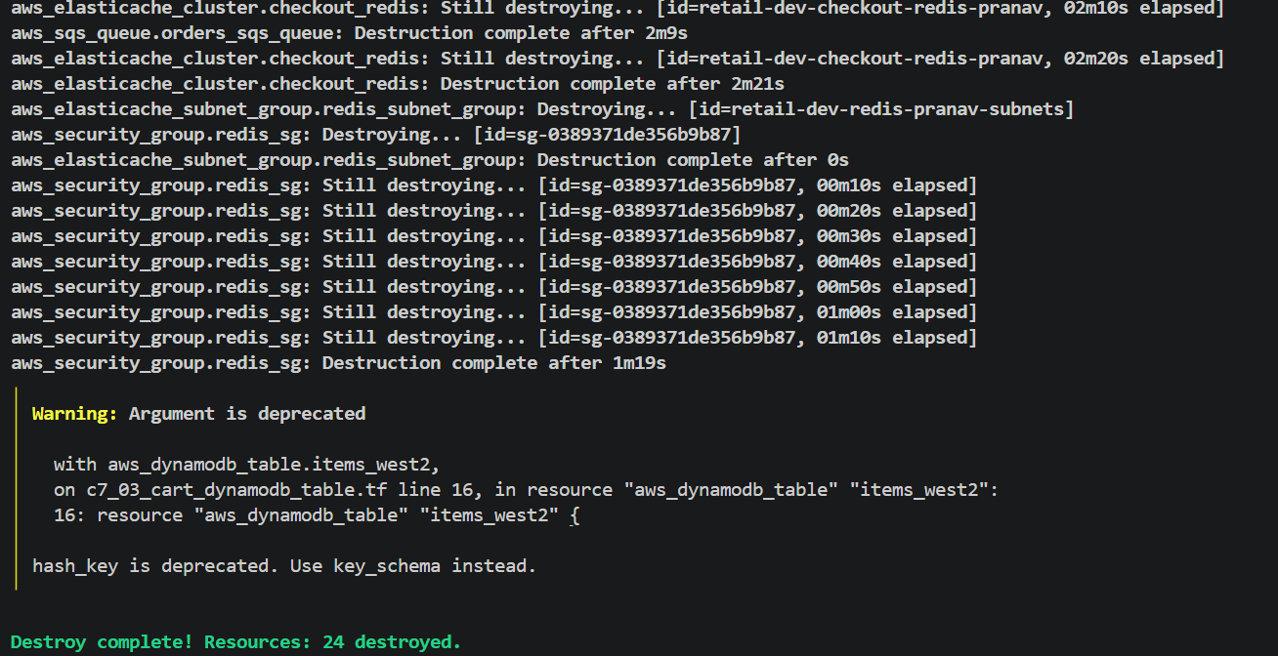

- Deleted EKS Cluster, Karpenter, all the Add ons, Node group, Iam roles for through terraform destroy –auto-approve command.
