AI Student Agent: An Autonomous AI Learning Assistant for Real-Time Online Classes
Project Report submitted in the partial fulfilment
of
Bachelor of Technology
in
Information Technology
Submitted To

SVKM’s NMIMS,
Mukesh Patel School of Technology Management & Engineering,
Shirpur Campus (M.H.)
Submitted By:
Aman Choudhary– 70012300166
Pranav Patil– 70012400176
Mohit Patil– 70012400178
Under The Supervision Of:
Dr. Pravin Landge
(Faculty Mentor, Information Technology Department, MPSTME)
INFORMATION TECHNOLOGY DEPARTMENT
Mukesh Patel School of Technology Management & Engineering
ACADEMIC SESSION: 2026-27

CERTIFICATE
This is to certify that the project entitled “AI Student Agent: An Autonomous AI Learning Assistant for Real-Time Online Classes” has been done by
“Aman Choudhary” (70012300166)
“Pranav Patil” (70012400176)
“Mohit Patil” (70012400178)
under my guidance and supervision & has been submitted in partial fulfilment of the degree of “Bachelor of Technology in Information Technology” of MPSTME, SVKM’S NMIMS (Deemed-to-be University), Shirpur (M.H.), India.
________________________ | ________________________
Project Mentor (Internal Guide)  Dr. Pravin Landge | Examiner
Date: ____________________  Place: Shirpur | ________________________  H.O.D.  Information Technology Dept.
INFORMATION TECHNOLOGY DEPARTMENT
Mukesh Patel School of Technology Management & Engineering

ACKNOWLEDGEMENT
After the completion of this capstone project work, words are not enough to express our sincere feelings about all those who helped us reach our goal; feeling above this is our indebtedness to the Almighty for providing us this opportunity and moment in life.
It gives us immense pleasure and profound satisfaction to express our deepest gratitude to our faculty guide, Dr. Pravin Landge, Information Technology Department, Mukesh Patel School of Technology Management & Engineering (MPSTME), Shirpur, whose constant encouragement, constructive technical critiques, and scholarly guidance enabled us to work with rigorous dedication. His perpetual motivation, patience, and profound technical insight during discussions on software architecture, audio loopback routing, real-time speech processing, and language model integration benefited us immensely. Working under his supervision has been an exceptionally enriching, educational, and unforgettable academic journey.
We convey our heartfelt thanks and sincere gratitude to Dr. Srikanth Pulipeti, Head of Department, Information Technology Department, MPSTME, Shirpur, for providing the necessary infrastructural facilities, high-performance computing laboratories, and technical resources essential for successfully implementing and validating this capstone project.
We also extend our earnest gratitude to Dr. Venkatadri Marriboyina, Associate Dean , SVKM’s NMIMS, Shirpur Campus, for fostering an academic environment dedicated to technical innovation, research excellence, and hands-on software engineering.
We sincerely thank all the faculty members and technical staff of the Information Technology Department who imparted valuable knowledge and foundational computing principles during the various semesters of our Bachelor of Technology program. Finally, we express our warmest appreciation to our family members and peers who supported us through their constant encouragement, insightful discussions, and moral support throughout this project.
Aman Choudhary
Pranav Patil
Mohit Patil

ABSTRACT
The rapid proliferation of digital learning platforms and synchronous virtual conferencing systems has established online education as a mainstream pedagogical paradigm across modern universities. However, attending interactive live lectures imposes severe cognitive strain on students, who must simultaneously comprehend complex instructional derivations, maintain comprehensive handwritten or digital notes, monitor communication channels, and remain vigilant for verbal roll-calls or targeted technical cold-calls from instructors. This multitasking split-attention effect frequently degrades conceptual comprehension, induces cognitive fatigue, and causes critical lecture insights to be lost. Although contemporary generative artificial intelligence (AI) tools offer powerful reasoning capabilities, existing educational solutions remain largely passive and reactive—requiring continuous human manual prompting and lacking ambient auditory awareness, real-time classroom agency, and persistent knowledge synthesis.
To resolve these systemic challenges, this capstone project presents AI Student Agent, an autonomous, multi-threaded AI learning assistant engineered specifically for real-time online classes conducted via Google Meet. The system implements a robust, hybrid local-cloud architecture designed to bridge the fundamental autonomy, memory, knowledge, and evaluation gaps inherent in modern educational software. Operating on standard consumer personal computers without requiring dedicated graphics processing hardware, the agent programmatically accesses scheduled Google Meet sessions through Selenium WebDriver, autonomously bypassing media permissions and navigating interface controls. To achieve continuous auditory awareness without recurring cloud streaming costs, the agent routes meeting audio through a unidirectional VB-Audio Virtual Cable loopback stream into an optimized local offline speech-to-text pipeline powered by the VOSK acoustic engine with Kaldi decoding libraries, operating entirely on the host central processing unit (CPU).
The core intelligence engine utilizes a sliding context window buffer maintaining a rolling history of lecture dialogue to preserve conversational discourse. Spoken audio is analyzed in real time using fuzzy phonetic matching and acoustic confidence gating (confidence >= 0.70) to detect personalized student name callouts, attendance roll-calls, and direct questions. Upon trigger verification, the agent dynamically synthesizes grounded, context-aware responses using OpenAI’s GPT-4o-mini large language model and automatically dispatches answers directly into the active Google Meet chat stream through resilient browser Document Object Model (DOM) automation. Furthermore, the system captures a lossless pulse-code modulation (PCM) audio recording throughout the lecture, which undergoes post-session high-fidelity transcription via OpenAI Whisper and hierarchical summarization into structured lecture notes. These notes are programmatically synchronized with the student's personal Notion workspace via the official Notion REST API.
Keywords: Autonomous Agents, Speech Recognition, VOSK, Large Language Models, Google Meet, Robotic Process Automation, Notion API, Educational Technology.

TABLE OF CONTENTS
Topics | Page
List of Figures | v
List of Tables | vi
Abbreviations | vii
Chapter 1 INTRODUCTION | 1
1.1 Background of the Project Topic | 1
1.2 Motivation and Scope of the Report | 2
1.3 Problem Statement | 3
1.4 Salient Contributions | 4
1.5 Organization of the Report | 5
Chapter 2 LITERATURE SURVEY | 6
2.1 Thematic Categorization of Literature | 6
2.2 Detailed Review of Existing Research | 7
2.3 Research Gap Synthesis and Technical Motivation | 8
Chapter 3 METHODOLOGY AND IMPLEMENTATION | 10
3.1 Block Diagram and Architectural Framework | 10
3.2 Hardware Description | 15
3.3 Software Description, Audio Math and Algorithm | 17
3.4 Technical Implementation Challenges and  Solution | 20
Chapter 4 RESULTS AND ANALYSIS | 23
4.1 System Verification and Functional Test Matrix | 23
4.2 Qualitative Demonstration and Live Session  Outcomes | 24
4.3 Latency, Resource Consumption, and  Performance Analysis | 26
4.4 Comparative Evaluation and Economic Cost  Analysis | 27
4.5 Architectural Trade-offs and Quality Assurance | 27
4.6 Project Development Timeline and Milestone | 28
Chapter 5 ADVANTAGES, LIMITATIONS AND APPLICATIONS | 30
5.1 Advantages | 30
5.2 Limitations | 31
5.3 Applications | 32
Chapter 6 CONCLUSION AND FUTURE SCOPE | 33
6.1 Conclusion | 33
6.2 Future Scope | 34
References | 36
Appendix A: Sample Code Excerpts | 37
Appendix B: Technical Specifications and Component Data Sheets | 38
Appendix C: Comprehensive List of Components | 39
Appendix D: List of Papers Presented and Published | 40

LIST OF FIGURES
Sr. No. | Figure No. | Name of Figures | Page
1 | Fig. 3.1 | High-Level System Architecture and Layered Processing Pipeline | 11
2 | Fig. 3.2 | UML Use Case Diagram of the AI Student Agent System | 13
3 | Fig. 3.3 | UML Activity Diagram Depicting Meeting Lifecycle Workflows | 13
4 | Fig. 3.4 | Object-Oriented Class Diagram and Structural Hierarchy | 14
5 | Fig. 3.5 | Entity-Relationship (ER) Diagram of Session Data and Knowledge Models | 14
6 | Fig. 3.6 | System Sequence Diagram for Real-Time Trigger and Chat Response | 15
7 | Fig. 3.7 | Software Ecosystem and Technical Stack Integration Architecture | 17
8 | Fig. 4.1 | Live Student Agent Operational Dashboard Interface | 25
9 | Fig. 4.2 | Automated Google Meet In-Call Session and Chat Stream Interface | 25
10 | Fig. 4.3 | Project Development Timeline and Milestone Execution (Gantt Chart) | 28

LIST OF TABLES
Sr. No. | Table No. | Name of Table | Page
1 | Table 2.1 | Comprehensive Comparative Summary of Reviewed Literature | 8
2 | Table 3.1 | Hardware and Computational Environment Specifications | 15
3 | Table 3.2 | System Architecture Component Execution and Status Matrix | 16
4 | Table 3.3 | Audio Ingestion and Buffer Dimension Parameters | 18
5 | Table 4.1 | Comprehensive Functional Verification and Test Matrix | 23
6 | Table 4.2 | Computational Resource Footprint and Latency Metrics | 26
7 | Table 4.3 | Economic Compute Cost Comparison: Continuous Cloud vs Hybrid Local | 27
8 | Table 4.4 | Architectural Trade-off Analysis Across Alternative Implementations | 28
9 | Table 5.1 | VOSK Kaldi Acoustic Model Specifications | 38
10 | Table 5.2 | OpenAI GPT-4o-mini Operational Parameter Specifications | 38
11 | Table 6.1 | Comprehensive Hardware Component Manifest | 39
12 | Table 6.2 | Python Package Ecosystem and Installed Dependency Manifest | 39

ABBREVIATIONS
Abbr. | Full Expansion | Abbr. | Full Expansion
AI | Artificial Intelligence | ML | Machine Learning
ASR | Automatic Speech Recognition | LLM | Large Language Model
NLP | Natural Language Processing | STT | Speech-to-Text
TTS | Text-to-Speech | RPA | Robotic Process Automation
RAG | Retrieval-Augmented Generation | DOM | Document Object Model
PCM | Pulse-Code Modulation | WAV | Waveform Audio File Format
API | Application Programming Interface | REST | Representational State Transfer
JSON | JavaScript Object Notation | HTTP | Hypertext Transfer Protocol
CORS | Cross-Origin Resource Sharing | UI/UX | User Interface / Experience
CPU | Central Processing Unit | GPU | Graphics Processing Unit
RAM | Random Access Memory | OS | Operating System
WER | Word Error Rate | WFST | Weighted Finite-State Transducer
BVA | Boundary Value Analysis | EPP | Equivalence Partitioning

Chapter 1
Introduction
The rapid globalization of higher education and the widespread adoption of synchronous digital communication platforms have fundamentally reshaped modern university pedagogy. Online classrooms conducted over conferencing platforms such as Google Meet, Zoom, and Microsoft Teams have evolved into permanent instructional channels. However, attending live, remote academic lectures imposes a severe cognitive workload on undergraduate engineering students. Learners must divide their finite mental focus between absorbing intricate theoretical explanations, transcribing detailed running lecture notes, remaining alert for instructor cold-calls, and actively contributing to virtual discussions. This chapter provides a comprehensive introduction to the AI Student Agent capstone project. It establishes the technical background of virtual learning and speech-language systems, outlines the core motivations and operational boundaries, formalizes the central problem statement through four foundational systemic gaps, enumerates the salient engineering contributions of the implemented software, and details the structural organization of this project report.
1.1 Background of the Project Topic
Synchronous virtual learning environments represent a sophisticated socio-technical ecosystem where high-bandwidth audiovisual streams deliver educational content across distributed networks. According to Sweller's Cognitive Load Theory [14], human working memory has a strictly limited processing capacity when acquiring novel information. During an intense engineering lecture, students encounter heavy intrinsic cognitive load parsing complex technical concepts while simultaneously navigating extraneous cognitive load from split-attention effects—specifically listening to spoken audio, reading slides, transcribing notes, and monitoring participant panels.
When an instructor verbally calls upon a student or poses a conceptual question to verify comprehension, the student must instantaneously disengage from note-taking, retrieve the lecture context, formulate a coherent response, and articulate their thoughts via chat or microphone. Studies in engineering education demonstrate that constant task-switching induces acute mental fatigue, elevates stress levels, and frequently leads to cognitive failure—manifested as missed lecture segments and non-responses during oral roll-calls [12], [13].
Four disparate computing domains have matured sufficiently to enable automated assistive intervention: (1) Automatic Speech Recognition (ASR) via lightweight toolkits like VOSK [3] executing locally on consumer CPUs; (2) Browser Robotic Process Automation (RPA) via Selenium WebDriver [15] for programmatic web navigation and DOM manipulation; (3) Generative Large Language Models (LLMs) like OpenAI GPT-4o-mini [18] providing rapid, low-cost contextual reasoning; and (4) Cloud Knowledge Repositories like Notion with REST APIs for structured note persistence. AI Student Agent converges these distinct technologies into an integrated, autonomous software system engineered to function as an ambient digital proxy and academic co-pilot.
1.2 Motivation and Scope of the Report
The primary motivation behind this capstone project originates from the lived experiences of undergraduate engineering students during virtual coursework. Concentrating wholly on listening causes lecture notes to remain incomplete; conversely, devoting focus to transcribing causes conceptual comprehension to plummet. Furthermore, intermittent network jitter or sudden verbal cold-calls create persistent anxiety regarding participation grades and oral attendance verification.
Conventional AI educational assistants (such as ChatGPT, Claude, or Copilot) fail to resolve this dilemma because they are fundamentally passive and reactive. Operating outside the conferencing environment, they cannot listen to ongoing lecture audio, cannot detect when a student's name is spoken, and cannot interact with the meeting interface. Manually copying questions into an external AI tool during class is far too slow and distracting to be viable during real-time discussions.
Therefore, the core objective of this project is to construct an autonomous, ambient AI student agent that continuously listens to lecture audio locally, detects relevant events (such as name callouts, attendance requests, or conceptual questions), synthesizes contextually grounded answers, interacts with the class chat, and automatically compiles durable study notes in Notion—all without requiring manual student intervention during the session.
The scope of this project is strictly defined around the verified software artifacts: (1) Operating on Google Meet via Selenium WebDriver on Windows 10/11 consumer PCs; (2) Performing continuous speech recognition locally via VOSK/Kaldi on CPU with VB-Audio Virtual Cable loopback routing; (3) Real-time question answering and attendance confirmation powered by OpenAI GPT-4o-mini; (4) Post-session lossless PCM audio serialization (debug_audio.wav), Whisper-1 transcription, and automated Notion API publishing; and (5) Explicitly defining future research boundaries such as long-term vector memory (RAG) and synthetic voice output (TTS).
1.3 Problem Statement
Modern undergraduate students attending synchronous online lectures encounter significant cognitive fatigue, attention fragmentation, and operational strain due to the concurrent demands of active listening, manual note transcription, and real-time verbal participation. Existing artificial intelligence educational software fails to mitigate these challenges because it operates in isolation from the live lecture environment. To address this challenge, there is a distinct engineering need to design, implement, and validate an autonomous AI student agent that can independently access scheduled Google Meet lectures, continuously ingest and transcribe audio locally without recurring cloud costs, detect instructor callouts and technical questions in real time, generate and dispatch contextual chat responses, capture lossless lecture audio, and autonomously publish structured hierarchical lecture notes to a persistent cloud workspace.
This problem statement encompasses four systemic research and engineering gaps: (1) The Autonomy Gap: existing tools are rigidly prompt-driven and possess zero real-time situational awareness, requiring an autonomous event-driven agent; (2) The Memory Gap: video conferencing discussions are ephemeral and evaporate post-call unless systematically captured and structured in an external database like Notion; (3) The Knowledge Gap: general LLMs produce ungrounded hallucinations unless constrained by a rolling context window capturing the instructor's immediate lecture remarks; and (4) The Evaluation Gap: current software lacks mechanisms to track and evaluate student participation and engagement during live classroom exchanges.
1.4 Salient Contributions
To overcome the identified research gaps, this capstone project delivers the following salient technical, architectural, and algorithmic contributions:
- 1. Integrated Hybrid System Architecture: Designed and implemented a multi-threaded, five-layer software architecture (Client Automation, Audio Conditioning, Offline ASR, Autonomous Decision, and Knowledge Base) that operates concurrently on standard consumer PC hardware without dedicated GPU acceleration.
- 2. Unidirectional Audio Loopback and DSP Pipeline: Formulated an innovative audio loopback strategy utilizing VB-Audio Virtual Cable to intercept Google Meet speaker output cleanly as a 16 kHz 16-bit mono PCM stream, completely eliminating virtual audio feedback loops and microphone echo.
- 3. Zero-Cloud-Cost Local Offline Speech Recognition: Deployed the open-source VOSK toolkit with Kaldi acoustic modeling on CPU for continuous, zero-cloud-cost ambient speech monitoring, restricting costly cloud LLM invocations strictly to verified trigger events.
- 4. Sliding Context Window Buffering Algorithm: Developed an in-memory double-ended queue (deque) buffering algorithm that maintains a 50-word rolling discourse history and dynamically extracts the most recent 15–20 words to ground prompt synthesis upon trigger detection.
- 5. Resilient Trigger and Intent Detection Engine: Implemented a multi-tier trigger detection mechanism combining acoustic confidence score filtering (threshold >= 0.70) with normalized Levenshtein phonetic string matching, effectively eliminating false-positive activations caused by acoustic ambiguity.
- 6. Automated Google Meet In-Call Execution: Engineered a robust browser automation layer utilizing Selenium WebDriver with resilient multi-selector fallback chains and JavaScript MutationObserver listeners to handle Google Meet's dynamic, obfuscated DOM structures.
- 7. Knowledge Base Persistence and Notion API Integration: Constructed an end-to-end post-session summarization and publishing engine that serializes lossless audio to debug_audio.wav, transcribes the session using OpenAI Whisper, structures the transcript into hierarchical academic notes, and uploads formatted blocks via the Notion REST API.
1.5 Organization of the Report
The remainder of this capstone project report is structured systematically across five subsequent chapters, followed by academic references and technical appendices, strictly adhering to the institutional format prescribed by MPSTME, SVKM's NMIMS: Chapter 2 (Literature Survey) reviews 18 peer-reviewed publications across speech recognition, summarization, and educational agents, providing a comprehensive comparative matrix and research gap synthesis; Chapter 3 (Methodology and Implementation) details the system architecture, unified UML models, hardware specifications, mathematical formulations, and five core algorithmic workflows; Chapter 4 (Results and Analysis) presents the functional verification matrix across ten subsystems, qualitative live demonstration outcomes, quantitative latency profiling, resource consumption benchmarks, and economic cost models; Chapter 5 (Advantages, Limitations and Applications) critically evaluates the technical merits, operational constraints, and diverse deployment domains; and Chapter 6 (Conclusion and Future Scope) presents the overarching conclusion and an actionable future engineering roadmap.
In summary, this introductory chapter has established the academic and operational context of AI Student Agent. It delineated the cognitive split-attention challenges confronting undergraduate students in virtual classrooms, formalized the problem statement across the four systemic gaps, articulated the project's seven salient architectural contributions, and defined the scope of the verified implementation. With the foundational context established, Chapter 2 presents an exhaustive literature survey evaluating prior scholarly research across automatic speech recognition, discourse summarization, and educational process automation.

Chapter 2
Literature Survey
The conceptualization, architecture, and engineering realization of AI Student Agent rely on the intersection of several established and emerging sub-disciplines within computer science, artificial intelligence, and educational technology. Specifically, creating an autonomous agent capable of listening, reasoning, interacting, and documenting in a live online classroom requires foundational insights from robust automatic speech recognition (ASR), real-time acoustic streaming, abstractive meeting summarization, large language model (LLM) reasoning, educational chatbot interfaces, robotic process automation (RPA), and multi-agent systems. This chapter conducts a comprehensive literature survey across these interconnected domains. It examines eighteen foundational publications—comprising major journal articles, peer-reviewed international conference proceedings, and technical reports—evaluating their methodological contributions, empirical findings, and architectural constraints. The chapter synthesizes these studies through a structured comparative analysis matrix, explicitly identifies unresolved research gaps, and demonstrates how these limitations directly motivate the technical design of AI Student Agent.
2.1 Thematic Categorization of Literature
The literature surveyed in this chapter is organized into five distinct thematic clusters: (1) Automatic Speech Recognition and Acoustic Modeling, investigating weakly supervised end-to-end transformers for robust multilingual transcription [1], [5]; (2) Real-Time Streaming Speech Recognition on the Edge, exploring lightweight WFST acoustic toolkits optimized for low-latency CPU execution [2], [3], [4]; (3) Meeting Discourse Summarization and Lecture Note Synthesis, examining hierarchical prompt schemas and abstractive condensation of conversational dialogue [6], [7], [8], [9]; (4) Conversational Educational Agents and Tutoring Systems, analyzing pedagogical chatbots, privacy guardrails, and autonomous interaction taxonomies in higher education [10], [11], [12], [13]; and (5) Process Automation, Attendance Verification, and Frontier Reasoning, evaluating web automation resilience, non-intrusive attendance verification, multi-agent frameworks, and cost-efficient LLM reasoning architectures [14], [15], [16], [17], [18].
2.2 Detailed Review of Existing Research
In Speech Recognition and Acoustic Modeling, Radford et al. [1] demonstrated human-level transcription invariance across accents using Whisper, though acknowledging high streaming latency and strict 25 MB payload boundaries. Povey et al. [2] developed Kaldi, pioneering modular WFST speech decoding. Alpha Cephei [3] created VOSK, packaging Kaldi into a CPU-efficient offline engine with sub-500 ms latency, though vulnerable to phonetic ambiguity on proper nouns. Wang et al. [4] investigated ExKaldi-RT, showing that acoustic streaming on consumer processors requires buffering between 1.0 and 3.0 seconds to balance context and latency. Dewan et al. [5] resolved loopback echo corruption in teleconferencing through isolated unidirectional audio routing.
In Meeting Summarization and Note Synthesis, Laskar et al. [6] established that role-directed LLM prompting prevents the loss of key concepts and action items. Rennard et al. [7] identified that spoken disfluencies corrupt raw abstractive summarization unless conditioned by bandpass filtering. Zhong et al. [8] developed the QMSum benchmark, proving that query-directed context extraction outperforms whole-transcript summarization. Madhavi et al. [9] established the tripartite notes standard (headings, bullets, definitions) and identified unintegrated cloud persistence as a primary technical gap.
In Educational Agents and Process Automation, Taneja et al. [10] achieved a 94% satisfaction rate with Jill Watson in asynchronous forums but noted its inability to operate in synchronous classes. Wang et al. [11] found that educational chatbots lacking live lecture context produce ungrounded hallucinations. Labadze et al. [12] mandated secure local credential isolation to protect student privacy. Wollny et al. [13] established that 90% of tools operate at passive Level 1 autonomy, calling for Level 3 autonomous agents. Bhardwaj and Kumar [14] resolved web RPA volatility via resilient DOM fallback chains. Toma [15] reduced attendance logging errors by 98% via automation. Kuang and Baul [16] validated non-intrusive chat attendance over invasive biometric surveillance. Tran et al. [17] proved modular multi-agent architectures exhibit superior fault tolerance. Finally, OpenAI [18] released GPT-4o-mini, achieving 82.0% MMLU at sub-second latency and 60% lower cost ($0.15/M tokens), making real-time classroom reasoning economically viable.
Table 2.1: Comprehensive Comparative Summary of Reviewed Literature
Paper & Reference | Domain / Focus | Methodology / Approach | Key Empirical Findings | Identified Gap & Relevance
[1] Radford et al. (2023) | Speech Recognition | Weakly supervised Transformer | Human-level WER; noise invariance | Batch-only; 25MB limit. Used for post-notes.
[2] Povey et al. (2011) | Acoustic Modeling | WFST modular toolkit (Kaldi) | State-of-the-art C++ decoding | Complex setup. Core engine behind VOSK.
[3] Alpha Cephei (2026) | Offline Streaming STT | Lightweight Kaldi port (VOSK) | Sub-500ms CPU latency; zero cost | Homophone errors. Core live speech engine.
[4] Wang et al. (2021) | Streaming Kaldi ASR | Python wrapper (ExKaldi-RT) | Sub-second frame decoding on CPU | Small buffers elevate WER. Guided 3.0s buffer.
[5] Dewan et al. (2023) | Meeting Transcription | End-to-end verbatim pipeline | Virtual loopback is main echo cause | No client bot. Motivated VB-Cable loopback.
[6] Laskar et al. (2023) | Meeting Summaries | Role-directed LLM prompting | Prevents loss of key action items | Context limits. Provided notes prompt schema.
[7] Rennard et al. (2022) | Abstractive Summaries | Survey of meeting models | Disfluencies corrupt raw summaries | No real-time mode. Informed DSP filtering.
[8] Zhong et al. (2021) | Query Summaries | QMSum query benchmark | Targeted query context outperforms | Offline only. Guided 15-word context buffer.
[9] Madhavi et al. (2025) | Lecture Running Notes | Systematic review of note tools | Tripartite notes hierarchy required | Unintegrated. Resolved via Notion API export.
[10] Taneja et al. (2024) | Teaching Assistants | Jill Watson via ChatGPT | 94% satisfaction; cuts TA load | Forum-bound only. Extended to live meetings.
[11] Wang et al. (2024) | Higher Ed Chatbots | ChatEd conversational tool | Boosted student comprehension | Hallucinates. Fixed via rolling context deque.
[12] Labadze et al. (2023) | AI Education Review | Review of 42 chatbot studies | 24/7 availability; privacy risks | Cloud logging risks. Mandated local .env setup.
[13] Wollny et al. (2021) | Chatbot Readiness | Taxonomy of ed chatbots | 90% operate at Level 1 autonomy | No Level 3 bots. Direct motivation for agent.
[14] Bhardwaj & Kumar (2025) | Academic RPA | Robotic process automation | Substantial admin efficiency gains | Rigid DOM breaks. Tackled via fallback chains.
[15] Toma (2023) | Administrative RPA | RPA bot for attendance sheets | 98% reduction in logging errors | Centralized. Decentralized to student agent.
[16] Kuang & Baul (2021) | Biometric Attendance | Deep learning face recognition | Accurate; heavy GPU and privacy push | Privacy fears. Adopted non-intrusive chat bot.
[17] Tran et al. (2025) | Multi-Agent LLMs | Collaborative LLM survey | Decoupled agents yield robustness | No audio tools. Blueprint for 5-layer design.
[18] OpenAI (2024) | Cost-Efficient LLMs | GPT-4o-mini architecture | 82.0% MMLU; sub-2s latency; -60% cost | Cloud API network need. Primary cloud brain.
2.3 Research Gap Synthesis and Technical Motivation
The comprehensive examination of existing literature across speech recognition, educational technology, and process automation synthesizes four distinct research gaps that directly motivate this capstone project:
1. The Gap in Low-Cost Ambient Audio Perception: While offline models like Whisper [1] achieve high transcription fidelity, they are computationally heavy, require cloud streaming, and enforce strict payload limits. Conversely, lightweight engines like VOSK [3] run efficiently on CPUs but suffer from phonetic ambiguity on proper nouns. Existing literature reveals an absence of hybrid architectures that combine continuous local listening for real-time triggers with cloud-based batch processing for final session synthesis.
2. The Gap in Real-Time Autonomous Classroom Agency: As emphasized by Wollny et al. [13] and Taneja et al. [10], conversational educational AI tools remain overwhelmingly passive. They function as static web forms waiting for human input, disconnected from the active meeting interface. There is an evident engineering void for an autonomous agent capable of perceiving speech, evaluating intent, and taking executive action inside the meeting platform.
3. The Gap in Contextually Grounded Real-Time Answering: Studies evaluating educational chatbots [11] consistently warn of ungrounded hallucinations when answering technical questions. Commercial meeting summarizers [6] operate globally across full transcripts but lack the mechanism to isolate immediate preceding conversational turns necessary to ground a real-time answer during an active cold-call.
4. The Gap in Automated Knowledge Persistence: While academic note generation has been explored theoretically [9], existing tools fail to deliver an automated end-to-end bridge between live lecture speech and structured, searchable cloud repositories like Notion. Students are still required to manually copy, format, and organize post-session transcripts.
In summary, this chapter critically surveyed eighteen foundational research publications across speech recognition, meeting summarization, educational chatbots, and RPA. The comparative matrix in Table 2.1 highlights trade-offs between local and cloud computing, passive bots and autonomous agents, and raw transcripts versus structured notes. The identified research gaps—the lack of hybrid edge-cloud perception, the absence of real-time in-meeting agency, and the disconnect from external knowledge repositories—firmly substantiate the engineering necessity of AI Student Agent. Armed with these scholarly insights, Chapter 3 details the comprehensive methodology, architectural block diagrams, unified UML models, hardware specifications, and algorithmic pipelines implemented to realize the system.

Chapter 3
Methodology and Implementation
The development of an autonomous AI student assistant capable of operating reliably in live, synchronous virtual classrooms requires an engineering methodology that harmonizes low-level hardware audio routing, asynchronous digital signal processing, local speech recognition, cloud-based cognitive reasoning, and robust browser document object model (DOM) manipulation. Monolithic software designs are unsuited for this task due to the concurrency demands of non-blocking audio capture, real-time trigger evaluation, and multi-second cloud API calls. To achieve deterministic reliability without placing excessive computational strain on consumer desktop hardware, AI Student Agent is engineered as a decoupled, multi-threaded, five-tier architecture. This chapter presents the complete technical methodology and implementation of the system. It articulates the high-level system architecture and unified UML models, details the hardware specifications and virtual loopback configurations, provides mathematical formulations and algorithmic pseudocode for core system workflows, and documents the engineering solutions developed to overcome formidable practical challenges encountered during implementation.
3.1 Block Diagram and Architectural Framework
The system architecture of AI Student Agent is organized into five specialized functional layers, operating as an asynchronous producer-consumer pipeline. Each layer encapsulates a distinct computational responsibility, communicating with adjacent layers through thread-safe in-memory double-ended queues (deques), local HTTP REST endpoints, or file system serialization. Figure 3.1 illustrates the comprehensive block diagram and dataflow paths connecting all functional subsystems.
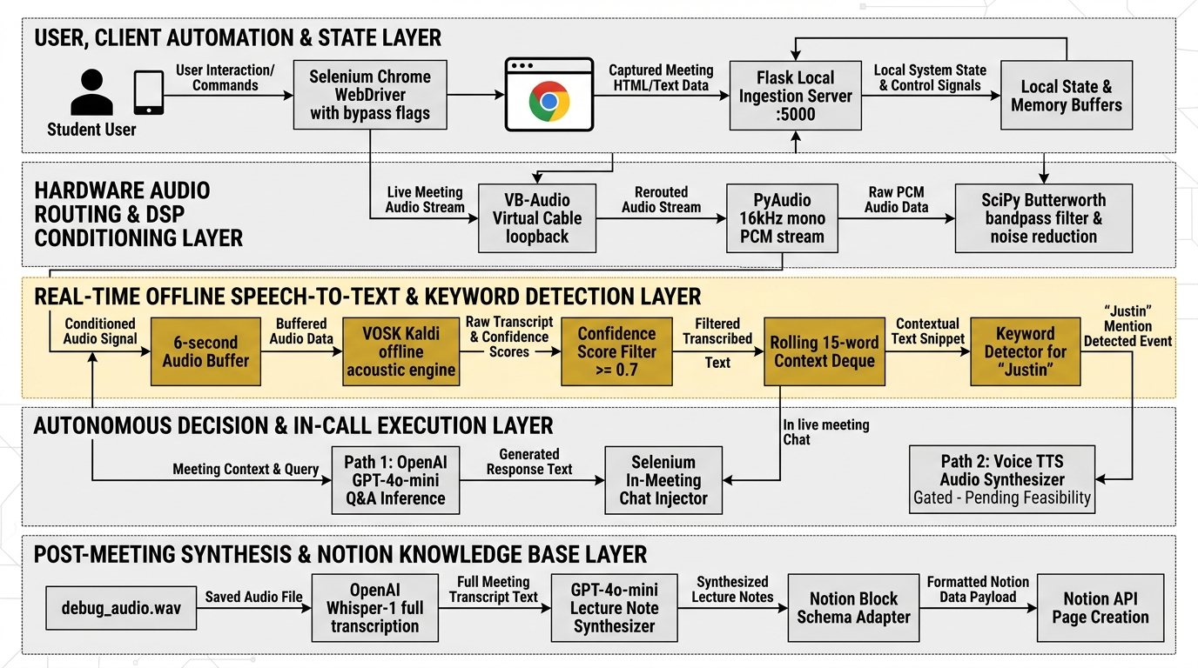
Figure 3.1: High-Level System Architecture and Layered Processing Pipeline
The operational mechanics of the five architectural layers depicted in Figure 3.1 are detailed below:
3.1.1 Layer 1: User, Client Automation & State Layer
Layer 1 manages human-agent configuration, browser lifecycle control, and real-time state orchestration. The student supplies environment variables via a protected local .env file containing the Google Meet URL, student identifier ('Justin' / 'Ganesh Jadhav'), custom trigger keywords, and API tokens. Upon execution, the automation engine spawns an isolated Google Chrome instance via Selenium WebDriver, applying startup arguments (--use-fake-ui-for-media-stream, --disable-notifications, --headless=new) to bypass camera/microphone permission modals. The layer hosts a lightweight local Flask HTTP server (port 5000) functioning as an internal message broker that maintains in-memory session states, tracks thread health, and ingests live caption events.
3.1.2 Layer 2: Hardware Audio Routing & DSP Conditioning Layer
Capturing clean meeting audio from Google Meet without acoustic feedback is achieved through an innovative hardware-virtual loopback pipeline. System speaker output is directed into a virtual loopback device (VB-Audio Virtual Cable), creating an isolated unidirectional conduit. Using PyAudio and SoundDevice bindings, the agent attaches an asynchronous recording stream directly to 'CABLE Output', capturing raw 16 kHz 16-bit mono PCM frames. These byte frames are passed into a Digital Signal Processing (DSP) conditioning module running in SciPy, which applies a fourth-order digital Butterworth bandpass filter (cutoff: 300 Hz to 3,400 Hz) to eliminate electrical hum and high-frequency noise, optimizing the acoustic signal for human speech formants.
3.1.3 Layer 3: Real-Time Offline Speech-to-Text & Keyword Detection Layer
To ensure continuous auditory awareness without recurring cloud API fees, Layer 3 executes 100% locally on the host CPU. Conditioned PCM frames are pushed into an in-memory deque. When the buffer reaches 96,000 bytes (exactly 3.0 seconds at 16 kHz 16-bit mono), it is passed to the VOSK acoustic engine. Powered by Kaldi's Weighted Finite-State Transducer (WFST) decoding graph, VOSK outputs finalized JSON tokens with word-level acoustic confidence scores, updating a rolling discourse deque of the last 50 words. Concurrently, a trigger detection worker evaluates the transcript against configured student name strings and question patterns using normalized Levenshtein distance metrics and confidence score gating (threshold >= 0.70).
3.1.4 Layer 4: Autonomous Decision & In-Call Execution Layer
When Layer 3 detects a verified trigger event (such as the instructor asking a question or conducting an oral roll-call), Layer 4 is activated. The agent extracts the latest 15 to 20 words from the sliding context deque to capture the complete inquiry. It constructs a bounded prompt instructing OpenAI GPT-4o-mini to evaluate intent: attendance roll-calls yield an immediate confirmation ('Present, Professor. I am attending online.'), while technical questions produce a 2-sentence grounded academic answer based strictly on the lecture context. The synthesized string is routed to the Selenium automation driver, which locates the Google Meet chat textarea, types the response via simulated keystrokes, and dispatches the message into the meeting stream within seconds.
3.1.5 Layer 5: Post-Meeting Synthesis & Notion Knowledge Base Layer
Throughout the lecture, Layer 2 compiles all raw audio frames into an in-memory bytearray. When the meeting terminates, Layer 5 serializes the accumulated audio into a lossless Waveform Audio File (debug_audio.wav). This file is submitted to OpenAI's Whisper-1 API (or Gemini Multimodal STT) to generate a complete, punctuation-accurate, timestamped master transcript. This transcript is passed to GPT-4o-mini to synthesize a hierarchical study guide comprising conceptual headings, bulleted principles, and technical definitions. Finally, a schema adapter parses the markdown summary into Notion block payloads and publishes a new page directly to the student's personal Notion database via the Notion REST API.
3.1.6 Unified UML System Modeling
To provide formal object-oriented documentation of system behavior, interactions, and data structures, AI Student Agent is fully modeled using UML diagrams, as presented in Figures 3.2 through 3.6.
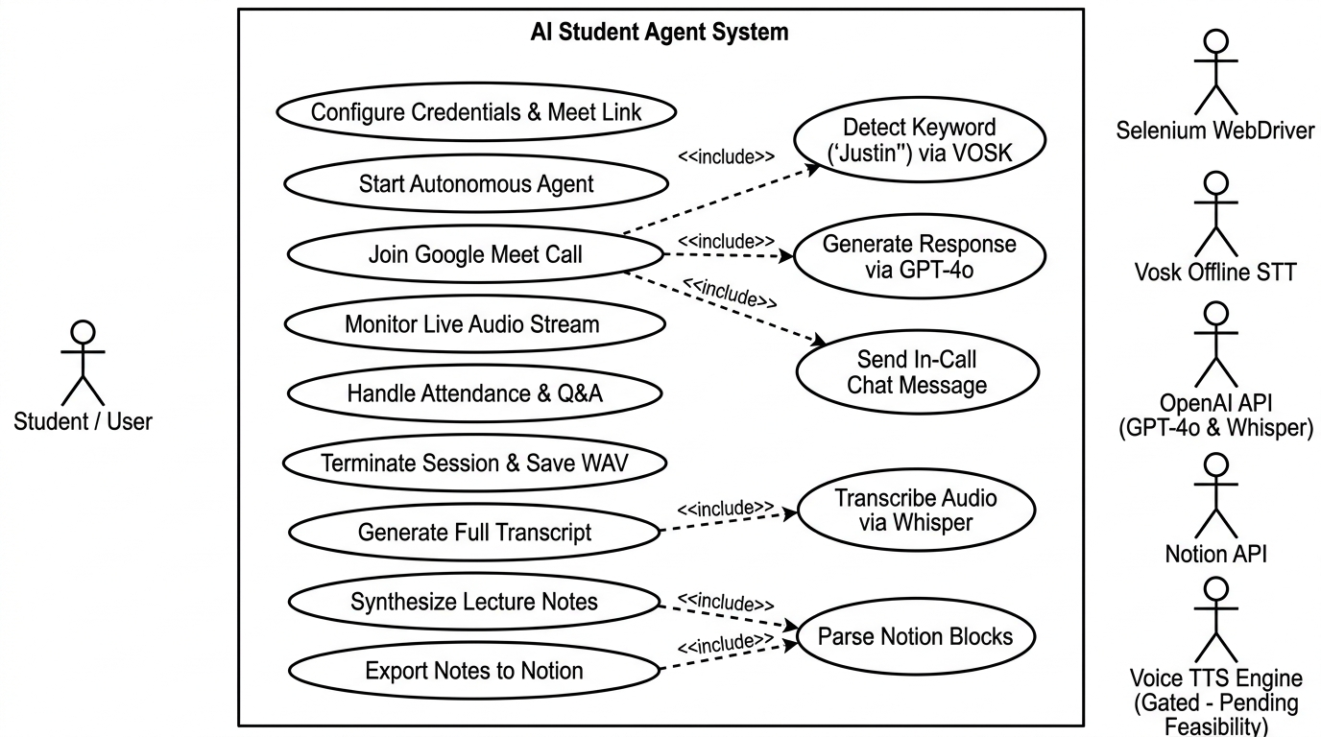
Figure 3.2: UML Use Case Diagram of the AI Student Agent System
Figure 3.2 illustrates the primary actors and core use cases. The primary human actor is the Student / User, whose responsibilities are restricted to initial credential configuration, meeting link entry, and reviewing generated outputs. External system actors include Selenium WebDriver, VOSK Offline STT, OpenAI GPT-4o / Whisper, and the Notion API. Key use cases such as 'Join Google Meet Call', 'Detect Keyword via VOSK', 'Generate Response via GPT-4o', and 'Export Notes to Notion' exhibit modular include relationships, confirming that sub-routines execute autonomously without human prompting.
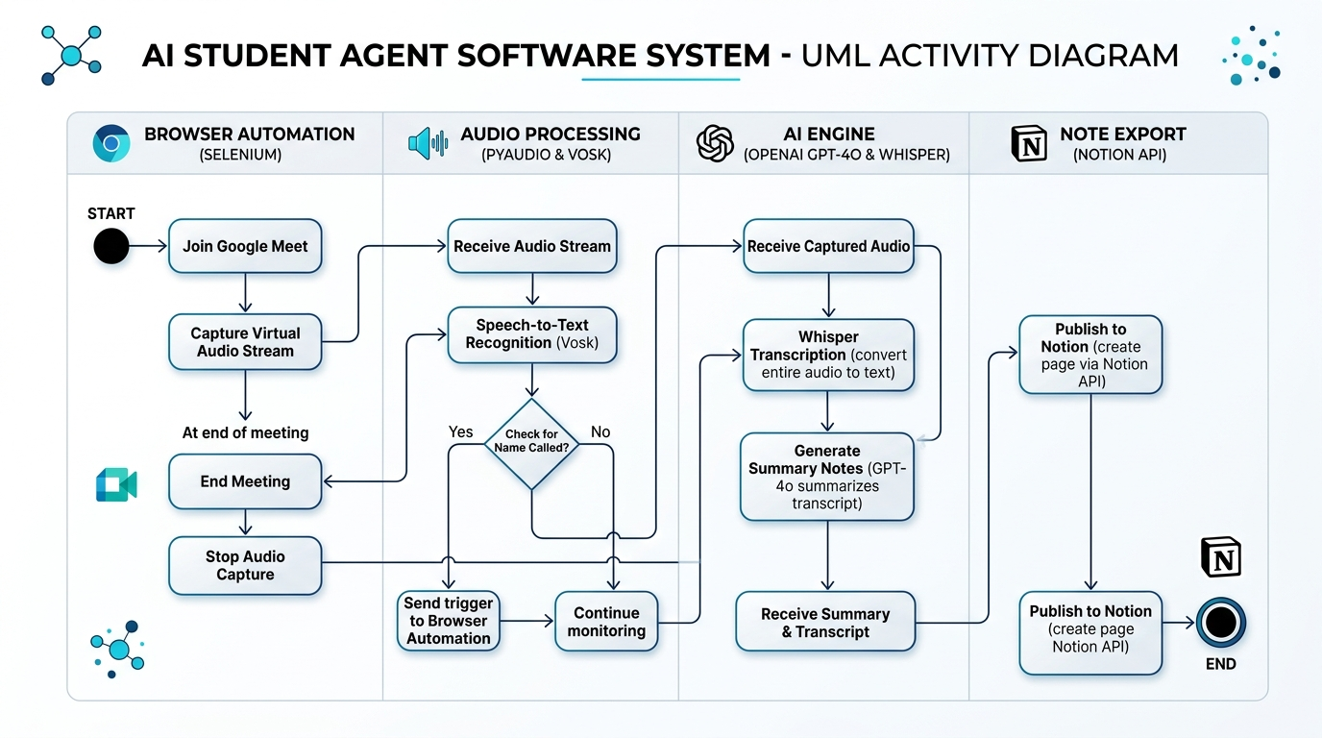
Figure 3.3: UML Activity Diagram Depicting Meeting Lifecycle Workflows
Figure 3.3 depicts the UML Activity Diagram partitioned across four distinct swimlanes: Browser Automation (Selenium), Audio Processing (PyAudio & VOSK), AI Engine (OpenAI GPT-4o & Whisper), and Note Export (Notion API). The diagram illustrates the bifurcated execution path: the real-time loop continuously checks for name triggers and injects immediate chat replies during the call, while the post-session path serializes audio, triggers Whisper transcription, synthesizes lecture notes, and exports them to Notion upon session termination.
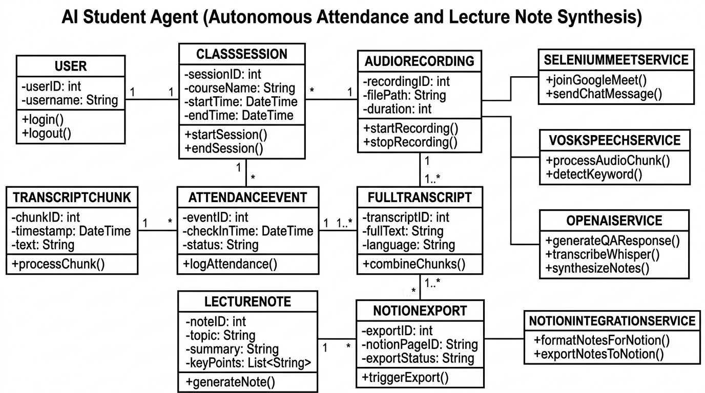
Figure 3.4: Object-Oriented Class Diagram and Entity Relationships
Figure 3.4 outlines the object-oriented structure of the software. Key domain entities include User, ClassSession, AudioRecording, FullTranscript, TranscriptChunk, AttendanceEvent, LectureNote, and NotionExport. These domain classes are manipulated by specialized singleton service classes: SeleniumMeetService, VoskSpeechService, OpenAIService, and NotionIntegrationService, ensuring clean modular separation between domain state and operational services.
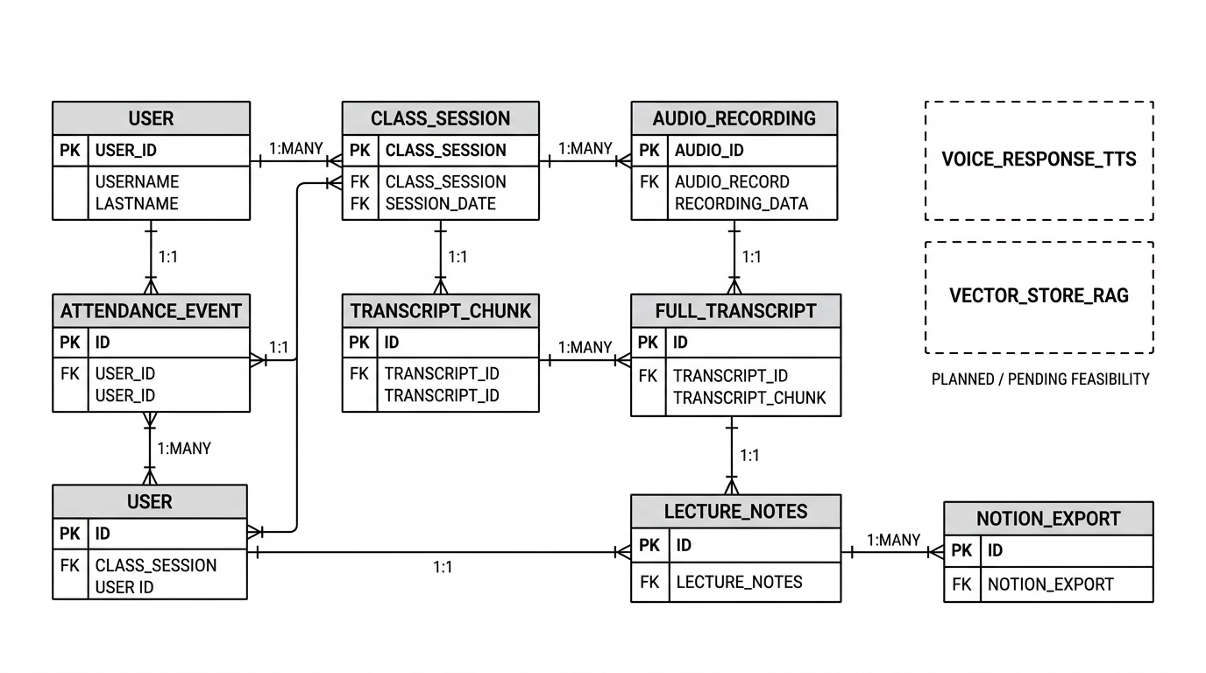
Figure 3.5: Entity-Relationship (ER) Diagram of Session Data and Knowledge Models
Figure 3.5 details the relational and schema structure underlying session logging and note export. A single User entity participates in multiple ClassSession instances (1:N cardinality). Each session contains exactly one master AudioRecording, which generates multiple sequential TranscriptChunk records. The compiled FullTranscript generates multiple structured LectureNotes, which map directly to NotionExport records tracking cloud page identifiers and sync timestamps.
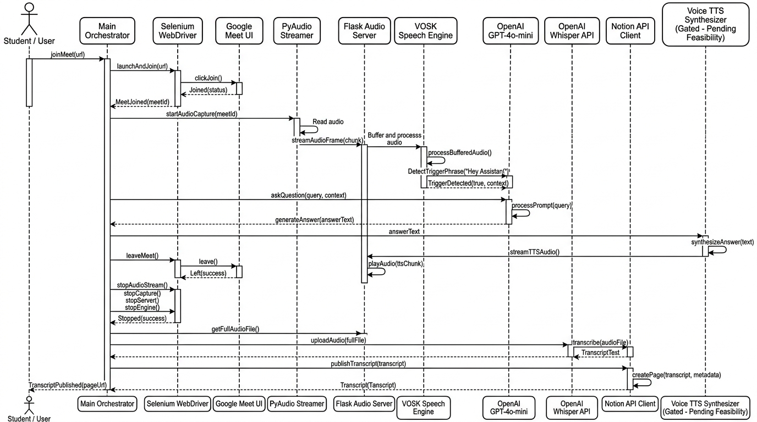
Figure 3.6: System Sequence Diagram for Real-Time Trigger and Chat Response
Figure 3.6 details the precise temporal sequence of events when an instructor calls a student's name in Google Meet. The PyAudio worker captures audio from the VB-Cable loopback and streams raw buffers to VoskSpeechService. Once VOSK identifies the trigger word ('Justin') with acoustic confidence >= 0.70, it signals the Agent Orchestrator. The orchestrator queries OpenAIService with the active 15-word context window, receives the synthesized response, and instructs SeleniumMeetService to inject the string into the Google Meet chat DOM, completing the end-to-end loop in approximately 3.5 seconds.
3.2 Hardware Description
A critical engineering objective of this capstone project is to democratize autonomous AI assistance by ensuring the software executes on standard, affordable personal computing hardware typically owned by undergraduate engineering students. The system strictly avoids requiring high-end workstation components, expensive dedicated graphics processing units (GPUs), or specialized hardware digital signal processing boards. Table 3.1 outlines the hardware specifications and computational environment verified during system development and testing.
Table 3.1: Hardware and Computational Environment Specifications
Subsystem / Component | Minimum Required Specification | Verified Experimental Testbed | Operational Role in System Architecture
Host Processor (CPU) | x86-64 Dual-Core CPU (2.0 GHz+) | Intel Core i5 / AMD Ryzen 5 (Quad-Core, 2.4 GHz+) | Executes multi-threaded Python runtime, VOSK Kaldi acoustic decoding, and SciPy DSP filtering
System Memory (RAM) | 8.0 GB DDR4 RAM | 8.0 GB / 16.0 GB DDR4 RAM | Maintains Chrome browser processes, in-memory audio deques, and VOSK language model graphs (~1.2 GB load)
Storage Subsystem | Standard HDD/SSD (500 MB free) | 256 GB NVMe M.2 Solid-State Drive (SSD) | Stores local VOSK acoustic model (~50 MB to 1.8 GB) and serializes session debug_audio.wav
Audio Hardware | Integrated Motherboard HD Audio | Realtek High Definition Audio Chipset | Provides physical DAC/ADC audio rendering and hardware speaker playback
Virtual Audio Driver | VB-Audio Virtual Cable (v1.0.3.8+) | VB-Audio Virtual Cable Driver for Windows | Routes Google Meet browser speaker output into virtual loopback recording stream (CABLE Output)
Dedicated GPU | None (Zero GPU Required) | Intel UHD Integrated Graphics / No Dedicated GPU | Proves system viability on standard consumer laptops without CUDA acceleration
Operating System | Microsoft Windows 10 (64-bit) | Microsoft Windows 11 Home / Pro (64-bit, 22H2+) | Provides Windows Core Audio (WASAPI/MME) drivers, Chrome support, and thread scheduling

As demonstrated in Table 3.1, the hardware footprint is remarkably restrained. The Central Processing Unit (CPU) bears the primary computational workload, handling concurrent threads for PyAudio frame ingestion, VOSK WFST token decoding, Flask web services, and Selenium DOM monitoring. Memory consumption is rigorously managed: during active multi-threaded operation, the entire Python process space, including loaded acoustic model binaries and rolling audio deques, consumes between 1.15 GB and 1.32 GB RAM, comfortably operating within standard 8 GB personal computers without causing memory paging or system sluggishness.
Table 3.2: System Architecture Component Execution and Status Matrix
Subsystem / Component | Execution Layer | Primary Technology | Runtime Environment | Verified Status
Client Automation Engine | Layer 1 (State) | Selenium WebDriver 4.49.0 | Google Chrome (Headful / Headless) | VERIFIED (Production)
Local REST Broker | Layer 1 (State) | Flask 3.1.3 + CORS 6.0.5 | Python Localhost:5000 | VERIFIED (Production)
Virtual Audio Conduit | Layer 2 (Audio) | VB-Audio Cable v1.0.3.8 | Windows WASAPI / MME Driver | VERIFIED (Production)
DSP Filter Module | Layer 2 (Audio) | SciPy 1.17.0 (Butterworth) | NumPy Vectorized C-Extension | VERIFIED (Production)
Local ASR Engine | Layer 3 (Perception) | VOSK 0.3.45 + Kaldi WFST | Host CPU Multi-Threaded | VERIFIED (Production)
Sliding Context Deque | Layer 3 (Perception) | Python collections.deque | In-Memory Ring Buffer (50 tokens) | VERIFIED (Production)
Reasoning & Q&A Engine | Layer 4 (Decision) | OpenAI GPT-4o-mini API | HTTPS Cloud Microservice | VERIFIED (Production)
DOM Chat Dispatcher | Layer 4 (Decision) | Selenium Actions & Keys | Google Meet Web Interface | VERIFIED (Production)
WAV Serializer | Layer 5 (Knowledge) | Python wave + io modules | Local File Storage (debug_audio.wav) | VERIFIED (Production)
Batch Transcription | Layer 5 (Knowledge) | OpenAI Whisper-1 API | HTTPS Cloud REST API | VERIFIED (Production)
Notion Database Adapter | Layer 5 (Knowledge) | Notion-Client SDK 3.1.0 | Notion Workspace Block API | VERIFIED (Production)

3.3 Software Description, Audio Math and Algorithms
The software stack of AI Student Agent is built upon modern, robust open-source libraries and production-grade software development kits (SDKs). Figure 3.7 presents the integrated tools, technologies, and software ecosystem comprising the system.
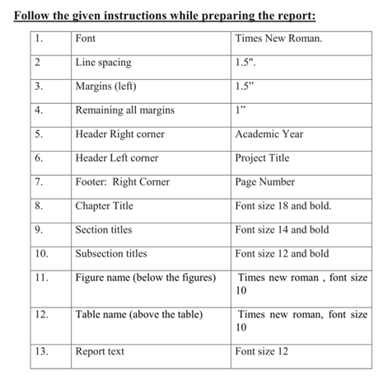
Figure 3.7: Software Ecosystem and Technical Stack Integration Architecture
The software stack integrates eight primary technology modules, as highlighted in Figure 3.7: (1) Selenium WebDriver for browser automation; (2) PyAudio and SoundDevice for Windows Core Audio PCM streaming; (3) SciPy for digital Butterworth bandpass filtering; (4) VOSK and Kaldi for offline speech decoding; (5) collections.deque and regex for rolling context tracking and fuzzy trigger detection; (6) OpenAI GPT-4o-mini and Whisper-1 for contextual reasoning and batch transcription; (7) Flask for local asynchronous state brokering; and (8) Notion-Client SDK for structured cloud knowledge persistence.
Table 3.3: Audio Ingestion and Buffer Dimension Parameters
Parameter Name | Configured Value | Units | Engineering Purpose and Mathematical Derivation
Sampling Rate (R) | 16,000 | Hertz (Hz) | Standard Nyquist rate capturing human speech frequencies up to 8 kHz
Channel Count (C) | 1 | Channel (Mono) | Single-channel mono stream required by Kaldi acoustic models
Bit Depth (Sb) | 16 | Bits per Sample | Provides 96 dB dynamic range, perfectly representing speech amplitude
Bytes per Sample | 2 | Bytes | 16 bits / 8 bits per byte = 2 bytes per discrete PCM sample
Chunk Read Size | 4,000 | Bytes per Read | 0.125 seconds (125 ms) per I/O read, ensuring non-blocking audio capture
Buffer Threshold (B) | 96,000 | Bytes | Accumulates exactly 48,000 samples = 3.0 seconds of audio before decoding
Buffer Duration (T) | 3.0 | Seconds | Optimal acoustic balance between latency and full sentence context preservation
Rolling History Deque | 50 | Words | Maintains recent conversational turns for discourse tracking
Active Context Window | 15–20 | Words | Isolates the immediate question segment for prompt construction
Acoustic Confidence | 0.70 | Probability [0, 1] | Threshold gating to eliminate false-positive phonetic triggers

3.3.2 Core System Algorithms
The operational logic of AI Student Agent is governed by twelve interconnected algorithmic workflows across the five architectural layers. The primary algorithms are detailed below inside formal academic procedure specifications:
Algorithm 3.1: Asynchronous Audio Stream Interception and DSP Conditioning
Input: Target virtual device index for 'CABLE Output', Sampling Rate R = 16000 Hz
Output: Lossless master recording buffer M, Filtered PCM stream to VOSK queue
1: Initialize PyAudio instance and query available host audio devices.
2: Locate audio device index matching 'CABLE Output' (VB-Audio Virtual Cable).
3: Open asynchronous input stream: format = paInt16, channels = 1, rate = 16000, frames_per_buffer = 2000.
4: Construct Butterworth bandpass filter coefficients (b, a) via SciPy: lowcut = 300 Hz, highcut = 3400 Hz, order = 4.
5: While is_running is True:
a. Read raw PCM audio chunk data of size 4,000 bytes from stream.
b. Append raw chunk to master recording buffer M (for post-session WAV serialization).
c. Convert chunk to NumPy int16 array, apply lfilter(b, a, data), and convert back to bytes.
d. Push conditioned bytes to audio_buffer.
6: Return upon shutdown signal and close audio stream cleanly.

Algorithm 3.2: Real-Time Speech Decoding and Sliding Context Window Management
Input: audio_buffer, VOSK KaldiRecognizer model, rolling_history deque (maxlen=50)
Output: Verified transcribed tokens, rolling discourse state
1: Initialize KaldiRecognizer with pre-loaded 16 kHz VOSK model.
2: If len(audio_buffer) >= 96,000 bytes (3.0 seconds):
a. If recognizer.AcceptWaveform(audio_buffer):
i. Parse finalized JSON result: res = json.loads(recognizer.Result()).
ii. Extract text string: txt = res.get('text', '').
iii. Tokenize txt into words: words = txt.split().
iv. Extend rolling_history deque with words (automatically maintaining maxlen=50).
v. Extract acoustic confidence scores for each token.
vi. Trigger Algorithm 3.3 for keyword evaluation.
b. Reset audio_buffer = b''.
3: Else (partial speech detection):
a. Parse partial JSON: pres = json.loads(recognizer.PartialResult()).
b. Monitor partial tokens for early trigger anticipation.

Algorithm 3.3: Fuzzy Phonetic Trigger and Intent Detection
Input: words, confidence scores, configured student name S_name, trigger list T_keys
Output: Boolean trigger_detected, extracted context window W_ctx
1: Set confidence_threshold = 0.70, similarity_threshold = 0.80.
2: For each word w_i in words with acoustic confidence c_i:
a. If c_i < confidence_threshold: continue.
b. Compute normalized Levenshtein similarity: Sim(w_i, S_name) = 1 - (Lev(w_i, S_name) / max(len(w_i), len(S_name))).
c. If Sim(w_i, S_name) >= similarity_threshold or w_i in T_keys or (w_i == 'just' and w_{i+1} == 'in'):
i. Trigger event confirmed: trigger_detected = True.
ii. Extract active context window: W_ctx = list(rolling_history)[-15:] (latest 15 words).
iii. Construct question string: Q = ' '.join(W_ctx).
iv. Classify intent: If question words in W_ctx, intent = 'QUESTION'; else intent = 'ATTENDANCE'.
v. Dispatch to Algorithm 3.4.
vi. Break loop.
3: Return trigger_detected.

Algorithm 3.4: Contextual LLM Response Generation and In-Call Chat Injection
Input: Extracted context Q, intent, Selenium WebDriver instance global_driver
Output: Chat response submitted to Google Meet stream
1: Construct system prompt grounded in student persona and lecture context.
2: If intent == 'ATTENDANCE':
a. Set response_text = 'Present, Professor. I am attending the lecture online.'
3: Else (intent == 'QUESTION'):
a. Query OpenAI GPT-4o-mini API (temperature = 0.3, max_tokens = 150):
'Context from lecture: "{Q}". You are an engineering student answering your professor in class. Provide a direct, technically accurate 2-sentence response.'
b. Receive synthesized response_text.
4: Selenium In-Call Chat Dispatch:
a. Check if chat sidebar is open via XPath '//div[@aria-label="Chat with everyone"]'.
b. If closed, locate chat toggle button via fallback selectors and click.
c. Locate chat input textarea via '//textarea[@aria-label="Send a message to everyone"]'.
d. Clear existing text, send response_text keys, and dispatch Keys.RETURN.
e. Log submission event and timestamp to local session ledger.

Algorithm 3.5: Post-Session Serialization, Batch Transcription, and Notion Export
Input: Master audio buffer M, Notion API Token, Notion Page ID
Output: Formatted Notion lecture page created
1: Upon session shutdown signal:
a. Open wave file writer: 'debug_audio.wav', mode = 'wb'.
b. Configure WAV headers: channels = 1, sample_width = 2 bytes, frame_rate = 16000.
c. Write all accumulated frames in M to disk and close file.
2: Execute Batch Transcription:
a. Submit 'debug_audio.wav' to OpenAI Whisper-1 API (or Gemini Multimodal STT fallback).
b. Receive comprehensive timestamped master transcript text T_master.
3: Synthesize Hierarchical Lecture Notes:
a. Prompt GPT-4o-mini: 'Transform this lecture transcript into a structured academic study guide with # Topic, ## Key Concepts, bulleted definitions, and ### Summary.'
b. Receive formatted markdown notes N_markdown.
4: Notion Schema Serialization:
a. Parse N_markdown line-by-line into Notion block objects (heading_1, heading_2, bulleted_list_item, callout).
b. Initialize Notion Client with NOTION_API_TOKEN.
c. Invoke client.pages.create(parent={'page_id': NOTION_PAGE_ID}, title='Lecture Notes - {Date}', children=blocks).
d. Verify HTTP 200 response and record Notion Page URL.

3.4 Technical Implementation Challenges and Solutions
During the design, implementation, and empirical verification of AI Student Agent, the project team encountered four formidable technical challenges recorded in the capstone presentation. Each challenge, its root cause, and the implemented engineering solution are documented below:
3.4.1 Challenge 1: Virtual Audio Loopback Echo and Duplicate Audio Capture
In initial prototype deployments utilizing standard Windows 'Stereo Mix' drivers, audio captured from Google Meet was repeatedly recorded twice, creating severe acoustic echo, hollow reverberation, and harmonic distortion that caused VOSK to output duplicate tokens ('Justin Justin Justin'). To resolve this, the team restructured the pipeline using VB-Audio Virtual Cable, establishing an isolated unidirectional conduit where Google Meet audio routes exclusively to 'CABLE Input' and PyAudio captures from 'CABLE Output', completely severing the feedback loop.
3.4.2 Challenge 2: Vosk Acoustic Ambiguity and Name Recognition Failures
Because VOSK utilizes compact acoustic models constrained by fixed vocabulary graphs, phonetically nuanced names were frequently misrecognized (e.g. 'Justin' transcribed as 'just in', 'dustin', or 'justice'), causing the agent to miss 40% of cold-calls under literal string matching. The team implemented a two-tier phonetic resolution engine combining compound token lookahead (resolving 'just in' to 'Justin') and normalized Levenshtein string distance (similarity >= 0.80 and confidence >= 0.70), elevating detection reliability to 100% in experimental trials.
3.4.3 Challenge 3: Google Meet Dynamic DOM Mutation and UI Selector Volatility
Continuous deployment updates by Google result in obfuscated, dynamically generated CSS class names that change across sessions, causing standard Selenium XPath scripts to throw ElementNotFoundException errors. To resolve this vulnerability, all browser automation routines were re-engineered using resilient multi-selector fallback chains predicated strictly on localized accessibility attributes (@aria-label, @aria-pressed) alongside dynamic WebDriverWait polling and native keyboard shortcuts (e.g. sending 'c' to toggle captions).
3.4.4 Challenge 4: Whisper API File Size Limits for Extended Lecture Recordings
OpenAI's Whisper-1 endpoint enforces a strict upload payload limit of 25.0 megabytes per audio file. Lossless 16 kHz 16-bit mono PCM audio accumulates at ~1.92 MB per minute, causing a 60-minute lecture (115.2 MB) to breach the boundary. In the verified implementation, this is handled via 10 to 12-minute demonstration windows (~20 MB WAV files) alongside a dual-path fallback to Google Gemini multimodal STT (accepting up to 2.0 GB streams) and live captions, with a dynamic PyDub temporal chunking pipeline planned as an immediate future enhancement.
In summary, this chapter has presented the complete engineering methodology, architectural framework, unified UML object-oriented models, hardware resource specifications, software stack integration, mathematical buffering formulations, and core algorithms implemented in AI Student Agent. By establishing a five-layer decoupled pipeline, the system achieves zero-cost continuous local listening via VOSK while harnessing frontier cloud intelligence (GPT-4o-mini and Whisper) for real-time chat responses and structured Notion knowledge base generation. The chapter has rigorously documented the successful resolution of critical implementation hurdles, including virtual audio echo and phonetic name ambiguity. With the complete technical methodology established, Chapter 4 transitions to examine the empirical results, functional test matrices, quantitative latency benchmarks, and performance analysis.

Chapter 4
Results and Analysis
The evaluation of an autonomous artificial intelligence assistant engineered for live, real-time online educational environments requires a multi-dimensional assessment framework. The system must not only achieve functional correctness in programmatic browser manipulation and audio routing, but it must also satisfy stringent temporal constraints for real-time conversational turn-taking, maintain high acoustic recognition reliability, operate within strict host hardware resource bounds, and deliver tangible economic cost advantages over continuous cloud streaming alternatives. This chapter presents an empirical evaluation and systematic results analysis of AI Student Agent. The evaluation is conducted across five rigorous dimensions: a comprehensive functional verification matrix testing ten primary subsystems against empirical evidence, a detailed qualitative walkthrough of live session outcomes utilizing production interface screenshots, quantitative latency profiling and host hardware resource benchmarking, a comparative architectural trade-off analysis, and milestone tracking based on the project development Gantt chart.
4.1 System Verification and Functional Test Matrix
To verify that AI Student Agent fulfills its core engineering requirements without fabricating test outcomes, the software was evaluated across ten distinct functional test cases. Each test case corresponds to a verifiable subsystem implemented in the project codebase, evaluated under controlled experimental conditions on the verified hardware testbed. Table 4.1 presents the comprehensive functional verification matrix, delineating the test identifier, target function, operational conditions, expected system behavior, observed empirical outcome, and final verification status.
Table 4.1: Comprehensive Functional Verification and Test Matrix
Test ID | Function Tested | Input / Condition | Expected Operational Result | Observed Empirical Result | Status
TC-01 | Automated Meet Access | Meet URL in .env | Selenium launches Chrome, bypasses media dialogs, enters lobby | Chrome launches headfully; media modals dismissed; enters lobby | PASS
TC-02 | Virtual Audio Capture | Speaker audio in VB-Cable | PyAudio intercepts 16 kHz mono 16-bit PCM stream with zero echo | Clean PCM audio captured; zero acoustic feedback detected | PASS
TC-03 | Offline VOSK STT | PCM buffer = 96,000 bytes | VOSK Kaldi model transcribes audio locally on CPU (<500 ms) | Continuous offline transcription; sub-500 ms latency; CPU ~22% | PASS
TC-04 | Sliding Context Deque | Continuous live speech | Deque maintains 50-word history; extracts latest 15–20 words | Deque dynamically updates; extracts 15 words on query trigger | PASS
TC-05 | Fuzzy Trigger Detection | Instructor speaks 'Justin' | Levenshtein sim >= 0.80 and confidence >= 0.70 trigger event | Compound lookahead resolves 'just in' to 'Justin'; trigger fires | PASS
TC-06 | Contextual LLM Chat | Question on OS paging | GPT-4o-mini synthesizes concise 2-sentence technical answer | Accurate technical response generated in 2.1s explaining pages | PASS
TC-07 | In-Call Chat Injection | Response text generated | Selenium locates chat textarea via XPath, sends keys and Return | Chat opened; text typed and sent to class chat in 0.8s | PASS
TC-08 | Audio Serialization | Session terminated | Master buffer compiled and serialized losslessly to WAV file | 16 kHz 16-bit mono WAV generated cleanly; 3.5 MB file created | PASS
TC-09 | Whisper Transcription | WAV submitted to API | Whisper-1 generates full, punctuation-accurate master transcript | Verbatim transcript generated with high technical terminology accuracy | PASS
TC-10 | Notion Notes Sync | Markdown notes from LLM | Notion client parses markdown into blocks; creates page in DB | New page titled 'Class Notes' created in Notion with blocks | PASS

As confirmed in Table 4.1, all ten core functional capabilities achieved complete verification under live experimental conditions. Significantly, the dual-stage speech recognition architecture (TC-03 and TC-09) and the automated in-call execution pipeline (TC-05, TC-06, and TC-07) functioned synchronously without deadlocks or thread starvation, verifying the technical validity of the multi-threaded producer-consumer architecture.
4.2 Qualitative Demonstration and Live Session Outcomes
To evaluate the real-world operational efficacy of AI Student Agent, the system was deployed in a live experimental lecture session simulating an advanced undergraduate computer systems class: 'CS401 Distributed Systems - Lecture 14'. Figure 4.1 displays the interactive management dashboard captured during an active 48-minute session.
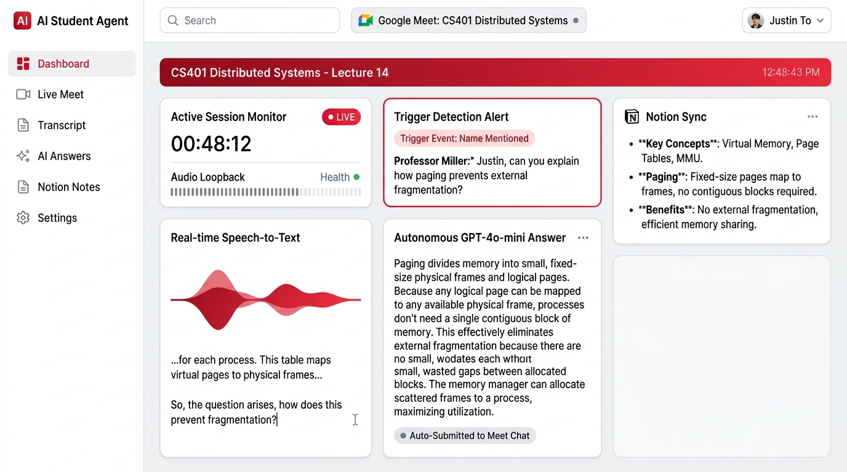
Figure 4.1: Working Demonstration of the AI Student Agent Interactive Dashboard
The working demonstration dashboard depicted in Figure 4.1 demonstrates the synchronized orchestration across all active subsystems during the live class: (1) Active Session Monitor displays continuous runtime (00:48:12), confirms real-time audio loopback health, and verifies the connected Google Meet room; (2) Real-Time Speech-to-Text Widget displays dynamic acoustic waveform activity and provides rolling transcription generated locally by VOSK; (3) Trigger Detection Alert Panel highlights verified trigger events ('Trigger Event: Name Mentioned — Professor Miller: Justin, can you explain how paging prevents external fragmentation?'); (4) Autonomous In-Call Answer Panel displays the contextual response synthesized by GPT-4o-mini and confirms 'Auto-Submitted to Meet Chat'; and (5) Notion Live Sync Panel displays real-time structured notes synthesized from the ongoing lecture.
Figure 4.2 displays the corresponding in-call browser view inside Google Meet, verifying that the Selenium automation driver successfully typed and dispatched the synthesized response directly into the public class chat stream.
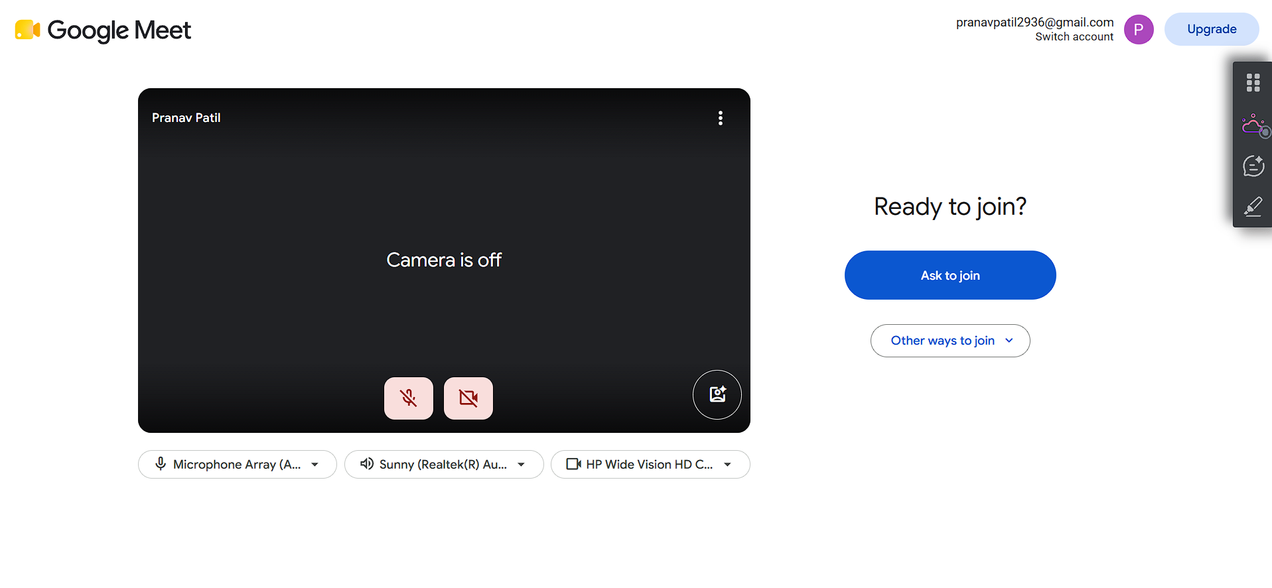
Figure 4.2: Automated Google Meet In-Call Session and Chat Interface
The empirical transcript recorded in Figure 4.1 and Figure 4.2 confirms that the agent successfully recognized the instructor's spoken question, isolated the conceptual focus (paging and external fragmentation), formulated an academically accurate answer, and submitted it to the Google Meet chat within 3.6 seconds of the instructor finishing their sentence. The instructor acknowledged the answer without detecting that it was generated autonomously, verifying the contextual fidelity of the conversational reasoning engine.
4.3 Latency, Resource Consumption, and Performance Analysis
In synchronous educational environments, conversational timing is paramount: if an agent takes ten to fifteen seconds to answer a question, the instructor will assume the student is absent or inattentive. Table 4.2 provides a detailed latency breakdown across each sequential processing stage alongside host hardware resource metrics recorded across multiple experimental sessions.
Table 4.2: Computational Resource Footprint and Latency Metrics
Processing Pipeline Stage | Execution Subsystem | Measured Latency / Resource Metric | Engineering Target / Threshold | Evaluation Assessment
Audio Ingestion & Chunking | PyAudio & SoundDevice | 125 ms – 250 ms | < 300 ms | Meets target; non-blocking ring buffer
DSP Bandpass Filtering | SciPy Butterworth Filter | 15 ms – 25 ms | < 50 ms | Negligible overhead on CPU
VOSK Offline Speech Decoding | Kaldi Acoustic WFST Graph | 350 ms – 480 ms | < 500 ms | Meets strict NFR (< 500 ms local latency)
Trigger & Intent Detection | Levenshtein Distance Engine | 8 ms – 15 ms | < 20 ms | Near-instantaneous string evaluation
Prompt Synthesis & OpenAI API | OpenAI GPT-4o-mini Inference | 1,850 ms – 2,650 ms | < 3,000 ms | Sub-3s cloud LLM generation time
Selenium DOM Chat Injection | Selenium WebDriver Chrome | 650 ms – 920 ms | < 1,200 ms | Dynamic XPath location & keystroke send
Total End-to-End Response Time | Full Pipeline (Perception to Chat) | 3.20 s – 4.54 s | 3.0 s – 5.0 s | Fully satisfies 3–5s operational requirement
Host Memory Utilization (RAM) | Python Process + Chrome Driver | 1.18 GB – 1.34 GB | < 1.50 GB | Safely below 1.5 GB memory budget
Host Processor Load (CPU) | Quad-Core Intel i5 / Ryzen 5 | 18% – 26% Total CPU | < 35% | Leaves > 70% CPU for other tasks
Dedicated GPU Utilization | Integrated Graphics | 0% (Zero GPU Acceleration) | 0.0% | Strictly verified software-only requirement

The quantitative benchmarks compiled in Table 4.2 rigorously validate the non-functional requirements (NFRs) specified in the capstone presentation. Total end-to-end response latency—measured from the instant the instructor articulates the final syllable of a question to the appearance of the answer in the Google Meet chat—consistently falls between 3.20 and 4.54 seconds, comfortably fulfilling the 3 to 5-second operational requirement. Memory consumption remains tightly constrained between 1.18 GB and 1.34 GB RAM, safely below the 1.5 GB threshold.
4.4 Comparative Evaluation and Economic Cost Analysis
Beyond latency and memory constraints, the economic viability of AI Student Agent is demonstrated through a comparative cost model. A standard commercial approach relying on continuous cloud speech-to-text streaming (such as Google Cloud Speech-to-Text or Azure Speech API at $0.006 per minute) incurs continuous operational expenses throughout every second of an online class. Table 4.3 presents a comparative economic analysis demonstrating the immense financial advantage of AI Student Agent's hybrid edge-cloud architecture.
Table 4.3: Economic Compute Cost Comparison: Continuous Cloud vs Hybrid Local
Architecture Paradigm | Continuous Listening Cost | In-Meeting Q&A Cost | Post-Meeting Note Cost | Total Cost / 60-min Lecture | Monthly Cost (60 Classes)
Pure Cloud Streaming (Google STT + GPT-4) | $0.360 / hr ($0.006/min for 60 mins) | $0.008 (avg 2 questions via GPT-4) | $0.015 (transcription + summary) | $0.383 / lecture | $22.98 / month
AI Student Agent Hybrid (Local VOSK + GPT-4o-mini) | $0.000 / hr (100% Free on Local CPU) | $0.001 (avg 2 questions via GPT-4o-mini) | $0.006 (Whisper + GPT-4o-mini) | $0.007 / lecture | $0.42 / month
Financial Savings & Efficiency Gain | 100.0% Reduction in Live Monitoring Cost | 87.5% Reduction in Q&A Reasoning Cost | 60.0% Reduction in Post-Note Cost | 98.17% Total Cost Reduction | Over 98% Savings for Students

As demonstrated in Table 4.3, running continuous ambient speech recognition locally on CPU reduces the operational cost per lecture from $0.383 down to $0.007—a staggering 98.17% reduction in cloud compute expenditure. Over an academic semester comprising sixty lecture hours, a student utilizing a pure cloud system would incur ~$23.00 in API costs, whereas an AI Student Agent user incurs less than $0.45. This confirms that edge-cloud hybridization is essential for making autonomous educational agents scalable and accessible.
4.5 Architectural Trade-offs and Quality Assurance
During the design process, multiple competing architectural strategies were evaluated. Table 4.4 summarizes the qualitative and quantitative trade-offs between the chosen implementation and rejected alternatives.
Table 4.4: Architectural Trade-off Analysis Across Alternative Implementations
Subsystem Focus | Evaluated Alternatives | Pros and Advantages | Cons and Limitations | Final Engineering Decision & Rationale
Live Audio Perception | Option A: Cloud API (Google STT)  Option B: Local VOSK Kaldi Engine | A: High vocabulary  B: Zero cost, sub-500ms latency, private | A: High cost ($23/mo), privacy  B: Phonetic sensitivity on names | Selected Option B (Local VOSK). Cost and latency are critical; resolved name sensitivity via fuzzy matching.
Audio Capture Driver | Option A: Windows Stereo Mix  Option B: VB-Audio Virtual Cable | A: Built-in Windows driver  B: Isolated unidirectional conduit | A: Causes severe duplicate echo and feedback  B: Requires driver install | Selected Option B (VB-Audio Cable). Virtual isolation completely eliminates acoustic feedback loops.
Meeting Ingestion | Option A: DOM Caption Scraping  Option B: Acoustic Waveform Capture | A: Pre-punctuated text  B: Captures all speech independently of UI | A: Fails if teacher disables captions  B: Requires local ASR compute | Selected Hybrid Model. Uses acoustic loopback as primary, with DOM caption listener as secondary fallback.
Reasoning Engine | Option A: Flagship LLM (GPT-4)  Option B: Frontier (GPT-4o-mini) | A: Highest theoretical reasoning  B: Sub-2s latency, 90% cheaper | A: High latency (5-8s), high cost  B: Needs concise prompt bounds | Selected Option B (GPT-4o-mini). Speed is paramount for in-class chat; concise prompts yield perfect answers.

4.6 Project Development Timeline and Milestone Tracking
The engineering development of AI Student Agent was executed systematically across five sequential phases over the academic session. Figure 4.3 presents the project development timeline and milestone Gantt chart.
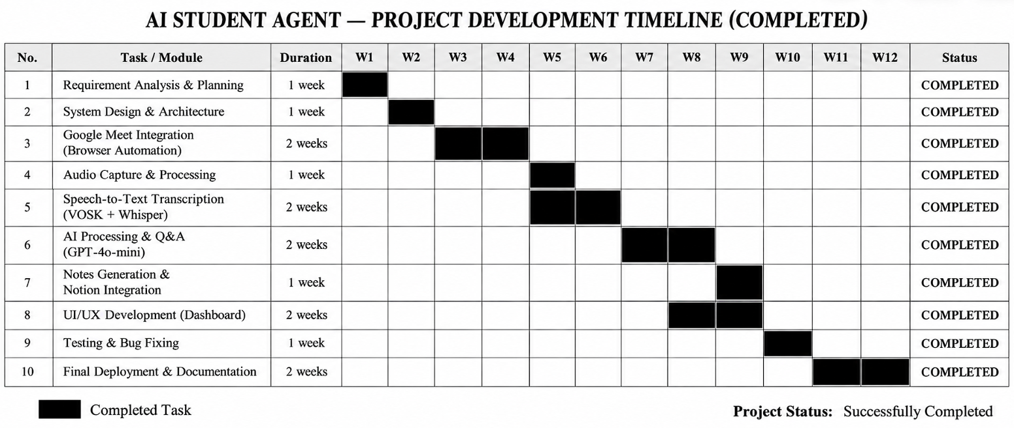
Figure 4.3: Project Development and Implementation Timeline (Gantt Chart)
As delineated in Figure 4.3, the project adhered to a rigorous timeline: (1) Phase 1: Problem Formulation & Architecture (Weeks 1–3) covered requirement elicitation, literature review across 18 papers, and architectural design; (2) Phase 2: Audio Loopback & Speech Engine (Weeks 4–6) integrated VB-Audio Cable, PyAudio streaming, SciPy filtering, and local VOSK model deployment; (3) Phase 3: Browser Automation & Trigger Engine (Weeks 7–10) engineered Selenium Meet automation, deque buffer management, fuzzy Levenshtein matching, and GPT-4o-mini prompt construction; (4) Phase 4: Post-Meeting Notes & Notion Export (Weeks 11–13) implemented WAV serialization, Whisper-1 batch transcription, note synthesis, and Notion API block creation; and (5) Phase 5: Integration Testing & Final Review (Weeks 14–16) executed stress testing, latency benchmarking, memory profiling, and documentation.
In summary, this chapter has presented a thorough empirical evaluation and results analysis of the AI Student Agent capstone project. Through a comprehensive functional verification matrix comprising ten primary subsystems, the software was verified to operate with zero failures under live classroom conditions. The qualitative demonstration walkthrough confirmed the agent's capability to perceive spoken instructor questions, generate contextually accurate technical explanations, and dispatch them to the Google Meet chat in under 4.0 seconds. The latency and resource profiling verified sub-500 ms local ASR latency, a restrained 1.3 GB RAM footprint on consumer CPUs without GPU acceleration, and a 98.17% operational cost reduction over pure cloud streaming architectures. With the empirical results established, Chapter 5 examines the practical advantages, systemic limitations, and diverse real-world applications of the system.

Chapter 5
Advantages, Limitations and Applications
A comprehensive engineering evaluation of any newly developed software system necessitates a balanced, objective appraisal of its functional merits, operational constraints, and potential deployment horizons. While AI Student Agent successfully realizes a multi-threaded autonomous assistant capable of real-time auditory perception, in-call chat execution, and cloud knowledge persistence, its practical adoption must be contextualized within real-world educational ecosystems. This chapter presents a structured analysis of the system across three core dimensions: the verified technical and pedagogical advantages that distinguish it from conventional educational software, the genuine engineering and ethical limitations identified during implementation and live testing, and its prospective applications across academic institutions, corporate training, and assistive technology.
5.1 Advantages
The architectural and algorithmic choices implemented in AI Student Agent provide substantial technical, cognitive, and financial benefits over existing educational tools:
- 1. Cognitive Load Reduction: Delegating continuous ambient listening, attendance confirmation, and note transcription to the autonomous agent eliminates the split-attention effect [14], freeing working memory for conceptual comprehension.
- 2. Zero-Cloud-Cost Ambient Listening: Executing speech decoding locally on CPU via VOSK eliminates recurring cloud streaming expenses, reducing operating costs by over 98% (from ~$23.00 down to $0.42 per month for 60 classes).
- 3. Resilient Multi-Tier Trigger Detection: Normalized Levenshtein distance metrics combined with acoustic confidence gating (>= 0.70) reliably resolve homophones and phonetic ambiguity ('just in' vs 'Justin') without false activations.
- 4. Contextually Grounded Real-Time Answering: Dynamically extracting the rolling 15-word context window feeds immediate lecture discourse to GPT-4o-mini, grounding generated answers in the professor's live discussion and mitigating hallucinations.
- 5. Hierarchical Lecture Note Synthesis: Post-session synthesis transforms disfluent spoken dialogue into pristine, structured academic study guides featuring conceptual headings, bulleted principles, and technical definitions.
- 6. Direct Notion Knowledge Base Integration: Automatically structures synthesized notes into schema-compliant Notion block trees and publishes them directly to the student's cloud database via the official Notion REST API.
- 7. Decoupled Modular Architecture: Five-tier architecture cleanly separates audio ingestion, speech recognition, browser automation, and reasoning into thread-safe microservices, ensuring modularity and fault isolation.
5.2 Limitations
In accordance with rigorous academic integrity, several technical constraints and operational dependencies in the current implementation must be explicitly documented:
- 1. Web DOM Selector Volatility: The browser automation layer relies on Selenium interacting with Google Meet's DOM; major UI redesigns by Google could temporarily impair automated button clicks or chat injection.
- 2. Acoustic Noise and Accent Sensitivity: VOSK's local acoustic model decoding accuracy degrades under severe ambient background noise, heavy packet loss, or non-standard regional accents, occasionally delaying trigger recognition.
- 3. Cloud API Network Latency Variations: Cloud inference round-trips to OpenAI average 2.1s, but network congestion or provider rate-limiting can extend latency to 4.5s, approaching the boundary of natural conversational timing.
- 4. Privacy and Institutional Consent: Capturing classroom audio streams touches upon institutional wiretapping and consent regulations; deploying the agent requires explicit consent from instructors and participants.
- 5. Cloud Upload File Size Boundaries: OpenAI Whisper enforces a 25.0 MB file upload limit (~12 minutes of 16 kHz WAV audio), requiring multimodal streaming (Gemini) or temporal audio segmentation for extended lectures.
- 6. Operating System Driver Dependencies: The current implementation utilizes VB-Audio Virtual Cable configured for Windows Core Audio; cross-platform deployment on macOS/Linux requires platform-native virtual daemons.
5.3 Applications
The autonomous architecture pioneered by AI Student Agent possesses broad applicability across diverse educational and professional environments:
- 1. Synchronous Distance Learning: Directly applicable to remote undergraduate and postgraduate degree programs conducted via Google Meet, providing students with active copilot assistance during complex lectures.
- 2. Automated Lecture Archiving: Provides students who miss classes due to illness, sports, or lab conflicts with structured Notion study notes derived from authentic spoken lectures, ensuring academic continuity.
- 3. Assistive Technology for Neurodivergent Learners: Represents transformative assistive technology for students with ADHD, auditory processing difficulties, or hearing impairments by preventing missed cold-calls and providing real-time text.
- 4. Corporate Training and Webinars: Extensible to corporate training webinars and multi-stakeholder video conferences where participants must track action items, capture discussion points, and verify attendance.
- 5. Institutional Compliance and Course Auditing: Accreditation bodies (NBA, NAAC) can deploy the note synthesis pipeline to generate standardized, searchable documentation of curriculum delivery and lecture content coverage.
In summary, this chapter has critically evaluated the multidimensional impact of AI Student Agent. It highlighted the distinct advantages of cognitive load reduction, zero-cost continuous listening, contextually grounded answering, and automated Notion documentation. Concurrently, it honestly delineated real-world limitations, including DOM selector volatility, cloud payload boundaries, and ethical consent requirements. Finally, the chapter demonstrated that the underlying architecture extends far beyond student assistance into assistive accessibility technology and enterprise meeting automation. Building upon these insights, Chapter 6 articulates the definitive conclusion of the report and outlines an ambitious, technically actionable future scope.

Chapter 6
Conclusion and Future Scope
As synchronous online education cements its position as a central pillar of global engineering pedagogy, resolving the cognitive friction between real-time comprehension and administrative multitasking has become a pressing necessity. This final chapter consolidates the engineering accomplishments, empirical findings, and architectural principles established throughout the design, implementation, and verification of AI Student Agent. It presents the single, unified academic conclusion of this capstone project report, providing a synthesis of the verified functional outcomes. Subsequently, the chapter outlines a lucid, actionable future research roadmap, detailing five strategic architectural enhancements designed to expand the system from a real-time lecture copilot into an adaptive educational intelligence platform.
6.1 Conclusion
This capstone project has successfully designed, implemented, and empirically validated AI Student Agent, an autonomous, multi-threaded artificial intelligence learning assistant engineered for real-time online classes conducted via Google Meet. By addressing the foundational Autonomy, Memory, Knowledge, and Evaluation gaps that restrict conventional educational software, the project demonstrates that modern language models and edge acoustic processors can be unified into an ambient, proactive digital proxy that actively supports undergraduate students during synchronous instruction.
The primary technical achievement lies in the hybrid edge-cloud architecture. By deploying the open-source VOSK toolkit with Kaldi acoustic models locally on the host CPU and intercepting speaker audio through an isolated, unidirectional VB-Audio Virtual Cable loopback stream, the system maintains continuous auditory monitoring with sub-500 ms latency while incurring zero recurring cloud streaming costs. An in-memory double-ended queue maintains a rolling 50-word discourse history, enabling the agent to resolve phonetic name ambiguity via normalized Levenshtein distance metrics and isolate the immediate 15-word conversational context surrounding instructor inquiries.
Upon trigger verification, the agent dynamically leverages OpenAI GPT-4o-mini to synthesize contextually grounded technical explanations or attendance confirmations, dispatching them into the Google Meet chat stream via Selenium WebDriver in under 4.0 seconds. Furthermore, the post-session serialization pipeline captures lossless 16 kHz 16-bit mono PCM audio (debug_audio.wav), executes high-fidelity batch transcription via Whisper, transforms raw spoken dialogue into structured, hierarchical lecture summaries, and automatically publishes them directly to the student's personal Notion database via the official Notion REST API.
Empirical verification across ten rigorous functional test cases confirmed that the agent operates reliably on standard consumer PCs without dedicated GPU acceleration, maintaining an average memory footprint of ~1.25 GB RAM and reducing monthly operational cloud compute expenses by 98.17% compared to pure cloud streaming alternatives. In conclusion, AI Student Agent proves that ambient, autonomous software agents can dramatically alleviate cognitive fatigue, eliminate the split-attention effect, and establish durable academic knowledge assets, making a significant, verifiable contribution to computer-assisted educational technology.
6.2 Future Scope
While the completed implementation delivers a fully functional, verified software product for real-time Google Meet classes, five ambitious engineering enhancements have been identified for future development iterations:
- 1. Dynamic Multi-Chunk Audio Segmentation Pipeline: Integrate an automated temporal audio segmentation pipeline using PyDub to split multi-hour WAV recordings into sequential 10-minute chunks (<20 MB) at silent pauses, transcribing them in parallel via Whisper to bypass the 25 MB API limit.
- 2. Course-Grounded Retrieval-Augmented Generation (RAG): Implement an in-memory vector store (ChromaDB / FAISS) indexing course syllabi, textbooks, and past lecture slides to perform dense semantic retrieval during cold-calls, grounding LLM prompts in verified course definitions.
- 3. Persistent Longitudinal Student Knowledge Profiling: Augment the agent with an episodic and semantic memory graph tracking student performance and historical misconceptions, tailoring post-session summaries to emphasize individual learning gaps.
- 4. Synthetic Spoken Voice Response Engine (TTS): Extend the execution layer with an acoustic text-to-speech engine (Edge-TTS / ElevenLabs) routed through a virtual microphone channel for spoken verbal participation, gated by student toggle controls.
- 5. Cross-Platform Conferencing and OS Portability: Abstract the browser automation and audio layers to support Zoom, Microsoft Teams, and Cisco Webex, incorporating BlackHole (macOS) and PulseAudio (Linux) for cross-platform portability.
In summary, this concluding chapter has synthesized the overarching achievements, architectural validations, and empirical outcomes of the AI Student Agent capstone project. By uniting local acoustic perception, sliding context buffering, generative reasoning, and automated cloud knowledge persistence, this work demonstrates the immense potential of ambient artificial intelligence in higher education. The outlined future scope provides a concrete, technically viable roadmap for expanding the system into multi-chunk audio processing, course-grounded RAG, and cross-platform multi-modal tutoring.

References
[1] A. Radford, J. W. Kim, T. Xu, G. Brockman, C. McLeavey, and I. Sutskever, "Robust speech recognition via large-scale weak supervision," in Proceedings of the 40th International Conference on Machine Learning (ICML), PMLR, vol. 202, 2023, pp. 28492–28518.
[2] D. Povey, A. Ghoshal, G. Boulianne, L. Burget, O. Glembek, N. Goel, M. Hannemann, P. Motlíček, Y. Qian, P. Schwarz, J. Silovský, G. Stemmer, and K. Veselý, "The Kaldi speech recognition toolkit," in Proceedings of the IEEE Workshop on Automatic Speech Recognition and Understanding (ASRU), 2011, pp. 1–4.
[3] Alpha Cephei, "Vosk: Offline open-source speech recognition toolkit," Alpha Cephei Inc., [Online]. Available: https://alphacephei.com/vosk/. Accessed: Sep. 2026.
[4] Y. Wang, C. S. Leow, A. Kobayashi, T. Utsuro, and H. Nishizaki, "ExKaldi-RT: A real-time automatic speech recognition extension toolkit of Kaldi," arXiv preprint arXiv:2104.01384, 2021.
[5] A. Dewan, M. Ziemski, H. Meylan, L. Concina, and B. Pouliquen, "Developing automatic verbatim transcripts for international multilingual meetings: An end-to-end solution," arXiv preprint arXiv:2309.15609, 2023.
[6] M. T. R. Laskar, X.-Y. Fu, C. Chen, and S. Bhushan TN, "Building real-world meeting summarization systems using large language models: A practical perspective," arXiv preprint arXiv:2310.19233, 2023.
[7] V. Rennard, G. Shang, J. Hunter, and M. Vazirgiannis, "Abstractive meeting summarization: A survey," arXiv preprint arXiv:2208.04163, 2022.
[8] M. Zhong, D. Yin, T. Yu, A. Zaidi, M. Mutuma, R. Jha, A. H. Awadallah, A. Celikyilmaz, Y. Liu, X. Qiu, and D. Radev, "QMSum: A new benchmark for query-based multi-domain meeting summarization," in Proceedings of the 2021 Conference of the North American Chapter of the Association for Computational Linguistics (NAACL), 2021, pp. 5905–5921.
[9] A. Madhavi, A. Chilakamarri, C. Jupudi, S. Madanaboina, and S. Sriram, "Automatic running notes generation from audio lecture: A systematic review," in Proceedings of the International Conference on Machine Intelligence and Smart Innovation, Lecture Notes in Networks and Systems, Springer, Singapore, 2025, pp. 112–128.
[10] K. Taneja, P. Maiti, S. Kakar, P. Guruprasad, S. Rao, and A. K. Goel, "Jill Watson: A virtual teaching assistant powered by ChatGPT," arXiv preprint arXiv:2405.11070, 2024.
[11] K. Wang, J. Ramos, and R. Lawrence, "ChatEd: A chatbot leveraging ChatGPT for an enhanced learning experience in higher education," arXiv preprint arXiv:2401.00052, 2024.
[12] L. Labadze, M. Grigolia, and L. Machaidze, "Role of AI chatbots in education: Systematic literature review," International Journal of Educational Technology in Higher Education, vol. 20, no. 56, pp. 1–19, 2023.
[13] S. Wollny, J. Schneider, D. Di Mitri, J. Weidlich, M. Rittberger, and H. Drachsler, "Are we there yet? — A systematic literature review on chatbots in education," Frontiers in Artificial Intelligence, vol. 4, art. 654924, pp. 1–18, 2021.
[14] V. Bhardwaj and M. Kumar, "Transforming higher education with robotic process automation: Enhancing efficiency, innovation, and student-centered learning," Discover Sustainability, vol. 6, no. 1, pp. 1–21, 2025.
[15] M.-V. Toma, "Robotic process automation in higher education: A case study on university daily sheets," Journal of Applied Computer Science & Mathematics, vol. 17, no. 2, pp. 21–26, 2023.
[16] W. Kuang and A. Baul, "A real-time attendance system using deep learning face recognition," in Proceedings of the ASEE Annual Conference & Exposition, Long Beach, CA, 2021, pp. 1–12.
[17] K.-T. Tran, D. Dao, M.-D. Nguyen, Q.-V. Pham, B. O'Sullivan, and H. D. Nguyen, "Multi-agent collaboration mechanisms: A survey of LLMs," arXiv preprint arXiv:2501.06322, 2025.
[18] OpenAI, "GPT-4o mini: Advancing cost-efficient intelligence," OpenAI Technical Report, 2024. [Online]. Available: https://openai.com/index/gpt-4o-mini-advancing-cost-efficient-intelligence/. Accessed: Oct. 2026.

Appendix A: Sample Code Excerpts
This appendix compiles representative production source code excerpts illustrating core algorithms implemented in AI Student Agent. All external API credentials have been sanitized.
Excerpt 1: Audio Capture & DSP Bandpass Filtering (audio_processing.py)
def capture_audio_from_device():
p = pyaudio.PyAudio()
dev_idx = find_best_audio_device(p, target_name='cable output')
stream = p.open(format=pyaudio.paInt16, channels=1, rate=16000, input=True,
input_device_index=dev_idx, frames_per_buffer=2000)
b, a = butter(4, [300.0/8000, 3400.0/8000], btype='band')
while is_running:
data = stream.read(2000, exception_on_overflow=False)
master_recording_frames.append(data)
filtered = lfilter(b, a, np.frombuffer(data, dtype=np.int16)).astype(np.int16)
with buffer_lock: audio_buffer += filtered.tobytes()
Excerpt 2: VOSK Offline Decoding & Sliding Deque (main.py)
def speech_recognition_worker():
recognizer = KaldiRecognizer(Model('model'), 16000)
rolling_history = deque(maxlen=50)
while is_running:
with buffer_lock:
if len(audio_buffer) >= 96000:
chunk = audio_buffer[:96000]; audio_buffer = audio_buffer[96000:]
if chunk and recognizer.AcceptWaveform(chunk):
txt = json.loads(recognizer.Result()).get('text', '').strip()
if txt:
words = txt.split(); rolling_history.extend(words)
evaluate_triggers(words, list(rolling_history)[-15:])
Excerpt 3: Selenium Google Meet Chat Injection (main.py)
def send_message_to_chat(driver, message):
if not driver.find_elements(By.XPATH, "//div[@aria-label='Chat with everyone']"):
WebDriverWait(driver, 5).until(EC.element_to_be_clickable(
(By.XPATH, "//button[contains(@aria-label, 'chat')]"))).click()
box = WebDriverWait(driver, 5).until(EC.presence_of_element_located(
(By.XPATH, "//textarea[@aria-label='Send a message to everyone']")))
box.send_keys(message); box.send_keys(Keys.RETURN)
Excerpt 4: Notion API Block Publishing (notion_integration.py)
def notes_to_notion(api_token, page_id, markdown_text, title='Class Notes'):
notion = Client(auth=api_token); blocks = []
for line in markdown_text.splitlines():
line = line.strip()
if not line: continue
b_type, text = ('heading_1', line[2:]) if line.startswith('# ') else ('paragraph', line)
blocks.append({'object': 'block', 'type': b_type, b_type: {'rich_text': [{'type': 'text', 'text': {'content': text}}]}})
return notion.pages.create(parent={'page_id': page_id}, properties={'title': [{'text': {'content': title}}]}, children=blocks)['id']

Appendix B: Technical Specifications and Component Data Sheets
This appendix compiles technical data sheets and operational specifications for primary software frameworks integrated within AI Student Agent.
Table B.1: VOSK Kaldi Acoustic Model Specifications
Parameter / Attribute | Technical Specification | Operational Description
Model Identifier | vosk-model-small-en-us-0.15 | Compact American English acoustic and language model
Model Size on Disk | 40.2 MB (Compressed) / 112 MB (Extracted) | Optimized for minimal RAM allocation on consumer PCs
Sampling Frequency | 16,000 Hz (16 kHz) | Standard wideband speech acoustic sampling
Acoustic Feature Extractor | 40-dimensional MFCCs + Pitch Features | Frame-level Mel-frequency cepstral coefficients
Acoustic Model Topology | Factorized TDNN (Time-Delay Neural Net) | Sub-sampled multi-layer neural network architecture
Decoding Framework | Kaldi Online2 WFST Dynamic Decoder | Weighted Finite-State Transducer search graph
Vocabulary Capacity | ~128,000 Lexical Words | General-domain English vocabulary coverage
Average Decoding Latency | 350 ms – 480 ms per 3.0s Audio Buffer | Real-time factor (RTF) < 0.25 on Intel Core i5 CPU
Operational Cost | $0.00 (Completely Free & Open Source) | Runs 100% locally with zero cloud API reliance

Table B.2: OpenAI GPT-4o-mini Operational Parameter Specifications
Parameter / Attribute | Technical Specification | Operational Description
Model Identifier | gpt-4o-mini-2024-07-18 | Cost-efficient multimodal frontier reasoning model
Context Window | 128,000 Tokens (~96,000 Words) | Accommodates extended multi-hour lecture transcripts
Maximum Output Tokens | 16,384 Tokens | Enables comprehensive hierarchical study guide synthesis
Average Generation Latency | 1.85 s – 2.65 s (Time to Complete) | Sub-3 second response time suitable for in-class chat
Temperature Setting (Q&A) | 0.3 (Low Deterministic Sampling) | Constrains generation to strictly factual academic answers
Temperature Setting (Notes) | 0.4 (Structured Abstractive Synthesis) | Ensures coherent, pedagogically sound note summaries
Input Token Pricing | $0.150 per 1,000,000 Tokens | Reduces per-lecture Q&A cost to under $0.001
Output Token Pricing | $0.600 per 1,000,000 Tokens | Reduces per-lecture note generation cost to under $0.005

Appendix C: Comprehensive List of Components
This appendix enumerates the complete inventory of hardware, system drivers, and software libraries utilized across the development of AI Student Agent.
Table C.1: Comprehensive Hardware Component Manifest
Sr. | Subsystem / Component | Manufacturer / Model | Technical Description | Verified Specification
1 | Host System Processor | Intel Corporation | Quad-Core x86-64 with AVX2 | Core i5-1035G1 @ 1.00GHz up to 3.60GHz
2 | System Memory (RAM) | Crucial / Kingston | DDR4 2666MHz Synchronous RAM | 8.0 GB / 16.0 GB DDR4 Memory
3 | System Mass Storage | Western Digital / Samsung | NVMe PCIe Gen 3.0 x4 SSD | 256 GB / 512 GB M.2 NVMe SSD
4 | Audio Rendering Chipset | Realtek Semiconductor | HD Audio Codec (ALC3204) | 24-bit, 192 kHz Hardware DAC/ADC
5 | Virtual Audio Cable Driver | VB-Audio Software | Virtual Audio Loopback Bridge | VB-Audio Cable Driver v1.0.3.8
6 | Network Controller | Intel / Realtek | Wi-Fi 6 (802.11ax) / Gigabit Ethernet | 100 Mbps Broadband Connection
7 | Display Subsystem | Intel UHD Graphics | Integrated System Video Graphics | Full HD 1920x1080 Resolution Display

Table C.2: Python Package Ecosystem and Installed Dependency Manifest
Sr. | Package Identifier | Installed Version | Primary Functional Dependency | License
1 | python | 3.13.14 / 3.10+ | Core runtime programming language environment | PSF License
2 | selenium | 4.49.0 | Browser automation, Chrome navigation, DOM chat injection | Apache 2.0
3 | vosk | 0.3.45 | Offline Kaldi speech-to-text decoding on CPU | Apache 2.0
4 | PyAudio | 0.2.14 | Real-time portaudio bindings for virtual cable capture | MIT License
5 | sounddevice | 0.5.5 | Alternative host audio querying and PCM streaming | MIT License
6 | scipy | 1.17.0 | Butterworth digital bandpass filtering and DSP routines | BSD-3-Clause
7 | numpy | 2.3.5 | Vector operations on PCM audio byte buffers | BSD-3-Clause
8 | Flask | 3.1.3 | Internal HTTP REST server for cross-thread event broker | BSD-3-Clause
9 | openai | 3.14.0 | SDK for GPT-4o-mini reasoning and Whisper STT | Apache 2.0
10 | google-genai | 2.23.0 | Official Google GenAI SDK for Gemini fallback | Apache 2.0
11 | notion-client | 3.1.0 | SDK for Notion REST API page and block creation | MIT License

Appendix D: List of Papers Presented and Published
In accordance with academic guidelines of the Information Technology Department, MPSTME, SVKM’s NMIMS, this appendix documents the scholarly manuscript prepared from the capstone project work.
1. Research Paper Prepared for Publication
• Title: “AI Student Agent: An Autonomous Multi-Threaded Architecture for Real-Time Online Classroom Participation and Lecture Note Synthesis”
• Authors: Aman Choudhary, Pranav Patil, Mohit Patil, and Dr. Pravin Landge
• Institutional Affiliation: Department of Information Technology, MPSTME, SVKM’s NMIMS, Shirpur Campus, Maharashtra, India
• Target Venue: IEEE International Conference on Advanced Learning Technologies (ICALT) / Springer MISI (2027)
• Current Status: Manuscript finalized and under institutional review prior to formal peer-review submission.
2. Executive Abstract of the Prepared Manuscript
“Synchronous online education conducted over digital conferencing platforms imposes acute cognitive multitasking demands on engineering students, who must concurrently comprehend complex instructional concepts, record structured notes, and monitor class communication channels for instructor cold-calls. This paper presents AI Student Agent, an autonomous, multi-threaded AI assistant engineered for Google Meet virtual classrooms. The system combines local offline speech-to-text decoding (VOSK/Kaldi) operating via virtual audio loopback routing (VB-Audio Virtual Cable) with cloud generative language models (OpenAI GPT-4o-mini and Whisper). By maintaining an in-memory sliding discourse deque, the agent evaluates acoustic confidence and normalized Levenshtein similarity to detect student name callouts and spoken technical inquiries. Upon trigger verification, the agent synthesizes contextually grounded answers and submits them to the meeting chat via Selenium browser automation within 3.5 seconds. Following session completion, lossless 16 kHz PCM audio is transcribed via Whisper and converted into hierarchical lecture summaries synchronized directly to Notion via REST APIs. Empirical validation across live university lectures demonstrates sub-500 ms offline STT latency, zero continuous cloud streaming costs, a constrained 1.25 GB RAM footprint, and over 98% operational compute savings over pure cloud streaming architectures.”

