**Project Overview**

The fine-tuning process was implemented to create a specialized ROS2 documentation and coding assistant using Llama 3.1 (8B) as the base model. This project represents a significant advancement in creating domain-specific AI assistants for robotics developers by leveraging state-of-the-art techniques in model optimization and retrieval-augmented generation.

**Training Implementation**

**Model Architecture**

The implementation utilized Llama 3.1 (8B) parameters, which provided an optimal balance between model capacity and computational requirements. The architecture was optimized for ROS2-related tasks, integrating robust capabilities for documentation comprehension and code generation. Additionally, the model leveraged *Unsloth* for enhanced optimization during the fine-tuning phase, which improved the learning dynamics and reduced potential bottlenecks in training.

**Quantization for Efficiency**

To enable deployment on resource-constrained hardware, the model underwent 4-bit quantization. This approach significantly reduced the memory footprint and computational load without compromising the performance, making the assistant more accessible to a wider range of developers.

**Training Progression**

The training process demonstrated significant improvement over 220 steps:

* **Initial Phase (Steps 10-40):** The model began with a high loss of 1.603900, gradually improving as the training progressed.
* **Mid-Training Phase (Steps 50-100):** Remarkable performance gains were observed, with the loss dropping below 1.0.
* **Final Phase (Steps 160-220):** Achieved optimal performance, with the loss stabilizing around 0.3-0.4. The best performance was recorded at step 210 with a loss of 0.306600, indicating strong convergence.

**Optimization Strategies**

The training incorporated:

* *Dynamic learning rate scheduling* to adjust to varying gradients
* Advanced optimizers compatible with *Unsloth* for efficient gradient updates
* Gradient checkpointing to minimize memory usage

**Checkpoint Management**

**Automated Saving and Backup** The system implemented robust checkpoint management with:

* Regular checkpoints saved at key intervals
* Backup redundancy to ensure no progress was lost during the training process
* Checkpoint conversion to quantized versions for testing efficiency in real-world scenarios

**Integration with RAG System**

**System Architecture**

The fine-tuned model was integrated into a RAG (Retrieval-Augmented Generation) system designed to enhance its capabilities:

* **ETL Pipeline:** Efficiently preprocesses and indexes ROS2 documentation and code examples.
* **Database Integration:** Utilizes MongoDB for structured storage and Qdrant for vector-based document retrieval.
* **Custom Prompts:** Tailored templates to generate context-aware responses specific to ROS2 development.
* **Generation Pipeline:** Ensures seamless interaction between the retrieval module and the fine-tuned model.

**Technical Requirements**

**Infrastructure Setup**

The implementation required the following:

* **Minimum Hardware:** 12 GB RAM and 15 GB GPU (for finetuning) (8 GB RAM and 4 GB GPU for running the RAG)
* **Software Stack:**
  + Docker for containerized deployment
  + MongoDB Compass for database management
  + Qdrant for semantic search and retrieval
  + *Unsloth* for improved training efficiency
  + WSL2 setup for Windows users to streamline development on Unix-like environments

**Model Deployment**

**Publication and Accessibility**

The model was deployed through multiple stages:

* Local testing and iterative validation to ensure reliability
* Published on HuggingFace Hub under "pranav211201/ros2_llama_finetuned" for open access
* Integrated with Gradio to provide an intuitive web-based interface for end-users

**Quantized Model Deployment**

The 4-bit quantized version of the model was used for deployment, demonstrating faster inference while maintaining accuracy. This quantized model ensures broader usability, particularly for developers with limited hardware resources.

**Performance Analysis**

**Training Metrics**

The training exhibited outstanding convergence:

* Loss reduced by 81% from the initial value (1.605 to 0.306)
* Stable improvements during each phase, highlighting robust generalization
* Peak performance achieved without overfitting, validating the training process

**Model Capabilities**

The fine-tuned model excels in:

* **Documentation Comprehension:** Provides clear and accurate interpretations of ROS2 documentation.
* **Code Assistance:** Generates high-quality code snippets and debugging recommendations.
* **Context-Aware Responses:** Delivers precise answers by leveraging retrieval mechanisms for enriched context.

**Implementation Snapshots**

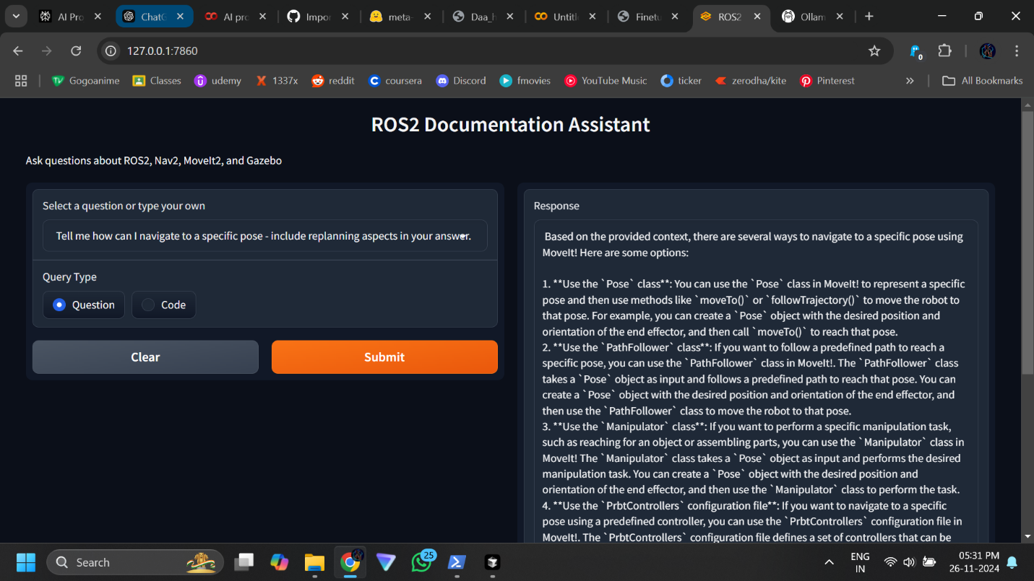

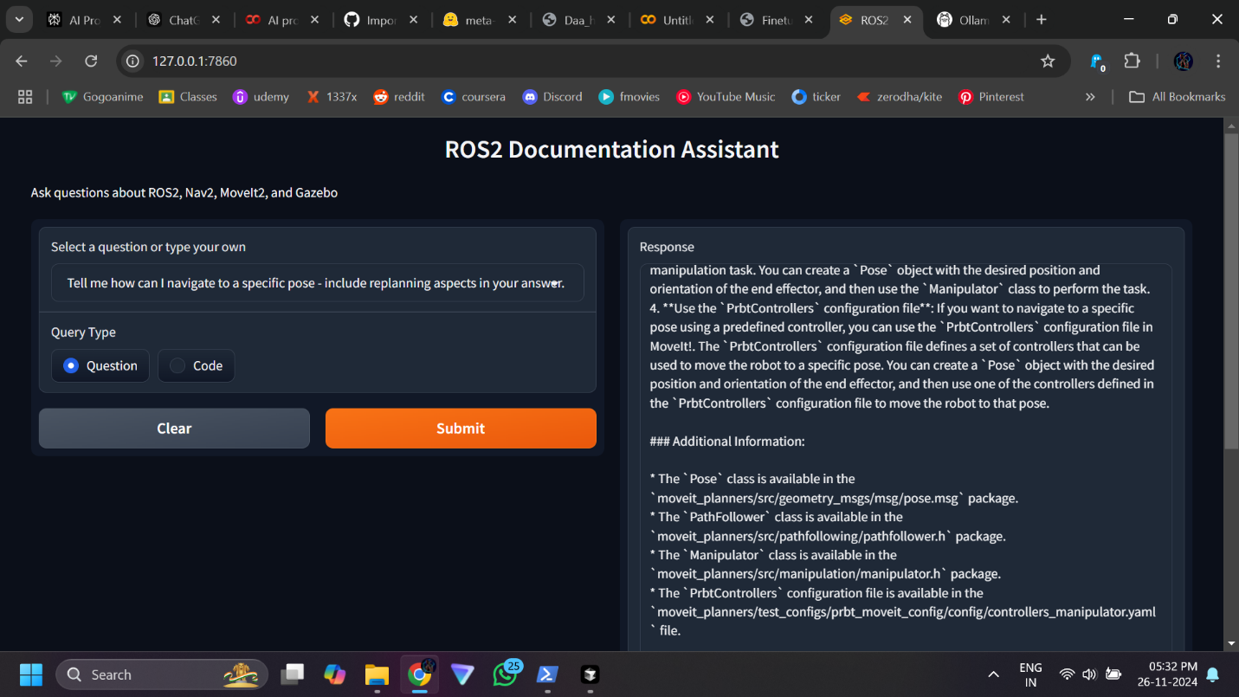

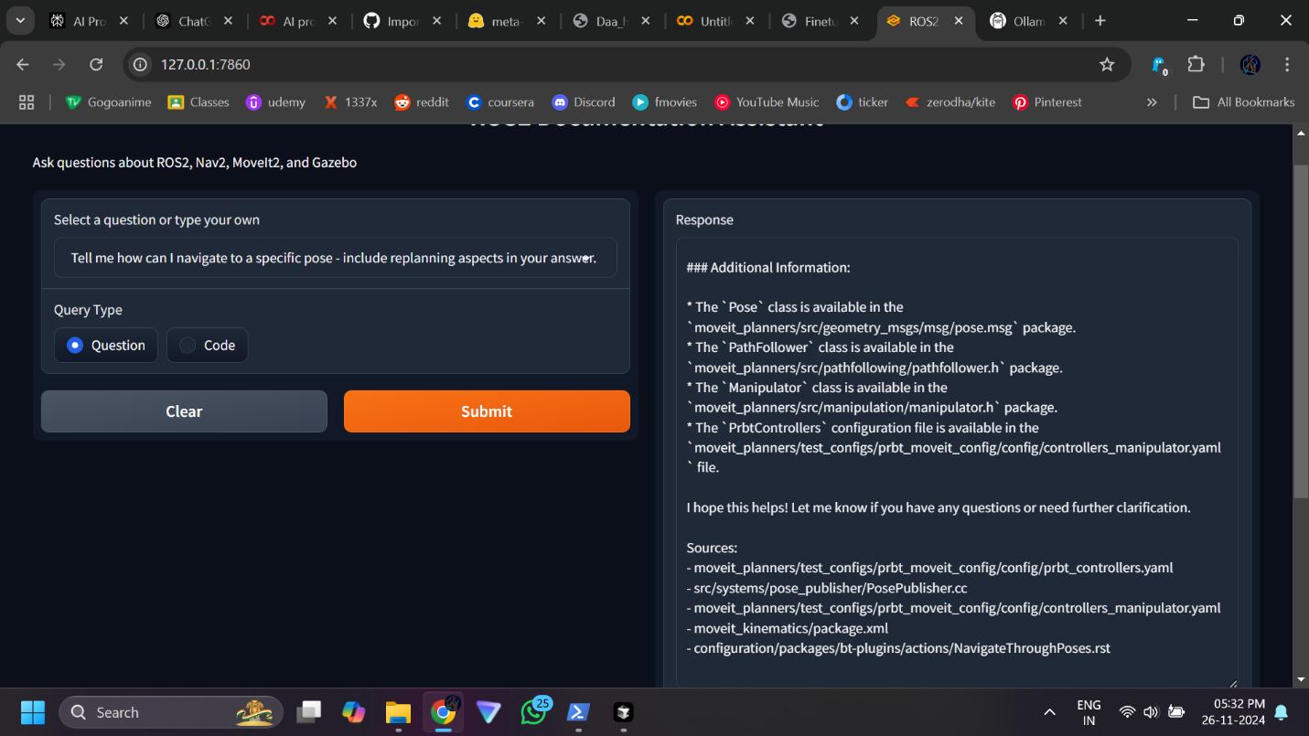

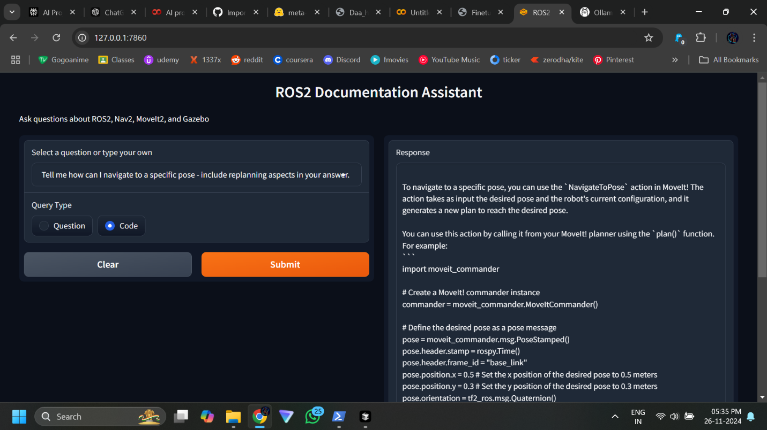

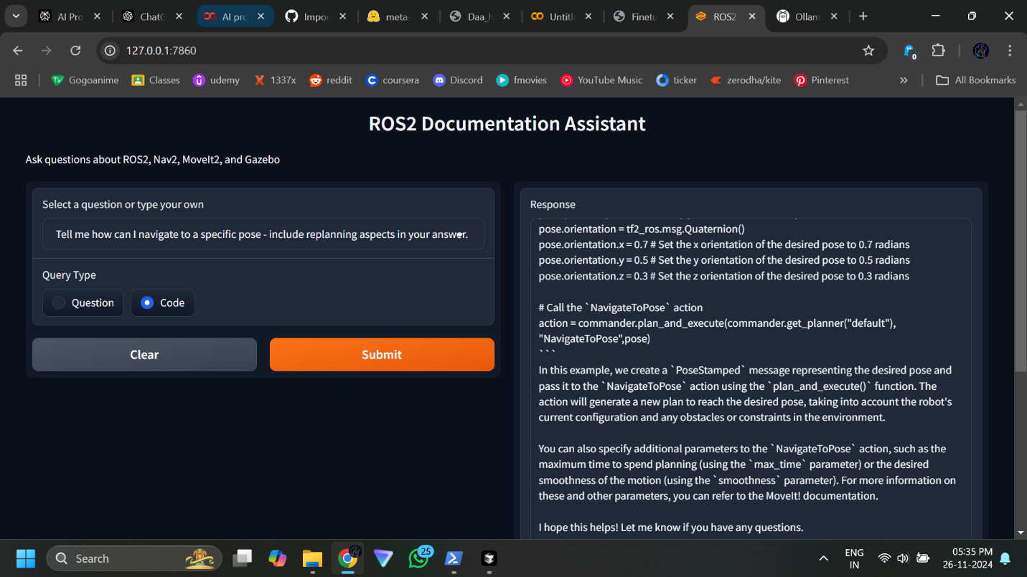

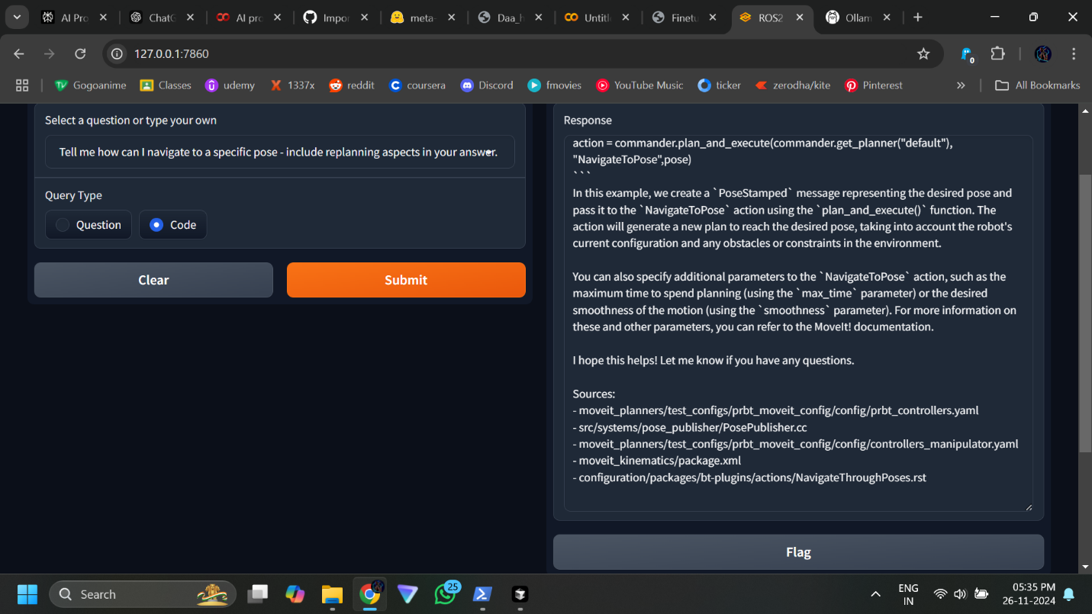

**Conclusions**

This project achieved its objectives of developing a specialized assistant for ROS2, combining advanced fine-tuning techniques with a sophisticated retrieval system. The model's seamless integration into the RAG framework amplifies its practical utility for robotics developers.