Let us see the execution of the project step by step.

Start the app and click on the server running at <https://127.0.0.1:5000>

This is the homepage of the application.

Click on Choose File and select the file that you want to test.

After selecting the file, click on Extract Keywords.

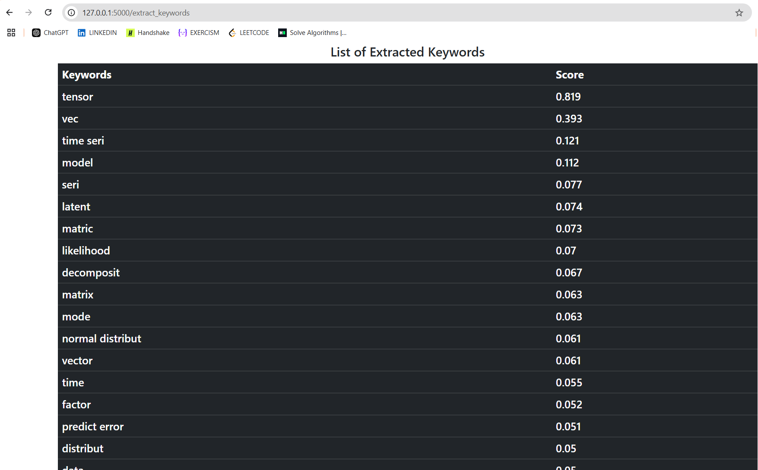

We get the list of keywords along with their scores.

We can compare the results with the words and score that we got from the code.

Go back and enter a keyword that you want to search.

This is the result that you get.

Go back and search for a keyword that is not present in the document.

Click on the Search keyword.

We get empty table as the keyword is not present in the document.