Name: Pranav Kalyani

Date: 4/17/2017

Section: Monday 630-800

Assignment:lab10

---------------------------------------------------------------------------------------------------------------------

**Problem 10.1**

$$A\left(t\right)=\frac{5}{\sqrt{t}}$$

A(24) = 1.02

---------------------------------------------------------------------------------------------------------------------

**Problem 10.2**

**Script**

clear

close

load('cardata.mat');

ii = 2;

while ii < 22

backward(ii-1) = ((v(ii)-v(ii-1))/4);

ii = ii +1;

end

p = 1;

while p < 21

forward(p) = ((v(p+1)-v(p))/4);

p = p +1;

end

cc = 2;

while cc < 21;

center(cc) = ((v(cc+1)-v(cc-1))/8);

cc = cc+1;

end

center(1) = forward(1);

center(21) = backward(20);

center(7)

plot(t,center)

xlabel('Time')

ylabel('Acceleration')

title('Acceleration v. Time')

**Command**

differentiation

ans =

0.2157

**Plot**

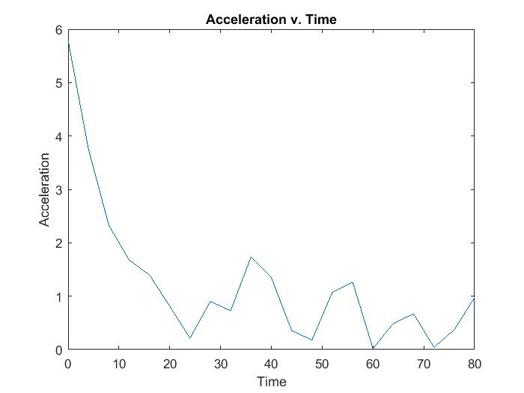

---------------------------------------------------------------------------------------------------------------------

**Problem 10.3**

X = (20/3).*t.^(3/2)

= 783.8367

---------------------------------------------------------------------------------------------------------------------

**Problem 10.4**

**Script**

clear

close

load('cardata.mat');

cc = 1;

while cc < 21

inter(cc) = (2*(v(cc+1)+v(cc)));

cc = cc + 1;

end

inter(21) = inter(20);

pp = 1;

tot = 0;

ee = 2;

totgraph(1) = inter(1);

while ee < 21

totgraph(ee)= inter(ee)+ totgraph(ee-1);

ee = ee + 1;

end

totgraph(21) = totgraph(20);

while pp < 7

tot = inter(pp)+ tot;

pp = pp + 1;

end

tot

plot(t,totgraph)

xlabel('Time')

ylabel('Position')

title('Position vs Time')

**Command**

>> integration

tot =

885.9632

**Plot**

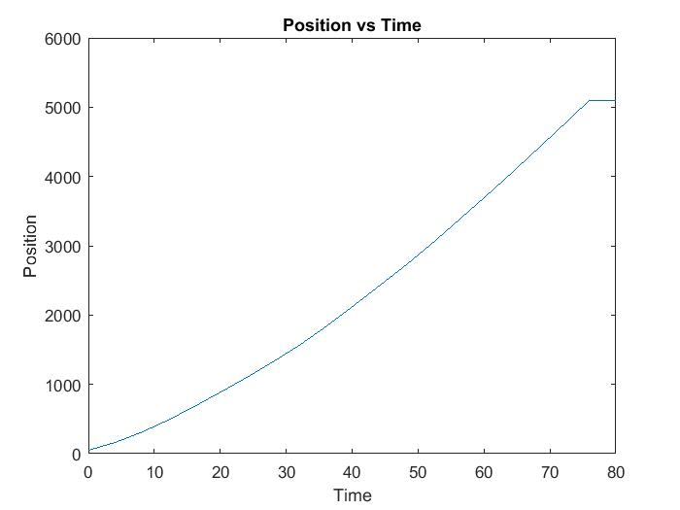

---------------------------------------------------------------------------------------------------------------------

**Problem 10.5**

**Script**

**(I know its alot of code but I got confused in the middle but I fixed the code without changing the original code … it came out pretty long sorry!!)**

clear

close

load('cardata.mat');

time05 = 0:.5:80;

time01 = 0:1:80;

time02 = 0:2:80;

timeto5 = 0:.5:79.5;

vel05 = (10)*time05.^(1/2);

vel01 = (10)*time01.^(1/2);

vel02 = (10)*time02.^(1/2);

cc = 1;

ee = 1;

totalposat5 = 0;

temp = 0;

totalposat1 = 0;

temp1 = 0;

totalposat2 = 0;

temp2 = 0;

while ee < 161

positionat05(ee) = ((1/4)*(vel05(ee+1)+vel05(ee)));

if(ee > 1)

temp = ee - 1;

totalposat5(ee) = positionat05(ee) + totalposat5(temp);

if(ee == 1)

totalposat5(1) = positionat05(1);

end

end

ee = ee + 1;

end

totalposat5(161) = totalposat5(160);

positionat05(161) = positionat05(160);

while cc < 49

pos05(cc) = ((1/4)*(vel05(cc+1)+vel05(cc)));

cc = cc + 1;

end

step05 = [sum(pos05, 2) (1-(sum(pos05)/783.84))*100]

pp = 1;

ll = 1;

while ll < 81

positionat01(ll) = ((1/2)*(vel01(ll+1)+vel01(ll)));

if(ll > 1)

temp1 = ll - 1;

totalposat1(ll) = positionat01(ll) + totalposat1(temp1);

if(ll == 1)

totalposat1(1) = positionat01(1);

end

end

ll = ll + 1;

end

totalposat1(81) = totalposat1(80);

positionat01(81) = positionat01(80);

while pp < 25

pos01(pp) = ((1/2)*(vel01(pp+1)+vel01(pp)));

pp = pp + 1;

end

step01 = [sum(pos01) (1-(sum(pos01)/783.84))*100]

dd = 1;

jj = 1;

while jj < 41

positionat02(jj) = ((vel02(jj+1)+vel02(jj)));

if(jj > 1)

temp2 = jj - 1;

totalposat2(jj) = positionat02(jj) + totalposat2(temp2);

if(jj == 1)

totalposat2(1) = positionat02(1);

end

end

jj = jj + 1;

end

totalposat2(41) = totalposat2(40);

positionat02(41) = positionat02(40);

while dd < 13

pos02(dd) = ((vel02(dd+1)+vel02(dd)));

dd = dd + 1;

end

step02 = [sum(pos02) (1-(sum(pos02)/783.84))*100]

figure

plot(time05, totalposat5)

xlabel('Time')

ylabel('Position')

title('Position vs Time @ .5')

figure

plot(time01,totalposat1)

xlabel('Time')

ylabel('Position')

title('Position vs Time @ 1')

figure

plot(time02,totalposat2)

xlabel('Time')

ylabel('Position')

title('Position vs Time @ 2')

**Command**

>> timelab10

step05 =

783.1230 0.0915

step01 =

781.8429 0.2548

step02 =

778.2970 0.7072

|  |  |  |
| --- | --- | --- |
| Step size | Position value | error |
| .5 | 783.1230 | 0.0915 |
| 1 | 781.8429 | 0.2548 |
| 2 | 778.2970 | 0.7072 |

**Plots**

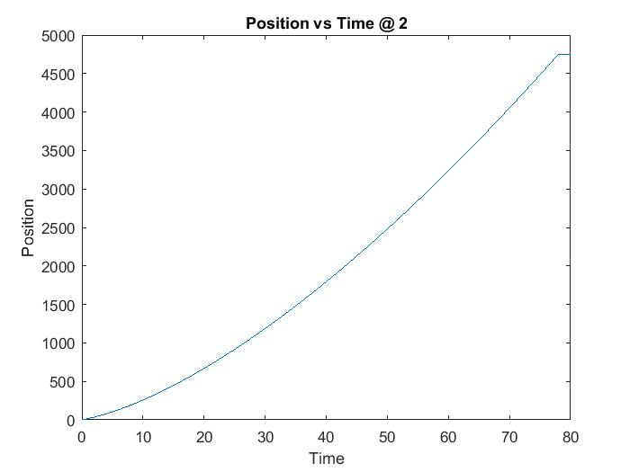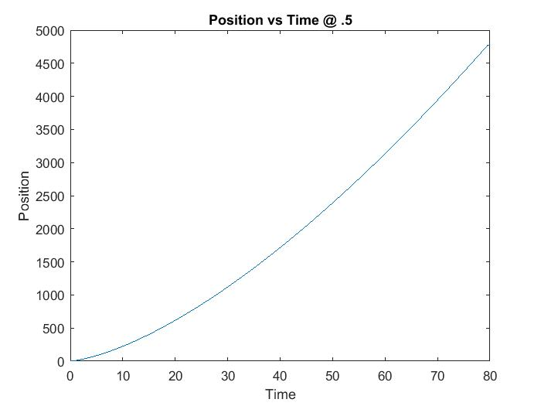

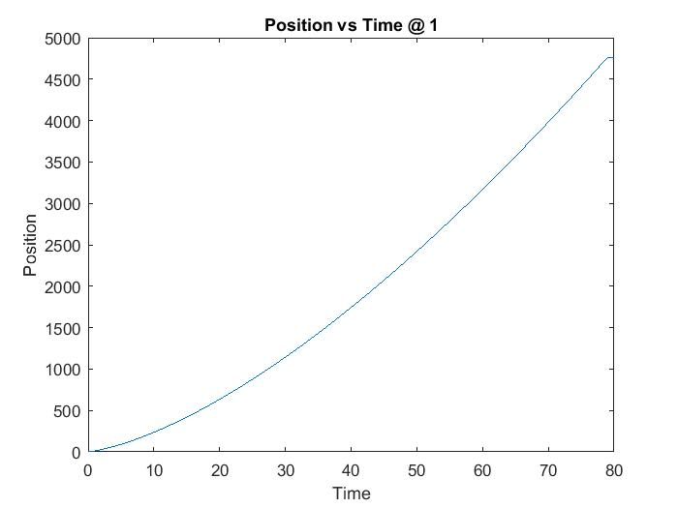

---------------------------------------------------------------------------------------------------------------------

**Problem 10.6**

**Script**

clear

close

load('cardata.mat');

simpson = (v(1) + 4*v(2) + 4*v(4) + 4*v(6) + 2*v(3) + 2*v(5) + v(7))*(4/3)

**Command**

>> simpsonlab10

simpson =

911.8884

---------------------------------------------------------------------------------------------------------------------

**Problem 10.7**

**Script**

clear

close

load('cardata.mat');

compositesimpson = (v(1) + 4*v(2) + 4*v(4) + 4*v(6) + 2*v(3) + 2*v(5) + v(7))*(24/21)

error = (1-(compositesimpson/783.84))*100

**Command**

compositesimpson =

781.6186

error =

0.2834

The composite Simpson’s method was more accurate than the trapezoidal method because the relative error between the Composite Simpson’s value and the actual value is less than the error given by the trapezoidal value. The Composite Simpson’s curve hugs the curve made by the actual values more suitably thus giving us a more accurate approximation to the position values.