Name: Pranav Kalyani

Date: 2/27/17

Section: Monday 630:800

Assignment: Lab 4

---------------------------------------------------------------------------------------------------------------------

**Problem 4.1**

Make sure that you comment your code properly. Copy and paste your code to a Word file

and also the output for the user input of array inputarray = [3, 9, -15, -1.8e-3, 1.8e3,

2400, -19000, 3.148, 96, 219].

Command Window

>> bubblesortpranav

Enter an array [3, 9, -15, -1.8e-3, 1.8e3,

2400, -19000, 3.148, 96, 219]

inputArray =

1.0e+04 *

-1.9000 0.0003 0.2400 -0.0000 0.1800

-0.0015 0.0009 0.0003 0.0096 0.0219

Script

inputArray = input('Enter an array'); % asks for an array

ii = length(inputArray); % gets the length

for j = 1:1:ii % first loop that will be used to keep one counter constant also decides how many loops

for s = 1:1:(ii-j) % inner loop thats going to be used to compare adjacent numbers

if(inputArray(s) > inputArray(s+1)) % compare first and second ... then second and third ….

temp = inputArray(s); % this template switched the two numbers

inputArray(s) = inputArray(s+1);

inputArray(s+1) = temp;

end

end

end

inputArray

---------------------------------------------------------------------------------------------------------------------

**Problem 4.2**

Make sure your code is well commented. Copy/paste your code and the contents of the third matrix in which the sum is stored.

Command

>> Randmatrix

array1 =

8.1472 1.2699 6.3236 2.7850

9.5751 1.5761 9.5717 8.0028

4.2176 7.9221 6.5574 8.4913

array2 =

9.0579 9.1338 0.9754 5.4688

9.6489 9.7059 4.8538 1.4189

9.1574 9.5949 0.3571 9.3399

array3 =

17.2052 10.4036 7.2990 8.2538

19.2240 11.2821 14.4254 9.4217

13.3750 17.5170 6.9145 17.8312

Script

for j = 1:1:3 % iterates to create rows

for s = 1:1:4 % iterates to create the columns

array1(j,s) = rand(1)*10; % adds a random number

array2(j,s) = rand(1)*10;

end

end

array3 = zeros(3,4); % intitailizes 3X4 array filled with zeros

for j = 1:1:4 % iterates through the columns

for s = 1:1:3 % iterates through the rows

array3(s,j) = [ array1(s,j) + array2(s,j)]; % adds the two arrays

end

end

array1

array2

array3

---------------------------------------------------------------------------------------------------------------------

**Problem 4.3**

Make sure that you title, label your plots and use the saveas command to save your figure in

a .jpg format in your code. Insert the figure in the solution template. Also copy/paste a well commented code into the solution template.

Command

displace =

Columns 1 through 7

0.5403 0.9048 0.4424 -0.3083 -0.6636 -0.3965 0.1557

Columns 8 through 14

0.4768 0.3388 -0.0592 -0.3352 -0.2793 0.0013 0.2309

Columns 15 through 19

0.1917 0.1555 0.1223 0.0925 0.0660

totaldisp =

5.7610

newdisplace =

0.0013

Script

function value = myfun() % creates the fn

cntr = 1; % counter 1

cntr2 = 1; % counter 2

x = 1;

y = 1;

z = 10;

t = 0:0.1:1.8; % time array

for ii = 1:1:length(t) % loop that iterates till it hits the length of the tme array

displace(cntr) = exp(-x * t(ii))* y * cos(z*t(ii)-y); % function

if abs(displace(cntr)) < .01 % compares the absolute values to .01

newdisplace(cntr2) = abs(displace(cntr)); % adds the values to a new array

z = t(ii); % takes in account for what time it happens

cntr2 = cntr2 +1; % increases the counter

end

cntr = cntr +1; % increases the counter

end

totaldisp = 0; % intitiates the variable

for ii = 1:1:length(t) % iterates till the length of t

totaldisp = abs(displace(ii)) + totaldisp; % adds the values of of the vector to a variable

end

displace % prints disp array

totaldisp % prints total disp

newdisplace % prints newdisplace value

plot(t,displace,'c'); % plots the graph with a cyan line

axis( [0 1.8 -1 1]);

title('Displacement vs Time');

xlabel('Time');

ylabel('Displacement');

hold on % uses the graph properties above to add something to the same graph

plot(z,newdisplace,'ro'); % plots the points in red circles

saveas(figure(1),'lab4.jpg');

end

Figure

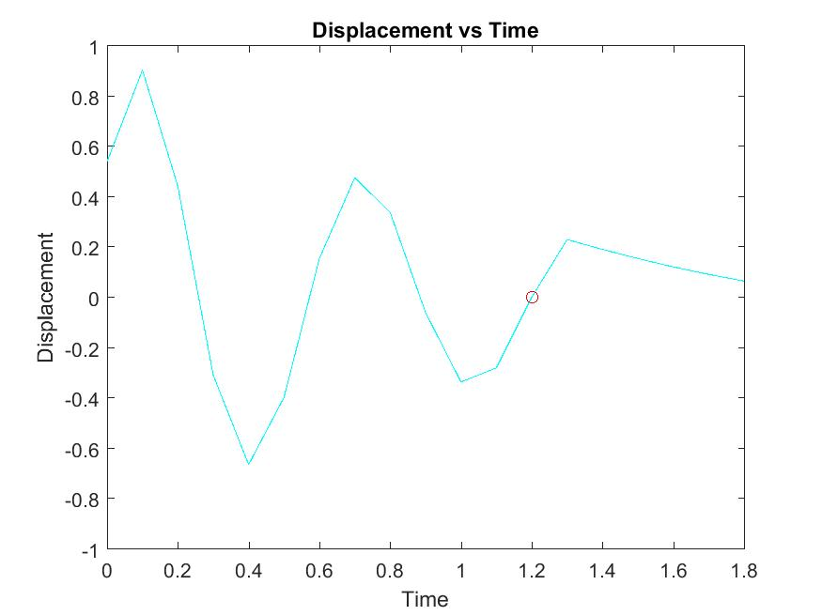

---------------------------------------------------------------------------------------------------------------------

**Problem 4.4**

Include the fixed code and add a comment on the line(s) where the error was in your output.

Desired output – 1 3 6 10 15 21

|  |  |  |
| --- | --- | --- |
| Desired Calc | | |
| i | Calc(i) | Mytran |
| 1 | (1/2)*2 | 1 |
| 2 | (2/2)*3 | 3 |
| 3 | (3/2)*4 | 6 |
| 4 | (4/2)*5 | 10 |
| 5 | (5/2)*6 | 15 |
| 6 | (6/2)*3 | 21 |

|  |  |  |
| --- | --- | --- |
| Error Calc | | |
| i | Calc(i) | Mytran |
| 1 | (6/2)*7 | 21 |
| 2 | (6/2)*7 | 21 |
| 3 | (6/2)*7 | 21 |
| 4 | (6/2)*7 | 21 |
| 5 |  |  |
| 6 |  |  |

n = input('How many numbers in the sequence do you want to see?'); %input was a string so I took out the s

mytran = zeros(1,n);

for i = 1:1:n % the iterations were divided by two

mytran(i) = (i/2)*(i+1); %N was a constant i is what is changing

end

disp ('The Triangular sequence is ');

mytran % vec wasn't intited or defined

Command

>> TriNumSeq

How many numbers in the sequence do you want to see?6

The Triangular sequence is

mytran =

1 3 6 10 15 21