Name: Pranav Kalyani

Eid – pk7683

Date: 3/6/17

Section: Monday 630-8

Assignment: Lab 5

---------------------------------------------------------------------------------------------------------------------

**Problem 5.1**

Command

>> myfunF(10)

ans =

-3.4106

>> myfunF([3 4 5])

ans =

-0.2078 -0.6100 -1.0907

>> myfunG(10)

ans =

70.0011

>> myfunG([3 4 5])

ans =

70.1201 70.3407 70.0315

Script

F(x)

function valueout = myfunF(x)

valueout = (3/500) * (x.^3-18.535*x.^2+25.697.*x+28.099);

end

G(x)

function valueout = myfunG(x)

valueout = 2*x.*exp(cos(3*x)).*exp(-x)+70;

end

---------------------------------------------------------------------------------------------------------------------

**Problem 5.2**

The Zeros appear to be near 16.9 and -.7

Plot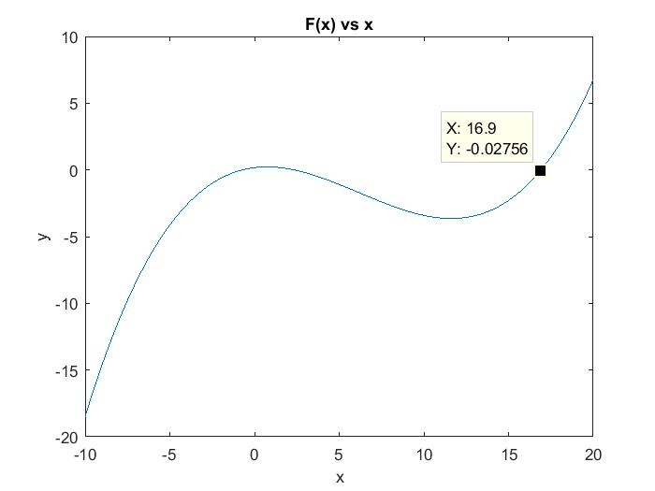

Script

x = -10:.1:20;

plot(x,myfunF(x))

title('F(x) vs x');

xlabel('x');

ylabel('y');

---------------------------------------------------------------------------------------------------------------------

**Problem 5.3**

Intital guess – (-.8,-.7) and (16,17)

Roots were at -.7128 and 16.9179

Command

>> bisection(-.8,-.7)

finalval =

-0.7128

ans =

-0.7128

>> bisection(16,17)

finalval =

16.9179

ans =

16.9179

Plot

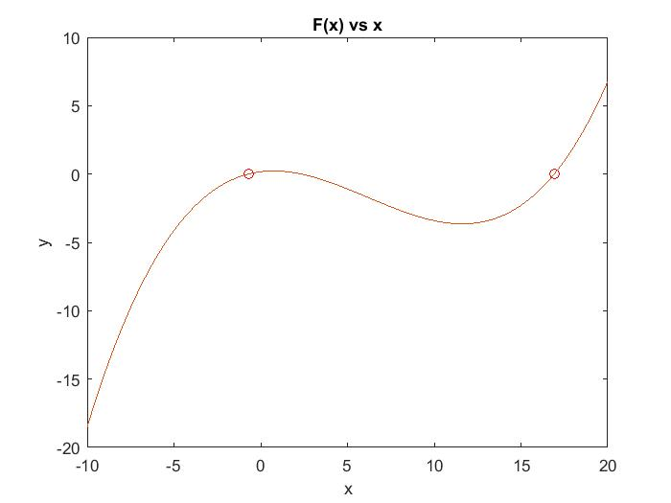

Script

function finalval = bisection(a,b)

cntr = 1; % counter to keep in track of the iterations

c = abs(b-a); % definces c

while cntr <= 20 && c > 1e-4

% condition where it kicks out after 20 iterations or if xb - xa < 1e-4

temp = (a + b)/2; % used to find Xm(for the bisection method)

if( myfunF(a) * myfunF(temp) < 0)

b = temp; %flips b to temp

else

a = temp; % flips a to temp

end

cntr = cntr +1;

c = abs(b-a);

end

finalval = temp

x = -10:.1:20;

plot(x,myfunF(x)) % plots f(x)

title('F(x) vs x');

xlabel('x');

ylabel('y');

hold on

plot(temp,myfunF(temp),'ro') % plots the point

---------------------------------------------------------------------------------------------------------------------

**Problem 5.4**

Initial Guesses (-3.5 , -3) ,(-3.5, -3), (-3.5 , -2)

And the roots were at -3.281, -2.6335, -1.961

Command

>> falsepostion(-3.5,-3)

c =

6.0128e-04

temp =

-3.2810

>> falsepostion(-3.5,-2.5)

c =

6.9977e-05

temp =

-2.6335

>> falsepostion(-3.5,-2)

c =

4.1252e-04

temp =

-1.9610

Plot

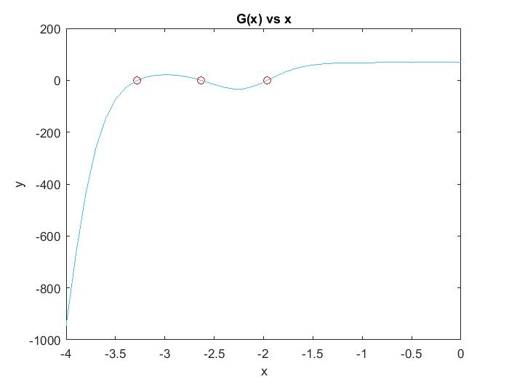

Script

function finalval = falsepostion(a,b)

cntr = 0;% counter to keep in track of the iterations

cntr2 = 1;

c = b; % definces c

temp = 1;

while cntr <= 100 && abs(c) >= 1e-3

% condition where it kicks out after 100 iterations or if f(xm) < 1e-3

fa = myfunG(a);

fb = myfunG(b);

temp = b - ((fb * (b - a))/(fb-fa)); % used to find Xm(for the false postion method)

if( myfunG(a) * myfunG(temp) < 0)

b = temp; %flips b to temp

else

a = temp; % flips a to temp

end

%temp2(cntr+1)=temp;

c =abs(myfunG(temp));

cntr = cntr +1;

end

%temp2

c % G(xm)

temp % xm

x = -4:.1:0;

plot(x,myfunG(x)) % plots G(x)

title('G(x) vs x');

xlabel('x');

ylabel('y');

hold on

plot(temp,myfunG(temp),'ro') % plots the point

---------------------------------------------------------------------------------------------------------------------

**Problem 5.5**

Script

>> newbisection(4,6)

finalval =

5.9999

ans =

70.0576

Plot

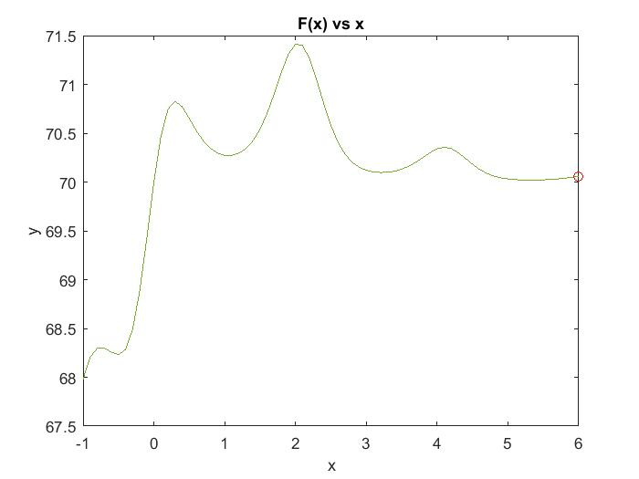  
The x value I got was 5.9999 and the function value at that point is 70.0576, it’s the last xm that can be created with in the 20 iterations

The function value is not near 0 because the interval doesn’t have a root. As shown by the graph above