Name: Pranav Kalyani

Date: 3/20/17

Section: Monday 630-8

Assignment: lab 6

---------------------------------------------------------------------------------------------------------------------

**Problem 6.1**

Command

>> newton(0)

ans =

-0.7136

>> newton(5)

ans =

2.3306

>> newton(15)

ans =

16.9183

Script

function finalval = newton(a)

cntr = 1; % counter to keep in track of the iterations

c = abs(myfunF(a)); %

while cntr <= 100 && c > 1e-3

% condition where it kicks out after 20 iterations or if xb - xa < 1e-4

a = a - (myfunF(a)/dervF(a));

cntr = cntr +1;

c = abs(myfunF(a));

end

finalval = a

myfunF(a)

x = -10:.1:20;

plot(x,myfunF(x)) % plots f(x)

title('F(x) vs x');

xlabel('x');

ylabel('y');

hold on

plot(a,myfunF(a),'ro') % plots the point

Plot

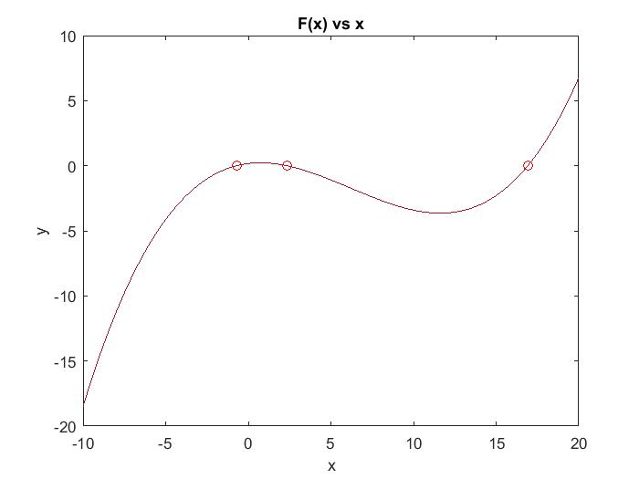

---------------------------------------------------------------------------------------------------------------------

**Problem 6.2**

Command

>> secant(-3.5,-3)

b =

-3.2810

>> secant(-3,-2.5)

b =

-2.6335

>> secant(-2,-1.5)

b =

-1.9610

Script

function finalval = secant(a,b)

cntr = 1; % counter to keep in track of the iterations

c = abs(myfunG(b)); % definces c

while cntr <= 100 && c > 1e-3

% condition where it kicks out after 20 iterations or if xb - xa < 1e-4

y2 = myfunG(b); % used to find Xm(for the bisection method)

y = myfunG(a);

x = b - ((b - a)/(y2 - y))*y2;

a = b;

b = x;

cntr = cntr +1;

c = abs(myfunG(b));

end

b

myfunG(b);

x = -3.5:.1:-1.5;

plot(x,myfunG(x)) % plots g(x)

title('G(x) vs x');

xlabel('x');

ylabel('y');

hold on

plot(b,myfunG(b),'ro') % plots the point

Plot

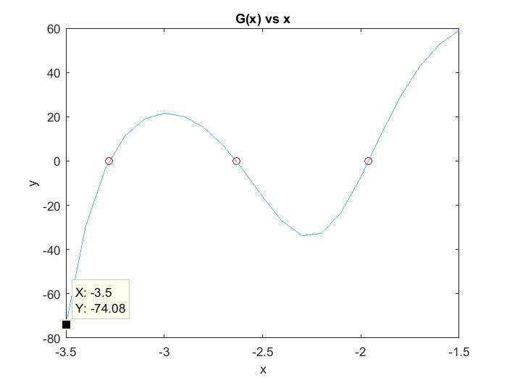

---------------------------------------------------------------------------------------------------------------------

**Problem 6.3**

Command

>> newton(11.61)

ans =

-0.7129

>> newton(11.62)

ans =

16.9182

The Difference between 11.62 and 11.61 is caused due the slope sign. The sign of the slope at 11.61 is negative thus the intersection of the derivative and the fx is to the left side. This drives the next point towards the left side 11.61. The sign of the slope at 11.62 is positive thus the intersection of the derivative and the fx is to the right side. This drives the next point towards the right side 11.62.

