Name: Pranav Kalyani

Date: 4/3/2017

Section: Monday 630-8

Assignment: lab 8

---------------------------------------------------------------------------------------------------------------------

**Problem 8.1**

**Script**

figure(1);

x=0:(pi/100):pi/2; % range for x alpha

y=0:(pi/100):(pi); % range for y beta

[xg,yg]=meshgrid(x,y);

z=cos(xg) + cos(xg + yg); % function

surf(xg,yg,z); % plots the 3d function for range

xlabel('alpha')

ylabel('beta')

zlabel('Range')

figure(2);

x=0:(pi/100):pi/2;

y=0:(pi/100):(pi);

[xg,yg]=meshgrid(x,y);

z=sin(xg) + sin(xg + yg); % plots the 3d function for height

surf(xg,yg,z);

xlabel('alpha')

ylabel('beta')

zlabel('Height')

Plots

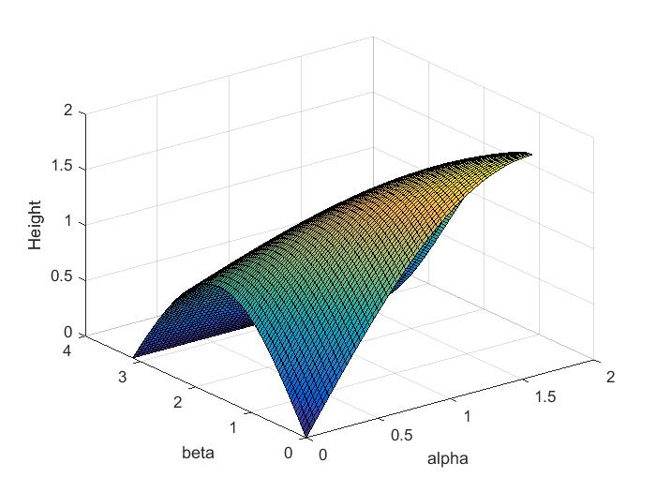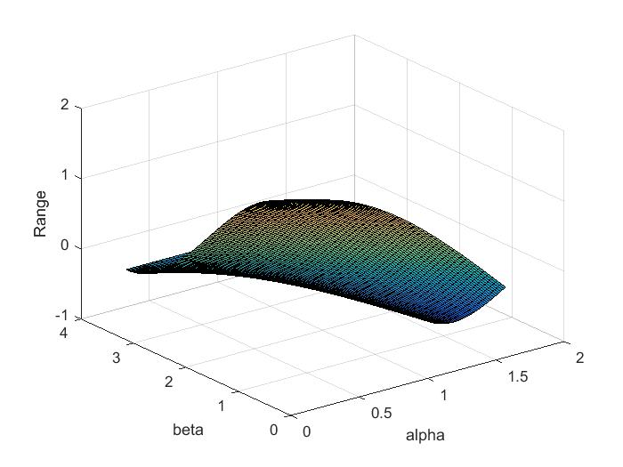

The maximum height is about at about alpha – pi/2 and beta 0.You want the joint to make a straight line going up thus beta should be 0. Alpha extends the furthest up when it hugs the y axis at 90 degrees (pi/2). And the robot cannot reach negative height because the angles are restricted to 0 to 90 degrees for alpha and 0 to 180 degrees. This setup mimics a real life arm that is only able to move the joints in a counterclockwise direction thus negative height is not possible.

---------------------------------------------------------------------------------------------------------------------

**Problem 8.2**

**1.**

**Script**

function x = vals8(x)

f1 = (cos(x(1)) + cos(x(1)+x(2))) - 1; % func 1

f2 = (sin(x(1)) + sin(x(1)+x(2))) - 1.1; % func 2

x = [f1;f2]; % disp vals in an array

end

**2.**

**Script**

function z = matrixL8(x)

f1y = -sin(x(1)+x(2));

f1x = -sin(x(1)) - sin(x(1)+x(2));

f2x = cos(x(1)) + cos(x(1)+x(2));

f2y = cos(x(1)+x(2));

z = [f1x f1y;f2x f2y];

end

---------------------------------------------------------------------------------------------------------------------

**Problem 8.3**

function z = newtonL8(x)

cntr = 1; % counter

c = 1; % initialize error

x = x'; % making the row into a column

while ((cntr <= 100) & (c > .01))

temp = x; % temp = xold

x = temp - (matrixL8(x)^(-1)) * vals8(x); % new x

c = abs(x - temp); % difference between new and old x

cntr = cntr + 1;

end

z = x;

end

---------------------------------------------------------------------------------------------------------------------

**Problem 8.4**

1. Initial guess (1,1)

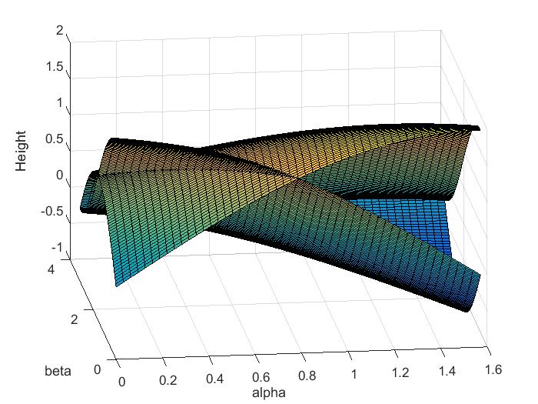

>> newtonL8([1,1])

ans =

0.1001

1.4657

The answer makes sense because it is included in the points where the two functions intersect. As shown by the graph above.

1. Newton method failed at (0,0) and (pi/2, pi)

Newton method failed because it got close to a point on the surface where the slope was near zero, or zero driving the next guess far away from the actual answer.

>> newtonL8([0,0])

Warning: Matrix is singular to working precision.

> In matlab.internal.math.mpower.viaMtimes (line 35)

In newtonL8 (line 7)

ans =

NaN

NaN

>> newtonL8([pi/2,(pi)])

Warning: Matrix is close to singular or badly scaled. Results may be

inaccurate. RCOND = 1.224647e-16.

> In matlab.internal.math.mpower.viaMtimes (line 35)

In newtonL8 (line 7)

ans =

1.0e+15 *

-8.9822

-0.0000