Homework 10

Problem 1a

Script

clear;

close

l=10;

E1=71e9;

p=1e3;

b=.05;

e1=.05;

ho=.05;

h=.1;

I=(b*ho^3)/12;

amnnode=l/h; % number of nodes

trigmatr=zeros(amnnode-1,amnnode-1); % trigonal matrix

node=zeros(amnnode-1,1); % node matrix

node(1)=0;

node(amnnode-1)=0;

c=0;

bulk=p/(E1*I);

Qx=2-(h^2)*bulk;

constant2=bulk*(e1*h^2/l);

for i=1:amnnode-1

trigmatr(i,i)=Qx; % diagonal part of the matrix

if i<amnnode-1 % adds negative to the horizontal or vertical direction of diagonal

trigmatr(i,i+1)=-1;

end

if i>1

trigmatr(i,i-1)=-1;

node(i)=constant2*c;

end

c=c+h;

end

matrixT=inv(trigmatr)*node;

y=[0;matrixT;0];

x=0:h:l;

plot(x,y)

title('Buckle')

**ypo Guess = .002**

Plot

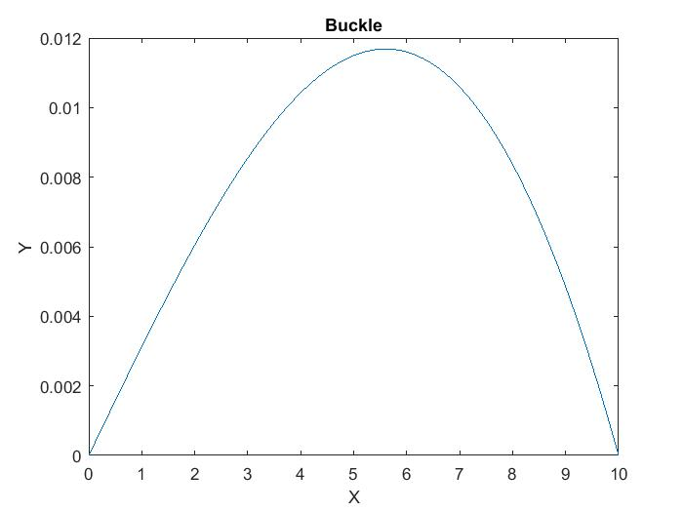

Problem 1b

A)

$$\frac{dz}{dx}= \frac{-P}{EI}(\frac{ex}{L}+y)$$

$$\frac{dy}{dx}= Z$$

B)

ybl = -0.0142

C)

ycl =

0.0041

D)

YL=

0.0032

E)

error = 2.5919e-17

Code for the Shooting method

function [y] = shootingmethod3(g)

l= 10;

E1 = 71e9;

P = 1e3;

e1 = .05;

h = .01;

b = .05;

ho = .05;

I = (b*ho^3)/12;

L = 0:h:l;

y=0;

z=g;

c = 0;

for ii=1:length(L)-1

k1y = z;

k2y = z + (k1y * h * (1/2));

k3y = z + (k2y * h * (1/2));

k4y = z + (k3y * h);

yslope = (k1y + 2*k2y + 2*k3y + k4y)/6;

k1z = (-P/(E1*I))*(((e1*c)/l)+y);

k2z = (-P/(E1*I))*(((e1*c+.5*h)/l)+y+k1z*.5*h);

k3z = (-P/(E1*I))*(((e1*c+.5*h)/l)+y+k2z*.5*h);

k4z = (-P/(E1*I))*(((e1*c+h)/l)+y+k3z*h);

vslope = (k1z + 2*k2z + 2*k3z + k4z)/6;

z = z + vslope * h;

y = y + yslope * h;

c = c + .01;

end

end

Code for the Boundary conditions with linear interpolation (false position method)

function valueout = fixer(ypo,yl)

a=.5;

b =2;

cntr = 0;

while cntr==0

ybl=shootingmethod3(a*ypo)

ycl=shootingmethod3(b*ypo)

if ybl>=0 & ycl<=0 % conditions to check whether out bounds contain the answer

cntr=1;

elseif ycl>=0 & ybl<=0

cntr=1;

else

ypo = input('guess ypo again')

end

end

valueout= ypo*a+(((ypo-a )* b *ypo)*(yl-ybl))/(ycl-ybl); % linear approximation

error = abs(shootingmethod3(valueout)-yl);

error

end