Name: Pranav

Date: 4/10/17

Section: Monday 630-8

Assignment: lab9

---------------------------------------------------------------------------------------------------------------------

**Problem 9.1**

**Script**

vec1 = [.5 .73 .96 1.19 1.42 1.65 1.88 2.11 2.34 2.57 2.80 3.03 3.26 3.49 3.72];

vec2 = [6.580 5.750 5.201 5.028 4.406 3.858 3.960 3.371 3.032 3.130 2.259 2.516 2.321 1.776 1.813];

vec3 = (-1.4)*vec1 +6.7;

figure

plot(vec1,vec2,'o')

hold on

plot(vec1,vec3)

xlabel('Distance')

ylabel('Amplitude')

title('Amplitude vs distance')

**Plot**

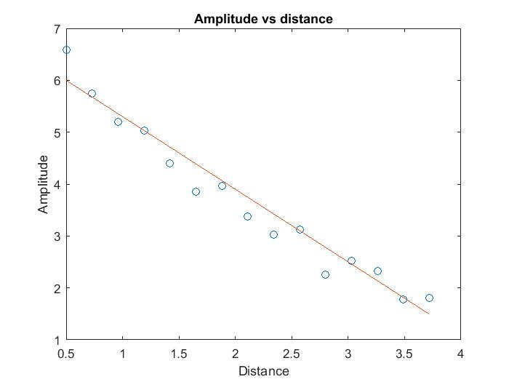

---------------------------------------------------------------------------------------------------------------------

**Problem 9.2**

**Script**

vec1 = [.5 .73 .96 1.19 1.42 1.65 1.88 2.11 2.34 2.57 2.80 3.03 3.26 3.49 3.72];

vec2 = [6.580 5.750 5.201 5.028 4.406 3.858 3.960 3.371 3.032 3.130 2.259 2.516 2.321 1.776 1.813];

vec3 = (-1.4)*vec1 +6.7;

vec4 = (vec3 - vec2).^2;

e = sum(vec4)

**Command**

>> q2lab9

e =

1.4626

---------------------------------------------------------------------------------------------------------------------

**Problem 9.3**

**Script**

vec1 = [.5 .73 .96 1.19 1.42 1.65 1.88 2.11 2.34 2.57 2.80 3.03 3.26 3.49 3.72];

vec2 = [6.580 5.750 5.201 5.028 4.406 3.858 3.960 3.371 3.032 3.130 2.259 2.516 2.321 1.776 1.813];

vec3 = polyfit(vec1,vec2,1);

a = vec3(1)

b = vec3(2)

vec4 = a*(vec1) + b;

vec5 = (vec4 - vec2).^2;

e = sum(vec5)

**Command**

>> q3lab9

a =

-1.4051

b =

6.6314

e =

1.3679

---------------------------------------------------------------------------------------------------------------------

**Problem 9.4**

**Script**

vec1 = [.5 .73 .96 1.19 1.42 1.65 1.88 2.11 2.34 2.57 2.80 3.03 3.26 3.49 3.72];

vec2 = [6.580 5.750 5.201 5.028 4.406 3.858 3.960 3.371 3.032 3.130 2.259 2.516 2.321 1.776 1.813];

yprime = log(vec2);

figure

plot(vec1,yprime,'o')

xlabel('Distance')

ylabel('yprime')

title('Amplitude vs yprime')

vec3 = polyfit(vec1,yprime,1);

aprime = vec3(1)

bprime = vec3(2)

vec4 = aprime'*(vec1) + bprime;

figure

plot(vec1,yprime,'o')

hold on

plot(vec1,vec4)

xlabel('Distance')

ylabel('yprime')

title('Amplitude vs yprime')

a = exp(bprime)

b = -1*aprime

expofit = a*exp(-1*b*vec1);

figure

plot(vec1,vec2,'o')

hold on

plot(vec1,expofit)

xlabel('Distance')

ylabel('Amplitude')

title('Amplitude vs distance')

**Command**

>> q4lab9

aprime =

-0.3970

bprime =

2.0590

a =

7.8383

b =

0.3970

**Plots**

**A)**

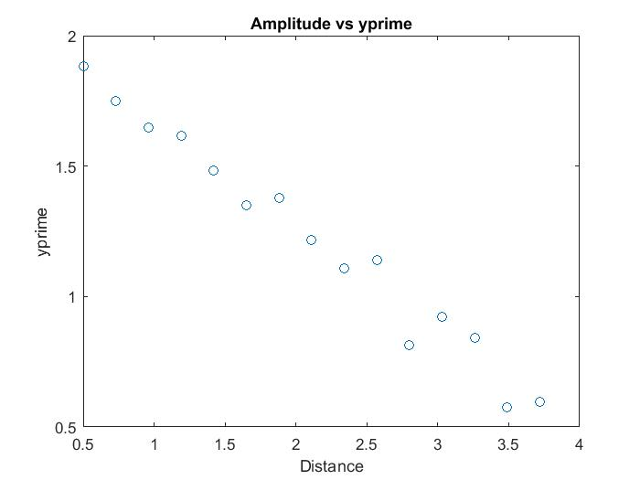

**B)**

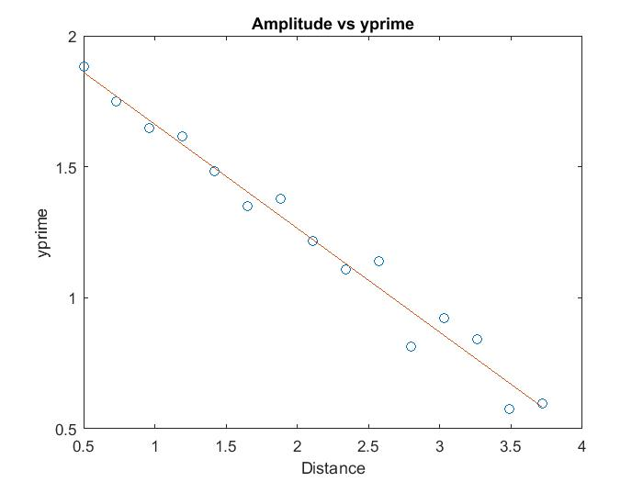

**C)**

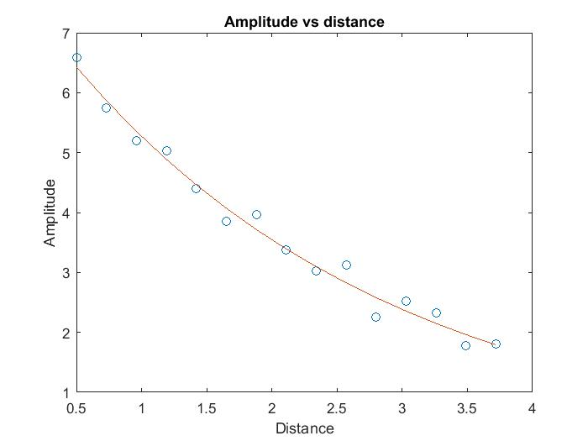

---------------------------------------------------------------------------------------------------------------------

**Problem 9.5**

Exponential fit is a better fit because it hugs the curve made by the points more accurate

Exponential fit @ 4

>> 7.8383*exp(-0.3970*4)

ans =

1.6016

---------------------------------------------------------------------------------------------------------------------

**Problem 9.6**

Richness of data matters when curve fitting because if you have a limited amount of terms it could cause your curve fit to be inaccurate because it doesn’t have sufficient data to create the right curve and predict the trend.

Very complex fits may increase the time of creating a fit, thus it will take a long time from a computer to come up with a trend for enormous amounts of data.

Initial trend fit guess Is important. If you pick a wrong fit to describe a set of points you are not going to be able to get an accurate trend. Also, your data needs to have a trend, if just random points you won’t be able to predict the type of curve neither will the computer program.