Title: Offline Automatic Dashboard System – Architecture

Objective
To design a fully offline analytics dashboard system for confidential maintenance data.

Design Constraints
- No internet connectivity
- No cloud usage
- Data confidentiality
- Editable dashboards

Architecture Overview
The system consists of the following layers:
- Data Ingestion Layer
- Feature Store & Normalization
- Data Profiling Layer
- ML Engine
- Rule Engine
- Insight Orchestrator
- Dashboard Blueprint Generator
- Frontend Intelligence Layer
- Local Data Storage

Key Design Principle
Analytics logic is handled at the backend, while the frontend focuses on visualization and configurability.

Future Extensions (Planned)
- Rule-based analytics engine
- Machine learning–based anomaly detection
- Feature store for derived maintenance metrics
- Support for SAP IW29, PLC/OPC UA, RFID, and Excel datasets

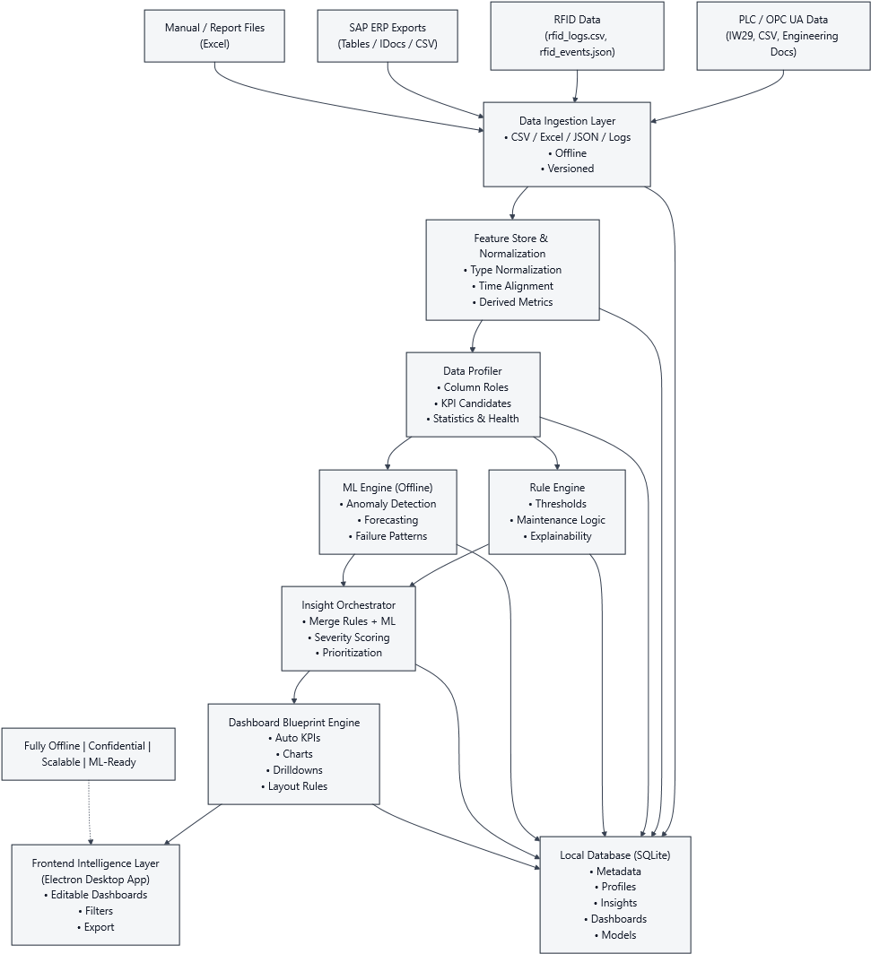
Offline Industrial Data Intelligence Platform Full Advanced Architecture

Operational Excel Ingestion Layer
The system includes a dedicated ingestion pathway for messy, human-maintained operational Excel files commonly used by maintenance engineers.
Unlike system-generated data, these files exhibit inconsistent layouts, merged cells, and mixed content. To address this, the ingestion layer employs heuristic-based table detection and schema-less validation to safely capture all available data without rejection.
Extracted tables and contextual metadata are persisted in a versioned raw format, enabling downstream Feature Store logic to normalize and interpret the data for analytics and dashboard generation.

Feature Store & Normalization Layer
The Feature Store & Normalization layer sits between the Data Ingestion Layer and downstream intelligence components.
Key Responsibilities
- Time alignment of heterogeneous industrial data sources
- Feature derivation and aggregation
- Configuration-driven normalization
- Feature validation and governance
Architectural Significance
- Decouples raw data capture from analytics interpretation
- Ensures deterministic, reproducible feature generation
- Enables scalable ML and rule-based analytics
The Feature Store acts as the semantic backbone of the system, ensuring that all analytics and dashboards are driven by trusted, validated features rather than raw, inconsistent data.
Day 6: - No architectural layer changes were introduced.
Frontend responsibilities were clarified as:
- Read-only intelligence consumer
- Export orchestration interface
- Visualization and explainability layer
Backend logic boundaries remain unchanged.

