PRANAV SINGH  Enterprise Architect  Contact Information  pranav_withyou@hotmail.com  +91-9818086064(Mobile)  Nationality : Indian  Languages : English, Hindi  LinkedIn  linkedin.com/in/simplyinvincible/  GitHub  github.com/pranavq212  StackOverflow    Certification Badges  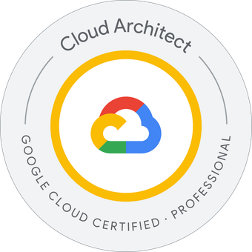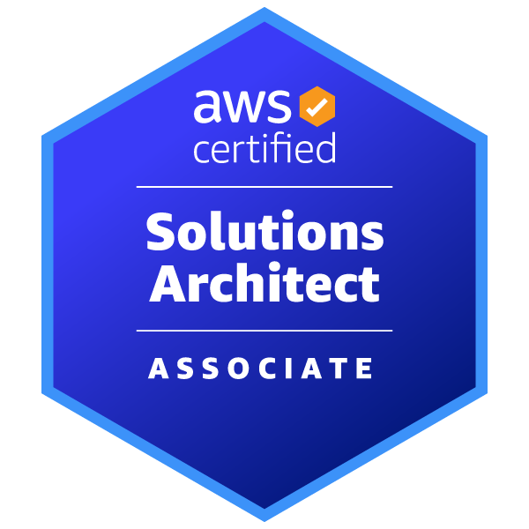  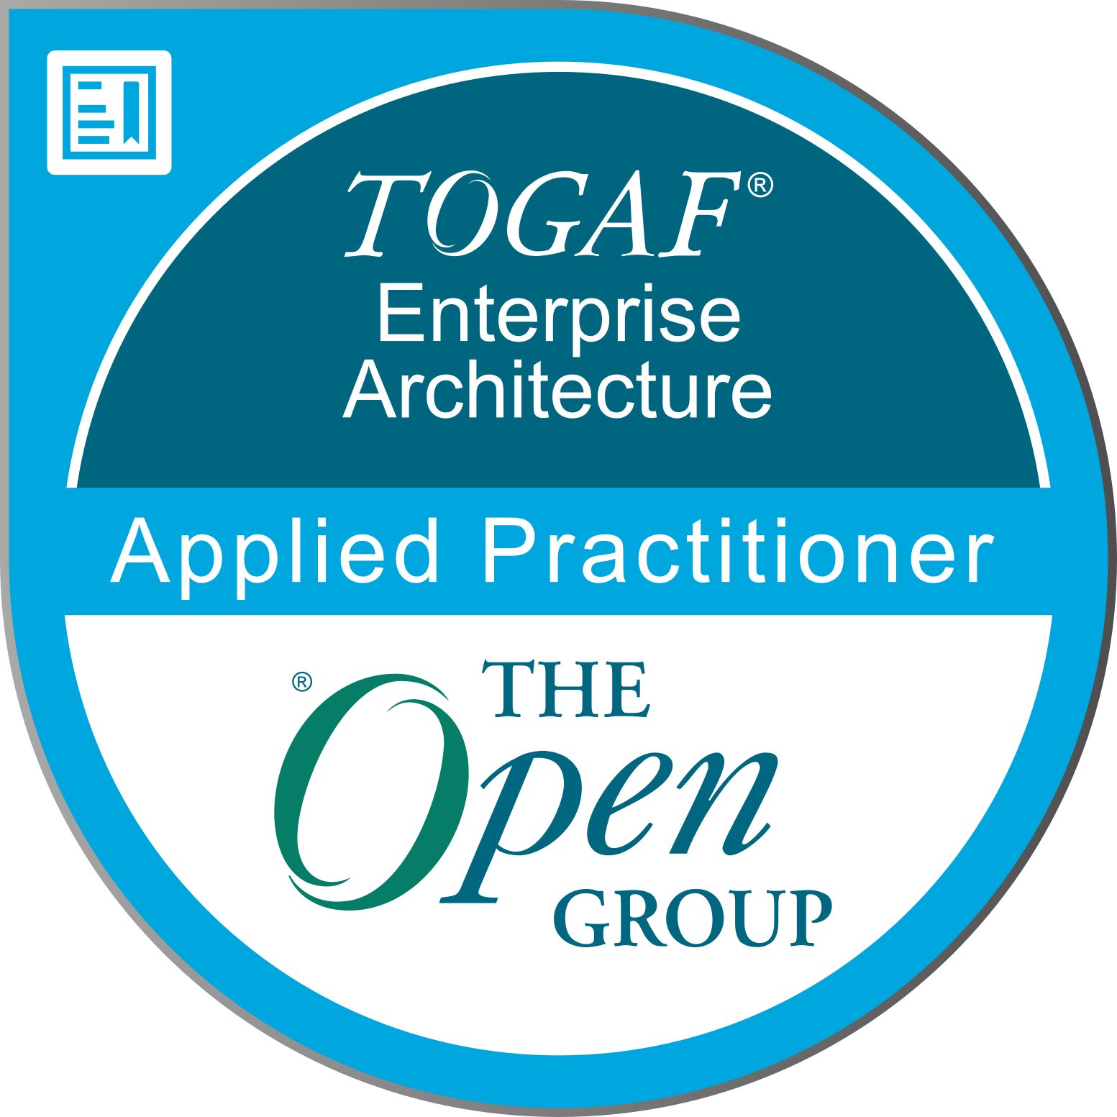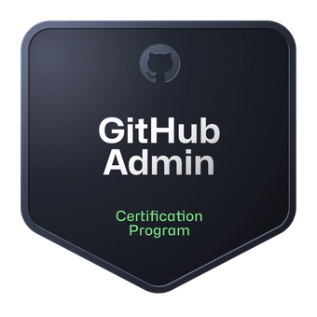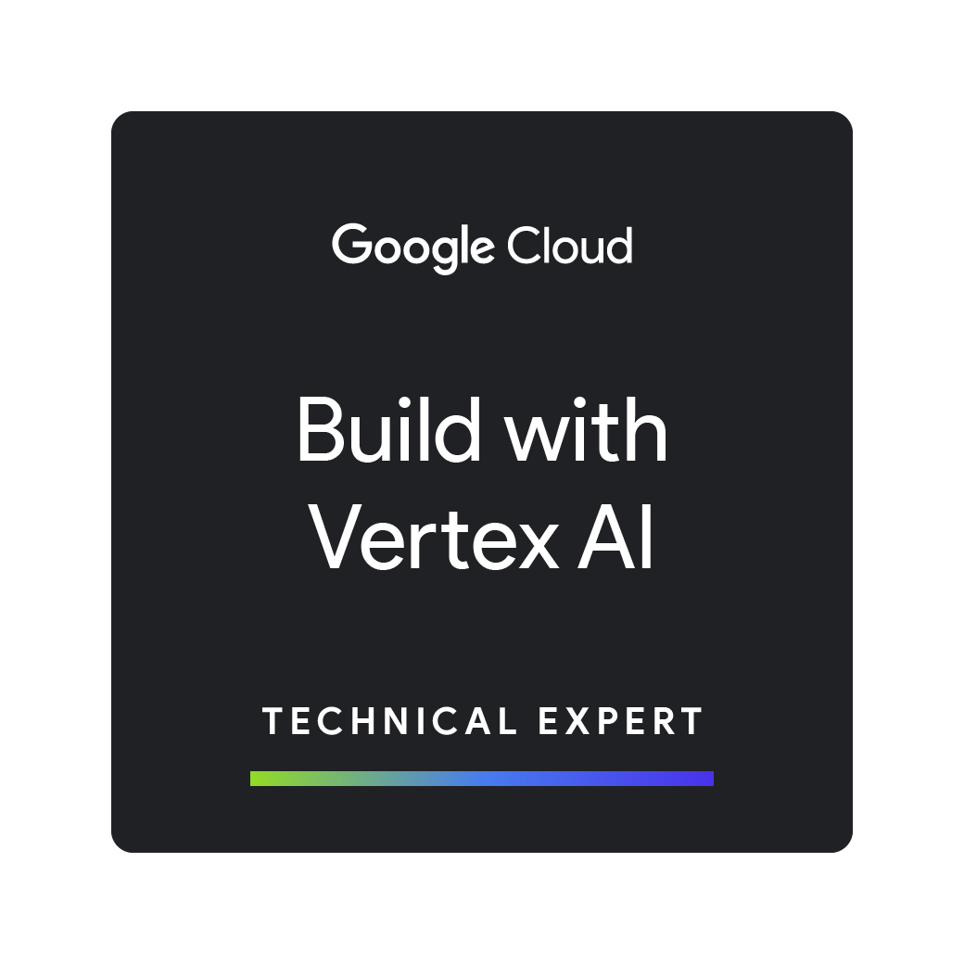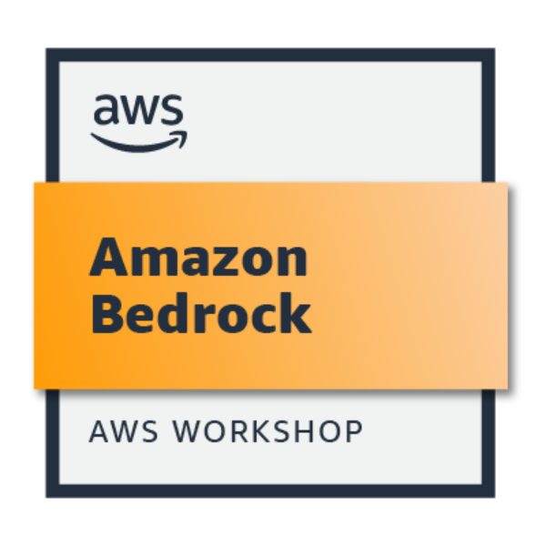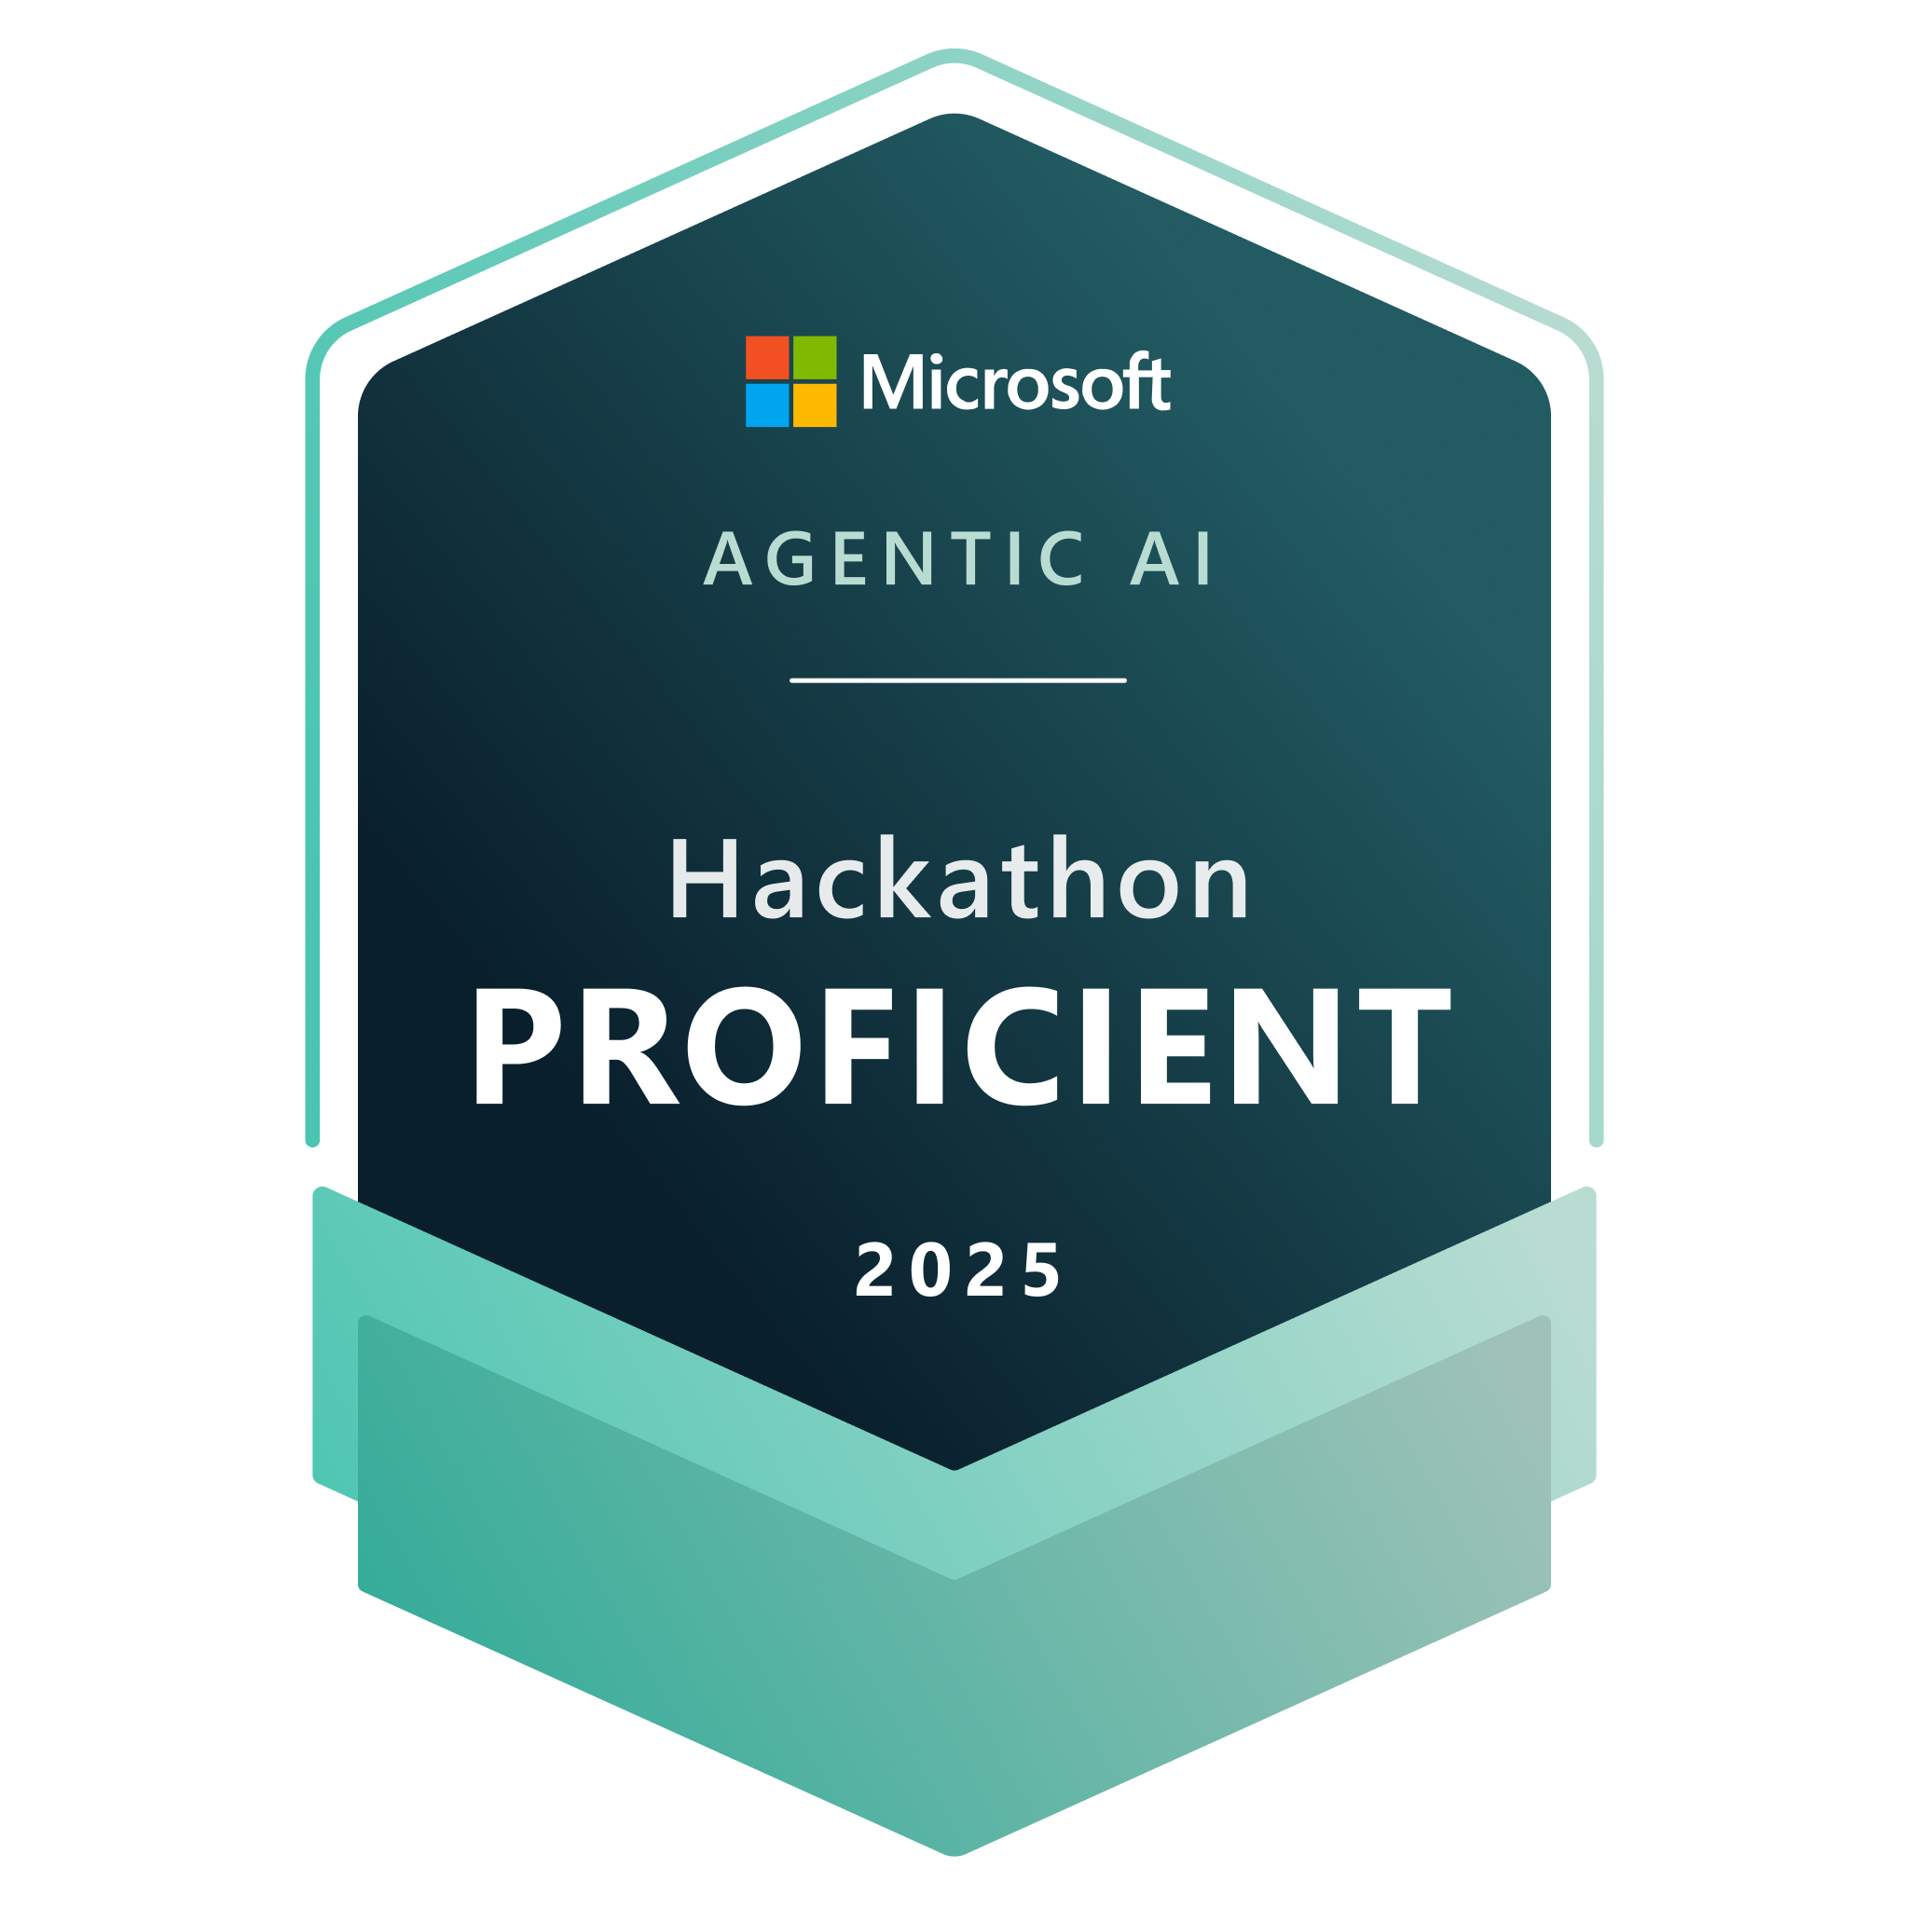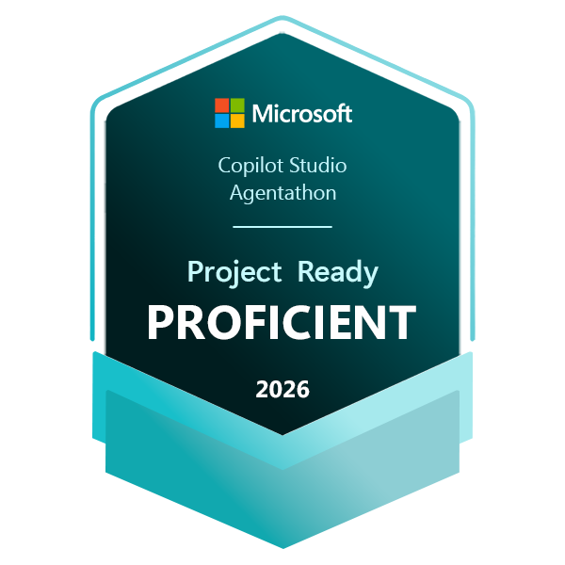  All Credly Badges  Credential.net Badges  Microsoft Learn Profile | Experience Summary  16 + years of total work experience in the following fields:  - Experience of leading multiple projects from requirement analysis to post-implementation phases including Design, Development, Deployment, Optimization and Maintenance.  - Driving AI Initiatives for improving development efficiency using AI tools like GitHub Copilot, Gemini, Claude, Cursor AI, Amazon Q  - Evaluating LLMs, AI platforms and implementing Agentic AI for value generation in client businesses.  - Hands-on working experience with different AI Platforms including Anthropic Claude, GitHub Copilot, Azure AI Foundry, Copilot Studio, Google Cloud Gemini, Vertex AI and Amazon Bedrock  - Experience in different domains including Retail, Commodities, Oil, Trading and Risk Management, Energy sector, Security, Travel and Health Care domain  - Experienced in onsite work & onsite co-ordination in multiple geographies including USA, NA, APAC, Japan, UK, Germany, Singapore, Gulf and ANZ.  - Good understanding Enterprise Design, TOGAF, Microservices, Blockchain, Agile, Kanban, Scrum, SAFe, UML, DevOps & Chaos Engineering.  - Experience of on-premises/legacy migration or modernization to cloud, design & develop in Multi Cloud or Poly Cloud including AWS, Azure and GCP.  - Experienced in involving in Pre-Sales, Project Pre-Launch Studies, Defining Project Goals, Road Map, Dependencies, Implementation Governance & SOW activities of IT Projects.  - Experienced in Cost Optimization, FinOps, Security and Performance Optimization for production applications.  - Experienced in Recruitment, Interviews, Vendor Management and Partnering Companies for building team.  - Experienced in coaching team, setting up team goals and providing support to achieve them.  - Experienced in Agile process in Product Backlog prioritization, PI Planning, Agile Estimation, Spikes, POCs, scope and design discussions with Client SMEs, Product Owners & Architect teams.  - Experience in API management (security, rate limiting, quotas, analytics, and subscription, REST, SOAP, JSON API, GraphQL) with Azure APIM, AWS API Gateway, TYK & Google APIGEE.  Certifications and Fellowship  - Junior Research Fellow (JRF) at IIT, Roorkee.  - Finishing School Program, 2009 from IIT Roorkee.  - Microsoft Certified Azure Solutions Architect Expert, Agentic AI Business Solutions Architect, AWS Certified Solutions Architect, GCP Professional Cloud Architect, TOGAF Enterprise Architecture Practitioner, Gremlin Certified Enterprise Chaos Engineering GECEC, PMI - Wicked Problem Solving Practitioner, Certified SAFe Agilist, API Academy Certified.  Awards & Participation  - Among the top 3 in SDLC Quiz Contest held by Microsoft.  - Among top teams in GlobalLogic Master Mind Biz Value contest  - Client-Focused delivery Sapient Core-value award.  - Client WOW Award at 3PillarGlobal.  Educational Qualifications  - B.Tech. (Computer Science & Engineering) from F.E.T., G.K.V. Haridwar, U.K. (2004-2008) with 77.3%.  - PGDBA (Marketing) from Symbiosis Centre for Distance Learning (2009-2011) with A grade.
Professional Experience
Solution Architect (Solution Architect) Dec 2023– Present
GlobalLogic
GlobalLogic, a Hitachi Group Company, is a trusted digital engineering partner to the world’s largest and most forward-thinking companies.

Roles: Solution Architect

Business Domains worked with: Retail, Ecommerce, Healthcare, Industry, Energy, Agentic AI integration

Responsibilities:
- Led agentic AI integration initiatives, including orchestration governance and MCP enablement.
- Delivered POCs for agent-to-agent, multiagent communication and reusable integration accelerators.
- Designed uniform integration platforms for cost optimization and cloud-native adoption.
- Standardized API contracts and event-driven flows across retail, healthcare, and energy domains.
- Partnered with DevOps and platform teams to ensure observability, resilience, and security in integrations.
- Cross vendors and cross teams’ dependency management.
- RFP for new Clients and projects
- Working on AI, GenAI and Agentic AI initiatives, implementation governance and new POCs.

Technologies worked with: Microsoft Copilot, Cofoundery, AWS Bedrock, Sagemaker, GCP VertexAI, Gemini, Azure, Azure DevOps, C#, .Net 6, 8, 10, SQL, Cosmos, WebApps, Azure Functions, Appservices, LogicApps, ServiceBus, AppInsight, OutSystems, Lucid, Google Cloud, C#, .Net 10.0, Oracle, MongoDB, Gigya Identity access management, SecretManager,Tyk API Gateway, Rancher, Kubernetes, Docker, Aurus, Avlara, Kafka, Kibana, Apache Airflow, Google BigQuery, Vtex Ecommerce Platform, Adobe AEM, SonarQube, AuditWorks, Mermaid, Shopify, SAP integration, Snowflake, Github copilot, Gemini, Azure AI Foundry, AWS, SQS, SNS, S3, API Gateway, Event Bridge, Appconfig, Systems Manager, Bedrock, Amazon Q

Associate Principal Engineer (Software Architect) Apr 2021– Dec 2023
Nagarro
Nagarro is a global digital engineering company that provides services such as software product engineering, enterprise digital transformation, and customer experience consulting.

Roles: Software Architect, Technical Architect and Individual contributor

Business Domains worked with: Energy, Commodities, Technology, GenAI

Responsibilities:
- Designing & development of Simulator systems from scratch for multiple devices.
- Designing & developing lambda functions for data integration from other services
- Developing Calculation Engine to combine multiple Lambda functions to do complex calculations.
- Developing JSON API & helping UI team to integrate.
- Interaction with other teams with cross-teams dependency & design closure.
- Interacting with Client for Sprint Planning, Grooming and Requirement gathering.
- Managing the Dev, QA & Prod environments for FMaaS for multiple plants.
- Onboarding new plants to environments
- Developing CI/CD pipelines, Deployment & testing.
- Helping team members in solving security and performance issues.

Environment: AWS Lambda, PostreSQL, C#, .Net 5,6, Entity Framework, SQS, SNS, S3, API Gateway, Event Bridge, Appconfig, Systems Manager, JSON API, AWS Fargate, Amazon Elastic Container Service, yaml, Docker, PostgreSQL, SignalR, AngularJs, Azure DevOps, Git, Azure Web Apps, Azure functions, APIM, C++, GenAI

Senior Associate, Platform L2 (Technical Architect) Jan 2017– Apr 2021
Publicis.Sapient
Publicis Sapient is a digital transformation partner helping established organizations get to their future, digitally-enabled state, both in the way they work and the way they serve their customers.
Role: Technical Architect, Azure & Microsoft Technology Specialist, API Architect

Business Domains worked with: Banking, Trade Finance, Energy, Commodities, CTRM, Retail, Data Management, Oil, pipeline management, cargo tracking

Responsibilities:
- Responsible for ensuring that technical solution meets performance, reliability requirements.
- Responsible for developing Web APIs / End Points for the Digital Platform.
- Responsible for Configuring infrastructure, CI/CD via Team City and Octopus
- Part of Cash-banking team for development & technical implementation.
- Developing Azure Logic apps & azure function for integration with different COTS & internal systems.
- Maintaining code sanctity by peer-review, code-coverage and Unit testing.
- Interaction with other teams for cross-teams dependency & design closure.
- Interacting with Client for Sprint Planning, Grooming and Requirement gathering.
- Doing POC for evaluation of new technologies & feasibility analysis
- Responsible for consistency, high quality and adherence to applicable standards in solution delivery
- Establish steps of doneness for various types of infrastructure related activities that are done during Development and Maintenance phases of a project with respect to Infrastructure
- Work with Client Infra team to deploy the application in the Production and staging environment and perform server and application hardening.
- Developing system using Azure platform to replace Biztalk solution
- Doing performance optimizations

Environment: Azure Devops, Azure PAAS, Azure Logic Apps, Azure Functions, API Management, CosmosDB, Supply/Chain Finance, Mambu, TradeIX, Fenergo, ReactJs, Azure Data Lake, Serverless architecture, C#, ASP.net Core, WebAPI, Bitbucket, TeamCity, Octopus deploy, Google APIGEE, Swagger, SQL Server, Blob, CosmosDB, Microservices, Docker, chocolatey, Kubernetes, AKS, Rancher, MVC 4, ReactJS, d3js, sass, webpack, Jenkins, SQL Azure, Elastic Search, Azure IAAS, AWS RDS, AWS S3, Gitlab, YAML, PowerShell, Shell Scripting, Allegro, TRM, Devops, Git, Custom Monitoring, App Service, Blob Storage, Event Grid, Durable Functions, PowerBI, Biztalk, Openlink RightAngle

Previous Roles & Experience:

3PillarGlobal. Module Lead May-2015 – Jan-2017
Sapient Global Markets. Senior Associate, Platform L1 (Team Lead) Dec-2013 – May-2015
GlobalLogic India Pvt. Ltd. Senior Software Engineer Aug 2012 – Dec2013
NIIT Technologies Ltd Senior Software Engineer Oct 2009 – July 2012

