PageRank Project Report
Name : Pranav Pradeep Rao (prao43)

Graph of results for 3 alphas for self-loop sink handling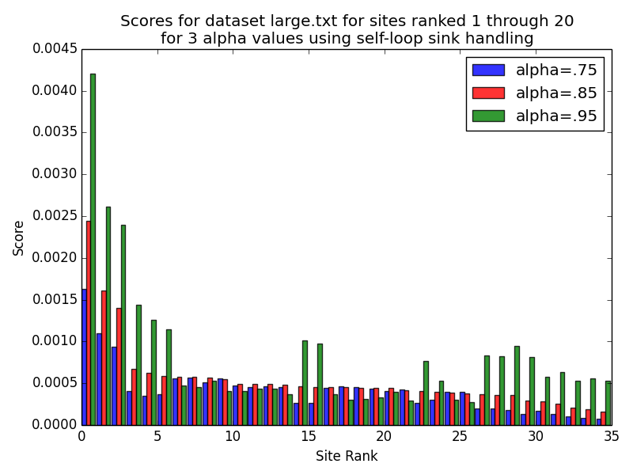
Graph of results for 3 alphas for Type 3 sink handling
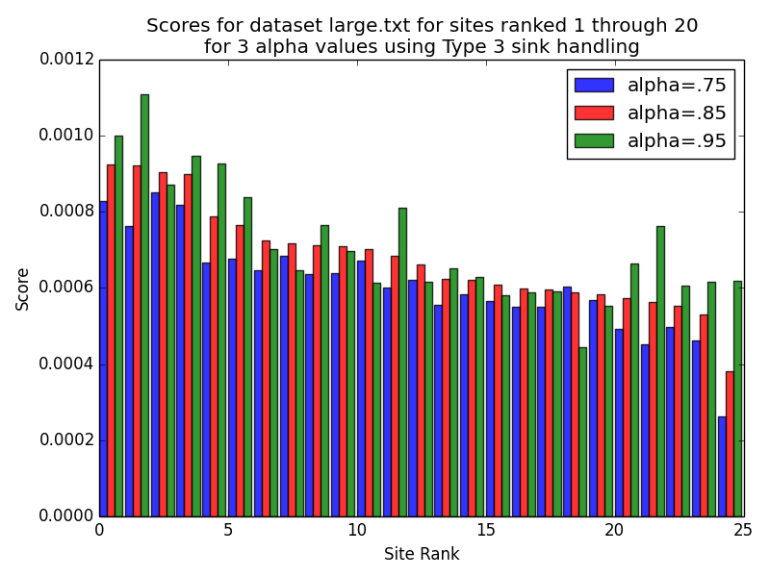
PageRank Project Report
Name : Pranav Pradeep Rao (prao43)

Plots Discussion :
(1) There are two plots with the same axis. The x axis, across the page, lists the top 25 and 35 sites with highest page rank score. The key legend lists the three different alpha (α) values I tested against (0.85, 0.75, 0.95). The sites are listed in descending order of their page rank score against the alpha value set to 0.85, while the respective site’s page rank score is displayed for the remaining two alpha values. The two plots demonstrate two different solution to the problem of sink notes in a graph of webpages.
(2) The values represent the page rank score of choosing one of two types of sink handing strategies for the top 20 and 35 sites. A sink is a webpage with no hyperlinks directed to other webpages. They pose a challenge since the page rank algorithm does a random walk and each time it reaches a webpage there is a probability (α) that it will pick one of the hyperlinks to follow or pick another random page. One solution is to have a ‘self-loop’ on all sinks the effect of this is shown in the first plot. The second solution is to always pick a random webpage for sinks and the second plot displays these results. The values show the page rank score of the highest 35 and 25 pages respectively for each α. It is ordered in descending order for α of 0.85.
(3) The page rank algorithm is provided with a graph of webpages and their connected hyperlinks as edges. It starts with a ‘random walk’. This means it will start at one webpage at random and evaluate its page rank before deciding to go to another webpage. This decision is based on a probability in our algorithm represented by α. α varies from zero to one and if our probability is less than alpha then we pick an edge and evaluate it, otherwise we randomly select another webpage in graph. This will be repeated until all page rank values approach convergence. By choosing a α of 1 we will always pick an edge rather than potential of picking another random webpage. If we choose this value then the we will need to implement correct sink handling strategies that correctly account for a situation where we pick a sink node or pick a sink SCC (strongly connected component).
(4) Changing alpha means the probability that the page rank algorithm will choose the current webpage’s hyperlinks to traverse or pick another random webpage. For the first graph a lower alpha yields lower page ranks for first six webpages than compared to higher alphas. It can also be noted that a higher divergence exists for some webpages with higher alphas compared to their lower alphas. The first graph displays sinks nodes each with a self-loop. The page rank algorithm determines the rank of a page by the determining the number of edges that point to it as well as the significance of the page pointing to it. Hence a sink page with a high rank will have its rank increase every time the algorithm picks its only edge and updates its rank. Thereby amplifying the significance of that page corresponding to others. In the second graph we set the probability to zero every time the algorithm reaches a sink, we pick a random webpage of the graph to traverse. This means that the effect of the significance of a sink webpage is limited and is not as amplified in our calculations.
(5) The run time for each calculation increases as alpha increases. The algorithm will traverse the edges of a webpage before it picks another random webpage to traverse by probability factor of alpha. By increasing the alpha values, the algorithm spends more time on each page calculating the rank of the edge pages.
(6) ‘Type 3’ sink handling strategy takes less time than the ‘self-loop’ strategy since it does, not need to calculate the page rank of the sink’s edge, itself, again. This allows the algorithm to continue its random walk and pick a different webpage to traverse. This also means the results of the page rank for the pages do not divergence significantly from each other using ‘Type 3’ option as alpha increases. But they do divergence for some in ‘self-loop’ strategy as significance of the sink page is repatriated to itself, amplifying its values as alpha increases. Implying that these webpages could be sinks.

