Library Management System
EECS 447 — Part 3: Entity-Relationship Modeling

1. Introduction

Project Overview
The Library Management System is a database for a small library. It stores library items, clients, memberships, loans, reservations, notifications, and late fees. It supports catalog searches, checkouts and returns, borrowing rules, and reports on availability and borrowing activity.

Scope
The project covers books, digital media, magazines, client accounts and membership types, checkouts and returns, reservations, notifications, item restrictions, and late fees. Part 3 models the entities, attributes, relationships, and constraints established in Part 2.

Glossary
- Client/Member — A registered library user with an account who may borrow or reserve eligible items.
- Library Item — An individual book, digital media item, or magazine in the library’s collection.
- Membership Type — A client category that determines the borrowing limit and daily late-fee rate.
- Loan — A record linking a client to a checked-out item, including checkout, due, and return information.
- Reservation — A client’s request for an eligible item that is currently unavailable.
- Notification — Due-date, overdue, or reservation notice
- Late Fee — An amount owed for an overdue loan, calculated according to the applicable membership rate and library rules.

2. Identify ER Modeling Components

Identify Entities
Part 2 identifies these seven entities:
Entity | Description
Library Item | Book, digital media item, or magazine
Client | Library member and account
Membership Type | Sets borrowing limit and daily late-fee rate
Loan | Item checkout and return
Reservation | Request for an item currently on loan
Notification | Due-date, overdue, or reservation notice
Late Fee | Amount owed and paid for an overdue loan
Library Item covers books, digital media, and magazines. Loan records returns. Reports use these records.

Define Attributes
Each entity has a primary key. IDs that link entities are foreign keys. Other attributes are required for the item types they apply to unless marked optional.

Library Item
Attribute | Data Type | Constraints
Item ID | int | Primary key
Title | Text | Required
Item Type | Text | Book, digital media, or magazine
Availability Status | Text | Matches circulation records
Borrowing Restricted | bool | Shows if checkout is restricted
Author/Creator | Text | Books and digital media only
ISBN | Text | Optional, not the primary key
Publication Year | int | Books and digital media only
Genre | Text | Books and digital media only
Issue Number | Text | Magazines only
Publication Date | Date | Magazines only

Client
Attribute | Data Type | Constraints
Client ID | int | Primary key
First Name | Text | Required
Last Name | Text | Required
Phone Number | Text | Required
Membership Type ID | int | Foreign key to Membership Type
Account Status | Text | Active, inactive, or restricted

Membership Type
Attribute | Data Type | Constraints
Membership Type ID | int | Primary key
Name | Text | Required
Borrowing Limit | int | 0 or more
Daily Late-Fee Rate | Decimal | 0 or more

Loan
Attribute | Data Type | Constraints
Loan ID | int | Primary key
Item ID | int | Foreign key to Library Item
Client ID | int | Foreign key to Client
Checkout Timestamp | Timestamp | Required
Due Date | Date | On or after checkout date
Return Timestamp | Timestamp | Blank until return, then on or after checkout

Reservation
Attribute | Data Type | Constraints
Reservation ID | int | Primary key
Client ID | int | Foreign key to Client
Item ID | int | Foreign key to Library Item
Reservation Date | Date | Required
Reservation Status | Text | Pending, available, fulfilled, or cancelled

Notification
Attribute | Data Type | Constraints
Notification ID | int | Primary key
Client ID | int | Foreign key to Client
Loan ID | int | Foreign key to Loan for due-soon or overdue notices
Reservation ID | int | Foreign key to Reservation for available-reservation notices
Notification Type | Text | Upcoming due date, overdue loan, or available reservation
Message | Text | Required
Creation Timestamp | Timestamp | Required
Each notification uses either Loan ID or Reservation ID, based on its type.

Late Fee
Attribute | Data Type | Constraints
Fee ID | int | Primary key
Loan ID | int | Foreign key to Loan, one fee per loan
Amount Owed | Decimal | 0 or more
Amount Paid | Decimal | 0 or more

Define Relationships
The table shows how many records can be linked on each side, including past loans and reservations.
Relationship | One side | Other side | Multiplicity
Membership Type–Client | Client: 1..1 Membership Type | Membership Type: 0..* Clients | One-to-many
Client–Loan | Loan: 1..1 Client | Client: 0..* Loans | One-to-many
Library Item–Loan | Loan: 1..1 Library Item | Library Item: 0..* Loans | One-to-many
Client–Reservation | Reservation: 1..1 Client | Client: 0..* Reservations | One-to-many
Library Item–Reservation | Reservation: 1..1 Library Item | Library Item: 0..* Reservations | One-to-many
Client–Notification | Notification: 1..1 Client | Client: 0..* Notifications | One-to-many
Loan–Notification | Notification: 0..1 Loan | Loan: 0..* Notifications | One-to-many
Reservation–Notification | Notification: 0..1 Reservation | Reservation: 0..* Notifications | One-to-many
Loan–Late Fee | Late Fee: 1..1 Loan | Loan: 0..1 Late Fee | One-to-one
Loan and Reservation link clients and items over time. Together, they form many-to-many relationships between clients and items.

Additional Constraints
An item can have only one active loan at a time. Checkout must follow membership limits and client and item restrictions. An item with an active loan or reservation cannot be removed. Due dates and return timestamps cannot be before checkout. Each notification must link to a loan or reservation for the same client.

3. ER Model (also attached as pdf, see Github)
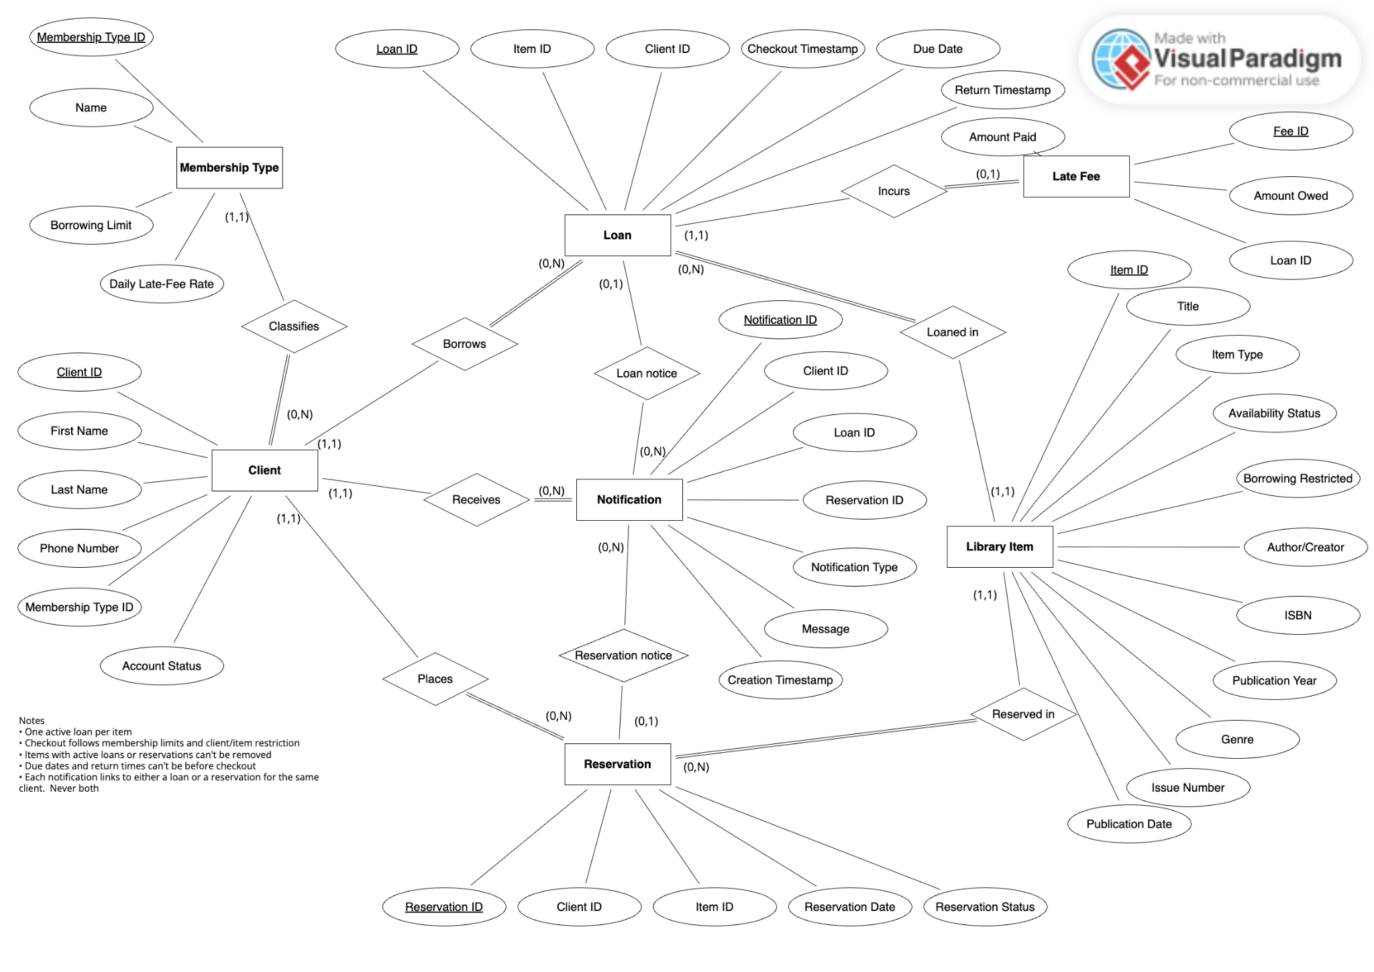

Project Meeting Log

Date: Sep 27th 2026
Time: 11-12
Location: Virtual

Objective: Review Part 3 requirements and divide the work
Team Members Present: Pranav, Mo, Gabe, Karim, Dani

Tasks Completed
- Reviewed Part 3 requirements and the Part 2 document
- Pranav and Mo completed the introduction
- Started planning the entities, attributes, and relationships

Tasks Allocated
- Karim, Dani, and Gabe: Identify ER Modeling Components
- Pranav: ER diagram and coordination
- Mo: Meeting log and later ER diagram review
Deadline: Oct 4, 2026

Follow-Up Action
- Finish the ER components and use them to create the diagram

Date: Oct 4th 2026
Time: 5-6
Location: Virtual

Objective: Complete and review the Part 3 ER model
Team Members Present: Pranav, Mo, Gabe, Karim, Dani

Tasks Completed
- Karim and Dani almost completed the ER components
- Pranav and Gabe planning out ER diagram in Visual Paradigm
- Reviewed the model against Part 2 and corrected diagram issues
- Checked primary keys, cardinalities, and mandatory participation

Tasks Allocated
- Pranav: Final document, diagram, and submission
- Mo: Review diagram and meeting log
- Gabe, Karim, and Dani: Final review and tighten ER components
Deadline: Before Part 3 submission

Follow-Up Action
- Team: Review the final document and diagram
- Pranav: Add the final files to GitHub and submit

