Screenshot of java version

Created JAVA_HOME variable

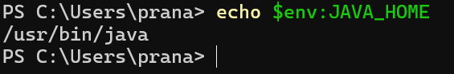
Compile and execute Hello World file

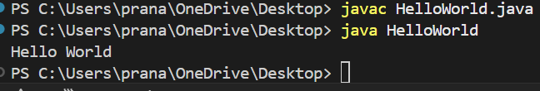
Execute JavaFX application

