**UNIVERSITY OF ILLINOIS AT CHICAGO**

**Crime Portal**

**Software Requirements Specification Document**

# 

# 1. Introduction

# During the last few years, there have been many crimes and robberies taking place. This number has been constantly on a rise since then. Many innocent people have lost their lives, been injured. The offenders are not caught, since the cops rely only on victim’s memory and nothing else. This project is an attempt to reduce such incidences by being more alert to catch the criminals by using proper evidences and technologies.

## 1.1 Purpose

The purpose of this document is to present a detailed description of features of Crime Portal Application. It gives an overview of the entire SRS with purpose, scope, definitions, acronyms, abbreviations & references. It will explain features of the system, the interfaces of the system, what the system will do, the constraints under which it must *operate.*

## 1.2 Scope

**Crime Portal is a mobile based application that proposes to display real time crime related information to the cops and the users.**

1. This system will be called Crime Portal.
2. It will be collecting data and keeping records of various crimes occuring around the world. This data could be used in the future, (if enough data is collected) to track and see if there are any patterns over a period of time.
3. The main objective of this software is to have exact accurate data from the victims or their families, rather than relying on news reports and other mediums.
4. The goal is to increase alertness among citizens and our society so as to reduce the number of crimes caused and take strong action against them.

## 1.3 Definitions, Acronyms, and Abbreviations.

UIC - University of Illinois, Chicago

CS - Computer Science

MySQL - My Structured Query Language

API - Application Programming Interface

*OS - Operating System*

*UML - Unified Modeling Language*

**1.4 Audience & Reading Suggestions**

This document is intended for any individual user,developer,tester,project manager that needs to understand the basic system architecture and its specifications.

Here are the potential uses for each one of the reader types:

Developer:The developer who wants to read,change,modify or add new requirements into the existing program,must firstly consult this document and update the requirements with appropriate manner so as to not destroy the actual meaning of them and pass the information correctly to the next phases of the development process.

User: The user of this program reviews the diagrams and the specifications presented in this

document and determines if the software has all the suitable requirements and if the developer has implemented all of them.

Tester:The tester needs this document to validate that the initial requirements of this

programs actually corresponds to the executable program correctly.

**1.5 The Client and the User**

**1.5 a. The Client**

The clients for the portals are the police officers. They are the ones, who will be using the

portal once they have complaints reported, to see the footage of the crime, if any.

**1.5 b. The User**

Any person witnessing the crime (third person) or someone who is a part of it (the victim) is the user.

Age Group : anything 7 & above

Role: Have the required hardware and software for the application.

Experience: No experience required. Only needs to know, how to capture an image or

record a video. These users will only need basic knowledge of their devices, as the application will be intuitive and easy to use.

System Actors:

Server: The server is the system that accepts connections from mobile devices and saves the results to view again in the future.

# 2. The Overall Description

## 2.1 Product Perspective

There are various reasons why one should use this product. One would be reporting incidents while on their way, thus telling other people about the same so that they are well informed if travelling on same route in future. Besides this, if the victim is alert, then they can also post a picture or a video using their own device and upload it online.

*The following subsections describe how the software operates under various constraints*.

The product will be available as an application on mobile devices which is made possible by cross compiling code into native mobile applications. The mobile application will be responsible to upload the sources of evidence on the portal.

2.2 Product Features

The major features this program contains are the following:

• Notes

In cases where, the image/video is unclear - a person can give detailed information about vehicle number, color of car, offender, etc. which can help in finding the accused.

• Symbols:

Each event reported is displayed using red symbolic flags.

• Map Based User Interface:

All the events reported, once verified will be shown visually on a Google Map so that the exact location, street can be seen next time before similar journey is started.

• Filter:

Show incidents based on time when it happened (morning/evening)

• Social Connectivity:

Post on Facebook/Twitter and other social sites/groups so as to gain momentum and more volunteers participating in the event.

**2.4 - Constraints**

One major constraint for an active user of the application is the hardware requirement.

So only devices with cameras are able to use the application fully.

Description: Phones with camera hardware would be using the application in its entirety.

Rationale: Camera will support the feature of capturing images and recording videos.

Description: The application is developed for Android OS.

Rationale: Android is easily available. No approval issues on Google Play. Most low end market phones support Android.

Description: The product will run on mobile phones and tablet devices.

Rationale: Mobile phones and tablet devices are the most portable devices used by

common people.

Description: While in use, battery should be well charged.

Rationale: Phone may switch off, if the mobile battery is low.

Description: Device should have Data and Internet Access

Rationale: To be able to upload the evidence clicked, one needs active data plan with high network speed, or WiFi connectivity.

Description: Device should support Gps, Date & Time Functionality

Rationale: If the phone supports Location services, then it will use the information to post the video with the location. Similarly, the application won’t ask the user to enter date/time manually, but it will capture based on the device settings.

Description: The user permission required during installation.

Rationale: Without the permission one cannot have access to data, post it or capture anything using phone’s camera.

Happy Path:

If all of the above constraints satisfied, then the application will function correctly.

Once the application has been started, we check for data connectivity. If we get, only then captured video is transmitted and live streaming is done. But if the user does not have data, then the video is stored to users gallery and once he moves in a wifi enabled area, it is directly uploaded to the server.

Unhappy Path: If anything except data access (at crime spot) doesn’t satisfy, the application would not work properly.

3. Specific Requirements

Appearance Requirements:

The application should have a very clean user interface.User would not have any time to search for an option and then click and so on, so the user can click on the Launcher icon, and then directly start recording. Not a lot of emphais is placed on colors, since it is a security application and not a game/social medium of communication.

Style Requirements:

The style of the application should be as per modern standards. It would not have sliders

like a desktop has all the time. But display them only when the user wishes to scroll up or down. Besides that the user should be given proper feedback for each event he performs, so that the user knows the application is in running mode and has not frozen. The feedback could be anything, like a small color change on hover, or something which appears to be

“pressed.”

Ease of Use:

The application is going to be used by a huge number of people, ranging from ages 7 and above. Also, since the application will be used in cases of emergency/help required, the UI of the application needs to be extremely simple and easy to use. The user does not want to be lost whilst using the application as he needs quick assistance when he uses the application.

Language Requirements:

The application is primarily being made in “English”. More support for other languages will be added in the upcoming versions.

Accessibility Requirements:

The product shall conform to the Americans with Disabilities Act. Colors will be chosen in such a way that they are easily distinguishable and recognizable by the color bind people as well.

Speed and Latency Requirements:

The application loading time should be less than 10 - 15 seconds.

There should be no notifiable decrease in performance.

Reliability & Availability Requirements:

The application should never crash or hang, except for an OS error.

All data should be saved, in cases of crashes.

Robustness or Fault tolerance Requirements:

Time to restart after failure is less than 10-15 seconds

Percentage of events causing failure is less than 5%

Probability of data corruption on failure is less than 5% to none.

Portability:

The application should run on Android OS, and more support for other versions can be expected in the future.

Training Related Requirements:

No training anywhere is needed to use the application. Anyone who knows how to use a mobile camera, can use the application efficiently. The application should give the user a guide when the application is opened for the first time.

Maintainability & Support Requirements:

The program files will have time stamps and author names whenever modified.

The code should be modular so as to keep addition of new methods more easier.

All code should be properly documented with comments and proper indentation.

Security Requirements:

The application does not have any of its own security, but uses the security of the OS.

Also it communicates with the websites, so it runs over the network.

Software should maintain a log of errors and the user should have an option to report them.

3.1 - External Interface Requirements

3.1.1 - User Interfaces

The Crime Portal application user interface comprises of few primary screens, a home screen and a loading animation screen.

Loading Animation Screen: It shows the application name and loading animation to give indication to the user how far the user is from using the application.

Home Screen - The home screen is the first screen to appear when a user starts the application or visits the website. The user will be asked to login for authentication purposes or if the user is not a registered user, then they will be asked to sign up for a new account.

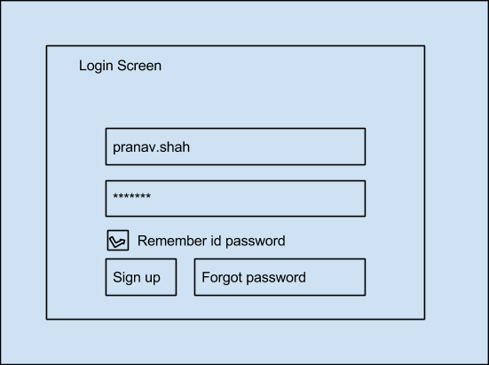

New User Screen: Here the user will have to input their name, address, gender, email address, contact details. We would be sending a confirmation code to the user. Only after entering this confirmation code, will a user get authorized account on our system.

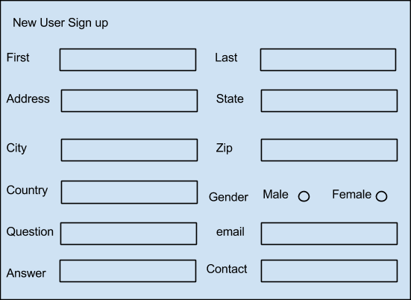

More Information: (in case the user wishes to be more specific and detailed)

Once the user has logged in, it will ask several questions related to the journey.Some of these are:

1. What type of crime did you witness?

2. Are you the victim?

3. Tell me more about the criminal.

4. Any accomplices? Tell us more about them if any

5. Exact Location, in cases of crimes taking places in the interiors.

Social Screen:

The top row will have options to contact the emergency institutions (nearest hospital/police station) Besides social sharing options are also provided, some of these are Pinterest, Google+, GMail, Facebook, Twitter, Linkedin.

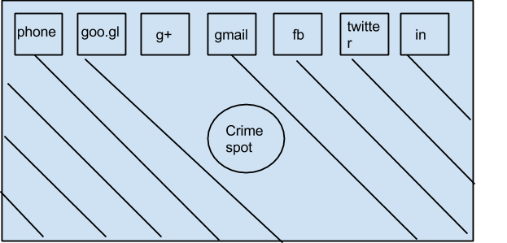

The users can search for emergency aid using their GPS location to find police stations/hospitals within a 10 mile radius or zip code.

3.1.2 - Hardware Interfaces

The applications will need to use resources of the phones such as the CPU, RAM, GPS, and input from the touch screen.

3.1.3 - Software Interfaces

Processing, Android SDK,Xcode are some of the softwares we are going to use.

Consumer Use Cases:

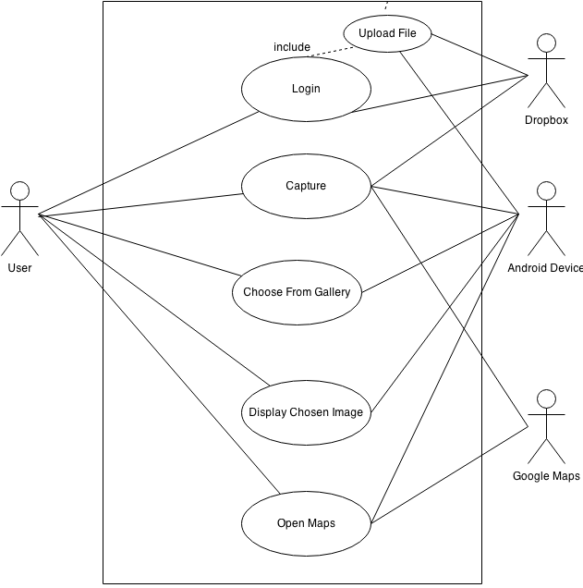

Use case: **Login**

Actors: User, Dropbox

Precondition: User has started application, clicked the upload button and can see the login screen.

Basic Path:

1. User starts the application
2. Clicks Button to Login
3. User enters Dropbox id and password
4. Dropbox System verifies credentials
5. Once approved, user is logged into the system.

Use case: **Capture image/video**

Actors: User, Android device, Google Maps

Precondition: The user has started the application.

Basic Path:

1. User starts “Camera” application.
2. The user has captured the image/video.
3. The file gets saved in the gallery or user specified folder.
4. Query is sent to Google Maps API.
5. Incident location, date and time is recorded on Google Maps.

Use case: **Choose from Gallery**

Actors: User, Android device

Precondition: User has started the application and also has evidence stored.

Flow of Events:

Basic Path:

1. User selects “Upload File”.
2. User can choose from the Gallery which file they wish to upload.

Use case: **Display image**

Actors: User, Android Device

Precondition: User has started the application and also has evidence stored.

Flow of Events:

Basic Path:

1. User selects “Upload File”.
2. User can choose from the Gallery which file they wish to upload.
3. Once chosen, user can view image chosen

Use case: **Upload Evidence**

Actors: User, Android Device, Dropbox Storage

Precondition: User has started the application and also has evidence stored.

Flow of Events:

Basic Path:

1. User selects “Upload File”.
2. User can choose from the Gallery which file they wish to upload.
3. Once chosen, user can view image chosen
4. Click “Confirm Button” To Upload File.

Use case: **Report emergency**

Actors: User

Precondition: User has started the application and has also start recording the incidence.

Flow of Events:

Basic Path:

1. In case of a mishap, the user clicks button “Report”

2. The location where “Report” was clicked, is recorded.

3. A query is sent to find the nearest police stations/hospitals and a list is displayed.

4. “Contact” button appears for each of the displayed results.

5. On selecting “Contact”, respected authorities are contacted by e-mail/message.

Usecase: **Open Maps**

Actors: User, Android Device, Google Maps

Precondition: User has logged on to the system; Flow of Events:

Basic Path:

1. The actor clicks button “Maps”
2. System uses GPS to retrieve current location co-ordinates.
3. Query sent to Google Maps with the co-ordinates.
4. Map returned to device and it is displayed on the mobile device.