Introduction

Ethylene, a key intermediate in plastic and alpha olefin production, is mainly derived from naphtha or ethane steam cracking. While methane, abundant in natural gas and also producible from coal or biomass, offers an alternative source, its conversion to olefins traditionally relies on an indirect route involving reforming to CO and H2, followed by Fischer-Tropsch synthesis (Gu et al. 2018) or syngas conversion(Jiao et al. 2016) over catalysts like ZnCrOx-SAPO. (Meng et al. 2021) This method, however, is energy-intensive and has low carbon utilization efficiency due to the transformation of CH4 to CO2.
Direct methane conversion to ethane and ethylene, which could be more economical and environmentally friendly, is been explored, showing high selectivity for light olefins and avoiding rapid catalyst deactivation. Since Keller and Bhasin's (KELLER 1982) 1982 research, oxidative coupling of methane (OCM) has been extensively studied. OCM uses oxygen as an oxidant, leading to various oxidation and dehydrogenation steps, producing not only the desired C2H4 but also H2, H2O, CO2, CO, C2H6, and small amounts of C3H6, C3H8, and C2H2. (Karakaya and Kee 2016)
The complete Oxidative Coupling of Methane (OCM) process has three main units: the OCM reaction, CO2 purification, and a demethanizer for methane recycling. The procedure initiates with preheated natural gas and oxygen continuously supplied to the OCM reactor. The effluent mixture from the reactor is then cooled in the separation unit, where CO2 is removed. The CO2-depleted stream proceeds to a demethanizer, which segregates unreacted CH4 while extracting products like C2H4 and C2H6. CO2 removal is typically achieved through gas adsorption, using monoethanolamine (MEA) as the absorbing solution. The MEA solvent is then regenerated in a stripper column, releasing the absorbed CO2.
While various mild oxidants (Arinaga, Ziegelski, and Marks 2021) such as gaseous S₂,(Zhu et al. 2013) N₂O,(Özdemir, Öksüzömer, and Ali Gürkaynak 2019; Liu et al. 2010) or H2O2(Shen et al. 2020) have been experimented with to activate CH4 in the OCM process, their inability to achieve high C2+ yields has left oxygen or air as the preferred oxidants. This review thus concentrates on the oxidative coupling of methane, specifically employing oxygen as the oxidant due to its effectiveness in the reaction. In the Oxidative Coupling of Methane (OCM) process, both heterogeneous and homogeneous reactions are critical for CH4 activation, C2+ hydrocarbon formation, and COX (CO and CO2) evolution. Although the exact catalytic mechanism remains under discussion for specific catalysts, the process is generally understood to involve three principal stages:

1. Oxygen Adsorption on the Catalyst: This can be dissociative or non-dissociative, where oxygen molecules bind to the catalyst's surface.
2. Methane Activation: Interaction of methane with surface oxygen leads to the formation of a methyl radical through hydrogen abstraction.
3. Methyl Radical Coupling: These radicals couple in the gas phase to produce C2+ hydrocarbons.
Heterogeneous pathways involve the formation of CH3⋅ radicals through surface oxygen attack, as shown in the reaction (Simon et al. 2004; SUN, THYBAUT, and MARIN 2008; Thybaut et al. 2011)
$${\text{CH}}_{4}+{\text{O}}^{*}↔{\text{CH}}_{3}⋅+{\text{OH}}^{*}$$
Methane can also react with oxygen in the gas phase at temperatures between 700–850°C, resulting in methyl radicals through various reactions such as:
$${\text{CH}}_{4}+{\text{O}}_{2}↔{\text{CH}}_{3}⋅+{\text{HO}}_{2}$$
$${\text{CH}}_{4}+{\text{O}}_{2}↔\text{HCHO}+\text{OH}$$
$${\text{CH}}_{4}+\text{O}⋅↔{\text{CH}}_{3}⋅+\text{OH}$$
OH⋅ radical-induced CH4 activation is another proposed mechanism,(Takanabe and Iglesia 2008) involving the generation of OH⋅ radicals through surface and gas phase reactions, leading to CH3⋅ radical formation.
Methyl radicals can combine in the gas phase with a third body (M) to form ethane (C2H6):
$${\text{CH}}_{3}⋅+{\text{CH}}_{3}⋅+\text{M}→C_{2}{\text{H}}_{6}+\text{M}$$

The formation of ethylene (C2H4) proceeds via hydrogen abstraction from C2H6, potentially by various radicals or surface oxygen atoms((Simon et al. 2004). The formation of CO, CO2, and H2O can occur through both homogeneous and heterogeneous reactions, (SUN, THYBAUT, and MARIN 2008) with the primary, rate-limiting step being the endothermic splitting of CH4's C–H bond on the catalyst surface to yield CH3⋅ radicals. This comprehensive understanding highlights the complex interplay of reactions in the OCM process, emphasizing the catalyst's role in efficiently generating methyl radicals and ultimately determining the yield and selectivity towards desired products. During above reactions there is high possibility of undesired side products like CO2, CO, etc which are favored due to their low activation energy requirement.
Machine Learning model was developed for this process to understand the relationship between different factors and their effects on C2 selectivity. Research has been going on this field for almost 40 years but no one has developed machine learning model for this. We also did SHAP analysis of the best model which showed us similar results as obtained from Literature but this time from data.
2. Methodology
2.1 Data Collection and Pre-Processing:
We gathered data from a variety of peer-reviewed journals, publications, and papers, employing keywords such as "Methane conversion to higher hydrocarbon," "Oxidative Coupling of Methane," "Ethene from Methane," and "Methane Conversion" during the data collection process. These selected keywords guided our search for relevant information. The majority of the examined papers provided detailed information on Surface Area, Gas Hourly Space Velocity (GHSV) ratio, Temperature, Pressure, Flow Rate, Amount of Catalyst, Catalyst Name, Reactor used, CH4 conversion%, C2 selectivity%, and C3 selectivity%. It is noteworthy that some features contained numerous missing values, and certain features could not be adequately represented in the raw data we acquired.
Consequently, in the interest of refining our model development process, we opted to focus on a subset of features from the aforementioned list. The chosen features for our final dataset include Amount of Catalyst (in grams), CH4 conversion%, Surface Area, GHSV ratio, Temperature, Pressure, Flow Rate, and C2 selectivity%, serving as independent variables, with C2 selectivity% as the target variable. This strategic selection of features aims to enhance the effectiveness and clarity of our model.
2.2 Data Preprocessing
Data preprocessing holds significant importance in the development of a model. It serves as a crucial step for identifying outliers, rectifying inconsistencies, and addressing missing values within the dataset. By undertaking these measures, we aim to enhance the accuracy and reliability of our results for subsequent data analysis and machine learning model development. This proactive approach not only minimizes the likelihood of errors but also mitigates biases, ensuring that the outcomes derived from our model are meaningful and robust.
In our model development process, we employed Jupyter(Perez and Granger 2007) Notebook, an interactive coding and data analysis environment. Python served as the primary language for coding purposes, and the Pandas library proved instrumental in detecting and managing missing values. Upon identifying gaps in the data, we utilized the MICE(Multiple Iterative Chained Equations) package for imputing missing values, thereby ensuring completeness in our dataset.
Following the imputation, we conducted exploratory data analysis to unveil insights into the dataset. Pearson’s correlation was computed to examine the relationships between different factors and their impact on the amount of C2 selectivity. We used matplotlib and seaborn for data visualisation and plotting purposes. To facilitate the model building and evaluation processes, we leveraged libraries such as Sklearn(Pedregosa FABIANPEDREGOSA et al. 2011) and XGBoost. These tools were instrumental in constructing and assessing the effectiveness of our models.
The pre-processed dataset comprising 52 data points underwent comprehensive training through a randomized split into training and test subsets. Specifically, 90% of the total data points were randomly assigned and designated as the training dataset, while the remaining 10% were allocated as the test dataset. This division facilitated the final evaluation of the developed models.
Throughout the training phase, the k-fold cross-validation (k-fold CV) method was implemented to fine-tune hyperparameters, aiming to enhance both the model's predictive accuracy and generalization capabilities simultaneously. In the k-fold CV process, the training data were segmented into k subsets. During each training iteration, one subset functioned as the validation set, while the remaining k − 1 subsets collectively formed the training set. This approach effectively addressed issues related to variance and bias in machine learning.
For model development, we employed two tree-based models, namely Gradient Boosting Decision Trees (GBDT) and Extreme Gradient Boosting (XGB), Random Forest Regressor (RFR) and Decision Tree Regressor. This approach allowed us to leverage the strengths of different models to achieve optimal predictive performance.
2.3 Machine Learning Models:
For model development we got the best results from the models below. So it is brief description of them
2.3.1 Gradient Boosting Decision Trees:
GBDT(Wang, Ou, and Lv 2021) are an ensemble-based approach that applies gradient boosting techniques to decision trees. This model integrates multiple decision trees, each refined based on the errors identified in prior models, to enhance the overall predictive accuracy. This is accomplished by iteratively incorporating new weak models into the strong model in a way that inversely corrects for the errors found, there by progressively raising the accuracy of the strong model. This is achieved by iteratively adding new weak models to the strong model in a manner that inversely adjusts for the identified errors, thereby continuously increasing the strong model's accuracy. Sum of all the values which are predicted from those models is the final value predicted from the GBDT.
$$F\left(x\right)=\sum_{i=1}^{M}{f_{i}\left(x\right)}$$
Eq (1)
where,
- F(x) is the prediction function.
- M is the number of trees in the ensemble.
- $f_{i}$ (x) is the prediction of the i^{th} tree.

2.3.2. Extreme Gradient Boost (XGBoost)
XGBoost(Chen and Guestrin 2016) is ensemble (boosting based) machine learning algorithm which is advanced implementation of gradient boost framework. It is based on aggregating the predictions of several weak learners (decision trees). It is good at handling large handsets in both regression and classification tasks. It works well with missing data because it uses a Sparsity Aware Split Finding algorithm. It also has in-built features as determining best splits and prioritizing important features which is beneficial while interacting with complex data.
2.3.3. Random Forest Regressor
Random Forest Regressor(Breiman 2001) is ensemble-based machine learning algorithm for prediction of numerical values. It works by combining the predictions of multiple decision trees, creating more accurate and stable prediction. Bagging of the predictions of decision tree results into final prediction. It can be represented by following equation
$$Y_{RF}\left(X\right)=\frac{1}{N}\sum_{i=1}^{N}{T_{i}\left(X\right)}$$
where,
- Y_{RF}​(X): Prediction made by the Random Forest for input vector X.
- N: Number of decision trees in the Random Forest.
- T_{i}​(X): Prediction function of the i^{th} decision tree for input vector X.

2.3.4. Decision Tree Regressor
Decision Tree Regressors(Panda and Daya Sagar 2022) are a machine learning algorithm which works by learning decision rules inferred from the features. They are represented by tree structure where feature is represented by node and decision by branches. It works by consecutively splitting data subsets based on decision rules which are decided by most informative features. It is flexible and easily interpreted machine learning technique. It can be represented in following form
$$Y=T\left(X\right)$$
Where,
- Y: Prediction made by the decision tree.
- T(X): Prediction function of the decision tree for input vector X.

2.4. Performance Parameters:
Root Mean Squared Errors:
The Root Mean Squared Error (RMSE) is a consolidated metric that signifies the average magnitude of differences between predicted and actual values. A lower RMSE is indicative of superior model performance, suggesting minimal prediction errors.
 | $$RMSE=\sqrt{\frac{\sum_{i=1}^{N}{{\left(y_{i}-\hat{y}\right)}^{2}}}{n}}$$ | Eq (1)
Where, y_{i}= Actual dependent variable
$\hat{y}$_{i}= Predicted dependent variable
n= Number of datapoints

R-Squared:
The coefficient of determination is a measure of how much dependent variable varies when independent variable is varied. It gives us insight how well the independent variable explains the variation in dependent variable.
 | $$R^{2}=1-\frac{\sum_{i=1}^{N}{{\left(y_{i}-\hat{y}\right)}^{2}}}{\sum_{i=1}^{N}{{\left(y_{i}-\overline{y}\right)}^{2}}}$$ | Eq (2)

Where, y_{i}= Actual dependent variable
$\hat{y}$_{i}= Predicted dependent variable
$\overline{y}$_{i}= Mean of dependent variable, $N=Number of datapoints$

2.5. Feature Importance with SHAP analysis:
Feature importance with SHAP(Lundberg Scott and Lee Su-An 2017) (Shapley Additive explanations) offers a powerful and interpretable approach to understanding how each feature in a dataset contributes to the predictions made by a model. Originating from game theory, SHAP values quantify the impact of each feature on the model's output for a particular prediction, providing a foundation for clear and fair attribution of prediction outcomes to the input features.

3. Results and discussions:
We did an exhaustive examination of the input characteristics and outcome metrics within the raw dataset. The dataset underwent a comprehensive descriptive analysis, focusing on the minimum, maximum, and average values of both the input variables and the target outcomes. This initial analysis provided foundational insights into the nature of the raw data. The analysis of C2 selectivity%, derived from a comprehensive review of the literature, revealed an average selectivity of 40.20% with a standard deviation of 16.77%. The maximum observed C2 selectivity was 70.3%, associated with a surface area of 4 m²/g, a flow rate of 30 ml/min, a GHSV ratio of 2400 hr⁻¹, and a run time of 30 minutes at a temperature of 800°C. In contrast, the minimum selectivity recorded was 2.6%, corresponding to a surface area of 4.9 m²/g, a GHSV ratio of 20000 hr⁻¹, a flow rate of 30 ml/min, and a run time of 30 minutes at a temperature of 725°C. The range of surface areas studied varied significantly, from 0.75 m²/g to 250 m²/g, with an average value of 21.46 m²/g and a notably high standard deviation of 65.95 m²/g, indicating a broad diversity in the physical characteristics of the catalysts evaluated. The experimental temperatures predominantly ranged from 700°C to 850°C, although some studies explored temperatures as low as 500°C and 600°C. Regarding run time, the majority of experiments were conducted over periods of 20 minutes, 30 minutes, and 360 minutes, with a selection of studies investigating alternative durations.
The Pearson Correlation Heatmap facilitated the derivation of several key insights, notably that CH₄ conversion exhibits a positive correlation with Run time, and inversely, a negative correlation with the Amount of Catalyst used. Furthermore, an inverse relationship was identified between C2 selectivity and the GHSV ratio, indicating that an increase in the GHSV ratio leads to a reduction in C2 selectivity. This phenomenon aligns with findings reported in existing scholarly literature.
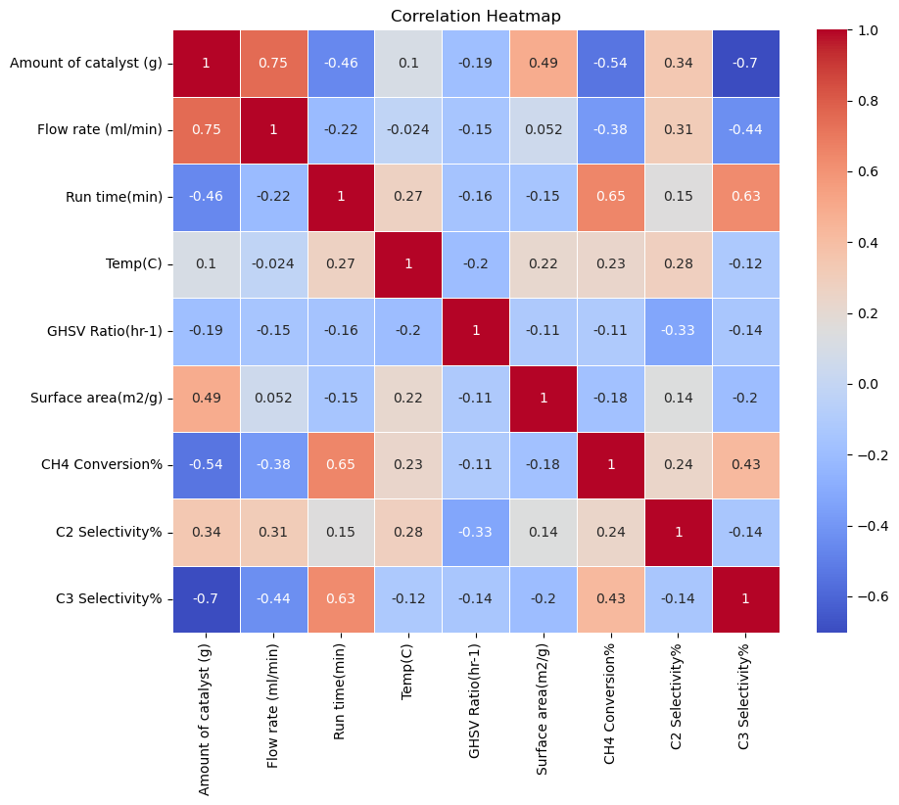
Fig 1. Heatmap analysis of dataset.

Model Prediction:
We used 4 models for prediction of C2 selectivity. All models which were used are Tree-based namely- XGBOOST, Gradient Boost, Random Forest Regressor and Decision Tree Regressor.
The models were developed using the input features outlined in the Data Preprocessing section. For each model, development occurred on a designated training dataset, with hyperparameters meticulously optimized through a grid search method. This optimization process incorporated cross-validation to ensure the robustness and generalizability of the model parameters. During training purposes since dataset size was very less, we used 10% as testing and 90% as training data. After splitting the dataset, we used basic Decision Tree based model because most of the it is easy to interpret and is good in learning Non-linear relationships. The decision tree model we deployed demonstrated commendable accuracy, evidenced by an R2 score of 0.99 on the training dataset and 0.87 on the testing dataset. The differential of 0.12 between the training and testing R2 scores necessitated further evaluation through k-fold cross-validation, which consistently yielded an average R2 score of 0.87. This consistency across cross-validation confirmed the absence of overfitting in our model.
In pursuit of further enhancing our model's performance, we subsequently explored the Random Forest Regressor. This advancement over the decision tree model employs an ensemble of decision trees to make predictions, capitalizing on the strength of multiple trees to improve prediction accuracy and mitigate the risk of overfitting. The Random Forest model builds on the decision tree's foundation by integrating the predictions from various trees, thereby achieving a more robust and reliable model performance. It gave us an accuracy of 0.95 on training data and 0.93 on testing data. For this model also we did cross-validation testing which gave us an average R2 value of 0.86.
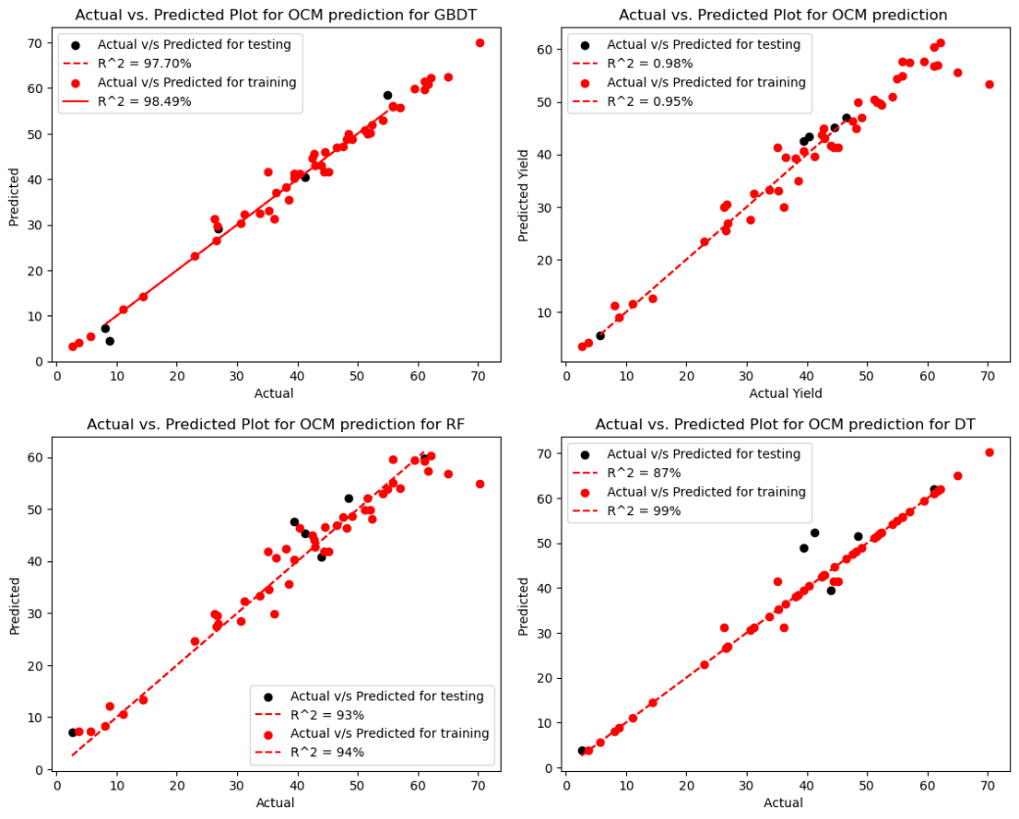Fig 2. Actual V/S Predicted plots for machine learning models.

Since we were able to observe that tree-based were giving us good results we also tried other tree-based ensemble models such as Gradient Boost and Extreme Gradient Boost. Gradient boost gave us accuracy 0.98 on training and testing data. XGBoost gave an accuracy of 0.95 on training and 0.98 on testing data.
Models | Training R² | Testing R² | k-fold cv R² | RMSE
GBDT | 0.98 | 0.98 | 0.94 | 2.76
XGB | 0.95 | 0.95 | 0.85 | 2.17
Decision Tree | 0.99 | 0.87 | 0.87 | 6.04
RFR | 0.95 | 0.93 | 0.86 | 4.60

Feature Importance
We utilized SHAP (SHapley Additive exPlanations), a model-agnostic explanation framework, to analyse the influence of input features on the target variable, such as C2 selectivity, within the context of our Gradient Boosting Decision Tree (GBDT) model, identified as the most efficacious for our study. SHAP values, grounded in cooperative game theory, quantify the contribution of each feature to the prediction of each instance in comparison to the average prediction across the dataset.
Figure 3 elucidates the impact of individual features on the target variable by displaying the absolute SHAP values associated with each feature. The magnitude of a feature's SHAP value indicates its relative importance in the model's predictive accuracy. Features with higher SHAP values have a more pronounced effect on the model's predictions, underscoring their critical role in the predictive process. This visualization highlights the key drivers behind the model's predictions and helps in transparency and interpretability of the model, allowing for a deeper understanding of the model's decision-making process.
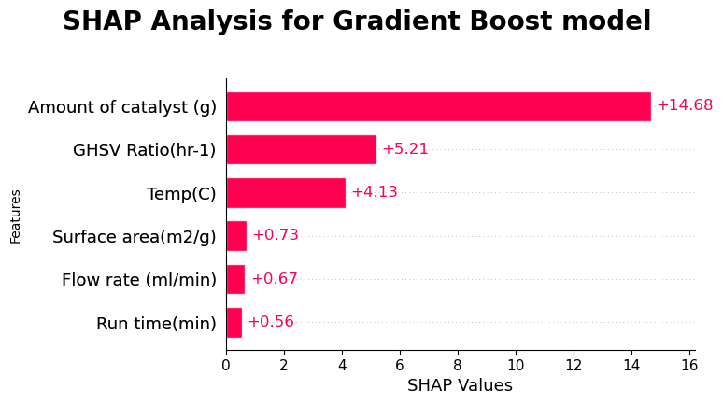
Fig 3. SHAP analysis of data.

Amount of Catalyst used followed by GHSV ratio were most important factors during SHAP analysis. Temperature was also one of the important factors during the contribution for results. Other features also affected models’ decision-making process but are comparatively less important. From the insights of literature review and SHAP establishes the priority of Amount of Catalyst and GHSV ratio. The role of temperature in this process also plays a significant role since it cannot be kept very as it would cause catalyst deactivation, decomposition of products or some undesired side reactions.

The post-development analysis of features within machine learning (ML) models yields critical insights that are instrumental in deciphering the operational mechanisms of these models. Such analytical endeavours are particularly valuable across domains such as ethylene production from methane, and the fields of chemical and material science, where they contribute significantly to process enhancement and the strategic development of materials. Employing a broad array of experimental data from published studies ensures a comprehensive and impartial perspective, contrasting with the narrower scope and potential biases inherent in individual experiments.

Furthermore, the adaptability of these ML models to be applied across various contexts amplifies their utility, particularly in exploring the efficiency of different compunds for production of ethane or ethylene, extending well beyond the initial focus on only methane The mechanistic insights gleaned from such data-driven investigations are not only corroborated by existing literature,(Yaghobi 2013) thereby bolstering the credibility and acceptance of these models, but also pave the way for innovative strategies in material synthesis and process optimization tailored to the intricate demands of carbon sequestration and related fields. This synergy between ML model analyses and empirical research fosters a more nuanced understanding of complex phenomena, driving forward the advancements in environmental sustainability and material science.

References:
Arinaga, Allison M., Morgan C. Ziegelski, and Tobin J. Marks. 2021. ‘Alternative Oxidants for the Catalytic Oxidative Coupling of Methane’. Angewandte Chemie International Edition 60 (19): 10502–15. https://doi.org/10.1002/anie.202012862.

Breiman, Leo. 2001. ‘RANDOM FORESTS’. Machine Learning 45 (1): 5–32. https://doi.org/10.1023/A:1010933404324.

Chen, Tianqi, and Carlos Guestrin. 2016. ‘XGBoost’. In Proceedings of the 22nd ACM SIGKDD International Conference on Knowledge Discovery and Data Mining, 785–94. New York, NY, USA: ACM. https://doi.org/10.1145/2939672.2939785.

Gu, Bang, Vitaly V. Ordomsky, Mounib Bahri, Ovidiu Ersen, Petr A. Chernavskii, Dmitry Filimonov, and Andrei Y. Khodakov. 2018. ‘Effects of the Promotion with Bismuth and Lead on Direct Synthesis of Light Olefins from Syngas over Carbon Nanotube Supported Iron Catalysts’. Applied Catalysis B: Environmental 234 (October): 153–66. https://doi.org/10.1016/j.apcatb.2018.04.025.

Jiao, Feng, Jinjing Li, Xiulian Pan, Jianping Xiao, Haobo Li, Hao Ma, Mingming Wei, et al. 2016. ‘Selective Conversion of Syngas to Light Olefins’. Science 351 (6277): 1065–68. https://doi.org/10.1126/science.aaf1835.

Karakaya, Canan, and Robert J. Kee. 2016. ‘Progress in the Direct Catalytic Conversion of Methane to Fuels and Chemicals’. Progress in Energy and Combustion Science 55 (July): 60–97. https://doi.org/10.1016/j.pecs.2016.04.003.

KELLER, G. 1982. ‘Synthesis of Ethylene via Oxidative Coupling of Methane I. Determination of Active Catalysts’. Journal of Catalysis 73 (1): 9–19. https://doi.org/10.1016/0021-9517(82)90075-6.

Liu, Hongfei, Yanying Wei, Jürgen Caro, and Haihui Wang. 2010. ‘Oxidative Coupling of Methane with High C ₂ Yield by Using Chlorinated Perovskite Ba _{0.5} Sr _{0.5} Fe _{0.2} Co _{0.8} O _{3− δ} as Catalyst and N ₂ O as Oxidant’. ChemCatChem 2 (12): 1539–42. https://doi.org/10.1002/cctc.201000217.

Lundberg Scott, and Lee Su-An. 2017. ‘SHAP’.

Meng, Fanhui, Xiaojing Li, Peng Zhang, Langlang Yang, Guinan Yang, Pengchuan Ma, and Zhong Li. 2021. ‘Highly Active Ternary Oxide ZrCeZnOx Combined with SAPO-34 Zeolite for Direct Conversion of Syngas into Light Olefins’. Catalysis Today 368 (May): 118–25. https://doi.org/10.1016/j.cattod.2020.03.023.

Özdemir, Hasan, M. A. Faruk Öksüzömer, and M. Ali Gürkaynak. 2019. ‘Studies on Oxidative Coupling of Methane Using Sm ₂ O ₃ -Based Catalysts’. Chemical Engineering Communications 206 (1): 48–60. https://doi.org/10.1080/00986445.2018.1471400.

Panda, Rajendra Mohan, and B. S. Daya Sagar. 2022. ‘Decision Tree’. In , 1–7. https://doi.org/10.1007/978-3-030-26050-7_81-2.

Pedregosa FABIANPEDREGOSA, Fabian, Vincent Michel, Olivier Grisel OLIVIERGRISEL, Mathieu Blondel, Peter Prettenhofer, Ron Weiss, Jake Vanderplas, et al. 2011. ‘Scikit-Learn: Machine Learning in Python Gaël Varoquaux Bertrand Thirion Vincent Dubourg Alexandre Passos PEDREGOSA, VAROQUAUX, GRAMFORT ET AL. Matthieu Perrot’. Journal of Machine Learning Research. Vol. 12. http://scikit-learn.sourceforge.net.

Perez, Fernando, and Brian E. Granger. 2007. ‘IPython: A System for Interactive Scientific Computing’. Computing in Science & Engineering 9 (3): 21–29. https://doi.org/10.1109/MCSE.2007.53.

Shen, Qikai, Changyan Cao, Runkun Huang, Lei Zhu, Xin Zhou, Qinghua Zhang, Lin Gu, and Weiguo Song. 2020. ‘Single Chromium Atoms Supported on Titanium Dioxide Nanoparticles for Synergic Catalytic Methane Conversion under Mild Conditions’. Angewandte Chemie International Edition 59 (3): 1216–19. https://doi.org/10.1002/anie.201913309.

Simon, Y., F. Baronnet, G.M. Côme, and P.M. Marquaire. 2004. ‘Detailed Mechanism of the Oxidative Coupling of Methane’. In , 571–76. https://doi.org/10.1016/S0167-2991(04)80113-7.

SUN, J, J THYBAUT, and G MARIN. 2008. ‘Microkinetics of Methane Oxidative Coupling’. Catalysis Today 137 (1): 90–102. https://doi.org/10.1016/j.cattod.2008.02.026.

Takanabe, Kazuhiro, and Enrique Iglesia. 2008. ‘Rate and Selectivity Enhancements Mediated by OH Radicals in the Oxidative Coupling of Methane Catalyzed by Mn/Na ₂ WO ₄ /SiO ₂’. Angewandte Chemie International Edition 47 (40): 7689–93. https://doi.org/10.1002/anie.200802608.

Thybaut, Joris W., Jianjun Sun, Louis Olivier, André C. Van Veen, Claude Mirodatos, and Guy B. Marin. 2011. ‘Catalyst Design Based on Microkinetic Models: Oxidative Coupling of Methane’. Catalysis Today 159 (1): 29–36. https://doi.org/10.1016/j.cattod.2010.09.002.

Wang, Feng, Jinxiang Ou, and Hairong Lv. 2021. ‘Gradient Boosting Forest: A Two-Stage Ensemble Method Enabling Federated Learning of GBDTs’. In , 75–86. https://doi.org/10.1007/978-3-030-92270-2_7.

Yaghobi, Nakisa. 2013. ‘The Role of Gas Hourly Space Velocity and Feed Composition for Catalytic Oxidative Coupling of Methane: Experimental Study’. Journal of King Saud University - Engineering Sciences 25 (1): 1–10. https://doi.org/10.1016/j.jksues.2011.06.007.

Zhu, Qingjun, Staci L. Wegener, Chao Xie, Obioma Uche, Matthew Neurock, and Tobin J. Marks. 2013. ‘Sulfur as a Selective “Soft” Oxidant for Catalytic Methane Conversion Probed by Experiment and Theory’. Nature Chemistry 5 (2): 104–9. https://doi.org/10.1038/nchem.1527.

