### PA89製作

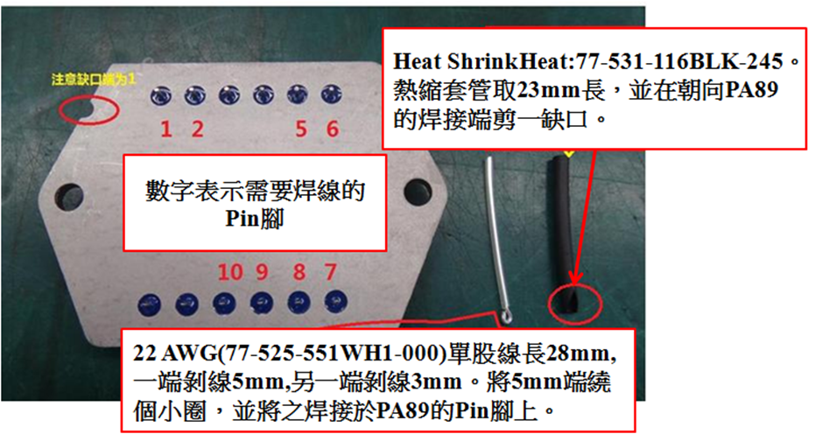

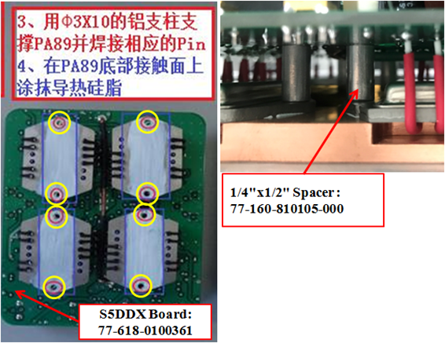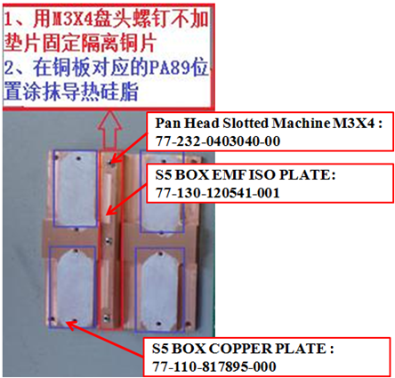

#### 

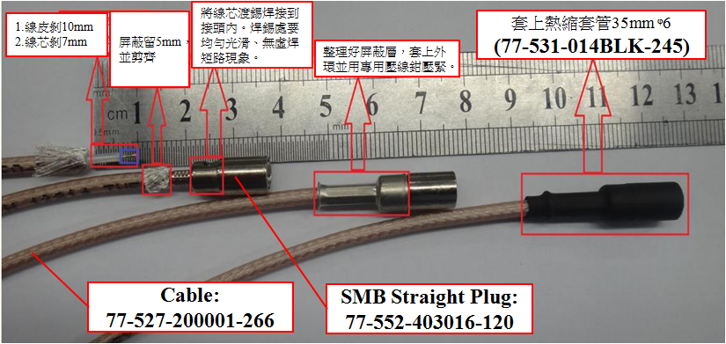

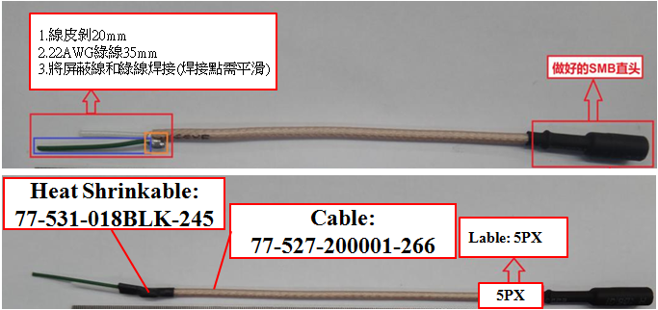

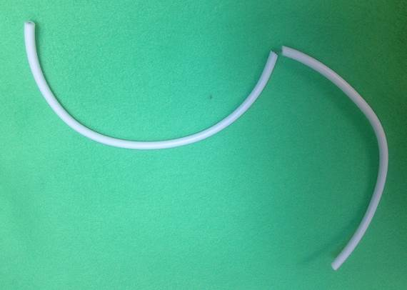

**77-527-0000001-00 Hight Voltage Wire, White, 20AWG(420mm), Peel off from the middle(10mm)**

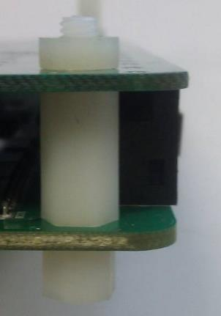

**77-245-0004040-00**

**Hex Nuts, Metric, Nylon, M4*0.7, 6.90mm *3.00mm**

**77-160-810470-000**

**Thread-Hex M-F Spacer M4x14 Nylon**

**77-160-810466-000**

**Thread-Hex M-F Spacer M4x6 Nylon**

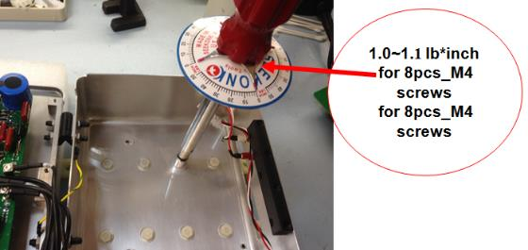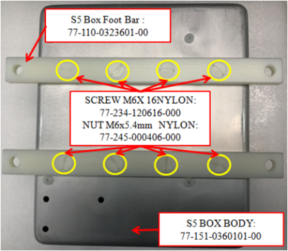

**S5BOX Body**

[**77-151-0301701-00**](https://app.bom.com/items/detail-spec?item_id=30363169&version_id=1262188677)

**2**

**1**

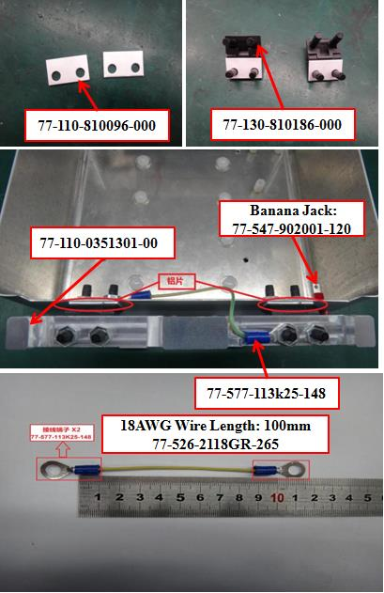

**4**

