# Pattern Testing Samples for OCR Pipeline
# Use these text samples to test if patterns.json is working correctly

## 1. NORMALIZATION PATTERNS

### remove_extra_spaces (Pattern: \\s+)
# Should convert multiple spaces to single space
Original: "This has multiple spaces"
Expected: "This has multiple spaces"

Original: "Text with tabs and spaces"
Expected: "Text with tabs and spaces"

### trim_whitespace (Pattern: ^\\s+|\\s+$)
# Should remove leading and trailing whitespace
Original: " leading and trailing spaces "
Expected: "leading and trailing spaces"

Original: " tab at start and end "
Expected: "tab at start and end"

### normalize_dashes (Pattern: [-–—])
# Should normalize en-dash (–) and em-dash (—) to hyphen (-)
Original: "Part number 77–123–456–789"
Expected: "Part number 77-123-456-789"

Original: "Range: 100—200 units"
Expected: "Range: 100-200 units"

Original: "Mixed dashes: 77-123–456—789"
Expected: "Mixed dashes: 77-123-456-789"

### normalize_quotes (Pattern: [\\u201c\\u201d\\u2018\\u2019`\\u00b4])
# Should normalize smart quotes to standard quotes
Original: "This is "quoted text" with 'single quotes'"
Expected: "This is \"quoted text\" with \"single quotes\""

Original: "OCR often reads `backticks´ as quotes"
Expected: "OCR often reads \"backticks\" as quotes"

## 2. PREPROCESSING PATTERNS

### normalize_part_number_newlines (Pattern: (?<![0-9])77[\\s\\n\\r]*-[\\s\\n\\r]*([0-9]+)[\\s\\n\\r]*-[\\s\\n\\r]*([0-9]+)[\\s\\n\\r]*-[\\s\\n\\r]*([0-9]+))
# Should normalize 77-*-*-* with newlines to clean format

# Test Case 1: Normal format (should remain unchanged)
Original: "77-123-456-789"
Expected: "77-123-456-789"

# Test Case 2: With newlines between segments
Original: "77
-
123
-
456
-
789"
Expected: "77-123-456-789"

# Test Case 3: With spaces and newlines mixed
Original: "77
-
123
-
456
-
789"
Expected: "77-123-456-789"

# Test Case 4: In parentheses (no preceding space)
Original: "(77-123-456-789)"
Expected: "(77-123-456-789)"

# Test Case 5: In parentheses with newlines
Original: "(77
-
123
-
456
-
789)"
Expected: "(77-123-456-789)"

# Test Case 6: Adjacent to text (no preceding space)
Original: "Part77-123-456-789end"
Expected: "Part77-123-456-789end"

# Test Case 7: Should NOT match if 77 is part of larger number
Original: "12377-123-456-789"
Expected: "12377-123-456-789" (unchanged)

# Test Case 8: Multiple part numbers in same text
Original: "Parts: 77-111-222-333 and 77
-
444
-
555
-
666"
Expected: "Parts: 77-111-222-333 and 77-444-555-666"

### ocr_noise_removal (Pattern: [^\\w\\s\\-\\.\\,\\:;\\(\\)\\[\\]\\{\\}])
# Should remove OCR noise characters while keeping allowed punctuation
Original: "77-123-456-789@#$%^&*+=|\\<>?/"
Expected: "77-123-456-789"

Original: "Part: 77-123-456-789, Model (ABC-123); Price: $99.99"
Expected: "Part: 77-123-456-789, Model (ABC-123); Price: 99.99"

### fix_common_ocr_errors
# Should fix common OCR misrecognitions

# Test Case 1: 0 → O when before digits
Original: "Part 0123-456-789"
Expected: "Part O123-456-789"

# Test Case 2: l → 1 when before digits
Original: "Code l234-567-890"
Expected: "Code 1234-567-890"

# Test Case 3: S → 5 when before digits
Original: "Item S678-901-234"
Expected: "Item 5678-901-234"

# Test Case 4: Should NOT change when not before digits
Original: "Part 0ABC, Code lXYZ, Item SABC"
Expected: "Part 0ABC, Code lXYZ, Item SABC" (unchanged)

## 3. VALIDATION PATTERNS (for reference)

### part_number_format_77 (Pattern: 77-\\d+-\\d+-\\d+)
# These should MATCH the validation pattern:
Valid: "77-123-456-789"
Valid: "77-1-2-3"
Valid: "77-999999-888888-777777"

# These should NOT match:
Invalid: "76-123-456-789" (wrong prefix)
Invalid: "77-123-456" (missing segment)
Invalid: "77-123-456-789-000" (extra segment)

### general_part_number_format (Pattern: \\d{2,3}-\\d{3}-\\d{6,7}-\\d{2,3})
# These should MATCH the validation pattern:
Valid: "12-345-678901-23"
Valid: "123-456-7890123-456"

# These should NOT match:
Invalid: "1-345-678901-23" (first segment too short)
Invalid: "12-34-678901-23" (second segment too short)

## 4. COMBINED TEST CASES
# Test multiple patterns working together

### Complex OCR Text Sample
Original: " Part number: 77
-
123
-
456
-
789 is "quoted" with noise@#$ and dashes–like—this "

Expected after all patterns:
"Part number: 77-123-456-789 is \"quoted\" with noise and dashes-like-this"

### Real OCR Scenario
Original: "(77
-
l23
-
4S6
-
0789) with extra spaces"

Expected after patterns:
"(77-123-456-0789) with extra spaces"

## 5. EDGE CASES

### Empty and whitespace
Original: ""
Expected: ""

Original: " "
Expected: ""

### Numbers that should NOT be affected
Original: "1277-123-456-789" (77 is part of larger number)
Expected: "1277-123-456-789" (unchanged)

Original: "77" (incomplete part number)
Expected: "77" (unchanged)

### Mixed content
Original: "Before 77-111-222-333 middle text 77
-
444
-
555
-
666 after"
Expected: "Before 77-111-222-333 middle text 77-444-555-666 after"

PA89製作

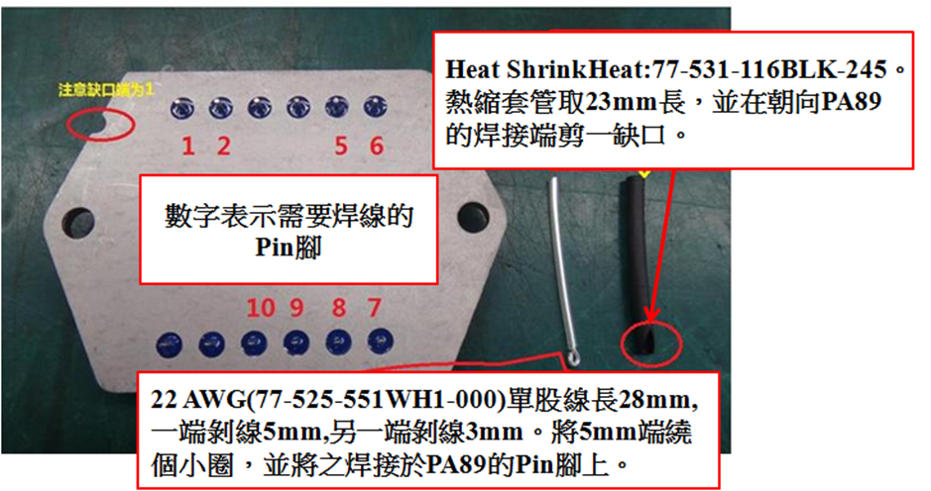

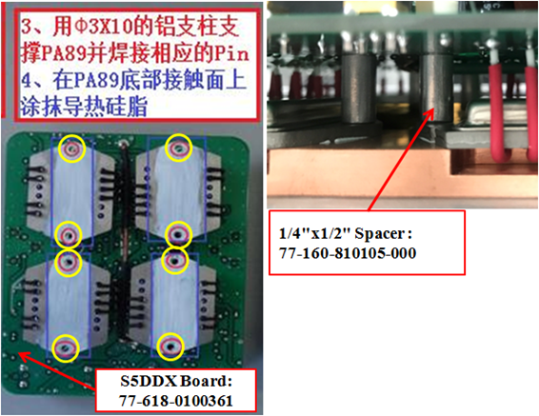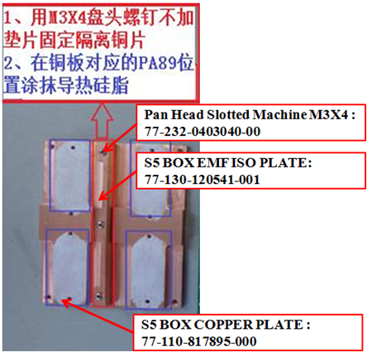

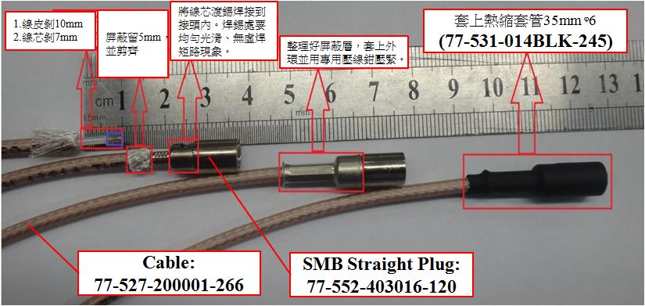

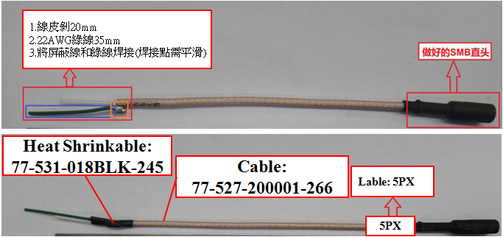

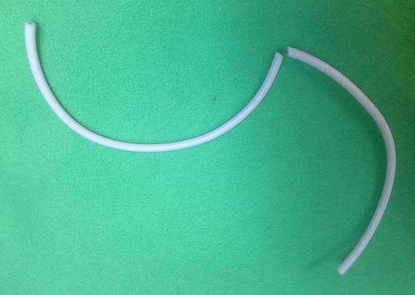
77-527-0000001-00 Hight Voltage Wire, White, 20AWG(420mm),4022-527-0000001-00
Peel off from the middle(10mm)

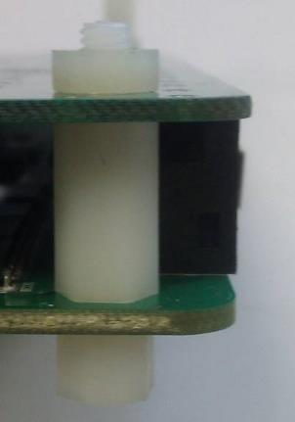
77-245-0004040-00
Hex Nuts, Metric, Nylon, M4*0.7, 6.90mm *3.00mm

77-160-810470-000
Thread-Hex M-F Spacer M4x14 Nylon

77-160-810466-000
Thread-Hex M-F Spacer M4x6 Nylon

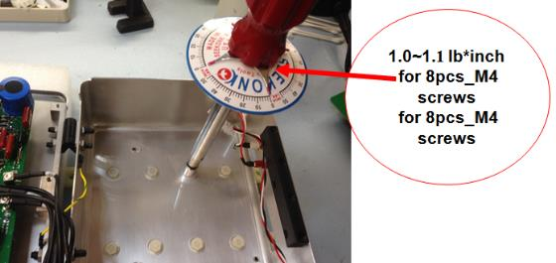
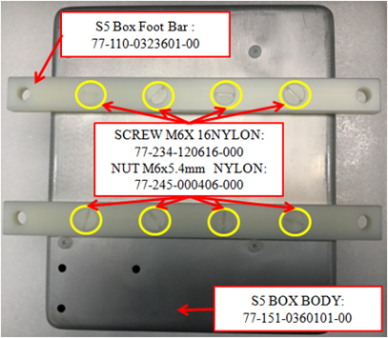
S5BOX Body
77-151-0301701-00
1
2

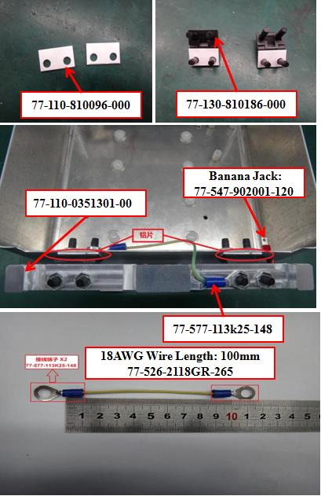

4

