node --version
v20.19.5

npm --version
11.6.2

pranav@pranav-Aspire-A315-41:~/Documents/AI and Machine Learning by me until 15 Oct 2025/ReactAi$ npm create vite@latest my-react-app -- --template react
Need to install the following packages:
create-vite@8.0.2
Ok to proceed? (y) y

> npx
> "create-vite" my-react-app --template react

│
◇ Use rolldown-vite (Experimental)?:
│ Yes
│
◇ Install with npm and start now?
│ Yes
│
◇ Scaffolding project in /home/pranav/Documents/AI and Machine Learning by me until 15 Oct 2025/ReactAi/my-react-app...
│
◇ Installing dependencies with npm...

added 157 packages, and audited 158 packages in 36s

35 packages are looking for funding
run `npm fund` for details

found 0 vulnerabilities
│
◇ Starting dev server...

> my-react-app@0.0.0 dev
> vite

ROLLDOWN-VITE v7.1.14 ready in 1682 ms

➜ Local: http://localhost:5173/
➜ Network: use --host to expose
➜ press h + enter to show help

o/p=>
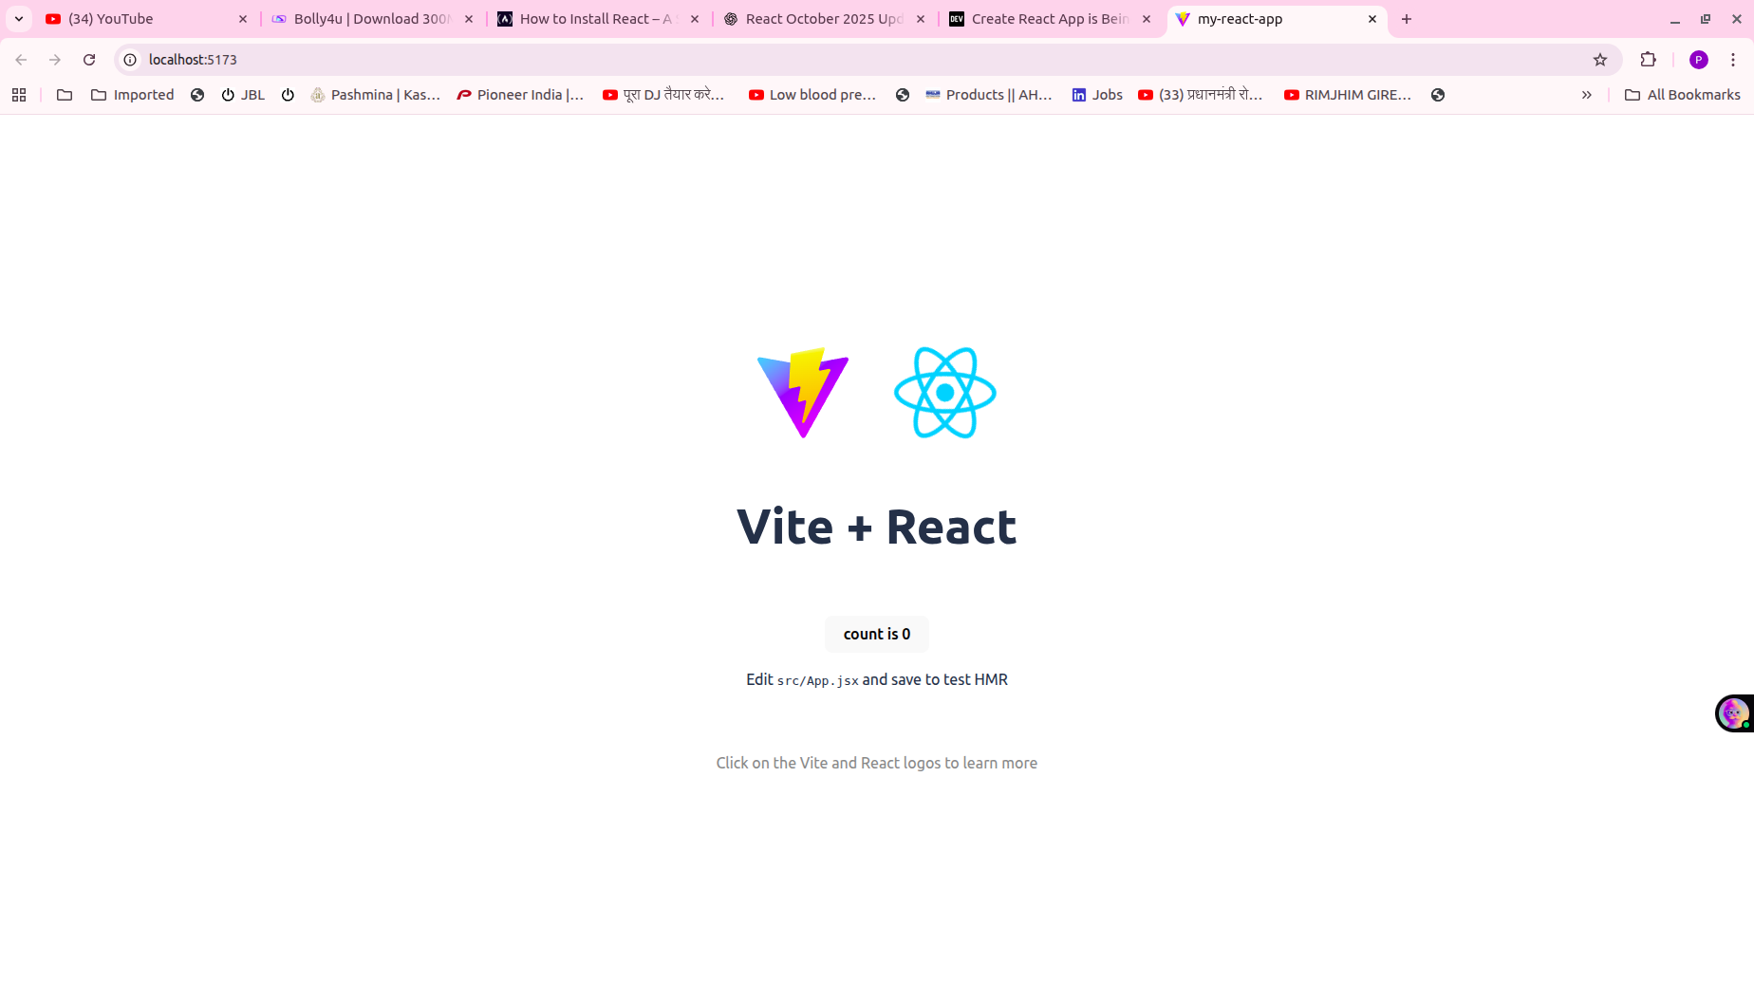

now we run again the application=>
pranav@pranav-Aspire-A315-41:~/Documents/AI and Machine Learning by me until 15 Oct 2025/ReactAi/my-react-app$ npm run dev

> my-react-app@0.0.0 dev
> vite

Port 5173 is in use, trying another one...

ROLLDOWN-VITE v7.1.14 ready in 888 ms

➜ Local: http://localhost:5174/
➜ Network: use --host to expose
➜ press h + enter to show help

How this o/p comes on browser=>
Because of App.jx component=>

import { useState } from 'react'
import reactLogo from './assets/react.svg'
import viteLogo from '/vite.svg'
import './App.css'

function App() {
const [count, setCount] = useState(0)

return (
<>
<div>
<a href="https://vite.dev" target="_blank">
<img src={viteLogo} className="logo" alt="Vite logo" />
</a>
<a href="https://react.dev" target="_blank">
<img src={reactLogo} className="logo react" alt="React logo" />
</a>
</div>
<h1>Vite + React</h1>
<div className="card">
<button onClick={() => setCount((count) => count + 1)}>
count is {count}
</button>
<p>
Edit <code>src/App.jsx</code> and save to test HMR
</p>
</div>
<p className="read-the-docs">
Click on the Vite and React logos to learn more
</p>
</>
)
}

export default App

Now we make our own basic level componet in src folder=>

var address="bhangel noida"
function Intro() {

return (
<>
<div >
<h1> This is pranav sharma</h1>
<p>{address}</p>

</div>
</>
)
}

export default Intro

First we understand this syntax=>
1.{} => we use curly brackets to write javascrit.Here we access variable inside html using {}
2.return=>In react every component is a function and this function return JXS similar to HTML.Without return statement component will not render any html,javascript and because of this any thing not show on screen.
3.<></>=> we can return multiple html tags.
4.export default Intro=>means for exporting component in another file like in App.jx

Now we show App.jx=>
in we import Inro.jx

import { useState } from 'react'
import reactLogo from './assets/react.svg'
import viteLogo from '/vite.svg'
import './App.css'
import Intro from './Intro' //Here you see

function App() {
const [count, setCount] = useState(0)

return (
<>
<div>
<a href="https://vite.dev" target="_blank">
<img src={viteLogo} className="logo" alt="Vite logo" />
</a>
<a href="https://react.dev" target="_blank">
<img src={reactLogo} className="logo react" alt="React logo" />
</a>
</div>
<h1>Vite + React</h1>
<div className="card">
<button onClick={() => setCount((count) => count + 1)}>
count is {count}
</button>
<p>
Edit <code>src/App.jsx</code> and save to test HMR
</p>
</div>
<p className="read-the-docs">
Click on the Vite and React logos to learn more
</p>
<Intro/> //Here you see

</>
)
}

export default App

o/p=>

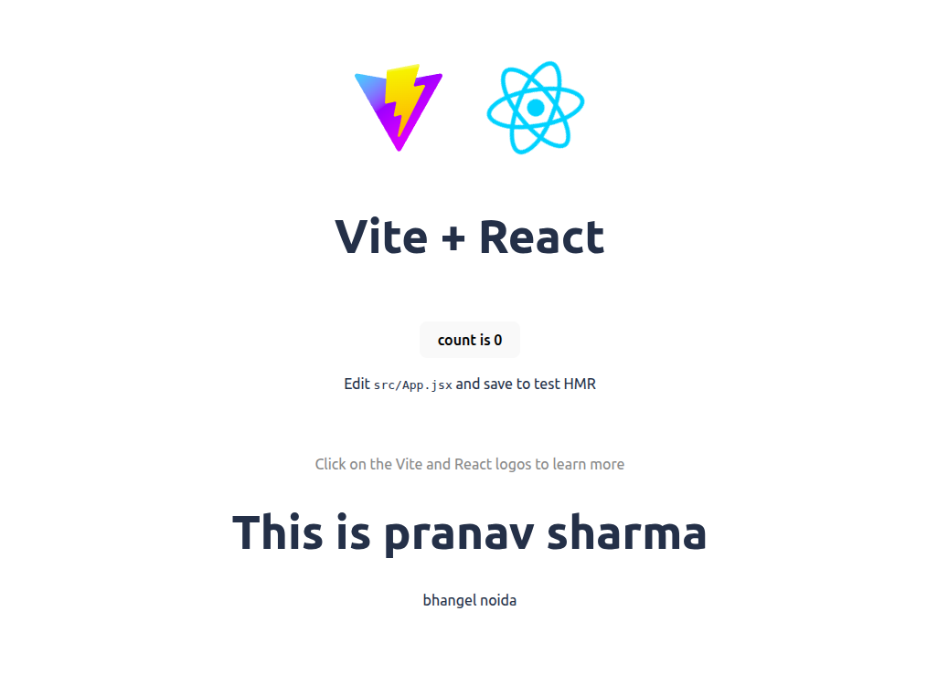
Now we return multiple components like Navbar,Container etc.

First we use Bootsrap in index.html that provides to all components.

Index.html=>which is already come in when we create react app

<!doctype html>
<html lang="en">
<head>
<meta charset="UTF-8" />
<link rel="icon" type="image/svg+xml" href="/vite.svg" />
<meta name="viewport" content="width=device-width, initial-scale=1.0" />
<link href="https://cdn.jsdelivr.net/npm/bootstrap@5.3.8/dist/css/bootstrap.min.css" rel="stylesheet"
integrity="sha384-sRIl4kxILFvY47J16cr9ZwB07vP4J8+LH7qKQnuqkuIAvNWLzeN8tE5YBujZqJLB" crossorigin="anonymous">

<title>my-react-app</title>
</head>
<body>
<div id="root"></div>
<script type="module" src="/src/main.jsx"></script>
<script src="https://cdn.jsdelivr.net/npm/bootstrap@5.3.8/dist/js/bootstrap.bundle.min.js" integrity="sha384-FKyoEForCGlyvwx9Hj09JcYn3nv7wiPVlz7YYwJrWVcXK/BmnVDxM+D2scQbITxI" crossorigin="anonymous"></script>
</body>
</html>

Now we make two component Navbar.jsx ,Card.jsx

Navbar.jsx=>

function Navbar() {
return (
<>
<nav className="navbar navbar-expand-lg bg-body-tertiary">
<div className="container-fluid">
<a className="navbar-brand" href="#">Navbar</a>
<button
className="navbar-toggler"
type="button"
data-bs-toggle="collapse"
data-bs-target="#navbarSupportedContent"
aria-controls="navbarSupportedContent"
aria-expanded="false"
aria-label="Toggle navigation"
>
<span className="navbar-toggler-icon"></span>
</button>
<div className="collapse navbar-collapse" id="navbarSupportedContent">
<ul className="navbar-nav me-auto mb-2 mb-lg-0">
<li className="nav-item">
<a className="nav-link active" aria-current="page" href="#">Home</a>
</li>
<li className="nav-item">
<a className="nav-link" href="#">Link</a>
</li>
<li className="nav-item dropdown">
<a
className="nav-link dropdown-toggle"
href="#"
role="button"
data-bs-toggle="dropdown"
aria-expanded="false"
>
Dropdown
</a>
<ul className="dropdown-menu">
<li><a className="dropdown-item" href="#">Action</a></li>
<li><a className="dropdown-item" href="#">Another action</a></li>
<li><hr className="dropdown-divider" /></li>
<li><a className="dropdown-item" href="#">Something else here</a></li>
</ul>
</li>
<li className="nav-item">
<a className="nav-link disabled" aria-disabled="true">Disabled</a>
</li>
</ul>
<form className="d-flex" role="search">
<input className="form-control me-2" type="search" placeholder="Search" aria-label="Search" />
<button className="btn btn-outline-success" type="submit">Search</button>
</form>
</div>
</div>
</nav>
</>
);
}

export default Navbar;

Card.jsx=>

function Card() {
return (
<>
<div className="card">
<img src="https://via.placeholder.com/300x200" className="card-img-top" alt="Card image" />
<div className="card-body">
<h5 className="card-title">Card title</h5>
<p className="card-text">
Some quick example text to build on the card title and make up the bulk of the card’s content.
</p>
<a href="#" className="btn btn-primary">Go somewhere</a>
</div>
</div>

</>
);
}

export default Card;

Now we have some change in App.css=>
html, body, #root {
margin: 0;
padding: 0;
width: 100%;
height: 100%;
box-sizing: border-box;
}

Now we use these components in App.jsx=>
import './App.css'
import Intro from './Intro'
import Navbar from './Navbar'
import Card from './Card'

function App() {
return (
<>
<Navbar/>
<Card/>
<Intro/>
</>
);
}

export default App

o/p=>

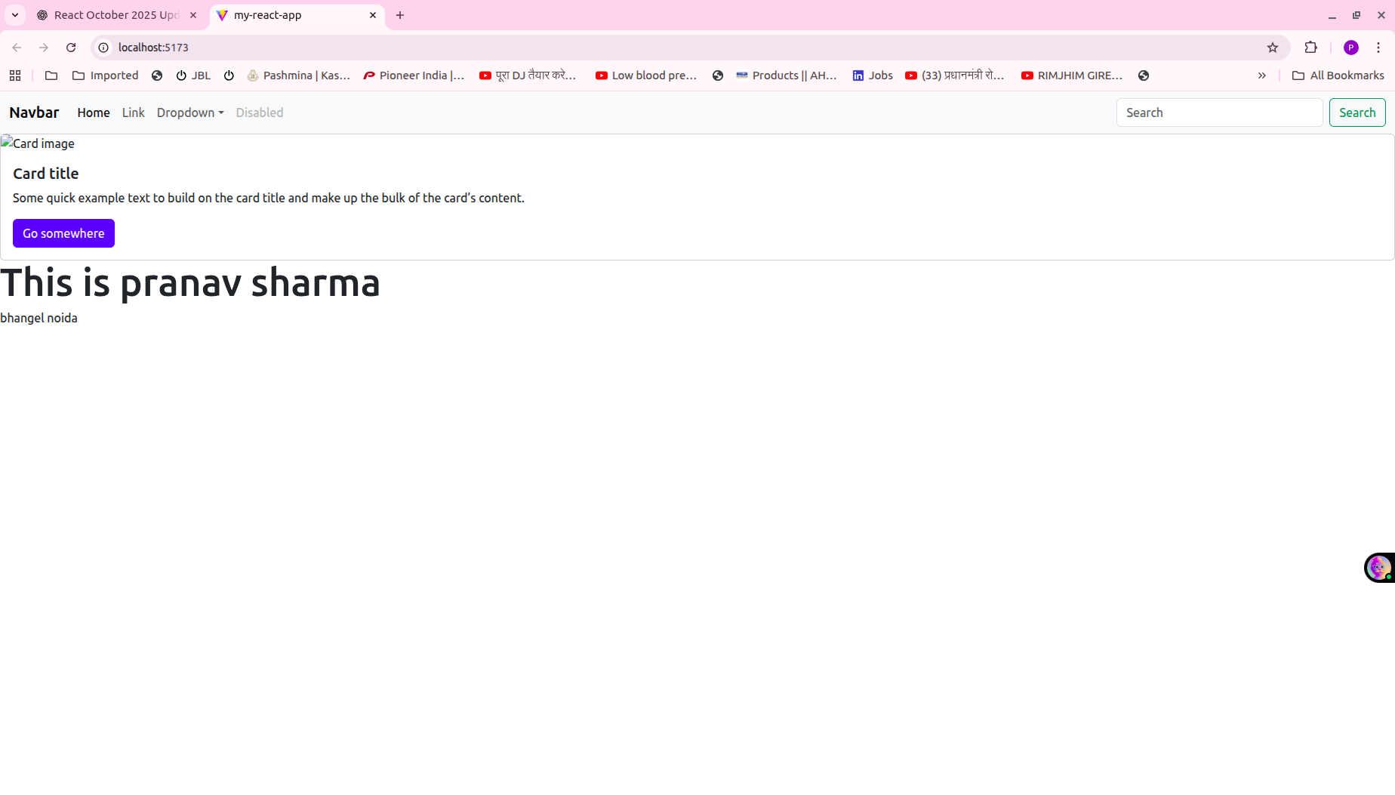

Props=>is way to pass data in the component through App.jsx.

Intro.jsx=>
function Intro(pros) {

return (
<>
<div >
<h1>Your name is : {pros.name}</h1>
<p>Your address is : {pros.address}</p>

</div>
</>
)
}

export default Intro;

Welcome.jsx=>

function Welcome(pros) {

return (
<>
<div >
<h1>Welcome Dear Mr: {pros.name}</h1>
</div>
</>
)
}

export default Welcome;

App.jsx=>
import './App.css'
import Intro from './Intro'
import Navbar from './Navbar'
import Welcome from './Welcome';

function App() {
return (
<>
<Navbar/>
<Intro name="pranav" address="Bhangel Noida"/>//calling component using props
<Welcome name="pranav"/>

</>
);
}

export default App

o/p=>

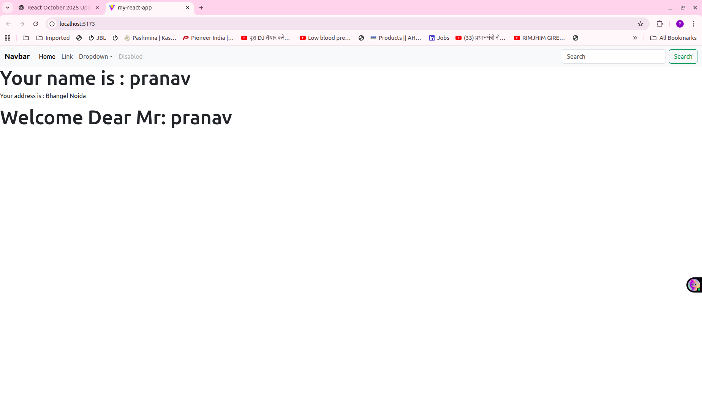

Conditional Based=>
1.If else Based=>

function IFELSE() {
const login=true

if (login)
{
return <h2>Welcome, pranav!</h2>;

}
else
{
return <h2>Please Login</h2>;

}

}

export default IFELSE;

2.Ternary Operator which is short version of If else=>

function TO() {
const login=true ;

return (

<div>
{login ? <h2>Welcome,pranav sharma</h2>:<h2>Who are you</h2>}
</div>
);

}

export default TO;

condition ? (yeh true hai toh) : (false hone par)

3.&& condition Based=>

function DUAND() {
const login=true ;

return (

<div>
{login && <h1>You are right pranav</h1>}
</div>
);

}

export default DUAND;

here means login is true only then h1 is show

4.Special Case=>
function SC({ name, login }) {
return (
<>
<div>
<h2>Your name is {name} from SC</h2>

{login && <h2>You are true, so welcome Mr {name}</h2>}
</div>
</>
);
}

export default SC;

when we calling by passing <SC name="pranav" login={true}/> it internally write props = { name: "Pranav", showDetails: true } So here we use short form instead of writing props.name we write directly name
Now login={true} here we use {} because true is javascript boolean object so if we want to write javascript we have to use {}

Loops=>

function Map() {
const items = ["Apple", "Banana", "Mango"];

return (
<ul>
{items.map((fruit) => (
<li key={fruit}>{fruit}</li>
))}
</ul>
);
}

export default Map;

here in this we can apply if else condition also

function Map() {
const items = ["Apple", "Banana", "Mango"];

return (
<ul>
{items.map((fruit) => {
if (fruit === "Mango") {
return <li>{fruit} is my favourite</li>;
}
return <li>{fruit}</li>;
})}
</ul>
);
}

export default Map;

With ternary opertor

function Map() {
const items = ["Apple", "Banana", "Mango"];

return (
<ul>
{items.map((fruit) =>
fruit === "Mango" ? (
<li>{fruit} is my favourite</li>
) : (
<li>{fruit}</li>
)
)}
</ul>
);
}

export default Map;

Other loops also we learn when we have requirements.

Now we learn about useState=>

Without use state what is problem=>

function Filter() {
function toUpper(text) {
text = text.toUpperCase();
console.log("Converted:", text); //PRANAV
}

return (
<>
<input type="text" id="my" />
<button
onClick={() => {
const value = document.getElementById("my").value; // 👈 yaha se value lete hain
toUpper(value); // aur function me pass karte hain
}}
>
Convert
</button>
<p>Updated text is: {text}</p>
</>
);
}

export default Filter;

o/p=>update text is :

why here updated text not come because When we click then <p> tag is not re-render by React for update so we go for useState()

import { useState } from "react";

function Filter() {
const [text,setText]=useState("")

function toUpper(text) {
setText(text.toUpperCase());
console.log("Converted:", text);
}

return (
<>
<input type="text" id="my" />
<button
onClick={() => {
const value = document.getElementById("my").value; // 👈 yaha se value lete hain
toUpper(value); // aur function me pass karte hain
}}
>
Convert
</button>
<p>Updated text is: {text}</p>
</>
);
}

export default Filter;

o/p=>
Updated text is PRANAV

Now after re-render component and change in useState() during that time I want do some another thing automatically.For this we can use useEffecr();

Now we take real time exam of api=>

import {useState,useEffect} from "react";

function Home()
{
const[text,setText]=useState("")
const[responseData,setResponseData]=useState(null)
const [loading, setLoading] = useState(false); // ✅ loading state

const handleSubmit = async (e) => {
e.preventDefault();
setLoading(true)

const payload = { prompt:text}; // data to send
console.log(payload)

const res = await fetch("http://127.0.0.1:8003/generate", {
method: "POST",
headers: { "Content-Type": "application/json" },
body: JSON.stringify(payload),
});

const data = await res.json();
console.log(data)
setResponseData(data);
console.log(responseData,1)
};

useEffect(() => {
if (responseData) {
console.log("Data posted successfully:", responseData);
setLoading(false)
}
}, [responseData]); // dependency array

return (
<>

<div
className="d-flex justify-content-center align-items-center vh-100 bg-light"
>
<div className="card p-4 shadow" style={{ width: "400px" }}>
<h4 className="text-center mb-3">AI Response Generator</h4>

<form onSubmit={handleSubmit}>
<div className="mb-3">
<label htmlFor="exampleInput" className="form-label">
Enter Your Text
</label>
<input
type="text"
placeholder="Type something..."
className="form-control"
id="exampleInput"
required
/>
</div>

<button type="submit" className="btn btn-primary w-100" onClick={() => {
const value = document.getElementById("exampleInput").value; // 👈 yaha se value lete hain
setText(value); // aur function me pass karte hain
}}>
Submit
</button>
</form>

<div className="mt-3">
<label htmlFor="floatingTextarea2" className="form-label">
Response
</label>
<textarea
className="form-control"
id="floatingTextarea2"
style={{ height: "300px" }}
value={
loading
? "⏳ Please wait... Generating response..."
: responseData?.result || ""
}
readOnly
/>
</div>
</div>
</div>

</>
);
}

export default Home;

Q=>Q=>ab humne text dalkar button par click ab execution flow kaise hoga begining to end hoga api call hone se respone ane take show hone tak completely.

Ans=>
Perfect 👏 — ab tum **second stage** samajhna chahte ho — matlab:
👉 jab user **input me text daalta hai**
👉 **button par click karta hai**,
👉 phir **API call hoti hai**,
👉 aur **response screen par dikhta hai**

Chalo, poora **step-by-step internal React + JS + async flow** samajhte hain.
(Example tumhara same `Home.jsx` code hai.)

---

## 🧠 BEFORE CLICK

* Component pehle hi render ho chuka hota hai (jaise pehle samjhaaya tha).
* `text = ""`
* `responseData = null`
* Form aur button screen par hain.
* `handleSubmit` aur button ke `onClick` dono listeners attach ho chuke hain.

---

## 🧩 STEP 1 — User types text in `<input>`

* User input field me type karta hai (e.g. “python”).
* Tum button click hone par hi value lena chahte ho,
so abhi tak `text` state **change nahi hui** — abhi bhi empty string hai.

DOM me `<input id="my">` ke andar `"python"` likha hua hai,
lekin React state me kuch update nahi hua.

---

## 🧩 STEP 2 — User clicks “Submit” button

Button ke `onClick={() => { ... }}` trigger hota hai:

```js
const value = document.getElementById("my").value;
setText(value);
```

### Internally kya hota hai:

1. React call karta hai `onClick` handler.
2. Browser se actual input value `"python"` milti hai.
3. Tum `setText("python")` call karte ho.

* React marks component dirty (needs re-render).
* React schedule karta hai re-render after event handler finishes.
4. Abhi re-render hua **nahi** hai (state update async hoti hai).
5. Button click event complete hone ke baad React render trigger karega.

---

## 🧩 STEP 3 — Form ke `onSubmit={handleSubmit}` trigger hota hai

Kyuki button form ke andar hai, button click se `onSubmit` bhi fire hota hai.

So ab React call karta hai:

```js
handleSubmit(event);
```

### Internally:

1. `e.preventDefault()` — page reload nahi hota.
2. `payload = { prompt: text }` banaya jata hai.
⚠️ **Important:** Abhi `text` ka value purana ho sakta hai (`""`),
kyunki `setText("python")` ka re-render abhi tak apply nahi hua.
(React async update karta hai state ko.)
3. `fetch("http://127.0.0.1:8001/generate", {...})` call hoti hai.

---

## 🧩 STEP 4 — API Request jaata hai

Browser background me ek **network request** bhejta hai:

* URL: `http://127.0.0.1:8001/generate`
* Method: `POST`
* Body: `{ prompt: "" }` (agar state async nahi update hui)
ya `{ prompt: "python" }` (agar update apply ho gayi — kabhi-kabhi depend karta hai timing par).

Flask backend request receive karta hai → process karta hai → output JSON return karta hai:

```json
{"result": "Python is a powerful language..."}
```

---

## 🧩 STEP 5 — JavaScript waits for response (await)

Code line by line chal raha hota hai:

```js
const res = await fetch(...);
const data = await res.json();
console.log(data);
setResponseData(data);
console.log(responseData, 1);
```

### Internal flow:

1. `await fetch(...)` — JS event loop par control chala jata hai.
React component freeze nahi hota; browser UI responsive rehta hai.
2. Jab server response milta hai → JS resume hota hai.
3. `res.json()` convert karta hai stream ko JSON object me.
4. `data = { result: "Python is a powerful language..." }`
5. `setResponseData(data)` call hota hai → React ko batata hai ki state badli hai.
6. `console.log(responseData, 1)` turant print karega purani value (`null`)
because React state update bhi async hoti hai (re-render abhi hone wala hai).

---

## 🧩 STEP 6 — React re-renders (due to `setResponseData`)

Ab React fir se `Home()` ko call karta hai:

* `text` (old ya updated value)
* `responseData` = `{ result: "Python is a powerful language..." }`

### JSX generation:

```jsx
{responseData && (
<div>
<h3>Response from API:</h3>
<p>ID: {responseData.result}</p>
</div>
)}
```

Ye condition true hai, toh `<div>` bana ke DOM me dikhaya jata hai.

---

## 🧩 STEP 7 — Commit to DOM (Re-render complete)

* Old DOM me koi “Response” section nahi tha → ab add ho gaya.
* Browser ab updated output dikhata hai:

```
Response from API:
Python is a powerful language...
```
* Console me `useEffect` chalta hai (dependency `[responseData]`):

```
Data posted successfully: {result: "Python is a powerful language..."}
```

---

## 🧩 STEP 8 — Component idle (Ready again)

Ab sab kuch dikh gaya, component re-render ke baad stable hai.
Next time agar user fir se submit kare → same flow repeat hoga.

---

## 🧭 Summary: Event & Re-render Timeline

| Step | Trigger | What Happens |
| ---- | --------------- | ---------------------------------------- |
| 1 | User opens page | `Home` render → initial UI show |
| 2 | User types | DOM change only (React unaware) |
| 3 | Click button | `setText()` called → re-render scheduled |
| 4 | Form submit | `handleSubmit()` → fetch call |
| 5 | API returns | `setResponseData()` updates state |
| 6 | Re-render | React shows new output |
| 7 | useEffect runs | Logs success message |
| 8 | Done | Component stable |

---

## 🔍 Why you sometimes see `null` in console:

`console.log(responseData, 1)` runs **before** React applies `setResponseData()` re-render,
so uss samay value purani hoti hai (`null`).

---

Agar chaho to main isi code ka **timeline visualization diagram** (render → API → re-render → effect) bana kar dikha sakta hoon taaki ek nazar me flow clear ho jaaye.
Chahte ho mai bana du?

Q=>re-render kya hota kyu hota hai and yaha kab kab ho raha hai
ans=>
Bahut accha sawal 👏 — ye **React ka sabse core concept** hai.
Agar “re-render” clear ho gaya, to React ka 80% samajh aa gaya.
Chalo step-by-step simple explanation me samajhte hain 👇

---

## 🧠 1️⃣ “Render” kya hota hai?

Jab tumhara component (like `Home()`, `Navbar()`, `Card()`) pehli baar **run** hota hai
aur React uska **JSX code ko HTML** me convert karke screen par dikhata hai,
us process ko **render** kehte hain.

👉 Simple words me:

> “Render = Component ka first time paint hona (screen par dikhna)”

Example:

```jsx
function Home() {
return <h1>Hello</h1>;
}
```

Jab app start hoti hai → React `Home()` call karta hai →
return hua `<h1>Hello</h1>` → Browser me “Hello” dikh jaata hai.
Ye hua **first render**.

---

## 🔁 2️⃣ “Re-render” kya hota hai?

Re-render matlab:

> “React component ko **dobara chalata hai**, kyunki uska data (state/props) badal gaya.”

React me component **function hota hai**, isliye jab bhi state ya props badalte hain,
React fir se **poora function dobara call** karta hai — ye hota hai **re-render**.

---

## ⚙️ 3️⃣ “Re-render hota kyu hai?”

React ka goal hai —

> “UI hamesha data ke sath sync me rahe.”

Matlab: agar data badle → UI bhi badle.

React khud detect karta hai:

* agar `useState` se koi value change hui hai (`setSomething()` call hua)
* ya parent ne naye props bheje hain
to React automatically **re-render** karta hai us component ko.

---

## 🧩 4️⃣ Tumhare `Home.jsx` me re-render kab kab hua?

### 🔹 Render #1 — Component mount hone par

Jab tumne pehli baar `Home` component open kiya, React ne call kiya:

```js
Home();
```

Is samay:

```js
text = "";
responseData = null;
```

Screen par form dikh gaya → ye hua **first render**.

---

### 🔹 Re-render #1 — Jab tumne button click karke `setText(value)` call kiya

`setText(value)` ne React ko signal diya:

> “Mere paas naya text hai, fir se component run karo.”

React ne `Home()` function **dobara chalaya**,
ab `text` me tumhara value (e.g. `"python"`) set ho gaya.

→ ye hua **first re-render**.
(UI par koi bada farq nahi dikh raha hoga, but React ne fir se evaluate kiya.)

---

### 🔹 Re-render #2 — Jab API call ka response aaya aur `setResponseData(data)` call hua

Jab server se result aaya:

```js
setResponseData({ result: "Python is a powerful language" });
```

React ne fir se `Home()` run kiya, ab:

```js
responseData = { result: "..." }
```

Ab condition `{responseData && (...)}` true ho gayi,
React ne response ko UI me show kar diya.
→ ye hua **second re-render**.

---

### 🔹 useEffect runs AFTER re-render

React jab render complete kar leta hai (screen update ho jata hai),
tab `useEffect` run hota hai.
Yani `useEffect` **re-render ke baad** chalta hai.

---

## 📊 To summarize — tumhare example me flow ye tha:

| Step | Event | Re-render hota hai? | Kyu hota hai? |
| ---- | ------------------------------- | -------------------- | ------------------------------ |
| 1 | Page open hota hai | ✅ Yes (first render) | Component mount |
| 2 | Button click → `setText()` | ✅ Yes | State change hua |
| 3 | API call se `setResponseData()` | ✅ Yes | State change hua |
| 4 | useEffect runs | ❌ | Ye render ke baad run hota hai |

---

## 💡 Ek line me yaad rakh lo:

> “React me render = function call.
> Re-render = function dubara call hota hai jab state/props change hota hai.”

Aur ye React ka magic hai — tumhe manually DOM update nahi karna padta,
React automatically re-render karke updated UI dikha deta hai.

---

Chahe main iska ek **diagram (render → re-render → effect)** bana du
jo visually dikhaye kab component dobara run hota hai aur kab screen update hoti hai?
Dikhau kya?

Q=>
value={
loading
? "⏳ Please wait... Generating response..."
: responseData?.result || ""
}
readOnly

ish code ka kya matlab hai

ans=>
Bahut accha question 👏
Yeh React ka **conditional rendering** + **ternary operator** + **optional chaining** ka perfect combo hai.
Chalo line-by-line samajhte hain 👇

---

### 🔹 Code:

```jsx
value={
loading
? "⏳ Please wait... Generating response..."
: responseData?.result || ""
}
readOnly
```

---

### 🔹 Step-by-step Explanation:

#### 🧩 1. `value={ ... }`

* Yeh line **input** ya **textarea** ke andar likhi hoti hai.
* React main, form elements **controlled components** hote hain.
* Iska matlab: element ki value state se control hoti hai — manually type karne se nahi.

---

#### 🧩 2. `loading ? "⏳ Please wait... Generating response..." : responseData?.result || ""`

Yeh part **ternary operator** hai.
Syntax:

```js
condition ? value_if_true : value_if_false
```

Iska matlab:

> Agar `loading` true hai → `"⏳ Please wait... Generating response..."` show karo
> Agar `loading` false hai → `responseData?.result || ""` show karo

---

#### 🧩 3. `responseData?.result`

* Yeh **optional chaining** (`?.`) ka use hai.
* Matlab: agar `responseData` null ya undefined hai, toh error na do — bas `undefined` return karo.
* Warna `responseData.result` ki value de do.

Example:

```js
responseData = null
responseData?.result → undefined (safe ✅)
responseData.result → ❌ error (cannot read property 'result' of null)
```

---

#### 🧩 4. `|| ""`

* Yeh **fallback** (default value) dene ke liye hai.
* Agar `responseData?.result` undefined ya null hua, toh empty string (`""`) show karo.

---

#### 🧩 5. `readOnly`

* Yeh prop batata hai ki user manually input box me likh nahi sakta.
* Sirf programmatically (React state se) value update ho sakti hai.

---

### 🔹 Full Meaning in Simple Hindi:

> Agar API abhi chal rahi hai (`loading === true`),
> toh input box me "⏳ Please wait... Generating response..." likha rahe.
>
> Aur jab API ka result aa jaye (`loading === false`),
> toh `responseData.result` ka text show kar do.
>
> Agar abhi tak koi result nahi aaya — toh blank rakho (`""`).
>
> Aur user box me manually kuch na likh sake — isliye `readOnly`.

---

### ✅ Example Output Flow:

| State | loading | responseData | What user sees |
| -------------- | ------- | -------------------------- | --------------------------------------- |
| Start | false | null | "" (blank) |
| Fetching | true | null | ⏳ Please wait... Generating response... |
| After response | false | { result: "Hello Pranav" } | Hello Pranav |

---

Chaaho toh main ishi logic ka **live mini demo component** likh du (with states), jisse tum browser me try kar sako?

