Mutual Fund Analytics & Performance Dashboard
Bluestock Fintech Capstone Project
Submitted By
Pranav Shinde
Bachelor of Science in Information Technology (B.Sc. IT)
Organization
Bluestock Fintech

Project Duration
June 2026 – July 2026
Technologies Used
- Python
- Pandas
- NumPy
- SQLite
- SQL
- Power BI
- Jupyter Notebook
- Git & GitHub

Submitted On
July 2026

Executive Summary
This project presents a complete Mutual Fund Analytics solution developed as part of the Bluestock Fintech Capstone Project. The objective was to build an end-to-end data analytics pipeline capable of processing mutual fund datasets, performing financial performance analysis, generating business insights, and visualizing results through an interactive Power BI dashboard.
The project begins with an automated ETL pipeline that ingests raw CSV datasets, validates and cleans the data, and loads the processed data into a SQLite database. Exploratory Data Analysis (EDA) was performed to study industry trends, mutual fund performance, investor behaviour, portfolio allocation, and benchmark movements.
Financial performance metrics including Compound Annual Growth Rate (CAGR), Sharpe Ratio, Sortino Ratio, Alpha, Beta, Maximum Drawdown, Tracking Error, Historical Value at Risk (VaR), Conditional Value at Risk (CVaR), and Herfindahl-Hirschman Index (HHI) were calculated to evaluate the return and risk characteristics of different mutual fund schemes.
Advanced analytics such as Rolling Sharpe Ratio analysis, Investor Cohort Analysis, SIP Continuity Analysis, Sector Concentration Analysis, and a Risk-Based Mutual Fund Recommendation System were implemented to provide deeper insights for investors.
The final Power BI dashboard contains four interactive pages with slicers and visualizations that help analyse industry growth, compare fund performance, understand investor behaviour, and monitor SIP trends. The project demonstrates practical application of Python, SQL, SQLite, Power BI, and financial analytics techniques in solving real-world investment analysis problems.

Project Objectives
The primary objective of this project is to design and develop a complete Mutual Fund Analytics System capable of collecting, processing, analysing, and visualising mutual fund data to support data-driven investment decisions.
Objectives
- Build an automated ETL pipeline to ingest, clean, validate, and process mutual fund datasets.
- Store cleaned data efficiently in a SQLite database for analysis.
- Perform Exploratory Data Analysis (EDA) to identify trends in AUM, SIP inflows, investor behaviour, and portfolio holdings.
- Calculate key financial performance metrics including CAGR, Sharpe Ratio, Sortino Ratio, Alpha, Beta, Maximum Drawdown, Tracking Error, VaR, and CVaR.
- Develop advanced analytics such as Investor Cohort Analysis, SIP Continuity Analysis, Rolling Sharpe Ratio, and Portfolio Concentration (HHI).
- Build a risk-based mutual fund recommendation system using historical performance and risk category.
- Design an interactive Power BI dashboard for visualising industry trends, fund performance, investor analytics, and SIP market statistics.
- Present actionable insights and recommendations based on the analysis.

Problem Statement
The Indian mutual fund industry has experienced significant growth in recent years, leading to an increasing number of investment schemes, investors, and financial products. While large volumes of data are generated daily, transforming this information into meaningful insights remains a challenge.
Investors often struggle to compare mutual funds based on both return and risk. Traditional comparisons based solely on historical returns ignore important risk indicators such as volatility, downside risk, drawdown, and benchmark performance. Similarly, fund houses require efficient tools to analyse investor behaviour, SIP continuity, portfolio diversification, and overall market trends.
This project addresses these challenges by developing an end-to-end Mutual Fund Analytics System that integrates data engineering, financial analytics, and business intelligence into a single workflow. The solution combines automated ETL processes, database management, statistical analysis, advanced risk metrics, and interactive dashboards to provide comprehensive insights into mutual fund performance and investor behaviour.
The final outcome enables users to evaluate mutual funds using multiple financial indicators rather than relying on returns alone, supporting more informed investment decisions.

Project Architecture
The Mutual Fund Analytics project follows a structured end-to-end data analytics pipeline. Data is collected from multiple raw datasets, cleaned using Python scripts, stored in a SQLite database, analysed using Jupyter Notebook, and finally visualised in an interactive Power BI dashboard.
Project Workflow
Raw CSV Files

Python ETL Pipeline
(Data Cleaning & Validation)

SQLite Database

Jupyter Notebook
(EDA + Performance Analytics + Advanced Analytics)

Power BI Dashboard

Business Insights & Recommendations

Technology Stack
Technology | Purpose
Python | Data processing and analytics
Pandas | Data cleaning and manipulation
NumPy | Numerical computations
SQLite | Database storage
SQL | Data querying
Jupyter Notebook | Analysis and documentation
Power BI | Interactive dashboard development
Git & GitHub | Version control
VS Code | Python development
Microsoft Excel | Initial data inspection

The project integrates Python, SQL, SQLite, Power BI, and Jupyter Notebook to build a complete end-to-end analytics pipeline. Python scripts automate data ingestion and cleaning, SQLite stores structured datasets, Jupyter Notebook performs analytical computations, and Power BI provides interactive visualizations for business users.

Dataset Description
The project uses ten primary datasets covering mutual fund schemes, NAV history, investor transactions, benchmark indices, portfolio holdings, SIP inflows, and industry statistics.
Dataset | Description | Records
01_fund_master.csv | Mutual fund master details | 40
02_nav_history.csv | Historical NAV prices | 46,000
03_aum_by_fund_house.csv | Assets under management | 90
04_monthly_sip_inflows.csv | Monthly SIP statistics | 48
05_category_inflows.csv | Category-wise inflows | 144
06_industry_folio_count.csv | Industry folio statistics | 21
07_scheme_performance.csv | Fund performance metrics | 40
08_investor_transactions.csv | Investor transactions | 32,778
09_portfolio_holdings.csv | Portfolio holdings | 322
10_benchmark_indices.csv | Benchmark index history | 8,050

These datasets collectively provide information required for financial performance evaluation, investor behaviour analysis, portfolio concentration analysis, benchmark comparison, and dashboard reporting.

ETL (Extract, Transform, Load) Pipeline
The ETL (Extract, Transform, Load) pipeline was developed to automate the complete data preparation process for the Mutual Fund Analytics project. The pipeline reads raw datasets, validates the data, performs cleaning and transformation operations, and loads the processed datasets into a SQLite database. Automating these steps ensures consistency, reduces manual effort, and prepares reliable data for further analysis.
ETL Workflow
- Extract raw mutual fund datasets.
- Validate dataset structure and data types.
- Clean missing values, duplicates, and invalid records.
- Standardize date formats and numerical fields.
- Save cleaned datasets to the processed folder.
- Load processed datasets into SQLite.
- Verify database tables and row counts.

Scripts Developed
Script | Purpose
data_ingestion.py | Reads raw datasets
clean_nav_history.py | Cleans NAV data
clean_scheme_performance.py | Cleans performance dataset
clean_investor_transactions.py | Cleans transaction dataset
load_to_sqlite.py | Loads data into SQLite
verify_sqlite_data.py | Verifies database
etl_pipeline.py | Runs the complete ETL process
live_nav_fetch.py | Fetches latest NAV from MF API

Figure 1: ETL Pipeline – Data Ingestion
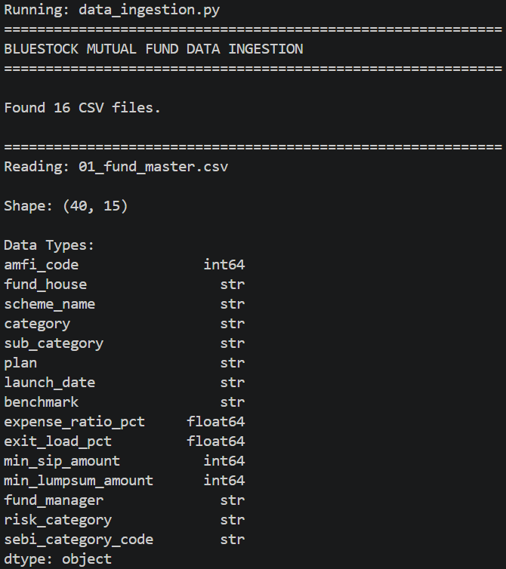
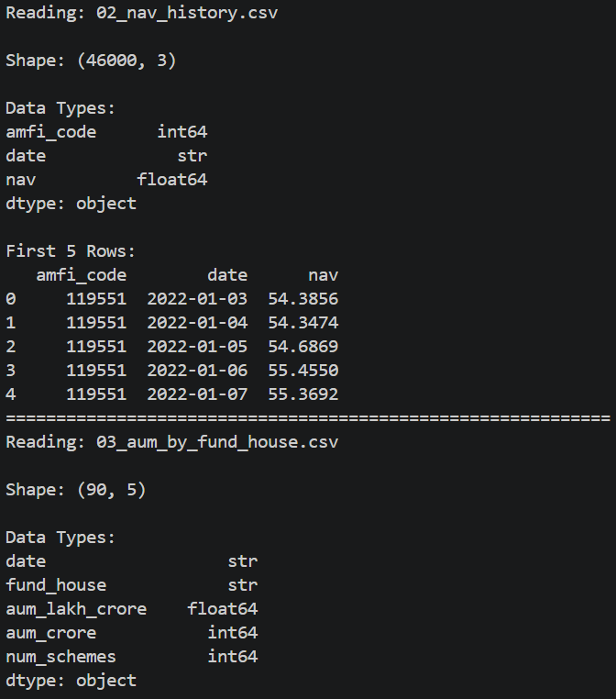

Figure 2: SQLite Database Loading
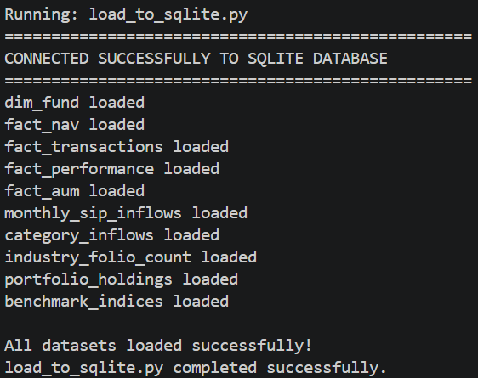

Figure 3: ETL Pipeline Completed Successfully
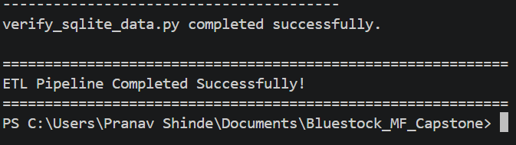

Exploratory Data Analysis (EDA)
Exploratory Data Analysis (EDA) was performed to understand the structure, quality, and characteristics of the mutual fund datasets before conducting performance analysis. Various visualizations were created to identify trends, distributions, relationships, and potential insights related to mutual funds, investors, and market behaviour.
The analysis covers industry growth, investor demographics, SIP patterns, sector allocation, portfolio diversification, and benchmark movements. These insights helped validate the data and provided a foundation for the financial analytics performed in later stages of the project.

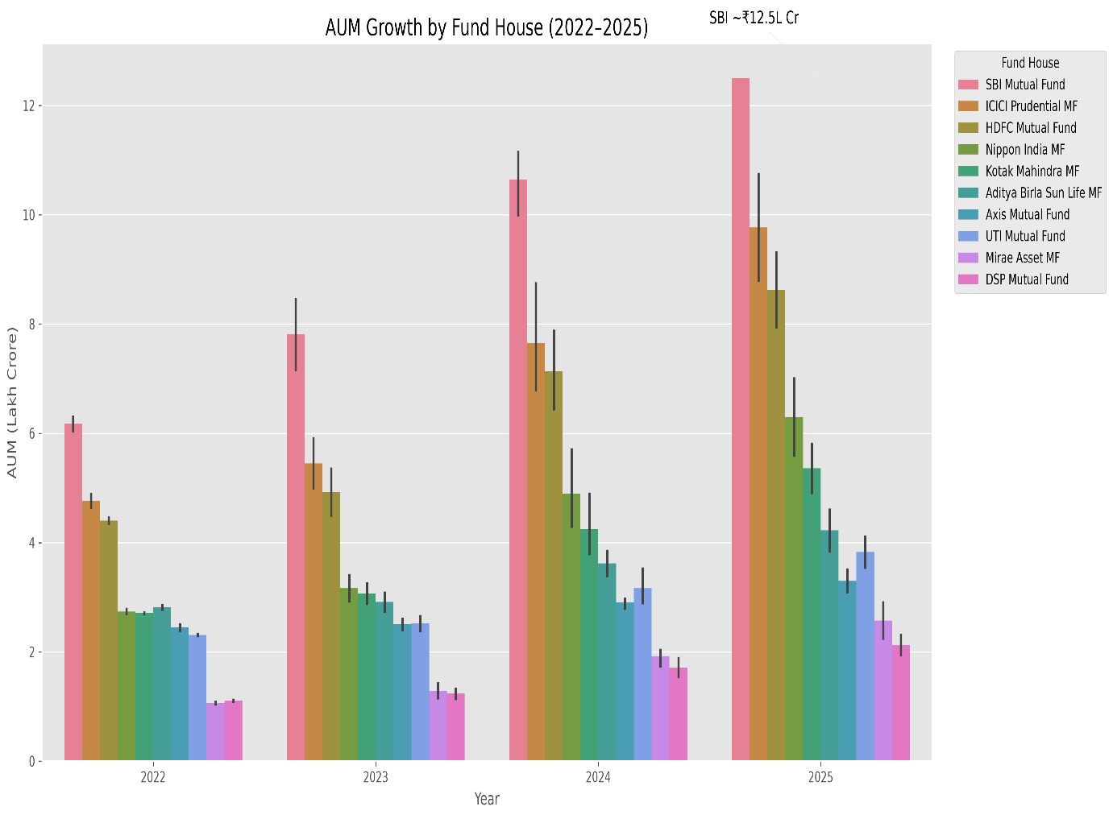

Figure 4.1 – Growth in Assets Under Management (AUM)
The chart compares the Assets Under Management (AUM) of different mutual fund houses from 2022 to 2025. SBI Mutual Fund consistently maintained the largest AUM, indicating its strong market position and investor confidence.
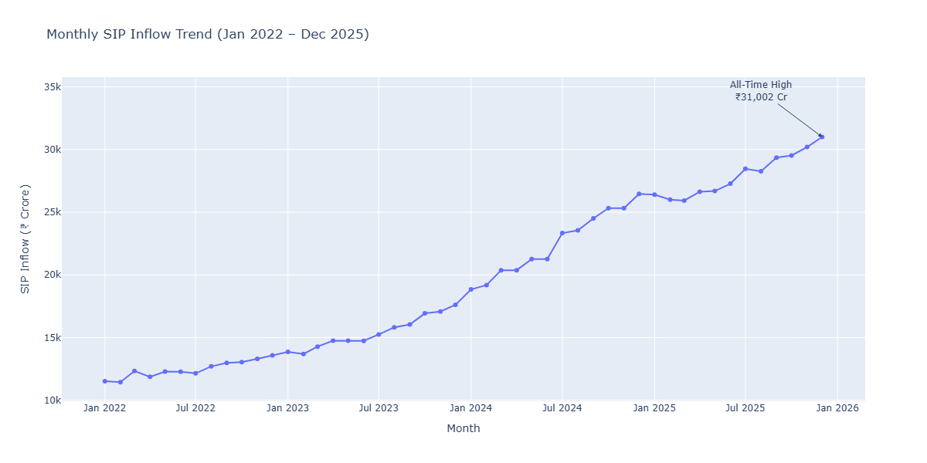
Figure 4.2 – Monthly SIP Inflow Trend
Monthly SIP inflows remained consistently strong throughout the observation period, reflecting increasing investor participation and the growing preference for disciplined long-term investing through Systematic Investment Plans.
Key Observations
- SBI Mutual Fund managed the highest Assets Under Management during the study period.
- Industry-wide AUM showed consistent growth over multiple years.
- Monthly SIP inflows remained stable with gradual upward movement.
- Investor participation continued to increase through systematic investment plans.

Investor Demographics Analysis
Figure 4.3 – Gender Distribution of Investors
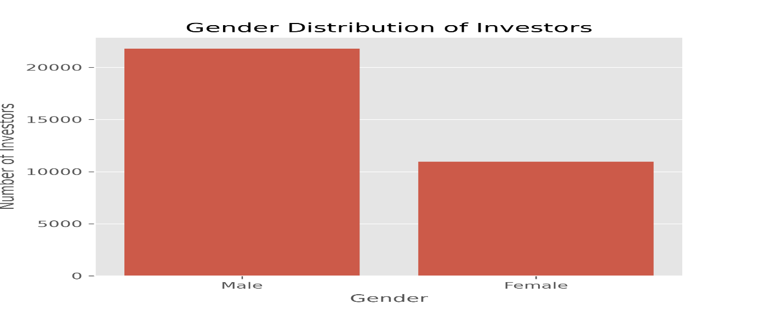
The gender distribution illustrates the participation of male and female investors in mutual fund investments, providing insights into investor diversity.

Figure 4.4 – Age Group Distribution
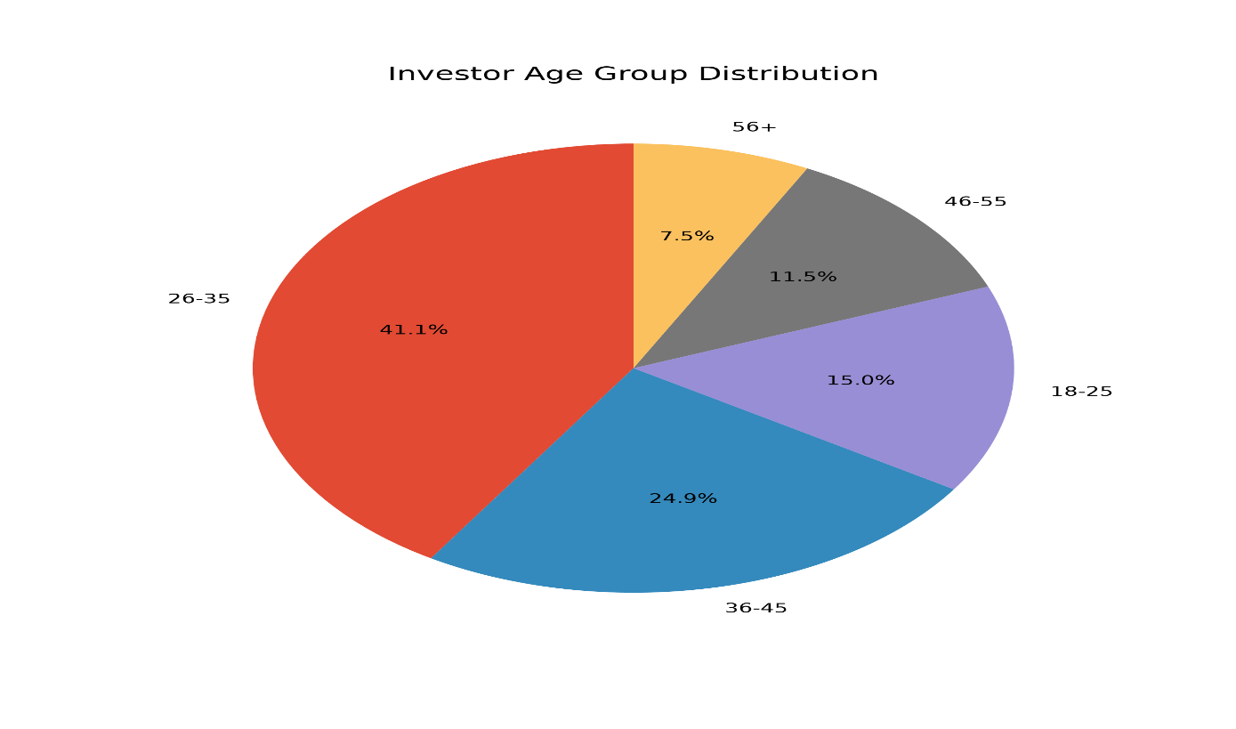
Most investments originate from economically active age groups, particularly investors between 26–35 years, indicating strong participation from working professionals.

Figure 4.5 – T30 vs B30 Distribution
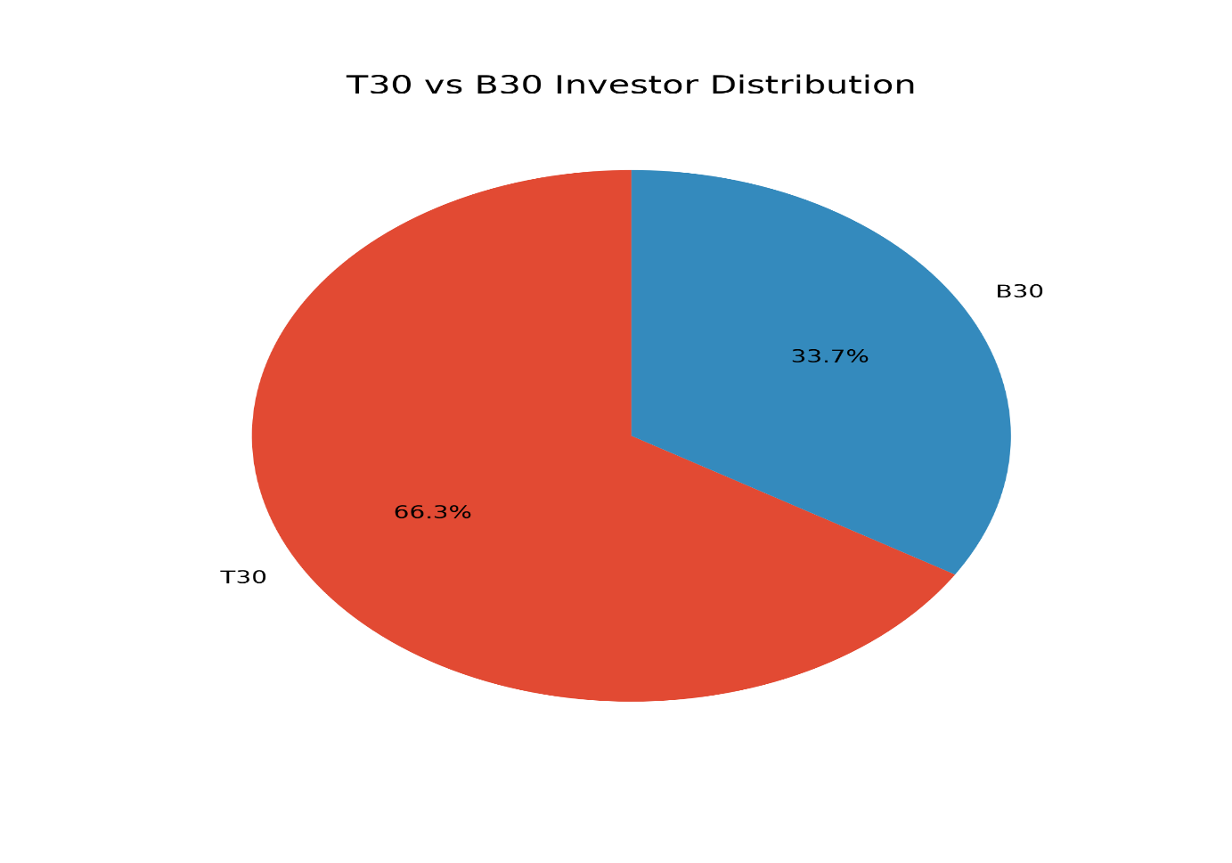

The comparison between T30 and B30 cities highlights investor participation across metropolitan and emerging markets, demonstrating expanding mutual fund penetration beyond major cities.

Key Observations
- Working-age investors represent the largest investment segment.
- Mutual fund participation is growing across both T30 and B30 cities.
- The investor base shows participation across multiple demographic groups.

Market & Portfolio Analysis
Figure 4.6 – Category-wise Net Inflows
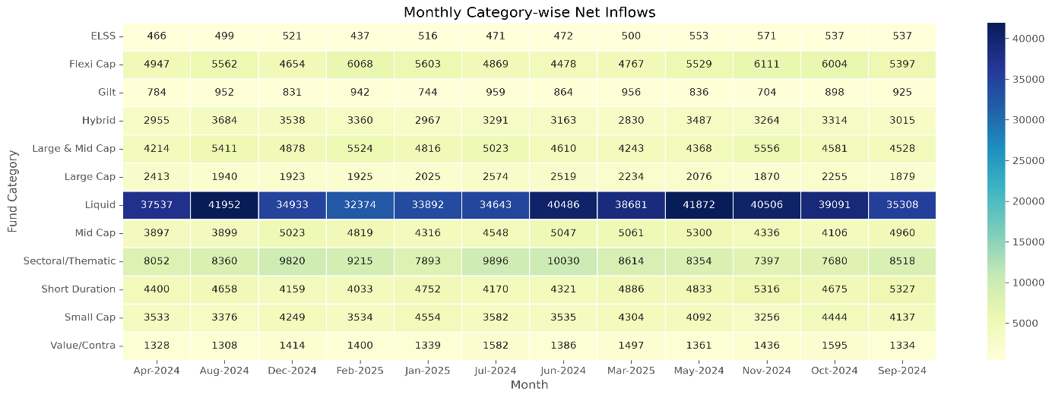
The heatmap illustrates monthly net inflows across different mutual fund categories. Flexi Cap, Mid Cap, and Large & Mid Cap funds consistently attracted higher investor inflows compared to other categories.

Figure 4.7 – Sector Allocation of Portfolio Holdings
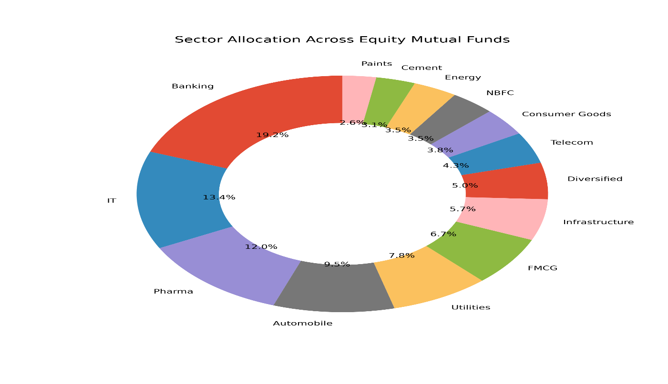
The portfolio holdings are diversified across multiple sectors such as Banking, IT, Pharma, FMCG, Utilities, and Manufacturing. Sector allocation provides insight into diversification and investment concentration.

Figure 4.8 – Growth of Mutual Fund Folios (2022–2025)
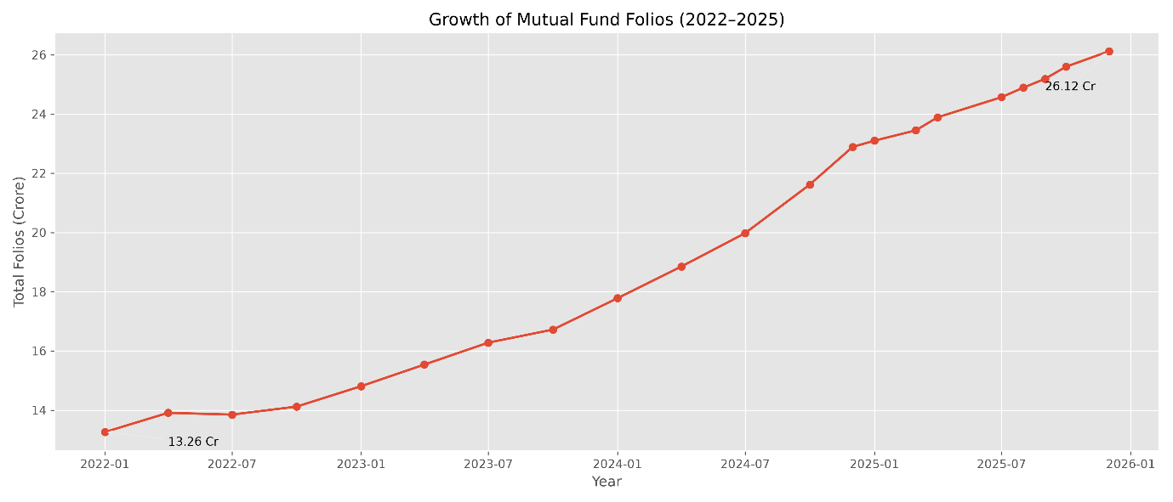

Description:
The chart illustrates the steady growth in the total number of mutual fund folios between 2022 and 2025. Total folios increased from approximately 13.26 crore in early 2022 to over 26.12 crore by the end of 2025, reflecting rising retail investor participation and increasing adoption of mutual fund investments in India.
Key Observations:
- Total mutual fund folios nearly doubled during the study period.
- Flexi Cap and Mid Cap funds consistently received strong net inflows.
- Banking and IT remain dominant sectors in equity portfolios
- The sharpest increase occurred throughout 2024 and 2025.
- Continuous folio growth indicates increasing investor confidence in mutual funds.
- Diversification across sectors reduces concentration risk
- Rising SIP participation is a major contributor to folio growth.

Investment Behaviour & Correlation Analysis
Figure 4.9 – NAV Return Correlation
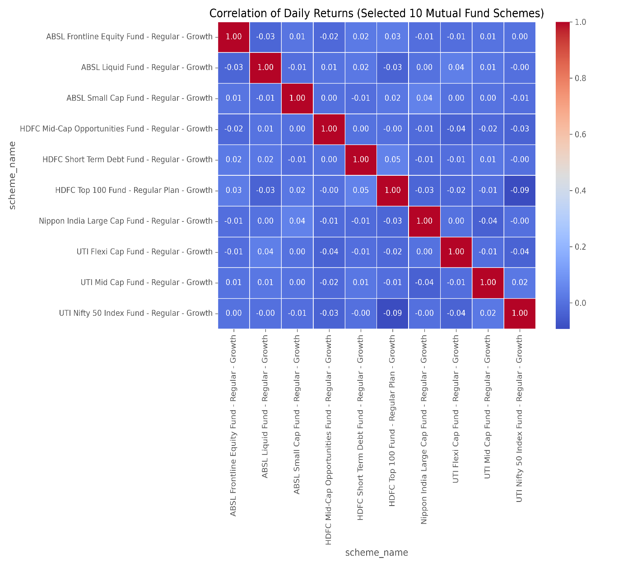

Correlation analysis measures the relationship between NAV movements and fund returns. Stronger positive correlations indicate consistent performance patterns across the selected schemes.

Figure 4.10 – State-wise SIP Distribution
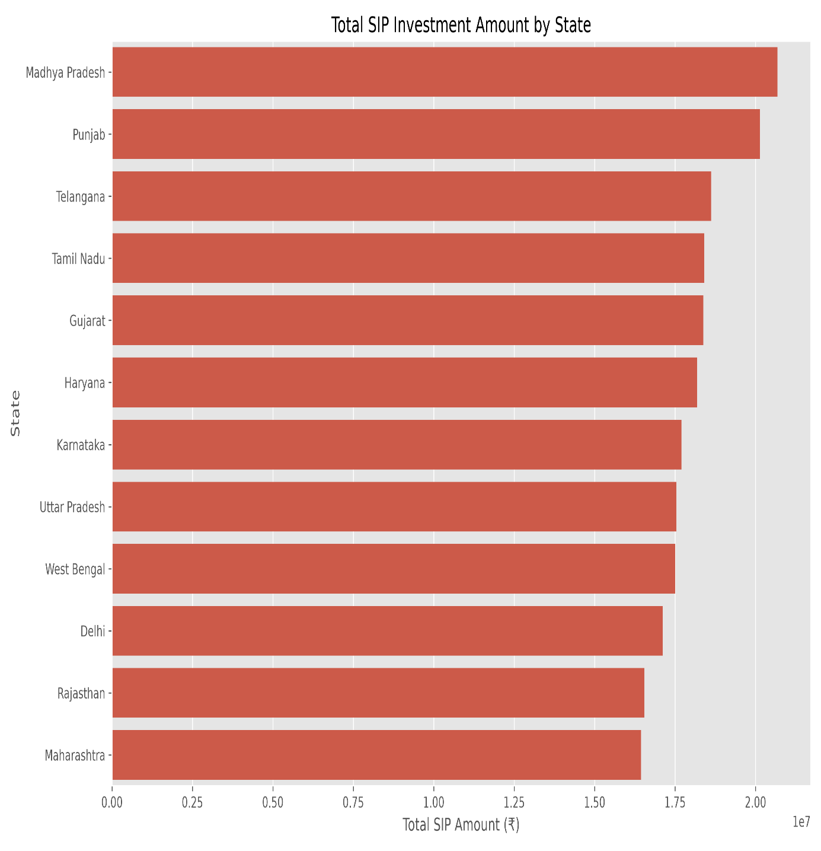

The state-wise distribution highlights geographical participation in SIP investments. States with larger urban populations contributed a higher number of SIP transactions.

Figure 4.9 – SIP Amount Distribution by Age Group
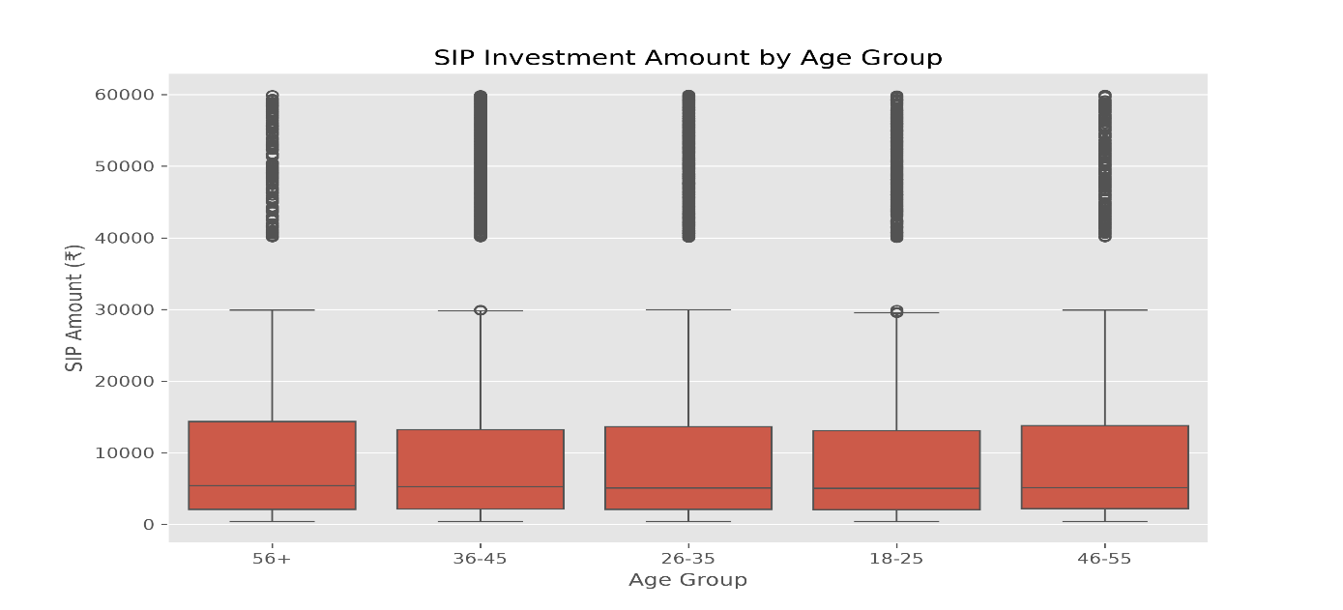

The box plot compares SIP investment amounts across different age groups. Median SIP amounts are broadly similar across all age categories, while each group contains several high-value outlier investments. This indicates that investor age alone does not strongly determine SIP contribution size, although a small subset of investors in every age group invests significantly higher amounts.

Key Observations
- NAV movements generally follow expected return behaviour.
- SIP participation is concentrated in financially active states.
- Most SIP investments fall within a moderate investment range, with relatively few large outliers.
- Investor behaviour indicates a preference for regular, long-term investing.

EDA Summary
The exploratory analysis confirmed that the datasets were clean, consistent, and suitable for financial analytics. The visualizations highlighted growing investor participation, increasing SIP adoption, diversified sector allocation, and strong market activity. These findings established a reliable foundation for the performance metrics and advanced risk analysis presented in the following sections.

Performance Analytics

Figure 5.1 – Sharpe Ratio Comparison
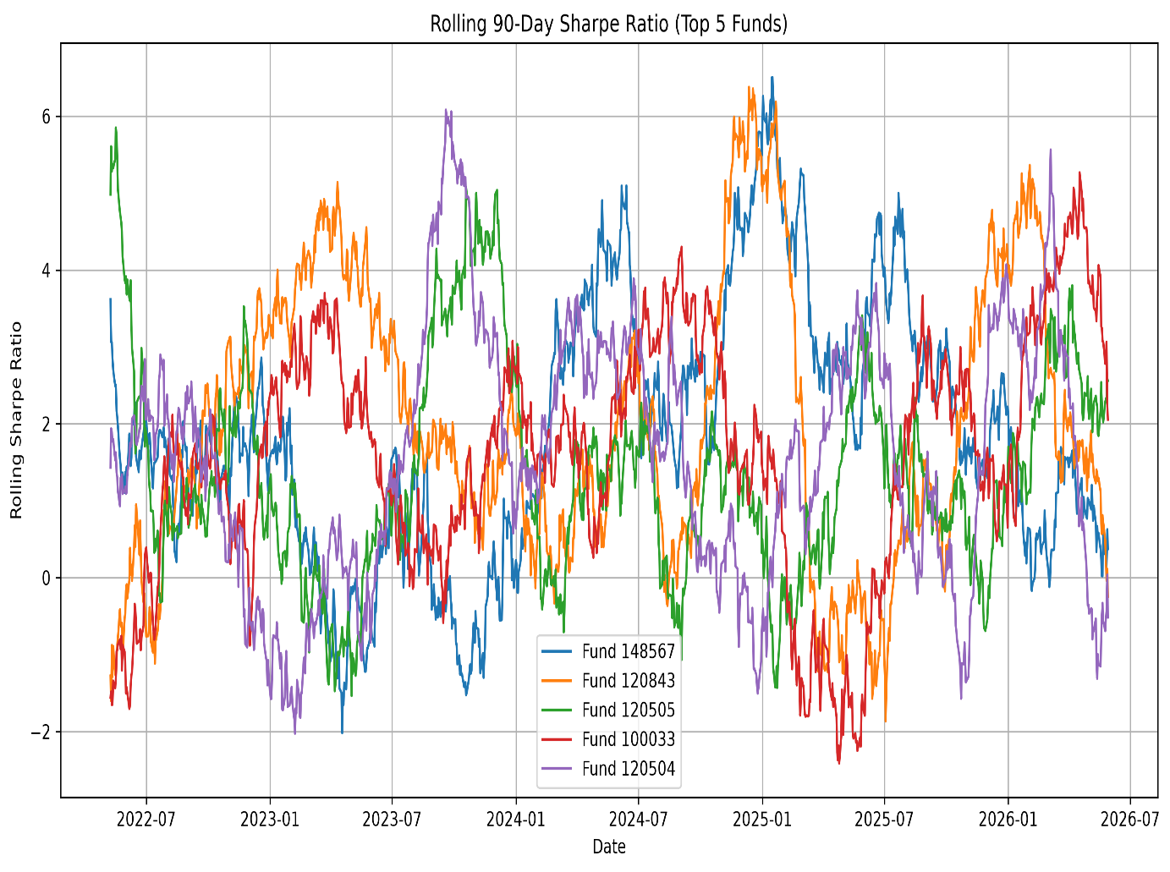

The Sharpe Ratio measures the risk-adjusted return generated by each mutual fund. A higher Sharpe Ratio indicates that the fund delivers better returns for every unit of risk undertaken.

Figure 5.2 – Benchmark Performance Comparison
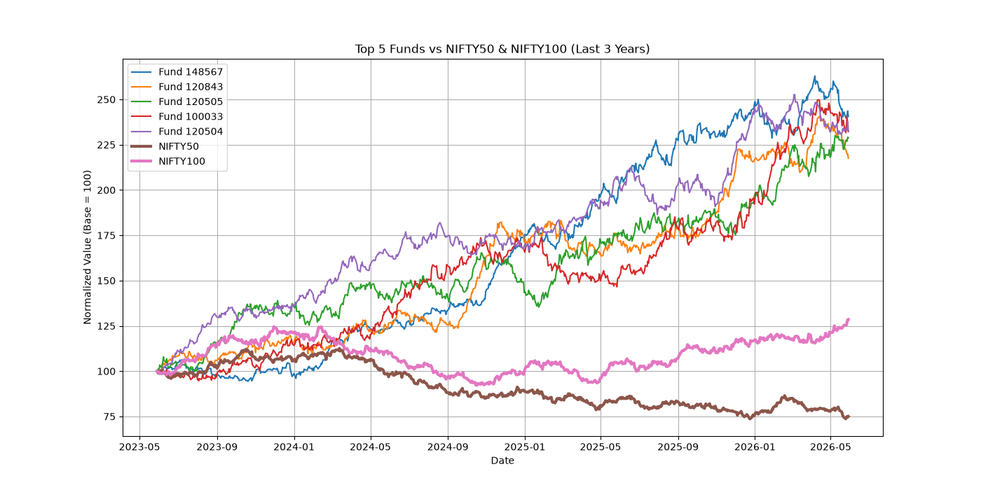
This comparison evaluates fund performance against the benchmark index. Funds consistently outperforming their benchmark demonstrate stronger portfolio management and investment efficiency.

Metric | Source
CAGR | cagr_comparison.csv
Sharpe Ratio | sharpe_ratio.csv
Alpha & Beta | alpha_beta.csv
Sortino Ratio | sortino_ratio.csv
Maximum Drawdown | maximum_drawdown.csv
Tracking Error | tracking_error.csv

Key Findings
- Risk-adjusted performance varies across different mutual fund schemes.
- Higher Sharpe Ratio funds provide better returns relative to the level of risk.
- Positive Alpha values indicate fund managers outperforming their benchmark.
- Lower Maximum Drawdown reflects stronger downside protection during market declines.
- Tracking Error helps evaluate how closely a fund follows its benchmark index.

Advanced Analytics
Figure 6.1 – Value at Risk (VaR) & Conditional VaR (CVaR)
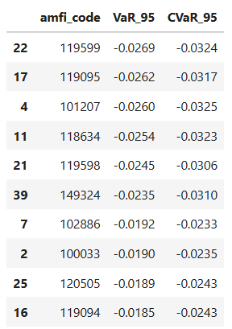
Value at Risk (VaR) estimates the maximum expected portfolio loss at a given confidence level over a specified period. Conditional Value at Risk (CVaR) measures the average loss when losses exceed the VaR threshold, providing insight into extreme downside risk.

Figure 6.2 – Portfolio Concentration (HHI)
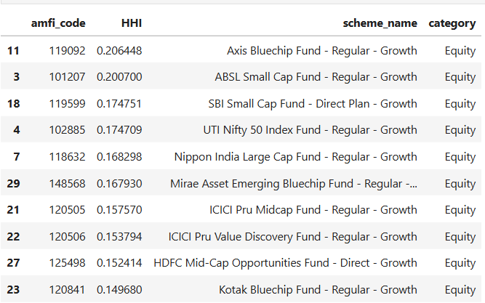
The Herfindahl–Hirschman Index (HHI) was used to measure the concentration of portfolio holdings. Lower HHI values indicate better diversification, whereas higher values indicate that a portfolio is concentrated in fewer securities and therefore carries relatively higher concentration risk
Figure 6.3 – Mutual Fund Recommendation System
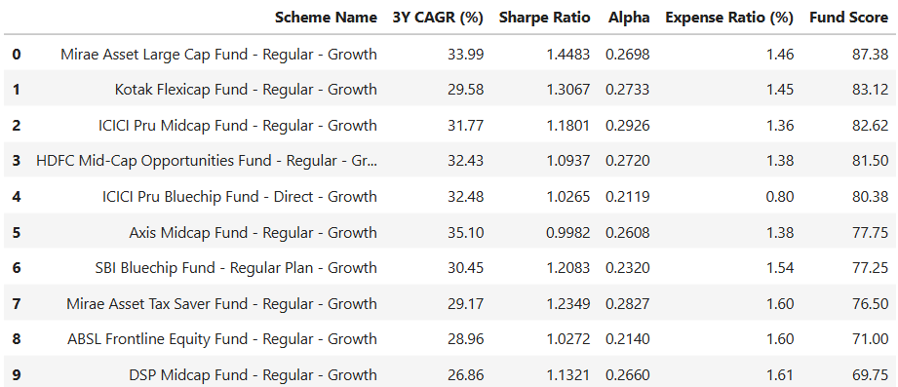

A rule-based recommendation engine was developed to rank mutual funds using multiple performance indicators including 3-Year CAGR, Sharpe Ratio, Alpha, Expense Ratio, and the overall Fund Score. This approach provides investors with a balanced recommendation by considering both returns and risk-adjusted performance rather than relying on a single metric.

Key Insights
- VaR and CVaR quantify the downside risk associated with mutual fund investments.
- HHI analysis indicates the level of diversification within each mutual fund portfolio.
- Funds with lower concentration generally provide better diversification benefits.
- The recommendation engine ranks funds using multiple quantitative performance indicators.
- The Fund Score combines return, risk-adjusted performance, expense ratio, and alpha into a single ranking metric.
- These advanced analytics assist investors in making informed and data-driven investment decisions.

Conclusion & Recommendations
This Mutual Fund Analytics Capstone Project successfully developed a complete data analytics pipeline for analysing mutual fund performance, investor behaviour, and market trends. The project integrated data ingestion, cleaning, storage, exploratory data analysis, performance evaluation, advanced risk analytics, and interactive dashboards into a single workflow.
Performance metrics such as CAGR, Sharpe Ratio, Sortino Ratio, Alpha, Maximum Drawdown, Tracking Error, Value at Risk (VaR), and Conditional Value at Risk (CVaR) were computed to evaluate mutual fund performance comprehensively. Investor cohort analysis, SIP continuity analysis, portfolio concentration analysis using the Herfindahl–Hirschman Index (HHI), and a rule-based recommendation system further enhanced the analytical capabilities of the project.
The Power BI dashboard enables interactive exploration of fund performance, investor demographics, portfolio diversification, and SIP market trends. Overall, the project demonstrates practical applications of Python, SQL, data visualization, and business intelligence techniques in the financial services domain.

Key Project Outcomes
- Successfully built an automated ETL pipeline.
- Loaded cleaned datasets into a SQLite database.
- Performed comprehensive Exploratory Data Analysis (EDA).
- Calculated major mutual fund performance metrics.
- Built an interactive Power BI dashboard with multiple pages.
- Implemented advanced analytics including VaR, CVaR, HHI, cohort analysis, SIP continuity analysis, and a recommendation engine.
- Generated reports and visualisations for investment decision support.

Business Recommendations
- Investors should evaluate risk-adjusted returns rather than relying only on historical returns.
- Diversified portfolios with lower concentration (HHI) are generally less risky.
- Regular SIP investments help reduce market timing risk.
- Investors should consider expense ratios while selecting mutual funds.
- Periodic portfolio reviews are recommended to maintain diversification and risk alignment.
- Financial institutions can leverage predictive analytics to personalise fund recommendations.

Future Scope
The project can be extended by integrating live AMFI APIs for real-time NAV updates, implementing machine learning models for return prediction, performing portfolio optimisation using the Markowitz Efficient Frontier, conducting Monte Carlo simulations for future NAV forecasting, and developing a Streamlit-based web application for interactive portfolio analysis.

References
- Association of Mutual Funds in India (AMFI). Mutual Fund Industry Data and NAV Information. https://www.amfiindia.com
- MFAPI. Mutual Fund NAV API. https://api.mfapi.in
- Microsoft. Power BI Documentation. https://learn.microsoft.com/power-bi/
- Python Software Foundation. Python Documentation. https://docs.python.org/3/
- Pandas Development Team. Pandas Documentation. https://pandas.pydata.org/docs/
- NumPy Developers. NumPy Documentation. https://numpy.org/doc/
- Matplotlib Development Team. Matplotlib Documentation. https://matplotlib.org/stable/
- SQLite Documentation. https://sqlite.org/docs.html
- Jupyter Project. Jupyter Notebook Documentation. https://jupyter.org
- SEBI. Mutual Fund Regulations and Guidelines. https://www.sebi.gov.in

