Design and Performance Evaluation of a Secure Smart Hospital Network for Telemedicine and Critical Care

1. Problem Understanding and Formulation
1.1 Problem Overview
The proposed system is a modern computer network for a multi-specialty hospital consisting of three interconnected buildings:
- Emergency & ICU Block
- Diagnostic & Imaging Block
- Administrative & OPD Block
The network must support critical hospital applications such as real-time telemedicine, continuous monitoring of IoT-enabled medical devices, transfer of large DICOM medical images, electronic medical records, administrative services, and emergency alerts.
The existing network has several problems, including high packet loss in wireless areas near MRI rooms, slow routing updates during network/device failures, TCP retransmission storms during peak telemedicine usage, DNS lookup delays, insecure file transfers, and unreliable email alerts.
Therefore, the objective is to design a reliable, low-latency, secure, scalable and fault-tolerant hospital network using concepts from the Data Link, Network, Transport and Application layers.

1.2 Network Entities
A. Buildings
Building | Major Departments | Main Network Requirements
Emergency & ICU Block | ICU, Emergency, Patient Monitoring | Very low latency, high reliability, highest priority
Diagnostic & Imaging Block | Radiology, MRI, CT, Imaging | High bandwidth and reliable DICOM transfer
Administrative & OPD Block | OPD, Reception, Billing, Administration | Reliable general-purpose and administrative traffic
B. Device Types
The network contains several types of devices:
- Patient monitors
- Infusion pumps
- Wearable medical sensors
- MRI and CT systems
- Radiology workstations
- Doctor/nurse computers
- IP phones
- Telemedicine systems
- Wireless access points
- Servers
- Network switches and routers
- Printers
- Administrative PCs
- Guest devices
Different devices generate different traffic patterns. For example, patient monitors generate small but frequent data packets, while MRI systems generate very large DICOM files.

1.3 Traffic Classes
Hospital traffic is divided into classes according to its importance.
Priority | Traffic | Example | Requirement
1 – Highest | Emergency/ICU | Patient monitoring, emergency alerts | Very low latency, high reliability
2 | Telemedicine | Real-time video consultation | Low latency and low jitter
3 | Medical IoT | Sensors, infusion pumps | Reliable continuous communication
4 | DICOM | MRI/CT image transfer | High throughput and reliability
5 | Administration | Billing, records, email | Normal reliability
6 – Lowest | Guest | Guest Internet access | Best-effort
Priority-based QoS is therefore required so that emergency and telemedicine traffic is not delayed by large imaging transfers or guest traffic.

1.4 Failure Modes
The important failure modes in the existing hospital network are:
1. Wireless packet loss
MRI and other imaging equipment can create a difficult RF environment. Wireless clients near these areas may experience interference and packet loss.
Solution: Wi-Fi 6/802.11ax, appropriate AP placement, channel planning, OFDMA and QoS.
2. Link failure
A fibre or network link between buildings may fail.
Solution: redundant fibre links and dynamic routing using OSPF.
3. Router/switch failure
A routing device may become unavailable.
Solution: redundant network devices and dynamic routing.
4. Network congestion
During peak telemedicine hours, excessive traffic can cause queue buildup and TCP retransmissions.
Solution: QoS, priority queuing, traffic classification and congestion-control analysis.
5. DNS failure/delay
Slow or unavailable DNS services can delay application access.
Solution: hierarchical DNS, caching and redundant DNS servers.
6. File-transfer security failure
Plain FTP can expose sensitive medical information.
Solution: secure transfer using HTTPS/TLS, SFTP or DICOM over TLS.
7. Email alert failure
Critical medical alerts may fail to reach authorized staff.
Solution: authenticated SMTP over TLS, retries, logging and backup notification mechanisms.
8. Unauthorized access
Guest or compromised IoT devices could attempt to access ICU or administrative systems.
Solution: VLAN segmentation, ACLs, firewall policies, authentication and least-privilege access.

1.5 Assumptions
The following assumptions are made for the network design:
- Each building has multiple departments and network users.
- Fibre is available for the inter-building backbone.
- Ethernet is used for fixed high-performance devices.
- Wi-Fi 6 is used for mobile/ward devices.
- BLE is used for suitable wearable medical sensors.
- IPv4 is used as the primary addressing scheme; IPv6 can be added later.
- OSPF is used as the preferred dynamic routing protocol.
- Medical IoT devices are placed in a dedicated VLAN.
- Critical hospital traffic receives higher QoS priority.
- Servers are placed in a separate server VLAN.
- Guest Wi-Fi is isolated from hospital networks.
- Security policies follow HIPAA-like principles for confidentiality, integrity and availability.
- The simulation uses representative traffic rather than actual patient information.
- Network performance is evaluated using latency, packet loss, throughput, jitter and retransmissions.

1.6 Constraints
The design must consider the following constraints:
- Patient-care traffic must have high availability.
- Emergency traffic must experience minimal delay.
- Large DICOM files require high bandwidth.
- Wireless coverage must be reliable in wards.
- Medical data must be protected from unauthorized access.
- The network should remain operational during individual link/device failures.
- The design should be scalable when new departments or devices are added.
- The solution should control implementation and operational costs.
- Battery-powered medical sensors should use energy-efficient communication where possible.
- The simulation cannot perfectly reproduce all real-world hospital RF interference and medical-device behaviour.

2. Application of Course Knowledge
The hospital network applies concepts from all four networking layers to improve reliability, performance and security.
Data Link Layer
- CRC: Used to detect transmission errors in medical/network data.
- Hamming Code: Demonstrates error correction for single-bit errors.
- Wi-Fi 6/OFDMA: Reduces wireless congestion and improves communication for multiple medical devices.
- Ethernet/Fibre: Provides reliable high-speed wired and inter-building connectivity.
Network Layer
- IPv4 Subnetting: Separate networks are created for ICU, Radiology, OPD, Administration and Medical IoT.
- Example: 10.10.10.0/24 provides 254 usable addresses.
- OSPF: Selected instead of Distance Vector routing because it provides faster convergence after link failures.
- ICMP: Used with ping/traceroute to test connectivity and diagnose faults.
Transport Layer
- TCP: Used for reliable medical records, DICOM transfers and administrative data.
- UDP: Used for latency-sensitive telemetry and real-time communication.
- QUIC: Provides secure, reliable and low-latency communication for modern applications.
- QoS: ICU and emergency traffic receives the highest priority.
Queuing Analysis
For an M/M/1 queue:
- Arrival rate: λ = 80 packets/s
- Service rate: μ = 100 packets/s
Utilization:
ρ = λ/μ = 80/100 = 0.8 = 80%
Average delay:
W = 1/(μ − λ) = 1/(100 − 80) = 0.05 s = 50 ms
This shows that as traffic approaches the link's service capacity, queueing delay increases, demonstrating the importance of QoS and congestion control.
Application & Security
- DNS: Hierarchical DNS and caching reduce lookup delays.
- HTTPS/TLS 1.3: Protects telemedicine and patient information.
- Secure DICOM: Protects medical imaging during transfer.
- SMTP/TLS: Provides secure emergency email alerts.
- SNMPv3: Monitors network devices and infrastructure.
- VLANs + ACLs: Isolate ICU, IoT, Admin and Guest traffic.
Overall, these networking concepts provide low latency, reliability, security, fault tolerance and scalability for the hospital network.

Solution/design/methodology;
Student A — Lead / Topology
Based on the team-role allocation, Student A is responsible for the overall network design, building the complete topology in Packet Tracer, the addressing plan, VLAN configuration, and wireless AP deployment. The hospital assignment specifically requires a hierarchical, hybrid topology spanning three buildings, department-wise VLAN segmentation, and a modern WLAN standard (Wi-Fi 6 / 802.11ax) for ward and diagnostic-area connectivity.

1. Network Topology Design
The hospital network is designed as a three-tier hierarchical (Core – Distribution – Access) topology, which is itself a hybrid of star and extended-star/tree topologies. Each of the three buildings — Emergency & ICU Block, Diagnostic & Imaging Block, and Administrative & OPD Block — is modelled as its own distribution zone, so that a failure or upgrade in one building does not disrupt the others. Within each building, access-layer switches and wireless access points connect end devices in a star pattern, and the buildings are tied together through a single collapsed core switch.
- Core Layer: CORE-SW (3560-24PS Multilayer Switch) — single high-speed backbone point interconnecting all three buildings; carries inter-building and inter-VLAN traffic.
- Distribution Layer: ICU-DIST, DIAG-DIST, ADMIN-DIST (3560-24PS Multilayer Switches) — one per building, aggregates access-layer traffic, performs inter-VLAN routing, and enforces department-level policy.
- Access Layer: ICU-ACCESS, DIAG-ACCESS, ADMIN-ACCESS (2960-24TT Switches) — connects wired end devices and access points within each building.
- Wireless Layer: 6 Access Points (2 per building) — provides Wi-Fi coverage to ward staff, laptops and mobile devices in each block.
- End Devices: PC-ICU-01–03, PC-RAD-01–03, PC-OPD-01–02, PC-ADMIN-01, Laptop0–5 — ward/ICU PCs, radiology PCs, OPD/admin PCs and staff laptops.
- Servers: DNS Server, Web Server, Email Server, DIACOM (DICOM imaging) Server — centralised application services placed in the Admin block server farm.
This design keeps the three physical/functional buildings separate at the distribution layer while still allowing every device in the hospital to reach shared services (DNS, web, email, DICOM) through the core, satisfying the requirement for a scalable, hybrid, multi-building topology. The full topology, including all switches, access points, end devices and servers, was built and tested end-to-end in Cisco Packet Tracer.
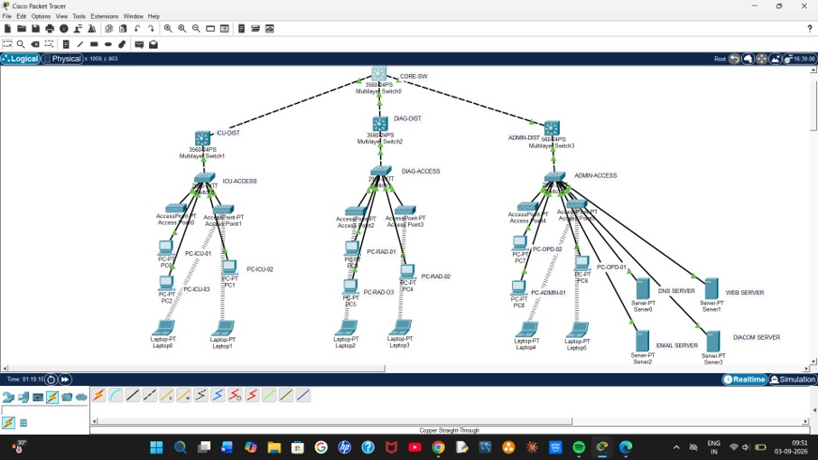
Figure 1: Three-building hierarchical hospital network topology (Cisco Packet Tracer)

2. VLAN Design (per Department)
VLANs are configured on the access and distribution switches to logically separate departmental traffic, reduce broadcast domains, and align with the addressing plan used for subnetting. The VLAN numbering below maps directly onto Student B's IP subnetting plan (10.10.0.0/16) so that each VLAN corresponds one-to-one with a department subnet.
- VLAN 10 — ICU & Emergency (ICU-DIST) — mapped to 10.10.0.0/22
- VLAN 20 — Diagnostic & Imaging / Radiology (DIAG-DIST) — mapped to 10.10.4.0/22
- VLAN 30 — OPD Network (ADMIN-DIST) — mapped to 10.10.8.0/22
- VLAN 40 — Administration (ADMIN-DIST) — mapped to 10.10.12.0/23
- VLAN 50 — IoT Medical Devices, monitors, pumps, wearables (ICU-DIST / DIAG-DIST) — mapped to 10.10.14.0/22
- VLAN 60 — Servers: DNS, Web, Email, DIACOM (ADMIN-DIST) — mapped to 10.10.18.0/24
- VLAN 99 — Network Management / native VLAN (CORE-SW) — mapped to 10.10.19.0/24
Access ports on ICU-ACCESS, DIAG-ACCESS and ADMIN-ACCESS are assigned to the relevant VLAN using:
Switch(config)# interface range fa0/1-8
Switch(config-if-range)# switchport mode access
Switch(config-if-range)# switchport access vlan 10
Trunk links between each access switch and its distribution switch, and between each distribution switch and CORE-SW, are configured with 802.1Q trunking so that all department VLANs can reach the core for inter-VLAN routing and access to the server farm.

3. Wireless LAN Design (Wi-Fi 6 / 802.11ax)
Six access points are deployed, two per building, to provide ward-wide and department-wide wireless coverage for staff laptops, tablets and IoT medical devices while keeping wired PCs on the access switches. Wi-Fi 6 (802.11ax) is chosen over legacy 802.11n/ac because it uses OFDMA to serve many simultaneous low-data-rate IoT sensors efficiently, supports Target Wake Time (TWT) to extend the battery life of wearable medical devices, and still relies on CSMA/CA for contention-based medium access, which the assignment requires to be justified.
- Emergency & ICU Block: AccessPoint0, AccessPoint1 — SSID HOSP-ICU-WLAN — mapped to VLAN 10 / 50.
- Diagnostic & Imaging Block: AccessPoint2, AccessPoint3 — SSID HOSP-DIAG-WLAN — mapped to VLAN 20 / 50.
- Administrative & OPD Block: AccessPoint4, AccessPoint5 — SSID HOSP-ADMIN-WLAN — mapped to VLAN 30 / 40.
Placing two APs per block (rather than one) also reduces the packet loss seen near MRI/imaging rooms mentioned in the problem statement, by giving client devices a nearer AP to associate with and avoid RF interference from imaging equipment.

4. Alternative Topologies Considered
Two alternative designs were evaluated before finalising the hierarchical hybrid topology:
- Flat single-switch star topology — all devices connected to one central switch. Rejected because a single point of failure would take down all three buildings at once, and it does not scale to 2,000+ wireless clients and 300 IoT sensors.
- Full-mesh topology between three building switches — every building switch directly connected to every other. Rejected because it adds unnecessary cabling/fibre cost between buildings for only three nodes, and does not provide the clean Core–Distribution–Access separation needed for VLAN-based departmental policy and SDN/policy-based traffic prioritisation.
Therefore, the three-tier hierarchical/hybrid topology is preferred because it isolates departments through VLANs, keeps each building's failures local, supports the 802.1Q trunking and OSPF routing configured by Student B, and gives a single, clear point (the core) at which SDN/policy-based prioritisation of critical ICU traffic can be applied.

5. Student A Contribution Summary
Student A contributed to the overall network design by building the complete three-building hierarchical topology in Cisco Packet Tracer (core, distribution and access switches, six Wi-Fi 6 access points, all end devices and the shared server farm), defining the department-wise VLAN scheme aligned with the team's IP addressing plan, configuring access and trunk ports, and deploying the wireless access points per department. This topology forms the physical and logical foundation on which Student B's routing/OSPF configuration, Student C's Wireshark capture points, and Student D's application services were implemented and tested.
This directly matches the assigned responsibility of Student A: overall network design, Packet Tracer topology, addressing plan, VLANs, and wireless APs.

Student B – Routing & Network Layer
Based on the team-role allocation, Student B is responsible for IP subnetting, routing configuration and testing, SDN concepts, and ICMP diagnostics. The hospital assignment specifically requires hierarchical addressing, subnetting for departments, routing comparison, ICMP diagnostics, and policy-based prioritisation.

1. IP Addressing and Subnetting Plan
A hierarchical IPv4 addressing scheme can be used with the private network block 10.10.0.0/16.
Department / Network | Network Address | Subnet Mask | Usable Hosts
ICU & Emergency | 10.10.0.0/22 | 255.255.252.0 | 1022
Diagnostic & Imaging | 10.10.4.0/22 | 255.255.252.0 | 1022
OPD Network | 10.10.8.0/22 | 255.255.252.0 | 1022
Administration | 10.10.12.0/23 | 255.255.254.0 | 510
IoT Medical Devices | 10.10.14.0/22 | 255.255.252.0 | 1022
Servers | 10.10.18.0/24 | 255.255.255.0 | 254
Network Management | 10.10.19.0/24 | 255.255.255.0 | 254
This addressing scheme separates hospital departments and improves network scalability, security, and traffic management. VLANs can be associated with each department to reduce unnecessary broadcast traffic.

2. Routing Protocol Selection
For the Smart Hospital Network, OSPF (Open Shortest Path First) is selected as the primary routing protocol.

Why OSPF?
- It is a Link-State routing protocol.
- Provides fast routing convergence during network failures.
- Suitable for large and scalable networks.
- Supports hierarchical network design using areas.
- Uses cost as its routing metric.
- Helps achieve the requirement of rapid recovery during equipment or link failures.

Distance Vector vs Link State Routing

Feature | Distance Vector | Link State (OSPF)

Network Knowledge | Limited | Complete topology view

Convergence | Slower | Faster

Updates | Periodic | Triggered updates

Scalability | Lower | High

Example | RIP | OSPF

Hospital Suitability | Less suitable | Highly suitable

Therefore, OSPF is preferred because the hospital requires routing convergence in less than 3 seconds during a single link failure.

3. Basic OSPF Configuration
Example router configuration:
Router> enable
Router# configure terminal
Router(config)# router ospf 1
Router(config-router)# network 10.10.0.0 0.0.255.255 area 0
Router(config-router)# end

Each router in the three-building hospital topology can be configured with OSPF Area 0 for communication between:
- Emergency & ICU Block
- Diagnostic & Imaging Block
- Administrative & OPD Block
The routing tables can be verified using:
Router# show ip route
Router# show ip ospf neighbour
Router# show ip protocols

4. Routing Convergence Test
To test routing reliability:
- Establish communication between devices in different buildings.
- Use the ping command to verify connectivity.
- Disconnect one inter-router link.
- Observe OSPF selecting an alternate path.
- Measure the time required for routing convergence.
- Restore the link and verify that the routing table updates correctly.
The expected result is that the network should automatically reroute traffic through an alternative path with minimal interruption.

5. ICMP Diagnostics
ICMP is used for network troubleshooting and connectivity verification.
Important commands include:
PC> ping 10.10.18.10
PC> tracert 10.10.18.10
Ping verifies whether the destination device is reachable, while Traceroute identifies the path taken by packets through different routers.

ICMP diagnostics help identify:
- Unreachable devices
- Routing failures
- Link failures
- Excessive delay
- Incorrect IP configuration

6. SDN / Policy-Based Prioritisation Concept
A simple Software Defined Networking (SDN) or policy-based approach can be introduced to prioritise critical hospital traffic.
Traffic priority can be arranged as:
- Emergency ICU monitoring data – Highest Priority
- Telemedicine video traffic – High Priority
- Medical imaging transfer – Medium Priority
- Administrative traffic – Normal Priority
The SDN controller or policy-based routing mechanism can dynamically manage traffic based on its importance. This ensures that emergency patient-monitoring traffic receives faster delivery even during periods of high network congestion.

7. Student B Contribution Summary
Student B contributed to the Network Layer design by creating the IP subnetting table, configuring OSPF routing, testing routing convergence during link failures, performing ICMP-based diagnostics, and proposing an SDN/policy-based traffic prioritisation mechanism for critical-care communication. The routing design ensures scalable communication between the three hospital buildings while providing fast recovery and reliable connectivity for emergency medical services.
This directly matches the assigned responsibility of Student B: subnetting tables, routing configuration and convergence tests, and an SDN concept note.

Student C — Transport Layer & Performance Analysis
1. Introduction
The transport layer is responsible for end-to-end communication between hospital devices, servers, and users. The hospital network carries different types of traffic, including real-time telemedicine video, patient-monitoring data, DICOM medical images, medical records, DNS requests, and administrative services.
These applications have different requirements. For example, telemedicine requires low latency and low jitter, whereas medical records and DICOM files require reliable and complete delivery.
Therefore, this project evaluates TCP, UDP, and QUIC, together with congestion control and Quality of Service (QoS), to determine the most suitable transport approach for each hospital application.

2. TCP
Transmission Control Protocol (TCP) is a connection-oriented and reliable transport protocol.
TCP provides:
- Reliable delivery
- Ordered delivery
- Error detection
- Retransmission of lost segments
- Flow control
- Congestion control
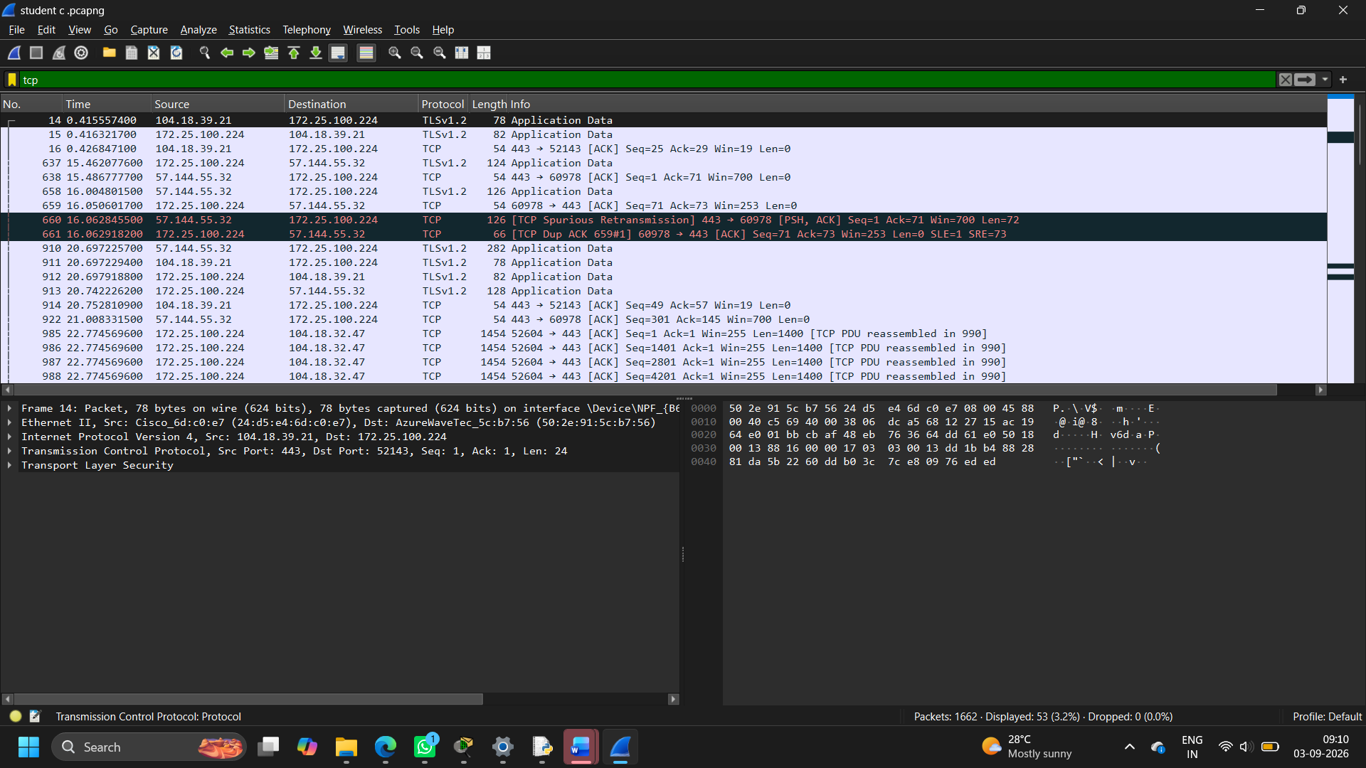TCP communication
Client Server
| |
|-------- SYN ---------------->|
|<------ SYN + ACK ------------|
|-------- ACK ---------------->|
| |
|====== Data transfer =========>|
|<========= ACK ===============|
This three-way handshake establishes a TCP connection.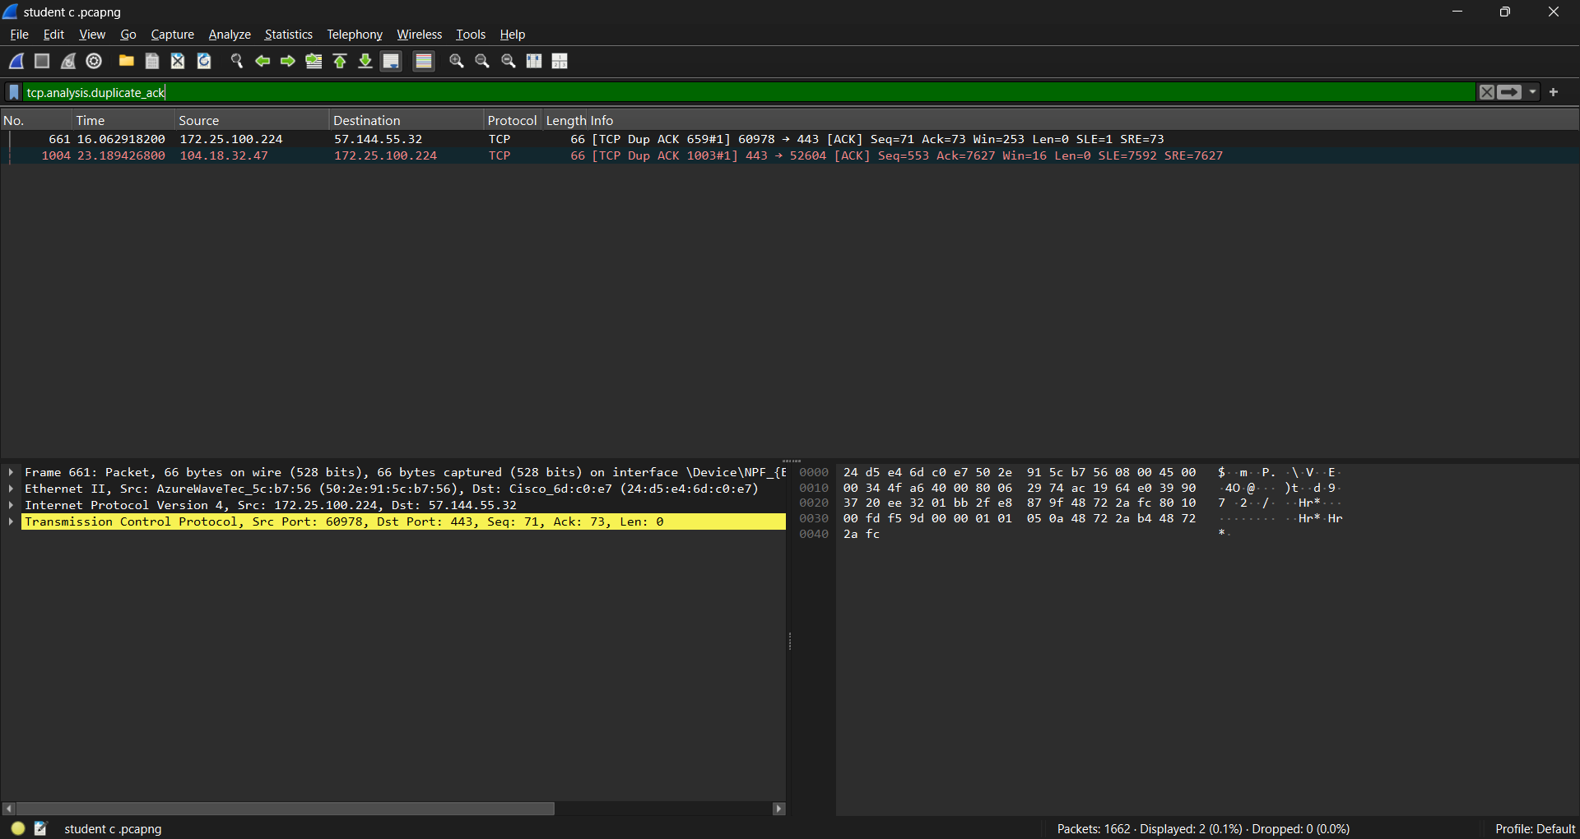
Hospital applications suitable for TCP
TCP is appropriate for:
- Electronic medical records
- DICOM file transfer
- Database communication
- Web applications
- Email
- Administrative applications
For these applications, losing or reordering data could result in an incomplete or corrupted transaction.

3. TCP Congestion Control
TCP attempts to prevent network congestion by adjusting its sending rate.
A simplified TCP congestion-control process is:
Increase sending rate
↓
Network becomes congested
↓
Packet loss / duplicate ACK
↓
TCP reduces sending rate
↓
Retransmission
↓
Gradual increase again
During peak telemedicine traffic, many simultaneous TCP flows can compete for bandwidth.
For example:
DICOM transfer
|
|
Telemedicine +----> Core Router ----> Server
|
|
Medical records
If the network becomes congested:
High traffic
↓
Queue fills
↓
Packets dropped
↓
TCP retransmissions
↓
Additional traffic
↓
More congestion
This can contribute to the TCP retransmission storms observed in the existing hospital network.

4. UDP
User Datagram Protocol (UDP) is connectionless and has very low protocol overhead.
Unlike TCP, UDP does not inherently provide:
- Guaranteed delivery
- Packet ordering
- Retransmission
- Congestion control equivalent to TCP
UDP communication
Sender Receiver
| |
|-------- UDP packet --------->|
|-------- UDP packet --------->|
|-------- UDP packet --------->|
There is no TCP-style three-way handshake.
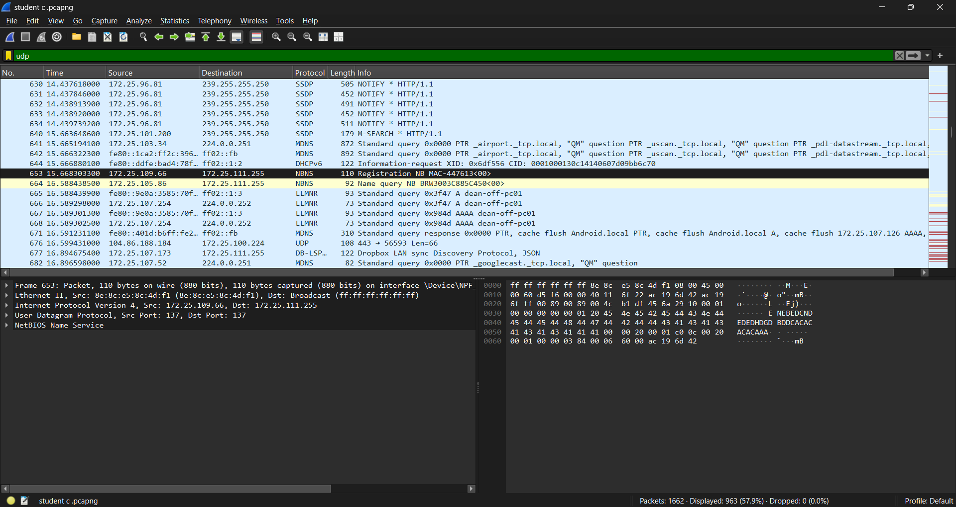Hospital applications
UDP is suitable for traffic where timeliness is more important than perfect delivery, such as:
- Real-time telemetry
- Voice/video components
- Certain real-time monitoring applications
For example, if one video packet is lost:
Video packets:

1 2 3 X 5 6
↑
lost
Waiting for retransmission may be worse for a real-time video stream than continuing with a small amount of loss.

5. QUIC
QUIC is a modern transport protocol built over UDP.
It provides features including:
- Reliable delivery
- Encryption
- Multiplexed streams
- Reduced connection-establishment overhead
- Modern congestion control
QUIC is particularly relevant to modern web and telemedicine applications.
A simplified architecture is:
Telemedicine Application
↓
QUIC
↓
UDP
↓
IP Network
Compared with traditional TCP + TLS, QUIC integrates transport security more closely into the protocol architecture.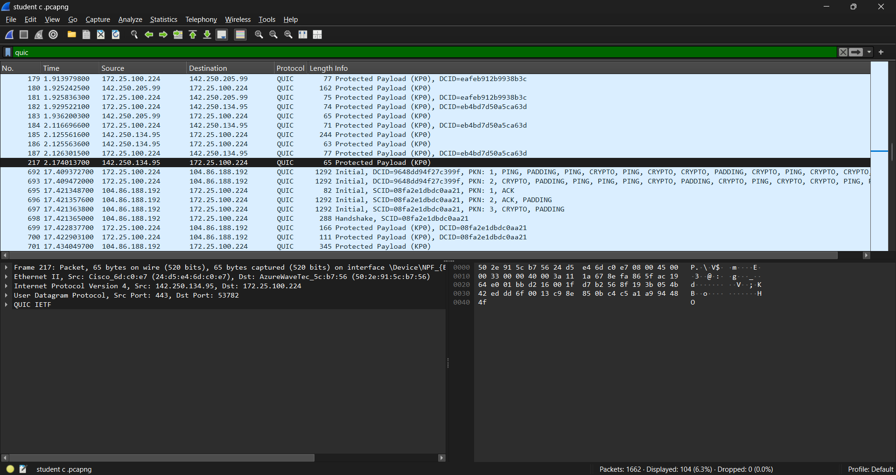

Possible hospital use
QUIC can be evaluated for:
- Telemedicine portals
- Real-time web applications
- Modern HTTPS/HTTP/3 services
- Remote consultation platforms

6. TCP vs UDP vs QUIC
Feature | TCP | UDP | QUIC
Connection-oriented | Yes | No | Yes
Reliable delivery | Yes | No | Yes
Ordered streams | Yes | No | Yes
Retransmission | Yes | No | Yes
Congestion control | Yes | Not inherently | Yes
Encryption | Usually TLS above TCP | Not inherent | Built into QUIC
Connection setup | Higher | Very low | Low
Best use | Files/records | Real-time traffic | Modern real-time/web applications
Hospital example | DICOM | Telemetry | Telemedicine portal
Conclusion
There is no single protocol that is best for every hospital application.
TCP → reliable data
UDP → time-sensitive traffic
QUIC → modern encrypted low-latency application
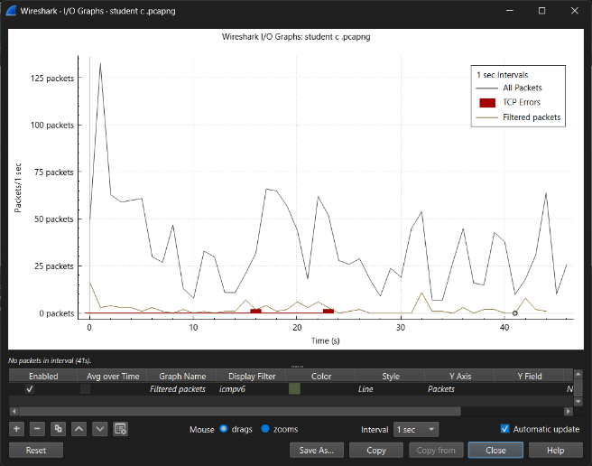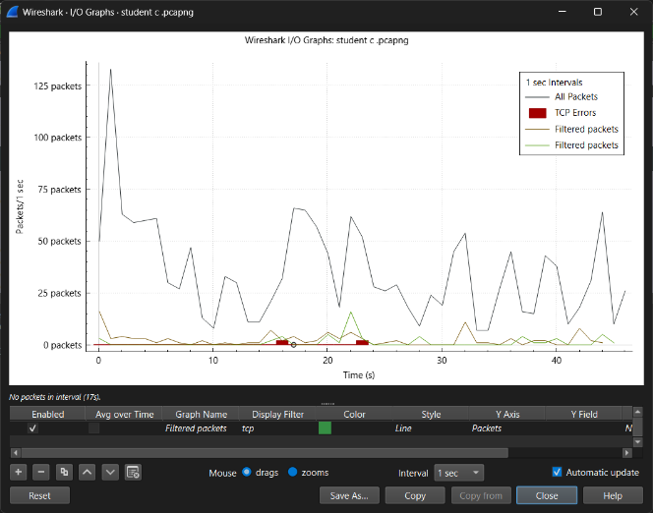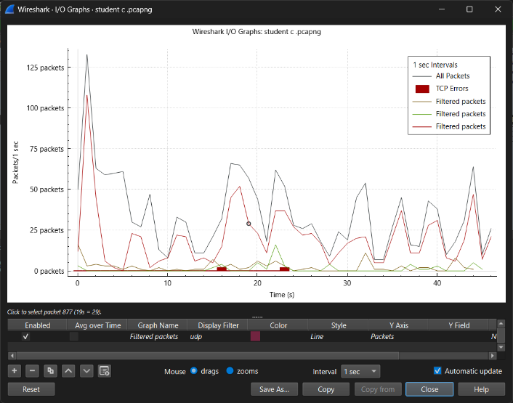

7. Quality of Service (QoS)
The hospital network must give priority to critical medical traffic.
Without QoS, traffic may compete equally:
ICU monitoring ──────┐
Telemedicine ────────┤
DICOM ────────────────┼──> Router → Congested link
Administration ──────┤
Guest downloads ─────┘
With QoS:
Router
|
+--------+--------+
| |
High priority Low priority
| |
ICU/telemedicine Admin/Guest
medical telemetry bulk traffic
Proposed priority
Priority | Traffic | Reason
1 | ICU/Emergency | Patient safety
2 | Telemedicine | Real-time communication
3 | Medical IoT | Continuous monitoring
4 | DICOM | Important but delay-tolerant
5 | Administration | Normal business traffic
6 | Guest Wi-Fi | Lowest priority

8. Priority Queuing
Priority queuing allows packets from critical applications to be transmitted before lower-priority packets.
Example:
Incoming packets
↓
+---------------------+
| Priority Class 1 | ← ICU
+---------------------+
| Priority Class 2 | ← Telemedicine
+---------------------+
| Priority Class 3 | ← Medical IoT
+---------------------+
| Priority Class 4 | ← DICOM
+---------------------+
| Priority Class 5 | ← Admin
+---------------------+
| Priority Class 6 | ← Guest
+---------------------+
↓
Outgoing link
During congestion, lower-priority traffic may experience greater delay, but critical traffic continues to receive network resources.

9. Performance Metrics
Student C should evaluate the network using the following metrics.
9.1 Latency
Latency is the time required for a packet to travel from source to destination.
$$Latency=T_{arrival}-T_{departure}$$
Lower latency is particularly important for:
- telemedicine
- ICU monitoring
- emergency communication

9.2 Packet Loss
Packet loss is:
$$Packet Loss\left(\%\right)=\frac{Packets Sent-Packets Received}{Packets Sent}×100$$
Example:
If 10,000 packets are sent and 50 are lost:
$$Packet Loss=\frac{50}{10000}×100=0.5\%$$

9.3 Throughput
Throughput represents the amount of useful data successfully transmitted per unit of time.
$$Throughput=\frac{Data transferred}{Time}$$
It is particularly important for DICOM imaging because medical images can be large.

9.4 Jitter
Jitter is the variation in packet arrival time.
For example:
Packet Arrival interval

1 10 ms
2 11 ms
3 10 ms
4 25 ms
5 12 ms
The sudden 25 ms interval produces increased jitter.
Low jitter is important for real-time video and voice.

9.5 TCP Retransmissions
Count the number of TCP segments that are retransmitted.
High retransmissions indicate:
- packet loss
- congestion
- poor link quality
- insufficient network capacity
The objective of QoS is to prevent critical traffic from suffering excessive congestion and loss.

10. Wireshark Analysis
Wireshark can be used to capture and inspect network packets during the simulation/emulation.
Useful display filters include:
tcp
udp
quic
tcp.analysis.retransmission
tcp.analysis.duplicate_ack
dns
icmp
TCP analysis
In Wireshark, identify:
- SYN
- SYN-ACK
- ACK
- Data segments
- ACKs
- Retransmissions
- Duplicate ACKs
A typical TCP sequence can be represented as:
SYN
↓
SYN-ACK
↓
ACK
↓
DATA
↓
ACK
↓
DATA
↓
ACK
If packets are lost:
DATA 100
DATA 101
DATA 102 ← lost
DATA 103

↓

Duplicate ACK
↓
Retransmission of DATA 102
This provides direct evidence of congestion or packet loss.

11. Simulation Experiment 1 — TCP Congestion
Objective
Determine how TCP behaves when the network is heavily loaded.
Procedure
Generate:
- multiple TCP flows
- DICOM transfers
- administrative traffic
- telemedicine traffic
Then observe:
- packet loss
- retransmissions
- throughput
- delay
Expected observation
As network utilisation increases:
$$Traffic↑⇒Queueing↑⇒Packet loss↑⇒TCP retransmissions↑$$
This demonstrates why uncontrolled bulk traffic can negatively affect hospital applications.

12. Simulation Experiment 2 — QoS OFF vs QoS ON
This should be one of your main experiments.
Case A — QoS disabled
DICOM ───────────┐
Telemedicine ────┤
ICU IoT ─────────┼──> Same queue
Admin ───────────┤
Guest ───────────┘
Measure:
- ICU latency
- telemedicine jitter
- packet loss
- DICOM throughput
- TCP retransmissions
Case B — QoS enabled
ICU ───────────────→ HIGH priority
Telemedicine ──────→ HIGH priority
IoT ───────────────→ HIGH priority
DICOM ─────────────→ MEDIUM
Admin ─────────────→ LOW
Guest ─────────────→ LOW
Run exactly the same traffic again.
Then compare the results.

14. Simulation Experiment 3 — TCP vs UDP
Generate equivalent traffic using TCP and UDP.
TCP
Observe:
- reliable delivery
- acknowledgements
- retransmissions
- congestion control
UDP
Observe:
- lower overhead
- no handshake
- no inherent retransmission
- packet loss when congestion occurs
Analysis
TCP may maintain reliability at the cost of additional delay when packets are lost.
UDP can maintain low overhead and latency but may sacrifice reliability.
Therefore:
For real-time patient telemetry, controlled UDP-based communication can be advantageous when the application can tolerate limited packet loss or implements its own recovery mechanism. For medical records and DICOM, reliable transport is preferable.

15. Simulation Experiment 4 — Routing Failure and Transport Behaviour
Although routing is primarily Student B's responsibility, Student C should analyse its transport-layer impact.
Normal:
ICU → Core 1 → Diagnostic Server
Failure:
ICU → Core 1 X

↓

ICU → Core 2 → Diagnostic Server
Observe in Wireshark:
- packet loss
- TCP retransmission
- temporary delay
- connection recovery
- UDP packet loss
This connects the Network Layer work with Student C's transport analysis.

16. Queuing Analysis
A simple M/M/1 model can be used to explain congestion.
Let:
$$λ=\text{packet arrival rate} \\ μ=\text{packet service rate}$$
The utilisation is:
$$ρ=\frac{λ}{μ}$$
For stable operation:
$$ρ<1$$
The average time in the system is:
$$W=\frac{1}{μ-λ}$$
For example, assume:
$$λ=700 packets/s$$
and:
$$μ=1000 packets/s$$
Then:
$$ρ=\frac{700}{1000}=0.7$$
and:
$$W=\frac{1}{1000-700}=0.00333s$$
Therefore:
$$\boxed{W≈3.33ms}$$
If traffic increases closer to the service capacity, queueing delay increases rapidly.
This explains why the hospital experiences significant delays during peak telemedicine periods.

17. Final Analysis
The transport-layer analysis demonstrates that different hospital applications require different communication strategies.
TCP provides reliable and ordered delivery and is appropriate for DICOM, medical records, databases, and administrative services. However, heavy congestion can result in retransmissions and increased delay.
UDP has lower overhead and is appropriate for latency-sensitive telemetry and real-time media when the application can tolerate some loss or provides its own recovery mechanism.
QUIC provides reliable, encrypted transport over UDP and is a strong option for modern telemedicine web applications where reduced connection overhead and multiplexing are beneficial.
QoS is essential because not all hospital traffic has equal importance. ICU monitoring, emergency traffic, and telemedicine should receive higher priority than administrative and guest traffic.

18. Student C Conclusion
Student C Conclusion:
The transport-layer evaluation shows that the hospital network should not use a single transport protocol for all applications. TCP is appropriate for reliable medical records and DICOM transfers, while UDP is suitable for latency-sensitive telemetry and real-time media where occasional packet loss can be tolerated. QUIC provides a modern alternative for secure, low-latency web-based telemedicine applications. Wireshark analysis can be used to identify TCP retransmissions, duplicate acknowledgements, packet loss, DNS delays, and transport behaviour during congestion. The QoS experiment demonstrates that prioritising ICU, emergency, telemedicine, and medical IoT traffic can protect critical services during periods of heavy network utilisation. Therefore, combining appropriate transport protocols with priority queuing provides better latency, reliability, and overall performance for the hospital's critical applications.

Student D — Application Layer, Security & Broader Impact
For your hospital network project, Student D should handle the Application Layer + Security + Privacy + Social/Sustainability impact.
Your work can be divided into:
- DNS
- HTTPS/TLS 1.3
- Secure DICOM/file transfer
- SMTP email alerts
- SNMP monitoring
- Security and privacy
- Energy efficiency
- Patient safety
- Cost and sustainability
- SDG 3, 9 and 11

1. Application Layer Architecture
The hospital should have a dedicated Server VLAN containing the main application services.
SERVER VLAN
|
+----------+-----------+-----------+----------+
| | | | |
DNS Web PACS SMTP SNMP
Server Server Server Server Monitor
| | | |
| Telemedicine DICOM Alerts
| Portal Files
| |
+----------+----------------------+
This separation prevents ordinary user traffic from directly accessing critical servers.

2. DNS Design
DNS converts names into IP addresses.
For example:
telemedicine.hospital.local
↓
10.10.70.20
Proposed DNS hierarchy
hospital.local
│
├── dns.hospital.local
├── telemedicine.hospital.local
├── pacs.hospital.local
├── mail.hospital.local
├── monitoring.hospital.local
├── icu.hospital.local
├── radiology.hospital.local
└── opd.hospital.local
Why DNS is important
The existing network has DNS lookup delays, which can slow down application access.
Use:
- local DNS caching
- redundant DNS servers
- appropriate DNS records
- controlled external DNS forwarding
For example:
Client
|
| DNS query
↓
Local DNS resolver
|
+---- Cached? ---- Yes → immediate response
|
No
↓
Authoritative/external DNS
DNS experiment
Compare:
Test 1: First/uncached lookup
Test 2: Repeated/cached lookup
Record:
Test | Lookup time
First DNS lookup | ___ ms
Cached lookup | ___ ms
Report statement
A hierarchical and caching DNS architecture is proposed to reduce name-resolution latency and improve application responsiveness. Redundant DNS infrastructure can also improve availability during server failures.

3. HTTPS and TLS 1.3
The telemedicine portal contains sensitive patient information, so it should never operate using plain HTTP for protected data.
Use:
Patient/Doctor
|
| HTTPS
↓
TLS 1.3
|
↓
Telemedicine Server
Security provided by TLS
TLS provides:
- Confidentiality
- Integrity
- Server authentication
Instead of:
HTTP
Patient information → readable over network
use:
HTTPS
Patient information → encrypted
Example
Doctor
|
| HTTPS / TLS 1.3
|
↓
Telemedicine Portal
|
↓
Hospital Application Server
Important security measures
- TLS 1.3
- Valid digital certificates
- Strong authentication
- Role-based access control
- Session timeout
- Audit logs
- Secure password handling
- Encryption of sensitive information at rest

4. DICOM / Medical Imaging
The Diagnostic & Imaging Block produces large medical imaging files such as:
- MRI
- CT
- X-ray
- Ultrasound
These can be transferred to the hospital's PACS.
MRI / CT
|
↓
Imaging workstation
|
↓
Secure DICOM transfer
|
↓
PACS Server
|
↓
Authorised Doctor
Existing problem
Large DICOM files can consume significant bandwidth:
Large DICOM transfer
↓
High bandwidth usage
↓
Network congestion
↓
Telemedicine delay
Therefore, DICOM traffic should be classified appropriately in the QoS design.
It should have high priority, but emergency/real-time traffic should normally receive higher priority.

5. Secure File Transfer
Plain FTP should not be used for sensitive medical information because traditional FTP can transmit credentials and data without adequate encryption.
Instead use:
- SFTP
- HTTPS
- DICOM over a protected connection/TLS where supported
Example:
Radiology
|
| Encrypted transfer
↓
PACS
FTP vs SFTP
Feature | FTP | SFTP
Encryption | No by default | Yes
Credentials protected | No by default | Yes
Suitable for patient data | ❌ | ✅
Secure transfer | Poor | Stronger
Demonstration
You can demonstrate:
FTP
↓
Unencrypted credentials/data

SFTP
↓
Encrypted communication
Then explain why secure transfer is required for patient information.

6. SMTP for Critical Alerts
The hospital needs an email alert system for events such as:
- patient monitoring alerts
- device failures
- server failures
- network failures
- system warnings
Architecture:
Patient Monitor
↓
Monitoring Server
↓
Alert Engine
↓
SMTP Server
↓
Authorised Staff
Example:
Abnormal patient reading
↓
Alert server
↓
SMTP/TLS
↓
Doctor/Nurse
Existing problem
The problem statement mentions email alert failures.
Therefore, your design should include:
- authenticated SMTP
- TLS
- retry mechanism
- monitoring of mail-server availability
- alert logging
- backup notification mechanism where appropriate
A critical clinical alert should not depend solely on email; the system should have an appropriate clinical escalation mechanism.

7. SNMP Monitoring
SNMP can be used to monitor network infrastructure and supported medical-device gateways.
Use SNMPv3 rather than insecure legacy configurations where possible.
Medical IoT Gateway
|
| SNMPv3
↓
Monitoring Server
|
↓
Dashboard / Alert
Monitor:
- CPU utilisation
- memory
- interface status
- packet errors
- bandwidth utilisation
- device availability
Example:
Switch Port
↓
Errors increasing
↓
SNMP monitoring
↓
Administrator alert
This allows administrators to identify network/device problems before they become major failures.

8. Security Architecture
The hospital should use defence in depth.
INTERNET
|
[Firewall]
|
[VPN Gateway]
|
Core Network
|
+---------------+---------------+
| | |
ICU VLAN IoT VLAN Admin VLAN
| | |
ACL ACL ACL
Main security controls
Security mechanism | Purpose
Firewall | Protect network perimeter
VLANs | Isolate departments
ACLs | Control communication
WPA3-Enterprise | Secure wireless
802.1X | User/device authentication
TLS 1.3 | Encrypt applications
VPN | Secure remote access
SNMPv3 | Secure monitoring
RBAC | Restrict application access
Logging | Detect suspicious activity
Backups | Disaster/ransomware recovery

9. Medical IoT Security
IoT devices are particularly important because there may be hundreds of:
- patient monitors
- infusion pumps
- wearable sensors
- gateways
Do not place them on the normal user network.
Use a dedicated:
MEDICAL-IOT VLAN
10.10.20.0/24
Example:
Patient Monitor
|
↓
Medical IoT VLAN
|
↓
IoT Gateway
|
↓
Monitoring Server
The ACL should allow only required communication.
For example:
Medical IoT → Monitoring Server ALLOW
Medical IoT → DNS ALLOW
Medical IoT → Internet DENY
Medical IoT → Admin PCs DENY
Guest → Medical IoT DENY
This reduces the impact of a compromised IoT device.

10. Patient Data Privacy
Hospital systems contain highly sensitive information.
The design should protect:
Confidentiality
Only authorised users should access patient information.
Integrity
Patient records must not be modified without authorisation.
Availability
Critical information must remain available when doctors need it.
This is the:
$$\boxed{\text{CIA Triad}}$$
Principle | Example
Confidentiality | TLS, ACLs, encryption
Integrity | TLS, authentication, logging
Availability | Redundant servers, links, backups

11. HIPAA-like Considerations
Even though the assignment says HIPAA-like considerations, you should present these as general healthcare privacy/security principles rather than claiming that the simulated network itself is legally HIPAA compliant.
Important controls include:
- Minimum necessary access
- User authentication
- Role-based permissions
- Audit logging
- Encryption
- Secure transmission
- Backup and disaster recovery
- Incident response
- Access monitoring
Example:
Doctor
↓
Authenticated
↓
Role = Doctor
↓
Patient records
↓
Access allowed
But:
Guest user
↓
Not authorised
↓
Patient records
↓
ACCESS DENIED

12. Application Security Testing
Student D can demonstrate simple security tests.
Test 1 — Guest isolation
Try:
Guest PC → ICU Server
Expected:
ACCESS DENIED
Test 2 — Admin access
Admin PC → Admin Server
Expected:
ACCESS ALLOWED
Test 3 — IoT isolation
Medical IoT → Admin PC
Expected:
ACCESS DENIED
Test 4 — HTTPS
Client → HTTPS → Telemedicine Server
Expected:
Encrypted traffic
Test 5 — SNMP
Verify that the monitoring server can receive information from authorised devices.

13. Energy Efficiency
Wi-Fi 6 provides Target Wake Time (TWT) for compatible devices.
This is particularly useful for battery-powered medical sensors.
Without TWT:
Sensor
↓
Wake
↓
Listen
↓
Transmit
↓
Listen again
↓
Sleep
With TWT:
Sensor
↓
Sleep
↓
Scheduled wake-up
↓
Transmit
↓
Sleep
This can reduce unnecessary radio activity.
Benefits
- Longer sensor battery life
- Lower energy consumption
- Reduced wireless contention
- Better IoT scalability

14. Patient Safety
Network reliability directly affects patient safety.
For example:
Patient Monitor
↓
Medical IoT Network
↓
Monitoring Server
↓
Clinical Staff
If the network fails:
Network failure
↓
Monitoring interruption
↓
Delayed clinical information
↓
Potential patient risk
Therefore the network should provide:
- redundancy
- QoS
- reliable routing
- secure communication
- monitoring
- rapid fault detection
Critical network traffic should receive priority over guest and non-critical traffic.

15. Cost Analysis
The proposed solution has a higher initial cost because it requires:
- managed switches
- fibre backbone
- redundant equipment
- Wi-Fi 6 access points
- firewall
- monitoring
- secure servers
However:
Higher initial investment
↓
Better reliability
↓
Less downtime
↓
Lower operational risk
↓
Better patient service
The design is therefore justified for a hospital where network failure can have consequences beyond ordinary business disruption.

16. Sustainability
The network supports sustainability through:
Wi-Fi 6 TWT
Reduces battery consumption of sensors.
Telemedicine
Patients in remote locations may avoid unnecessary travel.
Remote patient
↓
Telemedicine
↓
Hospital specialist
This can improve accessibility and potentially reduce travel-related environmental impact.
Fibre
Fibre provides high bandwidth and can support large volumes of data efficiently over the backbone.

17. SDG Alignment
SDG 3 — Good Health and Well-being
The network supports:
- continuous monitoring
- telemedicine
- faster access to specialists
- reliable emergency services
Therefore:
$$\boxed{\text{Reliable network}→\text{better healthcare access}}$$

SDG 9 — Industry, Innovation and Infrastructure
The project uses modern infrastructure:
- Fibre
- Wi-Fi 6
- IoT
- SDN
- secure cloud/web technologies
- modern transport protocols
This represents resilient and innovative digital infrastructure.

SDG 11 — Sustainable Cities and Communities
Telemedicine can improve healthcare access for people who live far from specialist hospitals.
Remote area
|
| Internet
↓
Telemedicine
↓
Hospital specialist
19. Student D Overall Conclusion
Student D Conclusion:
The application layer of the proposed hospital network provides secure and reliable services for telemedicine, medical imaging, administration and monitoring. A hierarchical and caching DNS architecture reduces name-resolution delays, while HTTPS with TLS 1.3 protects telemedicine communication. DICOM and other medical files should be transferred using secure mechanisms rather than plaintext FTP. SMTP with authentication and encryption can support reliable system alerts, while SNMPv3 enables secure network and device monitoring. Network segmentation, ACLs, firewalls, authentication and encryption protect medical IoT devices and patient information. The proposed design also improves energy efficiency through Wi-Fi 6 Target Wake Time and supports telemedicine accessibility. Overall, the solution contributes to patient safety, sustainable infrastructure and the objectives of SDG 3, SDG 9 and SDG 11.

