NAME : Pranav Madhukar Sirsufale

ID : 2119822

DEPARTMENT : M.Sc. Computer Science

1 ] Gather data

* Download dataset from Kaggle. (given link ) >> click on download button

<https://www.kaggle.com/datasets/markmedhat/student-scores/data>

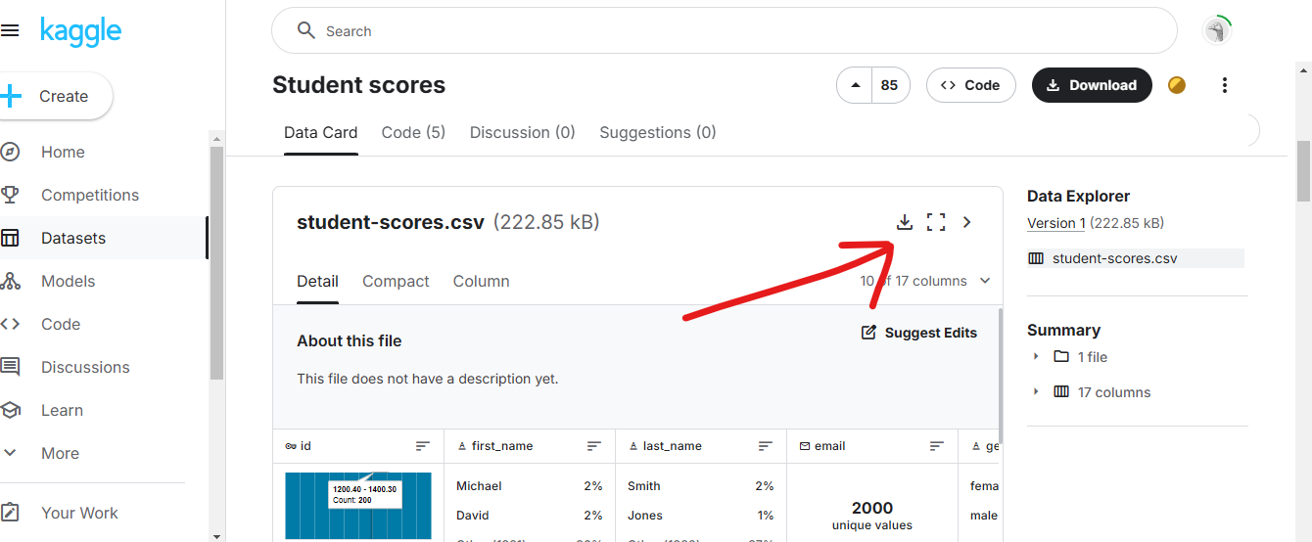

Open it in Excel.

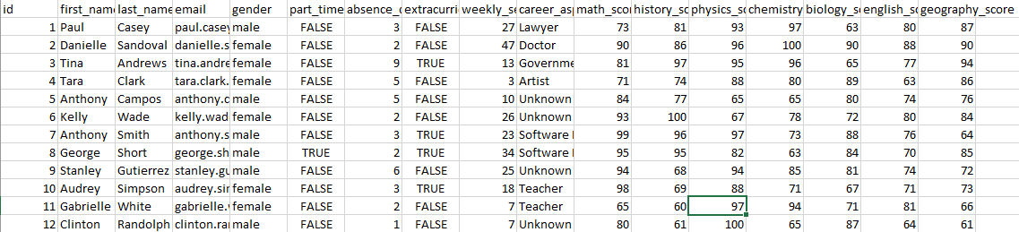

Shape = ( 17 x 2000 )

2 ] Organize and clean data (remove duplicates , handling missing values )

* Go To Home tab > Format > Select Autofit column width and autofit row height ( so we can see it properly )

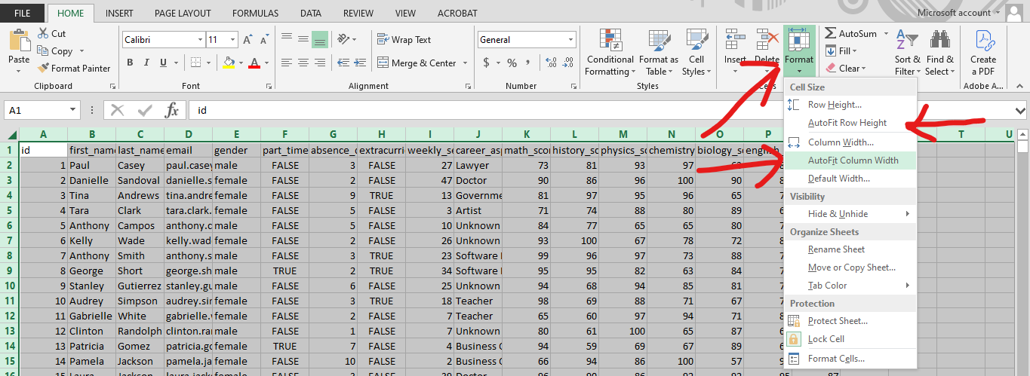

* Go to Data Rebun >> Remove Duplicates >> a window will appear then click ok it will remove all duplicates if there are.

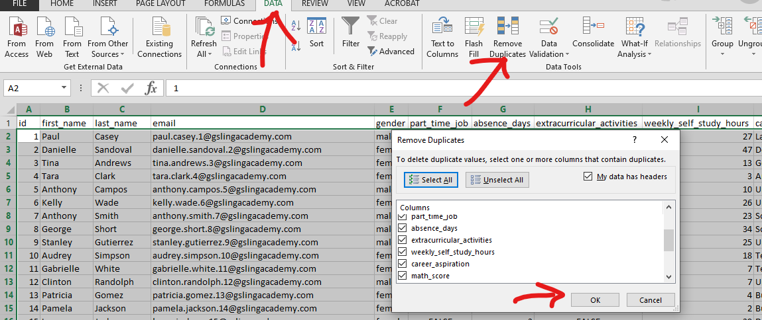

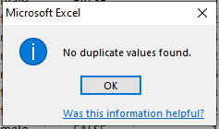

* calculating percentage column using =((SUM(K2:Q2) /700)*100) this formula

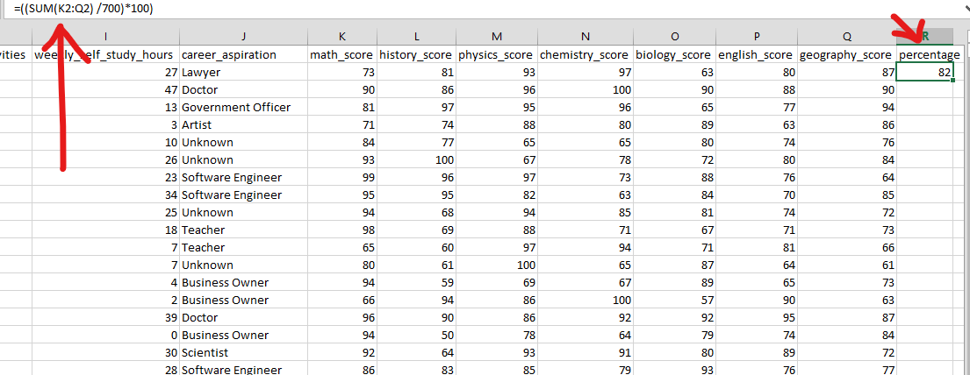

* calculating the average percentages using this formula =AVERAGE(R2:R1966)

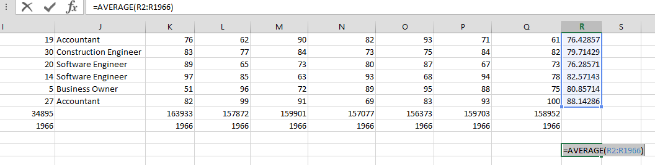

* adding column **Total marks** using **summation** =sum()

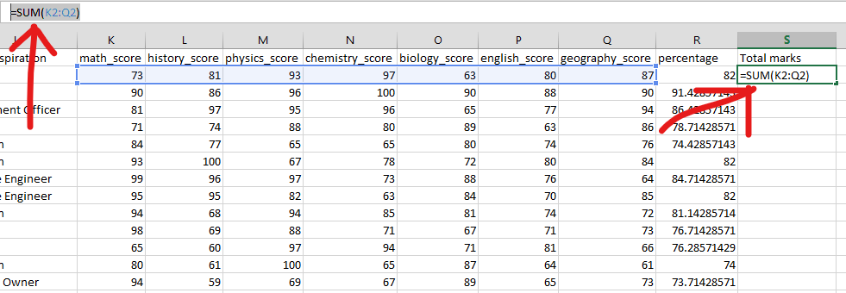

Apply **=VLOOPUP** function .( getting percentages corresponding names) using the expression >

=VLOOKUP(T1766,B1:R1966,17,FALSE)

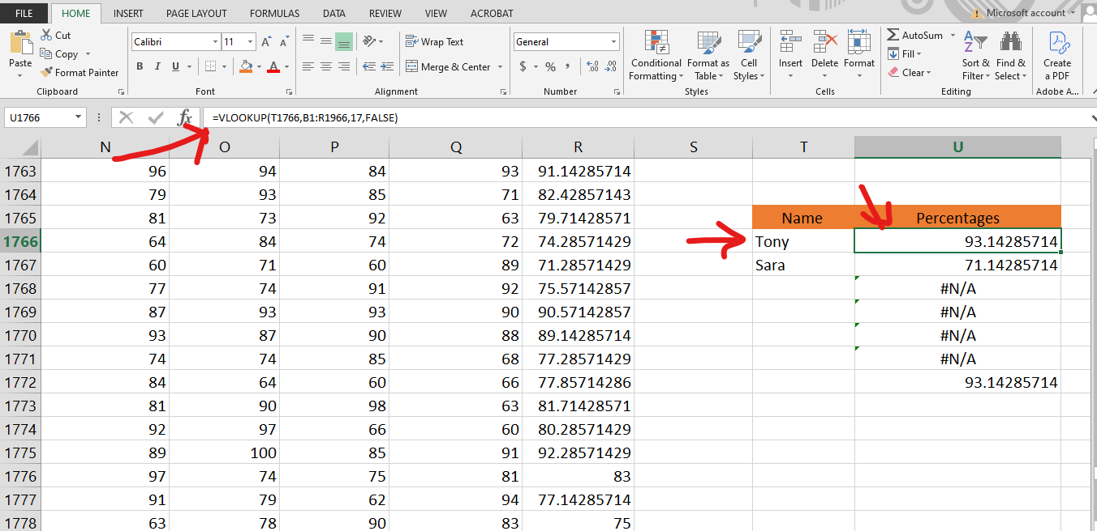

Apply =HLOOKUP() function getting subjectwise total marks using formula =HLOOKUP(U8,B1:R1968,1967,FALSE)

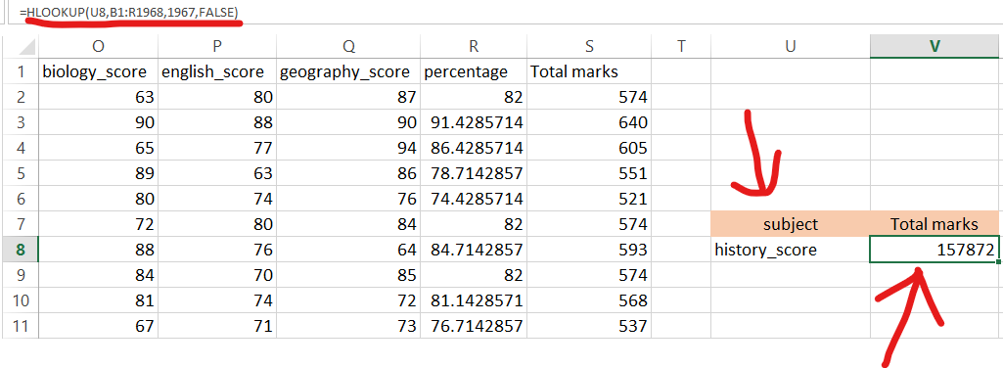

PIVOT TABLE

* go to Insert rebon

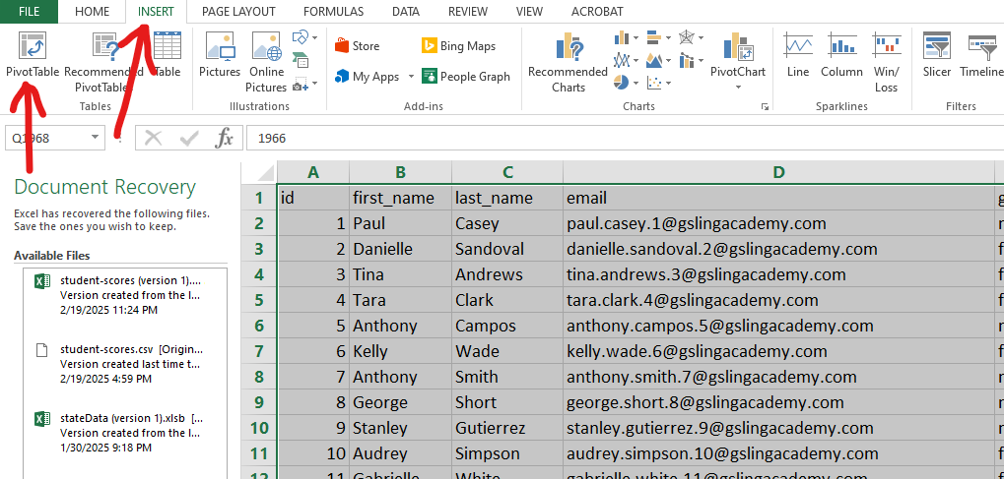

* drag the PivotTable Fields into VALES tab and ROWS it will create a table then go to analayze rebone and click on PivotChart

|  |  |
| --- | --- |
|  |  |

* Select an Appropriate Chart for the visualization

Pie Chart

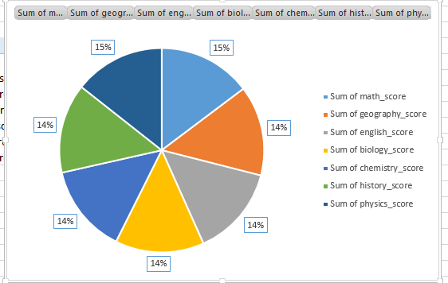

Bar chart

