Software Architecture and Design Specification
Project: Traffic Management Simulation
Version: 1.0
Authors: PATANGI NAVEEN (PES1UG24CS318), PRANAV SP (PES1UG24CS337), RACHANA K (PES1UG24CS354), VEDANTA TRIPATHI (PES1UG24CS920)
Guide: Dr. Ashok Kumar Patil
Date: 04-10-2026
Status: Draft

Revision History
Version | Date | Author | Change Summary
1.0 | 04-10-2026 | PATANGI NAVEEN, PRANAV SP, RACHANA K, VEDANTA TRIPATHI | Initial SAD prepared for the approved SRS Version 1.0 (FR-01 to FR-47, NFR-01 to NFR-14, SEC-01 to SEC-08, BR-01 to BR-07).

Approvals
Role | Name | Signature/Date
Developer (Vehicle Generation, Lane Queue Module) | PATANGI NAVEEN, PES1UG24CS318 | Pending
Developer (Signal Controller) | PRANAV SP, PES1UG24CS337 | Pending
Developer (Emergency Handler) | RACHANA K, PES1UG24CS354 | Pending
Developer (Configuration, Engine, Display, Statistics, Reports) | VEDANTA TRIPATHI, PES1UG24CS920 | Pending
Project Guide | Dr. Ashok Kumar Patil | Pending

1. Introduction
1.1 Purpose
This document specifies the architecture and design of the Traffic Management Simulation (TMS), Version 1.0, a C/C++ console application that simulates the flow of vehicles through a four-way signalised intersection using queues as the main data structure. It describes how the approved Software Requirements Specification (SRS) Version 1.0 will be realised: FR-01 to FR-47, NFR-01 to NFR-14, SEC-01 to SEC-08 and BR-01 to BR-07. The SRS is the authority for requirements and behaviour; where this document and the SRS differ, the SRS prevails.
1.2 Scope
Covers all seven feature groups of the SRS: simulation configuration (5.1), vehicle generation (5.2), lane queue management (5.3), traffic signal control (5.4), emergency vehicle priority (5.5), simulation execution and live display (5.6), and statistics and reporting, including the files report.txt and events.csv (5.7). The system is a standalone, single-threaded, discrete-time program with no network, database or real traffic hardware. Out of scope, as in the SRS: multi-intersection networks, real sensors or live traffic data, turning movements, pedestrian crossings, graphical animation and control of real signals. Implementation status: no source code exists yet; all component interfaces in this document are design proposals and every code and test reference is marked TBD.
1.3 Audience
The project development team (four members), testers, project reviewers and instructors, and future maintainers of the simulator.
1.4 Definitions
- TMS: Traffic Management Simulation.
- SRS / SAD / STP / RTM: Software Requirements Specification / Software Architecture and Design Specification / Software Test Plan / Requirements Traceability Matrix.
- FR / NFR / SEC / BR: Functional Requirement / Non-Functional Requirement / Security Requirement / Business Rule.
- Approach: one of the four roads (North, South, East, West) leading into the intersection. NS = North and South approaches; EW = East and West approaches.
- Phase: a period in which one set of non-conflicting approaches (NS or EW) has right of way.
- Tick: one unit of simulated time (one simulated second). Gmin / Gmax: minimum / maximum green time in ticks.
- All-Red: a short interval in which all signals are red so the intersection can clear.
- Pre-emption: interrupting the normal signal cycle to give right of way to an Emergency vehicle.
- Fixed / Adaptive mode: every green phase has the configured length / the green length depends on current queue lengths.
- ADT: Abstract Data Type. FIFO: First In, First Out. CSV: Comma-Separated Values. PRNG: pseudo-random number generator.

2. Document Overview
2.1 How to use this document
Section 3 gives the architecture: goals and constraints, stakeholders, the component diagram and descriptions, the architecture pattern, technology and data stores, risks, traceability to the SRS and the security architecture. Section 4 gives the design: the named design elements used in the SRS traceability matrix (4.1), UML sequence diagrams (4.2), the internal component interfaces (4.3), error handling, logging and monitoring (4.4), the console user experience (4.5) and open issues (4.6). Section 5 contains the glossary, references and tools. Requirement identifiers (FR-xx, NFR-xx, SEC-xx, BR-xx) are exactly those of the SRS. Operation names and signatures are design-level proposals, not existing code.
2.2 Related Documents
SRS: Software Requirements Specification, Traffic Management Simulation, Version 1.0 (15-09-2026), the authoritative source for requirements, field layouts (Appendix B) and the RTM (Appendix C).
STP: Software Test Plan, not yet available; test case references in this document are TBD.
RTM: SRS Appendix C; the architecture and design reference columns are realised by section 3.8 of this document.

3. Architecture
3.1 Goals & Constraints
Goals: (1) realise every SRS requirement without simplification; (2) guarantee a safe, conflict-free signal cycle in Fixed and Adaptive mode, also during emergency pre-emption (BR-01, NFR-05, NFR-06); (3) make runs reproducible from a seed (FR-11) so Fixed and Adaptive mode can be compared on identical traffic (FR-44); (4) constant-time queue operations (FR-13, NFR-02); (5) a modular, testable, maintainable code base (NFR-12, NFR-13); (6) robust handling of all invalid input (NFR-08, SEC-01); (7) meet performance targets (NFR-01, NFR-03, NFR-04).
Constraints: C/C++ built with g++ 9 or later, portable between Ubuntu 20.04 and Windows with MinGW (NFR-14); text console interface; standalone program with no network, no database and no third-party library; discrete simulated time, single thread; the queue and priority-queue ADTs are implemented by the team (linked list or circular array) and the standard library queue is not used for the core logic; one header and one source file per feature; only config.txt (input) and report.txt and events.csv (output) in the working folder; SRS, SAD and STP stay traceable through the RTM.
3.2 Stakeholders & Concerns
Student / Simulation Operator: usability and clear messages (NFR-10, NFR-11), live display, simple menu
Instructor / Evaluator (customer): correct queue, signal and emergency behaviour, reproducible seeded scenarios, Fixed vs Adaptive comparison, inspectable report and event log
Developers / Maintainers: modularity and the ability to add signal strategies (NFR-12), testability (NFR-13), portability (NFR-14)
Reviewers: traceability between SRS, SAD and STP; compliance with the SRS constraints
Team members: clear module ownership, as in SRS Appendix D.3

3.3 Component (UML) Diagram
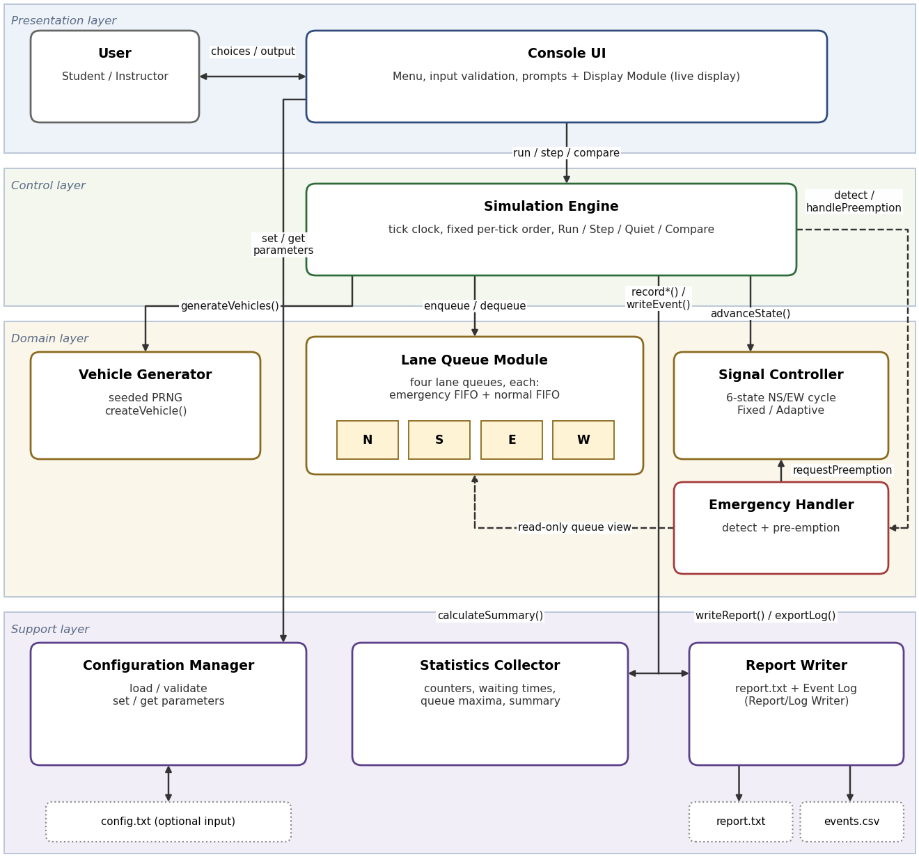
Figure 3.3: Component diagram of the TMS

3.4 Component Descriptions
- Console UI (with Display Module): menu-driven interface with the seven SRS options, bounded and validated input, prompts, live display of tick, signal state and remaining time, queue lengths, waiting emergency vehicles and vehicles served, summary and comparison screens (FR-05, FR-06, FR-24, FR-36, NFR-04, NFR-08, NFR-10, NFR-11, BR-07).
- Configuration Manager: holds the Configuration record, loads config.txt, validates every value and cross-field rule, applies defaults with a warning, reports rejected values for the event log (FR-01 to FR-06, SEC-01, SEC-05).
- Simulation Engine: owns the simulation clock and runs Run, Step and Compare. It executes the per-tick order of FR-37 (generate arrivals, update signal state, serve vehicles, update statistics), mediates all calls between domain modules and triggers display and logging (FR-34 to FR-38, FR-44).
- Vehicle Generator: draws random arrivals per approach with a seeded PRNG, assigns type (Car, Bike, Bus, Truck, Emergency), approach, arrival tick and a unique sequential Vehicle ID (FR-07 to FR-11).
- Lane Queue Module (Queue Manager): four independent lane queues built on a team-written generic linked-list FIFO ADT. Each lane queue is a two-level priority queue (emergency FIFO ahead of normal FIFO) with enqueue, dequeue, front, isEmpty, isFull and size in constant time; it tracks maximum length and blocked count and frees vehicle memory (FR-12 to FR-18, FR-27, BR-02, BR-05).
- Signal Controller (Traffic Signal Controller): six-state NS/EW circular phase table, Fixed and Adaptive green durations, yellow and All-Red timing, discharge permission, cycle count, safety check and next-cycle application of changed timings; accepts pre-emption requests (FR-19 to FR-26, BR-01, BR-03, BR-04).
- Emergency Handler: detects Emergency vehicles at the front of a lane queue whose approach is not GREEN, selects the phase by earliest arrival, requests and ends pre-emption, enforces the maximum pre-emption duration and reports start and end to the Simulation Engine for logging (FR-27 to FR-33).
- Statistics Collector: 64-bit counters and arrays for generated, served, blocked and waiting vehicles, waiting times (overall, per approach, emergency), queue maxima, throughput and pre-emptions; produces the summary used by display, Compare and reports (FR-39 to FR-44, NFR-07, SEC-08, BR-06).
- Report Writer (Report/Log Writer): owns the in-memory Event Log and writes report.txt and events.csv, with overwrite confirmation, fixed file names and write-failure handling (FR-32, FR-45 to FR-47, SEC-03, SEC-04, SEC-07).
Dependency rules: the Console UI calls the Configuration Manager, the Simulation Engine and the Report Writer; the Simulation Engine calls the domain and support modules; the Lane Queue Module depends on no other module; the Emergency Handler reads the lane queues through a read-only view supplied by the Simulation Engine, communicates with the Signal Controller for emergency pre-emption, and reports emergency events (pre-emption start and end) to the Simulation Engine, which writes them to the Event Log through the Report Writer logging interface; no lower module calls the Console UI.

3.5 Chosen Architecture Pattern and Rationale
Chosen pattern: a modular layered architecture with a central Simulation Engine acting as controller and mediator, driving a single-threaded discrete-time (tick) loop. The layers are Presentation (Console UI, Display Module), Control (Simulation Engine), Domain (Vehicle Generator, Lane Queue Module, Signal Controller, Emergency Handler) and Support (Configuration Manager, Statistics Collector, Report Writer with Event Log). Calls go downwards only; the Engine passes data between domain modules instead of letting them call one another.
Rationale: (1) the SRS fixes the order of work in every tick (FR-37); a controller that calls modules in that order makes the order explicit, testable and deterministic. (2) One thread and one clock make runs reproducible from a seed (FR-11, FR-44) and keep the safety property of the signal easy to verify (NFR-05). (3) Separate modules per feature satisfy NFR-12 and the module ownership of the four team members, and every module can be unit tested alone (NFR-13). (4) The Lane Queue Module and the Signal Controller are independent, so a new signal strategy can be added without touching the queues. (5) The layered structure has no network or storage dependency and runs on any g++ 9 platform (NFR-14).
Rejected alternatives: microservices, client-server, cloud and network communication (the system is standalone with no communication interface, SRS 3.3); multithreading (the SRS requires a single-threaded discrete clock and reproducible results); an event bus or publish-subscribe mechanism (ordering would be implicit and could differ from FR-37); a single monolithic source file (violates NFR-12).

3.6 Technology Stack & Data Stores
Language and tools: C/C++ (C++11 or later), g++ 9 or later (GCC on Ubuntu 20.04, MinGW on Windows), standard library only (input/output, strings, time). Compilation with -Wall -Wextra and AddressSanitizer or Valgrind for checks (SEC-02, NFR-09). The PRNG is implemented by the team so that sequences are identical on every platform (algorithm TBD). The build script (for example a Makefile) is TBD.
Data stores: there is no database. All simulation data is held in memory: four lane queues (linked lists of vehicle nodes), the Event Log (growable array of compact fixed-size records), the Statistics Collector counters and the Configuration record. Files: config.txt (optional input), report.txt and events.csv (outputs), all in the working folder. Memory budget: at most 4 x 500 vehicles can be queued, far below the 10,000-vehicle, 100 MB limit of NFR-03.

3.7 Risks & Mitigations
Risk: conflicting GREEN or YELLOW signals through a logic error → Mitigation: table-driven six-state phase table, safety check on every tick (FR-20), emergency pre-emption never skips yellow or All-Red, tests with 100 seeds (NFR-05, NFR-06).
Risk: emergency pre-emption blocks other approaches or repeats endlessly → Mitigation: maximum pre-emption duration (FR-31), earliest-arrival rule (FR-30), a pre-emption is never interrupted by another one.
Risk: different random sequences on Ubuntu and MinGW break reproducibility → Mitigation: team-written PRNG, fixed draw order independent of queue state (FR-11, NFR-14).
Risk: memory leaks or invalid access in the linked-list queues → Mitigation: single ownership of vehicle nodes, clear() on reset and exit, Valgrind or AddressSanitizer runs (FR-17, NFR-09, SEC-02).
Risk: invalid input or malformed config.txt crashes the program → Mitigation: one shared validation path, bounded reads, defaults with warnings (SEC-01, SEC-05, NFR-08).
Risk: Event Log grows too large for long runs → Mitigation: compact records, text produced only at export, memory checked against NFR-03; capacity is reserved before every tick and, if it cannot be reserved, the run stops safely before any event could be lost (see 4.4).
Risk: integration problems between modules written by four members → Mitigation: interfaces fixed in this document, shared types header, weekly integration as in the SRS plan of work.
Risk: default parameter values not yet confirmed (SRS 2.6) → Mitigation: all defaults are in one table in the Configuration Manager, so a change touches one place.

3.8 Traceability to Requirements
Every requirement of the approved SRS is mapped below to the architecture component(s) of section 3.4 and to the named design element of section 4.1. The first component listed is the primary owner. Design reference names are those used in the SRS RTM (Appendix C). No source files or test cases exist yet, so Code File Ref. and Test Case ID are TBD and will be filled in as the code and the STP are produced.
Req. ID | Requirement (short form) | Architecture Reference | Design Reference | Code File Ref. | Test Case ID
FR-01 | Set simulation duration (1 to 86,400 ticks) | Configuration Manager; Console UI | Configuration Design | TBD | TBD
FR-02 | Set arrival probability per approach | Configuration Manager; Console UI | Configuration Design | TBD | TBD
FR-03 | Set mode, green, Gmin, Gmax, yellow, discharge, max queue, emergency probability, seed | Configuration Manager; Console UI | Configuration Design | TBD | TBD
FR-04 | Load config.txt; defaults with warning | Configuration Manager; Report Writer | Configuration Design; File Handling Design | TBD | TBD
FR-05 | Reject invalid value, show range, re-prompt | Console UI; Configuration Manager | Input Validation Design; Configuration Design | TBD | TBD
FR-06 | Display active configuration | Console UI; Configuration Manager | Menu Design; Configuration Design | TBD | TBD
FR-07 | One random arrival per approach per tick | Vehicle Generator; Simulation Engine | Vehicle Generation Design | TBD | TBD
FR-08 | Unique sequential ID, type, approach, arrival tick | Vehicle Generator | Vehicle Generation Design | TBD | TBD
FR-09 | Non-emergency type mix 60/25/8/7 % | Vehicle Generator | Vehicle Generation Design | TBD | TBD
FR-10 | Emergency vehicle probability | Vehicle Generator | Vehicle Generation Design | TBD | TBD
FR-11 | Seeded deterministic PRNG | Vehicle Generator | Vehicle Generation Design | TBD | TBD
FR-12 | Four independent lane queues | Lane Queue Module | Queue ADT Design | TBD | TBD
FR-13 | Queue operations in constant time | Lane Queue Module | Queue ADT Design | TBD | TBD
FR-14 | FIFO order within same priority | Lane Queue Module | Queue ADT Design | TBD | TBD
FR-15 | Reject when full; Blocked count; BLOCKED event | Lane Queue Module; Simulation Engine; Statistics Collector; Report Writer | Queue ADT Design; Event Logging Design | TBD | TBD
FR-16 | Departure tick and waiting time | Simulation Engine; Lane Queue Module; Statistics Collector | Queue ADT Design; Simulation Loop Design | TBD | TBD
FR-17 | Release vehicle memory | Lane Queue Module | Queue ADT Design; Memory Management Design | TBD | TBD
FR-18 | Provide queue lengths on request | Lane Queue Module; Simulation Engine | Queue ADT Design | TBD | TBD
FR-19 | Six-state NS/EW cycle | Signal Controller | Signal State Machine Design | TBD | TBD
FR-20 | No conflicting GREEN/YELLOW; check every tick | Signal Controller | Signal State Machine Design | TBD | TBD
FR-21 | Fixed mode timings | Signal Controller | Signal State Machine Design | TBD | TBD
FR-22 | Adaptive green time (Gmin, Gmax) | Signal Controller; Simulation Engine | Signal State Machine Design | TBD | TBD
FR-23 | Discharge only on GREEN, up to discharge rate | Signal Controller; Simulation Engine | Signal State Machine Design | TBD | TBD
FR-24 | Signal state and remaining ticks to display | Signal Controller; Console UI | Signal State Machine Design; Simulation Loop Design | TBD | TBD
FR-25 | Count completed cycles | Signal Controller; Statistics Collector | Signal State Machine Design | TBD | TBD
FR-26 | Changed timings applied at next cycle | Signal Controller | Signal State Machine Design | TBD | TBD
FR-27 | Emergency ahead of normal; arrival order kept | Lane Queue Module; Emergency Handler | Queue ADT Design; Emergency Pre-emption Design | TBD | TBD
FR-28 | Notify controller of waiting Emergency vehicle | Emergency Handler; Signal Controller | Emergency Pre-emption Design | TBD | TBD
FR-29 | Complete yellow and All-Red, then GREEN | Emergency Handler; Signal Controller | Emergency Pre-emption Design | TBD | TBD
FR-30 | Earliest-arrived Emergency vehicle served first | Emergency Handler | Emergency Pre-emption Design | TBD | TBD
FR-31 | Maximum pre-emption duration | Emergency Handler; Signal Controller | Emergency Pre-emption Design | TBD | TBD
FR-32 | EMERGENCY_START / EMERGENCY_END events | Emergency Handler; Report Writer | Emergency Pre-emption Design; Event Logging Design | TBD | TBD
FR-33 | Emergency waiting time recorded separately | Emergency Handler; Statistics Collector | Emergency Pre-emption Design; Statistics and Report Design | TBD | TBD
FR-34 | Continuous run for configured duration | Simulation Engine; Console UI | Simulation Loop Design | TBD | TBD
FR-35 | Step mode, N ticks (1 to 100) | Simulation Engine; Console UI | Simulation Loop Design | TBD | TBD
FR-36 | Live display at refresh interval | Simulation Engine; Console UI | Simulation Loop Design | TBD | TBD
FR-37 | Fixed per-tick order | Simulation Engine | Simulation Loop Design | TBD | TBD
FR-38 | Quiet mode | Simulation Engine; Console UI | Simulation Loop Design | TBD | TBD
FR-39 | Generated, served, blocked, waiting totals | Statistics Collector; Report Writer | Statistics and Report Design | TBD | TBD
FR-40 | Average and maximum waiting time | Statistics Collector; Report Writer | Statistics and Report Design | TBD | TBD
FR-41 | Maximum queue length per approach | Statistics Collector; Report Writer | Statistics and Report Design | TBD | TBD
FR-42 | Throughput per simulated minute | Statistics Collector; Report Writer | Statistics and Report Design | TBD | TBD
FR-43 | Emergency served, average wait, pre-emptions | Statistics Collector; Report Writer | Statistics and Report Design | TBD | TBD
FR-44 | Compare Fixed and Adaptive on same seed | Simulation Engine; Statistics Collector; Report Writer | Statistics and Report Design; Simulation Loop Design | TBD | TBD
FR-45 | Write summary report to report.txt | Report Writer; Statistics Collector | Statistics and Report Design; File Handling Design | TBD | TBD
FR-46 | Write event log to events.csv | Report Writer | Event Logging Design; File Handling Design | TBD | TBD
FR-47 | Write failure: message, return to menu | Report Writer; Console UI | File Handling Design | TBD | TBD
NFR-01 | 3,600 ticks in quiet mode within 5 s | Simulation Engine; all modules | Performance Design | TBD | TBD
NFR-02 | Constant-time queue operations; bounded tick work | Lane Queue Module; Simulation Engine | Queue ADT Design; Performance Design | TBD | TBD
NFR-03 | Under 100 MB with up to 10,000 vehicles | Lane Queue Module; Report Writer | Performance Design | TBD | TBD
NFR-04 | Menu response within 1 second | Console UI | Menu Design | TBD | TBD
NFR-05 | No conflicting GREEN/YELLOW (100 seeds) | Signal Controller | Signal State Machine Design | TBD | TBD
NFR-06 | GREEN to RED via YELLOW and All-Red, also in pre-emption | Signal Controller; Emergency Handler | Signal State Machine Design; Emergency Pre-emption Design | TBD | TBD
NFR-07 | Generated = served + blocked + waiting | Statistics Collector; Simulation Engine | Statistics and Report Design | TBD | TBD
NFR-08 | 20 invalid-input cases handled | Console UI; Configuration Manager | Input Validation Design | TBD | TBD
NFR-09 | No memory leaks or invalid access | Lane Queue Module; all modules | Memory Management Design | TBD | TBD
SEC-01 | Validate type, length, range; bounded input | Configuration Manager; Console UI | Input Validation Design | TBD | TBD
SEC-02 | No buffer overflows; clean -Wall -Wextra and ASan | All modules | Memory Management Design | TBD | TBD
SEC-03 | Only report.txt and events.csv; no path in file names | Report Writer | File Handling Design | TBD | TBD
SEC-04 | Confirm before overwriting output files | Report Writer; Console UI | File Handling Design | TBD | TBD
SEC-05 | Read at most 1,000 lines of 200 characters from config.txt | Configuration Manager | File Handling Design | TBD | TBD
SEC-06 | No personal data | All modules | Data Handling Design | TBD | TBD
SEC-07 | Log blocked arrivals, pre-emptions, rejected values | Report Writer; Simulation Engine; Emergency Handler; Configuration Manager | Event Logging Design | TBD | TBD
SEC-08 | 64-bit counters; range checks before arithmetic | Statistics Collector | Data Handling Design | TBD | TBD
NFR-10 | Default run and summary within 2 minutes, 3 selections | Console UI | Menu Design | TBD | TBD
NFR-11 | Error messages state problem and allowed range | Console UI | Input Validation Design | TBD | TBD
NFR-12 | One header and source per feature; functions up to 50 lines | All modules | Module Structure Design | TBD | TBD
NFR-13 | Unit test for each public function | All modules | Test Design | TBD | TBD
NFR-14 | Portable to g++ 9 on Ubuntu and MinGW | All modules | Build Design | TBD | TBD
BR-01 | Only one phase non-red at any time | Signal Controller | Signal State Machine Design | TBD | TBD
BR-02 | Emergency priority; FIFO within same priority | Lane Queue Module; Emergency Handler | Queue ADT Design; Emergency Pre-emption Design | TBD | TBD
BR-03 | Green time within Gmin and Gmax | Signal Controller; Emergency Handler | Signal State Machine Design; Emergency Pre-emption Design | TBD | TBD
BR-04 | Vehicle leaves only on GREEN (incl. pre-emption) | Signal Controller; Simulation Engine | Signal State Machine Design | TBD | TBD
BR-05 | Each vehicle in exactly one queue, served at most once | Lane Queue Module | Queue ADT Design | TBD | TBD
BR-06 | Statistics from recorded data only; not editable | Statistics Collector | Statistics and Report Design | TBD | TBD
BR-07 | Same rights for all users; no roles | Console UI | Menu Design | TBD | TBD

Coverage: FR-01 to FR-47 (47 requirements), NFR-01 to NFR-14 (14), SEC-01 to SEC-08 (8) and BR-01 to BR-07 (7) are all mapped above: 76 requirements in total.

3.9 Security Architecture
The TMS is standalone, has no network interface, no authentication, no user roles (BR-07) and handles no personal data (SEC-06). Security therefore concentrates on integrity, robustness, safe file handling and accountability (SRS objectives SO-1 to SO-4). Threat modelling (STRIDE, adapted to a standalone console program):
- Spoofing: Not Applicable. There are no accounts or logins; all users have the same rights (BR-07).
- Tampering: all input is validated before use (SEC-01); output files have fixed names and are written only in the working folder (SEC-03); statistics are computed only from recorded simulation data and cannot be edited by the user (BR-06).
- Repudiation / accountability: blocked arrivals, emergency pre-emptions and rejected configuration values are written to the event log with tick (SEC-07).
- Information disclosure: no personal data is collected, stored or transmitted; vehicles are anonymous objects (SEC-06).
- Denial of service / robustness: bounded input lines, a limit of 1,000 config.txt lines of 200 characters (SEC-05), bounded queues, bounded duration and 64-bit counters with range checks (SEC-08).
- Elevation of privilege: Not Applicable. There are no privileged operations; memory safety (SEC-02) removes the main program-level attack path.
Security requirements to architecture:
- SEC-01: Console UI and Configuration Manager share one validation path (type, length, range) with bounded input functions only.
- SEC-02: fixed or managed buffer limits in all modules; build with -Wall -Wextra, run under AddressSanitizer; no unbounded scanf or gets.
- SEC-03: Report Writer uses the constant names report.txt and events.csv; no file name is ever read from the user; a defensive check rejects names with path separators or "..".
- SEC-04: Report Writer asks the Console UI for confirmation before overwriting an existing file.
- SEC-05: Configuration Manager reads at most 1,000 lines of at most 200 characters from config.txt and ignores the rest.
- SEC-06: no data structure holds personal data; the Vehicle record has only ID, type, approach and ticks.
- SEC-07: Event Log records BLOCKED, EMERGENCY_START, EMERGENCY_END and CONFIG_REJECTED events with tick.
- SEC-08: all counters and sums are unsigned 64-bit; additions are guarded by range checks; the run duration is limited to 86,400 ticks.

4. Design

4.1 Design Overview
The design realises the architecture of section 3 as a discrete-time program: the Simulation Engine advances a tick counter and, on every tick, calls the modules in the fixed order required by FR-37. The design is described below as the named design elements used in the SRS RTM. All names, types and file structures are proposals until implemented (TBD).
Configuration Design (FR-01 to FR-06, SEC-01, SEC-05): The Configuration record holds: duration (ticks), arrival probability for each of N, S, E, W, signal mode (F or A), green time, Gmin, Gmax, yellow time, All-Red (fixed at 1 tick), discharge rate, maximum queue length, emergency probability, maximum pre-emption, random seed and refresh interval. Defaults and ranges follow SRS 2.6 and Appendix B.1 (duration 3,600; probability 0.20; green 10; Gmin 5; Gmax 30; yellow 2; discharge 1; maximum queue 50; emergency probability 0.02; maximum pre-emption 15; refresh 10; default seed TBD). One table of parameter specifications (name, type, minimum, maximum, default) drives both interactive entry and config.txt loading, so every value passes the same check. Cross-field rules: Gmin not greater than Gmax (SRS); proposed additional rules so that BR-03 always holds: Gmin not greater than the base green time, the base green time not greater than Gmax, and Gmin not greater than the maximum pre-emption (see 4.6). The optional file config.txt contains one name=value pair per line (proposed format); at most 1,000 lines of 200 characters are read. A missing, malformed or invalid value is replaced by its default with a warning that names the parameter, and a CONFIG_REJECTED event is recorded. The Engine receives an immutable copy of the Configuration at the start of a run, so later edits cannot change a run in progress.
Vehicle Generation Design (FR-07 to FR-11): A Vehicle holds Vehicle ID, type (Car, Bike, Bus, Truck, Emergency), approach, arrival tick, departure tick and waiting time (SRS B.2). The Vehicle Generator owns a PRNG initialised from the seed. On every tick it visits the approaches in the fixed order N, S, E, W and draws one number for the arrival decision (arrival if below the approach probability). For each arrival it draws one number for Emergency (below the emergency probability) and, if not Emergency, one number for the type (Car 60 %, Bike 25 %, Bus 8 %, Truck 7 %). The draws never depend on queue state or signal mode, so the same seed and parameters give the same vehicle sequence in Fixed and Adaptive mode, which FR-44 requires. IDs come from a 64-bit counter that increases by one. The PRNG algorithm is written by the team (TBD), not rand(), so results match on Ubuntu and MinGW (NFR-14).
Queue ADT Design (FR-12 to FR-18, NFR-02, NFR-09, BR-02, BR-05): The base ADT is a generic singly linked-list FIFO with head, tail and count; enqueue appends at the tail and dequeue removes the head, both in constant time; front, isEmpty, isFull(capacity) and size are constant time. A Lane Queue (one each for N, S, E, W) is a two-level priority queue made of an emergency FIFO and a normal FIFO that share one capacity (the configured maximum queue length). enqueue places a vehicle in the sub-queue of its priority; front and dequeue take from the emergency FIFO first. This puts an Emergency vehicle ahead of all normal vehicles, keeps Emergency vehicles in arrival order and keeps FIFO order within one priority, without searching or sorting (FR-14, FR-27, BR-02). When size equals the capacity enqueue returns FULL; the Engine then counts the vehicle as Blocked and logs a BLOCKED event (FR-15). Each Lane Queue also keeps current length, maximum length reached, blocked count and the number of waiting Emergency vehicles (SRS B.3). Vehicle nodes are allocated on enqueue, owned by exactly one queue and freed on dequeue; clear() and the destructor free the rest on reset and exit (FR-17, BR-05). Copying a queue is disabled. At dequeue the Engine sets the departure tick and the waiting time (departure minus arrival tick, FR-16). The standard library queue is not used.
Signal State Machine Design (FR-19 to FR-26, BR-01, BR-03, BR-04, NFR-05): The Signal Controller holds a circular phase table of six states (table below) and a record with the current state, ticks remaining, cycle count and pre-emption-active flag (SRS B.4), plus an active and a pending timing set. Each tick advanceState counts down the remaining ticks; at zero it moves to the next state of the table. A green state gets its length from determineGreenDuration: in Fixed mode the configured green time (default 10); in Adaptive mode Gmin plus one tick for every 2 vehicles waiting on the two approaches about to receive green (rounded up), never more than Gmax and never less than Gmin (FR-22, BR-03). Yellow lasts the configured yellow time (default 2) and All-Red 1 tick (FR-21). The cycle count increases when S6 moves to S1 (FR-25). setTimings stores new timings as pending; they become active only at the S6 to S1 change (FR-26). After every update checkSafety verifies that NS and EW are never both GREEN or YELLOW (FR-20, BR-01); on a violation the controller forces All-Red, the Engine stops the run and reports an internal error. canDischarge(approach) is true only for an approach whose signal is GREEN (FR-23, BR-04). getState provides state and remaining time for every approach to the display (FR-24).
Signal states (SRS 4.3). The cycle is NS Green, NS Yellow, All-Red, EW Green, EW Yellow, All-Red, then repeats.
State | NS signal | EW signal | Duration | Next state
S1: NS Green | GREEN | RED | Fixed: green time (default 10). Adaptive: Gmin + 1 per 2 waiting vehicles (rounded up), at most Gmax (defaults 5 to 30) | S2
S2: NS Yellow | YELLOW | RED | Yellow time (default 2) | S3
S3: All-Red | RED | RED | 1 tick | S4
S4: EW Green | RED | GREEN | Same rule as S1 | S5
S5: EW Yellow | RED | YELLOW | Yellow time (default 2) | S6
S6: All-Red | RED | RED | 1 tick | S1

Fixed mode keeps every green at the configured green time. Adaptive mode computes the green time when the green state starts, from the queue lengths of the two approaches that are about to receive green; yellow and All-Red are the same in both modes.
Emergency Pre-emption Design (FR-27 to FR-33, NFR-06, BR-02, BR-03): (1) Priority: an Emergency vehicle is placed ahead of normal vehicles by the Lane Queue (FR-27).
(2) Detection: in step 2 of every tick detectEmergency examines the front vehicle of each of the four lane queues (constant work); if it is an Emergency vehicle and its approach signal is not GREEN, the Emergency Handler calls requestPreemption on the Signal Controller (FR-28).
(3) Choice of phase: if Emergency vehicles wait on conflicting approaches, the phase of the Emergency vehicle with the earliest arrival tick (tie: lower Vehicle ID) is served first; the other request is raised again when the pre-emption ends (FR-30).
(4) Safe transition: the controller completes the current yellow and All-Red states and then gives GREEN to the requested phase; yellow and All-Red are never skipped or shortened. If the other phase is in GREEN, that green continues until Gmin ticks have passed (BR-03) and then goes to yellow. If the requested phase has just shown yellow, the sequence yellow, All-Red, GREEN of the same phase is allowed (FR-29, NFR-06).
(5) End: handlePreemption runs every tick of the pre-empted green; endPreemption is called when no Emergency vehicle is waiting on the phase and at least Gmin ticks have passed, or when the maximum pre-emption duration (default 15 ticks, also limited to Gmax) is reached. The controller then continues the normal sequence with the yellow of that phase, All-Red and the other phase (FR-31). Normal vehicles on a pre-empted green are served as usual.
(6) Records: EMERGENCY_START (tick, approach) is logged when the pre-empted green begins and EMERGENCY_END when it ends (FR-32); the pre-emption counter increases; Emergency waiting time is recorded in separate Statistics Collector accumulators (FR-33). The handler states are IDLE, REQUESTED and ACTIVE; the pre-emption-active flag is set in REQUESTED and ACTIVE.
Simulation Loop Design (FR-34 to FR-38): executeTick performs, in this order on every tick:
(1) generate arrivals: the Vehicle Generator creates vehicles; each is enqueued (Emergency vehicles ahead of normal ones) and recorded as ARRIVAL, or counted as Blocked with a BLOCKED event when the queue is full;
(2) update the signal state: Emergency Handler detection and pre-emption handling, then Signal Controller advanceState, PHASE_CHANGE events and checkSafety;
(3) serve vehicles: for every approach with GREEN, up to the discharge rate vehicles are dequeued, their waiting times calculated and recorded, and DEPARTURE events written;
(4) update statistics: queue lengths and maxima. After step 4, if quiet mode is off and the tick is a multiple of the refresh interval, the Display Module shows a snapshot; the display only reads state, so the SRS order is unchanged. Run executes ticks 1 to the configured duration; Step executes N ticks (1 to 100) and then shows the state, continuing from the current tick until the duration is reached; quiet mode shows only the final summary. At the end the Engine checks that generated equals served plus blocked plus still waiting (NFR-07). reset() frees all vehicles, clears statistics, restores the signal and re-seeds the generator. Compare creates two independent Engine instances (Fixed and Adaptive) with the same configuration and seed, runs both in quiet mode and returns both summaries for a side-by-side display (FR-44).
Statistics and Report Design (FR-39 to FR-47, NFR-07, BR-06): The Statistics Collector holds unsigned 64-bit counters: generated, served, blocked, signal cycles, and per approach: served, blocked, waiting-time sum, waiting-time maximum and maximum queue length; and for Emergency vehicles: served, waiting-time sum, waiting-time maximum and pre-emptions. calculateSummary derives still waiting (sum of queue sizes at the end), averages (sum divided by count, with a guard for a zero count) and throughput (vehicles served x 60 / ticks simulated). Data enters only through the record operations called by the Engine; the Console UI receives a read-only summary, so the user cannot edit results (BR-06). Report data are the fields of SRS B.6: configuration used (including seed and mode), generated, served, blocked and waiting, average and maximum waiting time overall and per approach, maximum queue length per approach, throughput, signal cycles, and Emergency statistics. report.txt holds this summary; when Compare has been run, a comparison section with the right-hand column of B.6 (mode, served, average and maximum waiting time, maximum queue length, throughput, Emergency average wait) is added to report.txt (placement TBD, see 4.6). The Report Writer writes report.txt and events.csv on option 6.
Performance Design (NFR-01, NFR-02, NFR-03): All queue operations are constant time and the work of one tick depends only on the four approaches and the vehicles served in that tick. No per-tick allocation other than vehicle nodes; no console output in quiet mode; Event Log records are compact fixed-size structs and the text of the Details field is produced only at export. At most 4 x 500 vehicles are queued, so memory stays far below the NFR-03 limit; 3,600 ticks in quiet mode need only a few thousand operations per second of simulated time, well within the 5 s target of NFR-01.
Menu Design (NFR-04, NFR-10, BR-07): The main menu offers the seven options of SRS 3.1: 1 Configure parameters, 2 Run simulation, 3 Step mode, 4 View statistics, 5 Compare Fixed and Adaptive mode, 6 Export report and log, 7 Exit. Configuration defaults (and config.txt if present) are loaded at start, so a new user can select 2 and see the summary at once (NFR-10). Every screen states how to return to the main menu. Run asks whether to use live or quiet display; option 4 shows the summary of the last run. All options except Run, Step and Compare answer immediately (NFR-04). There is no login and no role (BR-07).
Input Validation Design (NFR-08, NFR-11, SEC-01, FR-05): Every input follows one pipeline: read a line with a bounded function (maximum 200 characters; excess is discarded), trim, reject empty input, parse the whole string as an integer or decimal (trailing characters make it invalid), check the allowed range, then accept; otherwise show a message of the form what is wrong plus the allowed range or action, keep the previous value and prompt again. Menu choices use the same pipeline (1 to 7). End of input on the keyboard is handled as Exit. The config.txt loader calls the same validation functions. No user input can lead to exit(), abort() or an unchecked conversion.
Memory Management Design (NFR-09, SEC-02, FR-17): Vehicle nodes have a single owner (a Lane Queue) and are freed on dequeue, blocking, reset and exit. No module keeps a raw owning pointer outside the Lane Queue Module. Text buffers are fixed-size or managed strings with explicit length limits; formatted output uses length-limited functions. An allocation failure is reported as a resource-allocation error and ends the run safely (see 4.4). The code is compiled with -Wall -Wextra without warnings and a complete run is executed under AddressSanitizer or Valgrind.
File Handling Design (SEC-03, SEC-04, SEC-05, FR-45 to FR-47): The only files are config.txt (read), report.txt and events.csv (written), always in the working folder. File names are constants; the program never asks for a file name, and a defensive isSafeFileName check rejects any name containing a path separator or "..". Before writing, the Report Writer checks whether the file exists and asks the Console UI for an overwrite confirmation (y/n) for each existing file. Every open and write is checked; on failure the Console UI shows an error that names the file and the cause, the program returns to the menu and all simulation data remain available for a retry (FR-47). config.txt is read line by line with the limits of SEC-05.
Data Handling Design (SEC-06, SEC-08): No structure stores personal data; vehicles are anonymous. All counters, sums and tick values that can grow are unsigned 64-bit integers; before an addition that could exceed the range, the code checks it (safeAdd). Since the duration is limited to 86,400 ticks and at most four arrivals occur per tick, no counter can overflow within the allowed duration.
Event Logging Design (SEC-07, FR-15, FR-32, FR-46): An Event Log Record has: tick, event type (ARRIVAL, DEPARTURE, BLOCKED, PHASE_CHANGE, EMERGENCY_START, EMERGENCY_END, CONFIG_REJECTED), approach (none for phase events), Vehicle ID (none if not applicable) and a detail code with a number (the text of Details, up to 40 characters, is generated at export). Records are appended to a growable array in memory in constant amortised time, with capacity reserved before each tick so that no record is lost (see 4.4) by the Report Writer's writeEvent, which the Engine calls for all run events (including the emergency start and end that the Emergency Handler reports to it) and the Configuration Manager calls for CONFIG_REJECTED. The log of a run is cleared at the start of the run, keeping the CONFIG_REJECTED records made since the last run (tick 0, parameter name in Details). exportLog writes the records to events.csv with the fields of SRS B.5 (a header row is proposed).
Module Structure Design (NFR-12): One header and one source file per component (nine modules) plus a shared types header (Approach, Phase, VehicleType, Vehicle, Configuration, event and summary types) and a main program that starts the Console UI. No function longer than 50 lines. File names are TBD.
Test Design (NFR-13): Modules depend only on plain data and can be tested without the console. Each public function of the queue, signal, emergency and statistics modules gets at least one unit test (test harness TBD). Scenario tests use fixed seeds: 100 seeds of 3,600 ticks for NFR-05 and NFR-06, the conservation check of NFR-07, and at least 20 invalid-input cases for NFR-08. Test case IDs are TBD until the STP exists.
Build Design (NFR-14, SEC-02): Standard C++ only (C++11 or later), no platform-specific headers; colour output is optional and the text GREEN, YELLOW, RED is always shown. The same sources are built with g++ 9 or later on Ubuntu 20.04 and with MinGW using -Wall -Wextra, plus an AddressSanitizer build for checks. Build script TBD.
Data structures. The structures required by the SRS (4.4 and Appendix B) are summarised here:
Structure | Key fields / form | Supports
Vehicle | ID, type, approach, arrival tick, departure tick, waiting time | FR-08, FR-16, BR-05, SEC-06
Directional FIFO queue | Generic linked list, head, tail, count; O(1) operations | FR-12 to FR-14, NFR-02
Priority / emergency structure (Lane Queue) | Emergency FIFO + normal FIFO, shared capacity, max length, blocked count | FR-15, FR-27, FR-18, BR-02
Signal State Machine | Six-state circular table; state, ticks remaining, cycle count, pre-emption flag; active and pending timings | FR-19 to FR-26, BR-01, BR-03
Configuration | Parameter record and parameter specification table | FR-01 to FR-06, SEC-01
Statistics | 64-bit counters and per-approach arrays | FR-39 to FR-43, NFR-07, SEC-08
Event Log Record | Tick, type, approach, Vehicle ID, detail code | FR-32, FR-46, SEC-07
Report data | Summary and comparison fields of SRS B.6 | FR-44, FR-45

4.2 UML Sequence Diagrams
Two flows of the TMS are shown. Figure 4.2a: configure and run a simulation and export the results. Figure 4.2b: one simulation tick, with vehicle generation, queue insertion, signal update and emergency handling, vehicle processing, statistics update and display or log update, in the order required by FR-37. The participants are the components of section 3.4.
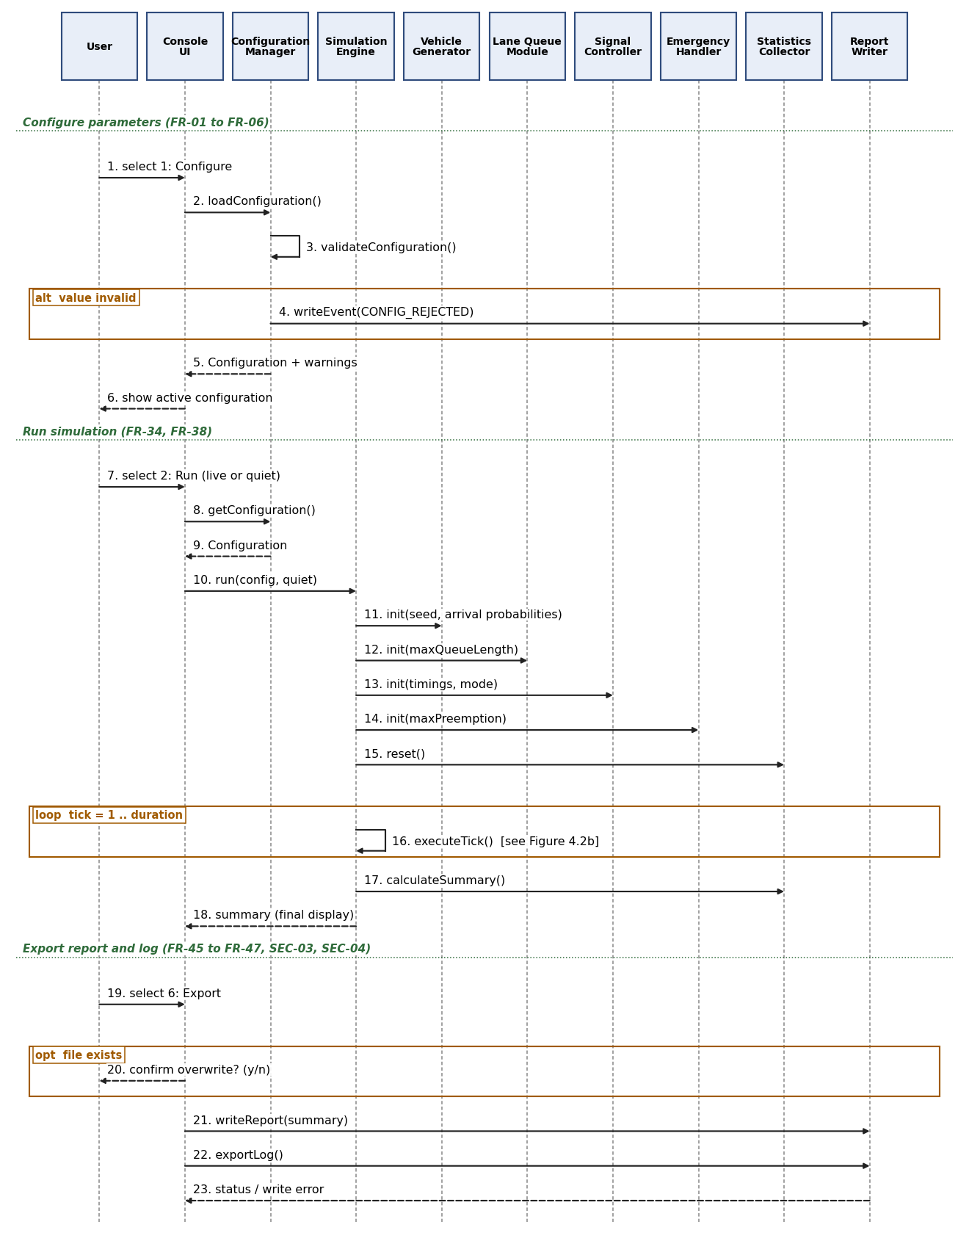
Figure 4.2a: Sequence diagram, configure and run simulation
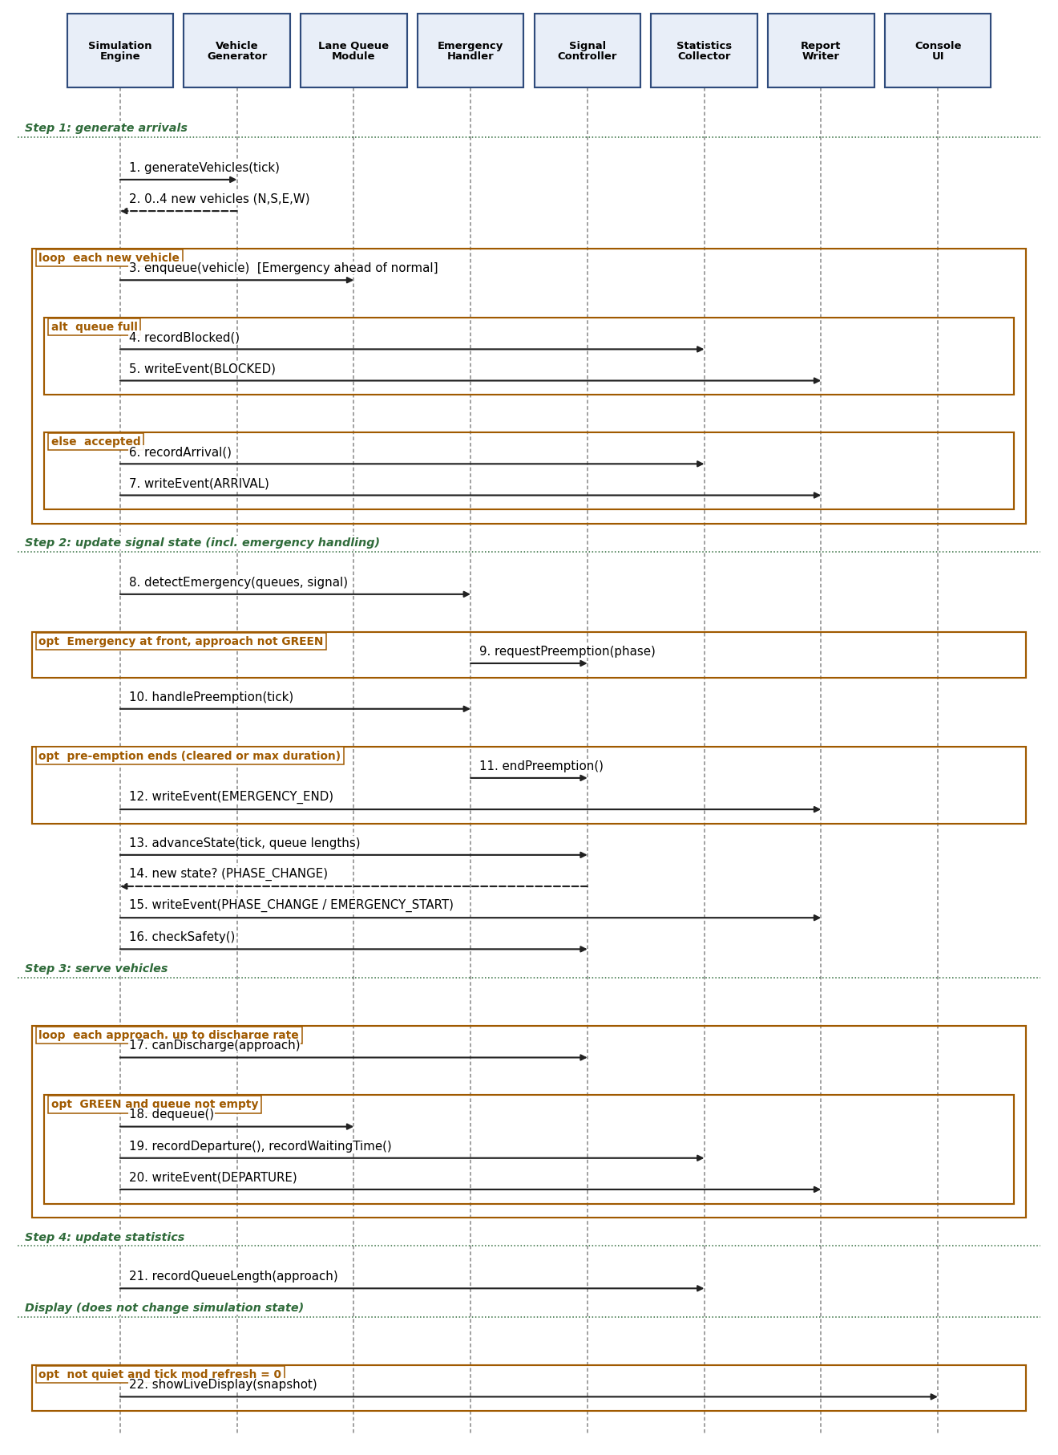
Figure 4.2b: Sequence diagram, one simulation tick (executeTick)

4.3 API Design
The TMS has no network API. This section defines the internal interfaces of all nine components. All names, parameter types and result types are proposed (TBD); none exists in code yet. Operations return a status value or a result structure; none terminates the program.
Console UI
- showMainMenu(), readMenuChoice() → int 1 to 7; Errors: invalid choice → message, prompt again
- readValidatedInt(prompt, min, max) / readValidatedDecimal(prompt, min, max) → value; Errors: empty, non-numeric, out of range → message with allowed range, prompt again
- showLiveDisplay(snapshot), showSummary(summary), showComparison(summaryFixed, summaryAdaptive), showError(text)
- confirmOverwrite(fileName) → bool
Configuration Manager
- loadConfiguration(fileName) → Configuration + list of warnings; Errors: file missing (defaults used silently), malformed or invalid line (default + warning)
- validateConfiguration(config) → list of rejected parameters (type, range and cross-field rules)
- setParameter(name, value) → OK or rejected (previous value kept)
- getConfiguration() → Configuration (copy)
Simulation Engine
- run(config, quiet) → Summary; step(n) with n 1 to 100 → state snapshot; reset(); executeTick() (internal, order of FR-37)
- compare(config) → pair of Summary (Fixed, Adaptive); Errors: internal safety violation → run stopped, error reported
Vehicle Generator
- generateVehicles(tick) → list of 0 to 4 Vehicle (order N, S, E, W)
- createVehicle(approach, tick) → Vehicle (type drawn, ID assigned)
Lane Queue Module (Queue Manager)
- enqueue(vehicle) → OK, FULL or ALLOC_ERROR; dequeue(vehicle&) → OK or EMPTY; front() → pointer or none
- isEmpty(), isFull(), size(), emergencyCount(), maxLengthReached(), blockedCount(), clear()
Signal Controller (Traffic Signal Controller)
- getState() → state, ticks remaining, cycle count, pre-emption flag; canDischarge(approach) → bool
- advanceState(tick, queueLengths) → state-change flag; determineGreenDuration(phase, queueLengths) → ticks
- setTimings(timings) (applied at next cycle); checkSafety() → bool
- acceptPreemption(phase) / releasePreemption() (called by the Emergency Handler)
Emergency Handler
- detectEmergency(queueView, signalState, tick) → request or none
- requestPreemption(phase, arrivalTick, vehicleId); handlePreemption(tick) → continue or end; endPreemption(tick); both report pre-emption start and end to the Simulation Engine, which logs them (the handler does not call the Report Writer directly)
Statistics Collector
- recordArrival(approach), recordBlocked(approach), recordDeparture(vehicle), recordWaitingTime(vehicle), recordQueueLength(approach, length), recordCycle(), recordPreemption()
- calculateSummary(ticksSimulated, stillWaiting) → Summary; Errors: counter limit reached → value capped and reported
Report Writer (Report/Log Writer)
- reserveEventCapacity(count) → OK or ALLOC_ERROR; writeEvent(tick, type, approach, vehicleId, detail); writeReport(summary, comparison?) → OK or write error; exportLog() → OK or write error
- Errors: file cannot be opened or written → error status with file name and cause, program returns to the menu

4.4 Error Handling, Logging & Monitoring
Standard message: every error message states what is wrong and the allowed range or action (NFR-11), for example: Error: duration must be a whole number from 1 to 86400. Please enter again.
- Invalid numeric input, empty input, out-of-range value: rejected by the shared validation pipeline, allowed range shown, previous value kept, prompt repeated (FR-05, NFR-08).
- Invalid configuration (cross-field rule broken, for example Gmin greater than Gmax): the change is rejected with the rule shown; in config.txt the default is used with a warning that names the parameter, and CONFIG_REJECTED is logged (FR-04, SEC-07).
- Malformed config.txt (no equals sign, unknown name, line over 200 characters, more than 1,000 lines, unreadable file): offending lines are skipped or defaulted with a warning; the rest is ignored; the program starts normally.
- Invalid menu choice: message and new prompt; end of input is treated as Exit.
- Full queue: enqueue returns FULL; the vehicle is counted as Blocked, a BLOCKED event is logged and the run continues (FR-15).
- Empty queue protection: dequeue and front check isEmpty first and return EMPTY or none; nothing is dereferenced from an empty queue.
- Report or log file write failure: error message with file name and cause, return to the menu, data kept for a retry (FR-47). Overwrite of an existing file needs confirmation (SEC-04).
- Memory and resource issues: every allocation is checked. If vehicle-node allocation fails, enqueue returns ALLOC_ERROR and the system reports a resource-allocation error and safely handles the failure without classifying the vehicle as queue-blocked: the Engine stops the run at that tick, the vehicle is discarded and not counted as generated, all memory is kept consistent (no leak, no partial node), the results up to that tick stay available marked as incomplete, and the menu is shown. A vehicle is classified as Blocked only when the applicable queue is full, consistent with FR-15.
- Event Log capacity (SEC-07): the Event Log is a critical record, so it is never allowed to lose an event silently. Before every tick the Engine calls reserveEventCapacity for the largest number of records one tick can produce (a small fixed bound: arrivals or blocked arrivals, a phase change, pre-emption start and end, and departures). If this reservation fails, the Engine does not execute the tick: it stops the run safely with a resource-allocation error that names the Event Log, keeps all records and statistics up to the last completed tick, and marks the run as incomplete. The user can still view the summary and export report.txt and events.csv for the completed ticks, after the usual overwrite confirmation (SEC-04). Blocked arrivals, emergency pre-emptions and rejected configuration values are therefore never dropped.
- Internal safety violation (conflicting signals or generated not equal to served + blocked + waiting): the run stops with an error message and the menu is shown; the program does not crash.
Logging: the Event Log (events.csv) records ARRIVAL, DEPARTURE, BLOCKED, PHASE_CHANGE, EMERGENCY_START, EMERGENCY_END and CONFIG_REJECTED events with tick; it contains no personal data. The summary report is written to report.txt (FR-45, FR-46).
Monitoring: the live display shows the state of the run every refresh interval; the summary shows the consistency check of NFR-07; the signal safety check runs on every tick (FR-20).

4.5 UX Design
Console menu with the seven options of SRS 3.1; each screen shows how to return to the main menu. Every prompt shows the parameter name, the allowed range and the default value.
Live display, every refresh interval (default 10 ticks): current tick; signal state with remaining time for each approach shown as GREEN, YELLOW or RED text (colour added where the console supports it, never as the only cue); queue length of each approach; number of Emergency vehicles waiting; vehicles served (FR-36).
Modes: Run asks for live or quiet display; Step asks for the number of ticks (1 to 100) and then shows the state; quiet mode shows only the final summary (FR-35, FR-38). The summary shows the totals, waiting times, queue maxima, throughput and Emergency statistics (FR-39 to FR-43). Compare shows the Fixed and Adaptive summaries side by side (FR-44). Export asks for confirmation before overwriting a file. All text is English; screens fit an 80-column console.

4.6 Open Issues & Next Steps
Open items taken from the SRS: confirmation of the default parameter values by the reviewer (SRS 2.6); group number on the cover page.
Design decisions to be confirmed by the team and reviewer (derived from the SRS but not stated in it): (1) cross-field rules Gmin ≤ green ≤ Gmax and Gmin ≤ maximum pre-emption, needed so that BR-03 holds in Fixed mode and during pre-emption; (2) the other phase's green is continued to Gmin before a pre-emption starts (BR-03) and the pre-empted green lasts at least Gmin ticks; (3) the maximum pre-emption duration is measured on the pre-empted green, not on the preceding yellow and All-Red; (4) the numeric ranges of Gmin, Gmax and refresh interval (SRS B.1 gives only lengths) and the default seed; (5) config.txt uses name=value lines; (6) the Compare section is appended to report.txt and events.csv holds the log of the last Run or Step; (7) Run asks for live or quiet display; (8) a resource-allocation failure (vehicle node or Event Log capacity) stops the run safely and marks the results incomplete.
Implementation status: not started. All operation names, types, file names, Code File Ref. and Test Case ID entries are TBD.
Next steps (SRS plan of work): fix module headers and interfaces and set up the repository (week 1); implement and unit test the modules (week 2); integrate, build the menu, display and comparison (week 3); system test, performance and memory checks, update SRS, SAD and RTM and prepare the demo (week 4). Update section 3.8 when code and the STP exist.

5. Appendices
5.1 Glossary: TMS, SRS, SAD, STP, RTM, FR, NFR, SEC, BR, ADT, FIFO, NS, EW, Tick, Gmin, Gmax, Approach, Phase, All-Red, Pre-emption, Fixed mode, Adaptive mode, Discharge rate, Blocked vehicle, Waiting time, Throughput, as defined in SRS Appendix A and section 1.4.
5.2 References: Software Requirements Specification, Traffic Management Simulation, Version 1.0 (15-09-2026); PES University Software Engineering mini-project deliverables and project guidelines; problem statement No. 13; IEEE 42010 (architecture description); ISO/IEC/IEEE 29148:2018 (requirements engineering); course notes on queues, priority queues and linked lists.
5.3 Tools: C/C++ with g++ 9 or later (GCC, MinGW); Valgrind and AddressSanitizer; build script TBD; diagrams in this document were drawn with Python (matplotlib).

