MTH – 522: Advanced Mathematical Statistics

Homework 1

Name: Pranav Vinod

UMassD ID: 01984464

Regression on Pearson’s Father-Son data.

Q1. Get the classical Pearson's father-son data by the following R commands.

Ans.

Q2. Produce a scatter plot of father's height (x axis) Vs son's height (y axis).

Ans.

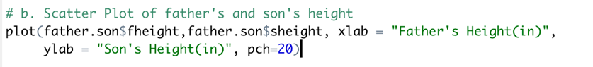

Q3. Add the regression line on the scatter plot.

Ans.



Q4. Add [the SD line](https://sites.google.com/view/umassdmth522/09-homework/homework-1/the-sd-line) (with blue color, different from the regression line) to the same plot.

Ans.

Q5. Mark the center of regression.

Ans.



Q6. Add horizontal and vertical lines (green color) through the center of regression.

Ans.

Q7. Report the linear regression output (including R^2 etc).

Ans.

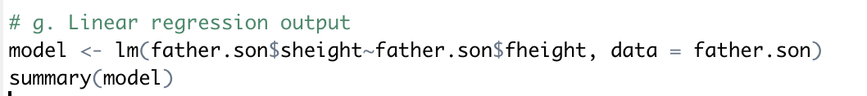

The errors are as follows:

1. RSE = 2.437
2. = 0.2513
3. = 361.2