1. What is pure component?

To avoid the unneccary call which is not update the value.

If the value is same so not render the value again and again

1. Middleware in react and why?

Middleware is thunk and saga. , it is used for asyn call to delay the delay the response

1. Lazy loading in react?

In lazy loading which data load first shown remaining one after . it used load callback function to import other component in suspense and fallback the default message

Lazy,suspense, fallback

1. Difference b/w state less and state full??
2. Difference b/w real dom and virtual dom?

Real dom:

Update very slow

Dom manuplation is very expensive

You can update html directly

Too much of memory wastage.

Create a new dom if element update

Virtual dom:

Update very fast

Dom manuplation is easy

You can’t directly update html

There is no memory wastage

It update the jsx if element update

1. State are changes or not? Why we are not change the state?
2. Differnce b/w component and pure component?

In react component case if state is not change it render again and again

In pure component case if state is not change it will not render again and again

1. What is synthetic event?

Synthetic is call asynchronously event is show null / undefined . if we apply event.persist then it recognize the event

1. Difference b/w normal function and arrow function?

Normal function this is not access so we used bind(this)

Arrow function me this is access

If return statement is one line so there is no need to used curly bracket and return

1. Life cycle of react?

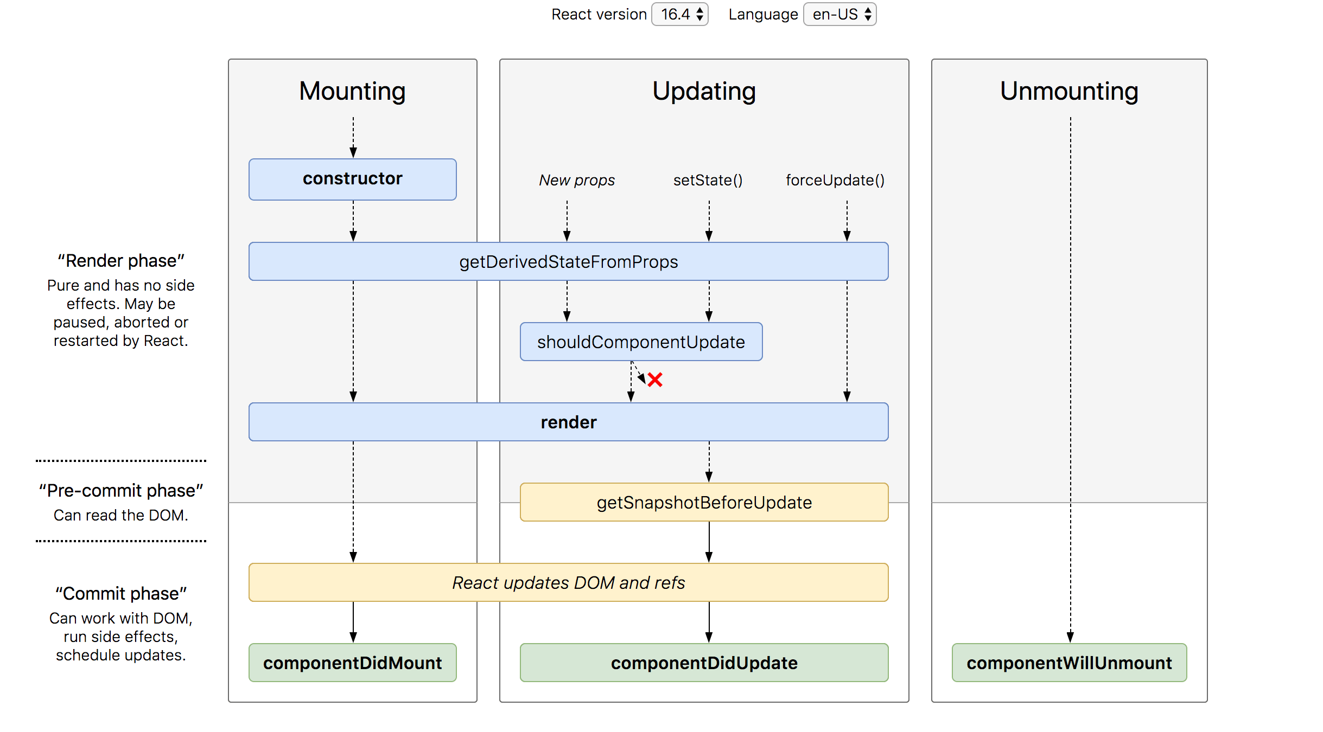

1)mounting -> putting element into dom

(i)Mounting

(ii)Constructor

(iii)render

(iv)componentDidMount

2)updating-> a component update there is a change in componenet state or props

(i)Updating

(ii)ShouldComponentUpdate

(iii)ComponentDidUpdate

3)unmount -> component is removed from the dom

(i)componentWillUnmount

11. useEffect??

It is lifecycle in functional component

It is the combiinaton of componentDidMount, componentDidUpdate, componentWillUnmount

[specific state], otherwise call every state change

12.context api?

It is used for sharing the data b/w different component(functional and class both component)

createContext is used to access global state, components

consumer

useContext

contextType

13. Hooks Routing?

useParams, useLocation, useHistory, useRouteMatch

14. High order and low order?

15) provider?

16) connect()?

17) useSelector,useDispatch

import { Provider } from 'react-redux';

import { createStore, combineReducers, applyMiddleware  } from 'redux';

const rootReducers = combineReducers({

    users:userReducer,

    api:apiUserReducer

})

const store = createStore(rootReducers,applyMiddleware(thunk));

<https://medium.com/@vigowebs/frequently-asked-react-js-interview-questions-and-answers-36f3dd99f486>

18) what is webpack?

Webpack create the creating build ,minify css js,create one entry file from multiple component is called module bundler.

Create a webpack.config.js file

If(mode==development) create main.js file with space

If(mode==) c reate main.js dile without space (default mode for production file)

If(mode==production) c reate main.js file without space (default mode for production file)

By default entry file is index.js, and buld file main.js

**Webpack dev server:**

Npm I webpack dev server

19) What is prop drilling?

Passing data from multiple component..so we used context api and redux

20) cors?

"proxy": "[http://localhost:4000](http://localhost:4000/)"

21) is react ismvc frame work?

No, React is not a mvc framework . it is just a library.

22) difference b/w controlled and uncontrolled component?

In forms Controlled component are handled by react

In form Uncontrolled component are handled by dom use a ref

23)what is error boundaries?

We used 2 method

1)getDrivedStateFromError()

2)componentDidCatch()

23) what is synthetic event?

24) what is useMemo?

It is same as pure component in functional component

25) update a record?

Create a new object

26) What is the advantage of cloudary?

27) what is advantage of sendgrid?

28) What is the principal of redux?

29) react build?

Npm run build

30) Differnce b/w flux and redux?

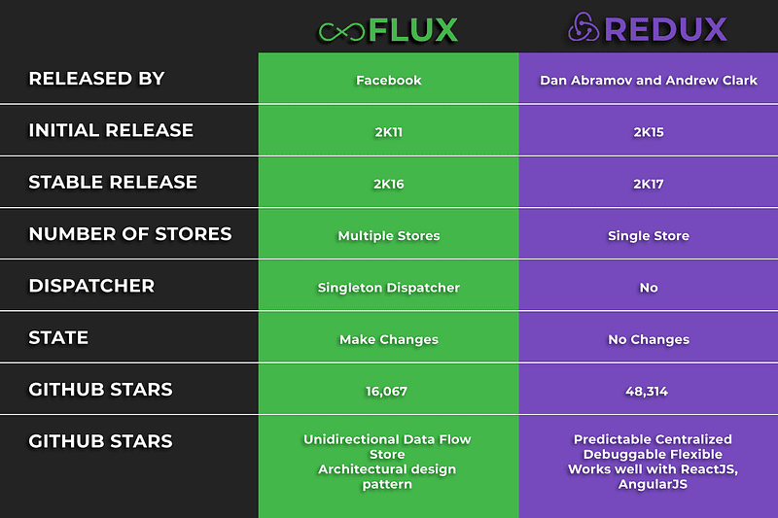

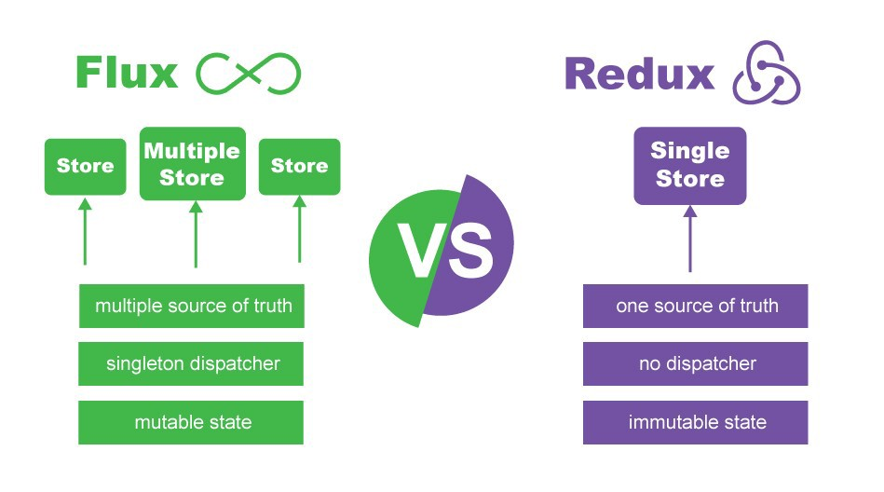

<https://enappd.com/blog/difference-between-redux-and-flux/106/>

31)What is web api utils/ in flux for above link check?

32) what is useRef?

It use to get focus, get value, change the color, dom manupaltion

33) when we use context api and when we use redux?

34) can we use html in props?

Yes, by using (props.children)

35) what is oauth?

Oauth is used to register with social platform .like google ,facebook

36) Hoc?

Taking a argument as acomponent and return a component?

37) context api/redux?

38) diifernce b/w action and action Creator?

Action creator is used to handle more complex action

39) what is the second argument of setState?