**PARIKSHA MITRA APP DESIGN DETAILS**

1. **COLOR PALETTE & COLORS USED:**

Base Color Palette Used for Tiles and other fields

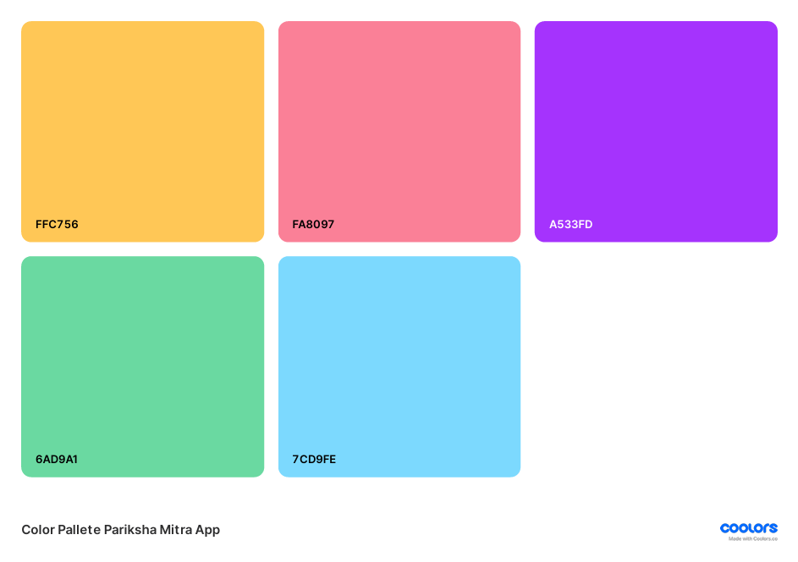

**Extra Colors Used:**

1. FC708A – Used for tiles and buttons
2. 0019FB – Used for registration link / forgot password section on login pages
3. 6378FD – Used for Dashboard header Sections
4. 08FF00 – Used to select correct option in MCQ type questions
5. 299910 – Used to display username and password
6. **FONTS USED:**
7. Rozha One (Regular) – “PARIKSHA MITRA” heading bar (size:128) & Header Section on Dashboard (size:70)
8. Laila (light) – For details on tiles and tabs (size:32 for buttons & some info / size:24 for light gray texts in input boxes and other simple info / size:26 & 28 for information on forgot password tab)
9. Laila (semiBold) – Used for text for buttons when they are clicked or selected (roles section on login pages / other buttons)
10. **GRADIENTS USED – For Page Backgrounds and Tiles**

**The Last Page Background Style is Used for Background Style throughout the Web-Portal Section**

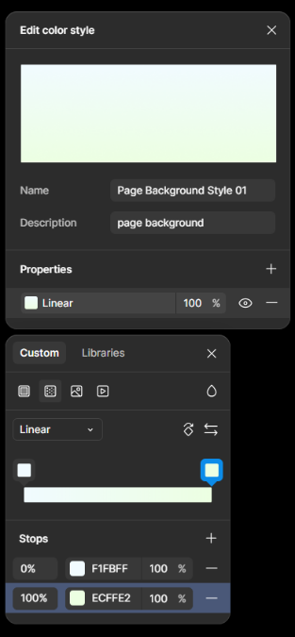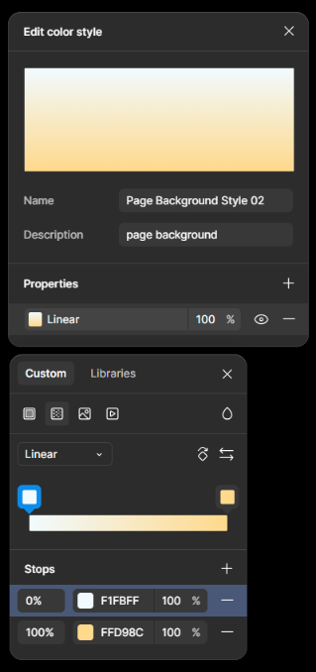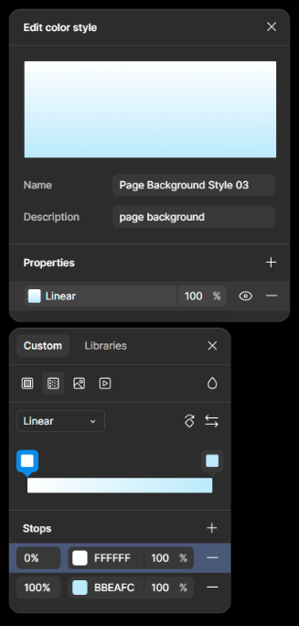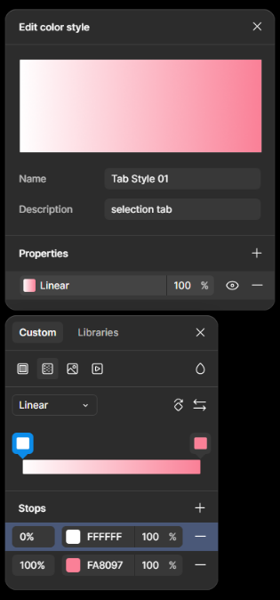

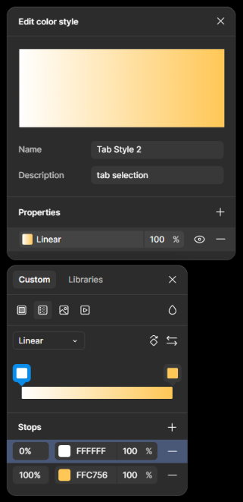 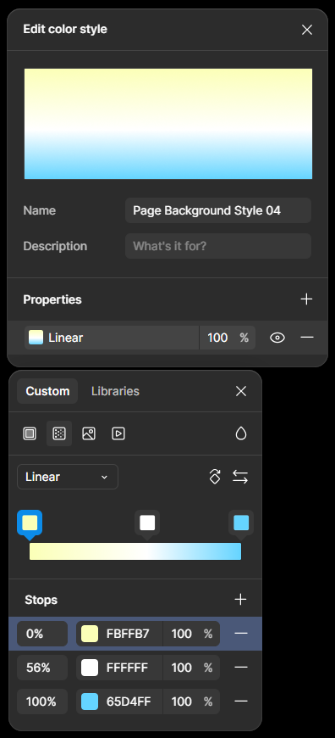

**FIGMA PROJECT (anyone can edit link):-** [**https://www.figma.com/design/ITeSATjwBqkFVCDvrOH01y/Pariksha-Mitra?node-id=97-10&t=7pSZMQyh6MLJbyAf-1**](https://www.figma.com/design/ITeSATjwBqkFVCDvrOH01y/Pariksha-Mitra?node-id=97-10&t=7pSZMQyh6MLJbyAf-1)

**You can directly checkout the sizes, colors, etc. for anything you need.**

**Use the Codify Plugin to get the precise code for pages within the FIGMA file**

**STEPS TO DIRECTLY GET CODE FORMAT FROM DESIGN:**

1. **Select the “Actions” button**

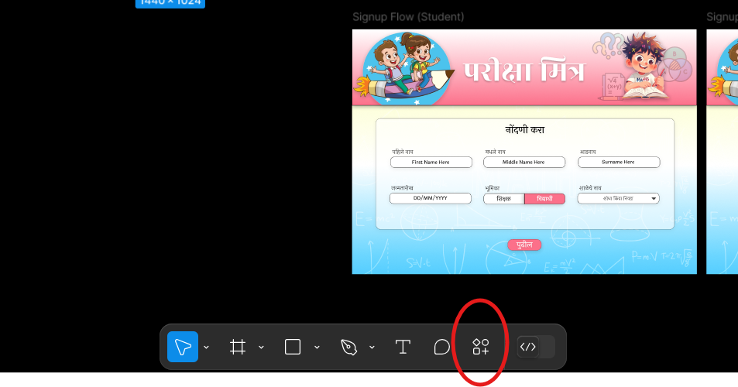

1. **Select the “Plugins and Widgets Section”**

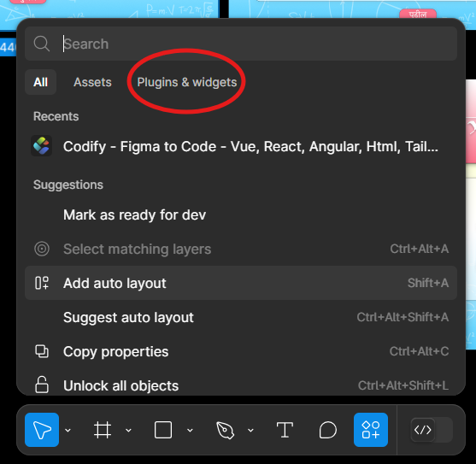

1. **Search for Codify Plugin**

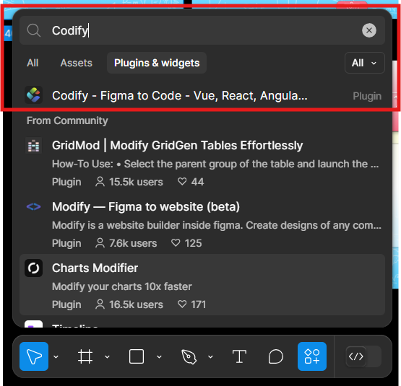

1. **Select and open it, choose the page for which the code is required, choose the type of code you need**

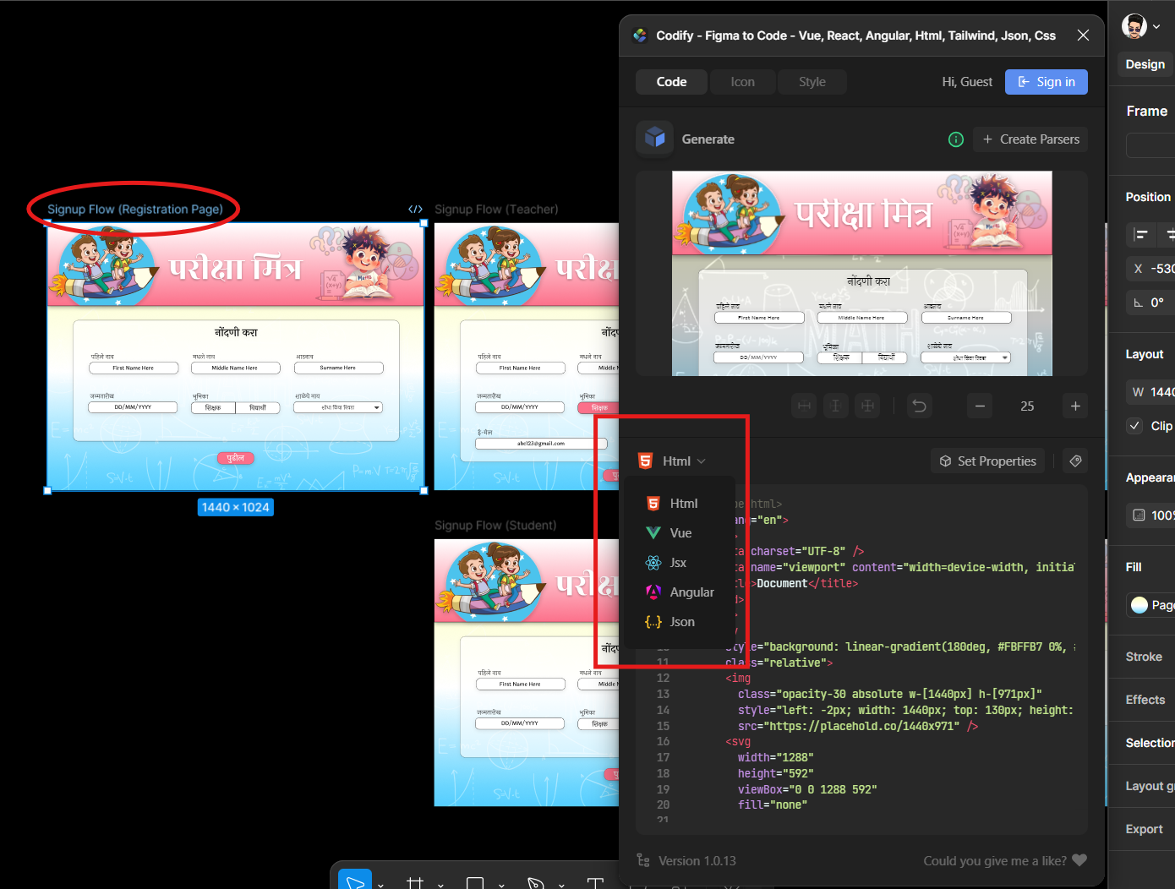

**USE THIS PLUGIN AND IT WILL BECOME EASY TO DEVELOP THE FRONTEND.**