A CASE-STUDY BASED REPORT
ON
Chronic Kidney Disease Prediction Using XGBoost and LightGBM Gradient-Boosted Trees
submitted in partial fulfilment of the requirements for the Course
MACHINE LEARNING
BACHELOR OF TECHNOLOGY
in
A.Y.: 2026-27
by
Nithish S roll 2520030346
Vuppalapati Pranav Varma roll 2520030351
Under the Esteemed guidance of
Mr. Shaik Asif
Asst.Professor, Dept. of CSE



INDEX
Abstract
Introduction
Background
Motivation for the Project
Overview of the Work Carried Out
Scope and Responsible-Use Statement
Problem Statement
Case-Study Scenario
Central Case-Study Question
Formal Problem Definition
Objectives that Guide the Study
Assumptions and Limitations
Dataset and Exploratory Data Analysis
About the Dataset
Purpose of EDA
Preparation Steps Actually Performed
EDA Exploration - Implementation
Summary of EDA Findings
Algorithm Selection and Implementation
Conclusion
Signature of the Team members

Abstract
Chronic Kidney Disease (CKD) is a progressive disorder that often remains undetected until it reaches an advanced stage, making early and accurate prediction essential for timely clinical intervention. This case study presents a machine-learning approach to predicting the presence of CKD using two gradient-boosted tree algorithms, XGBoost and LightGBM, and compares their predictive performance on a large, NHANES-style clinical dataset. The dataset comprises clinical attributes such as blood pressure, blood glucose level, serum creatinine, haemoglobin, albumin and other biochemical and haematological parameters commonly recorded during routine diagnosis.
The raw data was first audited across three candidate datasets, then preprocessed through handling of missing values, encoding of categorical attributes, and imputation of numerical features to ensure consistency and reliability. Exploratory data analysis was performed to understand feature distributions, correlations, and the attributes most strongly associated with CKD onset; this process also surfaced a critical label-leakage risk around the eGFR variable, which was deliberately excluded from modelling. Both XGBoost and LightGBM were trained on the processed dataset, with hyperparameters tuned using grid search and stratified cross-validation.
Performance was evaluated and compared using accuracy, precision, recall, F1-score and ROC-AUC. Feature-importance analysis was additionally carried out to identify the clinical parameters contributing most to the prediction, offering interpretability that can assist medical practitioners. Experimental results show that both ensemble models achieve very high predictive accuracy (99.5% and above), with LightGBM showing a marginally higher F1-score and recall and XGBoost fitting substantially faster on this dataset. The study concludes that gradient-boosted ensembles are an effective and interpretable basis for an early-CKD decision-support prototype, while being explicit that the system is an academic proof of concept rather than a validated clinical device.

Introduction

Background
Chronic Kidney Disease is a major global health concern, affecting a significant proportion of the adult population and contributing heavily to morbidity and mortality worldwide. It is characterised by a gradual loss of kidney function over time, often progressing silently through its early stages without noticeable symptoms. By the time clinical symptoms become apparent, the disease has frequently advanced to a stage where treatment options are limited and costly, such as dialysis or transplantation.
With the increasing availability of electronic health records and clinical laboratory data, machine-learning techniques have emerged as promising tools for building predictive models that can assist clinicians in early diagnosis. Ensemble learning methods based on gradient boosting, such as XGBoost (Chen & Guestrin, 2016) and LightGBM (Ke et al., 2017), have gained popularity due to their high predictive accuracy, robustness to noisy data, and ability to capture complex, non-linear relationships between features — properties that make them well suited to heterogeneous clinical tabular data.

Motivation for the Project
Early detection of CKD is critical to slowing disease progression, reducing healthcare costs, and improving patient outcomes. A system that can flag at-risk individuals from routinely collected clinical variables — before symptoms force a hospital visit — has direct value as a screening aid. This project is motivated by the question of whether two of the most widely used gradient-boosted ensembles can be trained, compared and interpreted on real clinical-style data to produce such a screening aid, and which of the two offers the better trade-off between accuracy, training efficiency and interpretability for this particular healthcare application.

Overview of the Work Carried Out
Three candidate CKD datasets supplied for the study were first profiled on row count, column count, missingness and target structure, and the largest and clinically richest of the three (an NHANES-style dataset of 11,933 records) was selected as the primary dataset. Systematic exploratory data analysis was then carried out to characterise class balance, missingness, demographic and clinical-variable relationships, and a leakage risk associated with the eGFR variable. A leakage-controlled preprocessing pipeline was built, after which XGBoost and LightGBM were trained under an identical train/test protocol, tuned via cross-validation, and compared on accuracy, precision, recall, F1-score, ROC-AUC and empirical training time. Feature-importance analysis was performed on both trained models, and a lightweight Streamlit prediction prototype was built on top of the saved pipelines.

Scope and Responsible-Use Statement
The scope of this case study is limited to a retrospective, cross-sectional classification task: distinguishing CKD-positive from CKD-negative records using supplied clinical attributes. It does not model time-to-event disease progression, and it has not been externally validated on an independent clinical cohort. Accordingly, the resulting prototype is presented strictly as an educational, academic decision-support exploration and is explicitly not a certified or clinically deployed diagnostic device. Any real-world use of similar tooling would require regulatory review, external validation, clinician oversight and fairness/subgroup auditing before influencing patient care.

Problem Statement

Case-Study Scenario
Consider a healthcare analytics team that has been handed three CSV extracts of patient clinical data by a research partner, with no accompanying data dictionary beyond column names and a brief note that one of the files is NHANES-style. The team's task is to decide which dataset is fit for building a CKD screening model, prepare it responsibly (including checking whether any supplied column effectively encodes the diagnosis itself), and then build and compare two candidate ensemble models so that a recommendation can be made about which approach to carry into a decision-support prototype.

Central Case-Study Question
Can routinely recorded demographic, biochemical, urinary, blood-pressure and metabolic variables be used to reliably distinguish CKD-positive from CKD-negative patients, and how do XGBoost and LightGBM compare under a leakage-controlled pipeline on this task?

Formal Problem Definition
Given a feature vector x drawn from the supplied clinical and demographic variables (excluding identifier, downstream-label and leakage-prone columns), the task is binary classification: learn a function f(x) → {0, 1} that predicts ckd_present, where 1 denotes a CKD-positive record and 0 denotes a CKD-negative record. The objective is to learn f using XGBoost and, separately, LightGBM, and to compare the two resulting classifiers on a held-out stratified test split using accuracy, precision, recall, F1-score and ROC-AUC.

Objectives that Guide the Study
- Audit and select the strongest of three supplied CKD datasets.
- Perform systematic EDA including class balance, missingness, distributions, relationships, and leakage checks.
- Build a leakage-controlled preprocessing pipeline (imputation, encoding, feature exclusion).
- Train XGBoost and LightGBM using the same train/test protocol and tuned hyperparameters.
- Compare accuracy, precision, recall, F1-score, ROC-AUC and empirical training time.
- Interpret feature importance and demonstrate a lightweight prediction interface.

Assumptions and Limitations
- The supplied dataset is cross-sectional and does not model time-to-event CKD progression.
- The target appears strongly linked to renal-function definitions, creating an unusually easy classification task even after excluding eGFR.
- Missingness is substantial in several variables (up to ~91% for insulin_use) and may not be missing completely at random.
- Dataset provenance and the exact collection protocol were not supplied alongside the CSV files.
- External validation on an independent cohort would be required before any clinical interpretation.

Dataset and Exploratory Data Analysis

About the Dataset
Three CSV files were profiled on row count, column count, missingness and target structure before a dataset was selected for modelling:
Dataset | Rows | Columns | Missing Cells | Target | Decision
CKD_NHANES_2021_2023 | 11,933 | 29 | 114,393 (33.1%) | ckd_present | PRIMARY
Testing_CKD_dataset | 4,800 | 36 | 0 (0%) | Target (5-class) | SECONDARY
kidney_disease | 400 | 26 | 1,009 (9.7%) | classification | REFERENCE
The NHANES-style file was selected as the primary dataset because it has the largest sample and the richest combination of clinical variables. The 400-row reference dataset is useful for academic comparison but is relatively small and has substantial missingness. The 4,800-row dataset has no missing values, but its integer-heavy distributions suggest it is better treated as a secondary sanity-check file than the primary clinical-style analysis dataset. Within the primary dataset, the target is imbalanced: 8,341 CKD-positive records (69.9%) against 3,592 CKD-negative records (30.1%).

Purpose of EDA
Exploratory data analysis was carried out before any modelling to understand the shape and quality of the selected dataset: the balance of the target class, the extent and pattern of missing data, how clinical variables differ between CKD-positive and CKD-negative patients, how strongly variables correlate with each other, and — critically — whether any supplied column so closely tracks the label that including it would let a model "cheat" rather than learn a genuinely predictive signal. This last check directly shaped the modelling methodology described later in this report.

Preparation Steps Actually Performed
- Treated age values below 1 as missing (data-entry artefact cleanup).
- Removed participant_id (identifier, no predictive meaning), ckd_stage (downstream of the label) and egfr (near-deterministic with the label — see leakage audit below).
- Applied median imputation to remaining numeric variables.
- Applied most-frequent imputation followed by one-hot encoding to categorical variables.
- Split the data 80% training / 20% held-out testing, stratified by target, with random_state = 42 so the 69.9% / 30.1% class balance is preserved in both subsets.

EDA Exploration - Implementation
The figures below were produced directly from the primary dataset as part of the EDA notebook.
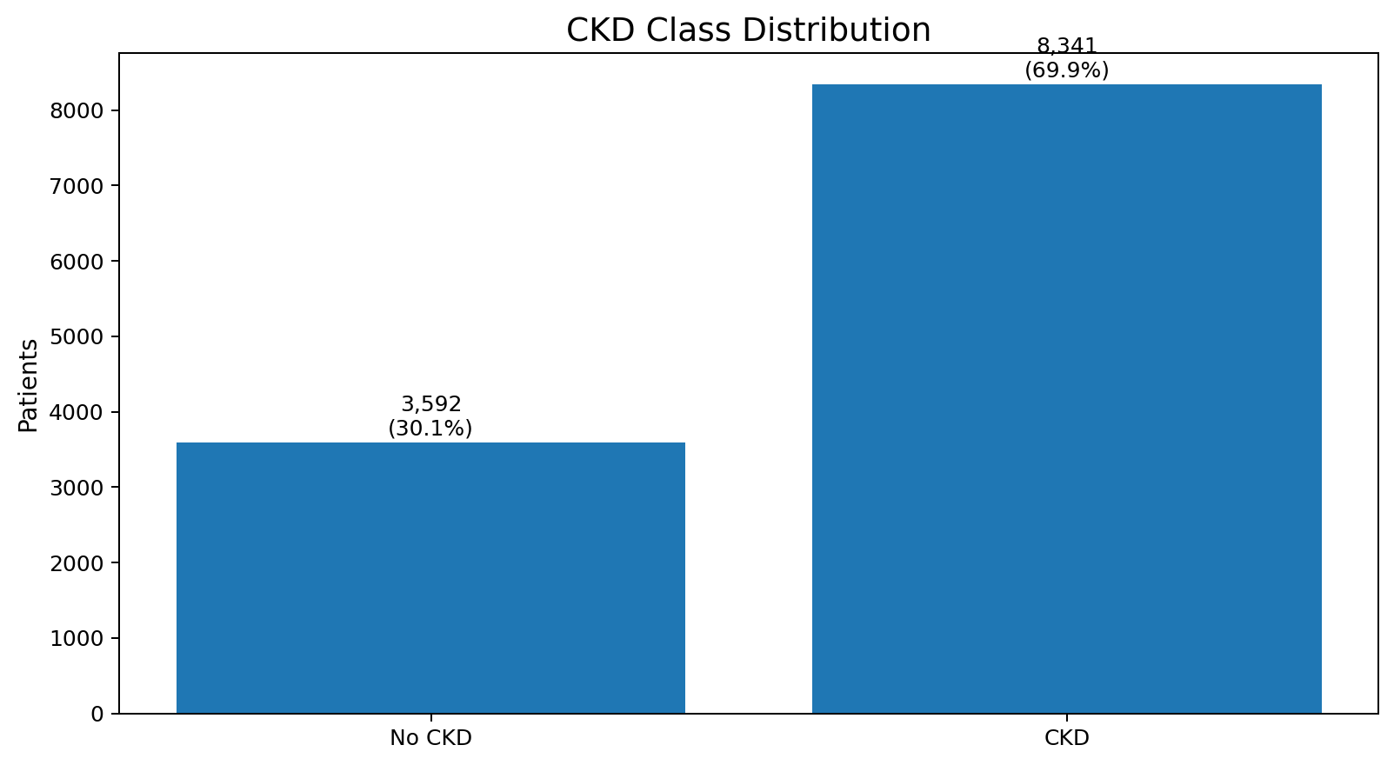
Figure 1. CKD class distribution in the primary dataset — 8,341 positive vs 3,592 negative records (≈69.9% positive).
The target is moderately imbalanced toward CKD-positive records, which is why stratified splitting was used for all train/test partitioning.
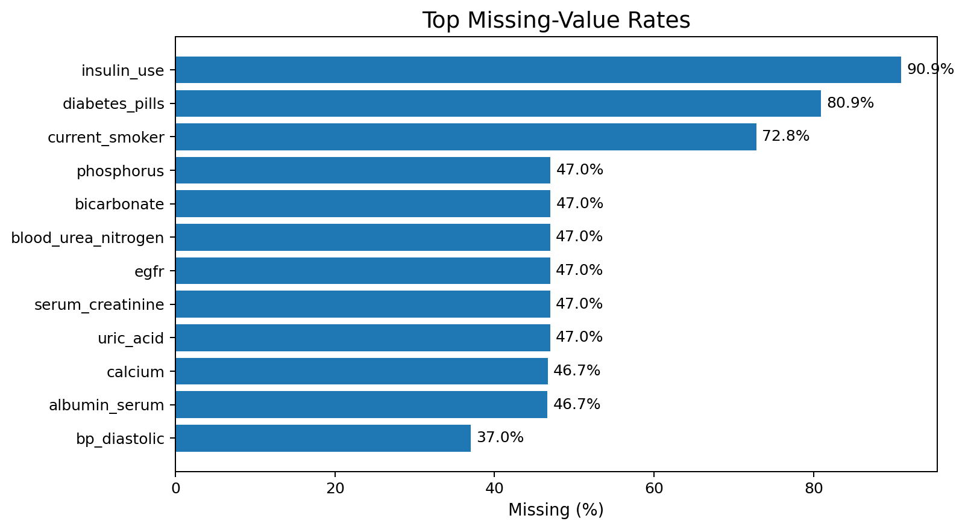
Figure 2. Top missing-value rates by column.
Missingness is concentrated in questionnaire-derived and laboratory variables — insulin_use (≈91%), diabetes_pills (≈81%) and current_smoker (≈73%) are the most affected, followed by several renal-panel variables in the 46–47% range. This motivated median/most-frequent imputation rather than row deletion, which would have discarded a large share of the dataset.
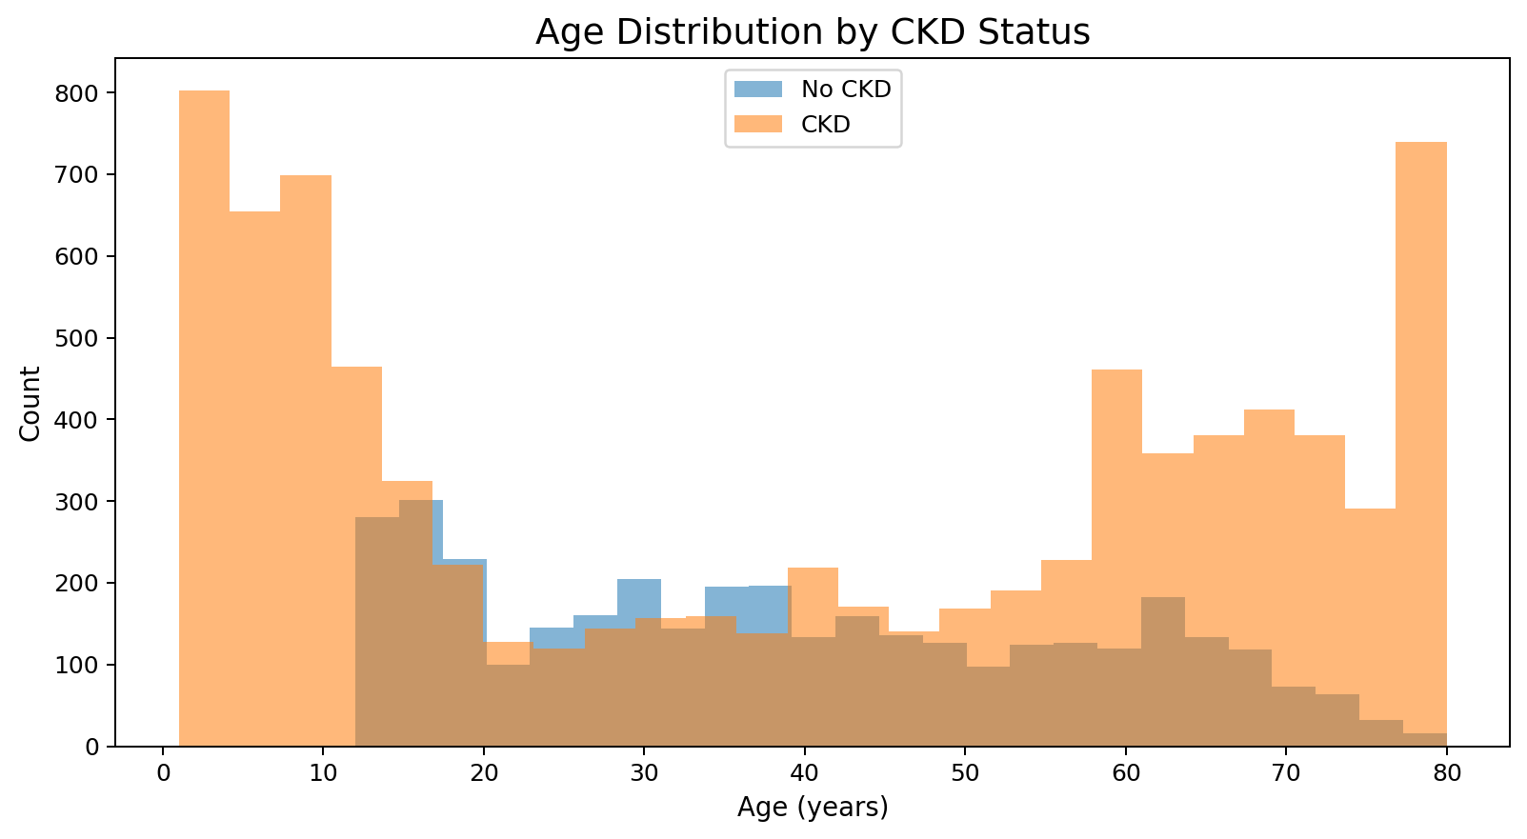
Figure 3. Age distribution by CKD status.
Age distributions overlap considerably between the two classes, indicating that age alone does not cleanly separate CKD-positive from CKD-negative patients. The useful signal was expected to come from combinations of clinical variables rather than any single demographic variable.
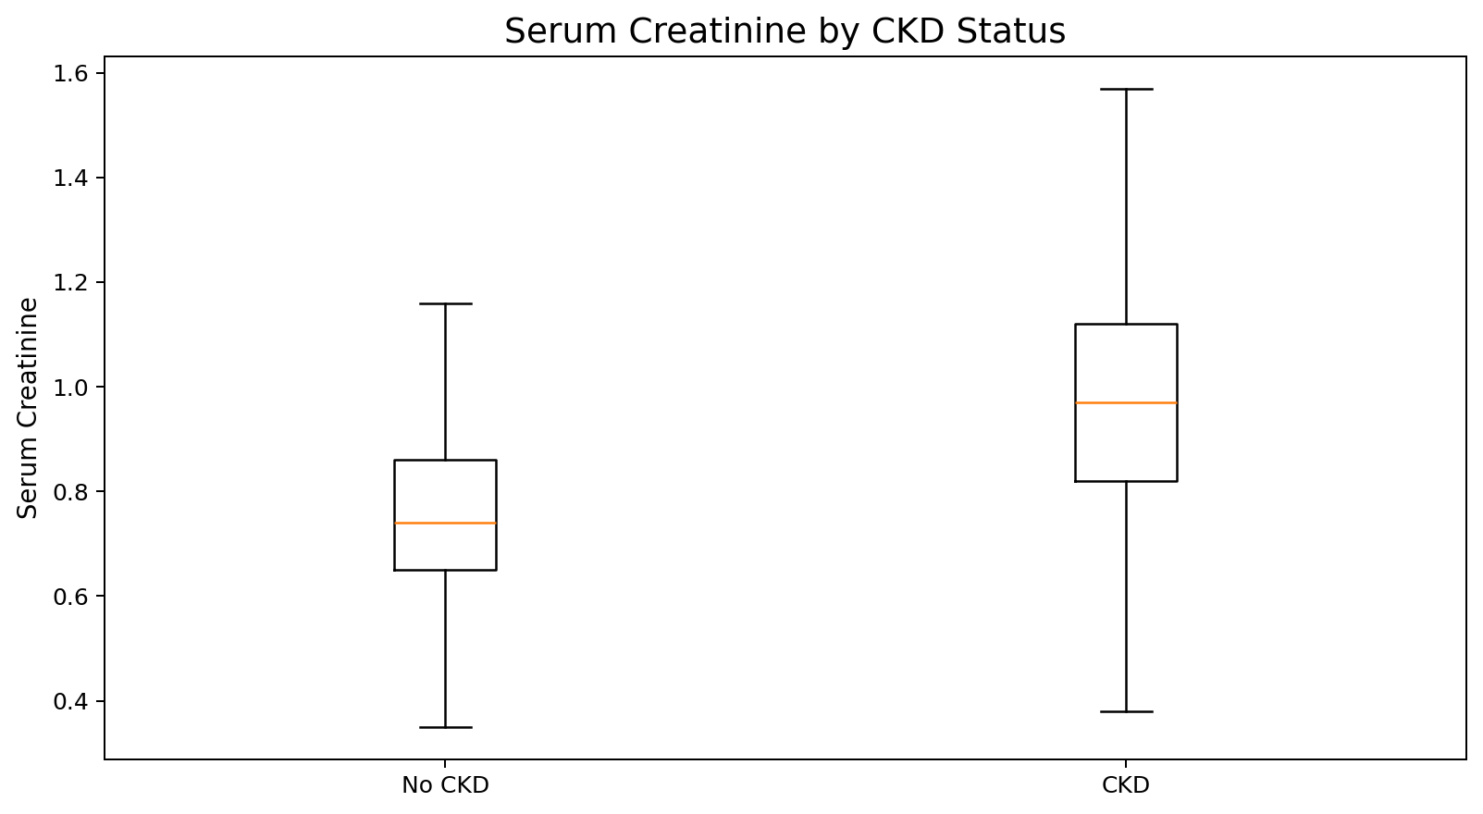
Figure 4. Serum creatinine by CKD status.
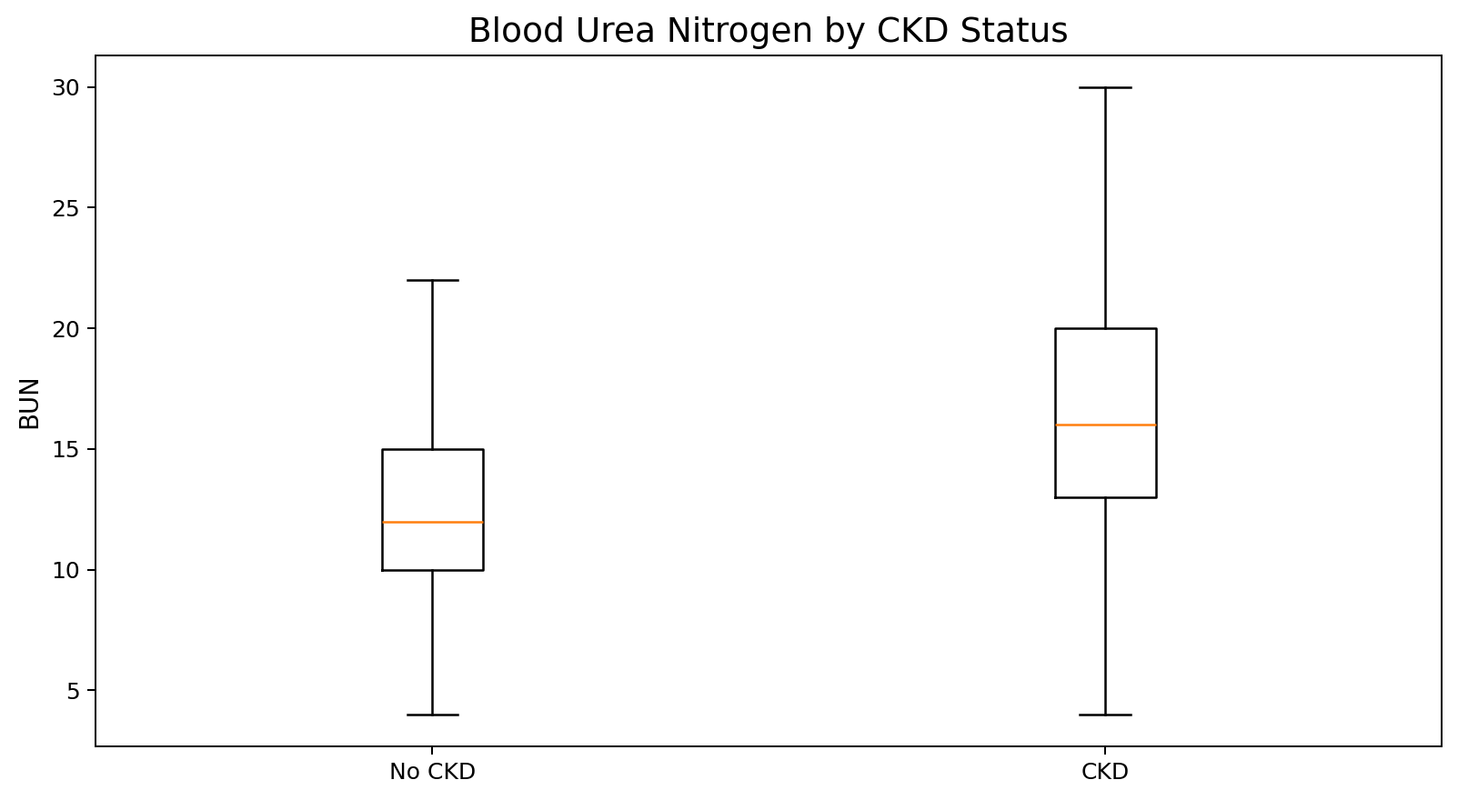
Figure 5. Blood urea nitrogen by CKD status.
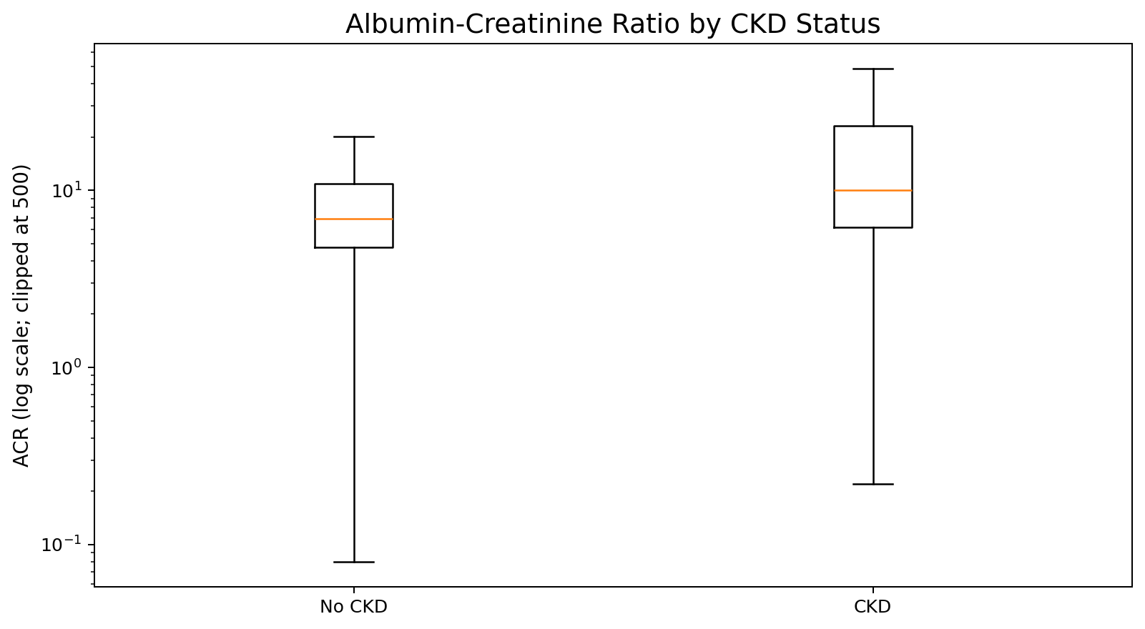
Figure 6. Albumin-creatinine ratio by CKD status (log visual scale).
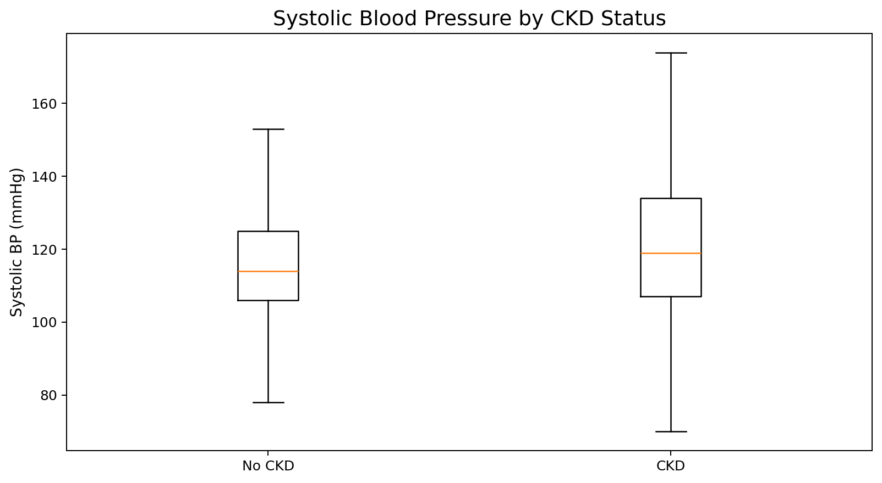
Figure 7. Systolic blood pressure by CKD status.
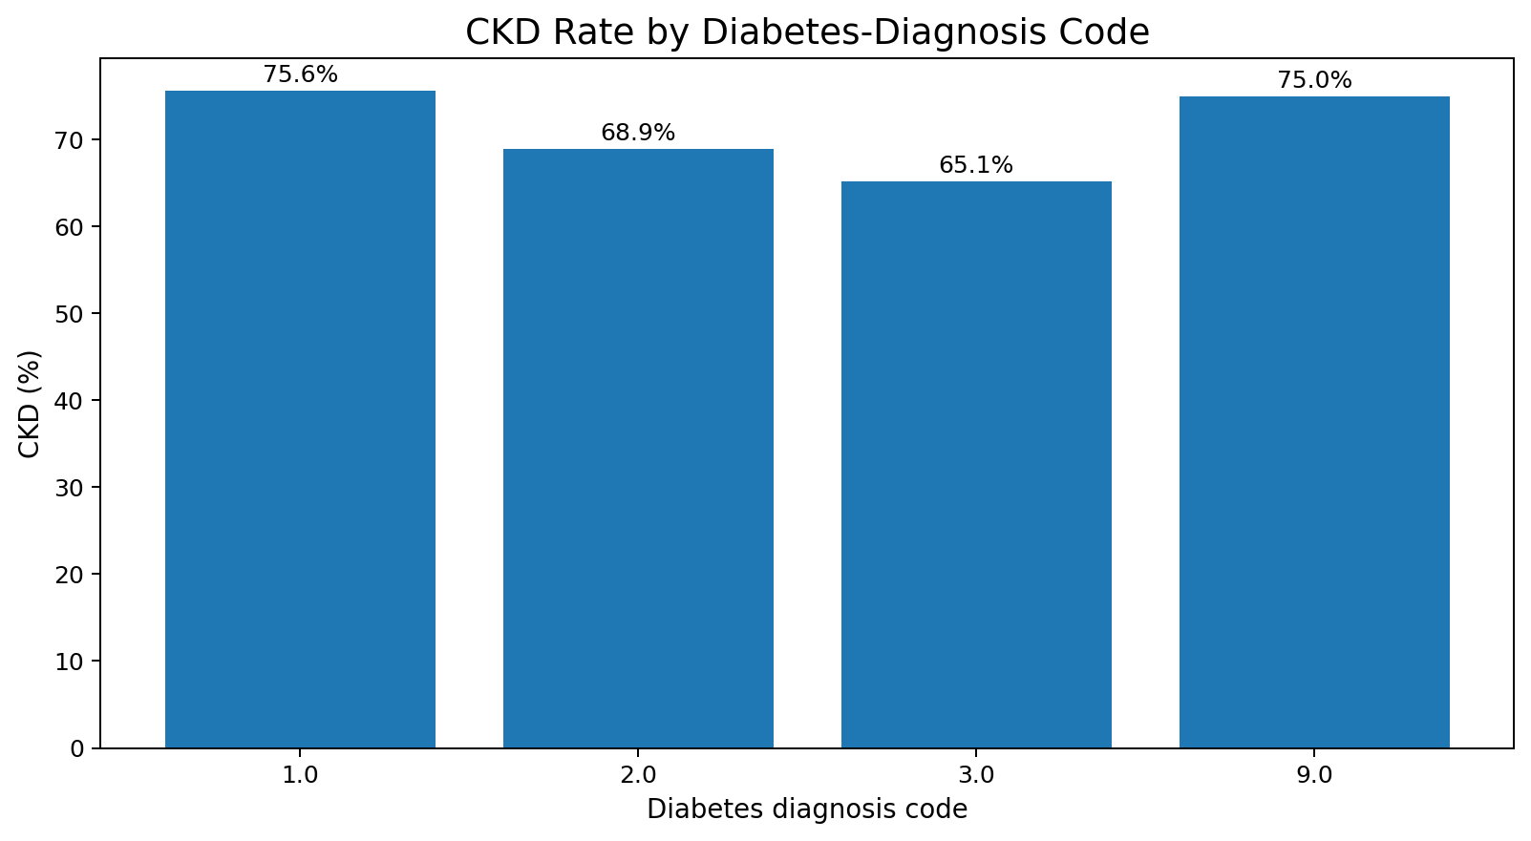
Figure 8. CKD rate by diabetes-diagnosis code.
Serum creatinine, blood urea nitrogen (BUN) and albumin-creatinine ratio (ACR) show much stronger separation between classes than age or blood pressure. ACR in particular is highly right-skewed, which motivated a log scale for visualisation. CKD rate also rises sharply with diabetes diagnosis, consistent with diabetes being a well-known clinical risk factor for kidney disease. These observations supported the choice of non-linear tree ensembles over a simple linear model.
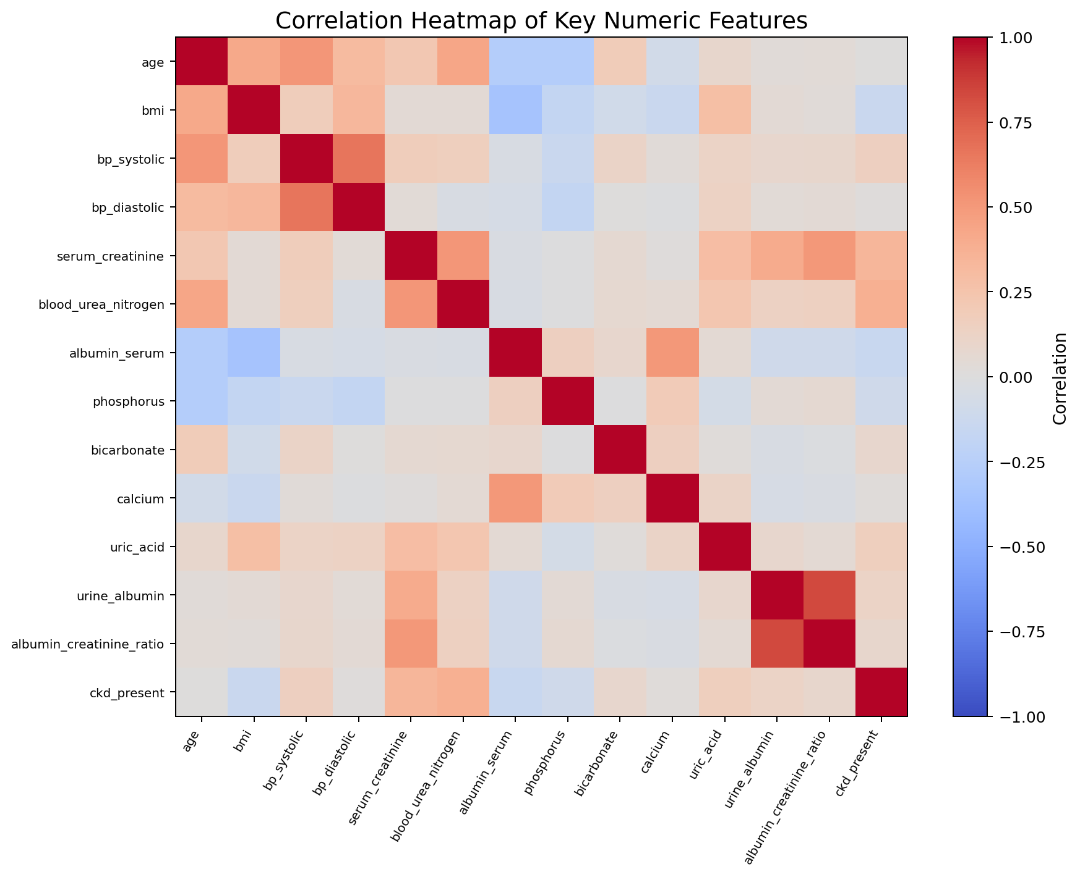
Figure 9. Correlation heatmap for selected numeric variables.
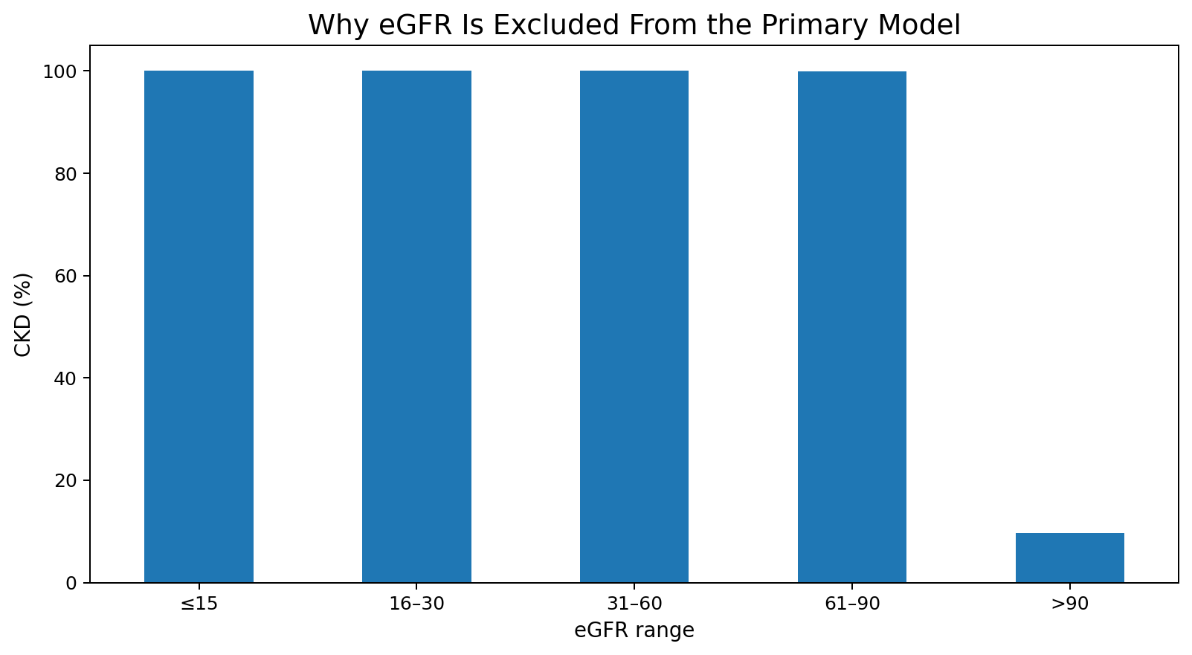
Figure 10. CKD rate by eGFR range, showing near-deterministic alignment with the supplied target.
Leakage control decision: participant_id, ckd_stage and eGFR were excluded from the primary model. eGFR is the most important of these exclusions, because the supplied CKD label is almost deterministic across eGFR bins — using it as a feature would make the task closer to reconstructing the rule that generated the label than to independent clinical screening from first-line variables.

Summary of EDA Findings
- The dataset is moderately imbalanced (≈70% CKD-positive), requiring stratified splitting.
- Missingness is substantial and concentrated in a handful of questionnaire/lab variables, handled via imputation rather than deletion.
- Age and blood pressure show weak class separation; renal-panel variables (creatinine, BUN, ACR) show strong separation.
- Diabetes diagnosis correlates with a markedly higher CKD rate, consistent with known clinical risk pathways.
- eGFR is near-deterministic with the target and was therefore excluded to avoid label leakage, along with the identifier and the downstream CKD-stage column.

Algorithm Selection and Implementation
Two gradient-boosted decision-tree ensembles were selected for this case study: XGBoost (Chen & Guestrin, 2016) and LightGBM (Ke et al., 2017). Both build an additive sequence of shallow trees, each correcting the residual error of the previous ensemble, and both are well established for structured/tabular clinical data because they handle non-linear feature interactions, are relatively robust to noisy or imperfectly scaled inputs, and provide built-in feature-importance scores for interpretability — an important property for a healthcare decision-support use case. LightGBM's histogram-based, leaf-wise growth strategy was of particular interest as a potential training-speed advantage over XGBoost's level-wise growth, which the case study set out to test empirically rather than assume.
Both models were trained on the identical leakage-controlled, preprocessed feature set, using an 80/20 stratified train/test split (random_state = 42). Hyperparameters for each model were tuned using grid search under 3-fold stratified cross-validation; the selected configurations were:
Model | Key tuned hyperparameters
XGBoost | n_estimators=200, max_depth=6, learning_rate=0.1, subsample=0.8, colsample_bytree=0.8, min_child_weight=1
LightGBM | n_estimators=500, num_leaves=63, learning_rate=0.03, subsample=0.8, colsample_bytree=1.0, min_child_samples=20
Each tuned model was then refit on the full training split and evaluated once on the untouched 20% test split (2,387 records), using accuracy, precision, recall, F1-score, ROC-AUC and single-fit wall-clock training time as the comparison metrics.
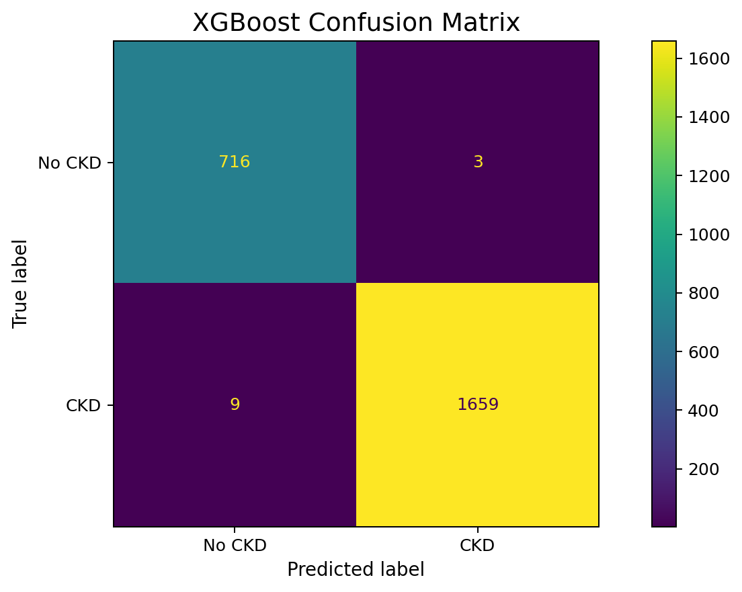
Figure 11a. XGBoost confusion matrix on the held-out test set.
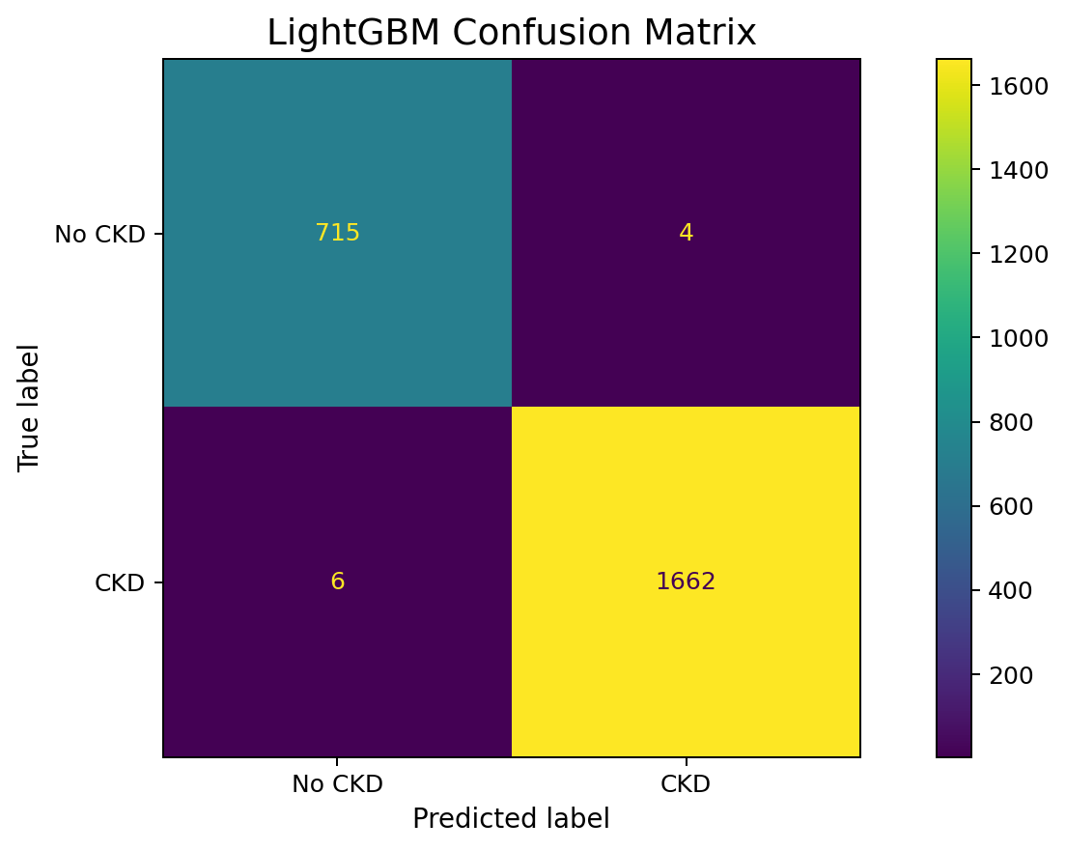
Figure 11b. LightGBM confusion matrix on the held-out test set.
Results:
Model | Accuracy | Precision | Recall | F1 | ROC-AUC | Train time (s)
XGBoost | 0.9950 | 0.9982 | 0.9946 | 0.9964 | 0.9999 | 5.97
LightGBM | 0.9958 | 0.9976 | 0.9964 | 0.9970 | 0.9999 | 24.73
Both models achieve very high, closely matched performance, with ROC-AUC effectively tied at 0.9999 for both. LightGBM is marginally ahead on accuracy, recall and F1-score in this run; XGBoost trades a very small amount of recall for substantially faster training (roughly 4× faster in this environment). Because empirical speed depends on hardware, parameter choice and preprocessing overhead, training time is reported here as an observed result for this run rather than a universal property of either algorithm.
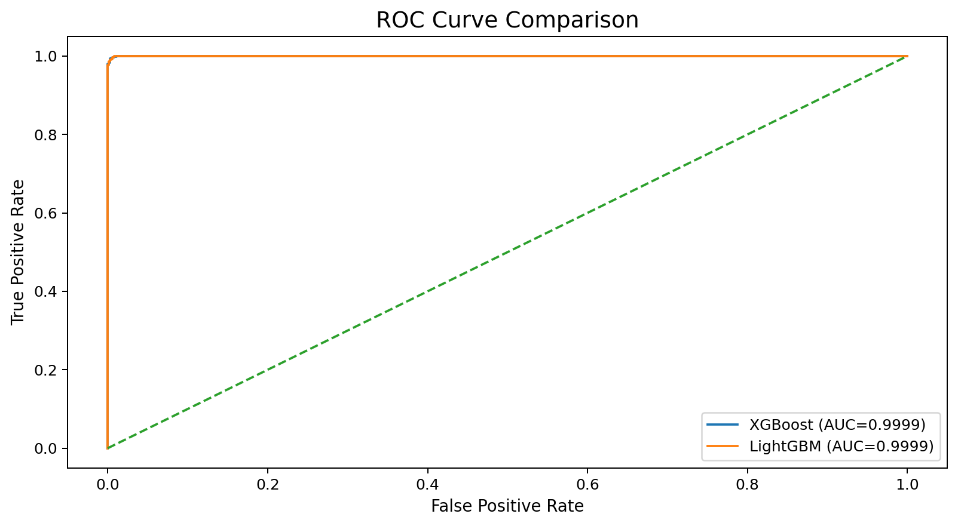
Figure 12. ROC curve comparison between XGBoost and LightGBM.
On the class-level breakdown, XGBoost reaches 98.8% precision / 99.6% recall on the CKD-negative class and 99.8% precision / 99.5% recall on the CKD-positive class; LightGBM reaches 99.2% precision / 99.4% recall on CKD-negative and 99.8% precision / 99.6% recall on CKD-positive — both models therefore handle the minority (CKD-negative) class well despite the class imbalance noted during EDA, rather than simply defaulting to the majority class.
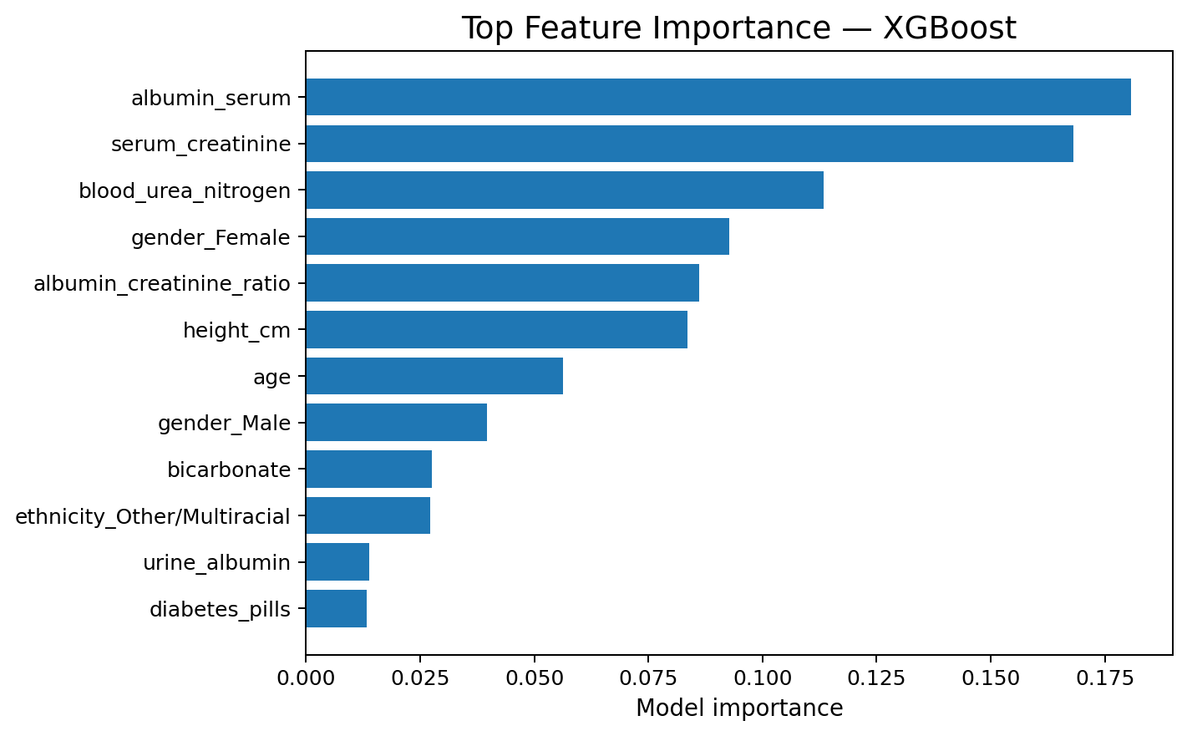
Figure 13a. XGBoost feature importance.
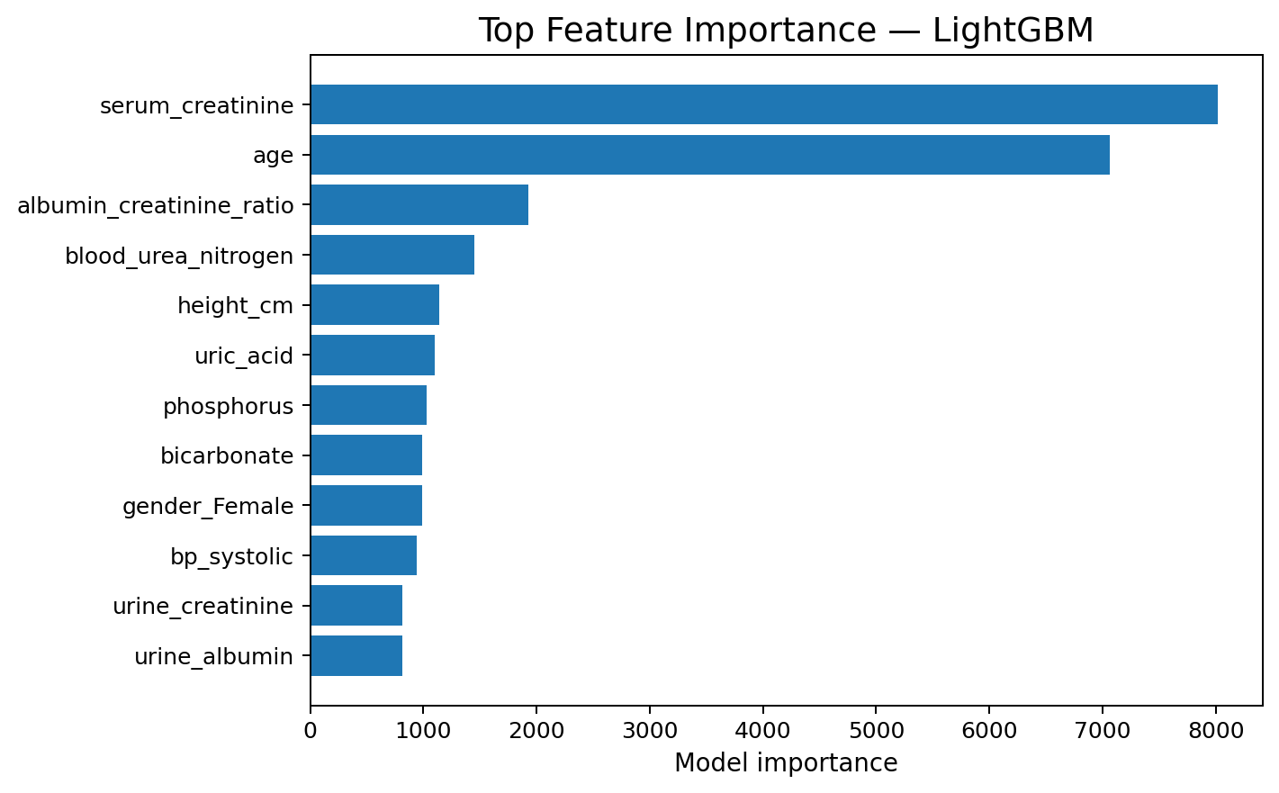
Figure 13b. LightGBM feature importance.
Both models consistently emphasise renal and metabolic variables — serum creatinine, albumin-creatinine ratio, blood urea nitrogen, age and related clinical measures — as the strongest predictors, which aligns with the class-separation patterns already observed during EDA. Feature importance is model-specific and reflects predictive contribution within these trained ensembles; it does not by itself establish clinical causality.
Implementation summary: data cleaning → leakage-aware feature selection → median/most-frequent imputation and one-hot encoding → stratified 80/20 split → grid-search-tuned XGBoost and LightGBM → evaluation on accuracy, precision, recall, F1, ROC-AUC and training time → feature-importance interpretation → a Streamlit prototype that loads the saved pipelines and serves live predictions from a subset of routine clinical inputs, explicitly labelled as educational rather than diagnostic.

Conclusion
This case study set out to determine whether routinely recorded clinical variables could support early CKD screening, and whether XGBoost or LightGBM offers the better basis for such a tool. Working from three candidate datasets, the largest and clinically richest (NHANES-style, 11,933 records) was selected, profiled and audited for a critical eGFR label-leakage risk, which was then deliberately excluded from the feature set along with the participant identifier and the downstream CKD-stage column.
Both gradient-boosted ensembles, trained under an identical leakage-controlled pipeline and tuned via cross-validation, achieved very high and closely matched performance (ROC-AUC ≈ 0.9999 for both; accuracy 99.50% for XGBoost and 99.58% for LightGBM). LightGBM showed a small edge in accuracy, recall and F1-score, while XGBoost trained markedly faster in this environment — meaning the better choice in practice depends on whether a deployment prioritises marginal predictive performance or training/iteration speed. Feature-importance analysis for both models consistently pointed to serum creatinine, albumin-creatinine ratio, blood urea nitrogen and age as the dominant clinical predictors, matching the patterns already visible during exploratory analysis.
Taken together, the case study demonstrates that gradient-boosted ensembles are an effective and reasonably interpretable basis for an early-CKD decision-support prototype, and that careful EDA — in particular, the leakage audit around eGFR — is what separates a genuinely useful screening model from one that merely re-encodes its own label. The resulting prototype is explicitly scoped as an educational artefact: before any real-world use, it would need external validation on an independent cohort, calibration and threshold analysis, subgroup/fairness auditing, and clinician-supervised deployment review.
Signature of the Team members
Nithish S (2520030346): ____________________
Vuppalapati Pranav Varma (2520030351): ____________________

