MINI HACKATHON 1
Early Chronic Kidney Disease Prediction
A comparative study of XGBoost and LightGBM on clinical tabular data

Koneru Lakshmaiah University
August 2026

Executive Summary
This project investigates machine-learning support for early CKD screening using two gradient-boosted tree models: XGBoost and LightGBM. Three supplied datasets were audited before model development. The NHANES-style dataset was selected as the primary dataset because it provides the largest sample (11,933 records) and rich clinical variables. Exploratory analysis was used to characterize target distribution, missingness, feature relationships, and a critical leakage risk.
The main modeling rule is deliberately conservative: participant_id is excluded as an identifier; ckd_stage is excluded because it is downstream of the CKD label; and eGFR is excluded from the primary model because the supplied ckd_present target is almost deterministic across eGFR ranges. This reduces the risk of the model simply reproducing the rule that created the label.

1. Problem Statement
Chronic Kidney Disease can progress silently, making earlier risk identification important. The project asks: can routinely recorded demographic, biochemical, urinary, blood-pressure, and metabolic variables be used to distinguish CKD-positive from CKD-negative records, and how do XGBoost and LightGBM compare under a leakage-controlled pipeline?

Objectives
- Audit and select the strongest of three supplied CKD datasets.
- Perform systematic EDA including class balance, missingness, distributions, relationships, and leakage checks.
- Train XGBoost and LightGBM using the same train/test protocol.
- Compare accuracy, precision, recall, F1-score, ROC-AUC, and empirical training time.
- Interpret feature importance and demonstrate a lightweight prediction interface.

2. Dataset Identification & Selection
The three CSV files supplied for the project were profiled on row count, column count, missingness, and target structure.
Dataset | Rows | Cols | Missing cells | Target | Decision
CKD_NHANES_2021_2023 | 11,933 | 29 | 114,393 | ckd_present | PRIMARY
Testing_CKD_dataset | 4,800 | 36 | 0 | Target | SECONDARY
kidney_disease | 400 | 26 | 1,009 | classification | REFERENCE
Selection rationale. The NHANES-style file has the largest sample and the richest combination of clinical variables. The 400-row reference dataset is valuable for academic comparison but is relatively small and has substantial missingness. The 4,800-row dataset has no missing values, but its integer-heavy distributions and ranges suggest it is better treated as a secondary/sanity-check dataset rather than the primary clinical-style analysis file.

3. Exploratory Data Analysis

3.1 Target distribution
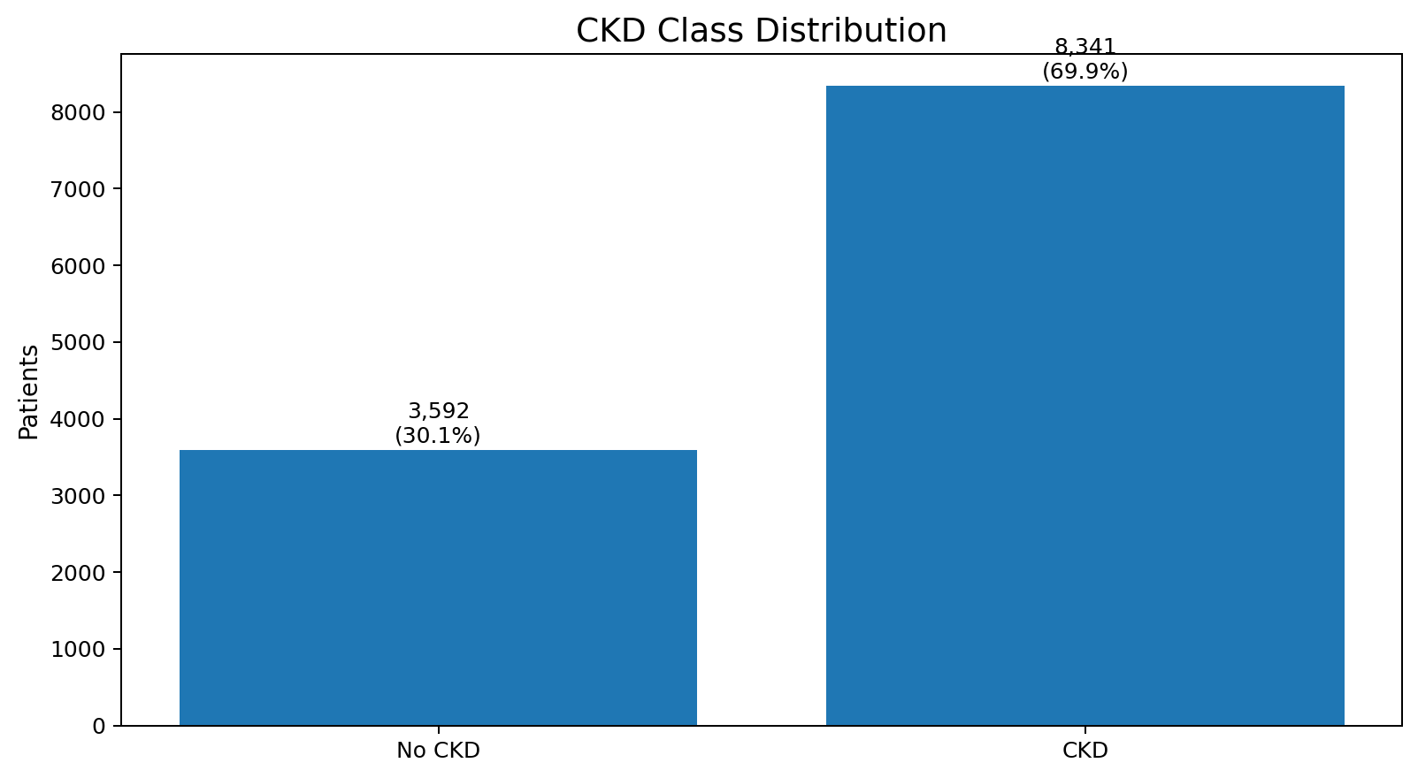
Figure 1. CKD class distribution in the primary dataset.
The target contains 8,341 CKD-positive and 3,592 non-CKD records. CKD-positive records therefore represent about 69.9% of the supplied labels. Stratified splitting is used so that this imbalance is preserved between training and test subsets.

3.2 Missingness
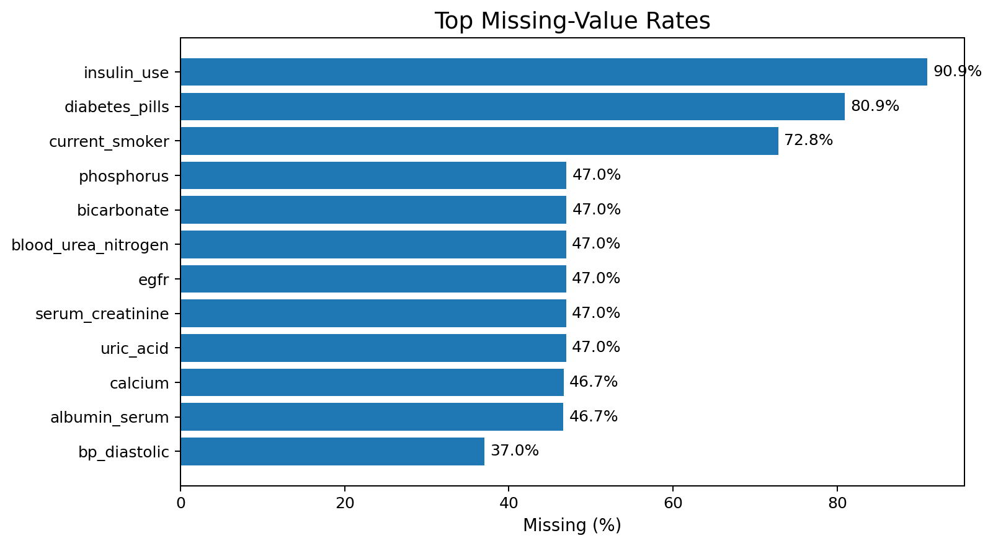
Figure 2. Top missing-value rates.
Missingness is concentrated in several laboratory and questionnaire-derived variables. In the primary pipeline, numeric variables are median-imputed and categorical variables receive most-frequent imputation followed by one-hot encoding. The amount of missingness remains a limitation and should be reported transparently.

3.3 Demographic patterns
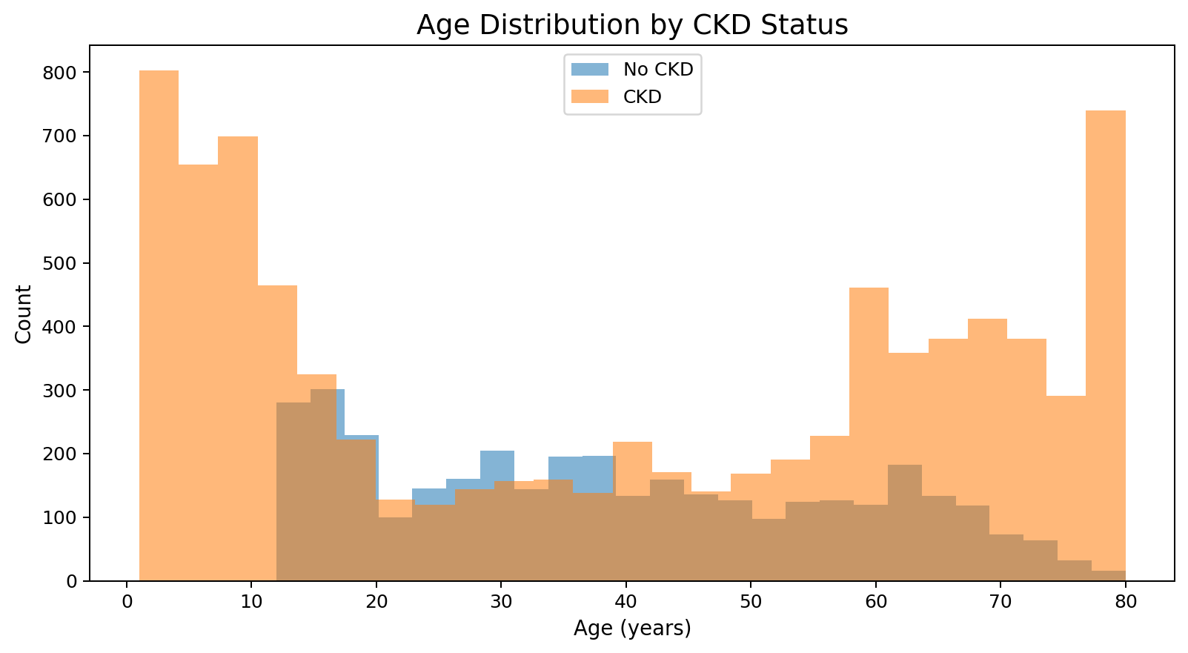
Figure 3. Age distribution by CKD status.
Age distributions overlap considerably, indicating that age alone does not cleanly separate the classes. The useful signal is expected to come from combinations of clinical variables rather than one demographic variable.

3.4 Clinical variables
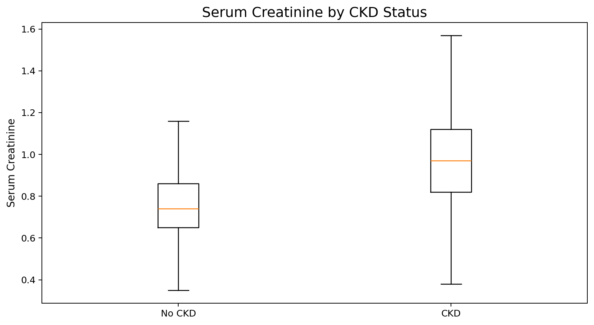
Figure 4. Serum creatinine by CKD status.
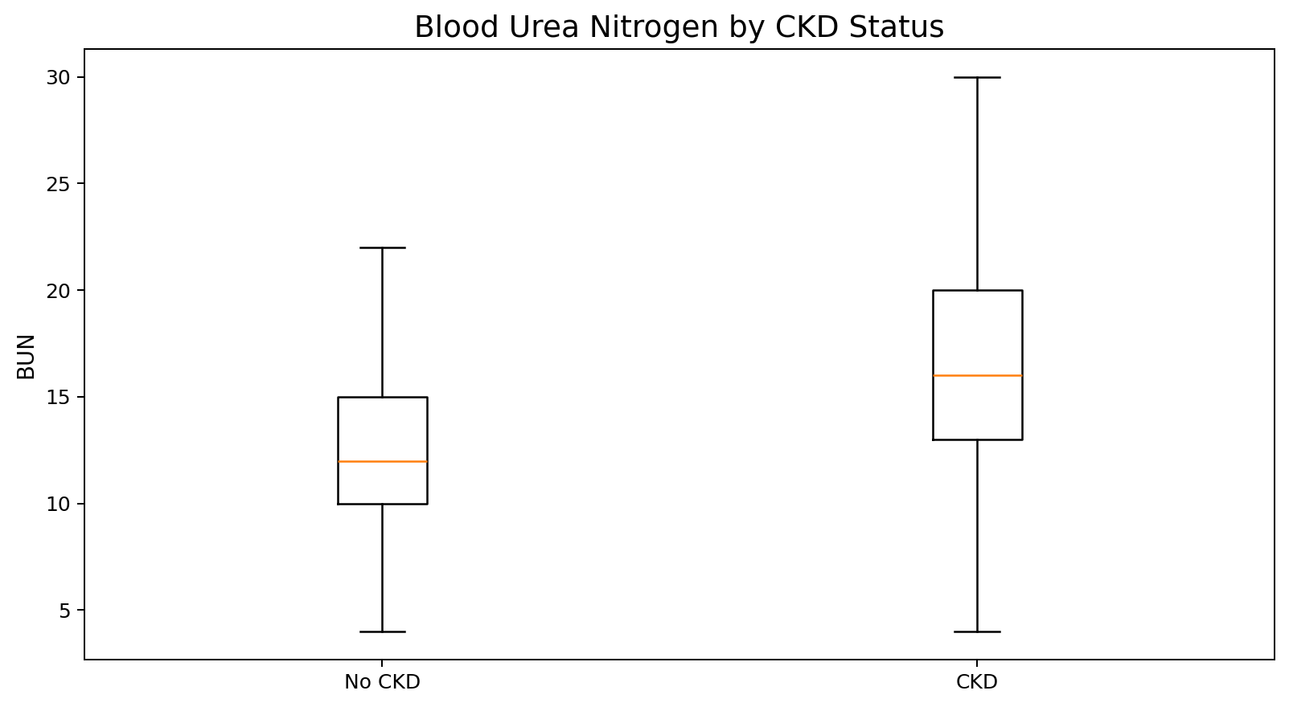
Figure 5. Blood urea nitrogen by CKD status.
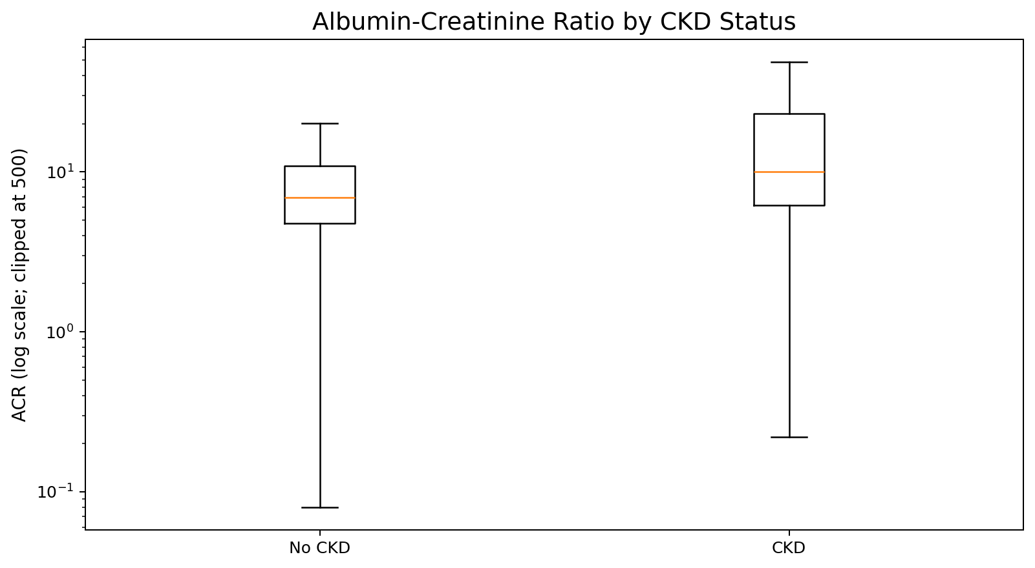
Figure 6. Albumin-creatinine ratio by CKD status (log visual scale).
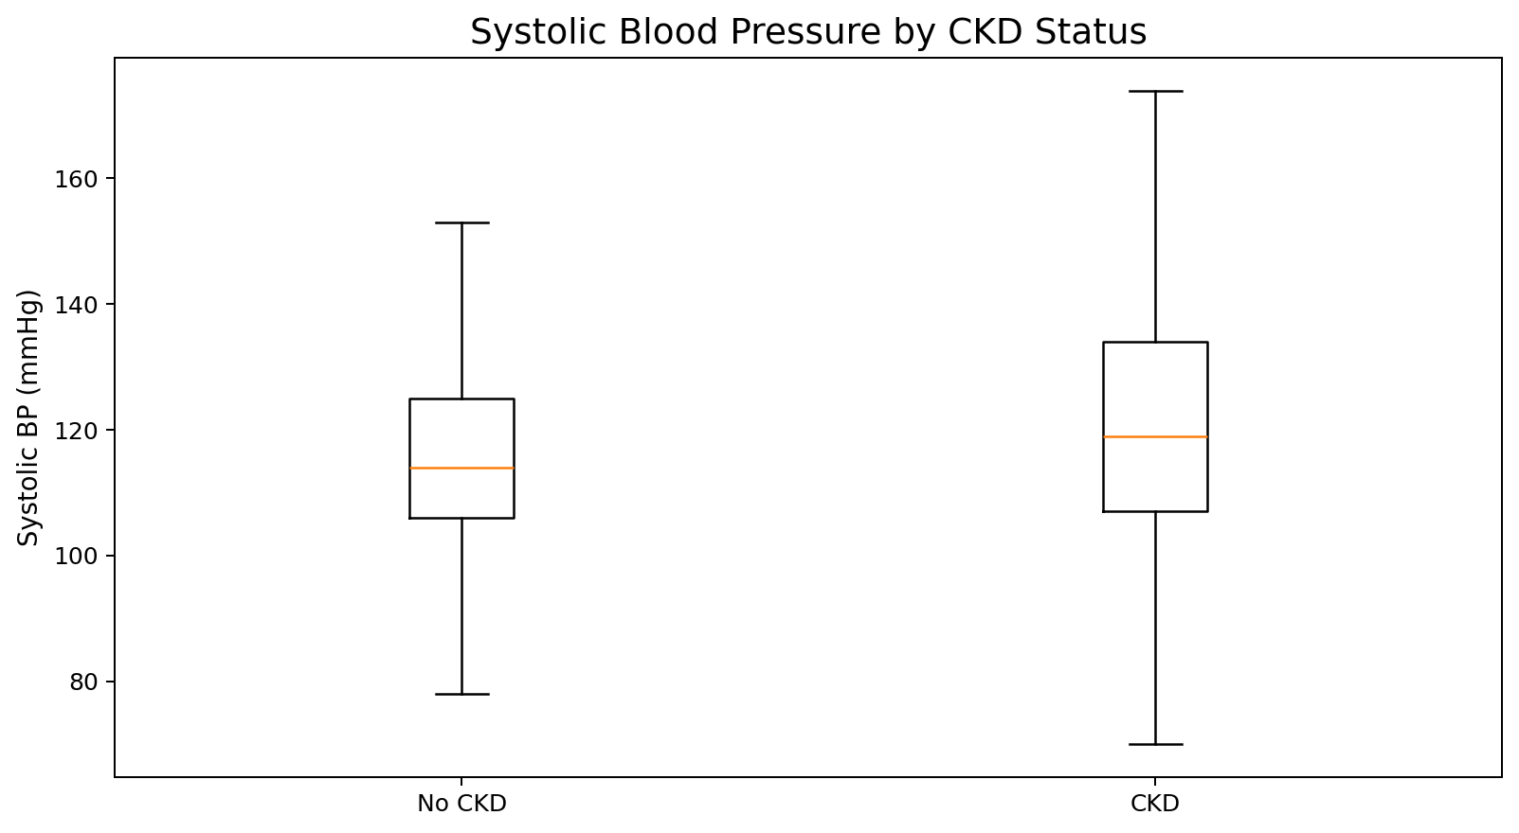
Figure 7. Systolic blood pressure by CKD status.
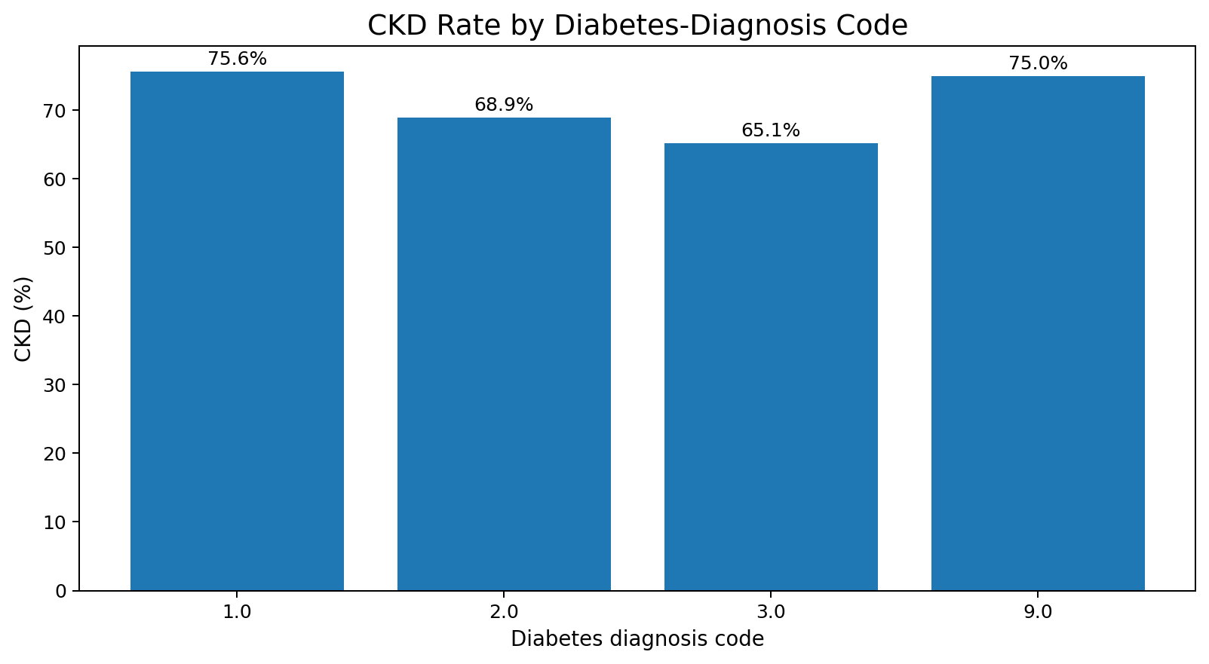
Figure 8. CKD rate by diabetes-diagnosis code.
The supplied data show stronger separation in serum creatinine, BUN and ACR than in age or blood pressure. ACR is highly right-skewed, which motivates a log scale for visualization. These observations support the use of nonlinear tree ensembles.

3.5 Correlation and leakage audit
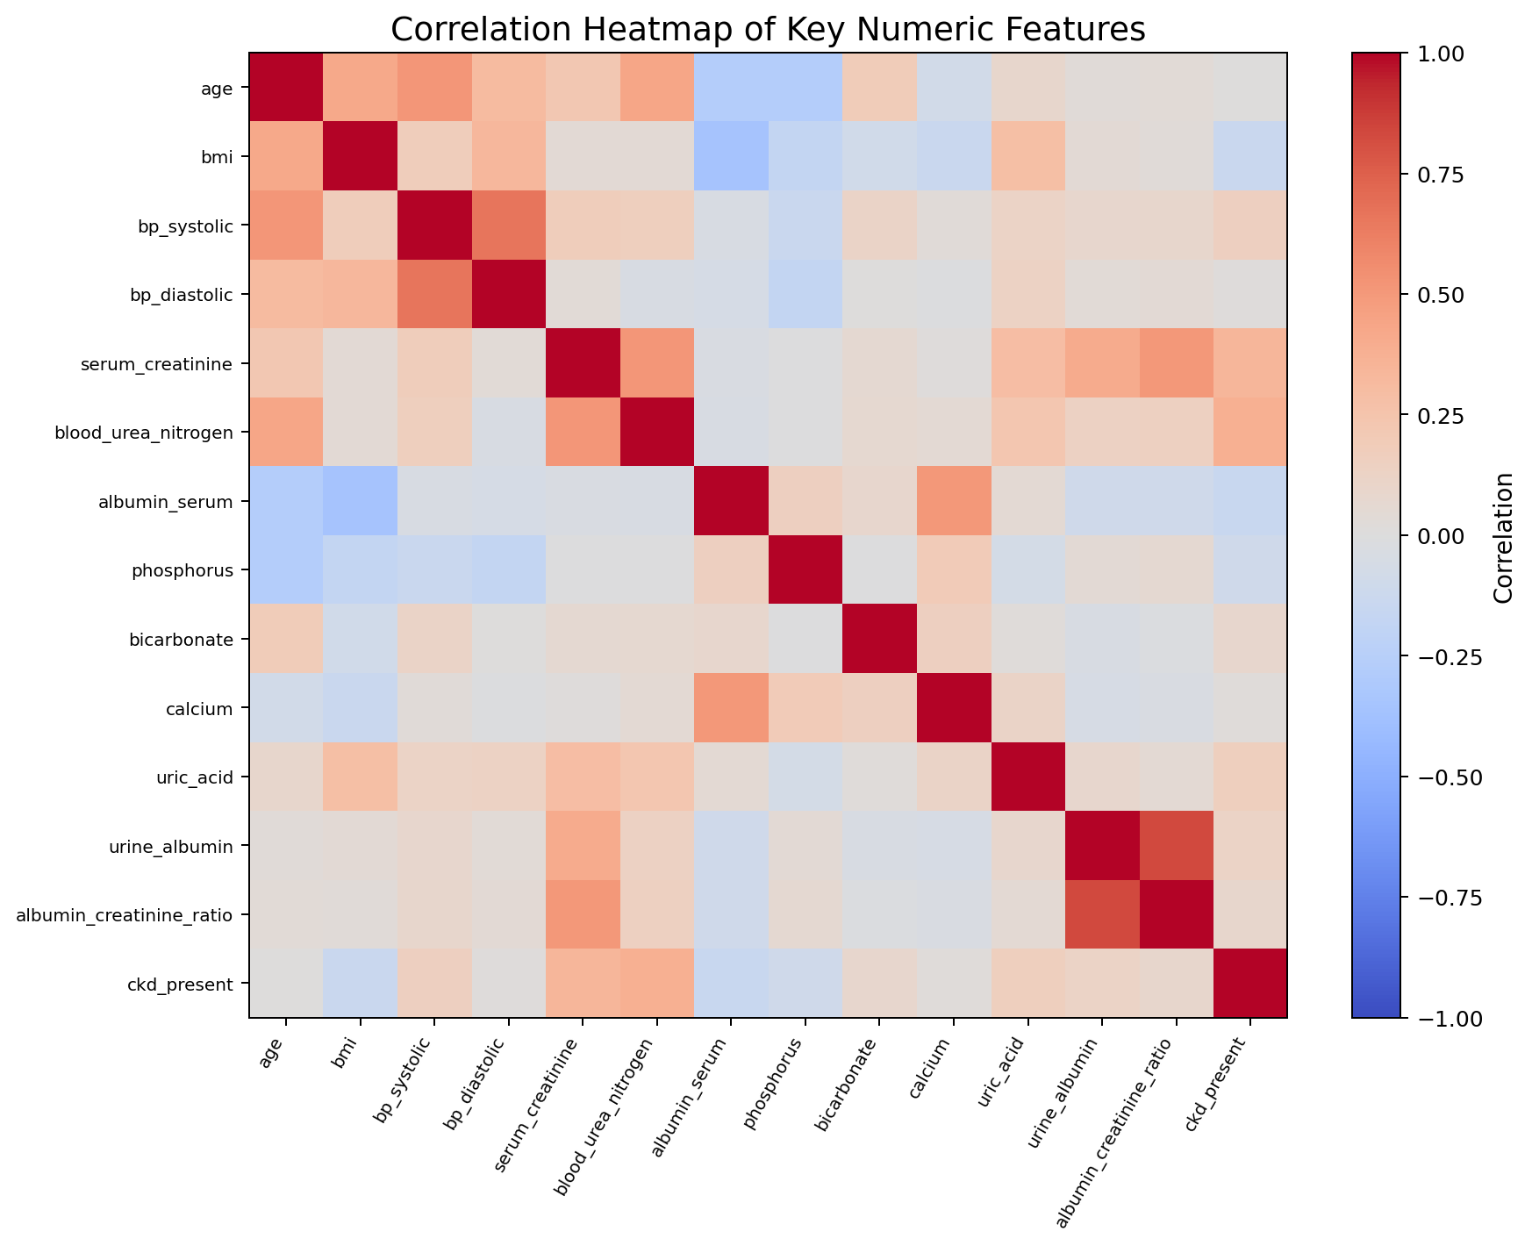
Figure 9. Correlation heatmap for selected numeric variables.
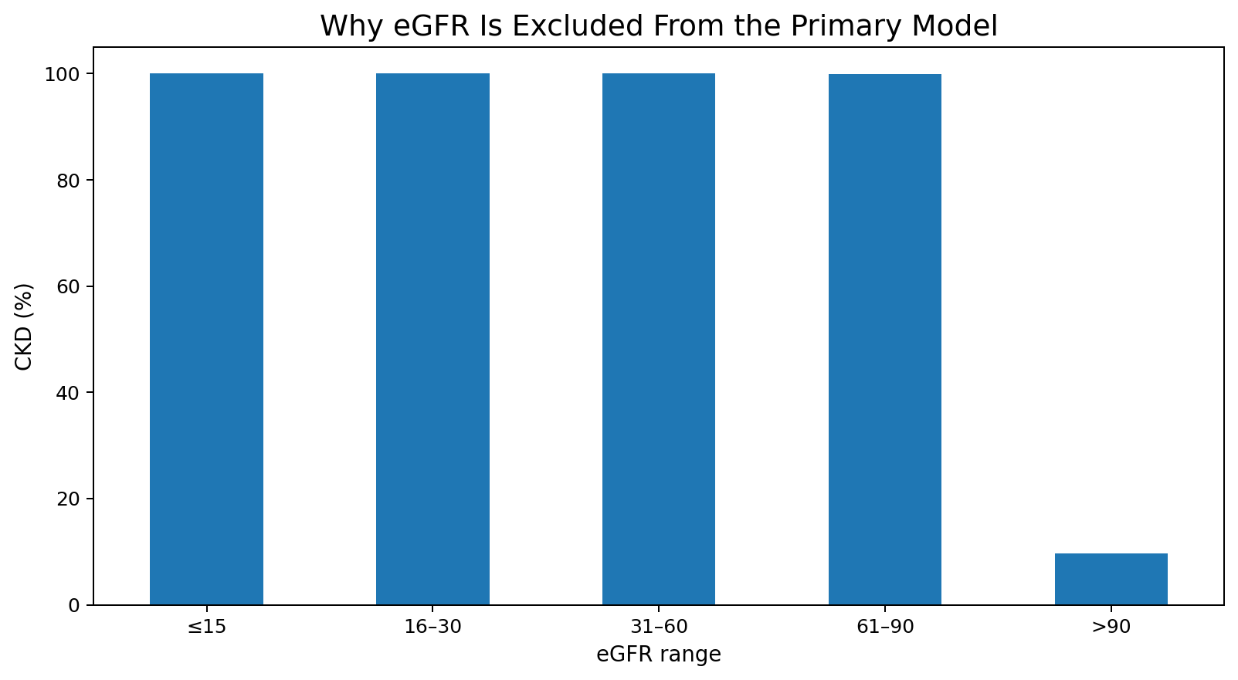
Figure 10. CKD rate by eGFR range, showing near-deterministic alignment with the supplied target.
Leakage control decision: participant_id, ckd_stage and eGFR are excluded from the primary model. eGFR is especially important because the supplied CKD label is almost deterministic across eGFR bins. Using eGFR would make the task much closer to reconstructing the label-definition rule than independent screening.

4. Modeling Methodology
- Data cleaning: treat age values below 1 as missing.
- Feature set: remove participant_id, ckd_stage, egfr and keep remaining clinical/demographic variables.
- Numeric preprocessing: median imputation.
- Categorical preprocessing: most-frequent imputation + one-hot encoding.
- Split: 80% training / 20% held-out testing, stratified by target, random_state=42.
- Models: XGBoost and LightGBM with tuned configurations from prior 3-fold stratified cross-validation.
- Metrics: accuracy, precision, recall, F1-score and ROC-AUC, plus empirical single-fit training time.
- Interpretability: model feature importance; future version can add SHAP explanations.

5. Experimental Results
Model | Accuracy | Precision | Recall | F1 | ROC-AUC | Single-fit time (s)
XGBoost | 0.9950 | 0.9982 | 0.9946 | 0.9964 | 0.9999 | 0.19
LightGBM | 0.9958 | 0.9976 | 0.9964 | 0.9970 | 0.9999 | 0.91
Interpretation: LightGBM is marginally better on accuracy, recall and F1 in this particular run, while ROC-AUC is effectively tied. XGBoost was faster for the single-fit timing measurement in this environment. Because actual speed depends on hardware, parameters and preprocessing, the report treats training time as an empirical result rather than a universal property.
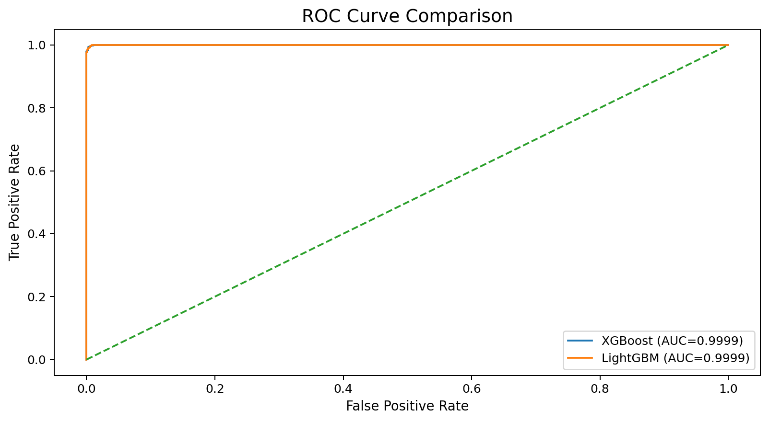
Figure 11. ROC curve comparison.

6. Feature Importance
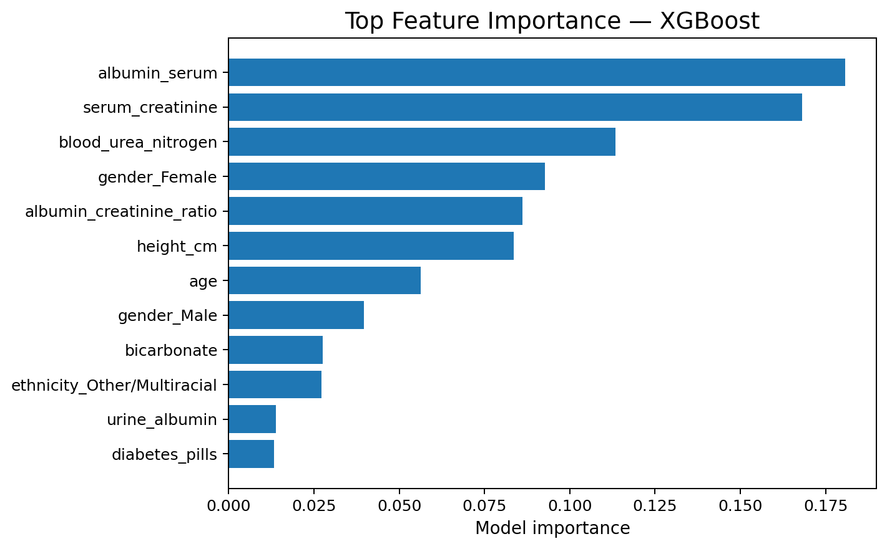
Figure 12. XGBoost top feature importance.
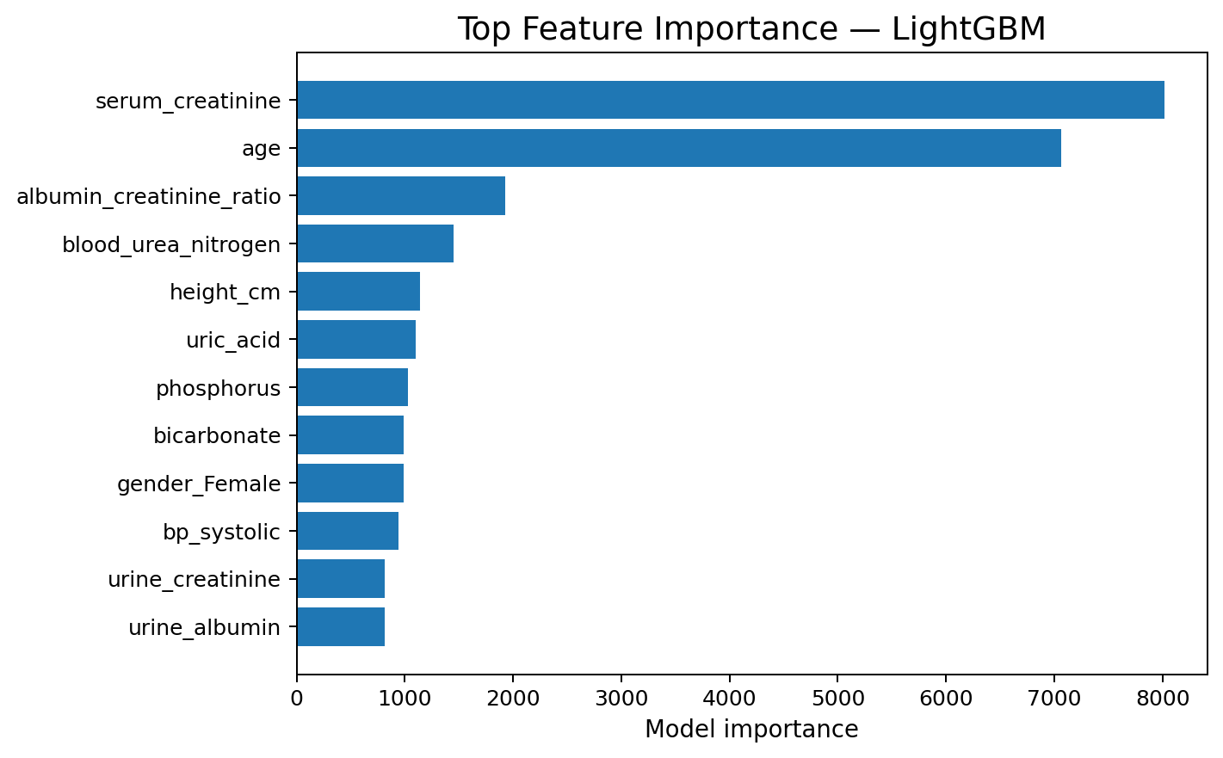
Figure 13. LightGBM top feature importance.
The models emphasize renal and metabolic variables such as serum creatinine, albumin-creatinine ratio, BUN, age and related clinical measures. Feature importance is model-specific and does not by itself prove causality.

7. Research Literature
Chen, T. & Guestrin, C. (2016). XGBoost: A Scalable Tree Boosting System. KDD 2016. https://arxiv.org/abs/1603.02754
Ke, G. et al. (2017). LightGBM: A Highly Efficient Gradient Boosting Decision Tree. NeurIPS 2017. https://papers.nips.cc/paper/2017/hash/6449f44a102fde848669bdd9eb6b76fa-Abstract.html
Capodici, A. et al. (2023). Predict, diagnose, and treat chronic kidney disease with machine learning: a systematic literature review. Journal of Nephrology. https://pubmed.ncbi.nlm.nih.gov/36786976/
Artificial Intelligence to Predict Chronic Kidney Disease Progression to Kidney Failure: A Narrative Review (2025). https://pubmed.ncbi.nlm.nih.gov/39763163/
The systematic review by Capodici et al. reports that ML has been widely studied for CKD prediction/diagnosis but also highlights limited clinical-context validation and poor generalizability assessment across studies. This supports presenting the project as an academic decision-support prototype rather than a clinically deployed diagnostic system.

8. Prototype
A Streamlit prototype is included with the project package. It loads the saved XGBoost and LightGBM pipelines, accepts a subset of routine clinical inputs, computes a predicted CKD probability, and allows the user to switch models. The prototype is explicitly marked as educational and not a medical diagnostic device.
Run commands:
pip install -r prototype/requirements.txt
streamlit run prototype/app.py

9. Limitations & Future Work
- The supplied dataset is cross-sectional and does not model time-to-event CKD progression.
- The target appears strongly linked to renal-function definitions, creating an unusually easy classification task even after excluding eGFR.
- Missingness is substantial in several variables and may not be missing at random.
- Dataset provenance and collection protocol were not included with the CSV files.
- External validation on an independent cohort is required before any clinical interpretation.
- Future work: SHAP explanations, calibration and threshold analysis, subgroup/fairness checks, external validation, and longitudinal progression prediction.

Appendix A. Primary Dataset Columns
participant_id, age, gender, ethnicity, education_level, poverty_income_ratio, bmi, weight_kg, height_cm, bp_systolic, bp_diastolic, serum_creatinine, blood_urea_nitrogen, albumin_serum, phosphorus, bicarbonate, calcium, uric_acid, urine_creatinine, urine_albumin, albumin_creatinine_ratio, diabetes_diagnosed, insulin_use, diabetes_pills, ever_smoked, current_smoker, egfr, ckd_stage, ckd_present

Appendix B. Reproducibility
All figures and model artifacts in this package are generated from the supplied CSV files. The modeling pipeline uses scikit-learn preprocessing, XGBoost 3.x and LightGBM 4.x with fixed random state 42. The package includes a reproducible training script, saved model pipelines, EDA notebook, report and presentation.

